SLE-3: Architectural Design (Full C4 Model)
Course: 02AML204 – Introduction to Artificial Intelligence
PRN: 25UAM133 | Name: Sanchit Sachin Magdum | Division: B
Date: 03-10-2026 | GitHub Link: https://github.com/sanchitmagdum17

1. System Title & Short Description
System: 8-Puzzle Solver using BFS and DFS (Search Agent), the same system profiled in SLE-2.
The 8-Puzzle is a 3×3 sliding-tile puzzle with one blank cell. The system searches from a given start state to a fixed goal state using two uninformed search algorithms, Breadth-First Search (BFS) and Depth-First Search (DFS), where every move has unit cost. It also measures execution time, nodes expanded and path length on three test cases (easy, medium and hard). The aim is to compare BFS, which gives the shortest path, with DFS, which does not guarantee it.

2. Context Diagram (Level 1)
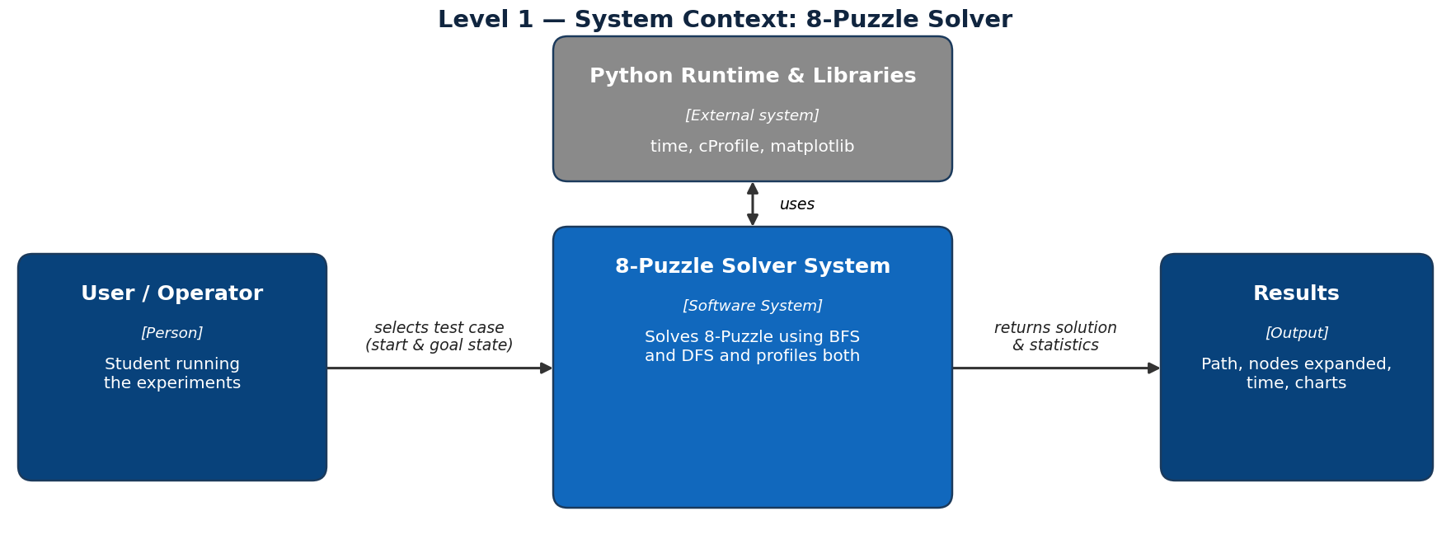
Fig. 1 — System context of the 8-Puzzle Solver.
The User (student) selects a test case, meaning the start and goal state, and runs the solver. The 8-Puzzle Solver System searches for the solution and returns the solution path, nodes expanded, time taken and charts. The only external dependency is the Python runtime with its libraries (time, cProfile and matplotlib), used for timing, profiling and plotting. No database or network service is needed.

3. Container Diagram (Level 2)
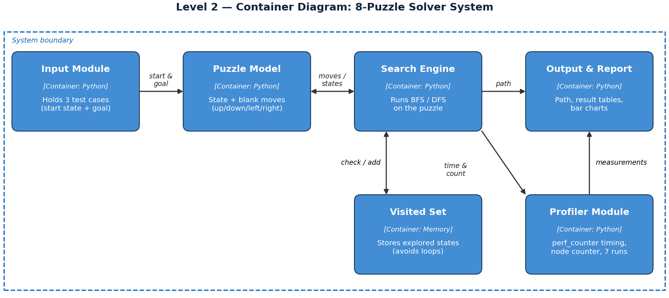
Fig. 2 — Containers (main building blocks) of the system.
- Input Module: holds the three fixed 8-Puzzle test cases (start state and common goal) and passes the chosen one to the solver.
- Puzzle Model: represents a board state and generates legal moves by sliding the blank up, down, left or right.
- Search Engine: runs BFS or DFS from the start state until the goal is found (opened up in Level 3).
- Visited Set: memory that stores explored states so that the same state is not expanded again.
- Profiler Module: measures time with time.perf_counter(), counts nodes expanded and averages 7 runs per algorithm per test case.
- Output & Report: shows the solution path and builds the result tables and bar charts used in the SLE-2 report.

4. Component Diagram (Level 3)
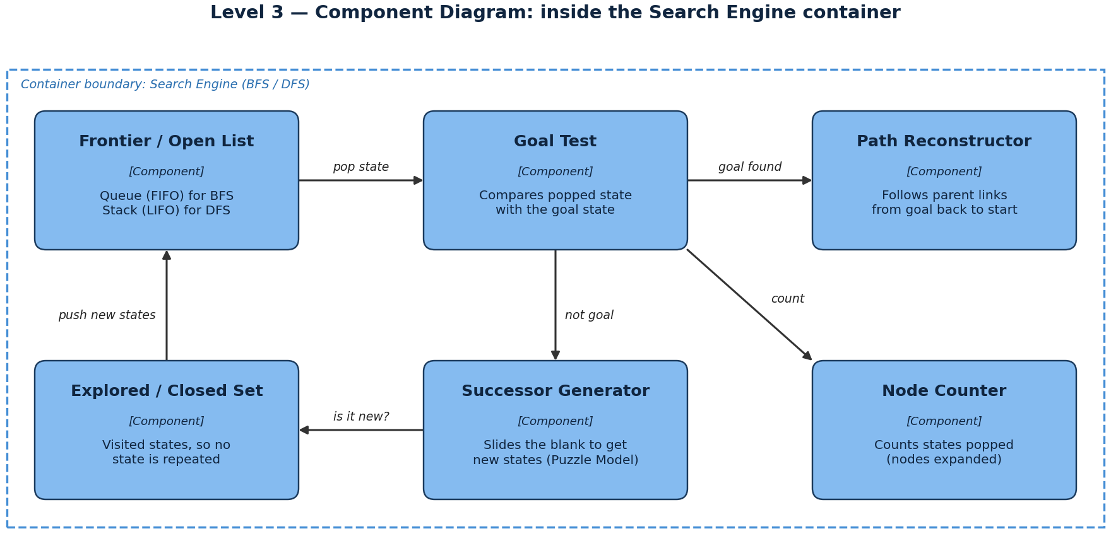
Fig. 3 — Components inside the Search Engine container.
The Search Engine is chosen because it is the core of the system. The Frontier holds states waiting to be explored: a queue for BFS and a stack for DFS, which is the only structural difference between the two algorithms. Each popped state goes to the Goal Test. If it is not the goal, the Successor Generator creates new states using the Puzzle Model, the Explored Set rejects states already seen, and the new states are pushed to the Frontier. The Node Counter counts every popped state, and when the goal is reached the Path Reconstructor follows parent links back to the start to build the path.

5. Code Level Overview (Level 4)
Main classes and functions (names and one-line responsibilities only):
Class / Function | One-line responsibility
class Node | Stores a state, its parent link, the move made and the depth.
def get_neighbors(state) | Generates legal next states by sliding the blank up, down, left or right.
def is_goal(state) | Checks whether a state is equal to the goal state.
def bfs(start, goal) | Queue-based search; returns the shortest path and nodes expanded.
def dfs(start, goal) | Stack-based search; returns a path and nodes expanded.
def reconstruct_path(node) | Follows parent links from the goal node back to the start.
def run_profile(algo, start, goal, runs=7) | Times an algorithm with time.perf_counter() and averages 7 runs.
def plot_results(results) | Draws the time and nodes-expanded bar charts for the report.

6. Design Decisions
The Puzzle Model is kept separate from the Search Engine so that BFS and DFS share the same move rules and goal state, which keeps the SLE-2 comparison fair. The Frontier is the only part that differs (queue vs stack), so one engine structure supports both algorithms. Profiling is a separate container so that timing code does not get mixed with search logic. I kept the design to six containers and drew components for the Search Engine only, to keep the diagrams simple and readable.

7. AI Contribution Note
- AI tools used: Claude.
- What AI helped with: suggesting the C4 diagram layout, drafting the explanation text and formatting the report.
- What I did myself: chose the 8-Puzzle (BFS/DFS) system from my SLE-2 work, reviewed the architecture against my own code, and checked that every level and design choice is something I can explain.

8. Conclusion
C4 helped me look at the same 8-Puzzle solver from four levels: who uses it, what its main parts are, how the Search Engine works inside, and which classes and functions implement it. I learned that separating responsibilities (model, search, memory, profiling and output) makes a system easier to understand and test, and that BFS and DFS differ mainly in the data structure used by the Frontier. Keeping each diagram small made the design much clearer.

