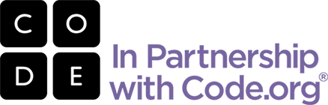

**[TEACHER NAME’S] CLASS IS LEARNING COMPUTER SCIENCE!**

**[SCHOOL NAME], [GRADE LEVEL]**

In [CLASS NAME], we’re teaching **Code.org’s K-8 Intro to Computer Science** course to your child.

**WHAT IS IT?**

K-8 Intro to Computer Science is fun, collaborative, and creative! It’s designed to inspire students to continue learning how technology improves real world relationships, connections, and life.

**Students learn:**

how the Internet works

basic computer programming

logic, problem solving and creativity

The course features puzzles, video lectures by Bill Gates, Mark Zuckerberg and Chris Bosh of the Miami Heat, as well as familiar characters from popular games Angry Birds and Plants vs. Zombies. Using a blended learning model, your children are learning with a mix of online, self-guided activities and “unplugged” activities that use no computer at all.

**WHY COMPUTER SCIENCE?**

Software is everywhere. It’s shaping almost every aspect of how we live our lives. But very few kids are learning how to actually create games, apps and programs.

**Did you know?**

90% of American schools don’t teach computer science.

Fewer students are learning how computers work than a decade ago!

All students can learn to code. But girls and students of color are severely underrepresented in computer science.

Computer science is a foundation for every student. That’s why we’re introducing ours to these critical 21st century skills.

Code.org is a non-profit dedicated to giving every student in every school the opportunity to learn computer science, and expanding participation by girls and students of color. Learn more at [www.Code.org](http://www.Code.org).