**Food Inventory Management System**:

Webpage hosted on Localhost with port 9001 and used Spring and MYSQL for Web programming framework and database, respectively**.**

**Screenshots of webpage:**

Home Page where it has navigation bar showing some of the operations that can be performed on the project. Also, few images showing the topic of the project. In addition, providing information about the team who developed this project.

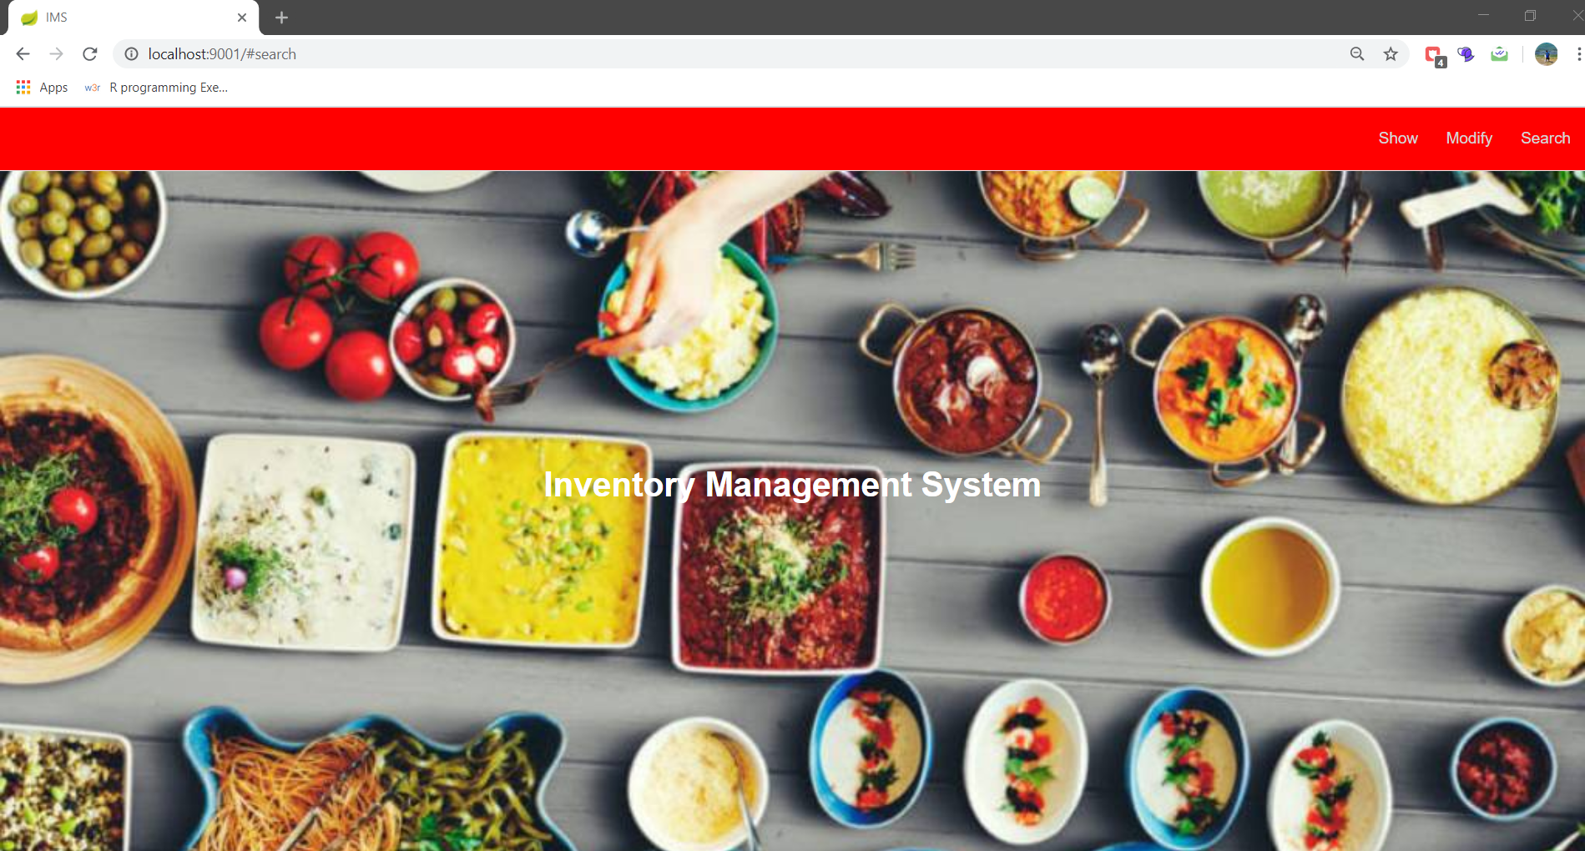

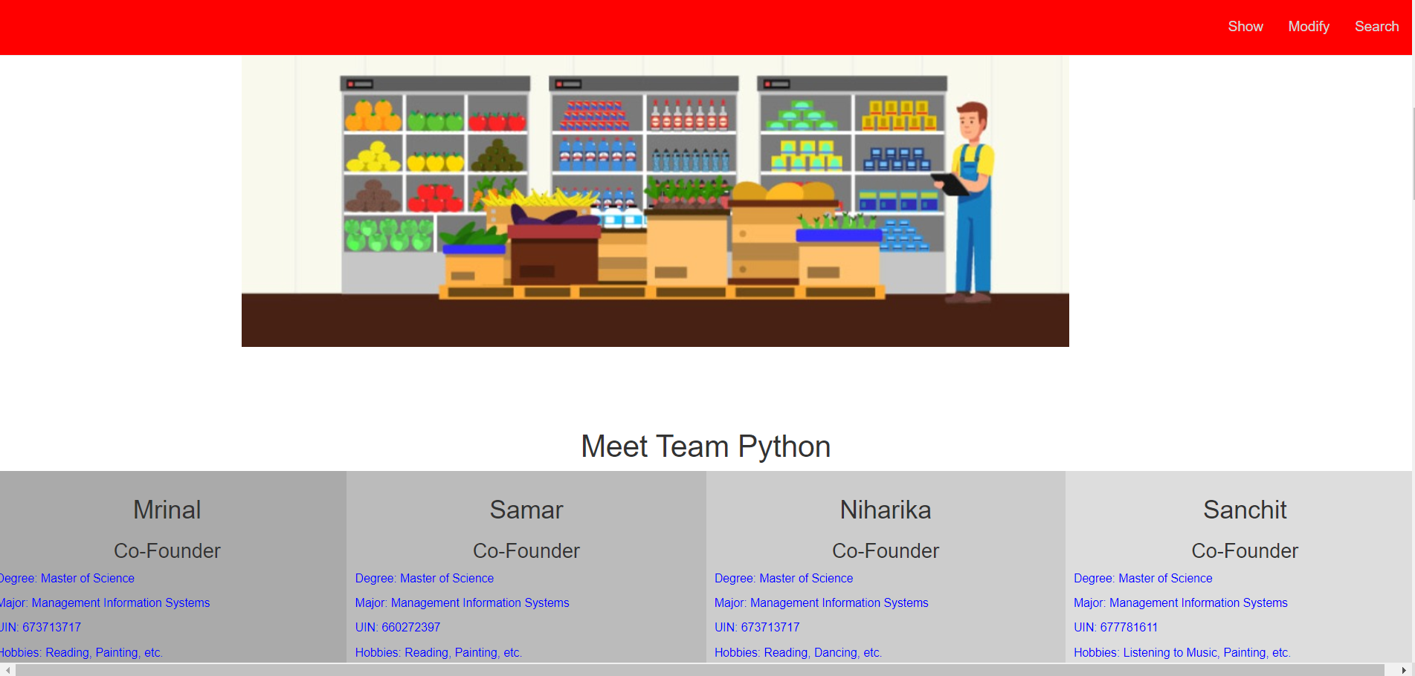

Charts for describing target market for the project where Pie chart is used portraying values and percentage associated with each of the business when one hovers over the graph. Here, the data used is static of about 24 samples.

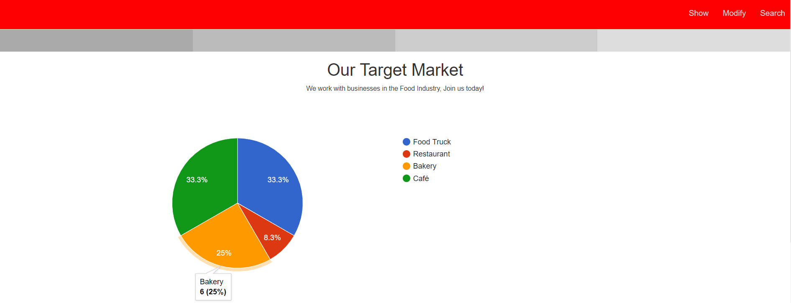

For examining the performance based on sales, profits, expenses from February till April 2020. Bar chart for describing values for each of the performance metric. Here, the data used is static.

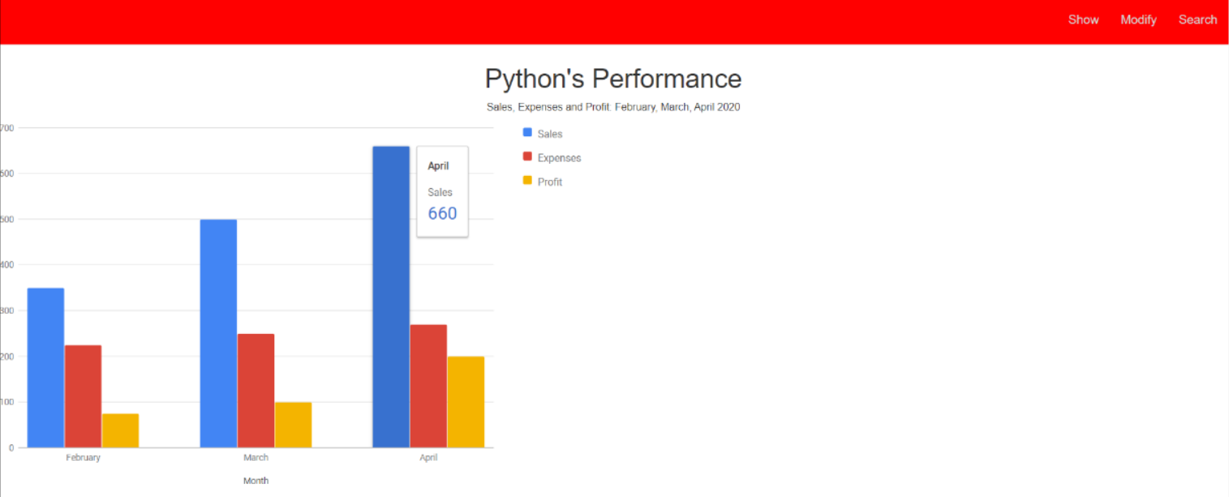

Show operation will display records that are been stored in the database. Fetch All displays all records from the database.

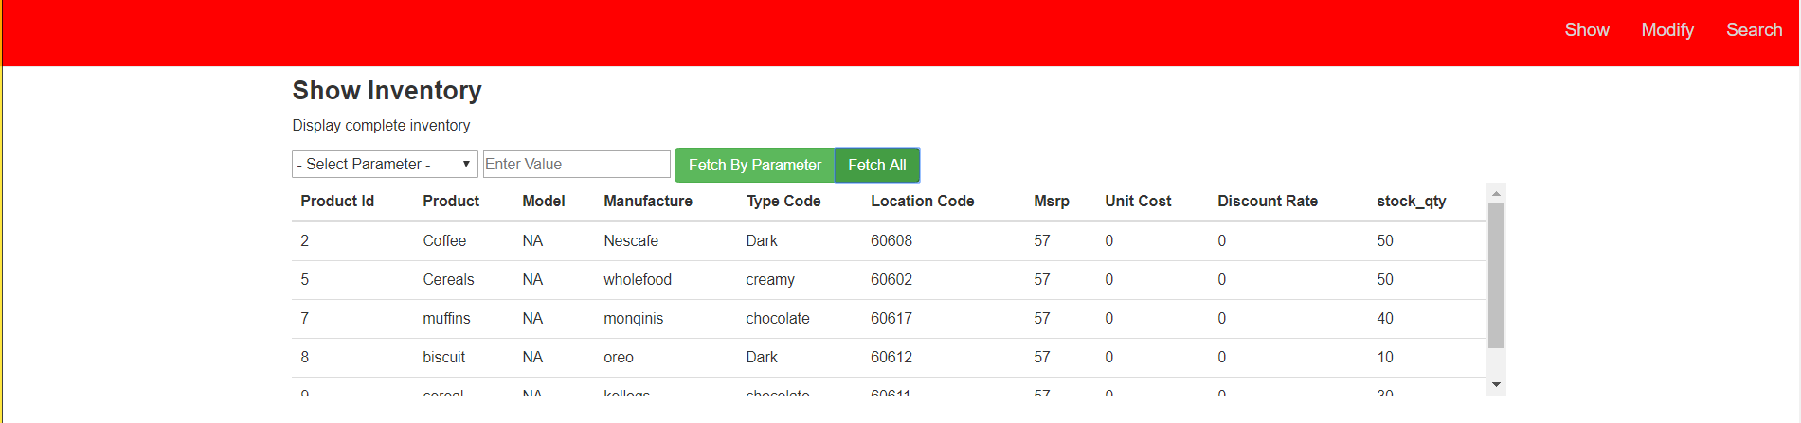

Also, Fetch by parameter will display that record for that specific parameter. Here, parameter selected is manufacture and value is “Nescafe”.



Here, Modify operation updates value for parameter. I have changed Product “Coffee” to “Tea”.



Here, Delete function removes that record by taking parameter. I have deleted product id “2” from the database.

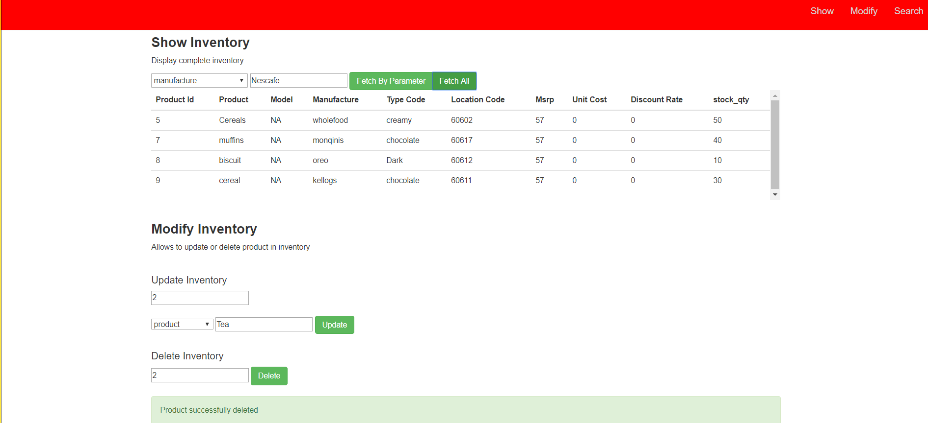

If incorrect data entered displays an error message saying that product do not exist.

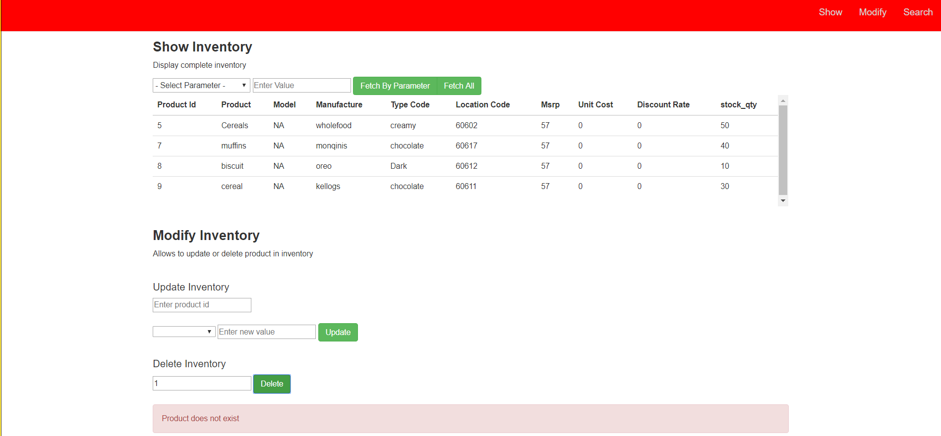

Search Operation will display that record where specific parameter is selected. I have searched for product id “5”



This is the google form which acts as a feedback form where one can enter his/her suggestions and submit its response and later can also edit the response.

