Hybris ImpEx Automation Tool - User Manual

1. Overview
The Hybris ImpEx Automation Tool is designed to streamline your data migration workflow. It allows you to effortlessly convert, sanitize, and format bulk spreadsheet content into production-ready ImpEx files, ensuring data integrity and saving development time.

2. Getting Started
Follow these steps to initiate your bulk content migration:

Bulk Spreadsheet ImpEx

Step 1: Uploading Data
1. Navigate to the 'Bulk Spreadsheet ImpEx' tab.
2. Drag and drop your Excel file into the designated Upload Zone, / click 'Or Browse Files' / click 'Upload Bulk Spreadsheet' Button to select a file from your machine.
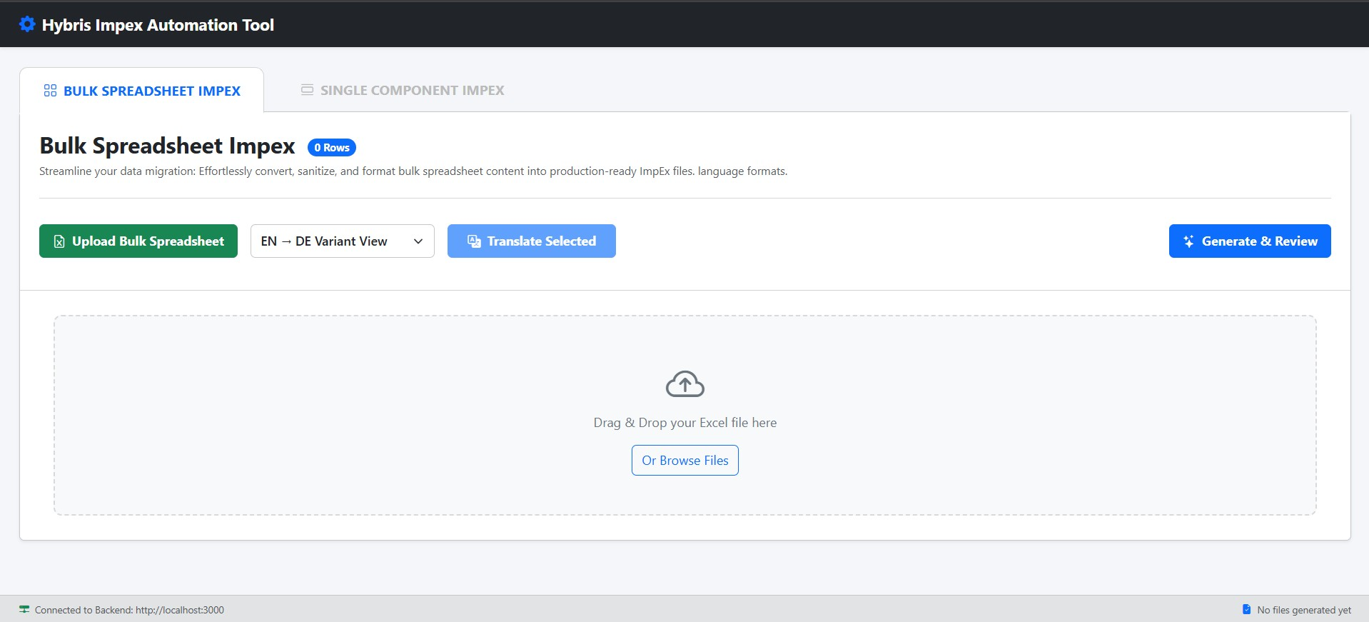

Step 2: The Excel file format Titles and content must be as below
Cell A1 = component_id
Cell B1 = content
Keep the relevant content below the headings

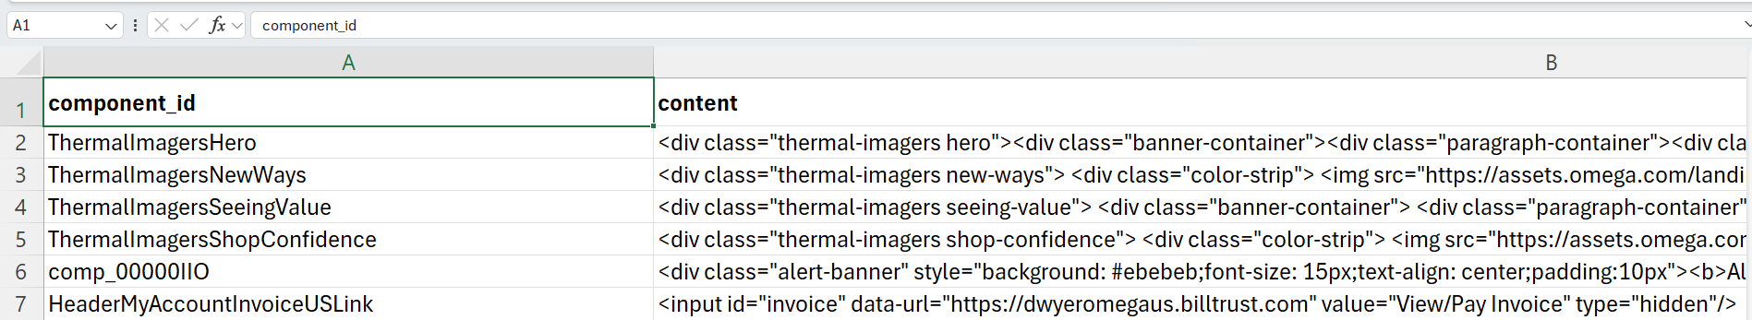

Step 3: Reviewing and Editing
Once uploaded, the grid will populate with your component data. You can:
- View the 'Component UID' and 'Content' for each row.
- Select rows to include in the final export using the checkboxes.
- Use the 'Translate Selected' button if you need to apply language variations.
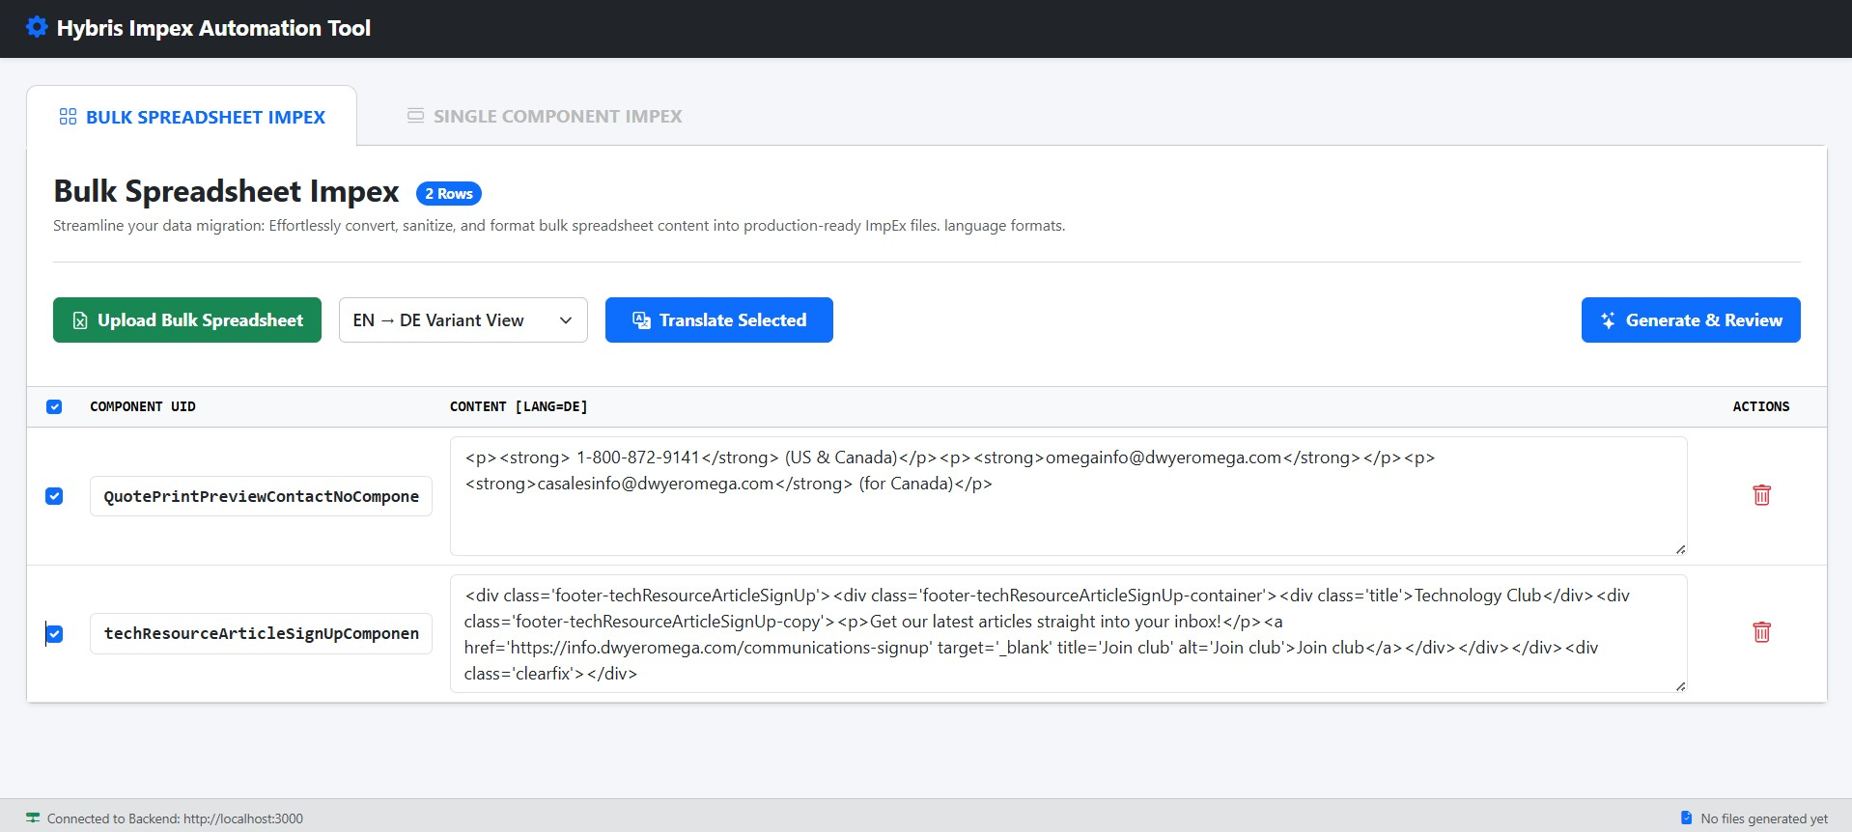

Step 4: Generating and Reviewing
1. Click the 'Generate & Review' button to finalize your content.
2. The 'ImpEx Editor' modal will open, displaying the processed ImpEx script.
3. Review the code for syntax or structural issues.

Step 5: Exporting the File
In the ImpEx Editor modal, you have two primary options:
- 'Copy Impex': Copy the script directly to your clipboard.
- 'Download .impex File': Save the script as a file for direct import into the Hybris platform.

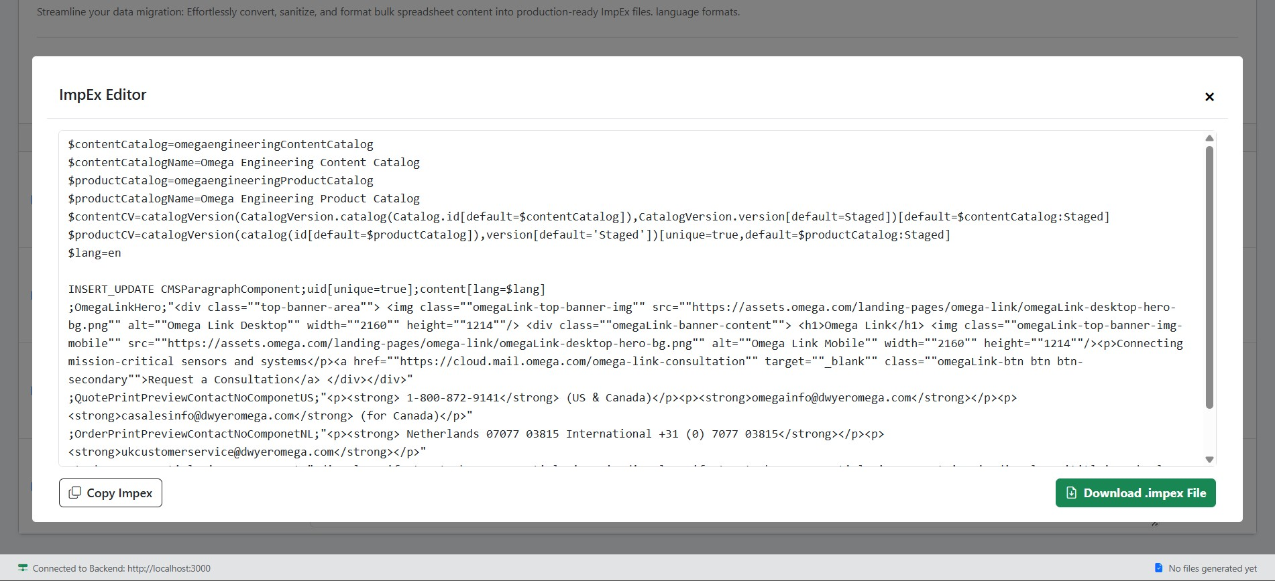

Single Component ImpEx
This module is designed for precise, manual control over individual CMS component configurations, allowing you to define headers, UIDs, and multi-language content before generating the final ImpEx syntax.

Step 1: Define Configuration Metadata
Before entering content, configure the global settings that define where and how the component will be imported.
- Impex Header Syntax: Navigate to the 'Single Component Impex' tab. Define the base ImpEx header (e.g., INSERT_UPDATE CMSParagraphComponent...). Ensure your macro variables (like $lang) are correctly placed.
- Component Target UID: Enter the unique identifier for the component you are modifying in the Hybris/SAP system.

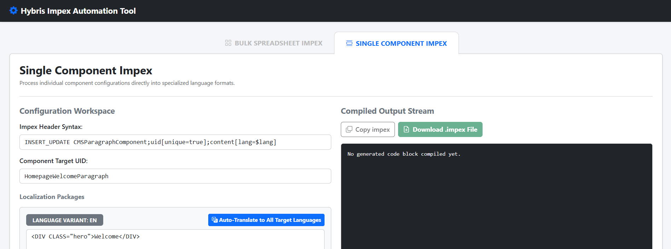

Step 2: Input Localized Content
The workspace provides dedicated text areas for each language variant required by your project.
- Manual Entry for EN : Enter the HTML content for EN language variant.
- Auto-Translation: Use the "Auto-Translate to All Target Languages" button to instantly sync content across all variants if you are starting with a master language template. It will directly paste translated content into its corresponding text area for DE, ES, FR, IT, UK.

Step 3: Generate and Review
Once the content is populated and verified:
- Click the "Generate & Review" button at the bottom left.
- The system will automatically process, sanitize, and format the input into the Compiled Output Stream (the dark panel on the right).
- Review the generated ImpEx code to ensure all quotes are escaped and tags are correctly formatted.

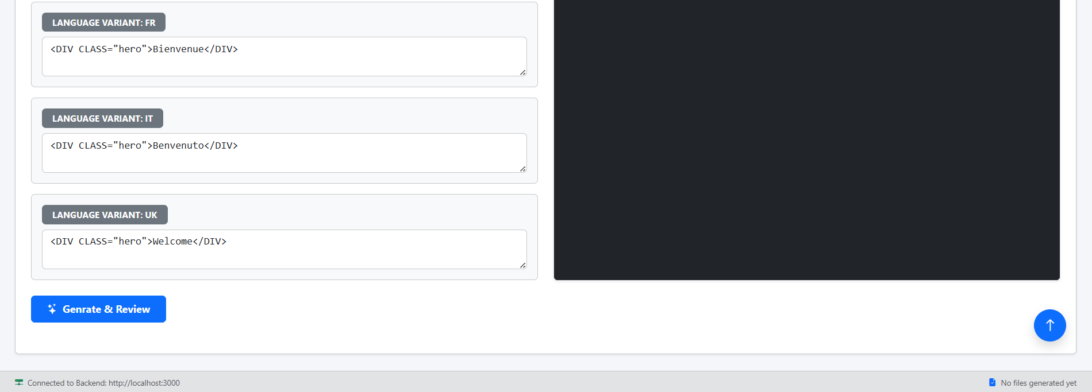

Step 4: Export Options
After the code is generated in the output stream, you have two export options located at the top of the dark panel:
- Copy Impex: Copies the entire generated block to your clipboard for quick pasting into your import console.
- Download .impex File: Triggers a direct download of the file to your local machine, ready for immediate upload to the Hybris platform.

