1-amaliyot

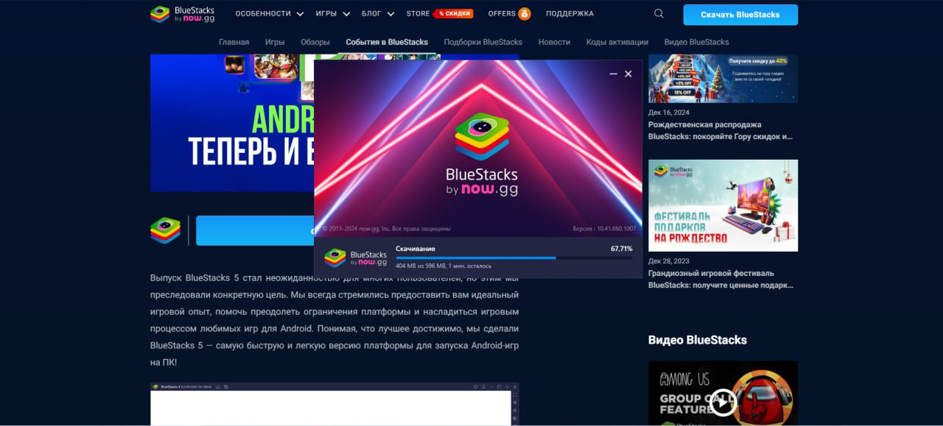

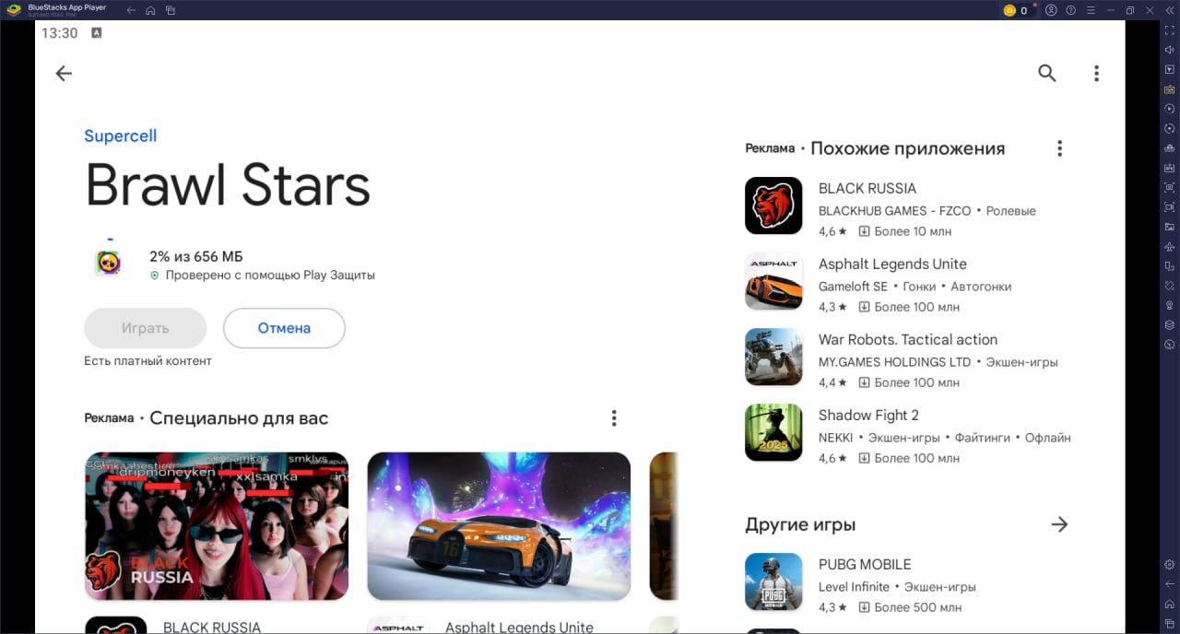

Bugungi darsimizda “BlueStacks” mobil ilovasini kampyuterga o’rtashish ko’nikmasiga ega bo’ldik.

1-misol

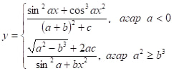

import static java.lang.Math.\*;

import java.util.Scanner;

public class Main {

public static void main(String[] args) {

Scanner scanner = new Scanner(System.in);

System.out.print("a ni kiriting: ");

double a = scanner.nextDouble();

System.out.print("b ni kiriting: ");

double b = scanner.nextDouble();

System.out.print("c ni kiriting: ");

double c = scanner.nextDouble();

System.out.print("x ni kiriting: ");

double x = scanner.nextDouble();

double y;

if (a < 0) {

// Birinchi formula

y = (pow(sin(a \* x), 2) + pow(cos(a \* x), 3)) / ((pow(a + b, 2)) + c);

} else if (pow(a, 2) >= pow(b, 3)) {

// Ikkinchi formula

double denominator = sin(pow(a + b \* x, 2));

if (denominator == 0) {

System.out.println("Xatolik: Mahraj nolga teng bo‘lishi mumkin emas.");

return;

}

y = sqrt(pow(a, 2) - pow(b, 3) + 2 \* a \* c) / denominator;

} else {

System.out.println("Berilgan shartlarga mos keladigan qiymat yo‘q."); return;

}

System.out.println("Natija: y = " + y);

scanner.close();

}

}

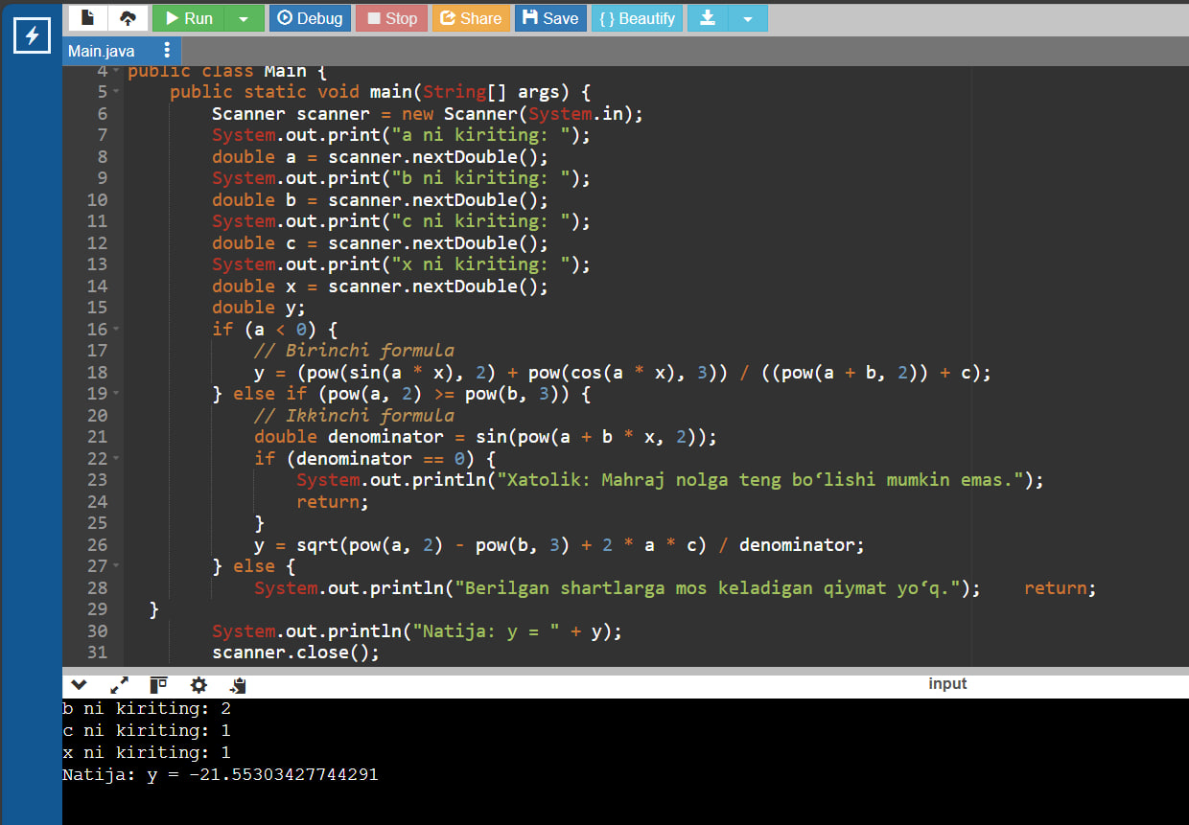

2-misol

Butun n (n>1) soni va n ta haqiqiy sonlardan iborat ketma-ketlik berilgan. Ketma-ketlikning musbat elementiari orasidan eng kichigi topilsin

import java.util.Scanner;

import java.util.ArrayList;

public class Main {

public static void main(String[] args) {

Scanner scanner = new Scanner(System.in);

System.out.print("N sonini kiriting: ");

int n = scanner.nextInt();

System.out.println("Ketma-ketlikni kiriting:");

ArrayList<Double> sequence = new ArrayList<>();

for (int i = 0; i < n; i++) {

sequence.add(scanner.nextDouble());

}

ArrayList<Double> positiveNumbers = new ArrayList<>();

for (double num : sequence) {

if (num > 0) {

positiveNumbers.add(num);

}

}

if (positiveNumbers.size() > 0) {

double minPositive = positiveNumbers.get(0);

for (double num : positiveNumbers) {

if (num < minPositive) {

minPositive = num;

}

}

System.out.println("Musbat sonlar orasidagi eng kichik son: " + minPositive);

} else {

System.out.println("Ketma-ketlikda musbat sonlar yo'q.");

}

scanner.close();

}

}

