Skrill Transaction flow

****

1. When the customer is ready to pay on the website, they select the Skrill payment option on the website.
2. You request a session identifier (SID) by passing customer and transaction details (e.g., amount, currency and language) to the Skrill Payment Gateway.
3. Skrill returns the generated SID.
4. Redirect the customer to the Skrill Payment Gateway and include the session identifier in the redirect URL. Skrill displays the relevant payment page.
5. The customer enters their payment information, plus any other details requested, and confirms the transaction.
6. Skrill requests authorisation for the payment from the customer’s bank, third party provider or card issuer.
7. The bank/provider approves or rejects the transaction.
8. Skrill displays the confirmation page, containing the transaction result, on the Skrill Payment Gateway.
9. Skrill provides you with an asynchronous notification, sent to the status URL or IPN (instant Payment Notification), confirming the transaction details and status.

Paypal Express Checkout flow   
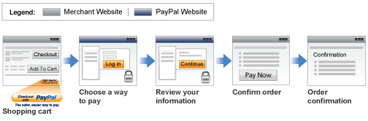

1. Chooses Express Checkout by clicking *Check out with PayPal*
2. Logs into PayPal to authenticate his or her identity
3. Reviews the transaction on PayPal
4. Confirms the order and pays from website
5. Receives an order confirmation

Stripe Payment flow

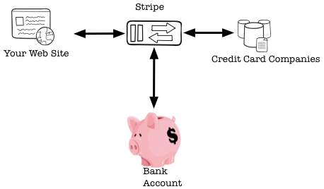

1. Collect credit card information
2. Convert those details to what we call a single-use token
3. Send that token, with the rest of the form, to stripe server
4. Get the response of the stripe payment gateway