Laser Harp

A laser harp is an electronic musical user interface and laser lighting display. It projects several laser beams and the musician blocks them to produce sounds, visually reminiscent of a harp. The laser harp has been popularised by Jean Michel Jarre, and has been a high profile feature of almost all his concerts since 1981. The laser harp became famous in Asia by Japanese artist Susumu Hirasawa.

A comparator was used to detect when the path of the laser was interrupted. This was given to a signal conditioning circuit. The outputs were given to an Arduino Nano(microcontroller). Appropriate tones were played depending on the user input.

Comparator was implemented using TL072. Since it’s output levels were at 1V and 5V rather than 0V and 5V, CD4007 was used as a NOT gate to obtain proper binary voltage levels. L293D was used as a driver for the two speakers.The system is powered using a 9V-2 Amp DC adapter.

Circuit Diagram

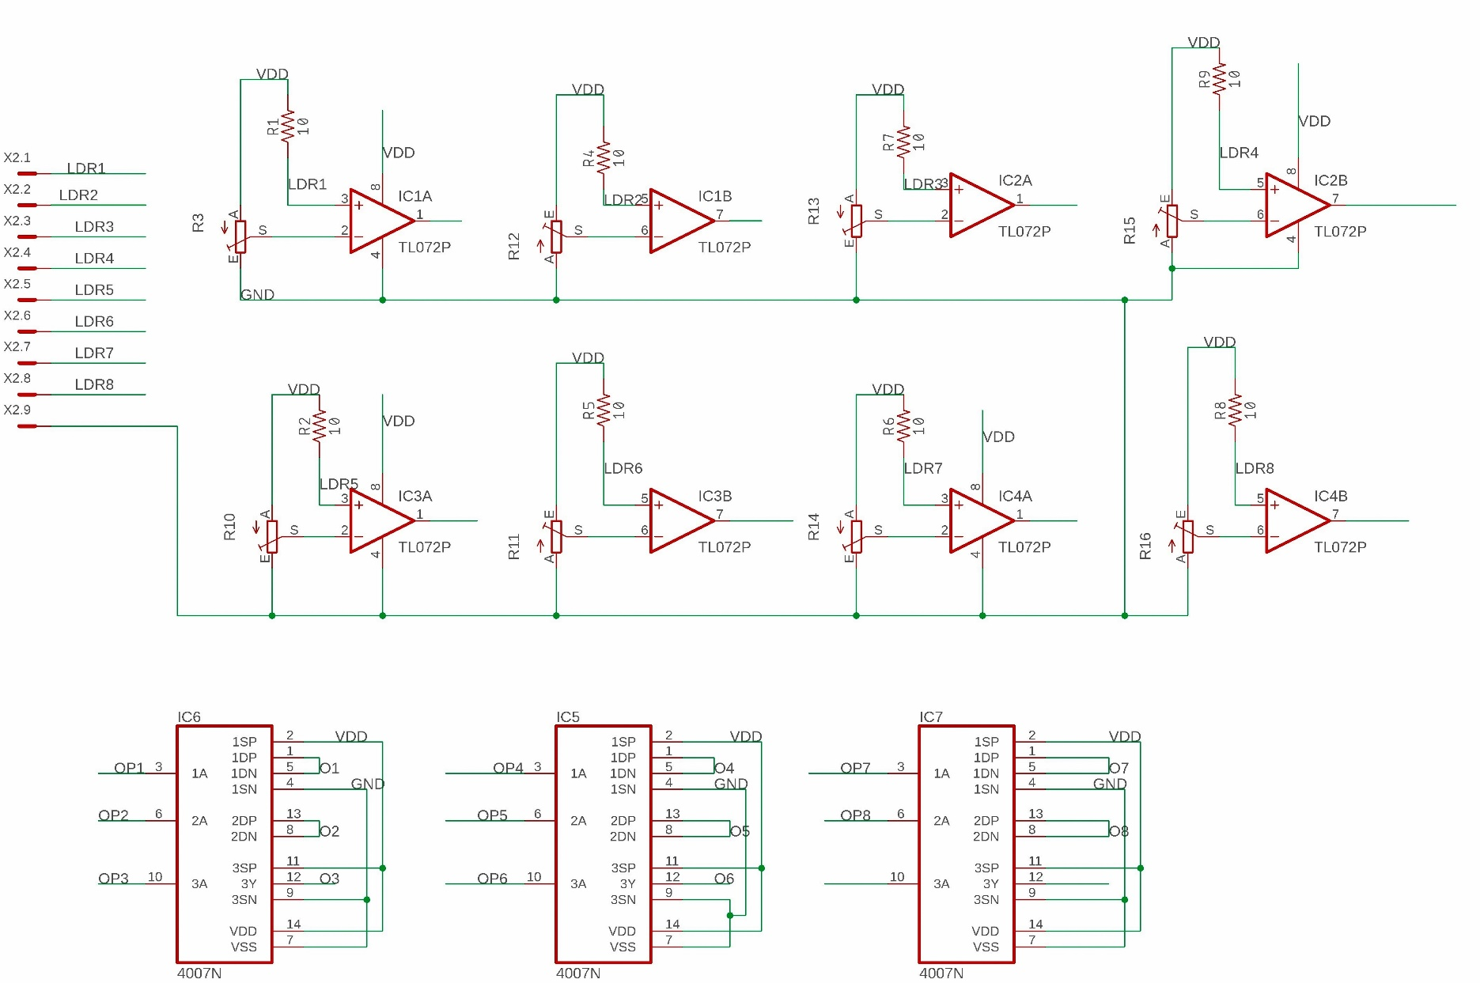

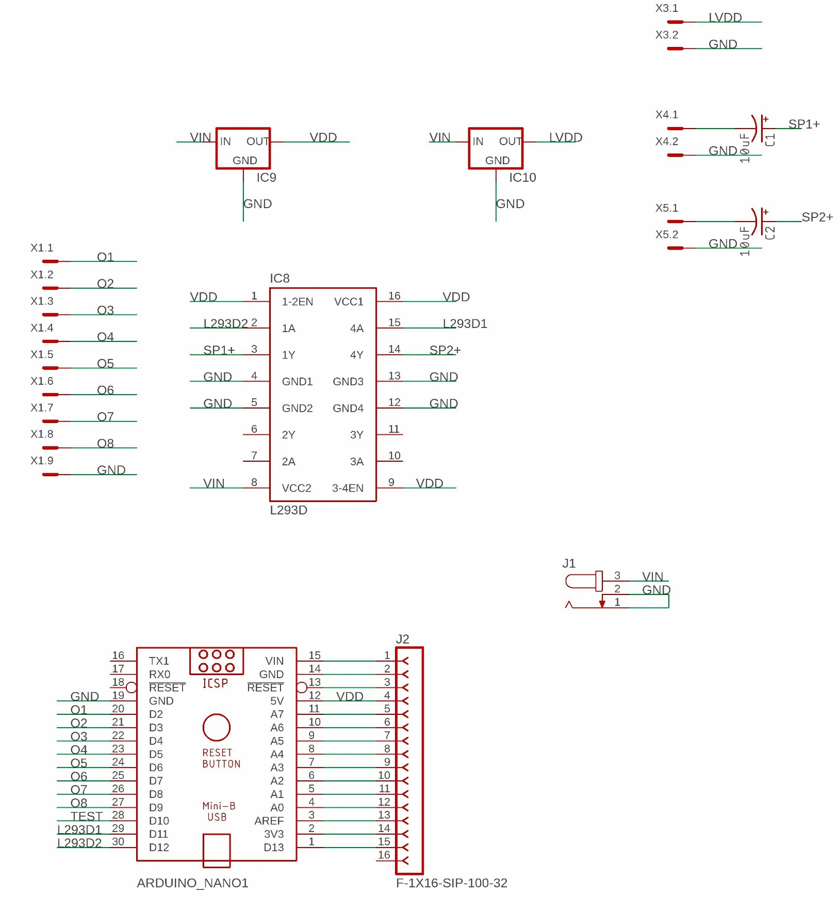

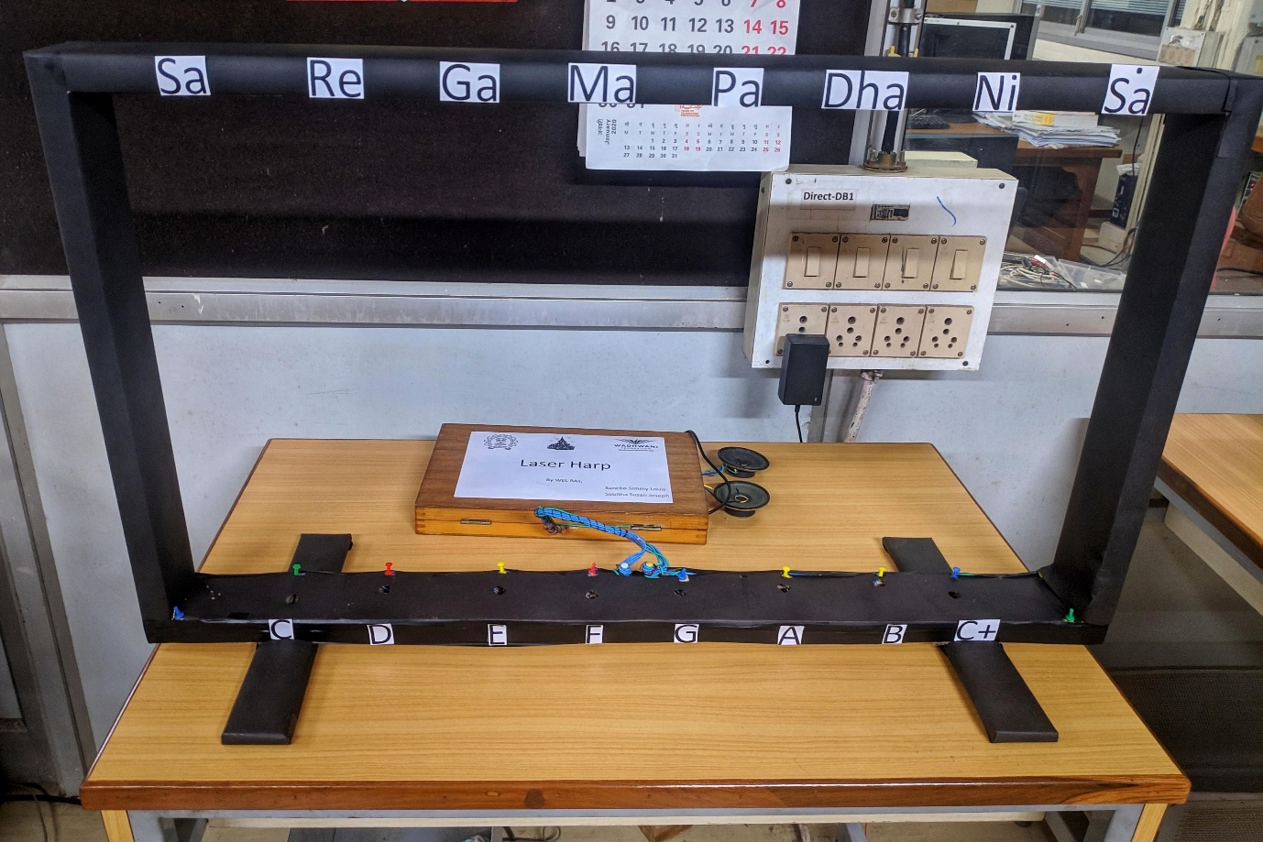Setup