# 📊 Sales Trend Analysis – Task 6

This project performs sales trend analysis using MySQL. The goal is to evaluate monthly revenue and order volume and identify the top-performing months using aggregation techniques.

## 📁 Dataset

- File: `online_sales.csv`

- Columns:

- `order_id`

- `order_date`

- `product_id`

- `amount`

## 🔧 Tools Used

- MySQL (Query Language)

- Sample Dataset (Mocked for analysis)

- Excel (for screenshot export)

## 📌 Objectives

1. Calculate monthly revenue and order volume.

2. Extract `MONTH` and `YEAR` from `order_date`.

3. Identify the top 3 months with highest revenue.

4. Display clean outputs with screenshots.

## 🧠 SQL Breakdown

### 1️⃣ Monthly Revenue & Order Volume

```sql

SELECT

YEAR(order_date) AS year,

MONTH(order_date) AS month,

COUNT(DISTINCT order_id) AS order_volume,

SUM(amount) AS monthly_revenue

FROM

online_sales

GROUP BY

YEAR(order_date), MONTH(order_date)

ORDER BY

year, month;

```

### 2️⃣ Top 3 Months by Revenue

```sql

SELECT

YEAR(order_date) AS year,

MONTH(order_date) AS month,

SUM(amount) AS monthly_revenue

FROM

online_sales

GROUP BY

YEAR(order_date), MONTH(order_date)

ORDER BY

monthly_revenue DESC

LIMIT 3;

```

## 📸 Output Screenshots

🔹 Monthly Revenue & Order Volume

![Monthly Revenue](screenshots/monthly_revenue_and_orders.png)

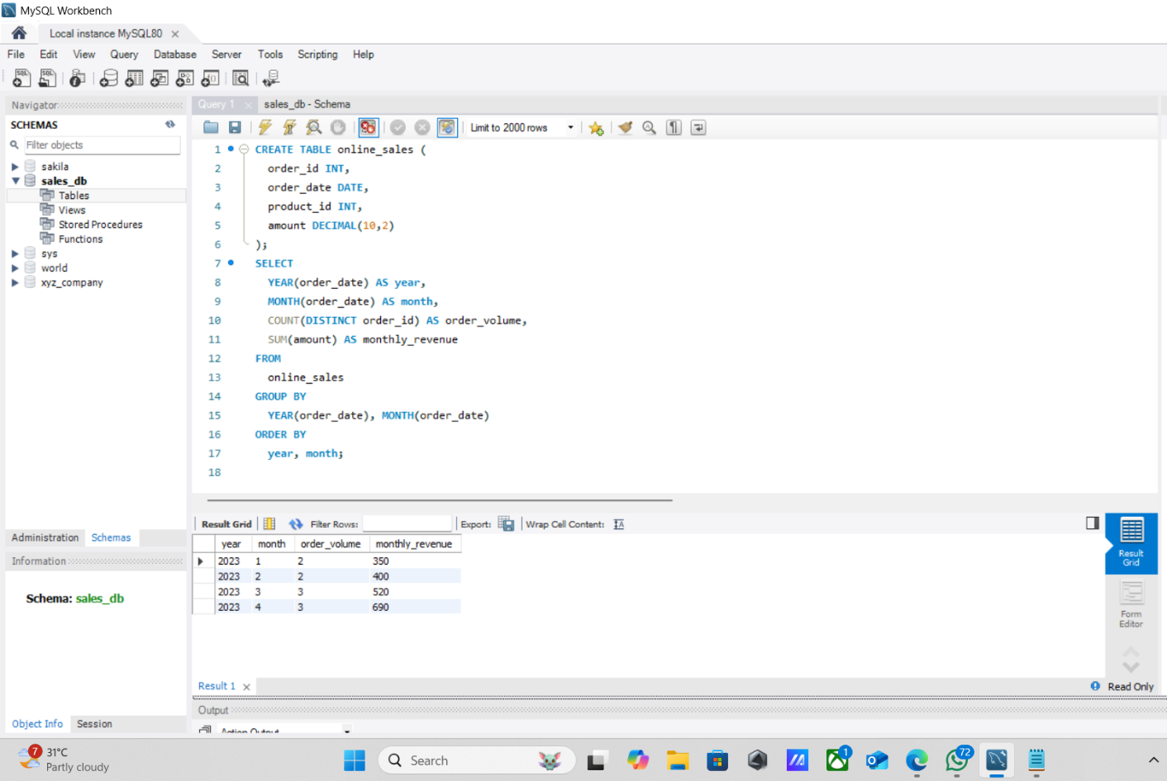

🔹 Top 3 Months by Revenue

![Top 3 Months](screenshots/top_3_months_by_sales.png)

