**EEG CLASSIFICATION MODEL**

**PROJECT REPORT**

***Of***

**IE 6400: FOUNDATIONS DATA ANALYTICS ENGINEERING**

**BY**

**GROUP NUMBER 15:**

ARCHIT SINGH (002813253)

ANIRUDH HEGDE (002813268)

RAHUL ODEDRA (002835990)

SHUBHI SINHA (002201029)

SANCIA SEROPHENE SALDANHA (002851577)

**DEPARTMENT OF COLLEGE OF ENGINEERING**

**NORTHEASTERN UNIVERSITY**

**BOSTON, MASSACHUSETTS – 022115**

**NOVEMBER 2023**

**ABSTRACT**

The project presents a detailed exploration of electroencephalogram (EEG) data for the purpose of categorizing brain activity into seizure and non-seizure events. Our approach utilizes advanced neural network models, including Convolutional Neural Networks (CNNs) and Bidirectional Long Short-Term Memory (Bi-LSTM) networks, to process and classify EEG signals, which are critical in the diagnosis and study of epilepsy.

During the project, we embarked on an initial phase of data preprocessing to organize and structure the EEG data effectively. This included segmenting the data into relevant time frames, categorizing based on the occurrence of seizures, and labelling the data to facilitate machine learning applications.

We then performed an extensive exploratory data analysis (EDA), showcasing the temporal dynamics of the EEG signals. By illustrating these signals, we captured the intricate patterns that underpin seizure activity. Advanced visualization techniques were employed to assess model performance, including confusion matrices, classification reports, and Receiver Operating Characteristic (ROC) curves. These analyses provided us with a quantifiable understanding of the model's predictive accuracy and the trade-offs between sensitivity and specificity.

The culmination of the project saw the comparison of model accuracies through a concise bar graph representation, highlighting the effectiveness of CNN and Bi-LSTM models in interpreting complex EEG data.

This research contributes to the field of medical data analysis, providing insights that could potentially enhance diagnostic procedures for epilepsy and other neurological conditions. With a commitment to academic integrity and the utility of simple yet precise language, this project aligns with the broader goal of advancing public health through data-driven insights.

**ACKNOWLEDGEMENT**

We wish to express our deep gratitude to those individuals who played essential roles in the successful completion of this data analysis report. Our collaborative efforts, commitment, and teamwork were the driving forces behind this project. We are thankful for the guidance and support provided by the following people:

Professor Sivarit (Tony) Sultornsanee

Associate Teaching Professor of Mechanical and Industrial Engineering

Professor Sivarit Sultornsanee's expertise and mentorship were instrumental in shaping the direction of our analysis. We are appreciative of the valuable insights and guidance he provided during the project.

Teacher Assistant - Venkat Navneeth Burla

Venkat Navneeth Burla, our dedicated teacher assistant, played a significant role in facilitating our progress. His timely assistance and responsiveness to our inquiries were greatly beneficial.

Team Members

Archit Singh, Anirudh Hegde , Rahul Odedra, Shubhi Sinha, Sancia Saldanha,

Our exceptional team members deserve our profound thanks for their unwavering commitment and collaboration. Together, we addressed various aspects of this project, including data sourcing, data cleaning, data analysis, and reporting. The project's quality and success would not have been achievable without their hard work and dedication.

This report stands as evidence of the exceptional teamwork and camaraderie that characterized our project. We take pride in working with such talented and cohesive team members. Our heartfelt appreciation goes out to everyone involved in this endeavour for their invaluable contributions

|  |  |
| --- | --- |
| **TABLE OF CONTENTS** |  |
| **TITLE PAGE** | **1** |
| **ABSTRACT** | **2** |
| **ACKNOWLEDGEMENT** | **3** |
| **TABLE OF CONTENTS** | **4** |
| **Chapter 1: Introduction And Background Information** | **5-6** |
| **Chapter 2: Data Pre-Processing And Feature Extraction Method** | **7 - 11** |
| **Chapter 3: Model Architecture And Training Details** | **12 - 14** |
| **Chapter 4: Evaluation Result and Discussion** | **15 - 19** |

|  |  |
| --- | --- |
| **Chapter 5: Conclusion And Future Work** | **20 - 21** |
| **References** | **22** |
|  |  |
|  |  |

**CHAPTER 1: INTRODUCTION. AND BACKGROUND INFORMATION**

Epilepsy occurs when repeated seizures manifest in the brain. The Electroencephalogram (EEG) test yields valuable information about brain functions and proves beneficial in detecting brain disorders, particularly epilepsy.

Electroencephalography (EEG) serves as a non-invasive neuroimaging technique that captures the brain's electrical activity through electrodes on the scalp.

The resulting electrical signals provide valuable insights into neural functioning, establishing EEG as a powerful tool for exploring brain activity and various neurological conditions. An important application of EEG involves classifying brain states, such as identifying epileptic seizures and cognitive states.

The field of EEG classification holds significant relevance in both clinical diagnosis and the advancement of brain-computer interface (BCI) technologies.

**FIGURE 1**

The types of EEG waves are identified according to their frequency range – delta: below 3.5 Hz (0.1–3.5 Hz), theta: 4–7.5 Hz, alpha: 8–13 Hz, beta: 14–40 Hz, and gamma: above 40 Hz. The EEG may show unusual electrical discharge when some abnormality occurs in the brain. The measurement of placing the electrodes in the brain area, namely, frontal pole (Fp), frontal (F), parietal (P), temporal (T), and occipital (O), provides meaningful communication. Even numbers and odd numbers as subscripts have been decided to differentiate the brain's hemisphere. The position of Fp2, F4, F8, C4, T4, T6, P4, and O2 electrodes indicates right hemisphere and Fp1, F3, F7, C3, T3, T5, P3, and O1 electrodes indicates left hemisphere, respectively. The position of FZ, CZ, and PZ electrodes indicates the midline in frontal, central, and parietal regions.

The interpretation of recorded brain signals, as seen in Electroencephalography (EEG), has traditionally relied on manual inspection by experts.

However, with the integration of machine learning and artificial intelligence, automated classification methods have gained prominence. These methods utilize sophisticated algorithms to extract meaningful features from EEG signals and categorize them into distinct groups. EEG classification proves particularly valuable in diagnosing and managing neurological disorders, such as epilepsy, where the timely identification of seizure activity is crucial for effective treatment.

The challenges in EEG classification encompass addressing the inherent variability in brain signals, distinguishing between normal and abnormal patterns, and managing the often high-dimensional nature of EEG data.

Researchers and practitioners in this field employ a diverse array of machine learning techniques, including convolutional neural networks (CNNs), recurrent neural networks (RNNs), and specialized algorithms tailored to the unique characteristics of EEG data.

As advancements persist in both EEG recording technology and machine learning methodologies, the potential for accurate and efficient EEG classification continues to grow. This progress holds implications not only for clinical applications but also for the development of brain-machine interfaces facilitating direct communication between the brain and external devices.

**CHAPTER 2: DATA PRE-PROCESSING AND FEATURE EXTRACTION METHOD**

* **DATA PRE-PROCESSING:**

EEG data is widely used in neuroscience and medical fields, including the diagnosis of epilepsy. We have considered the *CHB-MIT EEG Database* for our project. This dataset contains EEG recordings from 24 patients suffering from seizures. The readings were recorded when the subject was monitored for several days post-withdrawal of anti-seizure medication. They were stored in EDF format i.e. European Data Format.

1. **Understanding the Dataset:**

The initial step was to understand the dataset and filter out the data on which we will be going to take our next approach.

* **Dataset Overview:** This collection features 916 hours of scalp EEG recordings from a total of 24 individuals, sampled at a rate of 256 Hz. The group comprises 23 children and one adult, collectively accounting for 173 seizures that have been clinically verified.
* **Data Segmentation:** The EEG recordings are segmented into one-hour intervals. These segments are categorized as either 'nonseizure records' or 'seizure records', based on whether they contain seizure activity.
* **Participant Demographics:** Detailed information, including age and gender, about 22 of the participants (comprising five males and 17 females) can be found in the 'SUBJECT-INFO' file.
* **Data Organization:** The EEG data for each participant is divided into between 9 and 42 files in .edf format. There are brief interruptions in these files due to the constraints of the recording equipment.
* **Confidentiality Measures:** Personal health information within the .edf files has been carefully anonymized, though the sequence of the recordings has been preserved.
* **File Composition:** Most of the .edf files represent an hour of EEG data, typically comprising between 23 and 26 individual EEG channels, although there are some exceptions.
* **Seizure Record Identification:** For information specific to seizure occurrences, including precise timing and context, refer to the contents of the "RECORDS-WITH-SEIZURES" folder.
* **Supplementary Information:** Each subject’s file is accompanied by a 'chbnn-summary.txt' file, offering key details such as montage configurations and exact timings of seizures.

1. **Approach Taken:**

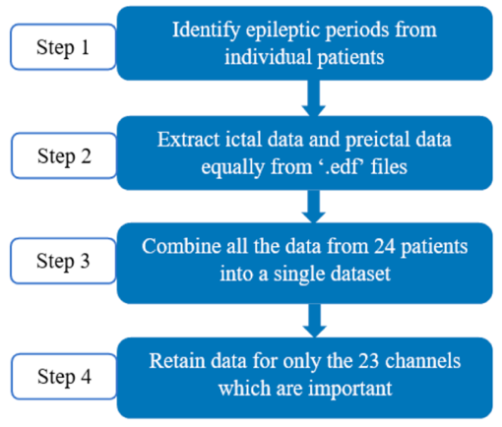

**FIGURE 2 (B1)**

We understood that from the supplementary information file of each subject about the time he/she had a seizure and for how many seconds.

Upon, this information we decided to divide the EEG file of a subject who had a seizure into two parts ‘non-seizure’ i.e. the preictal period and ‘seizure’ i.e. ictal period.

**FIGURE 2 (B2)**

As shown above in FIGURE 1 (B2), one of the seizure files was created from the Seizure Start Time: 2996 Seconds to the Seizure End Time: 3036 Seconds. For the non-seizure file, we took the 10-second pre-seizure start time.

The same process was performed manually on the same code while changing the paths and the Seizure Start and End Time.

We sorted the EEG data by whether it showed signs of seizures. This step is important for later work that aims to tell the difference between seizure and non-seizure conditions.

To make it easier to tell the data apart, we marked each dataset with a 'seizure' column. We used '1' to show seizure data and '0' for non-seizure data. This clear marking is crucial for any future machine learning work.

Post that, we understood that if any channel names we expected weren't in our data, we made a note of it. This helped us keep only the data that matched our list, which was important for keeping our analysis accurate.

Next, we updated our seizure and non-seizure data to include only the channels from our list. This step got rid of any extra information we didn't need.

1. **Handling Null Values**

In the combined data frames df_seizures and df_nonseizures, we saw that there were null values as shown in FIGURE 1 (C1) AND FIGURE 1 (C2).

**FIGURE 2 (C1)**

**FIGURE 2 (C2)**

To tackle this we make use of the interpolate function which will fill in missing values within the data, providing a complete dataset that can be used for further analysis which can be shown in FIGURE 2 (C3) and FIGURE 2(C4).

**FIGURE 2 (C3)**

**FIGURE 2 (C4)**

* **FEATURE EXTRACTION:**

In every machine learning application, making decisions on how to extract significant features from the input data stands as a crucial step. For EEG signals, three broad categories are possible one is the time domain, another frequency domain and the third is the time–frequency domain. We have used a time-frequency domain that employs a sturdy method for extracting features from EEG data, focusing on the distinction between seizure and non-seizure states. In this report, we explore the tactics used and the importance of the derived time and frequency-domain features.

* 1. **Importance of Feature Extraction:**

Feature extraction is pivotal in the provided code for dissecting EEG data, particularly in detecting seizures. The computation of time-domain features, covering metrics like mean and standard deviation, unveils crucial statistical details about the EEG signal. Concurrently, frequency-domain features explore the intricate frequency distribution, emphasizing bands like alpha and beta. Merging these time and frequency features enhances the model's ability to distinguish between seizure and non-seizure states with precision. Beyond discrimination, feature extraction trims down the dataset's complexity, streamlining it for effective analysis and model training. Moreover, the extracted features yield a representation closely aligned with clinical relevance, addressing the distinctive requisites of EEG data in neurological diagnostics and treatment. In essence, feature extraction plays a pivotal role in crafting insightful and manageable feature sets, refining both the model's functionality and its practical utility in clinical contexts

* 1. **Applying Feature Extraction on the EEG Signals:**

The process begins with the calculation of essential time-domain characteristics, such as mean, standard deviation, and skewness, revealing statistical intricacies of the EEG signal. Another function extracts frequency-domain features using the Welch method, emphasizing bands like alpha and beta. The code tactfully applies these feature extraction functions to both seizure and non-seizure EEG datasets, transforming the raw signals into a structured format with enriched temporal and frequency features. This transformation enhances the dataset's readiness for machine learning model training, providing nuanced insights into EEG characteristics associated with seizure events.

**CHAPTER 3: MODEL ARCHITECTURE AND TRAINING DETAILS**

* **MODEL ARCHITECTURE:**

1. **Bidirectional LSTM Networks:**

Traditional neural networks, such as Convolutional Neural Networks (CNNs), excel in extracting invariant features. However, when it comes to predicting the current output based on distant features, Recurrent Neural Networks (RNNs) outperform CNNs. RNNs are adept at modelling sequences by maintaining a memory that relies on historical information. In each RNN unit, the input captures features at time t with a dimensionality matching the feature size (see Figure 2). The hidden state ℎ−ͳ represents the memory preceding this unit. By leveraging ℎ−ͳ and the input, we can compute and propagate new memory ℎ to the next RNN unit.

Despite its strengths, RNNs have their limitations. They mechanically calculate sequential information one after another, without considering variations in the significance of these pieces of information. Consequently, RNNs struggle to identify and leverage long-term dependencies in a dataset. Dealing with sequential information, RNNs encounter issues like gradient explosion and gradient vanishing.

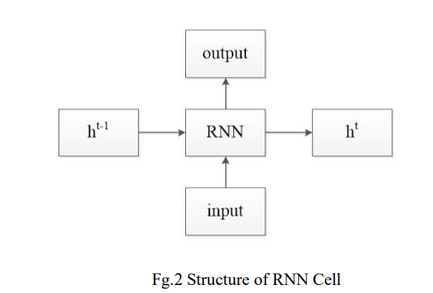

**FIGURE 3 (A1)** **FIGURE 3 (A2)**

Long short-term memory (LSTM) network is a recurrent neural network (RNN), aimed to deal with the vanishing gradient problem present in traditional RNNs. Its relative insensitivity to gap length is its advantage over other RNNs, hidden Markov models and other sequence learning methods. It aims to provide a short-term memory for RNN that can last thousands of timesteps, thus "long short-term memory".

A common LSTM unit is composed of a cell, an input gate, an output gate and a forget gate. The cell remembers values over arbitrary time intervals and the three gates regulate the flow of information into and out of the cell. Forget gates decide what information to discard from a previous state by assigning a previous state, compared to a current input, a value between 0 and 1. A (rounded) value of 1 means to keep the information, and a value of 0 means to discard it. Input gates decide which pieces of new information to store in the current state, using the same system as forget gates. Output gates control which pieces of information in the current state to output by assigning a value from 0 to 1 to the information, considering the previous and current states. Selectively outputting relevant information from the current state allows the LSTM network to maintain useful, long-term dependencies to make predictions, both in current and future time steps.

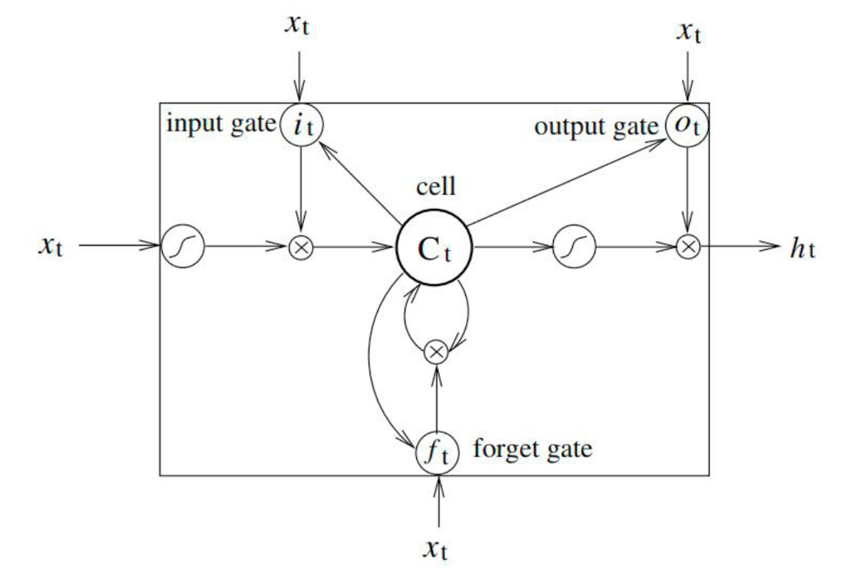

**FIGURE 3 (A3)**

we applied Bi-LSTM to construct our model. In bidirectional, our input flows in two directions, making a Bi-LSTM different from the regular LSTM. With the regular LSTM, we can make input flow in one direction, either backwards or forward. However, in bi-directional, we can make the input flow in both directions to preserve the future and the past information.

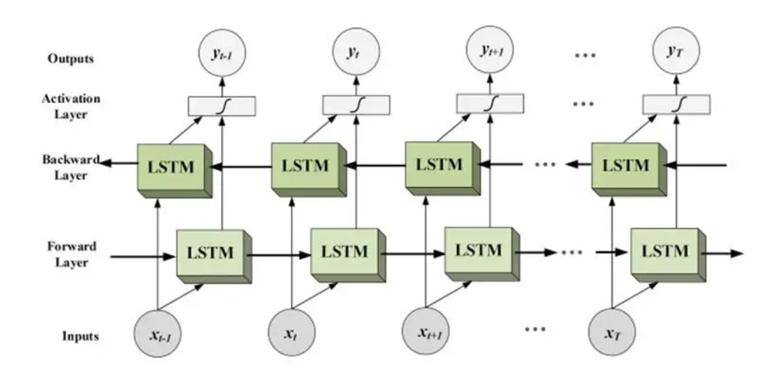

**FIGURE 3 (A4) FIGURE 3 (A5)**

* **TRAINING DETAILS:**

The process of data splitting is a crucial step in preparing the dataset for subsequent model implementation. The dataset, represented by the features (X) and labels (y), is initially separated. The features are defined as all columns except the 'seizure' column, while the labels correspond to the binary classification of seizures, denoted by the 'seizure' column.

The data is then partitioned into three distinct sets: a training set (`X_train` and `y_train`), a validation set (`X_val` and `y_val`), and a test set (`X_test` and `y_test`). This division is accomplished using the `train_test_split` function from scikit-learn, with a 70-15-15 split ratio for training, validation, and test sets, respectively. The `random_state` parameter is set to ensure reproducibility of the split.

Additionally, for compatibility with Long Short-Term Memory (LSTM) models, the feature data is reshaped to include an additional dimension, transforming it into a three-dimensional array. This reshaping is particularly useful when dealing with time series data, where LSTM networks can effectively capture sequential dependencies.

In summary, this part effectively manages the essential task of data splitting, facilitating the subsequent stages of model training, validation, and testing by ensuring well-organized and appropriately sized datasets.

**CHAPTER 4: EVALUATION RESULT AND DISCUSSION:**

1. **EEG Signal**

Our analysis began by illustrating a single EEG signal trace, exemplifying the complex nature of the data we're dealing with. The plot displays variations in amplitude over time, providing a clear depiction of the signal's characteristics that are essential for understanding brain activity.

**FIGURE 4 (A)**

1. **Model Performance Analysis**

We rigorously evaluated the predictive performance of our models using the validation and test datasets. The confusion matrices for both sets illuminated the true positives, true negatives, false positives, and false negatives, offering a comprehensive view of the model's classification capabilities. The classification report further quantified the accuracy, precision, recall, and F1 score, which are critical for assessing the model's reliability.

**FIGURE 4 (B1) FIGURE 4 (B2)**

**FIGURE 4 (B3)**

**FIGURE 4 (B4)**

1. **ROC Curve Insight**

The Receiver Operating Characteristic (ROC) curve was a pivotal tool in our analysis, allowing us to visualize the trade-off between the true positive rate and the false positive rate. The area under the curve (AUC) provided a singular metric to gauge the overall performance of our models, with the validation and test sets showcasing the models' robustness against unseen data.

**FIGURE 4 (C)**

1. **Training Process Overview**

A visual representation of the training and validation accuracy over epochs offered insights into the learning process of our models. It highlighted the improvement in the model's ability to generalize from the training data to the validation data with each epoch, ensuring the model's learning trajectory was on the right path.

**FIGURE 4 (D)**

1. **Comparative Analysis of Model Accuracies**

In a final comparative analysis, we illustrated the accuracies of the CNN and Bi-LSTM models in a bar graph format. This direct comparison was crucial for determining the most effective model, as it encapsulated the performance in a straightforward, visually accessible manner.

**FIGURE 4 (E)**

**CHAPTER 5: CONCLUSION AND FUTURE WORK**

**CONCLUSION:**

In summary, the EEG classification project has effectively tackled the crucial task of interpreting and classifying brain signals by employing advanced machine learning techniques. Through the utilization of methods like convolutional neural networks (CNNs), recurrent neural networks (RNNs), and customized algorithms tailored for EEG data, the project has significantly automated the classification process. The successful creation and deployment of an automated model for seizure detection highlight the potential of these advancements to contribute to the diagnosis and treatment of neurological disorders, particularly epilepsy.

Throughout the project duration, challenges associated with EEG classification, such as the variability in brain signals and the high-dimensional nature of the data, were adeptly managed. The outcomes emphasize the continual importance of advancements in both EEG recording technology and machine learning methodologies, collectively improving the precision and efficiency of EEG classification.

The project's implications extend beyond clinical applications, presenting promising opportunities for the development of brain-machine interfaces. These interfaces hold the transformative potential to reshape healthcare by facilitating direct communication between the brain and external devices. The successful conclusion of this project stands as a noteworthy contribution to our understanding of brain function, emphasizing the broader impact of EEG classification at the intersection of healthcare and technology.

As the field progresses, future endeavor’s might explore further enhancements to classification models, integration of emerging technologies, and continued validation of automated EEG classification in real-world scenarios. Overall, the project's accomplishments pave the way for ongoing progress in EEG classification, with profound implications for medical diagnosis and the broader landscape of brain-machine interface development.

**FUTURE WORK:**

* **Refinement of Classification Models:** Continuous improvement and refinement of existing classification models, including CNNs and RNNs, can enhance their accuracy and robustness. Exploring novel architectures or incorporating state-of-the-art techniques in deep learning may contribute to more effective EEG classification.
* **Real-time EEG Classification:** Developing real-time EEG classification systems can have significant implications for clinical applications. Future research can focus on creating models that provide timely and accurate classifications, enabling quick responses and interventions in medical settings.
* **Personalized Medicine Approaches:** EEG classification models tailored to individual patient profiles could enhance the accuracy of diagnosis and treatment. Future work can explore personalized medicine approaches, considering factors such as age, gender, and comorbidities in model development.

**REFERENCES**

* [analyticsindiamag](https://analyticsindiamag.com/)
* <https://en.wikipedia.org/wiki/Long_short-term_memory>