NAME: SANJANA M KULKARNI
SRN: PES1UG24AM249

Dropshipping Inventory & Order Orchestrator
Requirements Table
Req ID | Type | Description | Priority | Acceptance Criteria | Rationale
FR-001 | Functional | The system shall automatically synchronize real-time stock levels and pricing from each Supplier Partner's product feed into the store's inventory ledger. | High | Pass: For at least 99% of test SKUs, the synchronized stock quantity matches the supplier feed within the configured polling interval. Fail: A listed SKU shows available stock after the supplier feed reports zero. | Prevents overselling out-of-stock supplier items and keeps storefront inventory accurate.
FR-002 | Functional | The system shall allow an E-Store Owner to search the supplier product catalog and list a selected product to their online store with a configured markup. | High | Pass: When an in-stock product and a valid markup are selected, the system creates a unique store listing linked to the supplier SKU. Fail: The system creates a duplicate active listing for the same supplier SKU in the same store. | Enables owners to curate and publish supplier products without manual catalog entry.
FR-003 | Functional | The system shall calculate the customer-facing retail price for each order using the supplier cost, configured margin rules, and any applicable shipping fee. | High | Pass: For predefined test products, the calculated retail price exactly matches the configured margin schedule. Fail: Any margin tier is applied incorrectly or shipping fees are omitted where configured. | Ensures accurate, transparent pricing and protects the owner's profit margin.
FR-004 | Functional | The system shall automatically forward a validated customer order to the correct Supplier Partner for fulfillment immediately after payment is confirmed. | High | Pass: A paid order is transmitted to the matching Supplier Partner with correct SKU, quantity, and shipping address within the configured window. Fail: An order is forwarded to the wrong supplier or is not forwarded after payment success. | Prevents fulfillment delays and ensures suppliers receive accurate order details.
FR-005 | Functional | The system shall allow the E-Store Owner to view and flag orders that exceed the supplier's committed fulfillment or shipping duration. | High | Pass: When an order exceeds its committed fulfillment window by the configured threshold, it appears in the owner's delayed-orders list with its order ID, supplier, and elapsed time. Fail: An overdue order is not shown in the list. | Helps store owners proactively manage delays and maintain customer trust.
NFR-001 | Nonfunctional — Performance & Security | The order-forwarding API to Supplier Partner systems shall transmit a confirmed order in under 500 ms. | High | Pass: Under simulated peak load, at least 95% of order-forwarding requests complete within 500 ms and meet the configured security controls (encryption, authentication). Fail: More than 5% exceed 500 ms. | Supports timely fulfillment while protecting order and payment data in transit.
NFR-002 | Nonfunctional — Availability & Reliability | The inventory synchronization and order-orchestration service shall maintain at least 99.5% monthly availability. | High | Pass: Monitoring records at least 99.5% availability during each calendar month, excluding documented scheduled maintenance. Fail: Availability falls below 99.5%. | Ensures store owners and suppliers can reliably rely on real-time stock data and order flow.

Use Case Diagram
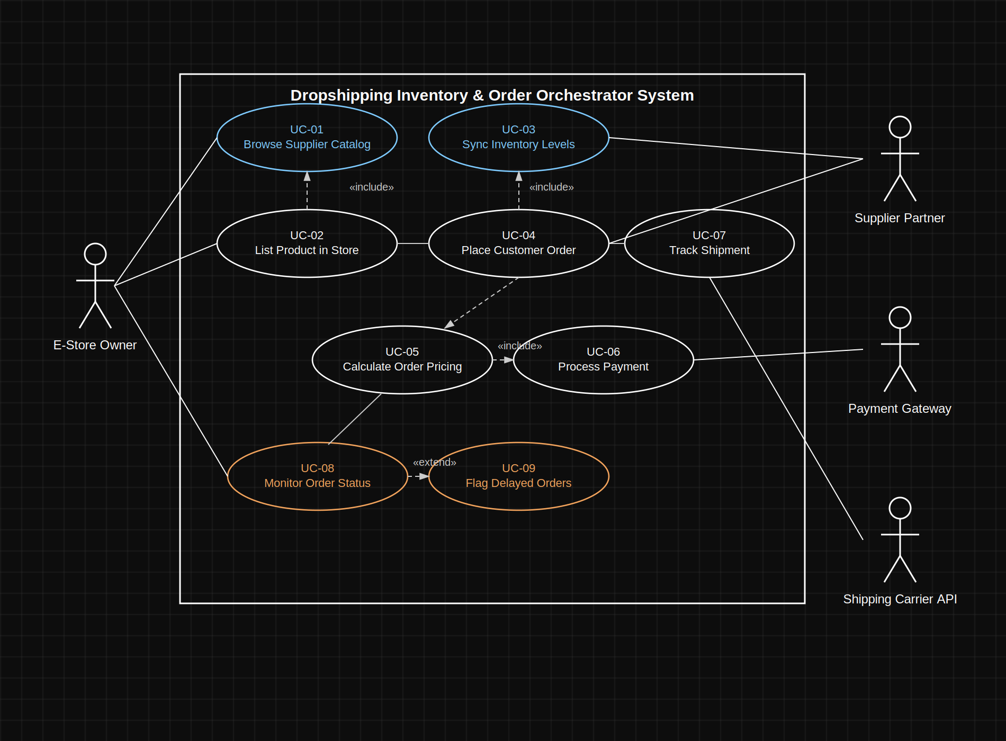

Use-Case Flow Specification — List Product in Store
Use Case ID: UC-02
Use Case Name: List Product in Store
Primary Actor: E-Store Owner
Supporting Actor: Dropshipping System / Supplier Partner Catalog Feed
Preconditions
The E-Store Owner has access to the platform; the supplier catalog and stock data are current; the owner can select a product and configure a markup or margin.
Postconditions
A unique store listing is created for the selected product, linked to the supplier SKU, and published to the online store with a calculated retail price.

Main Success Scenario
1. The E-Store Owner searches the supplier product catalog by category or keyword.
2. The system retrieves and displays supplier products currently in stock matching the search.
3. The E-Store Owner selects a product and specifies the desired markup or margin.
4. The system validates that the selected product is still in stock and available from the Supplier Partner.
5. The system calculates and displays the resulting retail price and estimated margin for the listing.
6. The E-Store Owner confirms the listing.
7. The system creates a unique listing ID and records the product, supplier SKU, retail price, and margin.
8. The system publishes the listing to the online store and displays a confirmation.

Alternate Flow — Selected Product Becomes Unavailable
1. At Step 4, the system determines that the selected product has gone out of stock or has been discontinued by the Supplier Partner.
2. The system does not create the listing.
3. The system informs the E-Store Owner that the product is unavailable and refreshes the catalog results.
4. The E-Store Owner selects another product and returns to Step 5, or cancels the listing process.

Key Acceptance Checks
- A confirmed listing receives a unique listing ID.
- The system does not allow duplicate active listings for the same supplier SKU within the same store.
- The listing stores the supplier SKU, retail price, and margin.
- A product that becomes unavailable before confirmation cannot be listed.

