PERTEMUAN 14

PEMROGRAMAN JAVA

Latihan 1

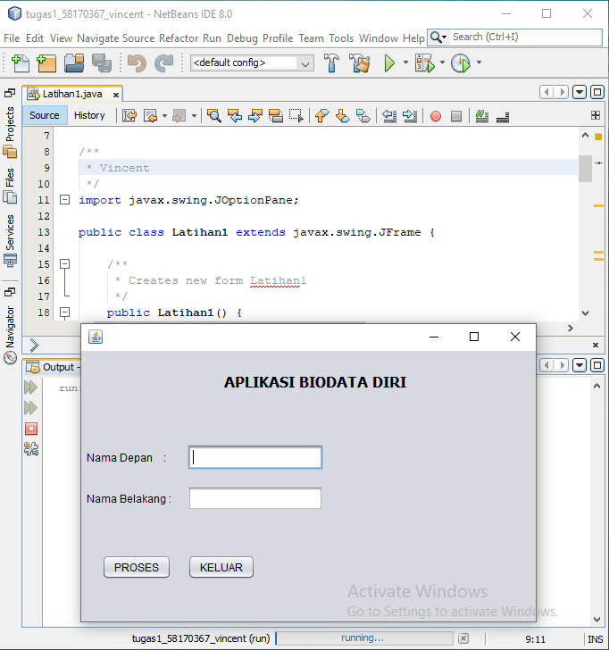

/*

* To change this license header, choose License Headers in Project Properties.

* To change this template file, choose Tools | Templates

* and open the template in the editor.

*/

package Pertemuan14;

/**

* V

*/

import javax.swing.JOptionPane;

public class Latihan1 extends javax.swing.JFrame {

/**

* Creates new form Latihan1

*/

public Latihan1() {

initComponents();

}

/**

* This method is called from within the constructor to initialize the form.

* WARNING: Do NOT modify this code. The content of this method is always

* regenerated by the Form Editor.

*/

@SuppressWarnings("unchecked")

// <editor-fold defaultstate="collapsed" desc="Generated Code">//GEN-BEGIN:initComponents

private void initComponents() {

jLabel1 = new javax.swing.JLabel();

jLabel2 = new javax.swing.JLabel();

jLabel3 = new javax.swing.JLabel();

nama_depan = new javax.swing.JTextField();

nama_belakang = new javax.swing.JTextField();

btproses = new javax.swing.JButton();

btkeluar = new javax.swing.JButton();

setDefaultCloseOperation(javax.swing.WindowConstants.EXIT_ON_CLOSE);

jLabel1.setFont(new java.awt.Font("Tahoma", 1, 16)); // NOI18N

jLabel1.setText("APLIKASI BIODATA DIRI");

jLabel2.setText("Nama Depan :");

jLabel3.setText("Nama Belakang :");

nama_depan.addActionListener(new java.awt.event.ActionListener() {

public void actionPerformed(java.awt.event.ActionEvent evt) {

nama_depanActionPerformed(evt);

}

});

btproses.setText("PROSES");

btproses.addActionListener(new java.awt.event.ActionListener() {

public void actionPerformed(java.awt.event.ActionEvent evt) {

btprosesActionPerformed(evt);

}

});

btkeluar.setText("KELUAR");

btkeluar.addActionListener(new java.awt.event.ActionListener() {

public void actionPerformed(java.awt.event.ActionEvent evt) {

btkeluarActionPerformed(evt);

}

});

javax.swing.GroupLayout layout = new javax.swing.GroupLayout(getContentPane());

getContentPane().setLayout(layout);

layout.setHorizontalGroup(

layout.createParallelGroup(javax.swing.GroupLayout.Alignment.LEADING)

.addGroup(layout.createSequentialGroup()

.addGroup(layout.createParallelGroup(javax.swing.GroupLayout.Alignment.LEADING)

.addGroup(layout.createSequentialGroup()

.addContainerGap()

.addComponent(jLabel2))

.addGroup(layout.createSequentialGroup()

.addGap(160, 160, 160)

.addComponent(jLabel1))

.addGroup(layout.createSequentialGroup()

.addContainerGap()

.addGroup(layout.createParallelGroup(javax.swing.GroupLayout.Alignment.TRAILING)

.addComponent(btproses)

.addComponent(jLabel3))

.addGap(18, 18, 18)

.addGroup(layout.createParallelGroup(javax.swing.GroupLayout.Alignment.LEADING)

.addComponent(nama_depan, javax.swing.GroupLayout.PREFERRED_SIZE, 152, javax.swing.GroupLayout.PREFERRED_SIZE)

.addComponent(nama_belakang, javax.swing.GroupLayout.PREFERRED_SIZE, 152, javax.swing.GroupLayout.PREFERRED_SIZE)

.addComponent(btkeluar))))

.addContainerGap(145, Short.MAX_VALUE))

);

layout.setVerticalGroup(

layout.createParallelGroup(javax.swing.GroupLayout.Alignment.LEADING)

.addGroup(layout.createSequentialGroup()

.addGap(25, 25, 25)

.addComponent(jLabel1)

.addGap(60, 60, 60)

.addGroup(layout.createParallelGroup(javax.swing.GroupLayout.Alignment.BASELINE)

.addComponent(jLabel2)

.addComponent(nama_depan, javax.swing.GroupLayout.PREFERRED_SIZE, javax.swing.GroupLayout.DEFAULT_SIZE, javax.swing.GroupLayout.PREFERRED_SIZE))

.addGap(18, 18, 18)

.addGroup(layout.createParallelGroup(javax.swing.GroupLayout.Alignment.BASELINE)

.addComponent(jLabel3)

.addComponent(nama_belakang, javax.swing.GroupLayout.PREFERRED_SIZE, javax.swing.GroupLayout.DEFAULT_SIZE, javax.swing.GroupLayout.PREFERRED_SIZE))

.addPreferredGap(javax.swing.LayoutStyle.ComponentPlacement.RELATED, 49, Short.MAX_VALUE)

.addGroup(layout.createParallelGroup(javax.swing.GroupLayout.Alignment.BASELINE)

.addComponent(btproses)

.addComponent(btkeluar))

.addGap(47, 47, 47))

);

pack();

}// </editor-fold>//GEN-END:initComponents

private void nama_depanActionPerformed(java.awt.event.ActionEvent evt) {//GEN-FIRST:event_nama_depanActionPerformed

// TODO add your handling code here:

}//GEN-LAST:event_nama_depanActionPerformed

private void btprosesActionPerformed(java.awt.event.ActionEvent evt) {//GEN-FIRST:event_btprosesActionPerformed

String ND = nama_depan.getText();

String NB = nama_belakang.getText();

JOptionPane.showMessageDialog(this, "Selamat Datang " + ND + " " + NB);

}//GEN-LAST:event_btprosesActionPerformed

private void btkeluarActionPerformed(java.awt.event.ActionEvent evt) {//GEN-FIRST:event_btkeluarActionPerformed

System.exit(0);

}//GEN-LAST:event_btkeluarActionPerformed

/**

* @param args the command line arguments

*/

public static void main(String args[]) {

/* Set the Nimbus look and feel */

//<editor-fold defaultstate="collapsed" desc=" Look and feel setting code (optional) ">

/* If Nimbus (introduced in Java SE 6) is not available, stay with the default look and feel.

* For details see http://download.oracle.com/javase/tutorial/uiswing/lookandfeel/plaf.html

*/

try {

for (javax.swing.UIManager.LookAndFeelInfo info : javax.swing.UIManager.getInstalledLookAndFeels()) {

if ("Nimbus".equals(info.getName())) {

javax.swing.UIManager.setLookAndFeel(info.getClassName());

break;

}

}

} catch (ClassNotFoundException ex) {

java.util.logging.Logger.getLogger(Latihan1.class.getName()).log(java.util.logging.Level.SEVERE, null, ex);

} catch (InstantiationException ex) {

java.util.logging.Logger.getLogger(Latihan1.class.getName()).log(java.util.logging.Level.SEVERE, null, ex);

} catch (IllegalAccessException ex) {

java.util.logging.Logger.getLogger(Latihan1.class.getName()).log(java.util.logging.Level.SEVERE, null, ex);

} catch (javax.swing.UnsupportedLookAndFeelException ex) {

java.util.logging.Logger.getLogger(Latihan1.class.getName()).log(java.util.logging.Level.SEVERE, null, ex);

}

//</editor-fold>

/* Create and display the form */

java.awt.EventQueue.invokeLater(new Runnable() {

public void run() {

new Latihan1().setVisible(true);

}

});

}

// Variables declaration - do not modify//GEN-BEGIN:variables

private javax.swing.JButton btkeluar;

private javax.swing.JButton btproses;

private javax.swing.JLabel jLabel1;

private javax.swing.JLabel jLabel2;

private javax.swing.JLabel jLabel3;

private javax.swing.JTextField nama_belakang;

private javax.swing.JTextField nama_depan;

// End of variables declaration//GEN-END:variables

}

Latihan 2

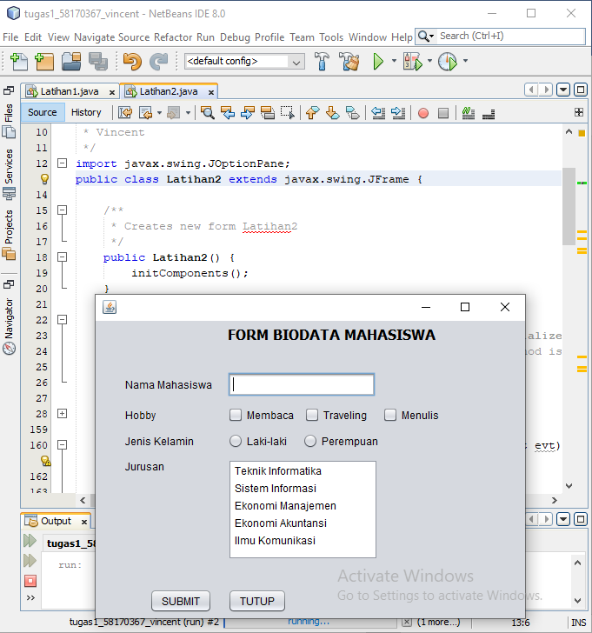

/*

* To change this license header, choose License Headers in Project Properties.

* To change this template file, choose Tools | Templates

* and open the template in the editor.

*/

package Pertemuan14;

/**

* Vincent

*/

import javax.swing.JOptionPane;

public class Latihan2 extends javax.swing.JFrame {

/**

* Creates new form Latihan2

*/

public Latihan2() {

initComponents();

}

/**

* This method is called from within the constructor to initialize the form.

* WARNING: Do NOT modify this code. The content of this method is always

* regenerated by the Form Editor.

*/

@SuppressWarnings("unchecked")

// <editor-fold defaultstate="collapsed" desc="Generated Code">//GEN-BEGIN:initComponents

private void initComponents() {

jCheckBox3 = new javax.swing.JCheckBox();

jLabel1 = new javax.swing.JLabel();

jLabel2 = new javax.swing.JLabel();

jLabel3 = new javax.swing.JLabel();

jLabel4 = new javax.swing.JLabel();

jLabel5 = new javax.swing.JLabel();

txtnama = new javax.swing.JTextField();

baca = new javax.swing.JCheckBox();

travel = new javax.swing.JCheckBox();

tulis = new javax.swing.JCheckBox();

rdlaki = new javax.swing.JRadioButton();

rdperempuan = new javax.swing.JRadioButton();

jScrollPane1 = new javax.swing.JScrollPane();

lstjurusan = new javax.swing.JList();

submit = new javax.swing.JButton();

tutup = new javax.swing.JButton();

jCheckBox3.setText("jCheckBox3");

setDefaultCloseOperation(javax.swing.WindowConstants.EXIT_ON_CLOSE);

jLabel1.setFont(new java.awt.Font("Tahoma", 1, 16)); // NOI18N

jLabel1.setText("FORM BIODATA MAHASISWA");

jLabel2.setText("Nama Mahasiswa");

jLabel3.setText("Hobby");

jLabel4.setText("Jenis Kelamin");

jLabel5.setText("Jurusan");

baca.setText("Membaca");

travel.setText("Traveling");

tulis.setText("Menulis");

rdlaki.setText("Laki-laki");

rdperempuan.setText("Perempuan");

lstjurusan.setModel(new javax.swing.AbstractListModel() {

String[] strings = { "Teknik Informatika", "Sistem Informasi", "Ekonomi Manajemen", "Ekonomi Akuntansi", "Ilmu Komunikasi" };

public int getSize() { return strings.length; }

public Object getElementAt(int i) { return strings[i]; }

});

jScrollPane1.setViewportView(lstjurusan);

submit.setText("SUBMIT");

submit.addActionListener(new java.awt.event.ActionListener() {

public void actionPerformed(java.awt.event.ActionEvent evt) {

submitActionPerformed(evt);

}

});

tutup.setText("TUTUP");

tutup.addActionListener(new java.awt.event.ActionListener() {

public void actionPerformed(java.awt.event.ActionEvent evt) {

tutupActionPerformed(evt);

}

});

javax.swing.GroupLayout layout = new javax.swing.GroupLayout(getContentPane());

getContentPane().setLayout(layout);

layout.setHorizontalGroup(

layout.createParallelGroup(javax.swing.GroupLayout.Alignment.LEADING)

.addGroup(layout.createSequentialGroup()

.addGap(34, 34, 34)

.addGroup(layout.createParallelGroup(javax.swing.GroupLayout.Alignment.TRAILING)

.addComponent(submit)

.addGroup(layout.createParallelGroup(javax.swing.GroupLayout.Alignment.LEADING)

.addComponent(jLabel2)

.addComponent(jLabel3)

.addComponent(jLabel4)

.addComponent(jLabel5)))

.addGap(18, 18, 18)

.addGroup(layout.createParallelGroup(javax.swing.GroupLayout.Alignment.LEADING)

.addComponent(tutup)

.addComponent(txtnama, javax.swing.GroupLayout.PREFERRED_SIZE, 170, javax.swing.GroupLayout.PREFERRED_SIZE)

.addGroup(layout.createSequentialGroup()

.addComponent(baca)

.addPreferredGap(javax.swing.LayoutStyle.ComponentPlacement.UNRELATED)

.addComponent(travel)

.addGap(18, 18, 18)

.addComponent(tulis))

.addComponent(jLabel1)

.addGroup(layout.createParallelGroup(javax.swing.GroupLayout.Alignment.TRAILING, false)

.addComponent(jScrollPane1, javax.swing.GroupLayout.Alignment.LEADING, javax.swing.GroupLayout.PREFERRED_SIZE, 0, Short.MAX_VALUE)

.addGroup(layout.createSequentialGroup()

.addComponent(rdlaki)

.addGap(18, 18, 18)

.addComponent(rdperempuan))))

.addContainerGap(99, Short.MAX_VALUE))

);

layout.setVerticalGroup(

layout.createParallelGroup(javax.swing.GroupLayout.Alignment.LEADING)

.addGroup(layout.createSequentialGroup()

.addContainerGap()

.addComponent(jLabel1)

.addGap(33, 33, 33)

.addGroup(layout.createParallelGroup(javax.swing.GroupLayout.Alignment.BASELINE)

.addComponent(jLabel2)

.addComponent(txtnama, javax.swing.GroupLayout.PREFERRED_SIZE, javax.swing.GroupLayout.DEFAULT_SIZE, javax.swing.GroupLayout.PREFERRED_SIZE))

.addPreferredGap(javax.swing.LayoutStyle.ComponentPlacement.UNRELATED)

.addGroup(layout.createParallelGroup(javax.swing.GroupLayout.Alignment.BASELINE)

.addComponent(jLabel3)

.addComponent(baca)

.addComponent(travel)

.addComponent(tulis))

.addPreferredGap(javax.swing.LayoutStyle.ComponentPlacement.UNRELATED)

.addGroup(layout.createParallelGroup(javax.swing.GroupLayout.Alignment.BASELINE)

.addComponent(jLabel4)

.addComponent(rdlaki)

.addComponent(rdperempuan))

.addPreferredGap(javax.swing.LayoutStyle.ComponentPlacement.UNRELATED)

.addGroup(layout.createParallelGroup(javax.swing.GroupLayout.Alignment.LEADING)

.addComponent(jLabel5)

.addComponent(jScrollPane1, javax.swing.GroupLayout.PREFERRED_SIZE, 116, javax.swing.GroupLayout.PREFERRED_SIZE))

.addPreferredGap(javax.swing.LayoutStyle.ComponentPlacement.RELATED, 33, Short.MAX_VALUE)

.addGroup(layout.createParallelGroup(javax.swing.GroupLayout.Alignment.BASELINE)

.addComponent(submit)

.addComponent(tutup))

.addContainerGap())

);

pack();

}// </editor-fold>//GEN-END:initComponents

private void submitActionPerformed(java.awt.event.ActionEvent evt) {//GEN-FIRST:event_submitActionPerformed

String nama="";

String hobi="";

String jeniskelamin="";

String jurusan="";

String info="";

nama=txtnama.getText();

if(baca.isSelected())

hobi+="Membaca";

if(travel.isSelected())

hobi+="Traveling";

if(tulis.isSelected())

hobi+="Menulis";

if(rdlaki.isSelected())

jeniskelamin+="Laki-laki";

else

jeniskelamin+="Perempuan";

jurusan=lstjurusan.getSelectedValue().toString();

info="Nama Saya Adalah = "+nama+" , Hobi : " +hobi+ ", Jenis Kelamin : "+jeniskelamin+" , Jurusan : "+jurusan+"";

JOptionPane.showMessageDialog(null, info);

}//GEN-LAST:event_submitActionPerformed

private void tutupActionPerformed(java.awt.event.ActionEvent evt) {//GEN-FIRST:event_tutupActionPerformed

System.exit(0);

}//GEN-LAST:event_tutupActionPerformed

/**

* @param args the command line arguments

*/

public static void main(String args[]) {

/* Set the Nimbus look and feel */

//<editor-fold defaultstate="collapsed" desc=" Look and feel setting code (optional) ">

/* If Nimbus (introduced in Java SE 6) is not available, stay with the default look and feel.

* For details see http://download.oracle.com/javase/tutorial/uiswing/lookandfeel/plaf.html

*/

try {

for (javax.swing.UIManager.LookAndFeelInfo info : javax.swing.UIManager.getInstalledLookAndFeels()) {

if ("Nimbus".equals(info.getName())) {

javax.swing.UIManager.setLookAndFeel(info.getClassName());

break;

}

}

} catch (ClassNotFoundException ex) {

java.util.logging.Logger.getLogger(Latihan2.class.getName()).log(java.util.logging.Level.SEVERE, null, ex);

} catch (InstantiationException ex) {

java.util.logging.Logger.getLogger(Latihan2.class.getName()).log(java.util.logging.Level.SEVERE, null, ex);

} catch (IllegalAccessException ex) {

java.util.logging.Logger.getLogger(Latihan2.class.getName()).log(java.util.logging.Level.SEVERE, null, ex);

} catch (javax.swing.UnsupportedLookAndFeelException ex) {

java.util.logging.Logger.getLogger(Latihan2.class.getName()).log(java.util.logging.Level.SEVERE, null, ex);

}

//</editor-fold>

/* Create and display the form */

java.awt.EventQueue.invokeLater(new Runnable() {

public void run() {

new Latihan2().setVisible(true);

}

});

}

// Variables declaration - do not modify//GEN-BEGIN:variables

private javax.swing.JCheckBox baca;

private javax.swing.JCheckBox jCheckBox3;

private javax.swing.JLabel jLabel1;

private javax.swing.JLabel jLabel2;

private javax.swing.JLabel jLabel3;

private javax.swing.JLabel jLabel4;

private javax.swing.JLabel jLabel5;

private javax.swing.JScrollPane jScrollPane1;

private javax.swing.JList lstjurusan;

private javax.swing.JRadioButton rdlaki;

private javax.swing.JRadioButton rdperempuan;

private javax.swing.JButton submit;

private javax.swing.JCheckBox travel;

private javax.swing.JCheckBox tulis;

private javax.swing.JButton tutup;

private javax.swing.JTextField txtnama;

// End of variables declaration//GEN-END:variables

}

Latihan 3

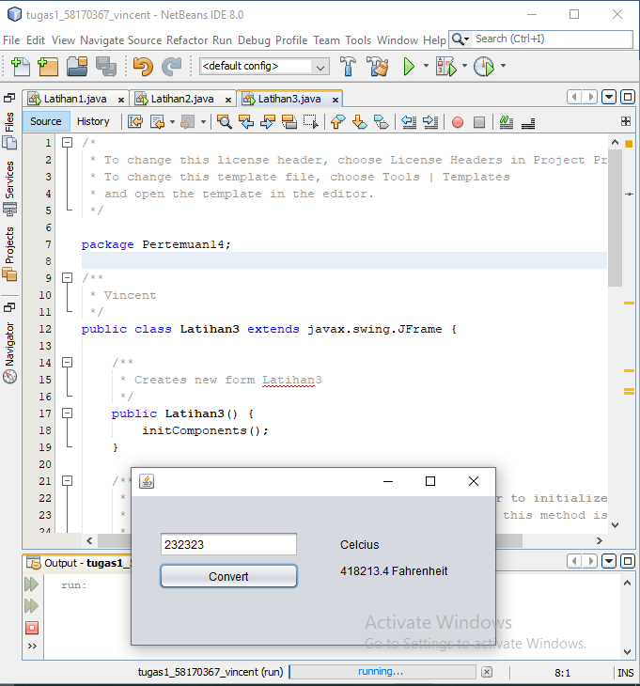

/*

* To change this license header, choose License Headers in Project Properties.

* To change this template file, choose Tools | Templates

* and open the template in the editor.

*/

package Pertemuan14;

/**

* Vincent

*/

public class Latihan3 extends javax.swing.JFrame {

/**

* Creates new form Latihan3

*/

public Latihan3() {

initComponents();

}

/**

* This method is called from within the constructor to initialize the form.

* WARNING: Do NOT modify this code. The content of this method is always

* regenerated by the Form Editor.

*/

@SuppressWarnings("unchecked")

// <editor-fold defaultstate="collapsed" desc="Generated Code">//GEN-BEGIN:initComponents

private void initComponents() {

celciustxt = new javax.swing.JTextField();

jLabel1 = new javax.swing.JLabel();

farenheitLabel = new javax.swing.JLabel();

convertbtn = new javax.swing.JButton();

setDefaultCloseOperation(javax.swing.WindowConstants.EXIT_ON_CLOSE);

jLabel1.setText("Celcius");

farenheitLabel.setText("Farenheit");

convertbtn.setText("Convert");

convertbtn.addActionListener(new java.awt.event.ActionListener() {

public void actionPerformed(java.awt.event.ActionEvent evt) {

convertbtnActionPerformed(evt);

}

});

javax.swing.GroupLayout layout = new javax.swing.GroupLayout(getContentPane());

getContentPane().setLayout(layout);

layout.setHorizontalGroup(

layout.createParallelGroup(javax.swing.GroupLayout.Alignment.LEADING)

.addGroup(layout.createSequentialGroup()

.addGap(29, 29, 29)

.addGroup(layout.createParallelGroup(javax.swing.GroupLayout.Alignment.LEADING, false)

.addComponent(celciustxt)

.addComponent(convertbtn, javax.swing.GroupLayout.DEFAULT_SIZE, 149, Short.MAX_VALUE))

.addGap(44, 44, 44)

.addGroup(layout.createParallelGroup(javax.swing.GroupLayout.Alignment.LEADING)

.addComponent(farenheitLabel)

.addComponent(jLabel1))

.addContainerGap(113, Short.MAX_VALUE))

);

layout.setVerticalGroup(

layout.createParallelGroup(javax.swing.GroupLayout.Alignment.LEADING)

.addGroup(layout.createSequentialGroup()

.addGap(37, 37, 37)

.addGroup(layout.createParallelGroup(javax.swing.GroupLayout.Alignment.BASELINE)

.addComponent(celciustxt, javax.swing.GroupLayout.PREFERRED_SIZE, javax.swing.GroupLayout.DEFAULT_SIZE, javax.swing.GroupLayout.PREFERRED_SIZE)

.addComponent(jLabel1))

.addPreferredGap(javax.swing.LayoutStyle.ComponentPlacement.RELATED)

.addGroup(layout.createParallelGroup(javax.swing.GroupLayout.Alignment.LEADING)

.addComponent(farenheitLabel)

.addComponent(convertbtn))

.addContainerGap(59, Short.MAX_VALUE))

);

pack();

}// </editor-fold>//GEN-END:initComponents

private void convertbtnActionPerformed(java.awt.event.ActionEvent evt) {//GEN-FIRST:event_convertbtnActionPerformed

double fahrenheit =Double.parseDouble(celciustxt.getText()) * 1.8 + 32;

farenheitLabel.setText(fahrenheit +" Fahrenheit");

}//GEN-LAST:event_convertbtnActionPerformed

/**

* @param args the command line arguments

*/

public static void main(String args[]) {

/* Set the Nimbus look and feel */

//<editor-fold defaultstate="collapsed" desc=" Look and feel setting code (optional) ">

/* If Nimbus (introduced in Java SE 6) is not available, stay with the default look and feel.

* For details see http://download.oracle.com/javase/tutorial/uiswing/lookandfeel/plaf.html

*/

try {

for (javax.swing.UIManager.LookAndFeelInfo info : javax.swing.UIManager.getInstalledLookAndFeels()) {

if ("Nimbus".equals(info.getName())) {

javax.swing.UIManager.setLookAndFeel(info.getClassName());

break;

}

}

} catch (ClassNotFoundException ex) {

java.util.logging.Logger.getLogger(Latihan3.class.getName()).log(java.util.logging.Level.SEVERE, null, ex);

} catch (InstantiationException ex) {

java.util.logging.Logger.getLogger(Latihan3.class.getName()).log(java.util.logging.Level.SEVERE, null, ex);

} catch (IllegalAccessException ex) {

java.util.logging.Logger.getLogger(Latihan3.class.getName()).log(java.util.logging.Level.SEVERE, null, ex);

} catch (javax.swing.UnsupportedLookAndFeelException ex) {

java.util.logging.Logger.getLogger(Latihan3.class.getName()).log(java.util.logging.Level.SEVERE, null, ex);

}

//</editor-fold>

/* Create and display the form */

java.awt.EventQueue.invokeLater(new Runnable() {

public void run() {

new Latihan3().setVisible(true);

}

});

}

// Variables declaration - do not modify//GEN-BEGIN:variables

private javax.swing.JTextField celciustxt;

private javax.swing.JButton convertbtn;

private javax.swing.JLabel farenheitLabel;

private javax.swing.JLabel jLabel1;

// End of variables declaration//GEN-END:variables

}

Latihan 4

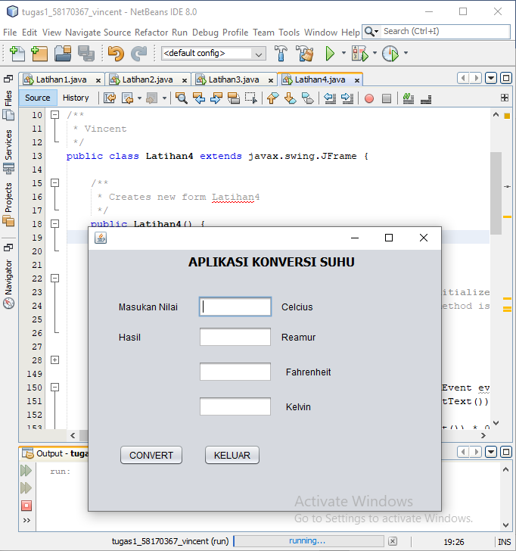

/*

* To change this license header, choose License Headers in Project Properties.

* To change this template file, choose Tools | Templates

* and open the template in the editor.

*/

package Pertemuan14;

import javax.swing.JOptionPane;

/**

* Vincent

*/

public class Latihan4 extends javax.swing.JFrame {

/**

* Creates new form Latihan4

*/

public Latihan4() {

initComponents();

}

/**

* This method is called from within the constructor to initialize the form.

* WARNING: Do NOT modify this code. The content of this method is always

* regenerated by the Form Editor.

*/

@SuppressWarnings("unchecked")

// <editor-fold defaultstate="collapsed" desc="Generated Code">//GEN-BEGIN:initComponents

private void initComponents() {

jLabel1 = new javax.swing.JLabel();

jLabel2 = new javax.swing.JLabel();

jLabel3 = new javax.swing.JLabel();

celciusField = new javax.swing.JTextField();

jLabel4 = new javax.swing.JLabel();

reamurField = new javax.swing.JTextField();

jLabel5 = new javax.swing.JLabel();

fahrenheitField = new javax.swing.JTextField();

jLabel6 = new javax.swing.JLabel();

kelvinField = new javax.swing.JTextField();

jLabel7 = new javax.swing.JLabel();

jButton1 = new javax.swing.JButton();

jButton2 = new javax.swing.JButton();

setDefaultCloseOperation(javax.swing.WindowConstants.EXIT_ON_CLOSE);

jLabel1.setFont(new java.awt.Font("Tahoma", 1, 16)); // NOI18N

jLabel1.setText("APLIKASI KONVERSI SUHU");

jLabel2.setText("Masukan Nilai");

jLabel3.setText("Hasil");

jLabel4.setText("Celcius");

jLabel5.setText("Reamur");

jLabel6.setText("Fahrenheit");

jLabel7.setText("Kelvin");

jButton1.setText("CONVERT");

jButton1.addActionListener(new java.awt.event.ActionListener() {

public void actionPerformed(java.awt.event.ActionEvent evt) {

jButton1ActionPerformed(evt);

}

});

jButton2.setText("KELUAR");

jButton2.addActionListener(new java.awt.event.ActionListener() {

public void actionPerformed(java.awt.event.ActionEvent evt) {

jButton2ActionPerformed(evt);

}

});

javax.swing.GroupLayout layout = new javax.swing.GroupLayout(getContentPane());

getContentPane().setLayout(layout);

layout.setHorizontalGroup(

layout.createParallelGroup(javax.swing.GroupLayout.Alignment.LEADING)

.addGroup(layout.createSequentialGroup()

.addGap(40, 40, 40)

.addGroup(layout.createParallelGroup(javax.swing.GroupLayout.Alignment.LEADING)

.addComponent(jLabel2)

.addComponent(jLabel3)

.addComponent(jButton1))

.addGroup(layout.createParallelGroup(javax.swing.GroupLayout.Alignment.LEADING)

.addGroup(layout.createSequentialGroup()

.addGap(26, 26, 26)

.addComponent(jButton2))

.addGroup(layout.createSequentialGroup()

.addGap(19, 19, 19)

.addGroup(layout.createParallelGroup(javax.swing.GroupLayout.Alignment.LEADING)

.addGroup(layout.createSequentialGroup()

.addGroup(layout.createParallelGroup(javax.swing.GroupLayout.Alignment.LEADING, false)

.addComponent(celciusField, javax.swing.GroupLayout.DEFAULT_SIZE, 98, Short.MAX_VALUE)

.addComponent(reamurField))

.addGroup(layout.createParallelGroup(javax.swing.GroupLayout.Alignment.LEADING)

.addGroup(layout.createSequentialGroup()

.addGap(12, 12, 12)

.addComponent(jLabel4))

.addGroup(layout.createSequentialGroup()

.addPreferredGap(javax.swing.LayoutStyle.ComponentPlacement.UNRELATED)

.addComponent(jLabel5))))

.addGroup(layout.createSequentialGroup()

.addGroup(layout.createParallelGroup(javax.swing.GroupLayout.Alignment.LEADING, false)

.addComponent(kelvinField, javax.swing.GroupLayout.DEFAULT_SIZE, 98, Short.MAX_VALUE)

.addComponent(fahrenheitField))

.addGap(18, 18, 18)

.addGroup(layout.createParallelGroup(javax.swing.GroupLayout.Alignment.LEADING)

.addComponent(jLabel6)

.addComponent(jLabel7)))))

.addGroup(javax.swing.GroupLayout.Alignment.TRAILING, layout.createSequentialGroup()

.addPreferredGap(javax.swing.LayoutStyle.ComponentPlacement.RELATED)

.addComponent(jLabel1)))

.addContainerGap(114, Short.MAX_VALUE))

);

layout.setVerticalGroup(

layout.createParallelGroup(javax.swing.GroupLayout.Alignment.LEADING)

.addGroup(layout.createSequentialGroup()

.addContainerGap()

.addComponent(jLabel1)

.addGap(35, 35, 35)

.addGroup(layout.createParallelGroup(javax.swing.GroupLayout.Alignment.BASELINE)

.addComponent(jLabel2)

.addComponent(celciusField, javax.swing.GroupLayout.PREFERRED_SIZE, javax.swing.GroupLayout.DEFAULT_SIZE, javax.swing.GroupLayout.PREFERRED_SIZE)

.addComponent(jLabel4))

.addPreferredGap(javax.swing.LayoutStyle.ComponentPlacement.UNRELATED)

.addGroup(layout.createParallelGroup(javax.swing.GroupLayout.Alignment.BASELINE)

.addComponent(jLabel3)

.addComponent(reamurField, javax.swing.GroupLayout.PREFERRED_SIZE, javax.swing.GroupLayout.DEFAULT_SIZE, javax.swing.GroupLayout.PREFERRED_SIZE)

.addComponent(jLabel5))

.addGap(18, 18, 18)

.addGroup(layout.createParallelGroup(javax.swing.GroupLayout.Alignment.BASELINE)

.addComponent(fahrenheitField, javax.swing.GroupLayout.PREFERRED_SIZE, javax.swing.GroupLayout.DEFAULT_SIZE, javax.swing.GroupLayout.PREFERRED_SIZE)

.addComponent(jLabel6))

.addGap(18, 18, 18)

.addGroup(layout.createParallelGroup(javax.swing.GroupLayout.Alignment.BASELINE)

.addComponent(kelvinField, javax.swing.GroupLayout.PREFERRED_SIZE, javax.swing.GroupLayout.DEFAULT_SIZE, javax.swing.GroupLayout.PREFERRED_SIZE)

.addComponent(jLabel7))

.addGap(36, 36, 36)

.addGroup(layout.createParallelGroup(javax.swing.GroupLayout.Alignment.BASELINE)

.addComponent(jButton1)

.addComponent(jButton2))

.addContainerGap(60, Short.MAX_VALUE))

);

pack();

}// </editor-fold>//GEN-END:initComponents

private void jButton1ActionPerformed(java.awt.event.ActionEvent evt) {//GEN-FIRST:event_jButton1ActionPerformed

double fahrenheit = Double.parseDouble(celciusField.getText()) * 1.8 + 32;

fahrenheitField.setText(fahrenheit+"");

double reamur = Double.parseDouble(celciusField.getText()) * 0.8;

reamurField.setText(reamur+"");

double kelvin = Double.parseDouble(celciusField.getText()) + 273;

kelvinField.setText(kelvin+"");

}//GEN-LAST:event_jButton1ActionPerformed

private void jButton2ActionPerformed(java.awt.event.ActionEvent evt) {//GEN-FIRST:event_jButton2ActionPerformed

int balas = JOptionPane.showConfirmDialog(null,"Yakin ingin keluar ?", "Konfirmasi Keluar Aplikasi", JOptionPane.YES_NO_OPTION);

if(balas==JOptionPane.YES_OPTION){

System.exit(0);

}

}//GEN-LAST:event_jButton2ActionPerformed

/**

* @param args the command line arguments

*/

public static void main(String args[]) {

/* Set the Nimbus look and feel */

//<editor-fold defaultstate="collapsed" desc=" Look and feel setting code (optional) ">

/* If Nimbus (introduced in Java SE 6) is not available, stay with the default look and feel.

* For details see http://download.oracle.com/javase/tutorial/uiswing/lookandfeel/plaf.html

*/

try {

for (javax.swing.UIManager.LookAndFeelInfo info : javax.swing.UIManager.getInstalledLookAndFeels()) {

if ("Nimbus".equals(info.getName())) {

javax.swing.UIManager.setLookAndFeel(info.getClassName());

break;

}

}

} catch (ClassNotFoundException ex) {

java.util.logging.Logger.getLogger(Latihan4.class.getName()).log(java.util.logging.Level.SEVERE, null, ex);

} catch (InstantiationException ex) {

java.util.logging.Logger.getLogger(Latihan4.class.getName()).log(java.util.logging.Level.SEVERE, null, ex);

} catch (IllegalAccessException ex) {

java.util.logging.Logger.getLogger(Latihan4.class.getName()).log(java.util.logging.Level.SEVERE, null, ex);

} catch (javax.swing.UnsupportedLookAndFeelException ex) {

java.util.logging.Logger.getLogger(Latihan4.class.getName()).log(java.util.logging.Level.SEVERE, null, ex);

}

//</editor-fold>

/* Create and display the form */

java.awt.EventQueue.invokeLater(new Runnable() {

public void run() {

new Latihan4().setVisible(true);

}

});

}

// Variables declaration - do not modify//GEN-BEGIN:variables

private javax.swing.JTextField celciusField;

private javax.swing.JTextField fahrenheitField;

private javax.swing.JButton jButton1;

private javax.swing.JButton jButton2;

private javax.swing.JLabel jLabel1;

private javax.swing.JLabel jLabel2;

private javax.swing.JLabel jLabel3;

private javax.swing.JLabel jLabel4;

private javax.swing.JLabel jLabel5;

private javax.swing.JLabel jLabel6;

private javax.swing.JLabel jLabel7;

private javax.swing.JTextField kelvinField;

private javax.swing.JTextField reamurField;

// End of variables declaration//GEN-END:variables

}

Latihan 5

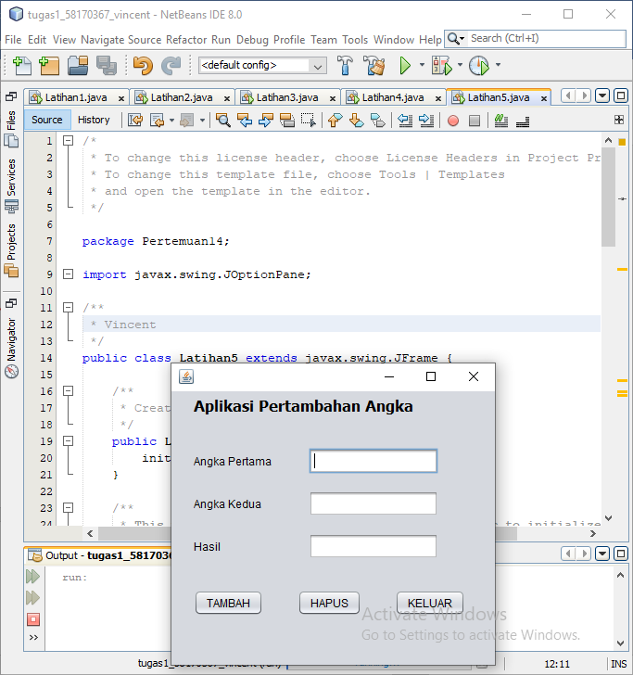

/*

* To change this license header, choose License Headers in Project Properties.

* To change this template file, choose Tools | Templates

* and open the template in the editor.

*/

package Pertemuan14;

import javax.swing.JOptionPane;

/**

* Vincent

*/

public class Latihan5 extends javax.swing.JFrame {

/**

* Creates new form Latihan5

*/

public Latihan5() {

initComponents();

}

/**

* This method is called from within the constructor to initialize the form.

* WARNING: Do NOT modify this code. The content of this method is always

* regenerated by the Form Editor.

*/

@SuppressWarnings("unchecked")

// <editor-fold defaultstate="collapsed" desc="Generated Code">//GEN-BEGIN:initComponents

private void initComponents() {

jLabel1 = new javax.swing.JLabel();

jLabel2 = new javax.swing.JLabel();

jLabel3 = new javax.swing.JLabel();

jLabel4 = new javax.swing.JLabel();

pertama = new javax.swing.JTextField();

kedua = new javax.swing.JTextField();

hasil = new javax.swing.JTextField();

tambah = new javax.swing.JButton();

hapus = new javax.swing.JButton();

keluar = new javax.swing.JButton();

setDefaultCloseOperation(javax.swing.WindowConstants.EXIT_ON_CLOSE);

setBackground(new java.awt.Color(102, 102, 0));

jLabel1.setFont(new java.awt.Font("Tahoma", 1, 16)); // NOI18N

jLabel1.setText("Aplikasi Pertambahan Angka");

jLabel2.setText("Angka Pertama");

jLabel3.setText("Angka Kedua");

jLabel4.setBackground(new java.awt.Color(0, 255, 0));

jLabel4.setText("Hasil");

tambah.setText("TAMBAH");

tambah.addActionListener(new java.awt.event.ActionListener() {

public void actionPerformed(java.awt.event.ActionEvent evt) {

tambahActionPerformed(evt);

}

});

hapus.setText("HAPUS");

hapus.addActionListener(new java.awt.event.ActionListener() {

public void actionPerformed(java.awt.event.ActionEvent evt) {

hapusActionPerformed(evt);

}

});

keluar.setText("KELUAR");

keluar.addActionListener(new java.awt.event.ActionListener() {

public void actionPerformed(java.awt.event.ActionEvent evt) {

keluarActionPerformed(evt);

}

});

javax.swing.GroupLayout layout = new javax.swing.GroupLayout(getContentPane());

getContentPane().setLayout(layout);

layout.setHorizontalGroup(

layout.createParallelGroup(javax.swing.GroupLayout.Alignment.LEADING)

.addGroup(layout.createSequentialGroup()

.addGap(24, 24, 24)

.addGroup(layout.createParallelGroup(javax.swing.GroupLayout.Alignment.LEADING)

.addComponent(jLabel1)

.addGroup(layout.createSequentialGroup()

.addComponent(tambah)

.addGap(37, 37, 37)

.addComponent(hapus)

.addGap(36, 36, 36)

.addComponent(keluar))

.addGroup(layout.createSequentialGroup()

.addGroup(layout.createParallelGroup(javax.swing.GroupLayout.Alignment.LEADING)

.addComponent(jLabel2)

.addComponent(jLabel3)

.addComponent(jLabel4))

.addGap(40, 40, 40)

.addGroup(layout.createParallelGroup(javax.swing.GroupLayout.Alignment.TRAILING, false)

.addComponent(kedua, javax.swing.GroupLayout.Alignment.LEADING, javax.swing.GroupLayout.DEFAULT_SIZE, 140, Short.MAX_VALUE)

.addComponent(pertama, javax.swing.GroupLayout.Alignment.LEADING)

.addComponent(hasil))))

.addContainerGap(32, Short.MAX_VALUE))

);

layout.setVerticalGroup(

layout.createParallelGroup(javax.swing.GroupLayout.Alignment.LEADING)

.addGroup(layout.createSequentialGroup()

.addContainerGap()

.addComponent(jLabel1)

.addGap(35, 35, 35)

.addGroup(layout.createParallelGroup(javax.swing.GroupLayout.Alignment.BASELINE)

.addComponent(jLabel2)

.addComponent(pertama, javax.swing.GroupLayout.PREFERRED_SIZE, javax.swing.GroupLayout.DEFAULT_SIZE, javax.swing.GroupLayout.PREFERRED_SIZE))

.addGap(18, 18, 18)

.addGroup(layout.createParallelGroup(javax.swing.GroupLayout.Alignment.BASELINE)

.addComponent(jLabel3)

.addComponent(kedua, javax.swing.GroupLayout.PREFERRED_SIZE, javax.swing.GroupLayout.DEFAULT_SIZE, javax.swing.GroupLayout.PREFERRED_SIZE))

.addGap(18, 18, 18)

.addGroup(layout.createParallelGroup(javax.swing.GroupLayout.Alignment.BASELINE)

.addComponent(jLabel4)

.addComponent(hasil, javax.swing.GroupLayout.PREFERRED_SIZE, javax.swing.GroupLayout.DEFAULT_SIZE, javax.swing.GroupLayout.PREFERRED_SIZE))

.addGap(33, 33, 33)

.addGroup(layout.createParallelGroup(javax.swing.GroupLayout.Alignment.BASELINE)

.addComponent(tambah)

.addComponent(hapus)

.addComponent(keluar))

.addContainerGap(53, Short.MAX_VALUE))

);

pack();

}// </editor-fold>//GEN-END:initComponents

private void tambahActionPerformed(java.awt.event.ActionEvent evt) {//GEN-FIRST:event_tambahActionPerformed

int a = Integer.parseInt(pertama.getText());

int b = Integer.parseInt(kedua.getText());

int c = a+b;

hasil.setText(Integer.toString(c));

}//GEN-LAST:event_tambahActionPerformed

private void hapusActionPerformed(java.awt.event.ActionEvent evt) {//GEN-FIRST:event_hapusActionPerformed

pertama.setText("");

kedua.setText("");

hasil.setText("");

}//GEN-LAST:event_hapusActionPerformed

private void keluarActionPerformed(java.awt.event.ActionEvent evt) {//GEN-FIRST:event_keluarActionPerformed

int balas = JOptionPane.showConfirmDialog(null,"Yakin ingin keluar ?", "Konfirmasi Keluar Aplikasi", JOptionPane.YES_NO_OPTION);

if(balas==JOptionPane.YES_OPTION){

System.exit(0);

}

}//GEN-LAST:event_keluarActionPerformed

/**

* @param args the command line arguments

*/

public static void main(String args[]) {

/* Set the Nimbus look and feel */

//<editor-fold defaultstate="collapsed" desc=" Look and feel setting code (optional) ">

/* If Nimbus (introduced in Java SE 6) is not available, stay with the default look and feel.

* For details see http://download.oracle.com/javase/tutorial/uiswing/lookandfeel/plaf.html

*/

try {

for (javax.swing.UIManager.LookAndFeelInfo info : javax.swing.UIManager.getInstalledLookAndFeels()) {

if ("Nimbus".equals(info.getName())) {

javax.swing.UIManager.setLookAndFeel(info.getClassName());

break;

}

}

} catch (ClassNotFoundException ex) {

java.util.logging.Logger.getLogger(Latihan5.class.getName()).log(java.util.logging.Level.SEVERE, null, ex);

} catch (InstantiationException ex) {

java.util.logging.Logger.getLogger(Latihan5.class.getName()).log(java.util.logging.Level.SEVERE, null, ex);

} catch (IllegalAccessException ex) {

java.util.logging.Logger.getLogger(Latihan5.class.getName()).log(java.util.logging.Level.SEVERE, null, ex);

} catch (javax.swing.UnsupportedLookAndFeelException ex) {

java.util.logging.Logger.getLogger(Latihan5.class.getName()).log(java.util.logging.Level.SEVERE, null, ex);

}

//</editor-fold>

/* Create and display the form */

java.awt.EventQueue.invokeLater(new Runnable() {

public void run() {

new Latihan5().setVisible(true);

}

});

}

// Variables declaration - do not modify//GEN-BEGIN:variables

private javax.swing.JButton hapus;

private javax.swing.JTextField hasil;

private javax.swing.JLabel jLabel1;

private javax.swing.JLabel jLabel2;

private javax.swing.JLabel jLabel3;

private javax.swing.JLabel jLabel4;

private javax.swing.JTextField kedua;

private javax.swing.JButton keluar;

private javax.swing.JTextField pertama;

private javax.swing.JButton tambah;

// End of variables declaration//GEN-END:variables

}

Latihan 6

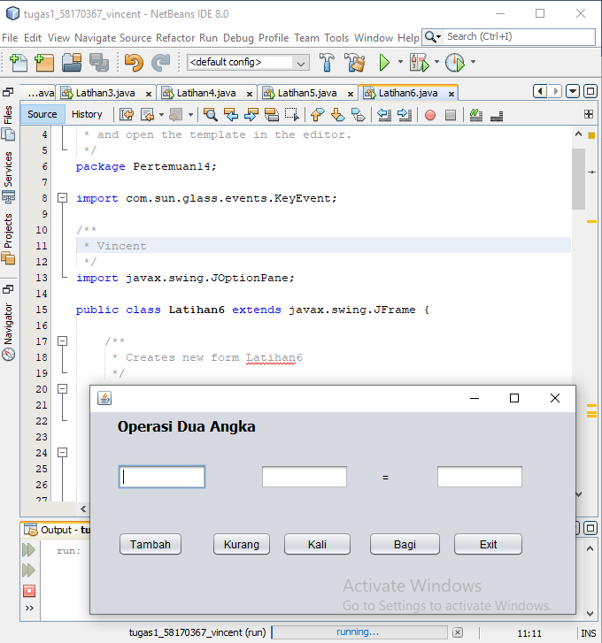

/*

* To change this license header, choose License Headers in Project Properties.

* To change this template file, choose Tools | Templates

* and open the template in the editor.

*/

package Pertemuan14;

import com.sun.glass.events.KeyEvent;

/**

* Vincent

*/

import javax.swing.JOptionPane;

public class Latihan6 extends javax.swing.JFrame {

/**

* Creates new form Latihan6

*/

public Latihan6() {

initComponents();

}

/**

* This method is called from within the constructor to initialize the form.

* WARNING: Do NOT modify this code. The content of this method is always

* regenerated by the Form Editor.

*/

@SuppressWarnings("unchecked")

// <editor-fold defaultstate="collapsed" desc="Generated Code">//GEN-BEGIN:initComponents

private void initComponents() {

jLabel1 = new javax.swing.JLabel();

satu = new javax.swing.JTextField();

dua = new javax.swing.JTextField();

jLabel2 = new javax.swing.JLabel();

hasil = new javax.swing.JTextField();

tambah = new javax.swing.JButton();

kurang = new javax.swing.JButton();

kali = new javax.swing.JButton();

bagi = new javax.swing.JButton();

exit = new javax.swing.JButton();

setDefaultCloseOperation(javax.swing.WindowConstants.EXIT_ON_CLOSE);

jLabel1.setFont(new java.awt.Font("Tahoma", 1, 16)); // NOI18N

jLabel1.setText("Operasi Dua Angka");

satu.addKeyListener(new java.awt.event.KeyAdapter() {

public void keyTyped(java.awt.event.KeyEvent evt) {

satuKeyTyped(evt);

}

});

dua.addKeyListener(new java.awt.event.KeyAdapter() {

public void keyTyped(java.awt.event.KeyEvent evt) {

duaKeyTyped(evt);

}

});

jLabel2.setText("=");

hasil.addKeyListener(new java.awt.event.KeyAdapter() {

public void keyTyped(java.awt.event.KeyEvent evt) {

hasilKeyTyped(evt);

}

});

tambah.setText("Tambah");

tambah.addActionListener(new java.awt.event.ActionListener() {

public void actionPerformed(java.awt.event.ActionEvent evt) {

tambahActionPerformed(evt);

}

});

kurang.setText("Kurang");

kurang.addActionListener(new java.awt.event.ActionListener() {

public void actionPerformed(java.awt.event.ActionEvent evt) {

kurangActionPerformed(evt);

}

});

kali.setText("Kali");

kali.addActionListener(new java.awt.event.ActionListener() {

public void actionPerformed(java.awt.event.ActionEvent evt) {

kaliActionPerformed(evt);

}

});

bagi.setText("Bagi");

bagi.addActionListener(new java.awt.event.ActionListener() {

public void actionPerformed(java.awt.event.ActionEvent evt) {

bagiActionPerformed(evt);

}

});

exit.setText("Exit");

exit.addActionListener(new java.awt.event.ActionListener() {

public void actionPerformed(java.awt.event.ActionEvent evt) {

exitActionPerformed(evt);

}

});

javax.swing.GroupLayout layout = new javax.swing.GroupLayout(getContentPane());

getContentPane().setLayout(layout);

layout.setHorizontalGroup(

layout.createParallelGroup(javax.swing.GroupLayout.Alignment.LEADING)

.addGroup(layout.createSequentialGroup()

.addGap(31, 31, 31)

.addGroup(layout.createParallelGroup(javax.swing.GroupLayout.Alignment.LEADING)

.addGroup(layout.createSequentialGroup()

.addGroup(layout.createParallelGroup(javax.swing.GroupLayout.Alignment.LEADING)

.addComponent(tambah)

.addComponent(satu, javax.swing.GroupLayout.PREFERRED_SIZE, 100, javax.swing.GroupLayout.PREFERRED_SIZE))

.addPreferredGap(javax.swing.LayoutStyle.ComponentPlacement.RELATED)

.addGroup(layout.createParallelGroup(javax.swing.GroupLayout.Alignment.TRAILING, false)

.addGroup(javax.swing.GroupLayout.Alignment.LEADING, layout.createSequentialGroup()

.addComponent(kurang)

.addPreferredGap(javax.swing.LayoutStyle.ComponentPlacement.UNRELATED)

.addComponent(kali, javax.swing.GroupLayout.PREFERRED_SIZE, 79, javax.swing.GroupLayout.PREFERRED_SIZE)

.addGap(18, 18, 18)

.addComponent(bagi, javax.swing.GroupLayout.PREFERRED_SIZE, 83, javax.swing.GroupLayout.PREFERRED_SIZE)

.addPreferredGap(javax.swing.LayoutStyle.ComponentPlacement.UNRELATED)

.addComponent(exit, javax.swing.GroupLayout.PREFERRED_SIZE, 81, javax.swing.GroupLayout.PREFERRED_SIZE))

.addGroup(javax.swing.GroupLayout.Alignment.LEADING, layout.createSequentialGroup()

.addGap(55, 55, 55)

.addComponent(dua, javax.swing.GroupLayout.PREFERRED_SIZE, 100, javax.swing.GroupLayout.PREFERRED_SIZE)

.addPreferredGap(javax.swing.LayoutStyle.ComponentPlacement.RELATED, javax.swing.GroupLayout.DEFAULT_SIZE, Short.MAX_VALUE)

.addComponent(jLabel2)

.addGap(53, 53, 53)

.addComponent(hasil, javax.swing.GroupLayout.PREFERRED_SIZE, 100, javax.swing.GroupLayout.PREFERRED_SIZE))))

.addComponent(jLabel1))

.addContainerGap(58, Short.MAX_VALUE))

);

layout.setVerticalGroup(

layout.createParallelGroup(javax.swing.GroupLayout.Alignment.LEADING)

.addGroup(layout.createSequentialGroup()

.addContainerGap()

.addComponent(jLabel1)

.addGap(33, 33, 33)

.addGroup(layout.createParallelGroup(javax.swing.GroupLayout.Alignment.BASELINE)

.addComponent(satu, javax.swing.GroupLayout.PREFERRED_SIZE, javax.swing.GroupLayout.DEFAULT_SIZE, javax.swing.GroupLayout.PREFERRED_SIZE)

.addComponent(dua, javax.swing.GroupLayout.PREFERRED_SIZE, javax.swing.GroupLayout.DEFAULT_SIZE, javax.swing.GroupLayout.PREFERRED_SIZE)

.addComponent(jLabel2)

.addComponent(hasil, javax.swing.GroupLayout.PREFERRED_SIZE, javax.swing.GroupLayout.DEFAULT_SIZE, javax.swing.GroupLayout.PREFERRED_SIZE))

.addGap(48, 48, 48)

.addGroup(layout.createParallelGroup(javax.swing.GroupLayout.Alignment.BASELINE)

.addComponent(tambah)

.addComponent(kurang)

.addComponent(kali)

.addComponent(bagi)

.addComponent(exit))

.addContainerGap(65, Short.MAX_VALUE))

);

pack();

}// </editor-fold>//GEN-END:initComponents

private void hasilKeyTyped(java.awt.event.KeyEvent evt) {//GEN-FIRST:event_hasilKeyTyped

// TODO add your handling code here:

}//GEN-LAST:event_hasilKeyTyped

private void duaKeyTyped(java.awt.event.KeyEvent evt) {//GEN-FIRST:event_duaKeyTyped

char a = evt.getKeyChar();

if (!((Character.isDigit(a)

|| (a == KeyEvent.VK_BACKSPACE)

|| (a == KeyEvent.VK_DELETE)))) {

getToolkit().beep();

JOptionPane.showMessageDialog(null, "Masukan Hanya Berupa Angka!");

evt.consume();

}

}//GEN-LAST:event_duaKeyTyped

private void satuKeyTyped(java.awt.event.KeyEvent evt) {//GEN-FIRST:event_satuKeyTyped

char a = evt.getKeyChar();

if (!((Character.isDigit(a)

|| (a == KeyEvent.VK_BACKSPACE)

|| (a == KeyEvent.VK_DELETE)))) {

getToolkit().beep();

JOptionPane.showMessageDialog(null, "Masukan Hanya Berupa Angka!");

evt.consume();

}

}//GEN-LAST:event_satuKeyTyped

private void tambahActionPerformed(java.awt.event.ActionEvent evt) {//GEN-FIRST:event_tambahActionPerformed

int a = Integer.parseInt(satu.getText());

int b = Integer.parseInt(dua.getText());

int c = a + b;

hasil.setText(Integer.toString(c));

}//GEN-LAST:event_tambahActionPerformed

private void kurangActionPerformed(java.awt.event.ActionEvent evt) {//GEN-FIRST:event_kurangActionPerformed

int a = Integer.parseInt(satu.getText());

int b = Integer.parseInt(dua.getText());

int c = a - b;

hasil.setText(Integer.toString(c));

}//GEN-LAST:event_kurangActionPerformed

private void kaliActionPerformed(java.awt.event.ActionEvent evt) {//GEN-FIRST:event_kaliActionPerformed

int a = Integer.parseInt(satu.getText());

int b = Integer.parseInt(dua.getText());

int c = a * b;

hasil.setText(Integer.toString(c));

}//GEN-LAST:event_kaliActionPerformed

private void bagiActionPerformed(java.awt.event.ActionEvent evt) {//GEN-FIRST:event_bagiActionPerformed

int a = Integer.parseInt(satu.getText());

int b = Integer.parseInt(dua.getText());

int c = a / b;

hasil.setText(Integer.toString(c));

}//GEN-LAST:event_bagiActionPerformed

private void exitActionPerformed(java.awt.event.ActionEvent evt) {//GEN-FIRST:event_exitActionPerformed

int balas = JOptionPane.showConfirmDialog(null, "Yakin ingin keluar ?", "Konfirmasi Keluar Aplikasi", JOptionPane.YES_NO_OPTION);

if (balas == JOptionPane.YES_OPTION) {

System.exit(0);

}

}//GEN-LAST:event_exitActionPerformed

/**

* @param args the command line arguments

*/

public static void main(String args[]) {

/* Set the Nimbus look and feel */

//<editor-fold defaultstate="collapsed" desc=" Look and feel setting code (optional) ">

/* If Nimbus (introduced in Java SE 6) is not available, stay with the default look and feel.

* For details see http://download.oracle.com/javase/tutorial/uiswing/lookandfeel/plaf.html

*/

try {

for (javax.swing.UIManager.LookAndFeelInfo info : javax.swing.UIManager.getInstalledLookAndFeels()) {

if ("Nimbus".equals(info.getName())) {

javax.swing.UIManager.setLookAndFeel(info.getClassName());

break;

}

}

} catch (ClassNotFoundException ex) {

java.util.logging.Logger.getLogger(Latihan6.class.getName()).log(java.util.logging.Level.SEVERE, null, ex);

} catch (InstantiationException ex) {

java.util.logging.Logger.getLogger(Latihan6.class.getName()).log(java.util.logging.Level.SEVERE, null, ex);

} catch (IllegalAccessException ex) {

java.util.logging.Logger.getLogger(Latihan6.class.getName()).log(java.util.logging.Level.SEVERE, null, ex);

} catch (javax.swing.UnsupportedLookAndFeelException ex) {

java.util.logging.Logger.getLogger(Latihan6.class.getName()).log(java.util.logging.Level.SEVERE, null, ex);

}

//</editor-fold>

/* Create and display the form */

java.awt.EventQueue.invokeLater(new Runnable() {

public void run() {

new Latihan6().setVisible(true);

}

});

}

// Variables declaration - do not modify//GEN-BEGIN:variables

private javax.swing.JButton bagi;

private javax.swing.JTextField dua;

private javax.swing.JButton exit;

private javax.swing.JTextField hasil;

private javax.swing.JLabel jLabel1;

private javax.swing.JLabel jLabel2;

private javax.swing.JButton kali;

private javax.swing.JButton kurang;

private javax.swing.JTextField satu;

private javax.swing.JButton tambah;

// End of variables declaration//GEN-END:variables

}

Latihan 7

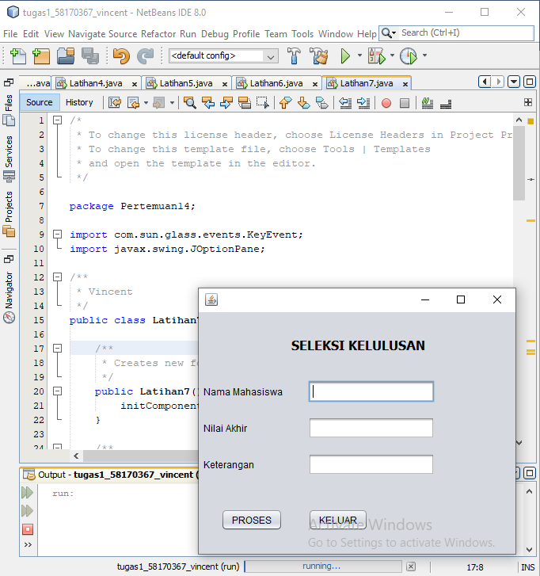

/*

* To change this license header, choose License Headers in Project Properties.

* To change this template file, choose Tools | Templates

* and open the template in the editor.

*/

package Pertemuan14;

import com.sun.glass.events.KeyEvent;

import javax.swing.JOptionPane;

/**

* Vincent

*/

public class Latihan7 extends javax.swing.JFrame {

/**

* Creates new form Latihan7

*/

public Latihan7() {

initComponents();

}

/**

* This method is called from within the constructor to initialize the form.

* WARNING: Do NOT modify this code. The content of this method is always

* regenerated by the Form Editor.

*/

@SuppressWarnings("unchecked")

// <editor-fold defaultstate="collapsed" desc="Generated Code">//GEN-BEGIN:initComponents

private void initComponents() {

jLabel1 = new javax.swing.JLabel();

jLabel2 = new javax.swing.JLabel();

jLabel3 = new javax.swing.JLabel();

jLabel4 = new javax.swing.JLabel();

namatxt = new javax.swing.JTextField();

nilaitxt = new javax.swing.JTextField();

hasiltxt = new javax.swing.JTextField();

jButton1 = new javax.swing.JButton();

jButton2 = new javax.swing.JButton();

setDefaultCloseOperation(javax.swing.WindowConstants.EXIT_ON_CLOSE);

jLabel1.setFont(new java.awt.Font("Tahoma", 1, 16)); // NOI18N

jLabel1.setText("SELEKSI KELULUSAN");

jLabel2.setText("Nama Mahasiswa");

jLabel3.setText("Nilai Akhir");

jLabel4.setText("Keterangan");

nilaitxt.addKeyListener(new java.awt.event.KeyAdapter() {

public void keyTyped(java.awt.event.KeyEvent evt) {

nilaitxtKeyTyped(evt);

}

});

jButton1.setText("PROSES");

jButton1.addActionListener(new java.awt.event.ActionListener() {

public void actionPerformed(java.awt.event.ActionEvent evt) {

jButton1ActionPerformed(evt);

}

});

jButton2.setText("KELUAR");

jButton2.addActionListener(new java.awt.event.ActionListener() {

public void actionPerformed(java.awt.event.ActionEvent evt) {

jButton2ActionPerformed(evt);

}

});

javax.swing.GroupLayout layout = new javax.swing.GroupLayout(getContentPane());

getContentPane().setLayout(layout);

layout.setHorizontalGroup(

layout.createParallelGroup(javax.swing.GroupLayout.Alignment.LEADING)

.addGroup(javax.swing.GroupLayout.Alignment.TRAILING, layout.createSequentialGroup()

.addGap(0, 117, Short.MAX_VALUE)

.addComponent(jLabel1)

.addGap(114, 114, 114))

.addGroup(layout.createSequentialGroup()

.addContainerGap()

.addGroup(layout.createParallelGroup(javax.swing.GroupLayout.Alignment.TRAILING)

.addComponent(jButton1)

.addGroup(layout.createParallelGroup(javax.swing.GroupLayout.Alignment.LEADING)

.addComponent(jLabel2)

.addComponent(jLabel3)

.addComponent(jLabel4)))

.addGap(32, 32, 32)

.addGroup(layout.createParallelGroup(javax.swing.GroupLayout.Alignment.LEADING)

.addGroup(layout.createParallelGroup(javax.swing.GroupLayout.Alignment.LEADING, false)

.addComponent(namatxt, javax.swing.GroupLayout.DEFAULT_SIZE, 160, Short.MAX_VALUE)

.addComponent(nilaitxt)

.addComponent(hasiltxt))

.addComponent(jButton2))

.addContainerGap(javax.swing.GroupLayout.DEFAULT_SIZE, Short.MAX_VALUE))

);

layout.setVerticalGroup(

layout.createParallelGroup(javax.swing.GroupLayout.Alignment.LEADING)

.addGroup(layout.createSequentialGroup()

.addGap(32, 32, 32)

.addComponent(jLabel1)

.addGap(34, 34, 34)

.addGroup(layout.createParallelGroup(javax.swing.GroupLayout.Alignment.BASELINE)

.addComponent(jLabel2)

.addComponent(namatxt, javax.swing.GroupLayout.PREFERRED_SIZE, javax.swing.GroupLayout.DEFAULT_SIZE, javax.swing.GroupLayout.PREFERRED_SIZE))

.addGap(18, 18, 18)

.addGroup(layout.createParallelGroup(javax.swing.GroupLayout.Alignment.BASELINE)

.addComponent(jLabel3)

.addComponent(nilaitxt, javax.swing.GroupLayout.PREFERRED_SIZE, javax.swing.GroupLayout.DEFAULT_SIZE, javax.swing.GroupLayout.PREFERRED_SIZE))

.addGap(18, 18, 18)

.addGroup(layout.createParallelGroup(javax.swing.GroupLayout.Alignment.BASELINE)

.addComponent(jLabel4)

.addComponent(hasiltxt, javax.swing.GroupLayout.PREFERRED_SIZE, javax.swing.GroupLayout.DEFAULT_SIZE, javax.swing.GroupLayout.PREFERRED_SIZE))

.addPreferredGap(javax.swing.LayoutStyle.ComponentPlacement.RELATED, 42, Short.MAX_VALUE)

.addGroup(layout.createParallelGroup(javax.swing.GroupLayout.Alignment.BASELINE)

.addComponent(jButton1)

.addComponent(jButton2))

.addGap(29, 29, 29))

);

pack();

}// </editor-fold>//GEN-END:initComponents

private void nilaitxtKeyTyped(java.awt.event.KeyEvent evt) {//GEN-FIRST:event_nilaitxtKeyTyped

char a = evt.getKeyChar();

if (!((Character.isDigit(a)

|| (a == KeyEvent.VK_BACKSPACE)

|| (a == KeyEvent.VK_DELETE)))) {

getToolkit().beep();

JOptionPane.showMessageDialog(null, "Masukan Hanya Berupa Angka!");

evt.consume();

}

}//GEN-LAST:event_nilaitxtKeyTyped

private void jButton2ActionPerformed(java.awt.event.ActionEvent evt) {//GEN-FIRST:event_jButton2ActionPerformed

int balas = JOptionPane.showConfirmDialog(null, "Yakin ingin keluar ?", "Konfirmasi Keluar Aplikasi", JOptionPane.YES_NO_OPTION);

if (balas == JOptionPane.YES_OPTION) {

System.exit(0);

}

}//GEN-LAST:event_jButton2ActionPerformed

private void jButton1ActionPerformed(java.awt.event.ActionEvent evt) {//GEN-FIRST:event_jButton1ActionPerformed

double nilai;

String hasil;

nilai = Double.parseDouble(nilaitxt.getText());

if (nilai >= 60){

hasil = "LULUS";

hasiltxt.setText(hasil);

}

else{

hasil="TIDAK LULUS";

hasiltxt.setText(hasil);

}

}//GEN-LAST:event_jButton1ActionPerformed

/**

* @param args the command line arguments

*/

public static void main(String args[]) {

/* Set the Nimbus look and feel */

//<editor-fold defaultstate="collapsed" desc=" Look and feel setting code (optional) ">

/* If Nimbus (introduced in Java SE 6) is not available, stay with the default look and feel.

* For details see http://download.oracle.com/javase/tutorial/uiswing/lookandfeel/plaf.html

*/

try {

for (javax.swing.UIManager.LookAndFeelInfo info : javax.swing.UIManager.getInstalledLookAndFeels()) {

if ("Nimbus".equals(info.getName())) {

javax.swing.UIManager.setLookAndFeel(info.getClassName());

break;

}

}

} catch (ClassNotFoundException ex) {

java.util.logging.Logger.getLogger(Latihan7.class.getName()).log(java.util.logging.Level.SEVERE, null, ex);

} catch (InstantiationException ex) {

java.util.logging.Logger.getLogger(Latihan7.class.getName()).log(java.util.logging.Level.SEVERE, null, ex);

} catch (IllegalAccessException ex) {

java.util.logging.Logger.getLogger(Latihan7.class.getName()).log(java.util.logging.Level.SEVERE, null, ex);

} catch (javax.swing.UnsupportedLookAndFeelException ex) {

java.util.logging.Logger.getLogger(Latihan7.class.getName()).log(java.util.logging.Level.SEVERE, null, ex);

}

//</editor-fold>

/* Create and display the form */

java.awt.EventQueue.invokeLater(new Runnable() {

public void run() {

new Latihan7().setVisible(true);

}

});

}

// Variables declaration - do not modify//GEN-BEGIN:variables

private javax.swing.JTextField hasiltxt;

private javax.swing.JButton jButton1;

private javax.swing.JButton jButton2;

private javax.swing.JLabel jLabel1;

private javax.swing.JLabel jLabel2;

private javax.swing.JLabel jLabel3;

private javax.swing.JLabel jLabel4;

private javax.swing.JTextField namatxt;

private javax.swing.JTextField nilaitxt;

// End of variables declaration//GEN-END:variables

}

Latihan 8

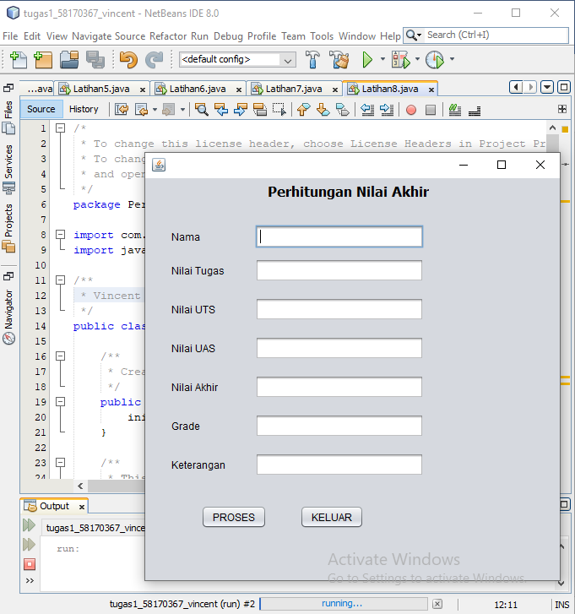

/*

* To change this license header, choose License Headers in Project Properties.

* To change this template file, choose Tools | Templates

* and open the template in the editor.

*/

package Pertemuan14;

import com.sun.glass.events.KeyEvent;

import javax.swing.JOptionPane;

/**

* Vincent

*/

public class Latihan8 extends javax.swing.JFrame {

/**

* Creates new form Latihan8

*/

public Latihan8() {

initComponents();

}

/**

* This method is called from within the constructor to initialize the form.

* WARNING: Do NOT modify this code. The content of this method is always

* regenerated by the Form Editor.

*/

@SuppressWarnings("unchecked")

// <editor-fold defaultstate="collapsed" desc="Generated Code">//GEN-BEGIN:initComponents

private void initComponents() {

jLabel1 = new javax.swing.JLabel();

jLabel2 = new javax.swing.JLabel();

jLabel3 = new javax.swing.JLabel();

jLabel4 = new javax.swing.JLabel();

jLabel5 = new javax.swing.JLabel();

jLabel6 = new javax.swing.JLabel();

jLabel7 = new javax.swing.JLabel();

jLabel8 = new javax.swing.JLabel();

proses = new javax.swing.JButton();

keluar = new javax.swing.JButton();

namatxt = new javax.swing.JTextField();

uts = new javax.swing.JTextField();

tugas = new javax.swing.JTextField();

uas = new javax.swing.JTextField();

akhir = new javax.swing.JTextField();

grade = new javax.swing.JTextField();

ket = new javax.swing.JTextField();

setDefaultCloseOperation(javax.swing.WindowConstants.EXIT_ON_CLOSE);

jLabel1.setFont(new java.awt.Font("Tahoma", 1, 16)); // NOI18N

jLabel1.setText("Perhitungan Nilai Akhir");

jLabel2.setText("Nama");

jLabel3.setText("Nilai Tugas");

jLabel4.setText("Nilai UTS");

jLabel5.setText("Nilai UAS");

jLabel6.setText("Nilai Akhir");

jLabel7.setText("Grade");

jLabel8.setText("Keterangan");

proses.setText("PROSES");

proses.addActionListener(new java.awt.event.ActionListener() {

public void actionPerformed(java.awt.event.ActionEvent evt) {

prosesActionPerformed(evt);

}

});

keluar.setText("KELUAR");

keluar.addActionListener(new java.awt.event.ActionListener() {

public void actionPerformed(java.awt.event.ActionEvent evt) {

keluarActionPerformed(evt);

}

});

uts.addKeyListener(new java.awt.event.KeyAdapter() {

public void keyTyped(java.awt.event.KeyEvent evt) {

utsKeyTyped(evt);

}

});

tugas.addKeyListener(new java.awt.event.KeyAdapter() {

public void keyTyped(java.awt.event.KeyEvent evt) {

tugasKeyTyped(evt);

}

});

uas.addKeyListener(new java.awt.event.KeyAdapter() {

public void keyTyped(java.awt.event.KeyEvent evt) {

uasKeyTyped(evt);

}

});

grade.addActionListener(new java.awt.event.ActionListener() {

public void actionPerformed(java.awt.event.ActionEvent evt) {

gradeActionPerformed(evt);

}

});

javax.swing.GroupLayout layout = new javax.swing.GroupLayout(getContentPane());

getContentPane().setLayout(layout);

layout.setHorizontalGroup(

layout.createParallelGroup(javax.swing.GroupLayout.Alignment.LEADING)

.addGroup(layout.createSequentialGroup()

.addGroup(layout.createParallelGroup(javax.swing.GroupLayout.Alignment.LEADING)

.addGroup(layout.createSequentialGroup()

.addGap(31, 31, 31)

.addGroup(layout.createParallelGroup(javax.swing.GroupLayout.Alignment.LEADING)

.addComponent(jLabel3)

.addComponent(jLabel2)

.addComponent(jLabel4)

.addComponent(jLabel5)

.addComponent(jLabel6)

.addComponent(jLabel7)

.addComponent(jLabel8))

.addGap(35, 35, 35)

.addGroup(layout.createParallelGroup(javax.swing.GroupLayout.Alignment.LEADING, false)

.addComponent(namatxt)

.addComponent(uts)

.addComponent(tugas)

.addComponent(uas, javax.swing.GroupLayout.DEFAULT_SIZE, 200, Short.MAX_VALUE)

.addComponent(akhir)

.addComponent(grade)

.addComponent(ket)))

.addGroup(layout.createSequentialGroup()

.addGap(66, 66, 66)

.addComponent(proses)

.addGap(39, 39, 39)

.addComponent(keluar)))

.addContainerGap(javax.swing.GroupLayout.DEFAULT_SIZE, Short.MAX_VALUE))

.addGroup(javax.swing.GroupLayout.Alignment.TRAILING, layout.createSequentialGroup()

.addGap(0, 145, Short.MAX_VALUE)

.addComponent(jLabel1)

.addGap(155, 155, 155))

);

layout.setVerticalGroup(

layout.createParallelGroup(javax.swing.GroupLayout.Alignment.LEADING)

.addGroup(layout.createSequentialGroup()

.addContainerGap()

.addComponent(jLabel1)

.addGap(29, 29, 29)

.addGroup(layout.createParallelGroup(javax.swing.GroupLayout.Alignment.BASELINE)

.addComponent(jLabel2)

.addComponent(namatxt, javax.swing.GroupLayout.PREFERRED_SIZE, javax.swing.GroupLayout.DEFAULT_SIZE, javax.swing.GroupLayout.PREFERRED_SIZE))

.addPreferredGap(javax.swing.LayoutStyle.ComponentPlacement.UNRELATED)

.addGroup(layout.createParallelGroup(javax.swing.GroupLayout.Alignment.BASELINE)

.addComponent(jLabel3)

.addComponent(tugas, javax.swing.GroupLayout.PREFERRED_SIZE, javax.swing.GroupLayout.DEFAULT_SIZE, javax.swing.GroupLayout.PREFERRED_SIZE))

.addGap(18, 18, 18)

.addGroup(layout.createParallelGroup(javax.swing.GroupLayout.Alignment.BASELINE)

.addComponent(jLabel4)

.addComponent(uts, javax.swing.GroupLayout.PREFERRED_SIZE, javax.swing.GroupLayout.DEFAULT_SIZE, javax.swing.GroupLayout.PREFERRED_SIZE))

.addGap(18, 18, 18)

.addGroup(layout.createParallelGroup(javax.swing.GroupLayout.Alignment.BASELINE)

.addComponent(jLabel5)

.addComponent(uas, javax.swing.GroupLayout.PREFERRED_SIZE, javax.swing.GroupLayout.DEFAULT_SIZE, javax.swing.GroupLayout.PREFERRED_SIZE))

.addGap(18, 18, 18)

.addGroup(layout.createParallelGroup(javax.swing.GroupLayout.Alignment.BASELINE)

.addComponent(jLabel6)

.addComponent(akhir, javax.swing.GroupLayout.PREFERRED_SIZE, javax.swing.GroupLayout.DEFAULT_SIZE, javax.swing.GroupLayout.PREFERRED_SIZE))

.addGap(18, 18, 18)

.addGroup(layout.createParallelGroup(javax.swing.GroupLayout.Alignment.BASELINE)

.addComponent(jLabel7)

.addComponent(grade, javax.swing.GroupLayout.PREFERRED_SIZE, javax.swing.GroupLayout.DEFAULT_SIZE, javax.swing.GroupLayout.PREFERRED_SIZE))

.addGap(18, 18, 18)

.addGroup(layout.createParallelGroup(javax.swing.GroupLayout.Alignment.BASELINE)

.addComponent(jLabel8)

.addComponent(ket, javax.swing.GroupLayout.PREFERRED_SIZE, javax.swing.GroupLayout.DEFAULT_SIZE, javax.swing.GroupLayout.PREFERRED_SIZE))

.addGap(34, 34, 34)

.addGroup(layout.createParallelGroup(javax.swing.GroupLayout.Alignment.BASELINE)

.addComponent(proses)

.addComponent(keluar))

.addContainerGap(61, Short.MAX_VALUE))

);

pack();

}// </editor-fold>//GEN-END:initComponents

private void gradeActionPerformed(java.awt.event.ActionEvent evt) {//GEN-FIRST:event_gradeActionPerformed

// TODO add your handling code here:

}//GEN-LAST:event_gradeActionPerformed

private void prosesActionPerformed(java.awt.event.ActionEvent evt) {//GEN-FIRST:event_prosesActionPerformed

double ntugas = Double.parseDouble(tugas.getText());

double nuts = Double.parseDouble(uts.getText());

double nuas = Double.parseDouble(uas.getText());

double nakhir = (ntugas * 0.4) + (nuts * 0.3) + (nuas * 0.3);

akhir.setText(Double.toString(nakhir));

if (nakhir >= 80) {

grade.setText("A");

ket.setText("Lulus");

} else if (nakhir >= 70) {

grade.setText("B");

ket.setText("Lulus");

} else if (nakhir >= 56) {

grade.setText("C");

ket.setText("Lulus");

} else if (nakhir >= 40) {

grade.setText("D");

ket.setText("Tidak Lulus");

} else {

grade.setText("E");

ket.setText("Tidak Lulus");

}

}//GEN-LAST:event_prosesActionPerformed

private void keluarActionPerformed(java.awt.event.ActionEvent evt) {//GEN-FIRST:event_keluarActionPerformed

int balas = JOptionPane.showConfirmDialog(null, "Yakin ingin keluar ?", "Konfirmasi Keluar Aplikasi", JOptionPane.YES_NO_OPTION);

if (balas == JOptionPane.YES_OPTION) {

System.exit(0);

}

}//GEN-LAST:event_keluarActionPerformed

private void tugasKeyTyped(java.awt.event.KeyEvent evt) {//GEN-FIRST:event_tugasKeyTyped

char a = evt.getKeyChar();

if (!((Character.isDigit(a)

|| (a == KeyEvent.VK_BACKSPACE)

|| (a == KeyEvent.VK_DELETE)))) {

getToolkit().beep();

JOptionPane.showMessageDialog(null, "Masukan Hanya Berupa Angka!");

evt.consume();

}

}//GEN-LAST:event_tugasKeyTyped

private void utsKeyTyped(java.awt.event.KeyEvent evt) {//GEN-FIRST:event_utsKeyTyped

char a = evt.getKeyChar();

if (!((Character.isDigit(a)

|| (a == KeyEvent.VK_BACKSPACE)

|| (a == KeyEvent.VK_DELETE)))) {

getToolkit().beep();

JOptionPane.showMessageDialog(null, "Masukan Hanya Berupa Angka!");

evt.consume();

}

}//GEN-LAST:event_utsKeyTyped

private void uasKeyTyped(java.awt.event.KeyEvent evt) {//GEN-FIRST:event_uasKeyTyped

char a = evt.getKeyChar();

if (!((Character.isDigit(a)

|| (a == KeyEvent.VK_BACKSPACE)

|| (a == KeyEvent.VK_DELETE)))) {

getToolkit().beep();

JOptionPane.showMessageDialog(null, "Masukan Hanya Berupa Angka!");

evt.consume();

}

}//GEN-LAST:event_uasKeyTyped

/**

* @param args the command line arguments

*/

public static void main(String args[]) {

/* Set the Nimbus look and feel */

//<editor-fold defaultstate="collapsed" desc=" Look and feel setting code (optional) ">

/* If Nimbus (introduced in Java SE 6) is not available, stay with the default look and feel.

* For details see http://download.oracle.com/javase/tutorial/uiswing/lookandfeel/plaf.html

*/

try {

for (javax.swing.UIManager.LookAndFeelInfo info : javax.swing.UIManager.getInstalledLookAndFeels()) {

if ("Nimbus".equals(info.getName())) {

javax.swing.UIManager.setLookAndFeel(info.getClassName());

break;

}

}

} catch (ClassNotFoundException ex) {

java.util.logging.Logger.getLogger(Latihan8.class.getName()).log(java.util.logging.Level.SEVERE, null, ex);

} catch (InstantiationException ex) {

java.util.logging.Logger.getLogger(Latihan8.class.getName()).log(java.util.logging.Level.SEVERE, null, ex);

} catch (IllegalAccessException ex) {

java.util.logging.Logger.getLogger(Latihan8.class.getName()).log(java.util.logging.Level.SEVERE, null, ex);

} catch (javax.swing.UnsupportedLookAndFeelException ex) {

java.util.logging.Logger.getLogger(Latihan8.class.getName()).log(java.util.logging.Level.SEVERE, null, ex);

}

//</editor-fold>

/* Create and display the form */

java.awt.EventQueue.invokeLater(new Runnable() {

public void run() {

new Latihan8().setVisible(true);

}

});

}

// Variables declaration - do not modify//GEN-BEGIN:variables

private javax.swing.JTextField akhir;

private javax.swing.JTextField grade;

private javax.swing.JLabel jLabel1;

private javax.swing.JLabel jLabel2;

private javax.swing.JLabel jLabel3;

private javax.swing.JLabel jLabel4;

private javax.swing.JLabel jLabel5;

private javax.swing.JLabel jLabel6;

private javax.swing.JLabel jLabel7;

private javax.swing.JLabel jLabel8;

private javax.swing.JButton keluar;

private javax.swing.JTextField ket;

private javax.swing.JTextField namatxt;

private javax.swing.JButton proses;

private javax.swing.JTextField tugas;

private javax.swing.JTextField uas;

private javax.swing.JTextField uts;

// End of variables declaration//GEN-END:variables

}