PERTEMUAN 15

PEMROGRAMAN JAVA

Kasus 1

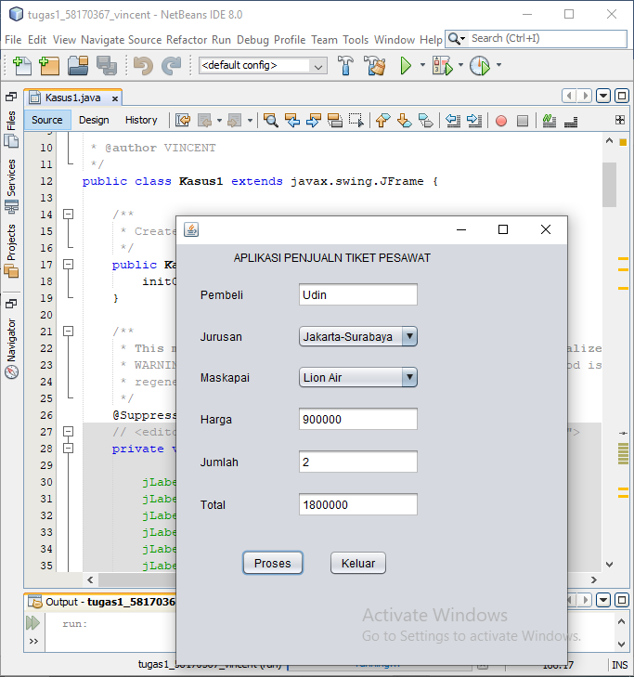

/*

* To change this license header, choose License Headers in Project Properties.

* To change this template file, choose Tools | Templates

* and open the template in the editor.

*/

package Pertemuan15;

/**

*

* @author VINCENT

*/

public class Kasus1 extends javax.swing.JFrame {

/**

* Creates new form Kasus1

*/

public Kasus1() {

initComponents();

}

/**

* This method is called from within the constructor to initialize the form.

* WARNING: Do NOT modify this code. The content of this method is always

* regenerated by the Form Editor.

*/

@SuppressWarnings("unchecked")

// <editor-fold defaultstate="collapsed" desc="Generated Code">

private void initComponents() {

jLabel1 = new javax.swing.JLabel();

jLabel2 = new javax.swing.JLabel();

jLabel3 = new javax.swing.JLabel();

jLabel4 = new javax.swing.JLabel();

jLabel5 = new javax.swing.JLabel();

jLabel6 = new javax.swing.JLabel();

jLabel7 = new javax.swing.JLabel();

btproses = new javax.swing.JButton();

btkeluar = new javax.swing.JButton();

jTextField1 = new javax.swing.JTextField();

cjurusan = new javax.swing.JComboBox();

cmaskapai = new javax.swing.JComboBox();

tharga = new javax.swing.JTextField();

tjumlah = new javax.swing.JTextField();

ttotal = new javax.swing.JTextField();

setDefaultCloseOperation(javax.swing.WindowConstants.EXIT_ON_CLOSE);

jLabel1.setText("APLIKASI PENJUALN TIKET PESAWAT");

jLabel2.setText("Pembeli");

jLabel3.setText("Jurusan");

jLabel4.setText("Maskapai");

jLabel5.setText("Harga");

jLabel6.setText("Jumlah");

jLabel7.setText("Total");

btproses.setText("Proses");

btproses.addActionListener(new java.awt.event.ActionListener() {

public void actionPerformed(java.awt.event.ActionEvent evt) {

btprosesActionPerformed(evt);

}

});

btkeluar.setText("Keluar");

btkeluar.addActionListener(new java.awt.event.ActionListener() {

public void actionPerformed(java.awt.event.ActionEvent evt) {

btkeluarActionPerformed(evt);

}

});

cjurusan.setModel(new javax.swing.DefaultComboBoxModel(new String[] { "Jakarta-Medan", "Jakarta-Surabaya" }));

cjurusan.setName("cjurusan"); // NOI18N

cmaskapai.setModel(new javax.swing.DefaultComboBoxModel(new String[] { "Garuda Indonesia", "Lion Air", "Air Asia" }));

cmaskapai.setName("cmaskapai"); // NOI18N

cmaskapai.addActionListener(new java.awt.event.ActionListener() {

public void actionPerformed(java.awt.event.ActionEvent evt) {

cmaskapaiActionPerformed(evt);

}

});

tharga.setName("tharga"); // NOI18N

javax.swing.GroupLayout layout = new javax.swing.GroupLayout(getContentPane());

getContentPane().setLayout(layout);

layout.setHorizontalGroup(

layout.createParallelGroup(javax.swing.GroupLayout.Alignment.LEADING)

.addGroup(layout.createSequentialGroup()

.addGroup(layout.createParallelGroup(javax.swing.GroupLayout.Alignment.LEADING)

.addGroup(layout.createSequentialGroup()

.addGap(62, 62, 62)

.addComponent(jLabel1))

.addGroup(layout.createSequentialGroup()

.addGap(26, 26, 26)

.addGroup(layout.createParallelGroup(javax.swing.GroupLayout.Alignment.LEADING)

.addComponent(jLabel2)

.addComponent(jLabel3)

.addComponent(jLabel4)

.addComponent(jLabel5)

.addComponent(jLabel6)

.addComponent(jLabel7))

.addGap(51, 51, 51)

.addGroup(layout.createParallelGroup(javax.swing.GroupLayout.Alignment.LEADING, false)

.addComponent(jTextField1)

.addComponent(cjurusan, 0, 121, Short.MAX_VALUE)

.addComponent(cmaskapai, 0, javax.swing.GroupLayout.DEFAULT_SIZE, Short.MAX_VALUE)

.addComponent(tharga)

.addComponent(tjumlah)

.addComponent(ttotal)))

.addGroup(layout.createSequentialGroup()

.addGap(70, 70, 70)

.addComponent(btproses)

.addGap(26, 26, 26)

.addComponent(btkeluar)))

.addContainerGap(147, Short.MAX_VALUE))

);

layout.setVerticalGroup(

layout.createParallelGroup(javax.swing.GroupLayout.Alignment.LEADING)

.addGroup(layout.createSequentialGroup()

.addContainerGap()

.addComponent(jLabel1)

.addGap(18, 18, 18)

.addGroup(layout.createParallelGroup(javax.swing.GroupLayout.Alignment.BASELINE)

.addComponent(jLabel2)

.addComponent(jTextField1, javax.swing.GroupLayout.PREFERRED_SIZE, javax.swing.GroupLayout.DEFAULT_SIZE, javax.swing.GroupLayout.PREFERRED_SIZE))

.addGap(18, 18, 18)

.addGroup(layout.createParallelGroup(javax.swing.GroupLayout.Alignment.BASELINE)

.addComponent(jLabel3)

.addComponent(cjurusan, javax.swing.GroupLayout.PREFERRED_SIZE, javax.swing.GroupLayout.DEFAULT_SIZE, javax.swing.GroupLayout.PREFERRED_SIZE))

.addGap(18, 18, 18)

.addGroup(layout.createParallelGroup(javax.swing.GroupLayout.Alignment.BASELINE)

.addComponent(jLabel4)

.addComponent(cmaskapai, javax.swing.GroupLayout.PREFERRED_SIZE, javax.swing.GroupLayout.DEFAULT_SIZE, javax.swing.GroupLayout.PREFERRED_SIZE))

.addGap(18, 18, 18)

.addGroup(layout.createParallelGroup(javax.swing.GroupLayout.Alignment.BASELINE)

.addComponent(jLabel5)

.addComponent(tharga, javax.swing.GroupLayout.PREFERRED_SIZE, javax.swing.GroupLayout.DEFAULT_SIZE, javax.swing.GroupLayout.PREFERRED_SIZE))

.addGap(18, 18, 18)

.addGroup(layout.createParallelGroup(javax.swing.GroupLayout.Alignment.BASELINE)

.addComponent(jLabel6)

.addComponent(tjumlah, javax.swing.GroupLayout.PREFERRED_SIZE, javax.swing.GroupLayout.DEFAULT_SIZE, javax.swing.GroupLayout.PREFERRED_SIZE))

.addGap(18, 18, 18)

.addGroup(layout.createParallelGroup(javax.swing.GroupLayout.Alignment.BASELINE)

.addComponent(jLabel7)

.addComponent(ttotal, javax.swing.GroupLayout.PREFERRED_SIZE, javax.swing.GroupLayout.DEFAULT_SIZE, javax.swing.GroupLayout.PREFERRED_SIZE))

.addGap(35, 35, 35)

.addGroup(layout.createParallelGroup(javax.swing.GroupLayout.Alignment.BASELINE)

.addComponent(btproses)

.addComponent(btkeluar))

.addContainerGap(96, Short.MAX_VALUE))

);

pack();

}// </editor-fold>

private void btprosesActionPerformed(java.awt.event.ActionEvent evt) {

// TODO add your handling code here:

int a = Integer.parseInt(tharga.getText());

int b = Integer.parseInt(tjumlah.getText());

int c = a * b;

ttotal.setText(Integer.toString(c));

}

private void cmaskapaiActionPerformed(java.awt.event.ActionEvent evt) {

// TODO add your handling code here:

if (cjurusan.getSelectedItem().equals("Jakarta-Medan")) {

if (cmaskapai.getSelectedItem().equals("Garuda Indonesia")) {

tharga.setText("1500000");

} else if (cmaskapai.getSelectedItem().equals("Lion Air")) {

tharga.setText("1300000");

} else if (cmaskapai.getSelectedItem().equals("Air Asia")) {

tharga.setText("1100000");

}

} else if (cjurusan.getSelectedItem().equals("Jakarta-Surabaya")) {

if (cmaskapai.getSelectedItem().equals("Garuda indonesia")) {

tharga.setText("1000000");

} else if (cmaskapai.getSelectedItem().equals("Lion Air")) {

tharga.setText("900000");

} else if (cmaskapai.getSelectedItem().equals("Air Asia")) {

tharga.setText("850000");

}

}

}

private void btkeluarActionPerformed(java.awt.event.ActionEvent evt) {

// TODO add your handling code here:

System.exit(0);

}

/**

* @param args the command line arguments

*/

public static void main(String args[]) {

/* Set the Nimbus look and feel */

//<editor-fold defaultstate="collapsed" desc=" Look and feel setting code (optional) ">

/* If Nimbus (introduced in Java SE 6) is not available, stay with the default look and feel.

* For details see http://download.oracle.com/javase/tutorial/uiswing/lookandfeel/plaf.html

*/

try {

for (javax.swing.UIManager.LookAndFeelInfo info : javax.swing.UIManager.getInstalledLookAndFeels()) {

if ("Nimbus".equals(info.getName())) {

javax.swing.UIManager.setLookAndFeel(info.getClassName());

break;

}

}

} catch (ClassNotFoundException ex) {

java.util.logging.Logger.getLogger(Kasus1.class.getName()).log(java.util.logging.Level.SEVERE, null, ex);

} catch (InstantiationException ex) {

java.util.logging.Logger.getLogger(Kasus1.class.getName()).log(java.util.logging.Level.SEVERE, null, ex);

} catch (IllegalAccessException ex) {

java.util.logging.Logger.getLogger(Kasus1.class.getName()).log(java.util.logging.Level.SEVERE, null, ex);

} catch (javax.swing.UnsupportedLookAndFeelException ex) {

java.util.logging.Logger.getLogger(Kasus1.class.getName()).log(java.util.logging.Level.SEVERE, null, ex);

}

//</editor-fold>

/* Create and display the form */

java.awt.EventQueue.invokeLater(new Runnable() {

public void run() {

new Kasus1().setVisible(true);

}

});

}

// Variables declaration - do not modify

private javax.swing.JButton btkeluar;

private javax.swing.JButton btproses;

private javax.swing.JComboBox cjurusan;

private javax.swing.JComboBox cmaskapai;

private javax.swing.JLabel jLabel1;

private javax.swing.JLabel jLabel2;

private javax.swing.JLabel jLabel3;

private javax.swing.JLabel jLabel4;

private javax.swing.JLabel jLabel5;

private javax.swing.JLabel jLabel6;

private javax.swing.JLabel jLabel7;

private javax.swing.JTextField jTextField1;

private javax.swing.JTextField tharga;

private javax.swing.JTextField tjumlah;

private javax.swing.JTextField ttotal;

// End of variables declaration

}

Kasus 3

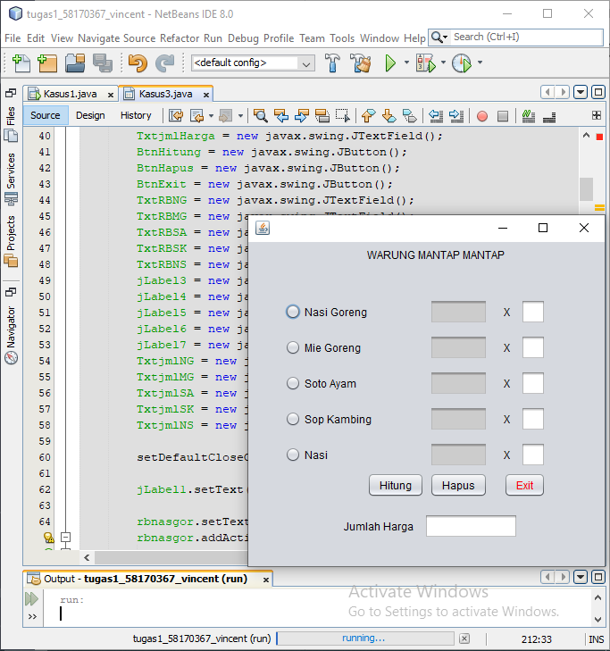

/*

* To change this license header, choose License Headers in Project Properties.

* To change this template file, choose Tools | Templates

* and open the template in the editor.

*/

package Pertemuan15;

/**

*

* @author VINCENT

*/

public class Kasus3 extends javax.swing.JFrame {

/**

* Creates new form Kasus3

*/

public Kasus3() {

initComponents();

}

/**

* This method is called from within the constructor to initialize the form.

* WARNING: Do NOT modify this code. The content of this method is always

* regenerated by the Form Editor.

*/

@SuppressWarnings("unchecked")

// <editor-fold defaultstate="collapsed" desc="Generated Code">

private void initComponents() {

buttonGroup1 = new javax.swing.ButtonGroup();

buttonGroup2 = new javax.swing.ButtonGroup();

buttonGroup3 = new javax.swing.ButtonGroup();

jLabel1 = new javax.swing.JLabel();

rbnasgor = new javax.swing.JRadioButton();

rbmie = new javax.swing.JRadioButton();

rbsoto = new javax.swing.JRadioButton();

rbsop = new javax.swing.JRadioButton();

rbnasi = new javax.swing.JRadioButton();

jLabel2 = new javax.swing.JLabel();

TxtjmlHarga = new javax.swing.JTextField();

BtnHitung = new javax.swing.JButton();

BtnHapus = new javax.swing.JButton();

BtnExit = new javax.swing.JButton();

TxtRBNG = new javax.swing.JTextField();

TxtRBMG = new javax.swing.JTextField();

TxtRBSA = new javax.swing.JTextField();

TxtRBSK = new javax.swing.JTextField();

TxtRBNS = new javax.swing.JTextField();

jLabel3 = new javax.swing.JLabel();

jLabel4 = new javax.swing.JLabel();

jLabel5 = new javax.swing.JLabel();

jLabel6 = new javax.swing.JLabel();

jLabel7 = new javax.swing.JLabel();

TxtjmlNG = new javax.swing.JTextField();

TxtjmlMG = new javax.swing.JTextField();

TxtjmlSA = new javax.swing.JTextField();

TxtjmlSK = new javax.swing.JTextField();

TxtjmlNS = new javax.swing.JTextField();

setDefaultCloseOperation(javax.swing.WindowConstants.EXIT_ON_CLOSE);

jLabel1.setText("WARUNG MANTAP MANTAP");

rbnasgor.setText("Nasi Goreng");

rbnasgor.addActionListener(new java.awt.event.ActionListener() {

public void actionPerformed(java.awt.event.ActionEvent evt) {

rbnasgorActionPerformed(evt);

}

});

rbmie.setText("Mie Goreng");

rbmie.addActionListener(new java.awt.event.ActionListener() {

public void actionPerformed(java.awt.event.ActionEvent evt) {

rbmieActionPerformed(evt);

}

});

rbsoto.setText("Soto Ayam");

rbsoto.addActionListener(new java.awt.event.ActionListener() {

public void actionPerformed(java.awt.event.ActionEvent evt) {

rbsotoActionPerformed(evt);

}

});

rbsop.setText("Sop Kambing");

rbsop.addActionListener(new java.awt.event.ActionListener() {

public void actionPerformed(java.awt.event.ActionEvent evt) {

rbsopActionPerformed(evt);

}

});

rbnasi.setText("Nasi");

rbnasi.addActionListener(new java.awt.event.ActionListener() {

public void actionPerformed(java.awt.event.ActionEvent evt) {

rbnasiActionPerformed(evt);

}

});

jLabel2.setText("Jumlah Harga");

BtnHitung.setText("Hitung");

BtnHitung.addActionListener(new java.awt.event.ActionListener() {

public void actionPerformed(java.awt.event.ActionEvent evt) {

BtnHitungActionPerformed(evt);

}

});

BtnHapus.setText("Hapus");

BtnHapus.addActionListener(new java.awt.event.ActionListener() {

public void actionPerformed(java.awt.event.ActionEvent evt) {

BtnHapusActionPerformed(evt);

}

});

BtnExit.setForeground(new java.awt.Color(255, 0, 0));

BtnExit.setText("Exit");

BtnExit.addActionListener(new java.awt.event.ActionListener() {

public void actionPerformed(java.awt.event.ActionEvent evt) {

BtnExitActionPerformed(evt);

}

});

TxtRBNG.setBackground(new java.awt.Color(204, 204, 204));

TxtRBMG.setBackground(new java.awt.Color(204, 204, 204));

TxtRBMG.addActionListener(new java.awt.event.ActionListener() {

public void actionPerformed(java.awt.event.ActionEvent evt) {

TxtRBMGActionPerformed(evt);

}

});

TxtRBSA.setBackground(new java.awt.Color(204, 204, 204));

TxtRBSK.setBackground(new java.awt.Color(204, 204, 204));

TxtRBNS.setBackground(new java.awt.Color(204, 204, 204));

jLabel3.setText("X");

jLabel4.setText("X");

jLabel5.setText("X");

jLabel6.setText("X");

jLabel7.setText("X");

javax.swing.GroupLayout layout = new javax.swing.GroupLayout(getContentPane());

getContentPane().setLayout(layout);

layout.setHorizontalGroup(

layout.createParallelGroup(javax.swing.GroupLayout.Alignment.LEADING)

.addGroup(layout.createSequentialGroup()

.addGroup(layout.createParallelGroup(javax.swing.GroupLayout.Alignment.LEADING)

.addGroup(layout.createSequentialGroup()

.addGap(41, 41, 41)

.addGroup(layout.createParallelGroup(javax.swing.GroupLayout.Alignment.LEADING)

.addComponent(rbmie)

.addComponent(rbnasgor)

.addComponent(rbsoto)

.addComponent(rbsop)

.addComponent(rbnasi)))

.addGroup(layout.createSequentialGroup()

.addGap(107, 107, 107)

.addComponent(jLabel2)

.addPreferredGap(javax.swing.LayoutStyle.ComponentPlacement.UNRELATED)

.addComponent(TxtjmlHarga, javax.swing.GroupLayout.PREFERRED_SIZE, 105, javax.swing.GroupLayout.PREFERRED_SIZE))

.addGroup(layout.createSequentialGroup()

.addGap(133, 133, 133)

.addGroup(layout.createParallelGroup(javax.swing.GroupLayout.Alignment.LEADING)

.addComponent(jLabel1)

.addGroup(layout.createSequentialGroup()

.addComponent(BtnHitung)

.addPreferredGap(javax.swing.LayoutStyle.ComponentPlacement.RELATED)

.addGroup(layout.createParallelGroup(javax.swing.GroupLayout.Alignment.LEADING, false)

.addComponent(TxtRBNS)

.addComponent(TxtRBSK)

.addComponent(TxtRBSA)

.addComponent(TxtRBNG)

.addComponent(TxtRBMG)

.addComponent(BtnHapus, javax.swing.GroupLayout.DEFAULT_SIZE, javax.swing.GroupLayout.DEFAULT_SIZE, Short.MAX_VALUE))

.addGap(18, 18, 18)

.addGroup(layout.createParallelGroup(javax.swing.GroupLayout.Alignment.LEADING, false)

.addComponent(BtnExit)

.addGroup(layout.createSequentialGroup()

.addComponent(jLabel3)

.addPreferredGap(javax.swing.LayoutStyle.ComponentPlacement.UNRELATED)

.addComponent(TxtjmlNG))

.addGroup(layout.createSequentialGroup()

.addComponent(jLabel4)

.addPreferredGap(javax.swing.LayoutStyle.ComponentPlacement.UNRELATED)

.addComponent(TxtjmlMG))

.addGroup(layout.createSequentialGroup()

.addComponent(jLabel5)

.addPreferredGap(javax.swing.LayoutStyle.ComponentPlacement.UNRELATED)

.addComponent(TxtjmlSA))

.addGroup(layout.createSequentialGroup()

.addComponent(jLabel6)

.addPreferredGap(javax.swing.LayoutStyle.ComponentPlacement.UNRELATED)

.addComponent(TxtjmlSK))

.addGroup(layout.createSequentialGroup()

.addComponent(jLabel7)

.addPreferredGap(javax.swing.LayoutStyle.ComponentPlacement.UNRELATED)

.addComponent(TxtjmlNS)))))))

.addContainerGap(66, Short.MAX_VALUE))

);

layout.setVerticalGroup(

layout.createParallelGroup(javax.swing.GroupLayout.Alignment.LEADING)

.addGroup(layout.createSequentialGroup()

.addContainerGap()

.addComponent(jLabel1)

.addGap(42, 42, 42)

.addGroup(layout.createParallelGroup(javax.swing.GroupLayout.Alignment.BASELINE)

.addComponent(rbnasgor)

.addComponent(TxtRBNG, javax.swing.GroupLayout.PREFERRED_SIZE, javax.swing.GroupLayout.DEFAULT_SIZE, javax.swing.GroupLayout.PREFERRED_SIZE)

.addComponent(jLabel3)

.addComponent(TxtjmlNG, javax.swing.GroupLayout.PREFERRED_SIZE, javax.swing.GroupLayout.DEFAULT_SIZE, javax.swing.GroupLayout.PREFERRED_SIZE))

.addPreferredGap(javax.swing.LayoutStyle.ComponentPlacement.UNRELATED)

.addGroup(layout.createParallelGroup(javax.swing.GroupLayout.Alignment.BASELINE)

.addComponent(rbmie)

.addComponent(TxtRBMG, javax.swing.GroupLayout.PREFERRED_SIZE, javax.swing.GroupLayout.DEFAULT_SIZE, javax.swing.GroupLayout.PREFERRED_SIZE)

.addComponent(jLabel4)

.addComponent(TxtjmlMG, javax.swing.GroupLayout.PREFERRED_SIZE, javax.swing.GroupLayout.DEFAULT_SIZE, javax.swing.GroupLayout.PREFERRED_SIZE))

.addPreferredGap(javax.swing.LayoutStyle.ComponentPlacement.UNRELATED)

.addGroup(layout.createParallelGroup(javax.swing.GroupLayout.Alignment.BASELINE)

.addComponent(rbsoto)

.addComponent(TxtRBSA, javax.swing.GroupLayout.PREFERRED_SIZE, javax.swing.GroupLayout.DEFAULT_SIZE, javax.swing.GroupLayout.PREFERRED_SIZE)

.addComponent(jLabel5)

.addComponent(TxtjmlSA, javax.swing.GroupLayout.PREFERRED_SIZE, javax.swing.GroupLayout.DEFAULT_SIZE, javax.swing.GroupLayout.PREFERRED_SIZE))

.addPreferredGap(javax.swing.LayoutStyle.ComponentPlacement.UNRELATED)

.addGroup(layout.createParallelGroup(javax.swing.GroupLayout.Alignment.BASELINE)

.addComponent(rbsop)

.addComponent(TxtRBSK, javax.swing.GroupLayout.PREFERRED_SIZE, javax.swing.GroupLayout.DEFAULT_SIZE, javax.swing.GroupLayout.PREFERRED_SIZE)

.addComponent(jLabel6)

.addComponent(TxtjmlSK, javax.swing.GroupLayout.PREFERRED_SIZE, javax.swing.GroupLayout.DEFAULT_SIZE, javax.swing.GroupLayout.PREFERRED_SIZE))

.addPreferredGap(javax.swing.LayoutStyle.ComponentPlacement.UNRELATED)

.addGroup(layout.createParallelGroup(javax.swing.GroupLayout.Alignment.BASELINE)

.addComponent(rbnasi)

.addComponent(TxtRBNS, javax.swing.GroupLayout.PREFERRED_SIZE, javax.swing.GroupLayout.DEFAULT_SIZE, javax.swing.GroupLayout.PREFERRED_SIZE)

.addComponent(jLabel7)

.addComponent(TxtjmlNS, javax.swing.GroupLayout.PREFERRED_SIZE, javax.swing.GroupLayout.DEFAULT_SIZE, javax.swing.GroupLayout.PREFERRED_SIZE))

.addPreferredGap(javax.swing.LayoutStyle.ComponentPlacement.RELATED, 6, Short.MAX_VALUE)

.addGroup(layout.createParallelGroup(javax.swing.GroupLayout.Alignment.BASELINE)

.addComponent(BtnHitung)

.addComponent(BtnHapus)

.addComponent(BtnExit))

.addGap(18, 18, 18)

.addGroup(layout.createParallelGroup(javax.swing.GroupLayout.Alignment.BASELINE)

.addComponent(jLabel2)

.addComponent(TxtjmlHarga, javax.swing.GroupLayout.PREFERRED_SIZE, javax.swing.GroupLayout.DEFAULT_SIZE, javax.swing.GroupLayout.PREFERRED_SIZE))

.addGap(31, 31, 31))

);

pack();

}// </editor-fold>

private void BtnExitActionPerformed(java.awt.event.ActionEvent evt) {

// TODO add your handling code here:

int X= JOptionPane.showConfirmDialog(null, "Keluar Program", "Exit" , JOptionPane. YES_NO_OPTION, JOptionPane QUESTION_MESSAGE);

if (X==JOptionPane. YES_OPTION) {

dispose();

}

}

private void rbnasgorActionPerformed(java.awt.event.ActionEvent evt) {

// TODO add your handling code here:

int nasigoreng = 15000;

if (rbnasgor.isSelected()) {

TxtRBNG.setText("" + rbnasgor.getText());

TxtRBNG.setText("" + nasigoreng);

} else {

TxtRBNG.setText("");

}

}

private void rbmieActionPerformed(java.awt.event.ActionEvent evt) {

// TODO add your handling code here:

int miegoreng = 15000;

if (rbmie.isSelected()) {

rbmie.setText("" + rbmie.getText());

rbmie.setText("" + miegoreng);

} else {

rbmie.setText("");

}

}

private void TxtRBMGActionPerformed(java.awt.event.ActionEvent evt) {

// TODO add your handling code here:

}

private void rbsotoActionPerformed(java.awt.event.ActionEvent evt) {

// TODO add your handling code here:

int sotoayam = 15000;

if (rbsoto.isSelected()) {

TxtRBSA.setText("" + rbsoto.getText());

TxtRBSA.setText("" + sotoayam);

} else {

TxtRBSA.setText("");

}

}

private void rbsopActionPerformed(java.awt.event.ActionEvent evt) {

// TODO add your handling code here:

int sopkambing = 25000;

if (rbsop.isSelected()) {

TxtRBSK.setText("" + rbsop.getText());

TxtRBSK.setText("" + sopkambing);

} else {

TxtRBSK.setText("");

}

}

private void rbnasiActionPerformed(java.awt.event.ActionEvent evt) {

// TODO add your handling code here:

int nasi = 5000;

if (rbnasi.isSelected()) {

TxtRBNS.setText("" + rbnasi.getText());

TxtRBNS.setText("" + nasi);

} else {

TxtRBNS.setText("");

}

}

private void BtnHitungActionPerformed(java.awt.event.ActionEvent evt) {

// TODO add your handling code here:

int total = 0;

if (rbnasgor.isSelected()) {

String NG = TxtjmlNG.getText();

int jmlNG = Integer.parseInt(NG);

int HargaNG=jmlNG * 15000;

total = total + HargaNG;

}

if (rbmie.isSelected()) {

String MG = TxtjmlNG.getText();

int jm1MG = Integer.parseInt(MG);

int HargaMG= jmlMG * 15000;

total = total + HargaMG;

}

if (rbsoto.isSelected()) {

String SA = TxtjmlSA.getText();

int jmlSA = Integer.parseInt(SA);

int HargaSA = jmlSA * 15000;

total = total + HargaSA;

}

if (rbsop.isSelected()) {

String SK = TxtjmlSK.getText();

int jmlSK = Integer.parseInt(SK);

int HargaSK = jmlSK * 25000;

total = total + HargaSK;

}

if (rbnasi.isSelected()) {

String NS = TxtjmlNS.getText();

int jmlNS = Integer.parseInt(NS);

int HargaNS = jmlNS * 5000;

total = total + HargaNS;

}

TxtjmlHarga.setText("" + total);

}

private void BtnHapusActionPerformed(java.awt.event.ActionEvent evt) {

// TODO add your handling code here:

TxtjmlNG.setEditable(false);

TxtjmlNG.setText("");

TxtjmlMG.setEditable(false);

TxtjmlMG.setText("");

TxtjmlSA.setEditable(false);

TxtjmlSA.setText("");

TxtjmlSK.setEditable(false);

TxtjmlSK.setText("");

TxtjmlNS.setEditable(false);

TxtjmlNS.setText("");

TxtjmlHarga.setText("");

}

/**

* @param args the command line arguments

*/

public static void main(String args[]) {

/* Set the Nimbus look and feel */

//<editor-fold defaultstate="collapsed" desc=" Look and feel setting code (optional) ">

/* If Nimbus (introduced in Java SE 6) is not available, stay with the default look and feel.

* For details see http://download.oracle.com/javase/tutorial/uiswing/lookandfeel/plaf.html

*/

try {

for (javax.swing.UIManager.LookAndFeelInfo info : javax.swing.UIManager.getInstalledLookAndFeels()) {

if ("Nimbus".equals(info.getName())) {

javax.swing.UIManager.setLookAndFeel(info.getClassName());

break;

}

}

} catch (ClassNotFoundException ex) {

java.util.logging.Logger.getLogger(Kasus3.class.getName()).log(java.util.logging.Level.SEVERE, null, ex);

} catch (InstantiationException ex) {

java.util.logging.Logger.getLogger(Kasus3.class.getName()).log(java.util.logging.Level.SEVERE, null, ex);

} catch (IllegalAccessException ex) {

java.util.logging.Logger.getLogger(Kasus3.class.getName()).log(java.util.logging.Level.SEVERE, null, ex);

} catch (javax.swing.UnsupportedLookAndFeelException ex) {

java.util.logging.Logger.getLogger(Kasus3.class.getName()).log(java.util.logging.Level.SEVERE, null, ex);

}

//</editor-fold>

/* Create and display the form */

java.awt.EventQueue.invokeLater(new Runnable() {

public void run() {

new Kasus3().setVisible(true);

}

});

}

// Variables declaration - do not modify

private javax.swing.JButton BtnExit;

private javax.swing.JButton BtnHapus;

private javax.swing.JButton BtnHitung;

private javax.swing.JTextField TxtRBMG;

private javax.swing.JTextField TxtRBNG;

private javax.swing.JTextField TxtRBNS;

private javax.swing.JTextField TxtRBSA;

private javax.swing.JTextField TxtRBSK;

private javax.swing.JTextField TxtjmlHarga;

private javax.swing.JTextField TxtjmlMG;

private javax.swing.JTextField TxtjmlNG;

private javax.swing.JTextField TxtjmlNS;

private javax.swing.JTextField TxtjmlSA;

private javax.swing.JTextField TxtjmlSK;

private javax.swing.ButtonGroup buttonGroup1;

private javax.swing.ButtonGroup buttonGroup2;

private javax.swing.ButtonGroup buttonGroup3;

private javax.swing.JLabel jLabel1;

private javax.swing.JLabel jLabel2;

private javax.swing.JLabel jLabel3;

private javax.swing.JLabel jLabel4;

private javax.swing.JLabel jLabel5;

private javax.swing.JLabel jLabel6;

private javax.swing.JLabel jLabel7;

private javax.swing.JRadioButton rbmie;

private javax.swing.JRadioButton rbnasgor;

private javax.swing.JRadioButton rbnasi;

private javax.swing.JRadioButton rbsop;

private javax.swing.JRadioButton rbsoto;

// End of variables declaration

}

Kasus 5

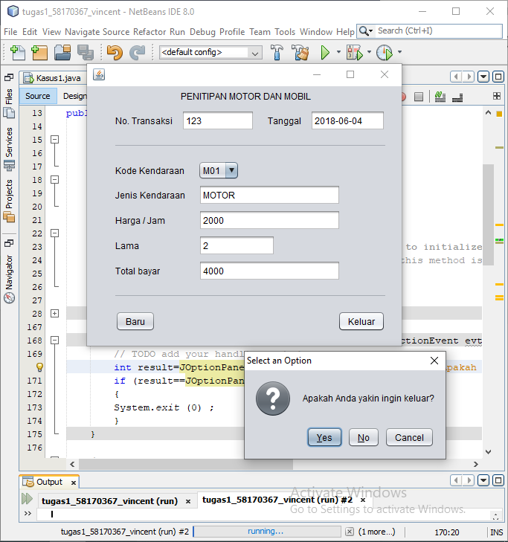

/*

* To change this license header, choose License Headers in Project Properties.

* To change this template file, choose Tools | Templates

* and open the template in the editor.

*/

package Pertemuan15;

import javax.swing.JOptionPane;

/**

*

* @author VINCENT

*/

public class Kasus5 extends javax.swing.JFrame {

/**

* Creates new form Kasus5

*/

public Kasus5() {

initComponents();

}

/**

* This method is called from within the constructor to initialize the form.

* WARNING: Do NOT modify this code. The content of this method is always

* regenerated by the Form Editor.

*/

@SuppressWarnings("unchecked")

// <editor-fold defaultstate="collapsed" desc="Generated Code">

private void initComponents() {

jLabel1 = new javax.swing.JLabel();

jLabel2 = new javax.swing.JLabel();

jLabel3 = new javax.swing.JLabel();

jTextField1 = new javax.swing.JTextField();

jTextField2 = new javax.swing.JTextField();

jSeparator1 = new javax.swing.JSeparator();

jLabel4 = new javax.swing.JLabel();

jComboBox1 = new javax.swing.JComboBox();

jLabel5 = new javax.swing.JLabel();

jTextField3 = new javax.swing.JTextField();

jLabel6 = new javax.swing.JLabel();

jTextField4 = new javax.swing.JTextField();

jLabel7 = new javax.swing.JLabel();

jTextField5 = new javax.swing.JTextField();

jLabel8 = new javax.swing.JLabel();

jTextField6 = new javax.swing.JTextField();

jSeparator2 = new javax.swing.JSeparator();

jButton1 = new javax.swing.JButton();

bkeluar = new javax.swing.JButton();

setDefaultCloseOperation(javax.swing.WindowConstants.EXIT_ON_CLOSE);

jLabel1.setText("PENITIPAN MOTOR DAN MOBIL");

jLabel2.setText("No. Transaksi");

jLabel3.setText("Tanggal");

jLabel4.setText("Kode Kendaraan");

jComboBox1.setModel(new javax.swing.DefaultComboBoxModel(new String[] { "M01", "M02", "M03", "M04" }));

jLabel5.setText("Jenis Kendaraan");

jLabel6.setText("Harga / Jam");

jLabel7.setText("Lama");

jLabel8.setText("Total bayar");

jButton1.setText("Baru");

bkeluar.setText("Keluar");

bkeluar.addActionListener(new java.awt.event.ActionListener() {

public void actionPerformed(java.awt.event.ActionEvent evt) {

bkeluarActionPerformed(evt);

}

});

javax.swing.GroupLayout layout = new javax.swing.GroupLayout(getContentPane());

getContentPane().setLayout(layout);

layout.setHorizontalGroup(

layout.createParallelGroup(javax.swing.GroupLayout.Alignment.LEADING)

.addGroup(javax.swing.GroupLayout.Alignment.TRAILING, layout.createSequentialGroup()

.addContainerGap(javax.swing.GroupLayout.DEFAULT_SIZE, Short.MAX_VALUE)

.addComponent(jLabel1)

.addGap(122, 122, 122))

.addGroup(layout.createSequentialGroup()

.addGap(38, 38, 38)

.addGroup(layout.createParallelGroup(javax.swing.GroupLayout.Alignment.LEADING, false)

.addGroup(layout.createSequentialGroup()

.addComponent(jButton1)

.addPreferredGap(javax.swing.LayoutStyle.ComponentPlacement.RELATED, javax.swing.GroupLayout.DEFAULT_SIZE, Short.MAX_VALUE)

.addComponent(bkeluar))

.addGroup(layout.createSequentialGroup()

.addComponent(jLabel4)

.addGap(18, 18, 18)

.addComponent(jComboBox1, javax.swing.GroupLayout.PREFERRED_SIZE, javax.swing.GroupLayout.DEFAULT_SIZE, javax.swing.GroupLayout.PREFERRED_SIZE))

.addComponent(jSeparator1)

.addGroup(layout.createSequentialGroup()

.addComponent(jLabel2)

.addPreferredGap(javax.swing.LayoutStyle.ComponentPlacement.UNRELATED)

.addComponent(jTextField1, javax.swing.GroupLayout.PREFERRED_SIZE, 98, javax.swing.GroupLayout.PREFERRED_SIZE)

.addGap(18, 18, 18)

.addComponent(jLabel3)

.addPreferredGap(javax.swing.LayoutStyle.ComponentPlacement.UNRELATED)

.addComponent(jTextField2, javax.swing.GroupLayout.PREFERRED_SIZE, 101, javax.swing.GroupLayout.PREFERRED_SIZE))

.addGroup(layout.createSequentialGroup()

.addGroup(layout.createParallelGroup(javax.swing.GroupLayout.Alignment.LEADING)

.addComponent(jLabel5)

.addComponent(jLabel6)

.addComponent(jLabel7)

.addComponent(jLabel8))

.addGap(18, 18, 18)

.addGroup(layout.createParallelGroup(javax.swing.GroupLayout.Alignment.LEADING, false)

.addComponent(jTextField3)

.addComponent(jTextField4)

.addComponent(jTextField6, javax.swing.GroupLayout.DEFAULT_SIZE, 191, Short.MAX_VALUE)

.addComponent(jTextField5, javax.swing.GroupLayout.PREFERRED_SIZE, 103, javax.swing.GroupLayout.PREFERRED_SIZE)))

.addComponent(jSeparator2))

.addContainerGap(22, Short.MAX_VALUE))

);

layout.setVerticalGroup(

layout.createParallelGroup(javax.swing.GroupLayout.Alignment.LEADING)

.addGroup(layout.createSequentialGroup()

.addContainerGap()

.addComponent(jLabel1, javax.swing.GroupLayout.PREFERRED_SIZE, 14, javax.swing.GroupLayout.PREFERRED_SIZE)

.addPreferredGap(javax.swing.LayoutStyle.ComponentPlacement.UNRELATED)

.addGroup(layout.createParallelGroup(javax.swing.GroupLayout.Alignment.BASELINE)

.addComponent(jLabel2)

.addComponent(jLabel3)

.addComponent(jTextField1, javax.swing.GroupLayout.PREFERRED_SIZE, javax.swing.GroupLayout.DEFAULT_SIZE, javax.swing.GroupLayout.PREFERRED_SIZE)

.addComponent(jTextField2, javax.swing.GroupLayout.PREFERRED_SIZE, javax.swing.GroupLayout.DEFAULT_SIZE, javax.swing.GroupLayout.PREFERRED_SIZE))

.addGap(18, 18, 18)

.addComponent(jSeparator1, javax.swing.GroupLayout.PREFERRED_SIZE, 10, javax.swing.GroupLayout.PREFERRED_SIZE)

.addPreferredGap(javax.swing.LayoutStyle.ComponentPlacement.UNRELATED)

.addGroup(layout.createParallelGroup(javax.swing.GroupLayout.Alignment.BASELINE)

.addComponent(jLabel4)

.addComponent(jComboBox1, javax.swing.GroupLayout.PREFERRED_SIZE, javax.swing.GroupLayout.DEFAULT_SIZE, javax.swing.GroupLayout.PREFERRED_SIZE))

.addPreferredGap(javax.swing.LayoutStyle.ComponentPlacement.RELATED)

.addGroup(layout.createParallelGroup(javax.swing.GroupLayout.Alignment.BASELINE)

.addComponent(jLabel5)

.addComponent(jTextField3, javax.swing.GroupLayout.PREFERRED_SIZE, javax.swing.GroupLayout.DEFAULT_SIZE, javax.swing.GroupLayout.PREFERRED_SIZE))

.addPreferredGap(javax.swing.LayoutStyle.ComponentPlacement.RELATED)

.addGroup(layout.createParallelGroup(javax.swing.GroupLayout.Alignment.BASELINE)

.addComponent(jLabel6)

.addComponent(jTextField4, javax.swing.GroupLayout.PREFERRED_SIZE, javax.swing.GroupLayout.DEFAULT_SIZE, javax.swing.GroupLayout.PREFERRED_SIZE))

.addPreferredGap(javax.swing.LayoutStyle.ComponentPlacement.RELATED)

.addGroup(layout.createParallelGroup(javax.swing.GroupLayout.Alignment.BASELINE)

.addComponent(jLabel7)

.addComponent(jTextField5, javax.swing.GroupLayout.PREFERRED_SIZE, javax.swing.GroupLayout.DEFAULT_SIZE, javax.swing.GroupLayout.PREFERRED_SIZE))

.addPreferredGap(javax.swing.LayoutStyle.ComponentPlacement.RELATED)

.addGroup(layout.createParallelGroup(javax.swing.GroupLayout.Alignment.BASELINE)

.addComponent(jLabel8)

.addComponent(jTextField6, javax.swing.GroupLayout.PREFERRED_SIZE, javax.swing.GroupLayout.DEFAULT_SIZE, javax.swing.GroupLayout.PREFERRED_SIZE))

.addGap(18, 18, 18)

.addComponent(jSeparator2, javax.swing.GroupLayout.PREFERRED_SIZE, 10, javax.swing.GroupLayout.PREFERRED_SIZE)

.addPreferredGap(javax.swing.LayoutStyle.ComponentPlacement.UNRELATED)

.addGroup(layout.createParallelGroup(javax.swing.GroupLayout.Alignment.BASELINE)

.addComponent(jButton1)

.addComponent(bkeluar))

.addContainerGap(19, Short.MAX_VALUE))

);

pack();

}// </editor-fold>

private void bkeluarActionPerformed(java.awt.event.ActionEvent evt) {

// TODO add your handling code here:

int result=JOptionPane. showConfirmDialog ( rootPane, "Apakah Anda yakin ingin keluar?");

if (result==JOptionPane.YES_NO_OPTION)

{

System.exit (0) ;

}

}

/**

* @param args the command line arguments

*/

public static void main(String args[]) {

/* Set the Nimbus look and feel */

//<editor-fold defaultstate="collapsed" desc=" Look and feel setting code (optional) ">

/* If Nimbus (introduced in Java SE 6) is not available, stay with the default look and feel.

* For details see http://download.oracle.com/javase/tutorial/uiswing/lookandfeel/plaf.html

*/

try {

for (javax.swing.UIManager.LookAndFeelInfo info : javax.swing.UIManager.getInstalledLookAndFeels()) {

if ("Nimbus".equals(info.getName())) {

javax.swing.UIManager.setLookAndFeel(info.getClassName());

break;

}

}

} catch (ClassNotFoundException ex) {

java.util.logging.Logger.getLogger(Kasus5.class.getName()).log(java.util.logging.Level.SEVERE, null, ex);

} catch (InstantiationException ex) {

java.util.logging.Logger.getLogger(Kasus5.class.getName()).log(java.util.logging.Level.SEVERE, null, ex);

} catch (IllegalAccessException ex) {

java.util.logging.Logger.getLogger(Kasus5.class.getName()).log(java.util.logging.Level.SEVERE, null, ex);

} catch (javax.swing.UnsupportedLookAndFeelException ex) {

java.util.logging.Logger.getLogger(Kasus5.class.getName()).log(java.util.logging.Level.SEVERE, null, ex);

}

//</editor-fold>

/* Create and display the form */

java.awt.EventQueue.invokeLater(new Runnable() {

public void run() {

new Kasus5().setVisible(true);

}

});

}

// Variables declaration - do not modify

private javax.swing.JButton bkeluar;

private javax.swing.JButton jButton1;

private javax.swing.JComboBox jComboBox1;

private javax.swing.JLabel jLabel1;

private javax.swing.JLabel jLabel2;

private javax.swing.JLabel jLabel3;

private javax.swing.JLabel jLabel4;

private javax.swing.JLabel jLabel5;

private javax.swing.JLabel jLabel6;

private javax.swing.JLabel jLabel7;

private javax.swing.JLabel jLabel8;

private javax.swing.JSeparator jSeparator1;

private javax.swing.JSeparator jSeparator2;

private javax.swing.JTextField jTextField1;

private javax.swing.JTextField jTextField2;

private javax.swing.JTextField jTextField3;

private javax.swing.JTextField jTextField4;

private javax.swing.JTextField jTextField5;

private javax.swing.JTextField jTextField6;

// End of variables declaration

}

Kasus 8