Kasus 1

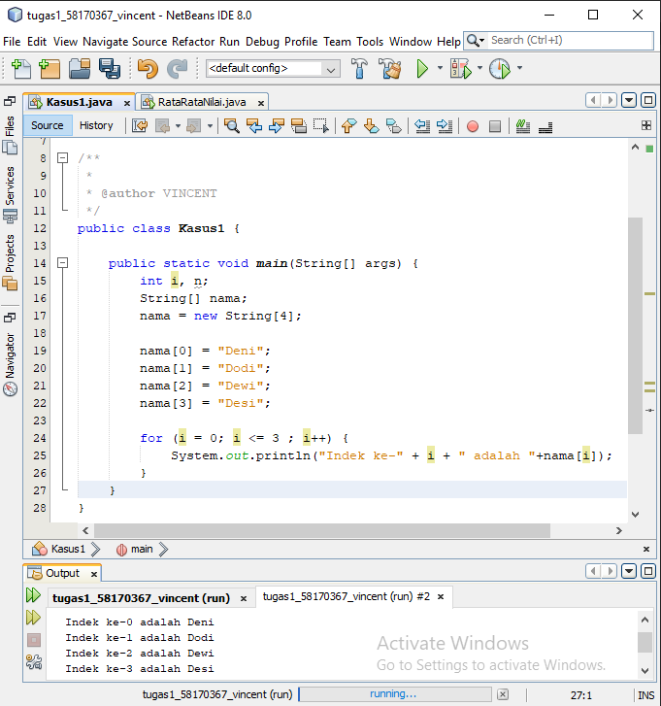

package Pertemuan11;

/\*\*

\*

\* @author VINCENT

\*/

public class Kasus1 {

public static void main(String[] args) {

int i, n;

String[] nama;

nama = new String[4];

nama[0] = "Deni";

nama[1] = "Dodi";

nama[2] = "Dewi";

nama[3] = "Desi";

for (i = 0; i <= 3 ; i++) {

System.out.println("Indek ke-" + i + " adalah "+nama[i]);

}

}

}

Kasus 2

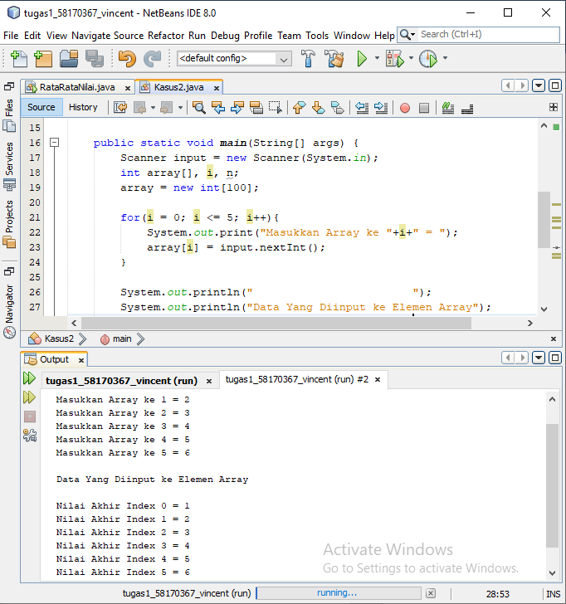

package Pertemuan11;

/\*\*

\*

\* @author VINCENT

\*/

import java.util.Scanner;

public class Kasus2 {

public static void main(String[] args) {

Scanner input = new Scanner(System.in);

int array[], i, n;

array = new int[100];

for(i = 0; i <= 5; i++){

System.out.print("Masukkan Array ke "+i+" = ");

array[i] = input.nextInt();

}

System.out.println(" ");

System.out.println("Data Yang Diinput ke Elemen Array");

System.out.println(" ");

for(i = 0; i <= 5; i++){

System.out.println("Nilai Akhir Index "+i+" = "+array[i]);

}

}

}

Kasus 3

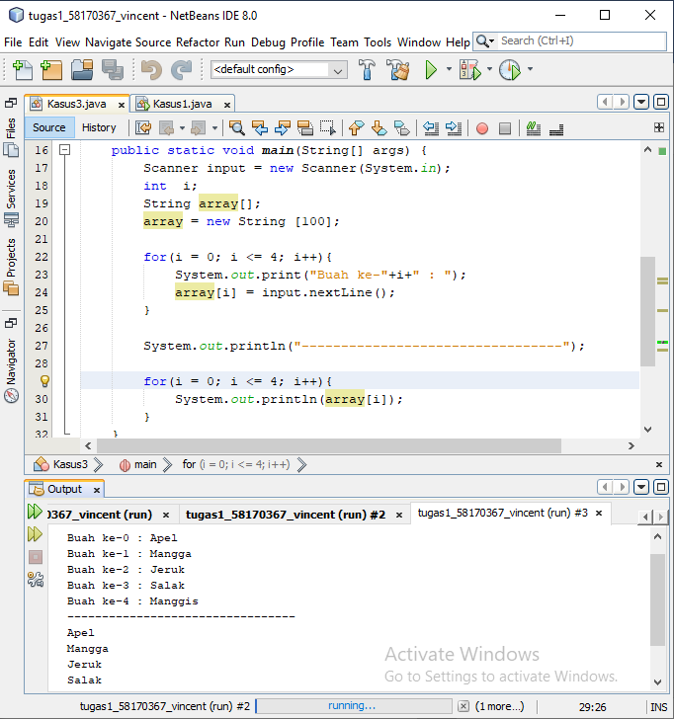

package Pertemuan11;

/\*\*

\*

\* @author VINCENT

\*/

import java.util.Scanner;

public class Kasus3 {

public static void main(String[] args) {

Scanner input = new Scanner(System.in);

int i;

String array[];

array = new String [100];

for(i = 0; i <= 4; i++){

System.out.print("Buah ke-"+i+" : ");

array[i] = input.nextLine();

}

System.out.println("---------------------------------");

for(i = 0; i <= 4; i++){

System.out.println(array[i]);

}

}

}

Kasus 4

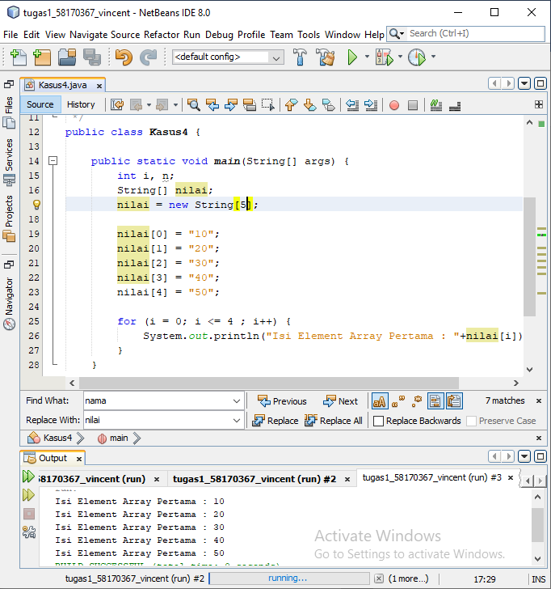

package Pertemuan11;

/\*\*

\*

\* @author VINCENT

\*/

public class Kasus4 {

public static void main(String[] args) {

int i, n;

String[] nilai;

nilai = new String[5];

nilai[0] = "10";

nilai[1] = "20";

nilai[2] = "30";

nilai[3] = "40";

nilai[4] = "50";

for (i = 0; i <= 4 ; i++) {

System.out.println("Isi Element Array Pertama : "+nilai[i]);

}

}

}

Kasus 5

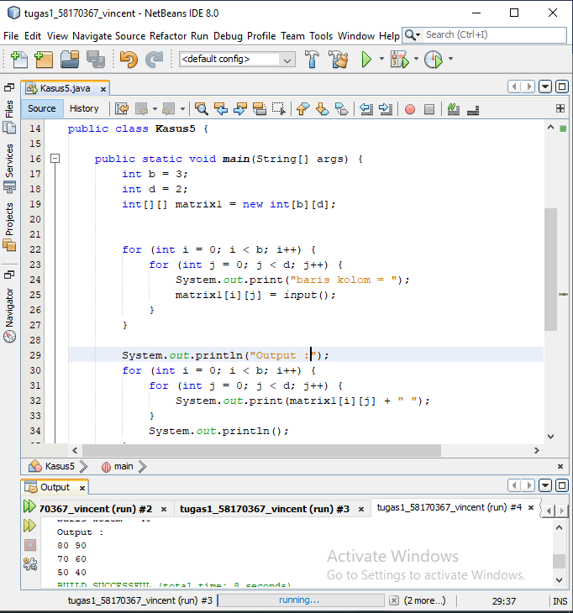

package Pertemuan11;

/\*\*

\*

\* @author VINCENT

\*/

import java.util.Scanner;

public class Kasus5 {

public static void main(String[] args) {

int b = 3;

int d = 2;

int[][] matrix1 = new int[b][d];

for (int i = 0; i < b; i++) {

for (int j = 0; j < d; j++) {

System.out.print("baris kolom = ");

matrix1[i][j] = input();

}

}

System.out.println("Output :");

for (int i = 0; i < b; i++) {

for (int j = 0; j < d; j++) {

System.out.print(matrix1[i][j] + " ");

}

System.out.println();

}

}

static int input() {

Scanner a = new Scanner(System.in);

int b = a.nextInt();

return b;

}

}

Kasus 6

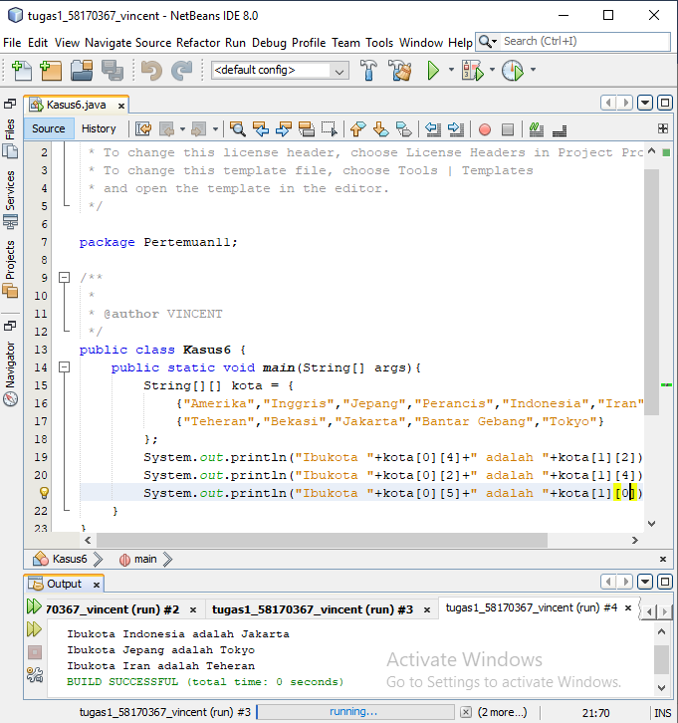

package Pertemuan11;

/\*\*

\*

\* @author VINCENT

\*/

public class Kasus6 {

public static void main(String[] args){

String[][] kota = {

{"Amerika","Inggris","Jepang","Perancis","Indonesia","Iran","Irak"},

{"Teheran","Bekasi","Jakarta","Bantar Gebang","Tokyo"}

};

System.out.println("Ibukota "+kota[0][4]+" adalah "+kota[1][2]);

System.out.println("Ibukota "+kota[0][2]+" adalah "+kota[1][4]);

System.out.println("Ibukota "+kota[0][5]+" adalah "+kota[1][0]);

}

}

Kasus 7

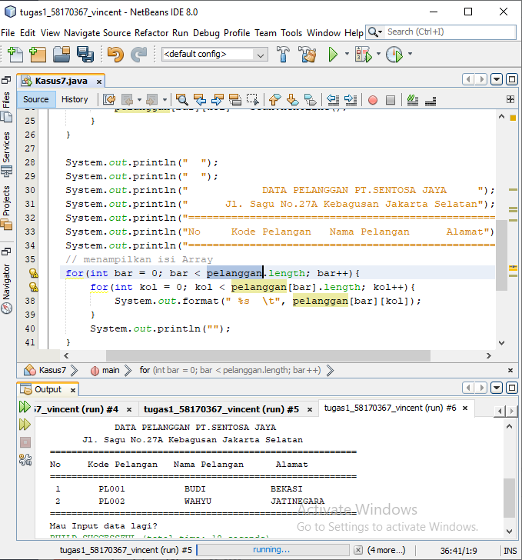

package Pertemuan11;

/\*\*

\*

\* @author VINCENT

\*/

import java.util.Scanner;

public class Kasus7 {

public static void main(String[] args) {

String[][] pelanggan = new String[2][4];

Scanner scan = new Scanner(System.in);

// mengisi setiap pelanggan

for(int bar = 0; bar < pelanggan.length; bar++){

for(int kol = 0; kol < pelanggan[bar].length; kol++){

System.out.format("Siapa yang akan duduk di pelanggan (%d,%d): ", bar, kol);

pelanggan[bar][kol] = scan.nextLine();

}

}

System.out.println(" ");

System.out.println(" ");

System.out.println(" DATA PELANGGAN PT.SENTOSA JAYA ");

System.out.println(" Jl. Sagu No.27A Kebagusan Jakarta Selatan");

System.out.println("=========================================================");

System.out.println("No Kode Pelangan Nama Pelangan Alamat");

System.out.println("=========================================================");

// menampilkan isi Array

for(int bar = 0; bar < pelanggan.length; bar++){

for(int kol = 0; kol < pelanggan[bar].length; kol++){

System.out.format(" %s \t", pelanggan[bar][kol]);

}

System.out.println("");

}

System.out.println("=========================================================");

System.out.println("Mau Input data lagi?");

}

}

Kasus 8

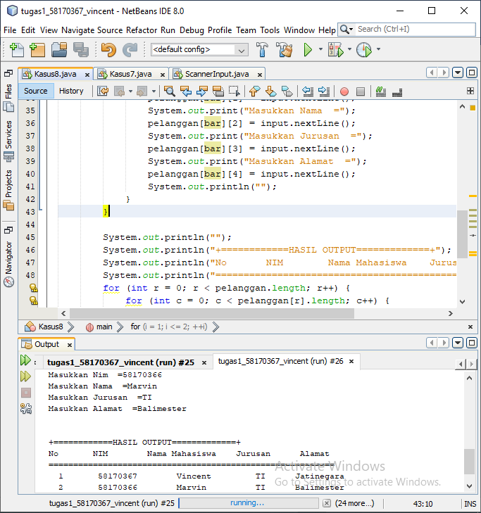

package Pertemuan11;

/\*\*

\*

\* @author VINCENT

\*/

import java.util.Scanner;

public class Kasus8 {

public static void main(String[] args) {

Scanner input = new Scanner(System.in);

String nama, nim, jur, alamat;

int array[][], i, n = 2;

String[][] pelanggan = new String[2][5];

System.out.println("BIODATA MAHASISWA");

System.out.println("+============INPUTAN=============+");

System.out.print("Masukkan banyak data = ");

n = input.nextInt();

System.out.println("");

for (i = 1; i <= 2; ++i) {

for (int bar = 0; bar < pelanggan.length; bar++) {

System.out.println("------Data ke-" + i + "-----");

System.out.print("Masukkan Nomor =");

pelanggan[bar][0] = input.nextLine();

System.out.print("Masukkan Nim =");

pelanggan[bar][1] = input.nextLine();

System.out.print("Masukkan Nama =");

pelanggan[bar][2] = input.nextLine();

System.out.print("Masukkan Jurusan =");

pelanggan[bar][3] = input.nextLine();

System.out.print("Masukkan Alamat =");

pelanggan[bar][4] = input.nextLine();

System.out.println("");

}

}

System.out.println("");

System.out.println("+============HASIL OUTPUT=============+");

System.out.println("No NIM Nama Mahasiswa Jurusan Alamat");

System.out.println("==========================================================");

for (int r = 0; r < pelanggan.length; r++) {

for (int c = 0; c < pelanggan[r].length; c++) {

System.out.format(" %s \t", pelanggan[r][c]);

}

System.out.println("");

}

}

}