Pemrograman Java

Perulangan

Kasus 1

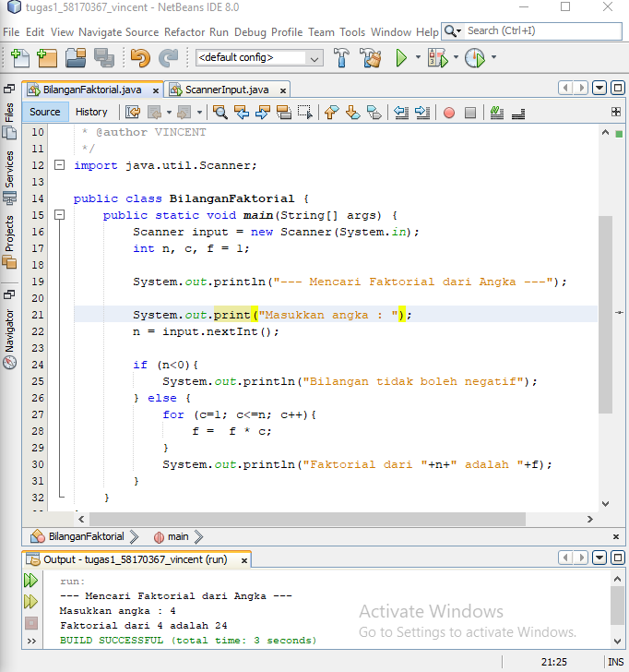

package Pertemuan10;

/**

*

* @author VINCENT

*/

import java.util.Scanner;

public class BilanganFaktorial {

public static void main(String[] args) {

Scanner input = new Scanner(System.in);

int n, c, f = 1;

System.out.println("--- Mencari Faktorial dari Angka ---");

System.out.print("Masukkan angka : ");

n = input.nextInt();

if (n<0){

System.out.println("Bilangan tidak boleh negatif");

} else {

for (c=1; c<=n; c++){

f = f * c;

}

System.out.println("Faktorial dari "+n+" adalah "+f);

}

}

}

Kasus 2

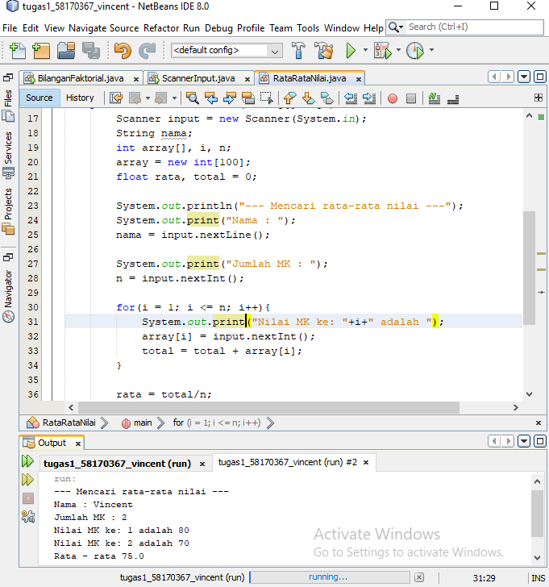

package Pertemuan10;

/**

*

* @author VINCENT

*/

import java.util.Scanner;

public class RataRataNilai {

public static void main(String[] args) {

Scanner input = new Scanner(System.in);

String nama;

int array[], i, n;

array = new int[100];

float rata, total = 0;

System.out.println("--- Mencari rata-rata nilai ---");

System.out.print("Nama : ");

nama = input.nextLine();

System.out.print("Jumlah MK : ");

n = input.nextInt();

for(i = 1; i <= n; i++){

System.out.print("Nilai MK ke: "+i+" adalah ");

array[i] = input.nextInt();

total = total + array[i];

}

rata = total/n;

System.out.println("Rata - rata "+ rata);

}

}

Kasus 3

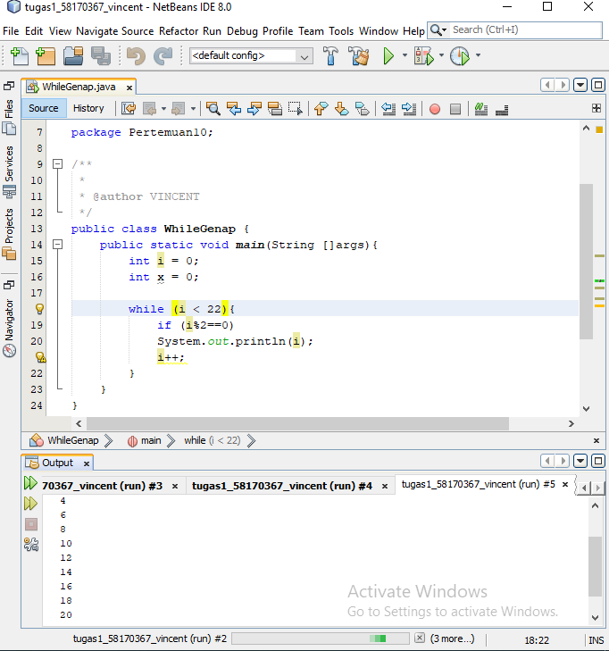

package Pertemuan10;

/**

*

* @author VINCENT

*/

public class WhileGenap {

public static void main(String []args){

int i = 0;

int x = 0;

while (i < 22){

if (i%2==0)

System.out.println(i);

i++;

}

}

}

Kasus 4

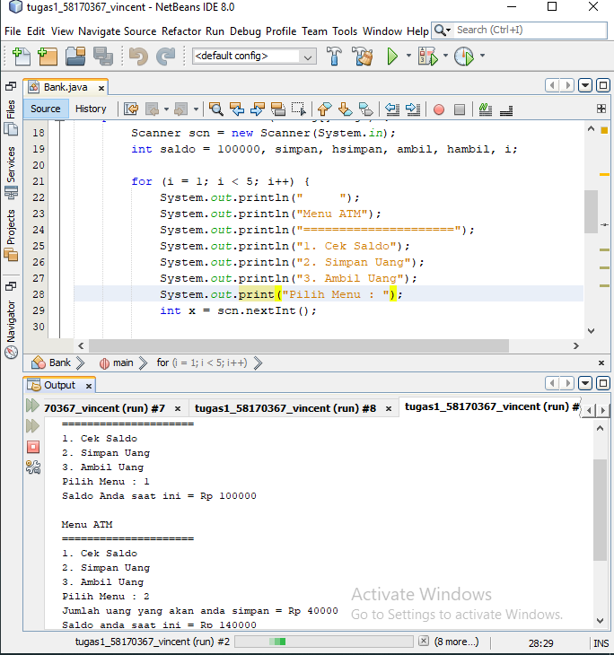

package Pertemuan10;

/**

*

* @author VINCENT

*/

import Pertemuan9_percabangan.*;

import java.util.Scanner;

public class Bank {

public static void main(String[] args) {

Scanner scn = new Scanner(System.in);

int saldo = 100000, simpan, hsimpan, ambil, hambil, i;

for (i = 1; i < 5; i++) {

System.out.println(" ");

System.out.println("Menu ATM");

System.out.println("=====================");

System.out.println("1. Cek Saldo");

System.out.println("2. Simpan Uang");

System.out.println("3. Ambil Uang");

System.out.print("Pilih Menu : ");

int x = scn.nextInt();

switch (x) {

case 1:

System.out.println("Saldo Anda saat ini = Rp " + saldo);

break;

case 2:

System.out.print("Jumlah uang yang akan anda simpan = Rp ");

simpan = scn.nextInt();

hsimpan = simpan + saldo;

System.out.println("Saldo anda saat ini = Rp " + hsimpan);

break;

case 3:

System.out.print("Jumlah uang yang akan anda ambil = Rp ");

ambil = scn.nextInt();

hambil = ambil + saldo;

System.out.println("Saldo anda saat ini = Rp " + hambil);

break;

default:

System.out.print("Salah input");

}

}

}

}