Kasus 1

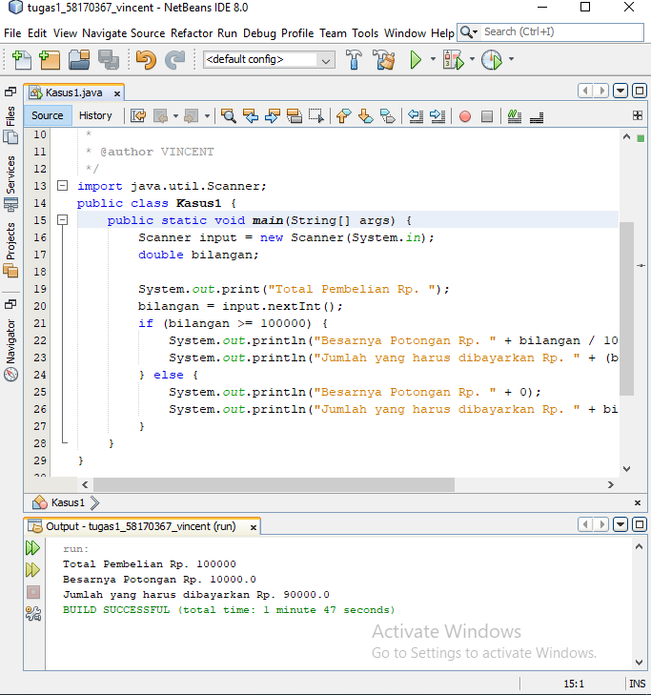

package Pertemuan7;

/\*\*

\*

\* @author VINCENT

\*/

import java.util.Scanner;

public class Kasus1 {

public static void main(String[] args) {

Scanner input = new Scanner(System.in);

double bilangan;

System.out.print("Total Pembelian Rp. ");

bilangan = input.nextInt();

if (bilangan >= 100000) {

System.out.println("Besarnya Potongan Rp. " + bilangan / 10);

System.out.println("Jumlah yang harus dibayarkan Rp. " + (bilangan - (bilangan / 10)));

} else {

System.out.println("Besarnya Potongan Rp. " + 0);

System.out.println("Jumlah yang harus dibayarkan Rp. " + bilangan);

}

}

}

Kasus 2

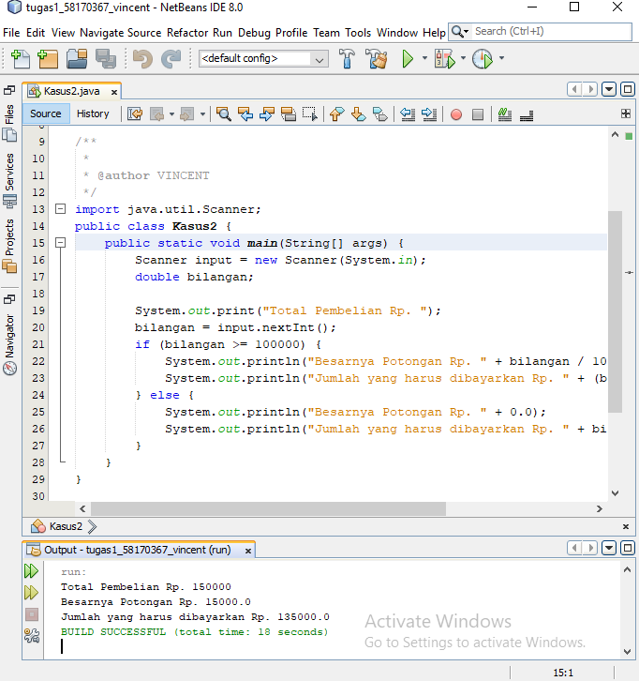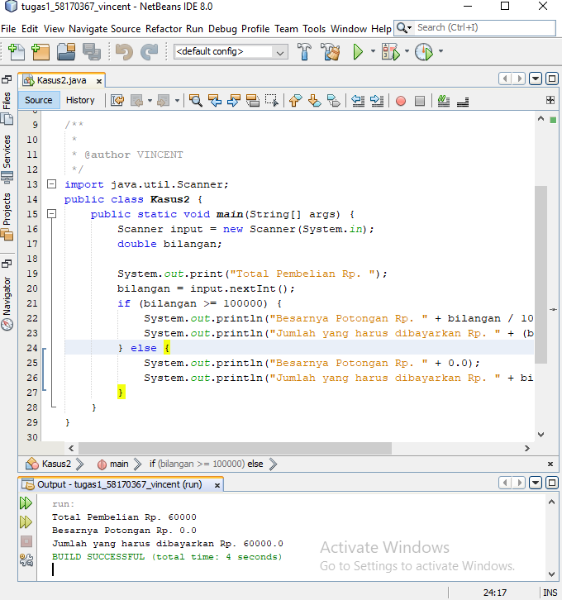

import java.util.Scanner;

public class Kasus2 {

public static void main(String[] args) {

Scanner input = new Scanner(System.in);

double bilangan;

System.out.print("Total Pembelian Rp. ");

bilangan = input.nextInt();

if (bilangan >= 100000) {

System.out.println("Besarnya Potongan Rp. " + bilangan / 10);

System.out.println("Jumlah yang harus dibayarkan Rp. " + (bilangan - (bilangan / 10)));

} else {

System.out.println("Besarnya Potongan Rp. " + 0.0);

System.out.println("Jumlah yang harus dibayarkan Rp. " + bilangan);

}

}

}

Kasus 3

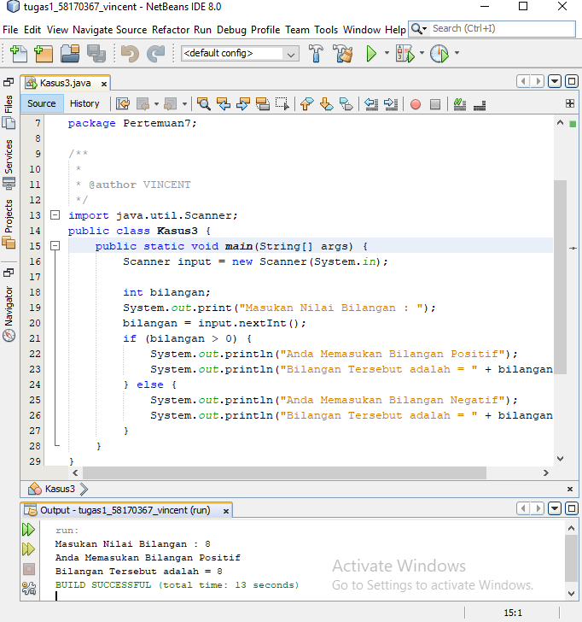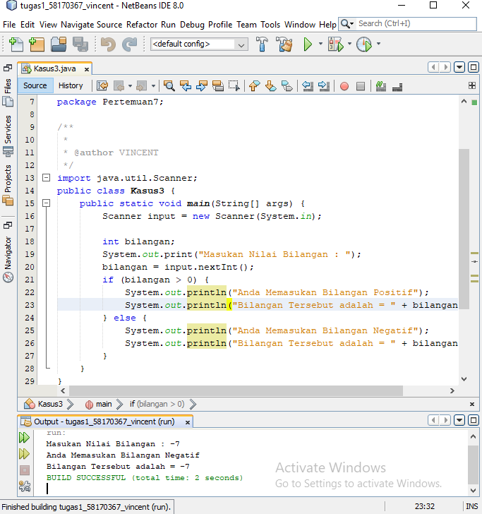

import java.util.Scanner;

public class Kasus3 {

public static void main(String[] args) {

Scanner input = new Scanner(System.in);

int bilangan;

System.out.print("Masukan Nilai Bilangan : ");

bilangan = input.nextInt();

if (bilangan > 0) {

System.out.println("Anda Memasukan Bilangan Positif");

System.out.println("Bilangan Tersebut adalah = " + bilangan);

} else {

System.out.println("Anda Memasukan Bilangan Negatif");

System.out.println("Bilangan Tersebut adalah = " + bilangan);

}

}

}

Kasus 4

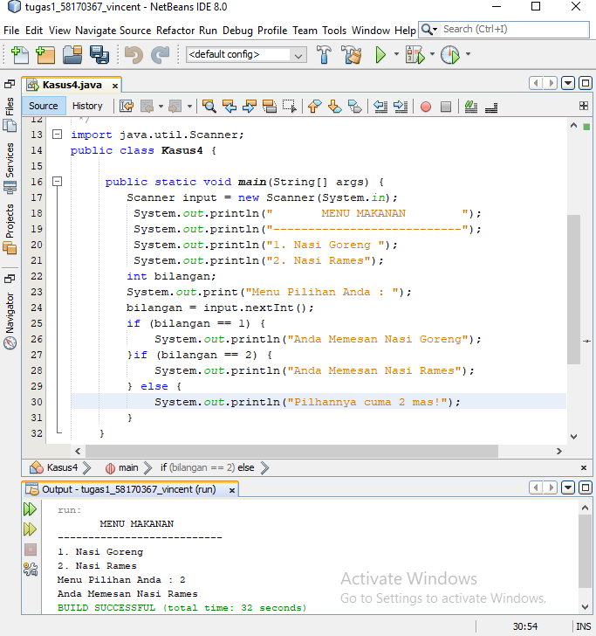

import java.util.Scanner;

public class Kasus4 {

public static void main(String[] args) {

Scanner input = new Scanner(System.in);

System.out.println(" MENU MAKANAN ");

System.out.println("---------------------------");

System.out.println("1. Nasi Goreng ");

System.out.println("2. Nasi Rames");

int bilangan;

System.out.print("Menu Pilihan Anda : ");

bilangan = input.nextInt();

if (bilangan == 1) {

System.out.println("Anda Memesan Nasi Goreng");

}if (bilangan == 2) {

System.out.println("Anda Memesan Nasi Rames");

} else {

System.out.println("Pilhannya cuma 2 mas!");

}

}

}

Kasus 5

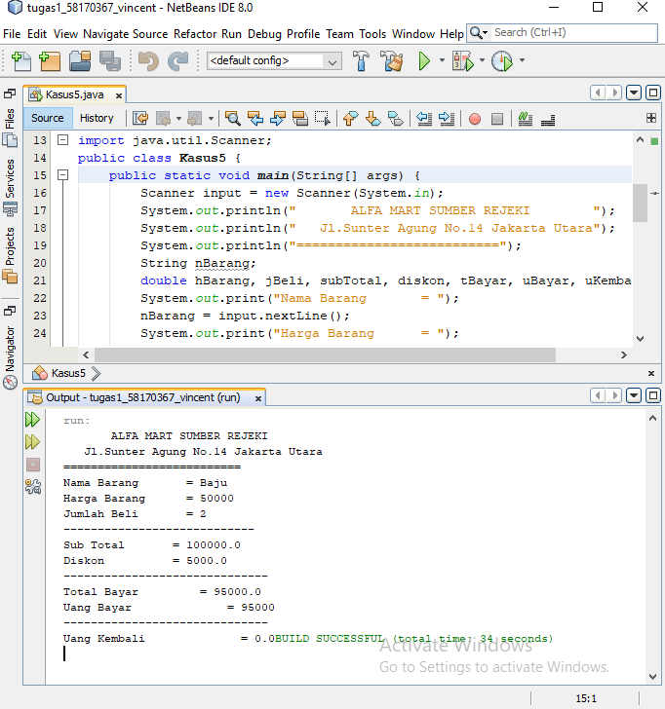

import java.util.Scanner;

public class Kasus5 {

public static void main(String[] args) {

Scanner input = new Scanner(System.in);

System.out.println(" ALFA MART SUMBER REJEKI ");

System.out.println(" Jl.Sunter Agung No.14 Jakarta Utara");

System.out.println("==========================");

String nBarang;

double hBarang, jBeli, subTotal, diskon, tBayar, uBayar, uKembali;

System.out.print("Nama Barang = ");

nBarang = input.nextLine();

System.out.print("Harga Barang = ");

hBarang = input.nextDouble();

System.out.print("Jumlah Beli = ");

jBeli = input.nextDouble();

System.out.println("----------------------------");

subTotal = jBeli \* hBarang;

System.out.println("Sub Total = " + subTotal);

if (subTotal >= 100000) {

diskon = (subTotal \* 5) / 100;

System.out.println("Diskon = " + diskon);

System.out.println("------------------------------");

tBayar = subTotal - diskon;

System.out.println("Total Bayar = " + (subTotal - diskon));

System.out.print("Uang Bayar = ");

uBayar = input.nextDouble();

System.out.println("------------------------------");

uKembali = uBayar - tBayar;

System.out.print("Uang Kembali = " + uKembali);

} else {

System.out.println("Diskon = " + 0);

System.out.println("------------------------------");

System.out.println("Total Bayar = " + subTotal);

System.out.print("Uang Bayar = ");

uBayar = input.nextDouble();

System.out.println("------------------------------");

uKembali = uBayar - subTotal;

System.out.println("Uang Kembali = " + uKembali);

}

}

}

Kasus 6

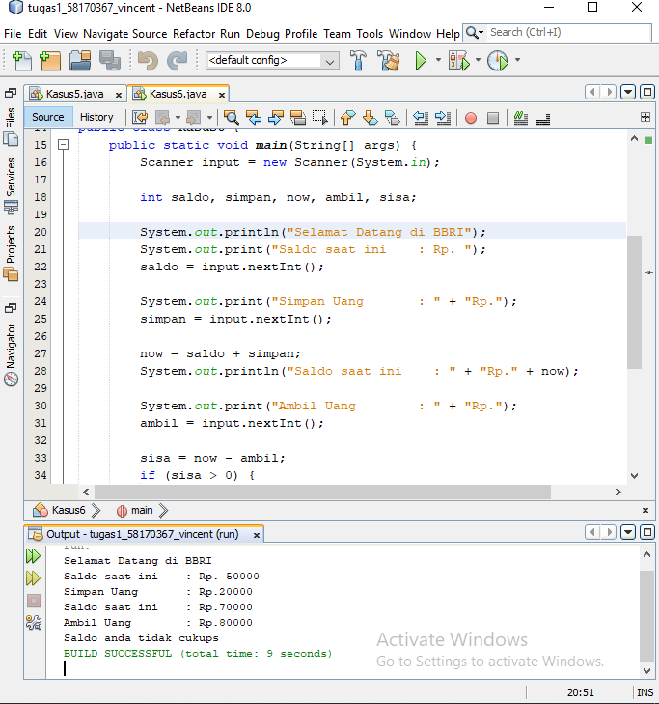

import java.util.Scanner;

public class Kasus6 {

public static void main(String[] args) {

Scanner input = new Scanner(System.in);

int saldo, simpan, now, ambil, sisa;

System.out.println("Selamat Datang di BBRI");

System.out.print("Saldo saat ini : Rp. ");

saldo = input.nextInt();

System.out.print("Simpan Uang : " + "Rp.");

simpan = input.nextInt();

now = saldo + simpan;

System.out.println("Saldo saat ini : " + "Rp." + now);

System.out.print("Ambil Uang : " + "Rp.");

ambil = input.nextInt();

sisa = now - ambil;

if (sisa > 0) {

System.out.println("Saldo saat ini : " + "Rp." + sisa);

} else {

System.out.println("Saldo anda tidak cukups");

}

}

}

Kasus 7

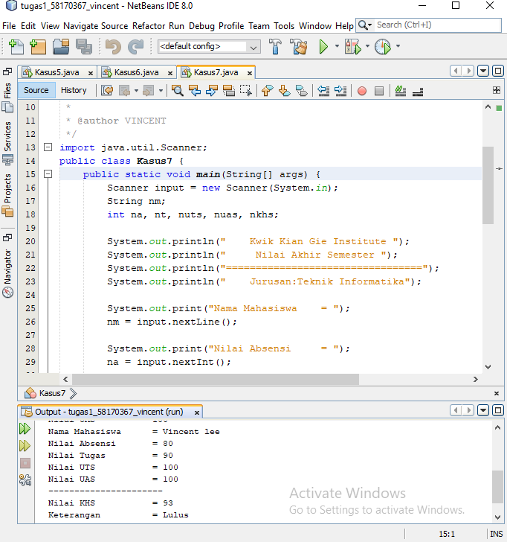

import java.util.Scanner;

public class Kasus7 {

public static void main(String[] args) {

Scanner input = new Scanner(System.in);

String nm;

int na, nt, nuts, nuas, nkhs;

System.out.println(" Kwik Kian Gie Institute ");

System.out.println(" Nilai Akhir Semester ");

System.out.println("=================================");

System.out.println(" Jurusan:Teknik Informatika");

System.out.print("Nama Mahasiswa = ");

nm = input.nextLine();

System.out.print("Nilai Absensi = ");

na = input.nextInt();

System.out.print("Nilai Tugas = ");

nt = input.nextInt();

System.out.print("Nilai UTS = ");

nuts = input.nextInt();

System.out.print("Nilai UAS = ");

nuas = input.nextInt();

nkhs = ((20 \* na) / 100) + ((25 \* nt) / 100) + ((25 \* nuts) / 100) + ((30 \* nuas) / 100);

System.out.println("Nama Mahasiswa = " + nm);

System.out.println("Nilai Absensi = " + na);

System.out.println("Nilai Tugas = " + nt);

System.out.println("Nilai UTS = " + nuts);

System.out.println("Nilai UAS = " + nuas);

System.out.println("----------------------");

System.out.println("Nilai KHS = " + nkhs);

if (nkhs>=60) {

System.out.println("Keterangan = Lulus");

} else {

System.out.println("Keterangan = Tidak Lulus");

}

}

}