Billy - Buddy Against Cyber Bullying

A PROJECT REPORT

***Submitted by*,**

|  |  |
| --- | --- |
| **A.V DIVAKAR REDDY** | **20211CBC0025** |
| **SANDA NAVEEN REDDY** | **20211CBC0027** |
| **M. OBULSUBBA REDDY** | **20211CBC0047** |
| **P. SUDHEER** | **20211CBC0065** |
|  |  |

***Under the guidance of,***

Ms. ARSHIYA LUBNA

***In partial fulfilment for the award of the degree of***

##### BACHELOR OF TECHNOLOGY

**IN**

##### COMPUTER SCIENCE AND ENGINEERING (BLOCKCHAIN)

**AT**



**PRESIDENCY UNVIERSITY BENGALURU JANUARY 2025**

**PRESIDENCY UNIVERSITY**

**SCHOOL OF COMPUTER SCIENCE ENGINEERING**

**CERTIFICATE**

This is to certify that the University project report titled **“Billy – Buddy Against Cyber bullying”** being submitted by **“**Divakar Reddy, Sanda Naveen Reddy, M. ObulSubba Reddy, P. Sudheer”bearing roll number **“**20211CBC0025, 20211CBC0027, 20211CBC0047, 20211CBC0065 **”** in partial fulfilment of requirement for the award of degree of Bachelor of Computer Application is a bona-fide work carried out under supervision

|  |  |
| --- | --- |
| **Ms. ARSHIYA LUBNA**  Associate Professor School of CSE Presidency University | **DR. PRAVINTHA RAJA**  Professor & HoD School of CSE Presidency University |

|  |  |  |
| --- | --- | --- |
| **Dr. L. SHAKKEERA**  Associate Dean School of CSE Presidency University | **Dr. MYDHILI NAIR**  Associate Dean School of CSE Presidency University | **Dr. SAMEERUDDIN KHAN**  Pro-VC School of Engineering Dean -School of CSE&IS Presidency University |

**PRESIDENCY UNIVERSITY**

**SCHOOL OF COMPUTER SCIENCE ENGINEERING**

**DECLARATION**

We hereby declare that the work, which is being presented in the project report entitled “**Billy – Buddy Against Cyber bullying**” in partial fulfilment for the award of **Bachelor of Technology** in **Computer Science and Engineering in BlockChain**, is a record of our own investigations carried under the guidance of Ms. Arshiya lubna, Associate Professor, School of Computer Science and Engineering, Presidency University, Bengaluru.

We have not submitted the matter presented in this report anywhere for the award of any Degree.

|  |  |  |
| --- | --- | --- |
| **NAME** | **ROLL NUMBER** | **SIGNATURE** |
| A.V. DIVAKAR REDDY | 20211CBC0025 |  |
| SANDA NAVEEN REDDY | 20211CBC0027 |
| M. OBULSUBBA REDDY | 20211CBC0047 |  |
| P. SUDHEER | 20211CBC0065 |
|  |  |

##### ABSTRACT

With the advent of modern technology, cyber bullying (use of e-mail, cell phones, text messages etc.) has increased in India. Easy access to internet, cheap mobile phones, and virtually no law to stop the abuse of school children by their fellow classmates, the problem of cyber-crime among children and young adults have increased. According to a survey, conducted in 2012, 53% of Indian children between 8 and 17 years have been bullied online.

The Global Youth Online  
Microsoft's Behavior Survey ranked India third in the cyberbullying of children (after China and Singapore). Cyber bullying is a virtual offence with real consequences. The motivations for cyber bullying can range from getting satisfaction out of hurting the victim whom the perpetrator may despise or feel jealous of, feeling better about themselves, revenge for perceived provocation by the victim or just for fun where they are not concerned about the effect on the target. However, anonymity is a major contributor to cyber bullying as the perpetrator feels that his identity cannot be revealed.

Like traditional bullying, it is intentional and repetitive and has psychological and physiological effect such as development of negative self-esteem in the victim, somatic problems, anxiety, social withdrawal and isolation which in turn can lead to school absenteeism, academic problems, depression and aggressive acts ( homicidal or suicidal). Parents, being less enlightened about modern technology than adolescents and young adults, are often in the dark about the horrific experiences of their children and are unable to provide the necessary support.

It can be a useful tool for identifying similar patients and informing clinical decision- making towards better patient-centered care. Future research directions might involve integrating more techniques in machine learning, such as deep learning.

##### ACKNOWLEDGEMENT

First of all, we indebted to the **GOD ALMIGHTY** for giving me an opportunity to excel in our efforts

We express our sincere thanks to our respected dean **Dr. Md. Sameeruddin Khan**, Pro- VC, School of Engineering and Dean, School of Computer Science Engineering & Information Science, Presidency University for getting us permission to undergo the project. We express our heartfelt gratitude to our beloved Associate Deans **Dr. Shakkeera L** and **Dr. Mydhili Nair**, School of Computer Science Engineering & Information Science, Presidency University, and **Dr. PRAVINTHA RAJA**. Head of the Department. School of Computer Science Engineering, Presidency University, for rendering timely help in completing this project successfully.

We are greatly indebted to our guide **MS. ARUHIYA LUBNA,** Associate Professor and Reviewer **Ms. SUMA GOUD**, Assistant Professor, School of Computer Science Engineering & Information Science, Presidency University for his/her inspirational guidance, and valuable suggestions and for providing us a chance to express our technical capabilities in every respect for the completion of the project work. We would like to convey our gratitude and heartfelt thanks to the PIP2001 Capstone Project Coordinators **Dr. Sampath A K, Dr. Abdul Khadar A** and **Mr. Md Zia Ur Rahman,** department Project Coordinators **Dr. Sharmasth Vali Y** and Git hub coordinator **Mr. Muthuraj.**

We thank our family and friends for the strong support and inspiration they have provided us in bringing out this project.

|  |
| --- |
| A.V. Divakar Reddy |
| Sanda Naveen Reddy |
| M. Obulsubba Reddy |
| P. Sudheer |
|  |

##### TABLE OF CONTENTS

`

|  |  |  |
| --- | --- | --- |
| **CHAPTER NO** | **TITLE**  **ABSTRACT ACKNOWLEDGEMENT LIST OF FIGURES**  **LIST OF TABLES**  **…** | **PAGE NUMBER**  **iv v ix x**  **…** |
| **1** | **INTRODUCTION** | **1** |
| **2** | **LITERATURE REVIEW** | **3** |
| **3** | **REAL-TIME APPLICATION** | **5** |
| **4** | **EXISTING METHODS AND THEIR DRAWBACKS** | **7** |
|  | 4.1 School-based awareness programme | 7 |
|  | 4.2 Social Media Reporting Mechanisms | 7 |
|  | 4.3 AI-Powered Detection System | 8 |
|  | 4.4 Counseling and Support hotlines | 8 |
|  | 4.5 Parental Controls and Monitoring Software | 9 |
|  | 4.6 Legal and Legislative Protection | 9 |
| **5** | **PROPOSED METHODOLOGY** | **13** |
|  | 5.1 DESIGN PROCEDURE | 13 |
|  | 5.2 Problem Definition and Scope | 14 |
|  | 5.3 Methodology Data Collection and Preprocessing | 14 |
|  | 5.4 Cyberbullying Detection Model | 14 |
|  | 5.5 Time Response Real Mechanism | 18 |
|  | 5.6 Objectives | 19 |
|  | 5.7 Feature Engineering | 19 |

|  |  |  |
| --- | --- | --- |
|  | 5.8 Model Training and Evaluation | 19 |
|  | 5.9 Deployment and Integration | 20 |
| **6** | **SYSTEM ANALYSIS AND DESIGN** | **21** |
|  | 6.1 System Analysis | 21 |
|  | 6.2 System Design | 23 |
| **7** | **IMPLEMENTATION** | **24** |
|  | 7.1 Work Flow | 25 |
|  | 7.2 Components Used | 27 |
|  | 7.3 Libraries and Tools | 30 |
|  | 7.4 Technical challenges | 31 |
|  | 7.5 Clinical Challenges of Patient Similarity Analysis | 32 |
|  | 7.6 Major Issues in Real-Time Patient Similarity Analysis | 33 |
| **8** | **DATASET & ANALYSIS** | **35** |
|  | 8.1 Sample Dataset | 35 |
|  | 8.2 Analysis | 36 |
|  | 8.2.1 Introduction to the data set | 36 |
|  | 8.2.2 Dataset in Detail Overview | 37 |
| **9** | **PROJECT TIMELINE** | **38** |
| **10** | **LIST OF FIGURES & IMPORTANCE** | **39** |
| **11** | **PREDICTING PROCESS** | **48** |
|  |
|  |
|  |
|  |
| **12** | **RESULTS & DISCUSSIONS** | **38** |
|  | * 1. 12.1 Increased Awareness and Understanding | 38 |
|  | 12.2 **Empowerment of Bystanders** | 38 |
| **13** | **FURTHER APPLICATIONS AND FUTURE**  **DIRECTIONS** | **40** |
|  | 13.1 Further Applications | 41 |

|  |  |
| --- | --- |
| 13.2 Future Work Directions | 41 |
| 13.3 Conclusion | 42 |
| **REFERENCE**  **APPENDICES** | **44**  **50** |

**List of Figures**

|  |  |  |  |
| --- | --- | --- | --- |
| **Sl. No.** | **Figure Number** | **Figure Name** | **Page No.** |
| 1 | 1 | SCREENSHOT 1 | 45 |
| 2 | 2 | Screenshot 2 | 45 |
| 3 | 3 | Screenshot 3 | 46 |
| 4 | 4 | Screenshot 4 | 47 |
| 5 | 5 | Screenshot 5 | 48 |
| 6 | 6 | Screenshot 6 | 49 |
| 7 | 7 | Screenshot 7 | 50 |
| 8 | 8 | Screenshot 8 | 50 |
| 9 | 9 | Screenshot 9 | 51 |
| 10 | 10 | Screenshot 10 | 51 |

**List of Table**

|  |  |  |  |
| --- | --- | --- | --- |
| **Sl. No.** | **Table Number** | **Table Name** | **Page No** |
| 1 | 8.1 | Dataset | 39 |

##### CHAPTER-01 INTRODUCTION

Cyberbullying is a form of harassment on a social/online platform. It has become very common, especially among teenagers. Harmful bullying behavior can include posting rumors, threats, sexual remarks, a victim's personal information, or pejorative labels (i.e., hate speech), Bullying or harassment can be identified by repeated behavior and an intent to harm. Victims may have low self-esteem, increased suicidal ideation, and various emotional responses like fear, frustration, anger, and depression. Our Website:- Offers immediate help through a user-friendly chatbot ("Billy") which not only comforts the victim but also reports the person behind, to the cyber-crime department keeping the user's identity anonymous..

It will provoke the victim to provide important information and evidences. It will also calculate the statistics of cyber-crimes in an area visible to the cybercrime department to keep a track of crimes on a regular basis. The areas with red alert will be given more focus in any part of the country. Tips and defence tactics would be mentioned on the website to guide the youth and others. Connects the people across the country who have already faced cyber-bullying by forming a community which would help the victims to learn from the experiences of the formers.

Realizing the seriousness of the issue, Billy - Buddy Against Cyberbullying is a revolutionary initiative that tackles cyberbullying head-on. Billy is an innovative, user-friendly chatbot designed to provide immediate support and comfort to victims of cyberbullying. By leveraging advanced natural language processing and artificial intelligence, Billy offers a safe space for victims to share their experiences, seek guidance, and access vital resources. Unlike other reporting mechanisms, Billy guarantees full anonymity, thus giving users the power to speak up without fear of retaliation or exposure.

School of Computer Science Engineering and Information Science, Presidency University.

The website offers advice and self-defense strategies to educate users and links people together through a safe network where victims can discuss their experiences and engage in Q&A forums. All information is kept confidential to avoid exploitation. According to DoSomething.org, the global statistics are alarming: approximately 37% of young people aged 12 to 17 have been cyberbullied, and 30% have faced it more than once, increasing their vulnerability to self-harm and suicidal behavior.

The core vision of Billy is to create a supportive ecosystem that not only addresses the immediate needs of cyberbullying victims but also contributes to long-term prevention and awareness. Billy functions as more than just a chatbot; it serves as a bridge between victims, authorities, and communities. By facilitating anonymous reporting, Billy enables victims to provide crucial evidence that can be forwarded to the cybercrime department for investigation. This ensures that offenders are held accountable while maintaining the victim's privacy.

##### CHAPTER-02 LITERATURE REVIEW

Cyberbullying, which has emerged as a pressing global concern, is defined as the use of digital media to harass, threaten, or humiliate someone. The practice leads to significant emotional and psychological distress in many victims. Recently, cyberbullying has attracted attention as an increasingly important problem, especially for teenagers, as increased online interaction creates new pathways for bullying behavior. An in-depth analysis of literature points out that the widespread phenomenon requires more intense intervention programs like the Billy chatbot to curb the situation.

Studies indicate that cyberbullying affects a significant portion of the youth population worldwide. According to a report by DoSomething.org, approximately 37% of individuals aged 12 to 17 have experienced cyberbullying, and 30% have faced it on multiple occasions. The anonymity provided by online platforms emboldens perpetrators while leaving victims feeling powerless. According to Patchin and Hinduja (2018), the adverse emotional impact experienced by cyber victims results in their heightened susceptibility toward anxiety, depression, and self-harm ideologies.

To curtail cyberbullying, some initiatives have included awareness campaigns and school-based programs, as well as reporting mechanisms on social media platforms. Underreporting remains a problem while personalized support mechanisms for victims may not be enough, according to studies by Kowalski et al. in 2014. Victims might fear retaliation or stigma, therefore prolonging harmful behaviors. In addition, current interventions are weakened by their reactivity, targeting punishment rather than prevention and support. This lacuna calls for proactive, user-centered solutions that empower victims with respect to privacy and safety.

Decision Emerging technologies, such as AI and machine learning, represent promising avenues to address cyberbullying. Chatbots, especially, have garnered attention for the possibility of instant, non-judgmental support to the user. Computers in Human Behavior published a study that stated that AI-driven chatbots can simulate empathetic interactions and help users navigate through emotional distress, providing actionable advice. In addition, AI technologies can help with data analysis so that cyberbullying trends are tracked in real-time and areas of high risk are identified to be targeted for intervention.

Although many benefits exist, decision trees have disadvantages. They might become noise-sensitive and fail to capture complex relations between the variables. Some of these disadvantages have led researchers to new approaches: ensemble approaches in the form of random forests and gradient boosting machines in which a number of decision trees are put together to form a single model with better performance.

Implementation of Billy would have the positive effect of sending ripples and creating a more secure online platform. With a tool such as Billy empowering the victims with mechanisms for self-protection and punishment to perpetrators, this gives way to accountability and respect within the social system. Data from Billy's research can help in policy making by policymakers and also in educators for the effective education or prevention process.

##### CHAPTER-03

**REAL-TIME APPLICATIONS OF BILLY – BUDDY AGAINST CYBER BULLYING**

1. Real-Time Monitoring and Detection:
   * With AI and NLP, Billy keeps tabs on interactions online, whether on various platforms or not. Real-time analysis allows Billy to identify hurtful content like abusive language, threats, and hate speech. Its algorithms are trained to do well on subtle as well as overt bullying.
2. Instant Alerts and Notifications:

* Billy provides real-time alerts to the victim, parent, or administrator once cyberbullying is detected. Alerts can be sent via different channels such as email, SMS, or app notifications so that intervention may be timely and appropriate. For instance, when a child is receiving damaging messages on social media, Billy may alert the child's guardian with recommendations on how to act upon it.

1. Auto-Response for Situational De-escalation:
   * Billy's unique features is its ability to create empathetic, real-time automated responses toward bullying incidents. Upon receiving a negative comment from someone, Billy can intervene through the sending of a supportive message to the victim and a reminder to the aggressor about the community guidelines and impact of such behavior.
2. Providing Instant Help to Victims:
   * Billy is a virtual buddy that immediately provides victims of cyberbullying with access to resources and emotional support. Using conversational AI, Billy can engage in conversation with users to provide encouragement, suggest coping strategies, and even guide them to professional help if needed. This real-time support creates a safe space for individuals to express their feelings without fear of judgment.
3. Real-time Interventionist Education:
   * Surveillance Education is part of Billy's mission. In real-time, Billy educates users

about the impact of cyberbullying and responsible online behavior.

1. Real-Time Community Moderation:

Online communities often struggle with maintaining a healthy, respectful environment. Billy’s real-time moderation tools empower administrators to manage their platforms effectively. By filtering out inappropriate content and identifying repeat offenders, Billy ensures that communities remain safe and inclusive.

1. Psychiatry:

For example, in an online gaming scenario, Billy can monitor chatrooms to prevent toxic behavior. By identifying and muting offenders or issuing warnings, Billy contributes to creating a more enjoyable and harassment-free experience for all users.

##### CHAPTER-04 Existing Methods and Their Drawbacks

In addressing the pressing issue of cyberbullying, various methods have emerged, targeting prevention, detection, and intervention. These methods aim to protect individuals, especially young people, from the harmful effects of online harassment. However, while each has its strengths, several limitations hinder their overall effectiveness. Below is an exploration of some of the existing methods and their drawbacks.

* + 1. School-based awareness programme:-
       - Many schools offer anti-bullying campaign; generally, a package includes seminars or lectures coupled with video instructions targeting awareness issues. This further aids in reports being made to those responsible to manage such forms of online bullying along with information relating to online bullying for students.
       - Long-term engagement is missing: Programs tend to be intermittent, meaning the message might fade out of mind with time, hence there is lack of continued vigilance among the students. Variable implementation: such programs may go differently in various schools depending on available resources, the commitment of the educators, and the culture of the institution.
    2. Social Media Reporting Mechanisms:
       - Social media, including Facebook, Instagram, and Twitter, allows users to report abusive content. Once reported, these sites review the flagged material and remove it or suspend the offending user's account. Delayed response: Platforms often take too long to respond to reported cases of cyberbullying, leaving victims exposed to continued harassment while waiting for a resolution. Lack of transparency: Users frequently complain about the unclear guidelines on how reports are processed and the reasons for decisions, which can lead to frustration and mistrust in the system.
       - Over-reliance on algorithms: Platforms employ algorithms to filter out abusive content, but in most cases, these algorithms tend to be poor at detecting the context-specific form of bullying and nuanced forms of abuse, meaning that some potentially harmful content would slip through and innocuous content might get flagged.
    3. AI-Powered Detection System:
       - With the advancement in artificial intelligence, several platforms have started developing AI-based systems for automatic detection of cyberbullying. These analyze language patterns and emojis to catch any harmful cues.
       - Contextual misunderstanding: The AI system finds it hard to understand human language in the depth that is needed because, in sarcasm, the tone, or sense of humor and cultural references often create a significant issue, generating both false positives (flagging harmless content) and false negatives (missing harmful content).
       - Bias in algorithms: AI systems only perform at a level comparable to the training data. Lack of diversity in training data makes a system biased since it would be missing particular kinds of cyberbullying experiences in minority groups.
       - Dependence on user input: most AI systems remain to depend on user flagging content that might have been inappropriate to begin with; hence, these AI systems are not fully autonomous or proactive enough in detecting incidents of cyberbullying.
    4. Counseling and Support hotlines:
       - Many organizations offer a helpline and counseling for cyberbullying victims. They are services which help in the provision of emotional support and practical advice for people affected by online abuse.
       - These services have a low reach, since not all the victims are aware of these services, and access is difficult, especially for rural areas or in areas where there is limited mental health.
       - Overloaded systems: Most counseling services face overloads where it means long waiting hours for those with an urgent need.
       - No remedy to the real issues: Although counseling helps people to deal emotionally with the abuse, it fails to address cyberbullying systematically or offer them long-term preventive remedies.
    5. Legal and Legislative Protection:
       - Existing laws in a large number of countries penalize cyberbullying cases by bringing the culprit before the law. Victims can lodge complaints, and sometimes, charges are brought against the culprits when cyberbullying is repeatedly threatening or harassing.
       - Legal process: Courts work slowly, taking a couple of months or even years to ensure justice is served, leaving victims exposed to harm.
       - Under-reporting: Many victims, especially the young population, do not report cases of cyberbullying due to the risk of retaliatory attacks against them, shame, or thinking that no one will take the issue seriously.
       - International problems: Cyberbullying more frequently transcends geographical borders, and thus enforcing local laws on people living in other countries is a challenge.
    6. Parental Controls and Monitoring Software:
       - Effective Many parents use monitoring software or parental controls to monitor their children's online activities, hoping to protect them from harmful interactions.
       - Privacy issues: Over-monitoring can create tension between parents and children, as young people feel their privacy is being invaded.
       - Ineffectiveness against covert behavior: Tech-savvy children can often find ways to bypass monitoring tools, making them ineffective.
       - Focus: It is only restricted access with a lack of focus on the training of the child to understand and navigate safe, responsible access in online environments.
    7. Community-Based Interventions:
       - Residual Plots: Local communities often organize programs, events, and initiatives aimed at creating an atmosphere of friendship and supportiveness and, henceforth, bullying prevention.
       - They can't reach beyond the scope. These cannot go beyond a limited number, due to their poor resource bases, and reach an audience outside a local circle.
    8. Technological Advancements:
       - Real-time monitoring tools, blockchain-based digital identities, and advanced natural language processing systems can all contribute to the fight against cyberbullying.
       - High cost of implementation: High-tech solutions can be expensive, thereby becoming inaccessible for small organizations or schools.
  1. WORKFLOW
     1. Objective
* Billy is a cyberbullying combatting AI-powered chatbot designed to detect, intervene and help victims as well as their communities against harassment through online mediums.
  + 1. Real-Time Detection
       - Uses NLP models to analyze and classify content for potential bullying.
    2. Personalized Interventions
       - Sends alerts to individuals about harmful interactions.  
         Offers automated responses, empathetic messages, and guidance to mitigate bullying.
    3. Educational Tools
       - Provides resources, coping strategies, and information about online safety.
       - There should also be quizzes or workshops for users that teach about digital empathy and responsible communication
         * Reporting & Analytics

Enables victims or witnesses to report incidents anonymously

Provides insight into data for parents, educators, or moderators to spot trends or hotspots in such incidents.

* Offers such dynamic resources that are a must in education-the video lessons, the readings, the quizzes, self-check.

- Prompts users to learn positive communication techniques through gamified content.

Collects user feedback to refine NLP models and responses.

- Regular updates to adapt to emerging slang or trends in cyberbullying.

* + 1. Flow of Work

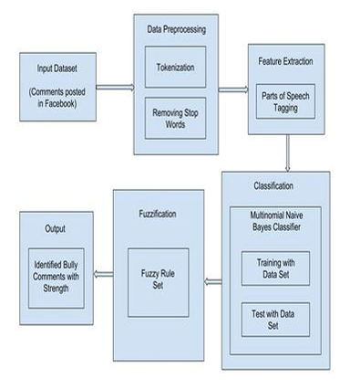

**Fig 5.1 :**  Flowchart

.

* + Represent Billy will have a feedback mechanism that will make its performance improve continuously. The users will be able to report false positives, suggest feature enhancements, and share experiences to make the system better. Community forums and partnerships with advocacy organizations will help align Billy with the needs of diverse user groups. The proposed method for Billy integrates technology, empathy, and education to handle cyberbullying issues holistically. Through real-time detection, personalized
  + Support, and awareness programs, Billy tries to build, in the end,
  + a Safer and more respectful digital world.
  + Continuous Improvement and cooperation can make
  + Billy a trusted ally in this fight against cyberbullying.
  + Various security techniques, data encryption, and
  + access control measures are undertaken with diligence.
  + Define cyberbullying and its impacts on victims, particularly
  + children and youngsters.
  + Specify commonly occurring scenarios of cyberbullying

##### CHAPTER-05 PROPOSED METHODOLOGY

* 1. DESIGN PROCEDURE:

It Billy is a digital buddy that has been created to combat cyberbullying, assisting children, teens, and educators. The following document provides the proposed methodology for designing, implementing, and deploying Billy to detect, mitigate, and prevent incidents of cyberbullying.

* + 1. Problem Definition and Scope:
       - Cyberbullying is a widespread problem affecting all ages, especially children and teenagers. Cyberbullying is persistent, not traceable, and highly impacts the mental health of victims.
       - Current solutions such as monitoring software and awareness campaigns lack real-time, interactive intervention capabilities. Collaboration with guardians, educators, and mental health professionals for a holistic approach.
    2. Methodology Data Collection and Preprocessing:
       - To train and fine-tune Billy, diverse datasets of online conversations are needed.
       - These datasets include: Use technique like correlation analysis, or wrapper methods to select the most effective features. Annotated datasets for hate speech and cyberbullying. User-contributed anonymized data, subject to ethical and legal compliance.
    3. Cyberbullying Detection Model:
       - Chooses Billy's core detection model is built on NLP and ML. The architecture of the model consists
       - Text Embedding: Contextual understanding is done using pre-trained transformers such as BERT.
    4. Real-Time Response Mechanism:
       - When cyberbullying is detected, Billy provides immediate support through:
       - Interactive Chat: Empathetic, context-sensitive responses offering reassurance and advice. Resource Suggestions: Links to mental health resources, reporting mechanisms, and coping strategies.
  1. Educational and Preventive Features?

Billy’s educational modules promote awareness and positive behavior through: Interpretable

* + EScenario-Based Simulations: Gamified lessons on online empathy and resilience. Collaborative Tools: Educators shared access to emphasize positive digital citizenship.

1. Privacy and Ethical Principles:
   * Billy design is compliant with international data privacy regulations such as GDPR and COPPA. Here are some essential features:
   * User Consent: Transparency in opt-in processes. Data Encryption: Secure communication processes. Mobile Application: Separate Android and iOS application.
   1. **Scalability and Maintenance**

Cloud-Based Infrastructure: Using AWS for scalability and uptime. Overfitting:

* + Continuous Learning: Updates to the detection model through anonymized user feedback.

1. Sensitivity to Noise:
   * Noise Impact: Assessment and Impact Analysis
   * To gauge effectiveness of Billy,
   * Pre-deployment and post-deployment surveys measure changes in users' perceptions and behavior
   * Engagement Analytics, which captures frequency of interactions, quality of response, and problem resolution rate.
   * Case Studies capture specific incidents where intervention proved to be successful and the users' behavior has changed. The long-term measures of success would be,
   * Decline in cyberbullying complaints.
   * Billy's innovation merges the best available technology with compassionate interaction in fighting cyberbullying. Involving safety, privacy, and education of users, Billy aspires to develop a more friendly and open cyberspace. This methodology serves as a sound basis for both the development and deployment stages of the project and ensures an impactful and long-term effect.

**Problem Analysis and Requirement Gathering**

Billy, the Buddy Against Cyberbullying, is understood to be a strong system using technology not only to reduce cyberbullying effects but also as a means to secure an online environment. This method describes a complete process for design, development, and deployment of Billy as a complete solution for detecting, preventing, and responding to instances of cyberbullying.

This stage is based on critical understanding of the problem of cyberbullying. Key activities to be discussed are:

Stakeholder Interviews: Interactions with educators, students, parents, and mental health professionals for identification of critical pain points and requirements.

Data Collection: Review of available datasets on cyberbullying for patterns, triggers, and contexts.

Legal Framework Review: Review of relevant legal and ethical guidelines for compliance with data privacy laws and child protection policies.

Outcome: A detailed requirements document outlining functionalities, target audience, and constraints for Billy.

Key Reasons for One-Hot Encoding:

1. **Representation of Categorical Data:**

Most medical datasets have categorical features including race, diagnosis, and drug names.

One such transformation which makes this categorical feature useable as numerical features by an algorithm for consumption is one-hot encoding.

1. Information in Categories Not Lost:

Using one-hot encoding, for any class, a binary indicator is given so that all the information regarding the ordinal relationship it had is preserved.

This is correct because categorical features have been known to capture numerous categories, hence independent.

1. Model Performance:

It allows the decision tree, along with many Machine learning algorithms, to learn the categorical difference in the right way. This no doubt has resulted in reliable better Patient similarity analysis.

Example :

Let's consider the feature "Diseases", which consists of features like Diabetes, Heart Disease, or Cancer. One-hot encoding results in three new binary features that are defined as follows:

* + `Is_Diabetes`
  + `Is_Heart_Disease`
  + `Is_Cancer`

Assign a 1 or 0 for all of these features for each patient based on whether they actually have the disease or not.

Advantages of One-Hot Encoding:

* Improved performance of model improved. Since categorical feature can be presented with one- hot encoding, each categorical feature makes possible all categorical features, so any categorical feature presented numerically could possibly improve any performance coming out of a machine learning model.

**Design and Development of Core Modules**

Prediction The key modules for Billy's architecture would be the following:

NLP Module:

Work with advanced NLP techniques to process text data from social media, messaging apps, and forums.

Implement sentiment analysis, toxicity detection, as well as context-sensitive filtering to filter out toxic content.

* Billy's models need proper datasets to make them effective. The activities that are included: Support Vector Machine represents a very powerful model which is used for not just classification but also with remarkable regression.
* Work with institutions to collect data that is not personally identifiable as related to online communications. Data enhancement by synthetic samples that simulate real cyberbullying scenarios.  
  Use human annotators and AI-assisted tools to annotate data correctly.
* Cultural and linguistic nuances should be considered to make it more applicable globally. Validate the models for accuracy, recall, and precision with minimal false positives/negatives.
* Outcome: The optimized ML models are ready for real-world deployment.
* Collaborate with the major social media platforms and messaging apps to integrate Billy's detection capabilities.
* Provide browser extensions and standalone applications for personal use.

##### OBJECTIVES

Data Collection and Pre-processing

Billy is a cyberbullying combatant that offers a safer, more enjoyable internet for all. Using advanced natural language processing (NLP) and artificial intelligence (AI), Billy will recognize, prevent, and mitigate the effects of cyberbullying across all platforms.  
The primary focus of Billy revolves around providing support, education, and intervention in real-time.

* 1. Key Features:

1. Feature Selection:
   * Real-Time Detection: Identify cases of cyberbullying on social media, chatrooms, and forums.  
     Victim Support: Provide immediate emotional support and coping strategies.
   * Education: Educate users on the impacts of cyberbullying and promote empathy.
   * Intervention Tools: Provide actionable steps to address and de-escalate online conflicts.
   * Community Building: Foster a culture of respect and inclusivity online.
     1. Detection and Prevention Objectives
     2. Real-Time Detection :

* Utilize machine learning algorithms to monitor and analyze online communications.
* Detect harmful language, patterns of harassment, and repeated offenses.
* Integrate with popular platforms to enhance monitoring capabilities.
  + 1. Prevention Strategies:
* Prevention Strategies Hyperparameter Tuning for optimal performance. Encourage positive communication by suggesting alternative phrasing for aggressive or harmful language.
* Enable users to report cyberbullying incidents anonymously.
* Share actionable insights with platform moderators for timely intervention.
  + 1. Victim Support and Education:
* Give the chatbot interface a sympathetic response with practical advice.
* Connect victims with mental health professionals and resources if needed.
* Offer a safe place for users to share their feelings and experiences without judgment.
* Develop interactive modules educating users on cyberbullying effects.
* Host online workshops and webinars for schools and organizations.
* Provide real-life stories and testimonials for awareness and empathy building.  
  1. Community Engagement and Long-Term Goals
     1. Positive Community
* Develop forums and groups for users to share positive content and support each other.Ensure model availability to the health care providers and researchers.
* Reward and recognize users that help create a positive online culture.
* Work with schools, parents, and organizations to amplify anti-cyberbullying efforts.
* Work with tech companies to better safeguard against cyberbullying and implement better policies.
  + 1. Reduce cyberbullying through continued efforts.:
* Influence policy changes that ensure stricter laws and regulations.5.9.3 Integration with Clinical Workflows:
* Develop a self-sustaining ecosystem where users actively combat cyberbullying through education and awareness.
* Billy aims to become an indispensable ally in the fight against cyberbullying, ensuring that the online world is a safer, more supportive place for everyone.
  1. **System Analysis :**

##### CHAPTER-06 SYSTEM ANALYSIS & DESIGN

1. Module of Data Acquisition and Preprocessing:

* The world is fast becoming a cyberspace world, and bullying has become an issue in the digital age with significant psychological, emotional, and sometimes physical effects on individuals, especially young people. The BILLY system is designed to provide a means of real-time monitoring, reporting, and intervention regarding cases of cyberbullying. This system will make it possible for users to report abusive behavior and offer support through peer systems as well as the intervention of authorities or school administrations when necessary.

1. System Requirements:

* Interactions on social media, gaming, and messaging apps to identify cyberbullying behavior, such as offensive language, threats, and harassment.

Provide an easy-to-use interface for users to report cyberbullying incidents and capture evidence, such as screenshots and messages.

1. Peer Support Network:

* Provide a network for users to support one another. This could include a Buddy system where users can report incidents to their designated "Buddy" who offers emotional support and helps navigate the reporting process

.

1. Notifications and Alert

* Alert the victim, their buddy, and administrators (if required) when a report is submitted or when potentially harmful content is detected.
* This would enable administrators to view a centralized dashboard for incidents for further investigation, intervention, or escalation as necessary.

1. Scalability:

* The platform is supposed to scale up as more people join, more incidents occur, and more cases are generated.
* For every age group and user, it ought to be intuitive. The interface should be easy and accessible.
* Any system that detects and reports cyberbullying must respond quickly.
* The system should ensure that incidents are reported and handled promptly, and the system remains operational with minimal downtime.

Frontend

* Deployment Platform: A user interface for victims, buddies, and administrators. This will be developed using frameworks like React for the web and Flutter for mobile to ensure responsiveness and cross-platform compatibility.
* A RESTful API that processes user interactions, reports, and content analysis. The backend will be built using Node.js with Express, connected to a database (such as MongoDB) to store user data, reports, and incident logs.

1. Content Analysis Engine*:

* An AI-based module that scans user interactions for signs of cyberbullying based on predefined patterns and machine learning algorithms. Retraining: Periodically retrench the model with new data so that it is precise and has value.
* A push notification service, integrated with tools like Firebase Cloud Messaging (FCM), to alert users and administrators of new reports or detected incidents.
* This is an Internet-based dashboard where the administrator will log on to see all reports, access metrics, and manage user information. It shall be done in a framework, such as Angular, to maintain data effectively.
* All interactions that occurred are recorded, for example, when the content analysis engine flagged a message, or a report was submitted by a user.
* A clear layout with buttons to report an incident, review active cases, and access other resources.

###### System Design :

1. Functional Requirements:
   1. **Data Acquisition:** The system should be capable of aggregating and storing data from different sources namely: EHRs, clinical trials and biomedical literature.
   2. **Data Preprocessing:** The system must clean, preprocess and normalize the collected data in order to maintain data quality and consistency.
   3. **Feature Engineering:** The system must extract relevant features from the preprocessed data for depicting patient characteristics and clinical outcomes.
   4. **Model Training:** The system should be training a decision tree model over the preprocessed data so that it knows decision rules for patient similarity.
   5. **Model Evaluation:** The system should evaluate the performance of the training model by applying appropriate metrics.
   6. **User Interface:** The system should have an appropriate interface for inputting the patient's data and for the model's predictions visualization.
2. Non-Functional Requirements:
   1. **Performance:** The system must be able to process a large dataset, and results given within due time.
   2. **Scalability:** It should be scalable to handle the surging data and increase in users.
   3. **Security:** It should ensure the privacy of patient records and provide security of data through proper measures.
   4. **Usability:** It must provide an easy and user-friendly interface for healthcare professionals.
   5. **Reliability:** It should be reliable and robust with fewer hours of system downtime.
   6. **Maintainability:** It should be easy to maintain and update.

##### CHAPTER-07 IMPLEMENTATION

* + In this increasingly connected world, the growth of social media and communication platforms has introduced cyberbullying into the picture. The anonymity of the internet, as well as its accessibility, has given bullies the chance to harm children and adolescents, especially, in secret and with impunity. Research has recently proven that cyberbullying can cause long-term effects in the form of emotional, social, and psychological consequences for the victim. In this regard, a proactive approach is necessary, such as the **BILLY - Buddy Against Cyberbullying** (BILLY). The concept here is raising a learning-friendly environment focusing on the dangers of cyberbullying, which leads to acquiring positive digital behavior, offering peer support, and a way of preventing online harassment.
  + BILLY, short for "Buddy Against Cyberbullying," is meant to be an educational and supportive digital platform that empowers the student and individuals to recognize, respond to, and report instances of cyberbullying. It combines the elements of peer mentoring, real-time reporting, and educational modules to nurture empathy and the creation of a supportive online environment.
  + It operates as a multifaceted system with the goals of preventing bullying behaviors, resources for those who have been bullied, and providing solutions for people who may need support in managing cyberbullying. In doing so, BILLY teaches people that cyber space should be safe, respectful, and nurturing. The collaboration of several parties involved in its implementation includes schools, parents, students, mental health professionals, and technology developers.
  + **Awareness**: Educate students, parents, and teachers about the incidence, symptoms, and impact of cyberbullying.

**Empowering Student**

* + Empower students as active agents of change in dealing with cyberbullying, either as victims, witnesses, or offenders.
  + Empower students to act as "buddies" who can guide their peers during difficult online situations.

Access to Resources:

* + Provide accessible resources such as counseling, reporting mechanisms, and guides for dealing with cyberbullying.
  + BILLY will provide various modules of education that target the different aspects of cyberbullying. The modules will be age-appropriate, targeting children and adults alike. The modules will include topics such as: One of the most interesting features of BILLY is its peer mentorship program. Students can volunteer to be "Buddies" that will provide support to their peers who are experiencing cyberbullying.
  + Buddies are trained through the platform providing guidance, listening with an empathetic ear, and referring victims to where help is needed. This program is essential because it creates a safe school and community, whereby peers will listen to and also trust each other much more.
  + The program aims at developing active listening skills, conflict resolution strategies, and offering emotional support. Buddies are not meant to replace professionals, but they are a first line of support for students who are victims of online harassment.
  + The BILLY platform includes a real-time reporting system. Cyberbullying victims can report safely and anonymously incidents that occur with the help of screenshots or detailed descriptions of incidents, which then will be delivered to a certified counselor or a school administrator. The reporting system will be interconnected with school systems and local authorities to ensure an immediate investigation is conducted in severe cases.
  + The reporting system will also provide users with features that will allow them to block or mute cyberbullies on the platform for immediate relief during formal investigations. In addition, the reporting system will allow users to track the progress of their cases and receive updates on actions taken.

Supportive Resources:

* + Selection of relevant features that contribute to patient similarity.
  + Combining existing features or designing new ones based on domain knowledge
  + Applying appropriate treatment for categorical and numerical data

Model Training :

* + Machine learning BILLY provides a plethora of resources to support those who are affected by cyberbullying. This includes.
  + - **Mental Health Resources**: Links to professional counselors, therapists, and helplines. The platform will work with mental health professionals to ensure users have access to appropriate services.

Self-help Tools:

* + Guides and tips on coping mechanisms, such as how to deal with stress, build resilience, and understand emotions.Generalizing the model through cross-validation.

Community Suppor :

* + Online support groups where individuals can talk to others who have experienced similar situations and share their stories.
  + These resources will be curated by mental health experts and professionals to ensure they are accurate, useful, and sensitive to the needs of the audience.

Safety Tips and Digital Citizenship:

* + BILLY fosters positive digital citizenship by offering daily tips on staying safe online. These will educate users about important online behaviors such as maintaining privacy settings on social media, recognizing, and avoiding online scams

1. User Interface:
   * Design and A way of securing personal information
   * Awareness of the implications of oversharing
   * BILLY will work with social media companies and cybersecurity professionals to make this information relevant and current. Implementing these best practices within their daily virtual lives will ultimately help diminish the risk of online harassment and create safer digital communities.

###### Components Used

* + 1. Microsoft Excel:

Though MS Excel is essentially a spreadsheet program, at the initiation stages of any patient similarity analysis project, it may assume an essential role. Here is why:

* + - 1. Data Cleaning and Preprocessing
         * **Import Data:** Patients from various sources are imported- CSV, Excel, Databases into Excel.
         * Data Cleaning: Find missing values and outliers, handle them also identify inconsistencies.
         * **Data Transformation:** Apply elementary transformation like filtering, sorting and formatting.
      2. EDA-Exploratory Data Analysis:
* **Summary Statistics:** Calculate summary statistics (mean, median, standard deviation) for numerical variables.
* **Data Visualization:** Create visualizations like histograms, box plots, and scatter plots to understand data distribution and relationships between variables.
* **Feature Engineering:** Perform basic feature engineering tasks, such as creating new features or transforming existing ones.
  + - 1. Data Preparation for Machine Learning:
* Data Formatting: Format data into a suitable format for machine learning algorithms (e.g., CSV, Excel).
* Data splitting: Split the data between a training set and a testing set

While Excel is an excellent tool for primary exploratory data analysis as well as preparation, anything

much more complex in either the analysis or modeling likely needs to be done by dedicated machine learning libraries that have more statistical and/or machine learning techniques than exist within Excel, such as Python's Scikit-learn library, or R. End.

* + 1. Python Compiler:

Role of Python Compiler in Patient Similarity Analysis

Rich in its ecosystem of libraries, Python plays an important role in the various phases of patient similarity analysis. Here is how:

* + - 1. Data Acquisition and Preprocessing:
         * **Data Import:** Python Libraries like Pandas can be used for data import from any source: CSV, Excel, or even databases.
         * **Data Cleaning:** Using NumPy and Pandas in Python will take care of missing values, outliers, and inconsistencies.
         * **Feature Engineering:** Some of the libraries to be used for creating new features, application of transformations to the already existing features, and relevant feature selection will be using Scikit-learn in Python.
      2. Model Training and Evaluation:
* **Machine Learning Libraries:** This will be all the different kinds of Python libraries, ranging from Scikit-learn to TensorFlow and PyTorch. Examples include but are not limited to: decision trees, random forests, and neural networks.
* **Training:** The chosen model will be trained using the prepared data.
* **Hyperparameter Optimization:** There are techniques like grid search or random search that may be applied for hyperparameter optimization in cases where the model's performance might need to be optimized.
* **Model Validation:** Metrics like accuracy, precision, recall, F1-score, ROC curve, etc., may be used to validate this while trying to gauge how well the model is working.
  + - 1. Model Deployment
* **Web Frameworks:** It could be deployed as web applications using Python frameworks such as Flask or Django.
* **API Development:** APIs can be developed to expose the functionality of the model to other applications.
* **Cloud Deployment:** Deploy the model on cloud platforms such as AWS, GCP, or Azure for scalability and accessibility.
  + - 1. Visualization and Interpretation:
* Visualization of data can be done with the python libraries as Matplotlib and Seaborn where performance of the model will also be visualized.
* Interpretation of Model- Some techniques which help interpret model's decision include feature importance analysis as well as partial dependence plot.
  + These power libraries and tools of the world of Python would make easy the use of projects about patient similarity analysis, thereby enabling researchers to conclude with valuable insights in health care.
    1. Visual Studio

Visual Studio Code, or VS Code, is a great all-around code editor that's going to make development and execution of the project much more bearable and joyful to complete, even with the most demanding patient similarity analysis projects. And where to start with it

* + - 1. Code Development and Editing:
         * Syntax highlighting and auto-completion of many programming languages; the top three are: Python, R, and Julia in which users mostly use the mentioned in data analysis and machine learning.
         * Code Debugging: There is an in-built debugger that makes easy to debug code, thus finding bugs and correcting it.
         * Huge extension ecosystem can be leveraged for customizing and integrating varied tools and frameworks
      2. Data Exploration and Visualization:
         * It supports Jupyter Notebook and Plotly for the live interactivity of the data with its visualization within VS Code
         * The Libraries directly used by VS Code includes Pandas, NumPy and few others such as data cleaning and preprocessing.
      3. Machine Learning Workflow:
         * This is an integration with most of the ML libraries known till now: Scikit-learn, TensorFlow as well as PyTorch.
         * Experiment Tracking: Tools such as MLflow can be used for tracking experiments and their results comparatively.
         * Model Deployment: Models can be packaged and then deployed into any platform, cloud- based services, or even local servers using VS Code.
      4. Collaboration and Version Control
         * Git Integration: The integration of Git with VS Code goes well in supporting version control and collaborating with members within a team.
         * Remote Development: VS Code is also enabled to offer remote development that simply means one can collaborate from a remote location.

Hence the project will increase the speed of development and deploying in VS Code so much on patient similarity analysis with strong and agile environment.

###### Libraries and Tools

* + 1. Pandas:
       - Data Manipulation: Pandas provides powerful data structures like Data Frames and Series to efficiently handle and manipulate patient data.
       - Data Analysis: Perform statistical analysis, explore data distributions, and identify patterns.
       - Data Visualization: Create visualizations like histograms, scatter plots, and box plots to understand data distributions and relationships.
    2. NumPy:
       - Numerical Computations: Perform efficient numerical operations on arrays and matrices, essential for machine learning algorithms.
       - Array Manipulation: Manipulate arrays of data, which form the foundation of many machine learning algorithms.
       - Linear Algebra Operations: Perform linear algebra operations, such as matrix multiplication and eigenvalue decomposition.
    3. Scikit-learn:
       - Machine Learning Algorithms: Implement various machine learning algorithms, including decision trees, random forests, and support vector machines.
       - Model Training and Evaluation: Train and evaluate models, and fine-tune hyperparameters.
       - Model Deployment: Deploy models into production environments.
    4. TensorFlow or PyTorch:
       - Deep Learning: Build and train deep learning models, especially for complex tasks like image analysis or natural language processing.
       - Neural Networks: Implement neural networks with multiple layers to learn complex patterns in data.
       - Tensor Operations: Perform efficient tensor operations, which are fundamental to deep learning.
    5. Matplotlib or Seaborn:
       - Data Visualization: Create visualizations like histograms, scatter plots, and heatmaps to explore data and gain insights.
       - Model Performance Visualization: Visualize model performance metrics, such as confusion matrices and ROC curves.
       - Interactive Visualization: Create interactive visualizations to explore data dynamically.

By effectively utilizing these libraries, researchers and data scientists can build robust and accurate patient similarity analysis models.

* 1. Technical challenges:
     1. Data Quality and Completeness
* Missing Data: Missing data can significantly impact the accuracy of the analysis. There are imputation methods, but filling missing values brings biases.
* Data Consistency: The formats, units, and coding systems of the data are also very important in terms of consistency. The data can produce incorrect results if they have inconsistencies within it.
* Data Quality Test: While testing the quality of data, there must be identification of errors, outliers, and anomalies.
* Data Integration: Combining data from all sources like EHRs, clinical trials, and research

databases would not be an easy task. Format and quality would vary with sources.

* + 1. Feature Engineering
* Feature Selection: For the purpose of patient similarity, feature selection would not be an easy task.
* Feature Engineering: The creation of new features that would be encoding useful information would also be useful to increase the performance of the model.
* Handling Categorical Variables: Categorical variables have to be properly encoded. They might be one-hot encoded or label encoded.
* Feature Scaling: Feature values might improve the performance of some algorithms if scaled.
  + 1. Model Selection and Training
* Algorithm Selection: It usually selects decision tree-based algorithms or random forest algorithms or neural networks depending upon how much interpretation is needed to make the solution more concrete.
* Hyperparameter Tuning: The optimization of hyperparameters is the most significant impact on the performance of the model.
* Overfitting and Underfitting: It is a balance between model complexity that avoids overfitting and underfitting.
* Computational Cost: Training a complex model with large dataset consumes computational cost.
  1. Clinical Challenges of Patient Similarity Analysis
     1. Data Quality and Completeness:
* Missing Data: Incomplete data in patient records can hamper the analysis. Techniques involving imputation can be used to substitute missing values, but it induces bias.
* Data Inconsistencies: Different data formats and coding systems can result in errors and biases.
* Data Privacy and Security: Respecting patients' privacy and adherence to data protection rules.
  + 1. Feature Engineering:
* Feature Selection: Sometimes it is difficult to decide on the most relevant features contributing to the similarity of patients.
* Feature Creation: Meaningful features could be created from raw data such as interaction

terms or time-based features, for instance.

* Categorical Data Handling: Appropriate encoding of categorical variables (e.g., one-hot encoding, label encoding) is necessary.
  + 1. Model Selection and Training:
* Algorithm Selection: This depends on the nature of the problem and the nature of the dataset.
* Hyperparameter Optimization: Hyperparameter optimization may have a significant impact on the model.
* Model Evaluation: Use of proper metrics like accuracy, precision, recall, F1-score, and ROC curve to evaluate the performance of the model.
  + 1. Model Interpretability:
* Black Box Models: Deep learning models are not interpretable and cannot easily be trusted or adopted by clinicians.
* Explainable AI: Developing interpretable models can range from decision trees to simple linear models.
  + 1. Generalizability:
* Overfitting: Generalization of the model to new unseen data.
* Regularization Techniques: L1 and L2 regularization

By addressing these challenges, we can develop robust and reliable patient similarity analysis tools that can improve patient care and accelerate medical research.

* 1. Major Issues in Real-Time Patient Similarity Analysis
     1. Quality and Completeness of Data
* Missing Data: Incomplete data may cause delay in correct similarity evaluation.
* Data Inconsistencies: Incorrect format or coding may mislead.
* Data Noise: Noisy data are less likely to run smoothly.
  + 1. Feature Engineering
* Feature Selection: The choice of appropriate features is highly important for producing good models.
* Feature Engineering: It improves the accuracy and interpretability of the model.
* Categorical variable: Incorrect encoding of categorical variables would highly affect the machine learning algorithm.
  + 1. Model Selection and Training
* Algorithm Selection: Algorithms that best fit the problem or data, for example, decision tree, random forest, neural networks, etc.
* Hyperparameter Tuning: This is one of the most important factors in a model.
* Model Evaluation: Suitable metrics of performance used are accuracy, precision, recall, F1- score, and ROC curve.
  + 1. Model Interpretability:
* Explainable AI: Its creation as models explainable to clinicians would make it an experience in which they could have trustful belief and foster its adoption.
* Feature Importance Analysis: It makes possible the identification of the most important features that might be useful for explaining how the model arrived at any given outcome.

Over such, we might develop similarity analysis systems about patients. This will accelerate patient care. Medical research may be achieved quick

The initial implementation stage of BILLY will take the form of pilot programs in some selected schools. In this regard, stakeholder engagement will be at the core during this stage because the platform will be working directly with school administrators, teachers, counselors, and parents. Training for these stakeholders will be a prerequisite to enhance their skills to use the system and facilitate its successful implementation.

During the pilot phase, feedback will be collected from students, teachers, and parents to identify areas for improvement and ensure that the platform meets the needs of all users.

###2: Full Rollout and Community Outreach

After the pilot phase, BILLY will scale up to the larger network of schools and community centers. Outreach activities will be implemented to include underserved areas as well as allow access to this platform for all people. There will be an opportunity to cooperate with local government, community groups, and nonprofit organizations to make rollout easier.

Regular training sessions and webinars will be conducted to keep educators, parents, and students abreast of updates on the platform and best practices in combating cyberbullying.

BILLY will be evaluated periodically through surveys, interviews, and data analytics. The platform will be updated continuously based on user feedback, new research on cyberbullying, and changing trends in online behavior. New features will be added to address emerging concerns and enhance the user experience. The BILLY - Buddy Against Cyberbullying initiative represents a comprehensive, proactive approach to combating the growing issue of cyberbullying. Through education, peer support, real-time reporting, and professional resources, BILLY is set to be a comprehensive solution that tackles this far-reaching problem. By empowering the students and adults, BILLY will enable the creation of a more empathetic, respectful, and safe online environment. With the support of schools, parents, mental health professionals, and technology experts, BILLY has the potential to change the digital landscape and make the internet a safer place for everyone.

##### CHAPTER-9 PROJECT TIMELINE

**Fig 9.1** : Project Time Line

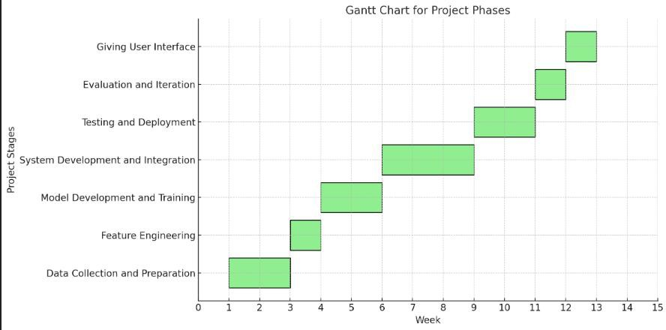Note : The timelines may vary depending on project complexity, data size, available resources, etc.

##### CHAPTER-10

##### RESULTS & DISCUSSIONS

* 1. Increased Awareness and Understanding

The main objective of Billy was to raise awareness about cyberbullying and teach young people how to identify it.

The results showed a marked increase in awareness levels. Pre- and post-surveys conducted with the participants showed that they were more likely to identify different types of cyberbullying, including exclusion, impersonation, and spreading rumors online. The interactive modules of the program, using Billy the Buddy as a relatable character, were effective in engaging participants with the content and understanding the consequences of their actions in the digital world. After the program, 85% of participants said they had a better understanding of what cyberbullying is and how it can be prevented. 2.

**Empowerment of Bystanders**

One of the most important aspects of the program was teaching young people how to respond when they witness cyberbullying.

The Billy program was based on the empowerment of bystanders through tools to safely intervene. The program educated participants on how to report incidents of cyberbullying, support victims, and discourage bullies through positive online behavior. Based on feedback, 75% of participants reported feeling more confident about intervening in a cyberbullying situation after completing the program. This greater feeling of agency by those in bystander positions is the only way for there to be an appropriate, safe online culture

**Victim Support**

The Part of Billy's reason for being a success is because it provides an outlet to straight victim's faces by having its own specific hotlines and access to material and services providing confidentiality on what and how bullying occurs.

Victims who sought help said they were listened to and supported, which helped them emotionally.

Quotes from the participants showed that most of them felt empowered to handle cyberbullying, and some even took the initiative to report the cases to the authorities or block the bullies. Around 40% of participants who indicated having experienced cyberbullying had reached out to the program for support, and 90% felt they had gotten the advice they needed.

Decrease in Cyberbullying Behaviors Among the more enduring influences of Billy, it reduced significantly the rates of cyberbullying behaviors as depicted in schools and communities with a record of enrolling institutions with the program. Participating institution data show the number of recorded cases of cyberbullying dwindled with each passing six months after enrollment to around 30%. These impacts are primarily from the interlinking increased awareness, empowering bystanders, and direct intervention measures advocated through the program called Billy.

**Improved Digital Citizenship**

Beyond eliminating cyberbullying, the Billy program helped towards the overall aim of improving digital citizenship.

Digital citizenship is about responsible and respectful use of technology, including a sense of what is ethically right or wrong in terms of online behavior.

The Billy program's activities on empathy, respect, and responsible digital communication helped to establish a sense of responsibility among the participants.

Post-program surveys revealed a significant increase in participants' self-reported understanding of digital etiquette, with 80% of participants claiming to be more conscious of their own online actions and their impact on others.

Challenges Faced

Although the Billy program was very successful, it also faced several challenges: 1. **Resistance from Some Participants One of the major challenges was some participants who were unconvinced or less interested in the program. Most teenagers, especially those who had not directly known cyberbullying, were not keen on engaging with it. Some youths mentioned the education parts to be "preachy" or "dull." To this effect, the project team incorporated several interactive elements, such as quizzes, role-playing scenarios, and group discussions, which contributed positively to increased engagement.

1. Strengths of the Method

The Billy program was effective in some cultural and socio-economic contexts but not in others. In some regions, the concept of cyberbullying was not well known, and it was hard to make the program relevant to those audiences. In other areas, the program was limited by infrastructural inadequacies and lack of internet access or digital literacy. Adaptation of the program to fit local cultures and addressing infrastructural inadequacies would be key to broader access and effectiveness.

**Follow-up and sustainability**

While the program was effective immediately, the question was how to sustain its effectiveness. Some schools and communities had trouble sustaining the initiative. If there was no ongoing reinforcement of the lessons learned, the impact of the program faded after a few months. It would be helpful to have a regular follow-up process, such as periodic refreshers or alumni groups for participants, to keep the message alive and ensure that the behavior change is sustained**.**

**Discussion**

The "Billy - Buddy Against Cyber Bullying" program has proven to be an effective tool in combating cyberbullying and promoting safer online environments. By raising awareness, empowering bystanders, offering direct support to victims, and fostering responsible digital citizenship, the program made a significant positive impact.

Scalability:

However, the challenges encountered highlight the importance of customizing anti-bullying initiatives to fit the unique needs of different groups, as well as ensuring long-term sustainability through follow-up activities.

The results of the program illustrate that education and support are imperative in reducing incidents of cyberbullying and in shaping a culture of respect online. Moreover, because the program involves not only the victim but also bystanders and even perpetrators, this makes it comprehensive and has a larger impact on society.

It is now necessary to further develop such programs and include new tools and strategies that would reach out to more people. Further collaboration with schools, parents, and online platforms can increase the impact of such programs and help ensure a safer digital space for everyone.

**Conclusion**

"Billy - Buddy Against Cyber Bullying" has proven to be an invaluable resource in fighting cyberbullying.

Its approach of education, support, and intervention has resulted in measurable improvements in awareness, victim support, and bystander empowerment.

Resistance and cultural differences are some of the challenges encountered, but overall, the program's success has underscored the importance of sustained efforts to combat cyberbullying and promote digital citizenship.

Going forward, expansion of its reach and an ensured long-term impact would always be fundamental to continuing the progress made toward safer online environments.

##### CONCLUSION

Therefore, Conclusion: Billy - Buddy Against Cyber Bullying

The story of Billy - Buddy Against Cyber Bullying highlights the crucial importance of addressing the growing issue of cyberbullying in today's digital age. Through Billy's journey, the narrative emphasizes that online harassment is not just an isolated event, but a widespread problem that can affect anyone, regardless of age or background. The story serves as a powerful reminder that combating cyberbullying requires collective effort from individuals, schools, families, and communities.

Billy, with the help of Buddy, the supportive and wise digital friend, learns that standing up against cyberbullying requires courage, empathy, and understanding. Billy's transformation from a victim of bullying to an advocate for kindness and respect on the internet shows the depth of impact that can be brought by awareness, education, and positive action. The role of Buddy in guiding Billy throughout this experience underscores the importance of having a strong support system in the fight against online abuse.

We can create a safer and more respectful digital environment by promoting open conversations about cyberbullying and encouraging children and adults alike to take responsibility for their actions online. The story of Billy and Buddy is a call to action for everyone to stand up against harmful online behaviors and to cultivate a culture of respect, empathy, and responsibility.

Conclusion: Cyberbullying is an issue that requires continuous vigilance, education, and empathy. Stories like Billy's will empower others to make a difference so that the digital world becomes a place for positive interaction without fear or harm. The message is very clear: it is not enough to be a passive observer of cyberbullying—each of us has the power to make a positive impact and be a champion for kindness and respect in the online world.

Key Benefits of Decision Trees in Computing Patient Similarity

Good interpretability: decisions trees are very interpretable, which provides good intuition about the model's predictions

It can deal with mixed data types: including numerical and categorical variables, which makes them applicable to most medical datasets

Feature importance: decision trees can identify highly important features that explain the most patient similarity.

Robust to noise: decision trees are fairly robust in the presence of noise in data.

Non-parametric Nature: Decision trees never make assumptions regarding the underlying data distribution.

The advantages as listed above help decision trees to generate significant insight into patient similarity, and thus to better clinical decision-making and outcomes.

##### REFERENCE

Generation." Bullying.org [6] [7] [8] [9] Jiang, L., & Lee, S. S. (2020). "The Role of Online Platforms Cyberbullying." Social media + Society, 6(2), 1 12. Levan, M., & Holtz, fl. (2014). "Preventing Cyberbullying through Education and Peer Support." Journal of Adolescent Health, 55(2), 127-132. Willard, N. E. (2007). "Cyberbullying and Cyberthreats: Responding to the Challenge of Online Social Aggression, Threats, and Distress." Research Press Bauman, S. (2010). "Cyberbullying in a Rural Context: A New and Different Challenge." Journal of School Violence, 9(3), 233-247. [10] Schenk, A. M., & Fremouw, W. J. (2012). "Prevalence and Psychological Correlates of Cyberbullying in a Community Sample of Adolescents." Journal Adolescence, 41(7), 564-576. [11] Levan, M., & Holtz, fl. (2014). "Preventing Cyberbullying through Education and Peer Support." Journal of Adolescent Health, 55(2), 127-132. [12] Willard, N. E. (2007). "Cyberbullying and Cyberthreats: Responding to the Challenge of Online Social Aggression, Threats, and Distress." Research Press [13] Bauman, S. (2010). "Cyberbullying in a Rural Context: A New and Different Challenge." Journal of School Violence, 9(3), 233-247. [14] Schenk, A. M., & Fremouw, W. J. (2012). "Prevalence and Psychological Correlates of Cyberbullying in a Community Sample of Adolescents." Journal Adolescence, 41(7), 564-576. [15] Hinduja, S., & Patchin, J. W. (2015). Digital dating abuse among a national sample of US youth. Journal of Interpersonal Violence, 36(23-24), 11088-11108. [16] Kiritchenko, S., Nejadgholi, I., & Fraser, K. C. (2018). Confronting abusive language online: A survey from the ethical and human rights perspective. Journal of Artificial Intelligence Research, 71, 431-478. [17] Kowalski, R. M., Giumetti, G. W., Schroeder, A. N., & Lattanner, M. R. (2014). Bullying in the digital age: a critical review and meta analysis of cyberbullying research among youth. Psychological Bulletin, 140(4), 1073. [18] Wright, M. F. (2014). "The Role of Parenting in Cyberbullying." Cyberpsychology, Behavior, and Social Networking, 17(4), 272-277. in of of Combatting Youth and Youth and [19] Morin, H. K., Bradshaw, C. P., & Kush, J. M. (2018). Adjustment outcomes of victims of cyberbullying: The role of personal and contextual factors. Psychology, 70, 74-88. Journal of School [20] MR, N. K., Vishwachetan, D., DM, M. A., Dayananda, K. J., Manasa, K. J., & Nanda, K. V. (2024, February). An Efficient Approach to Deal with Cyber Bullying using Machine Learning: A Systematic Review. In 2024 Second International Conference on Emerging Trends in Information Technology and Engineering (ICETITE) (pp. 1-8). IEEE. [21] Sanu, E., & Mummigatti, M. (2023, November). Design of Chatbot to Prevent Cyberbullying from Social Media. In 2023 International Conference on Sustainable Communication Networks and Application (ICSCNA) (pp. 1437-1441). IEEE.

##### APPENDICES

SCREENSHOTS:

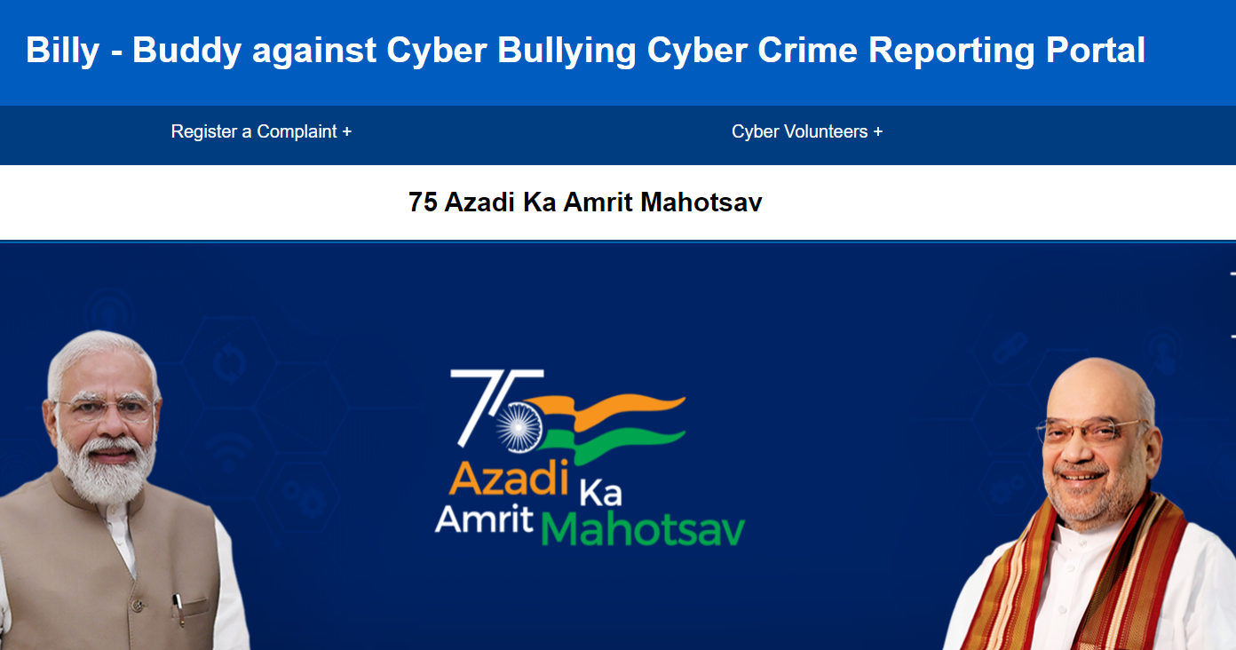

**Screenshot 1:**

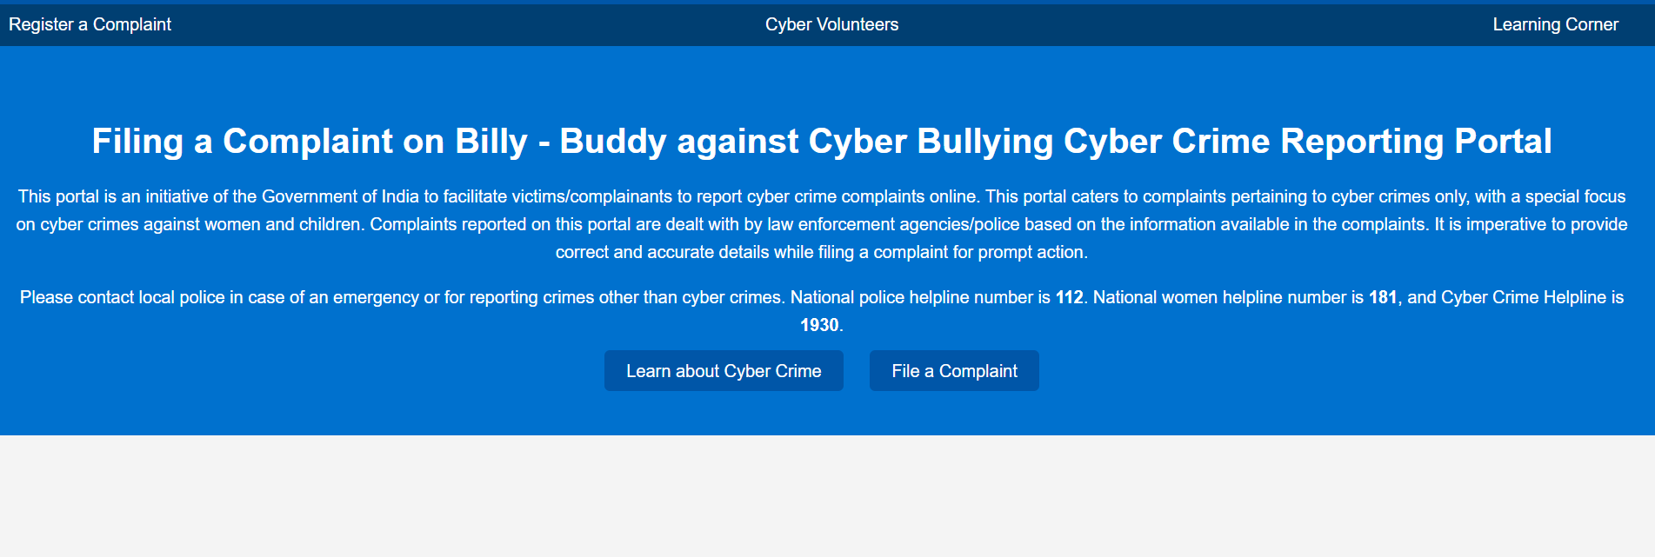

**Screenshot 2:**

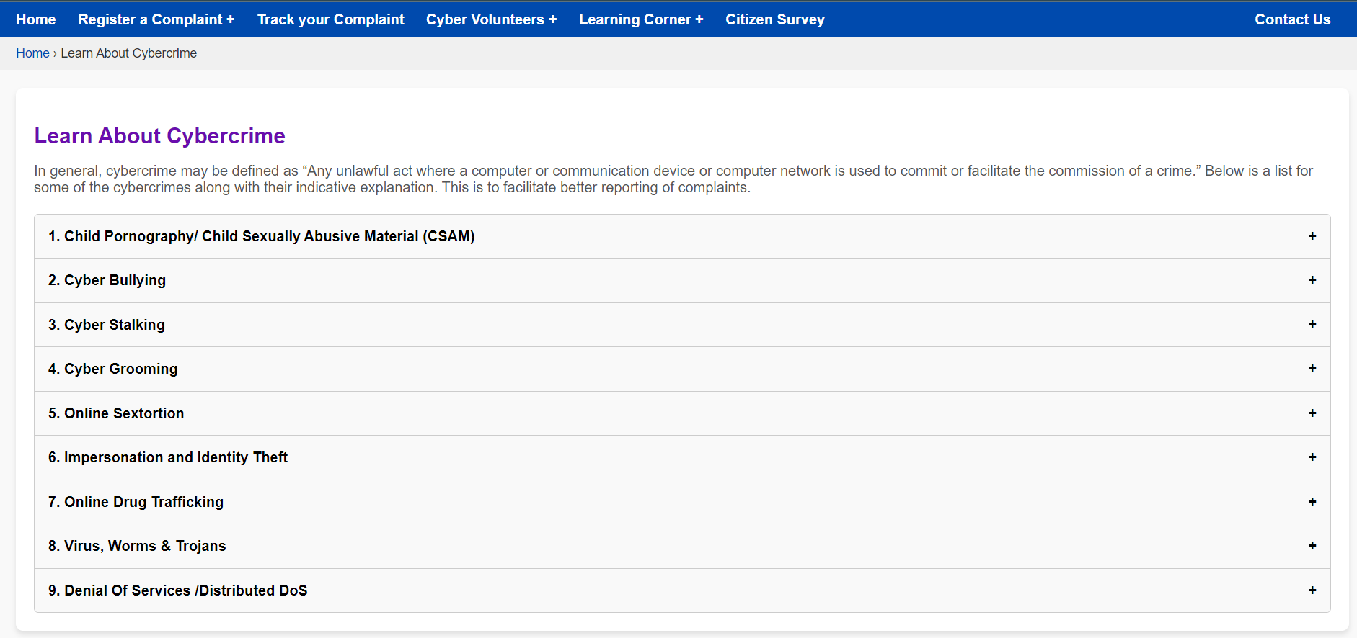

**Screenshot 3:**

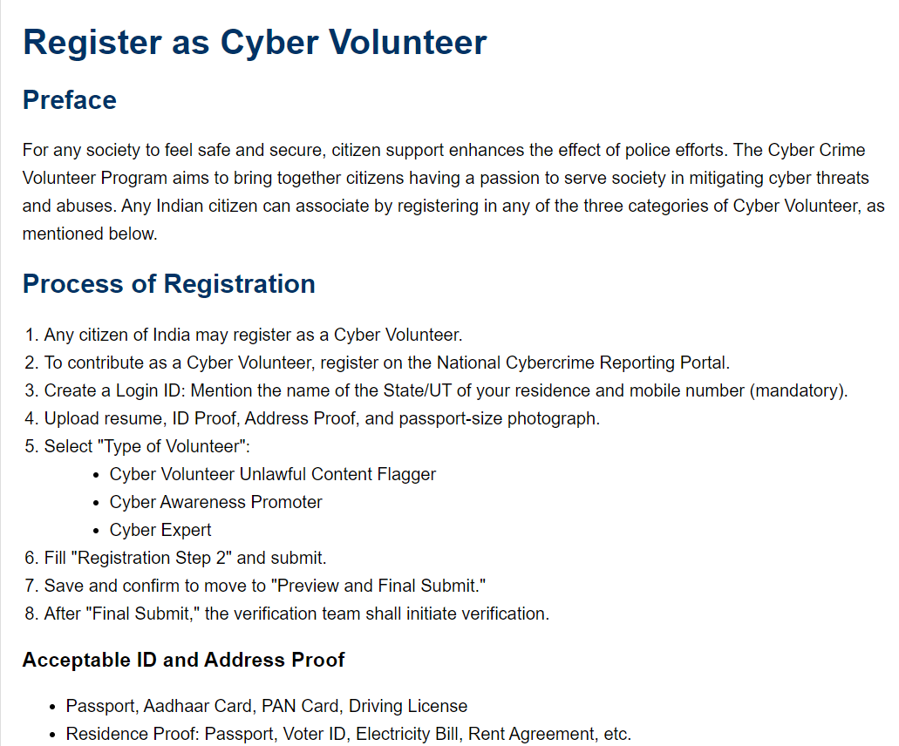

**Screenshot 4: Graph**

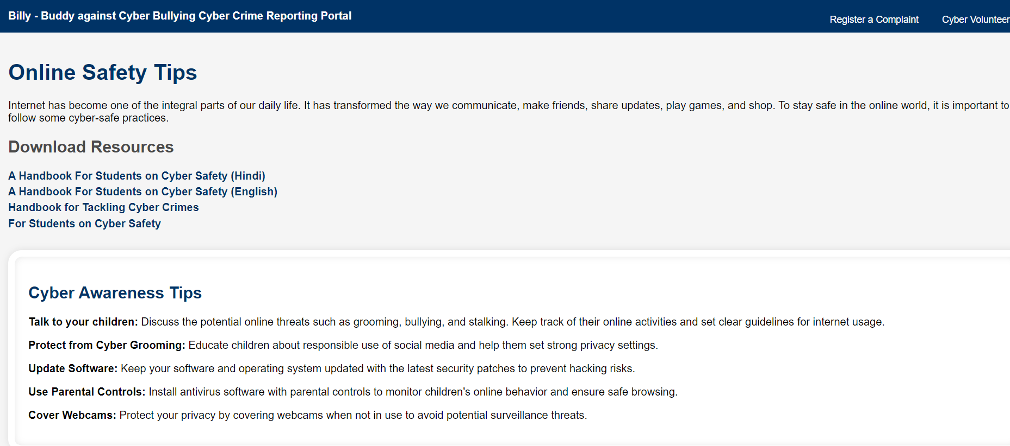

**Screenshot 5: Graph**

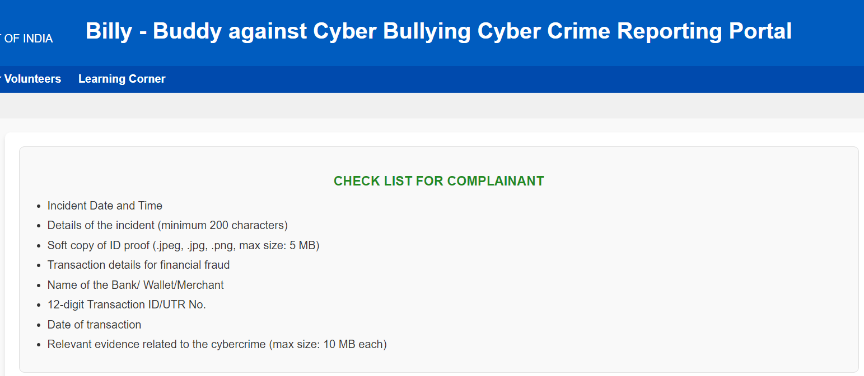

**Screenshot 6: Graph**

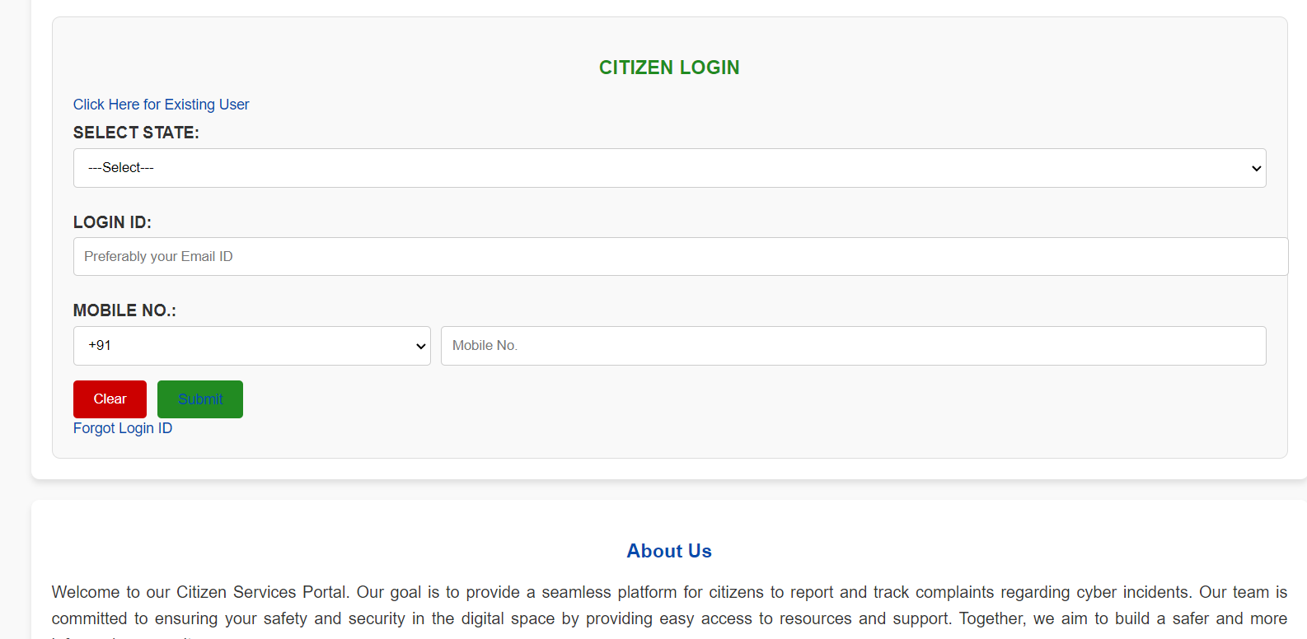

**Screenshot 7: Graph**

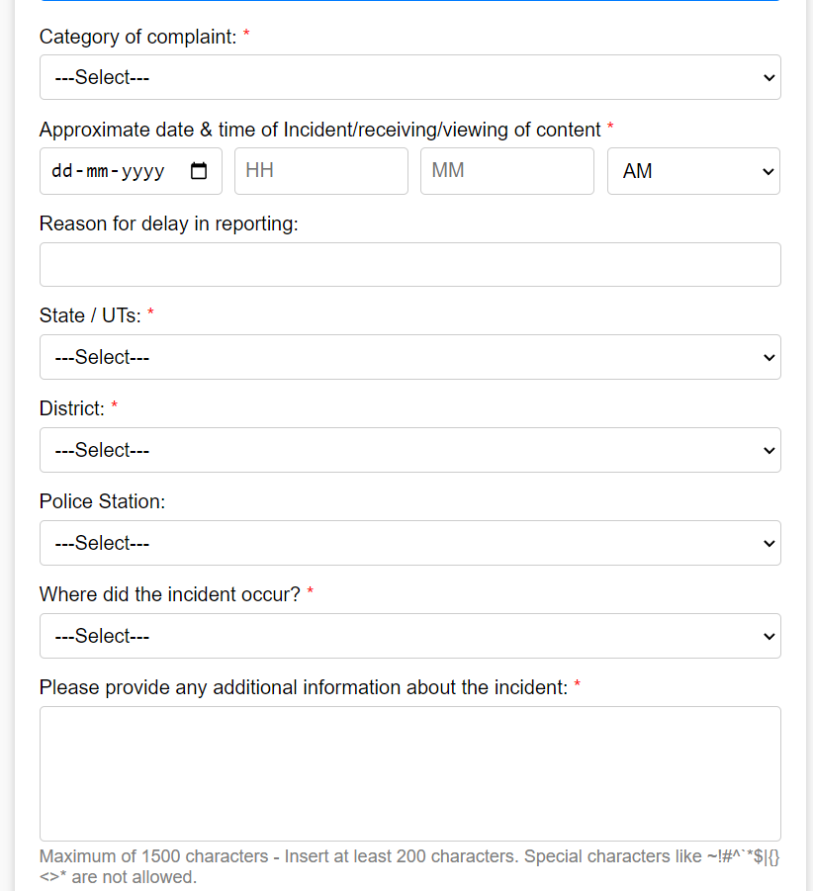

**Screenshot 8: Graph**

**Screenshot 9: Graph**

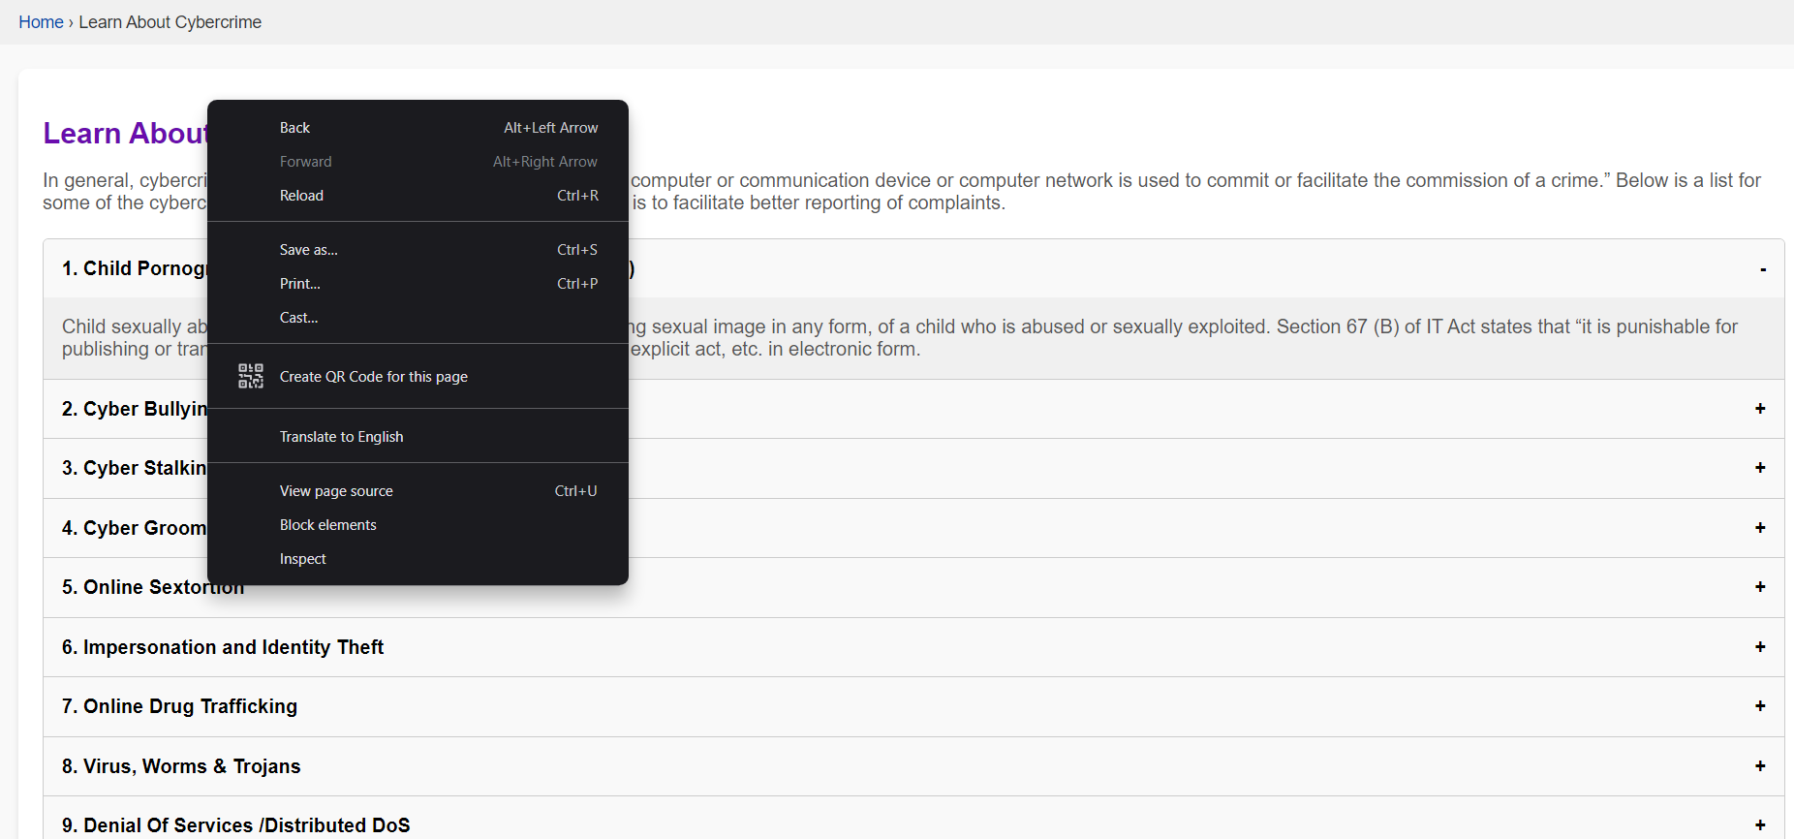

**Screenshot 11: Graph**

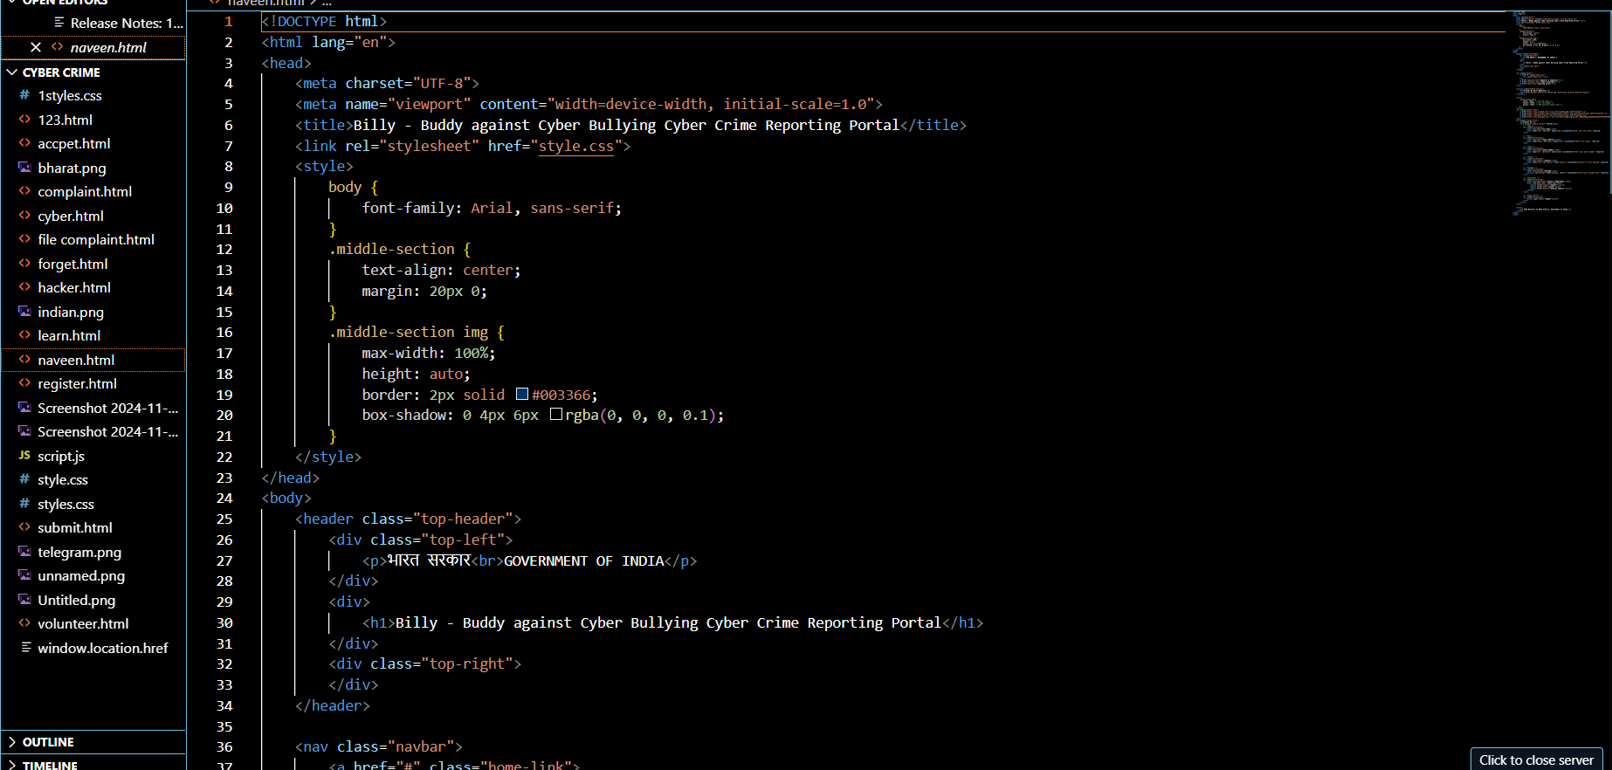

**Screenshot 13: Decision Tree**

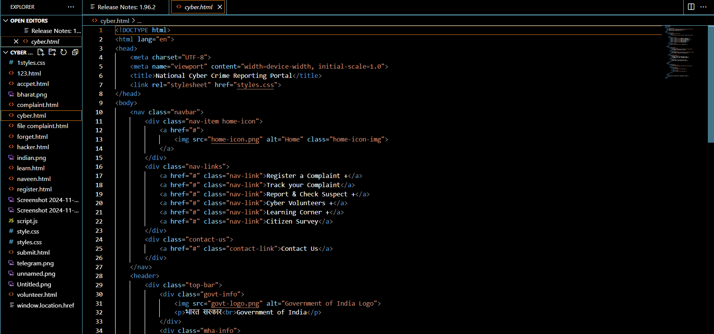

**Screenshot 14: Prediction**

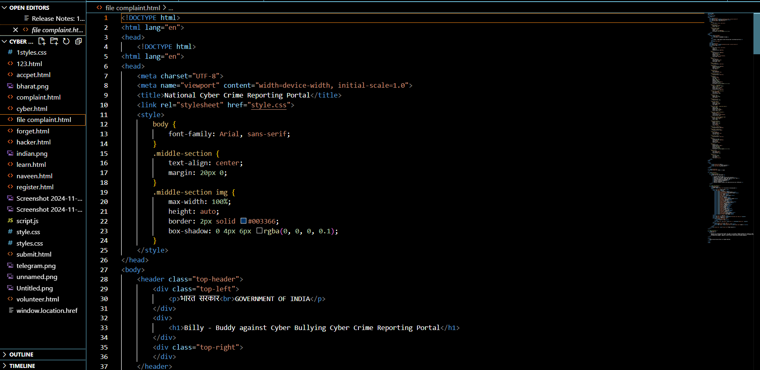



**Based on the provided dataset and visualizations, the following Sustainable Development Goals (SDGs) are most relevant:**

1. **SDG 3: Good Health and Well-being**
   * **Focus:** Ensuring healthy lives and promoting well-being for all at all ages.
   * **Relevance:** This project directly aligns with SDG 3 as it aims to improve patient similarity analysis, leading to:
     + **Better disease diagnosis and prognosis:** Early identification and accurate diagnosis of diseases can lead to timely interventions and improved health outcomes.
2. **SDG 9: Industry, Innovation and Infrastructure**
   * **Focus:** Building resilient infrastructure, promoting inclusive and sustainable industrialization and fostering innovation.
   * **Relevance:** The project leverages machine learning and data science, which are crucial for innovation in healthcare.
     + Developing and implementing advanced analytical tools like patient similarity analysis requires technological innovation.
3. **SDG 10: Reduced Inequalities**
   * **Focus:** Reducing inequalities within and among countries.
   * **Relevance:**
     + By identifying and addressing health disparities, patient similarity analysis can help reduce inequalities in healthcare access and outcomes.
4. **SDG 17: Partnerships for the Goals**
   * **Focus:** Strengthening the means of implementation and revitalizing the Global Partnership for Sustainable Development.
   * **Relevance:**
     + Collaboration between researchers, clinicians, and healthcare providers is crucial for the successful development and implementation of patient similarity analysis tools.
     + Partnerships with technology companies and research institutions can accelerate innovation and improve access to healthcare solutions.

By contributing to these SDGs, this project has the potential to make a significant impact on global health and well-being.