Financial Ecosystem Restoration
Restoring Global Banking Post-2065 Crisis
Date: July 22
Prepared for: Duothan 6.0
Prepared by: Team BigBug

Table of Contents

- Problem Identification
1.1 The Core Crisis: Ecosystem-Wide Paralysis
1.2 Socio-Economic Impact and Affected Users
1.3 The Specific Problem Our Solution Will Solve
- Proposed Solution
2.1 Platform Overview
2.2 How Our Solution Directly Solves the Identified Problem
2.3 Securely Restoring Financial Services
2.4 Core Features
2.5 Multi-Layered Security Architecture
2.6 Threat Model
2.7 Disaster Recovery Strategy
2.8 Innovation & Differentiators
2.9 Value Proposition Summary
- System Architecture Diagram
3.1 Full System Architecture
3.2 Transaction Data Flow (FR-15)
3.3 Secure Communication & Data Flow
- Wireframes Design
4.1 Design Principles Applied
4.2 User Flow
4.3 Screen Summary
4.4 Design Tool & Access
- Functional Requirements
5.1 Authentication & Security
5.2 Account Management
5.3 Transactions & Payments
5.4 Loan Management
5.5 Fraud Detection & Security Alerts
5.6 Notifications
5.7 Administration
5.8 Requirements Summary
- Non-Functional Requirements
6.1 Security (CRITICAL)
6.2 Disaster Recovery (CRITICAL)
6.3 Performance
6.4 Scalability & Cloud Infrastructure
6.5 Monitoring & Observability
6.6 Accessibility & Usability
6.7 Compliance & Regulatory
6.8 Requirements Summary
- Technology Stack Selection
7.1 Technology Stack Diagram
7.2 Detailed Justification Table
7.3 How the Stack Supports Key Requirements

1. Problem Identification

1.1 The Core Crisis: Ecosystem-Wide Paralysis
The 2065 cyber disaster orchestrated by the Super Malware Agent has brought the financial sector to a complete standstill. Core banking systems, ATMs, digital payment platforms, and loan systems have completely stopped working. While customer databases remain safe because of secure backups, meaning no user information has been lost—the Master Key needed to unlock the banking network is hidden behind strong security layers.

Root Cause: The major vulnerability of the old system was its reliance on a centralized, single-server architecture. Because all banking functions were tied together in one place, it allowed the malware to easily take down the entire network. Rebuilding the old system as it was is not an option; without shifting away from this single-server model to a scalable architecture featuring independent services, a future malware attack could easily cause another total system failure.

1.2 Socio-Economic Impact and Affected Users
This technological failure has generated severe real-world consequences, creating an urgent need for intervention:

- Impact on Small Businesses: Small businesses are completely unable to process digital transactions.
- Forced Reliance on Cash: Millions of people have abruptly lost access to essential financial services, forcing the public to rely entirely on physical cash.
- Economic Stagnation & Inequality: The widespread loss of secure banking has actively slowed global economic recovery. Furthermore, the lack of digital access has directly increased financial inequality across the world.

1.3 The Specific Problem Our Solution Will Solve
Customer databases remain safe because of secure backups, meaning no user information has been lost. However, the Master Key needed to unlock the banking network is hidden behind strong security layers.

The Defined Banking Problem: Rebuilding the old system is not enough. The specific problem we are solving is the urgent need to design, build, and deploy a secure, reliable, and inclusive financial platform from the ground up. This new platform must restore daily banking operations, protect customer data, and support secure transactions. Furthermore, it must utilize a scalable architecture with independent services, ensuring that a future malware attack cannot take down the entire system again.

Design Imperatives for the New System:

- Isolation & Scalability (Microservices Architecture): The system must be built on a scalable architecture utilizing independent services (microservices) so that a single point of failure does not result in total ecosystem paralysis.
- Modern Security: The platform must use modern cybersecurity and intelligent automation to ensure an attack of this magnitude can never happen again.
- Resilience (Cloud & Server Infrastructure): The solution must leverage robust cloud technology and decentralized server environments, incorporating a strong disaster recovery plan to guarantee system reliability.
- Accessibility & Trust: The platform must be an inclusive financial ecosystem that ensures services are accessible to everyone, ultimately restoring trusted digital banking for millions of users.

02. Proposed Solution

2.1 Platform Overview
Our solution is a next-generation, cloud-native digital banking platform engineered to replace the compromised legacy infrastructure. It uses a microservices-first, zero-trust architecture with 15 independent services across 10 architectural layers. Each service operates independently with its own database, ensuring a single breach cannot cascade.

It restores full digital financial services (authentication, transfers, payments, loans, and fraud detection). A secure Data Migration pipeline safely bridges uncorrupted legacy backups into the new platform, while an External Integration Layer reconnects the financial ecosystem to global networks (VISA, SWIFT) and identity APIs.

2.2 How Our Solution Directly Solves the Identified Problem

Our solution uses a four-pronged approach to bypass infected networks and restore services:

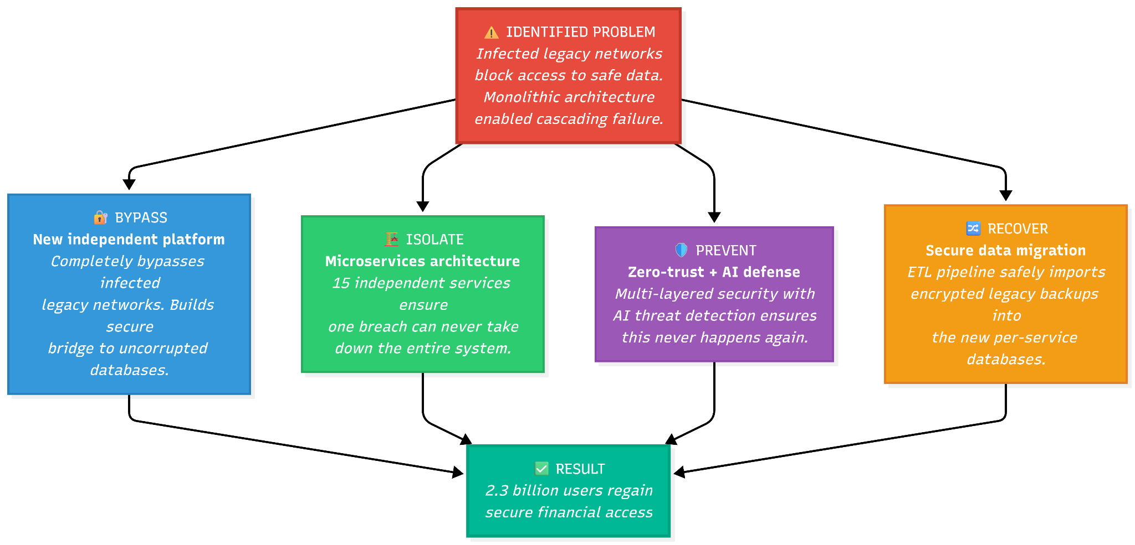

Identified Problem | Solution
Legacy networks infected | Brand-new platform bypassing infected infrastructure
Monolithic architecture caused cascading failure | 15 independent microservices with isolated databases
2.3B users locked out | Immediate restoration of core banking operations
Safe data inaccessible | Secure Data Migration ETL pipeline from legacy backups
Trust shattered | Tamper-proof hash-chain audit trails & user-controlled security
Vulnerable populations cut off | Mobile-first design with multi-language & accessibility features
Interbank networks severed | External Integration Layer reconnects to VISA, SWIFT, etc.
No disaster recovery | Multi-region failover with RPO < 1 hour and RTO < 30 minutes

2.3 Securely Restoring Financial Services
The legacy databases are safe, but accessing them through infected networks is impossible. Our Data Migration Service provides a secure ETL pipeline to bridge this data into the new platform:

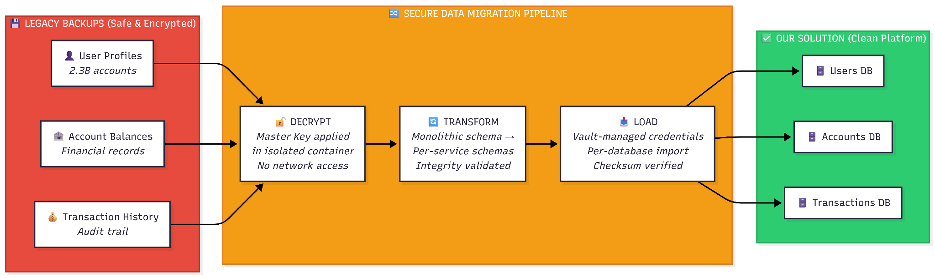

Recovery Process

Phase | What Happens | Security Measure
1. Decrypt | Decrypt legacy backups using recovered Master Key | Air-gapped container; no network access
2. Validate | Compare checksums and row counts | Mismatches halt the process instantly
3. Transform | Map monolithic schemas to per-service schemas | Strict schema validation
4. Load | Load data into individual PostgreSQL databases | Unique, Vault-managed credentials per DB
5. Verify | Verify row counts and sample transactions | Cryptographic checksums
6. Reconnect | Re-establish external API connections | mTLS-encrypted connections via Vault

2.4 Core Features
Our solution delivers 13 core capabilities across 15 microservices:

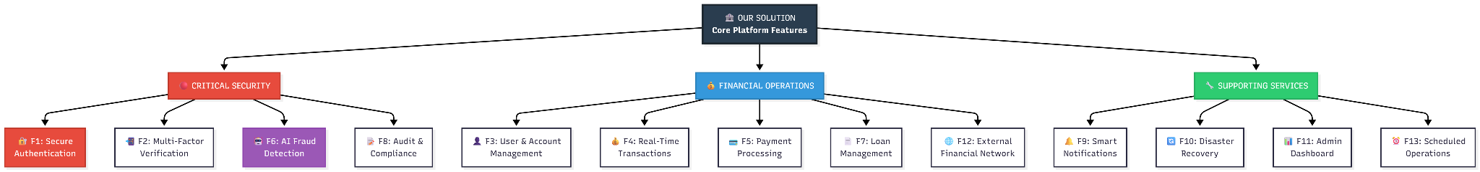

# | Feature | Key Capabilities | Services Involved
F1 | Secure Authentication | OAuth 2.0, JWT, account lockout, session timeout | Auth Service
F2 | Multi-Factor Verification | SMS, email, and biometric OTP verification | OTP, SMS, Email Services
F3 | User & Account Management | KYC profiles, multi-account support, document upload | User, Document Services
F4 | Real-Time Transactions | ACID-compliant transfers, PDF statements | Transaction, Document Services
F5 | Payment Processing | P2P, merchant, utility, and recurring payments | Payment, Scheduler Services
F6 | AI Fraud Detection | Real-time behavioral analysis, auto account freeze | Fraud Detection Service
F7 | Loan Management | Application, credit scoring, repayment tracking | Loan, Scheduler Services
F8 | Audit & Compliance | Hash-chain cryptographic audit trail | Audit Service
F9 | Smart Notifications | Push, SMS, and email alerts for events | Notification, SMS, Email Services
F10 | Disaster Recovery | Multi-region backup, automated failover (<30m) | Infrastructure Layer
F11 | Admin Dashboard | Real-time monitoring, account & KYC management | Admin Service
F12 | External Network | VISA/Mastercard, SWIFT, KYC, Credit Bureau integrations | External Integration Layer
F13 | Scheduled Operations | Recurring transfers, reports, retry failed events | Scheduler Service

2.5 Multi-Layered Security Architecture
Security is woven into every layer using a defense-in-depth strategy:

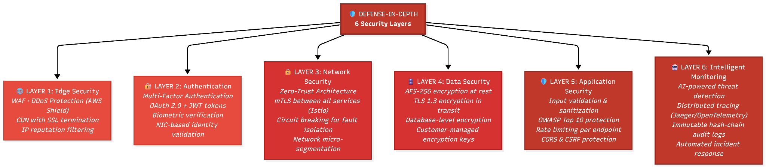

Zero-Trust Implementation
Operating on "never trust, always verify":

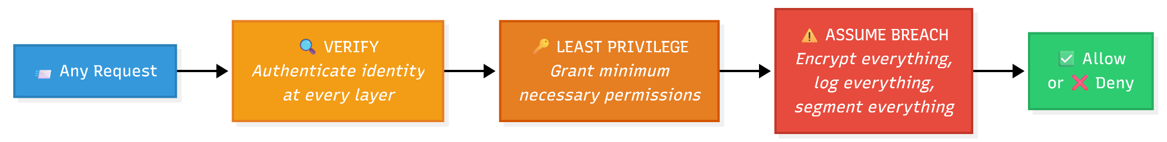

Principle | Implementation
Verify Explicitly | mTLS via Istio; JWT validation; Jaeger distributed tracing
Least Privilege | RBAC; granular permissions; isolated database credentials
Assume Breach | Encrypted internal traffic; hash-chain audit logs; circuit breakers

2.6 Threat Model
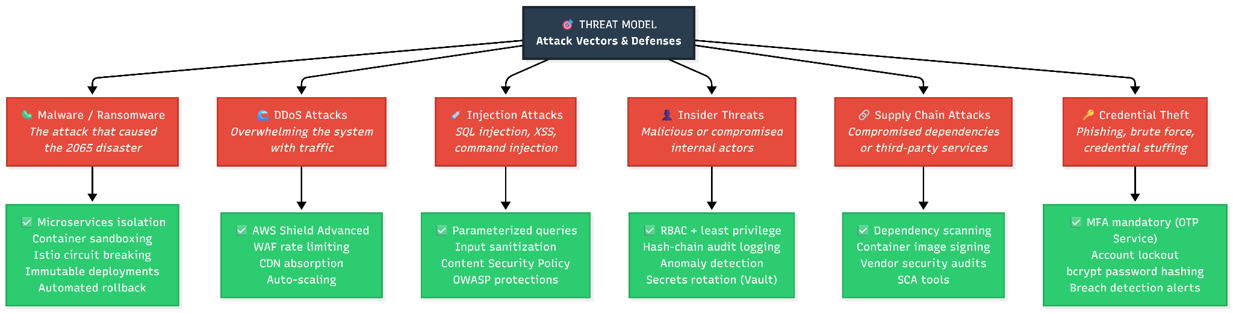

Threat Vector | Defense | Why It Works
Malware | Microservices isolation, container sandboxing, Istio circuit breaking | Malware cannot spread across service boundaries
DDoS Attacks | AWS Shield, WAF rate limiting, CDN, auto-scaling | Traffic floods are absorbed at the edge
Injection | Parameterized queries, input sanitization, OWASP protections | No raw user input reaches the database
Insider Threats | RBAC, hash-chain audit logging, automated secrets rotation | Every action is immutably logged; anomalies trigger alerts
Supply Chain | Dependency scanning, image signing, SCA tools | Compromised libraries detected pre-deployment
Credential Theft | Mandatory MFA, account lockout, breach detection alerts | Passwords are useless without the second factor

2.7 Disaster Recovery Strategy

Our disaster recovery operates on two levels: Initial data recovery (Section 2.3) and ongoing platform protection.

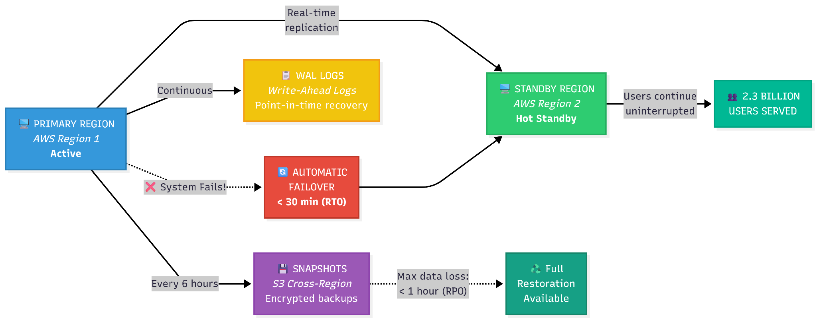

DR Metric | Target | How Achieved
RPO | < 1 hour | Continuous WAL streaming + 6-hourly cross-region snapshots
RTO | < 30 minutes | Hot standby region; automated DNS failover
Uptime | 99.99% | Multi-region active-passive architecture
Event Durability | Zero loss | Kafka Dead-Letter Queue catches and retries failed events

2.8 Innovation & Differentiators
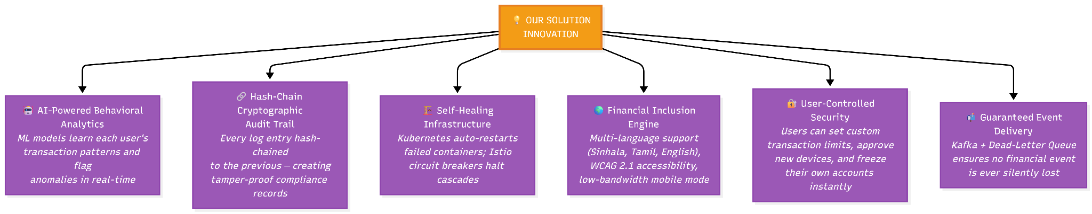

Innovation | What It Does / Why It Matters
AI Behavioral Analytics | Flags anomalies in real-time; catches fraud rule-based systems miss.
Hash-Chain Audit Trail | Creates tamper-proof compliance records for undeniable transaction integrity.
Self-Healing Infrastructure | Kubernetes auto-restarts failed containers; Istio halts cascading failures.
Financial Inclusion Engine | Multi-language, WCAG 2.1 AA accessible, optimized for low-bandwidth.
User-Controlled Security | Users can set limits, approve devices, and instantly freeze accounts.
Guaranteed Event Delivery | Kafka + DLQ ensures no financial event is ever silently lost.

2.9 Value Proposition Summary
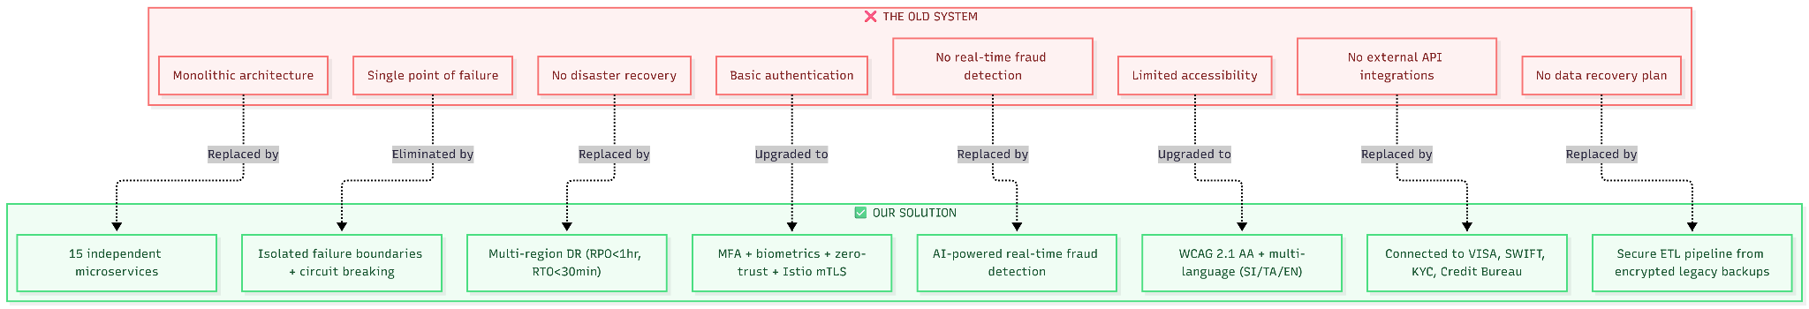

Stakeholder | Value Delivered
Individuals | Secure savings access, instant transfers, MFA, real-time fraud alerts
SMEs | Digital transactions, scheduled payroll, merchant payments, statements
Institutions | Hash-chain audit trails, real-time monitoring, credit bureau integration
Government | Restored disbursement channels, digital KYC verification
Vulnerable | Accessibility support (WCAG 2.1), multi-language, SMS fallback

Our solution doesn't just restore the old system, it delivers a platform architecturally incapable of suffering the same catastrophic failure, rebuilding trust for 2.3 billion users.

03. System Architecture Diagram

Standalone reference file Contains the complete system architecture Mermaid diagram with all 10 layers, 15 microservices, and full event-driven messaging flows.

3.1 Full System Architecture

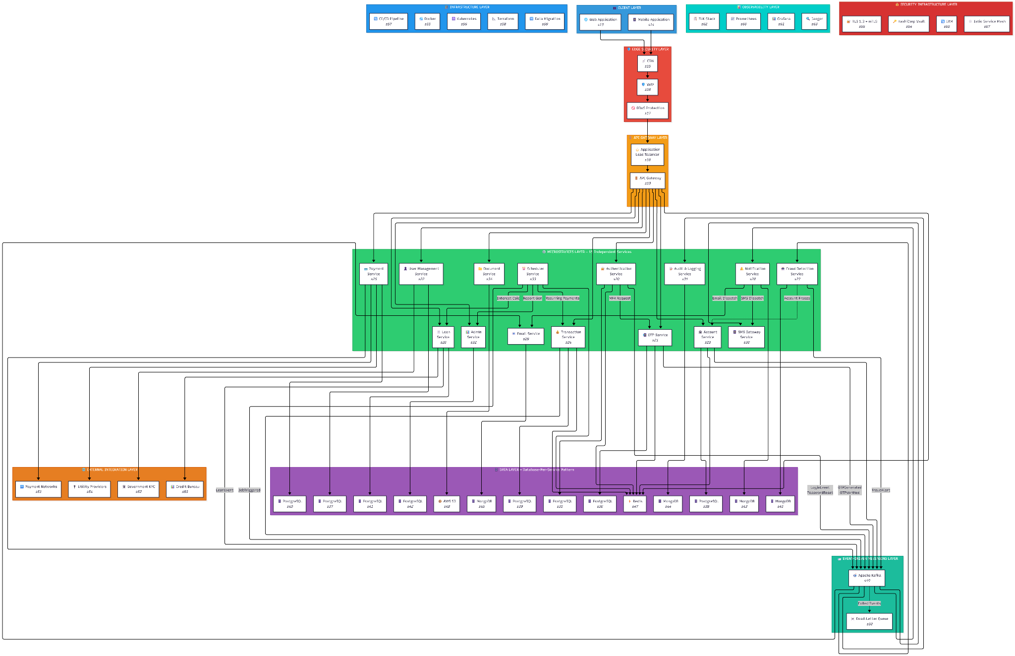

link to full system architecture image

3.2 Transaction Data Flow (FR-15)
This diagram demonstrates how core financial data flows through the application securely and asynchronously, satisfying the requirement for resilient, non-blocking communication.

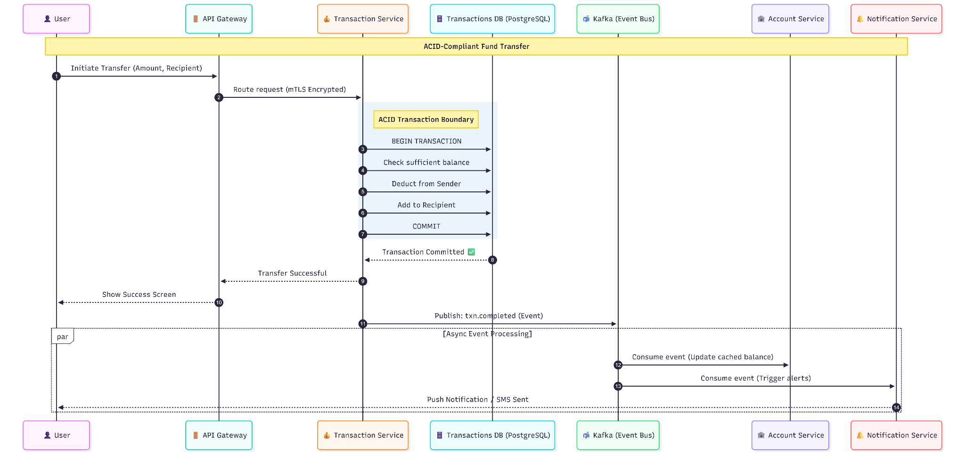

3.3 Secure Communication & Data Flow
To ensure the platform cannot suffer a cascading failure like the 2065 disaster, communication and data flows are strictly controlled:

- Zero-Trust Network Security (mTLS): All external traffic stops at the API Gateway. Internal communication between the 15 microservices uses Istio Service Mesh with mandatory mTLS (Mutual TLS). Services never trust each other blindly; every internal request is cryptographically authenticated and encrypted.
- Event-Driven Decoupling: Instead of synchronous API calls that can bottleneck and crash, the system uses Apache Kafka for asynchronous data flow. For example, when a transaction occurs, the Transaction Service commits the change to its isolated PostgreSQL database and fires an event to Kafka. Downstream services (like Notifications and Auditing) consume this event independently. If the Notification Service crashes, Kafka holds the message safely until it recovers, ensuring zero data loss and preventing cascading failures.
- Isolated Data Boundaries: The architecture implements the strict Database-per-Service pattern. No two services share a database or connection string. If a threat actor manages to compromise the Load DB, the Transactions DB remains completely inaccessible to them.

04. Wireframes Design

Overview
The following high-fidelity wireframes represent the planned user interface for our new digital banking platform. The design follows modern fintech UX best practices with a focus on trust, clarity, security, and accessibility, critical for a platform that must rebuild public confidence after the 2065 cyberattack.

4.1 Design Principles Applied
Principle | Implementation
Trust | Dark blue color palette (associated with security and professionalism), lock icons, encryption badges, "Secured by TLS 1.3" labels
Clarity | Large, readable balance displays, clear transaction labels, intuitive navigation
Simplicity | Minimal steps for common tasks (send money in 3 taps), clean uncluttered layouts
Security Indicators | Visible MFA prompts, device verification alerts, "Verified" badges, encryption badges
Accessibility | High contrast dark mode, large touch targets (44x44px minimum), clear typography

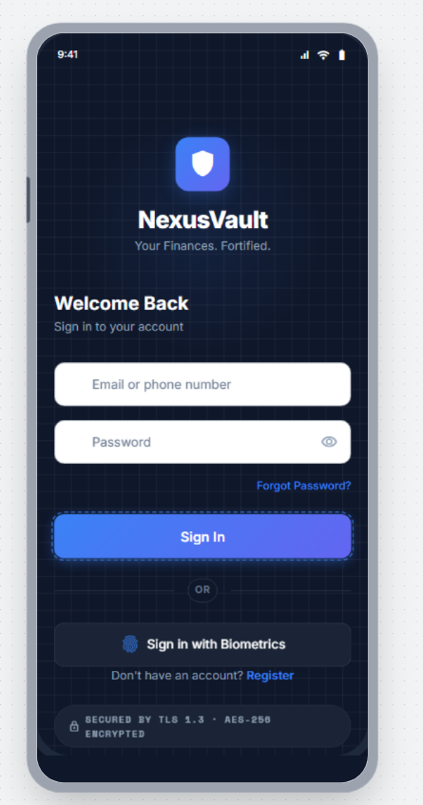
4.2 User Flow

Screen 1: Login / Registration
The entry point for all users. Supports traditional credential-based login and biometric authentication (fingerprint/face recognition) for returning users.

Key UX Decisions:

- MFA is mandatory, login always proceeds to verification (Screen 2)
- Biometric option prominently displayed to encourage faster, more secure login
- Security badge visible to reassure users about encryption
- Clean, professional design establishes trust from the first interaction

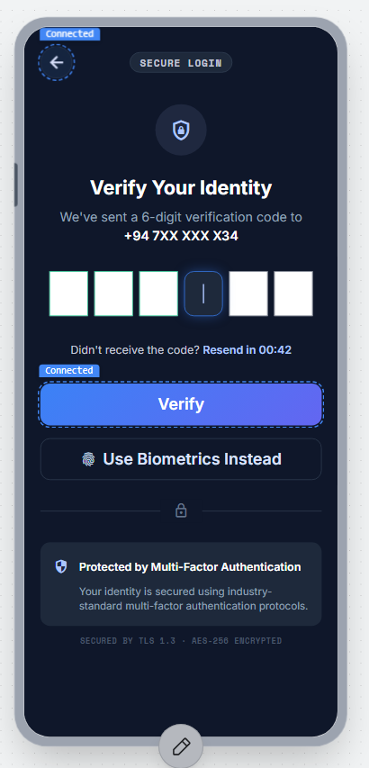

Screen 2: MFA Verification
Multi-factor authentication screen requiring a 6-digit OTP sent to the user's registered phone number. This screen appears after every login to enforce FR-02 (mandatory MFA).

Key UX Decisions:

- Individual digit boxes for clear OTP entry
- Countdown timer for resend functionality
- Alternative verification method (biometrics) offered
- Shield icon reinforces the security-focused design

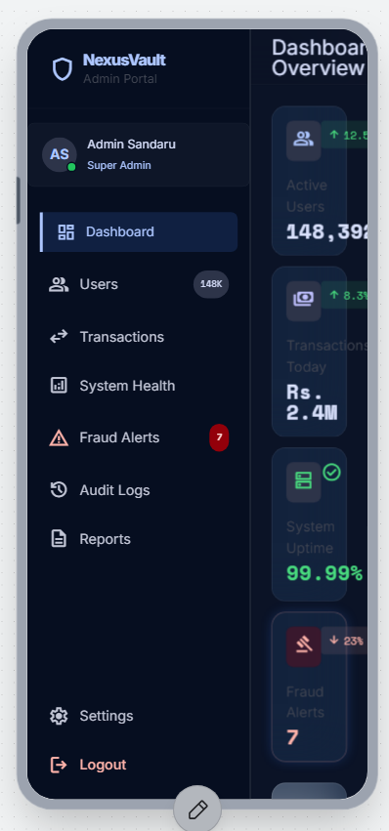
Screen 3: Dashboard / Home
The primary screen users see after authentication. Displays real-time account balance (FR-08), quick action buttons for common tasks, and recent transaction activity.

Key UX Decisions:

- Balance displayed prominently in large text (clarity for all ages)
- Quick actions (Send, Receive, Pay Bills, QR) minimize navigation depth
- Recent transactions provide immediate financial awareness
- Notification bell with unread indicator for security alerts
- Bottom navigation for consistent app-wide navigation
​

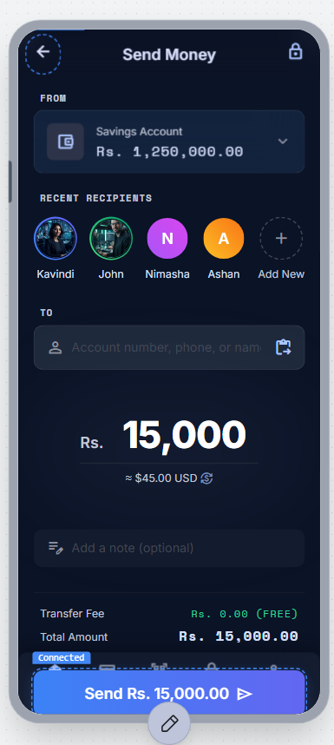

Screen 4: Send Money / Transfer
Core transaction screen for fund transfers (FR-14). Designed for speed. Users can complete a transfer in 3 steps: select recipient -> enter amount -> confirm.

Key UX Decisions:

- Recent recipients shown for quick repeat transfers
- Large amount input with clear currency prefix
- Transfer summary (fee + total) shown before confirmation
- Encryption badge visible during financial operations
- "From Account" selector for multi-account users (FR-10)

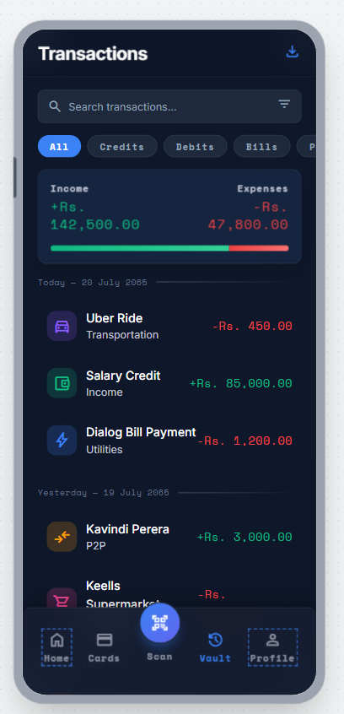
Screen 5: Transaction History
Complete transaction record with filtering and search capabilities (FR-09). Users can filter by type, search by keyword, and view transactions grouped by date.

Key UX Decisions:

- Filter chips (All, Credits, Debits, Bills) for quick filtering
- Search bar for finding specific transactions
- Color coding: green for credits (+), red for debits (-)
- Category icons for visual recognition
- Grouped by date for chronological clarity

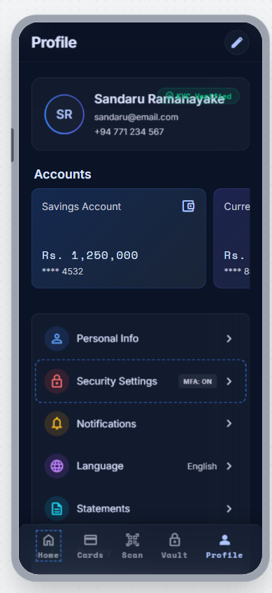

Screen 6: Profile & Settings
User profile management with KYC verification status, security settings, and preferences (FR-11, FR-12).

Key UX Decisions:

- KYC verification status prominently displayed ("Verified" badge)
- Security settings easily accessible with MFA status indicator
- Language selection supports multi-language requirement (NFR-34: Sinhala, Tamil, English)
- Clear logout button for session management
- Settings organized in logical groups with icons

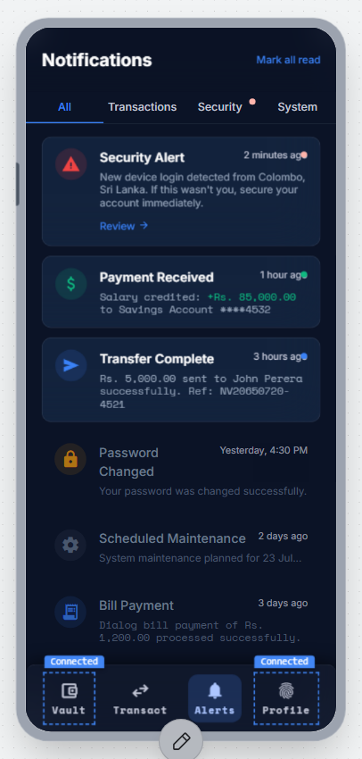

Screen 7: Notifications
Multi-channel notification center showing transaction alerts, security events, and system notifications (FR-29, FR-30).

Key UX Decisions:

- Filter tabs (All, Transactions, Security, System) for categorization
- Unread indicators (colored dots) for attention priority
- Security alerts highlighted with red icons for urgency
- "Mark all read" for bulk management
- Timestamps for event tracking

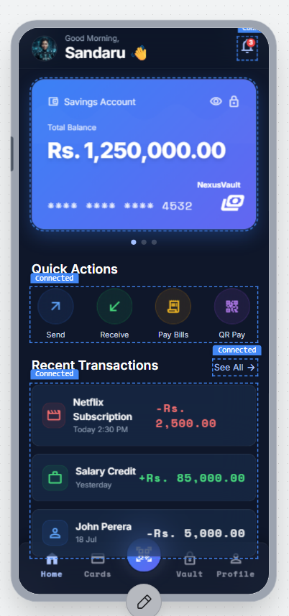
Screen 8: Admin Dashboard (Web Application)
System administration panel for monitoring platform health, managing users, and reviewing fraud alerts (FR-32, FR-33, FR-35). This is a web-based interface designed for desktop use by system administrators.

Key UX Decisions:

- Key metrics at a glance: active users, transaction volume, uptime, fraud alerts
- Real-time charts for transaction volume and service health
- Recent alerts table for immediate incident awareness
- Sidebar navigation for admin-specific functions (Users, Transactions, System Health, Fraud Alerts, Audit Logs)
- 99.99% uptime metric visible directly reflects NFR-15

4.3 Screen Summary
# | Screen | Platform | User Type | Key FRs Addressed
1 | Login / Registration | Mobile | All users | FR-01, FR-02, FR-03, FR-05
2 | MFA Verification | Mobile | All users | FR-02, FR-03
3 | Dashboard / Home | Mobile | Customers | FR-08, FR-09, FR-20
4 | Send Money / Transfer | Mobile | Customers | FR-10, FR-14, FR-15, FR-19
5 | Transaction History | Mobile | Customers | FR-09, FR-13
6 | Profile & Settings | Mobile | Customers | FR-11, FR-12, FR-30
7 | Notifications | Mobile | Customers | FR-20, FR-28, FR-29, FR-30, FR-31
8 | Admin Dashboard | Web (Desktop) | Administrators | FR-32, FR-33, FR-34, FR-35

4.4 Design Tool & Access
Design File Link: https://stitch.withgoogle.com/projects/12821434184842723830

Note: The wireframes above are high-fidelity mockups representing the planned visual design. For the final submission, embed these screenshots in the document AND include a working link to the design file.

05. Functional Requirements

Overview
The following functional requirements define what the new secure digital banking platform must do from the user's perspective. These requirements are directly derived from the need to restore the core services that were halted by the cyber disaster (core banking, digital payments, and loan systems) while implementing modern cybersecurity and intelligent automation.

Priority Definitions
- Must: Critical for the platform's core operation, security, or regulatory compliance. The system is not viable without this requirement being met.
- Should: Highly important and adds significant business or user value, but a temporary workaround exists, or it can be deferred to a later deployment phase if necessary.
- Could: A "nice-to-have" enhancement that improves user experience but is not core to the immediate restoration of banking services.

Requirements are grouped by domain and numbered for traceability.

5.1 Authentication & Security
To protect customer data and ensure the system cannot be easily compromised.

ID | Requirement | Priority
FR-01 | The system shall allow new users to register using their email address, phone number, and NIC (National Identity Card) for identity verification. | Must
FR-02 | The system shall enforce multi-factor authentication (MFA) for all login attempts, requiring at least two verification methods (password + OTP or biometric). | Must
FR-03 | The system shall support biometric authentication (fingerprint and facial recognition) as a second authentication factor on supported devices. | Must
FR-04 | The system shall automatically lock a user's account after 5 consecutive failed login attempts and notify the user via email and SMS. | Must
FR-05 | The system shall allow users to reset their password securely via email verification link or SMS OTP, with the reset link expiring after 3 minutes. | Must
FR-06 | The system shall automatically terminate inactive user sessions after 10 minutes of inactivity and require re-authentication. | Should
FR-07 | The system shall notify users via push notification and email when a login is detected from a new or unrecognized device. | Should

5.2 Account Management
To restore daily banking operations and core banking system functionality.

ID | Requirement | Priority
FR-08 | The system shall display the user's real-time account balance on the dashboard immediately upon login. | Must
FR-09 | The system shall allow users to view their complete transaction history with filtering options (by date range, transaction type, amount range, and recipient). | Must
FR-10 | The system shall support multiple account types (savings, current, business) under a single user profile. | Must
FR-11 | The system shall provide a KYC (Know Your Customer) verification workflow where users upload identity documents for administrative review and approval. | Must
FR-12 | The system shall allow users to manage their personal profile information including name, contact details, preferred language, and notification preferences. | Should
FR-13 | The system shall allow users to download account statements in PDF format for any specified date range. | Should

5.3 Transactions & Payments
To restore digital payment platforms and secure transactions for individuals and businesses.

ID | Requirement | Priority
FR-14 | The system shall allow users to transfer funds to other accounts within the platform with real-time confirmation and receipt generation. | Must
FR-15 | The system shall process all financial transactions atomically, ensuring that both debit and credit operations either complete fully or not at all (ACID compliance). | Must
FR-16 | The system shall allow users to make utility bill payments (electricity, water, internet, mobile) through integrated payment processing. | Must
FR-17 | The system shall support scheduled and recurring payments, allowing users to set up automatic transfers on specified dates and frequencies. | Should
FR-18 | The system shall support QR code-based payments for merchant transactions. | Could
FR-19 | The system shall generate a digital receipt for every completed transaction, accessible from the transaction history. | Must
FR-20 | The system shall send real-time push notifications to users for all transaction events (debits, credits, payment confirmations, failed transactions). | Must

5.4 Loan Management
To restore the frozen loan systems and credit platforms.

ID | Requirement | Priority
FR-21 | The system shall allow users to apply for loans by submitting a digital application with required financial information and supporting documents. | Should
FR-22 | The system shall provide an automated eligibility assessment based on account history, credit score, and financial behavior. | Should
FR-23 | The system shall allow users to track their loan application status (submitted, under review, approved, rejected) in real-time. | Should
FR-24 | The system shall display loan repayment schedules, outstanding balances, and next payment dates for approved loans. | Should
FR-25 | The system shall provide a secure administrative dashboard where authorized bank personnel can view loan applications flagged for manual review. | Must
FR-26 | The system shall allow authorized personnel to manually override the automated eligibility assessment to approve or reject an application. | Must
FR-27 | The system shall allow administrators to input specific reason codes when manually rejecting an application, which will be logged for compliance auditing. | Must

5.5 Fraud Detection & Security Alerts
To implement the intelligent automation and modern cybersecurity required by the brief.

ID | Requirement | Priority
FR-28 | The system shall use AI/ML-based behavioral analysis to detect and flag unusual transaction patterns (unusual amounts, times, locations, or recipients) in real-time. | Must
FR-29 | The system shall automatically freeze an account upon detecting confirmed suspicious activity and notify the user immediately via all available channels. | Must
FR-30 | The system shall allow users to report unauthorized or fraudulent transactions through an in-app reporting mechanism with case tracking. | Must
FR-31 | The system shall provide real-time fraud alerts to users and administrators when anomalous activity is detected. | Should

5.6 Notifications
To ensure reliable communication with users regarding their finances.

ID | Requirement | Priority
FR-32 | The system shall support multi-channel notifications including push notifications, SMS, and email for all critical events. | Must
FR-33 | The system shall allow users to customize their notification preferences (channels, frequency, event types) from their profile settings. | Should
FR-34 | The system shall maintain a notification history accessible from the user dashboard. | Should

5.7 Administration
To provide necessary oversight and system health monitoring.

ID | Requirement | Priority
FR-35 | The system shall provide administrators with a real-time dashboard displaying system health metrics (service status, response times, error rates, active users). | Must
FR-36 | The system shall allow administrators to manage user accounts including the ability to suspend, reactivate, verify, and delete accounts. | Must
FR-37 | The system shall generate automated daily, weekly, and monthly transaction summary reports for administrative review. | Should
FR-38 | The system shall provide a comprehensive audit trail viewer that allows administrators to search and filter all system events by user, action, timestamp, and IP address. | Must

5.8 Requirements Summary
Category | Count | Must | Should | Could
Authentication & Security | 7 | 5 | 2 | 0
Account Management | 6 | 4 | 2 | 0
Transactions & Payments | 7 | 5 | 1 | 1
Loan Management | 7 | 3 | 4 | 0
Fraud Detection | 4 | 3 | 1 | 0
Notifications | 3 | 1 | 2 | 0
Administration | 4 | 3 | 1 | 0
Total | 38 | 24 | 13 | 1

06. Non-Functional Requirements

Overview
The following non-functional requirements define how our system performs — the quality standards that ensure the platform is secure, resilient, performant, and production-ready. Given that the 2065 crisis was caused by a cyberattack exploiting architectural weaknesses, this section heavily emphasizes security, disaster recovery, cloud performance, and reliability as mandated by the competition brief.

All NFRs use specific, measurable values to enable objective verification.

6.1 Security (CRITICAL)
Given the catastrophic failure caused by the Super Malware Agent, security is the most critical quality attribute of our system. Every layer of the system is designed with defense-in-depth.

ID | Requirement | Metric
NFR-01 | All data transmitted between clients and servers must be encrypted using TLS 1.3 or higher. | 100% of connections encrypted
NFR-02 | All data stored at rest (databases, backups, logs) must be encrypted using AES-256 encryption with customer-managed encryption keys. | 100% of stored data encrypted
NFR-03 | The system must implement a zero-trust security architecture where every request is authenticated and authorized regardless of network origin. | All service-to-service calls use mTLS
NFR-04 | All inter-service communication must use mutual TLS (mTLS) for bidirectional authentication between microservices. | 100% of internal calls authenticated
NFR-05 | All user passwords must be hashed using bcrypt with a minimum cost factor of 12 and unique salt per password. | No plaintext or reversibly encrypted passwords
NFR-06 | All API endpoints must be rate-limited to prevent abuse and brute-force attacks (max 100 requests/minute for authenticated users, 20/minute for unauthenticated). | Rate limits enforced per endpoint
NFR-07 | The system must comply with PCI DSS (Payment Card Industry Data Security Standard) requirements for handling financial data. | Full PCI DSS compliance
NFR-08 | The system must implement protection against the OWASP Top 10 web application security risks including SQL injection, XSS, CSRF, and broken access control. | All OWASP Top 10 mitigated
NFR-09 | All API tokens (JWT) must expire after 15 minutes for access tokens and 7 days for refresh tokens, with mandatory re-authentication for sensitive operations. | Token lifecycle enforced
NFR-10 | The system must maintain an immutable audit trail of all security-relevant events that cannot be modified or deleted, retained for a minimum of 2 years. | 100% of security events logged

6.2 Disaster Recovery (CRITICAL)
The entire premise of our system is recovering from a catastrophic system failure. Use of disaster recovery capabilities are architected as first-class design concerns.

ID | Requirement | Metric
NFR-11 | The system must perform automated full database backups every 6 hours to geographically separate storage with AES-256 encryption. | Backups every 6 hours, encrypted
NFR-12 | The system must achieve a Recovery Point Objective (RPO) of less than 1 hour — maximum acceptable data loss in a disaster scenario. | RPO < 1 hour
NFR-13 | The system must achieve a Recovery Time Objective (RTO) of less than 30 minutes — maximum time to restore full service after a regional failure. | RTO < 30 minutes
NFR-14 | The system must support multi-region failover with a hot standby region that receives real-time data replication from the primary region. | Automatic failover to secondary region
NFR-15 | The system must maintain a guaranteed uptime SLA of 99.99% (maximum 52.6 minutes of unplanned downtime per year). | 99.99% availability
NFR-16 | Database backups must be retained for a minimum of 90 days with point-in-time recovery capability via continuous WAL (Write-Ahead Log) streaming. | 90-day retention + PITR
NFR-17 | The system must support automated disaster recovery testing on a monthly schedule to validate failover procedures without affecting production traffic. | Monthly DR drill completion

6.3 Performance
ID | Requirement | Metric
NFR-18 | API response time must be less than 200 milliseconds for 95% of all requests (p95 latency) under normal load conditions. | p95 latency < 200ms
NFR-19 | The system must support a minimum of 10,000 concurrent users without performance degradation. | 10,000+ concurrent connections
NFR-20 | All database queries must complete within 100 milliseconds under normal operational load. | Query execution < 100ms
NFR-21 | Web application pages must achieve a page load time of less than 3 seconds on standard broadband connections (10 Mbps+). | Page load < 3 seconds
NFR-22 | The system must achieve a Lighthouse performance score of 90+ for the web application. | Lighthouse score ≥ 90

6.4 Scalability & Cloud Infrastructure
ID | Requirement | Metric
NFR-23 | The system must auto-scale horizontally based on CPU utilization (scale-up at 70%, scale-down at 30%) and request rate thresholds. | Auto-scaling policies active
NFR-24 | All microservices must be containerized using Docker with multi-stage builds for minimal image sizes (< 200MB per service). | 100% containerized
NFR-25 | Container orchestration must use Kubernetes (EKS/GKE) with Horizontal Pod Autoscaler (HPA) for dynamic resource allocation. | Kubernetes orchestration active
NFR-26 | All infrastructure must be defined and managed as Infrastructure as Code (IaC) using Terraform, ensuring reproducible and version-controlled environments. | 100% IaC coverage
NFR-27 | The system must support rolling deployments with zero-downtime updates and automatic rollback on failure detection. | Zero-downtime deployments

6.5 Monitoring & Observability
ID | Requirement | Metric
NFR-28 | All microservices must expose health check endpoints (/health and /ready) for Kubernetes liveness and readiness probes. | 100% of services monitored
NFR-29 | The system must provide centralized logging from all microservices using the ELK Stack (Elasticsearch, Logstash, Kibana) with structured JSON log format. | Centralized log aggregation
NFR-30 | The system must maintain real-time monitoring dashboards (Grafana) displaying key metrics: response times, error rates, CPU/memory usage, active users, and transaction throughput. | Real-time dashboards available
NFR-31 | The system must trigger automated alerts when critical metrics exceed defined thresholds (e.g., error rate > 1%, CPU > 80%, response time > 500ms). | Automated alerting configured
NFR-32 | All requests must be traceable end-to-end across microservices using distributed tracing (correlation IDs propagated through every service call). | 100% request traceability

6.6 Accessibility & Usability
ID | Requirement | Metric
NFR-33 | The web and mobile applications must comply with WCAG 2.1 Level AA accessibility standards. | WCAG 2.1 AA compliance
NFR-34 | The system must support multi-language interfaces with at minimum Sinhala, Tamil, and English language options. | 3 languages supported
NFR-35 | All interactive elements must have a minimum touch target size of 44x44 pixels on mobile devices for elderly and accessibility users. | Touch targets ≥ 44x44px
NFR-36 | The application must maintain a minimum color contrast ratio of 4.5:1 for normal text and 3:1 for large text to ensure readability. | Contrast ratios compliant

6.7 Compliance & Regulatory
ID | Requirement | Metric
NFR-37 | The system must comply with GDPR and local data protection regulations for handling personal and financial data. | Regulatory compliance achieved
NFR-38 | The system must implement data residency controls ensuring customer financial data is stored within the regulatory jurisdiction of the user's registered country. | Data residency enforced

6.8 Requirements Summary
Category | Count | Focus Level
Security | 10 | 🔴 CRITICAL
Disaster Recovery | 7 | 🔴 CRITICAL
Performance | 5 | 🟡 High
Scalability & Cloud | 5 | 🟡 High
Monitoring & Observability | 5 | 🟡 High
Accessibility & Usability | 4 | 🟢 Important
Compliance & Regulatory | 2 | 🟢 Important
Total | 38 | —

07. Technology Stack Selection

Overview
The technology stack has been carefully selected to support three non-negotiable architectural requirements mandated by the competition:

- Independent services architecture (microservices)
- Security-first design (defense-in-depth)
- Disaster recovery (multi-region failover and self-healing)

7.1 Technology Stack Diagram

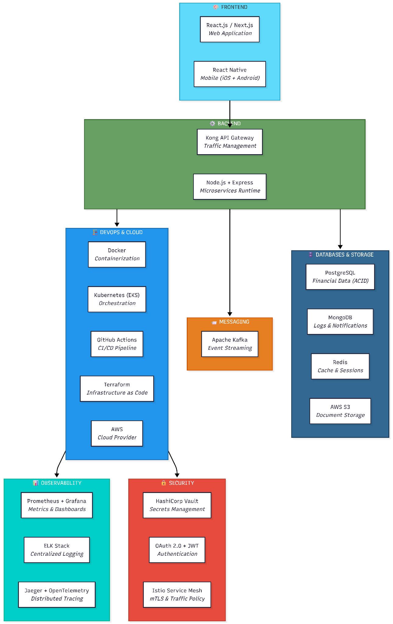

7.2 Detailed Justification Table

Frontend Layer

Technology | Purpose | Justification
React.js / Next.js | Web Application | SSR for faster page loads; component-based architecture for reusable modules.
React Native | Mobile Application | Cross-platform (iOS/Android) code sharing; native biometric authentication support.

Backend Layer

Technology | Purpose | Justification
Node.js + Express | Microservices Runtime | Async I/O for high concurrency; lightweight processes for individual services.
Kong API Gateway | API Management | Built-in rate limiting, routing, and zero-trust authentication enforcement.

Database & Storage Layer

Technology | Purpose | Justification
PostgreSQL | Relational Database | Mandatory ACID compliance for financial transactions; WAL for continuous replication.
MongoDB | NoSQL Database | Flexible schema for logs and scalable high-volume write operations.
Redis | In-Memory Cache | Sub-millisecond reads for sessions; reduces database load by 60-80%.
AWS S3 | Object Storage | Scalable, encrypted storage for KYC documents and PDF receipts.

Messaging Layer

Technology | Purpose | Justification
Apache Kafka | Event Streaming | Guaranteed asynchronous delivery; decouples microservices to prevent cascading failures.

DevOps & Cloud Layer

Technology | Purpose | Justification
Docker | Containerization | Strict service isolation; compromised containers cannot access others.
Kubernetes (EKS) | Orchestration | Auto-scaling, self-healing, and zero-downtime rolling updates.
GitHub Actions | CI/CD Pipeline | Automated testing, security scanning, and deployment pipelines.
Terraform | IaC (Infrastructure as Code) | Reproducible infrastructure for immediate disaster recovery (RTO < 30 min).
AWS | Cloud Provider | Multi-region support; PCI DSS certified managed services.

Observability Layer
Technology | Purpose | Justification
Prometheus & Grafana | Metrics & Dashboards | Real-time monitoring and alerting for all Kubernetes clusters.
ELK Stack | Centralized Logging | Aggregated, searchable logs for security auditing and post-incident forensics.
Jaeger (OpenTelemetry) | Distributed Tracing | Tracks financial transactions end-to-end across all 15 microservices.

Security Layer
Technology | Purpose | Justification
HashiCorp Vault | Secrets Management | Securely stores and automatically rotates API keys and database passwords.
OAuth 2.0 + JWT | Authentication | Stateless tokens for horizontal scaling; fine-grained role-based access control.
Istio Service Mesh | Service-to-Service Security | Enforces mandatory mTLS encryption between all microservices (Zero-Trust).

7.3 How the Stack Supports Key Requirements

