Department of Computer Engineering

University of Peradeniya

CO523 - Programming Languages

Lab 07: Subprograms, Parameter Passing, and Stack Frames

E/20/449
Wijewardhana A.R.S.S.

Task 01

Python
# Task 01 - Python (pass-by-value behavior with immutable int)
def modify(x): x = x + 10 print("Inside function:", x)
a = int(input("Enter an integer: ")) print("Before function:", a)

modify(a)
print("After function:", a)

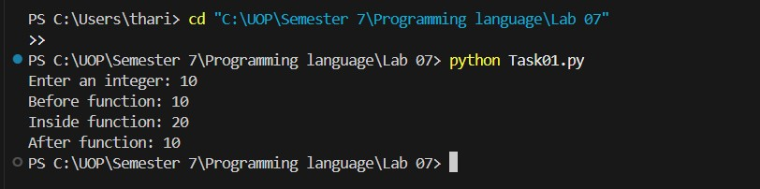

Explanation: Pass-by-Object-Reference in Python
- Function Call: In the Python program, the value of a is passed to the function modify(a).
- Internal Modification: Inside the function, the parameter x is increased and printed, which shows a changed value locally.
- External Consistency: After the function execution finishes, the value of a printed outside remains the same.
- Immutability: This occurs because integers in Python are immutable; modifying x inside the function creates a new object rather than changing the original variable a.

C
// Task 01 - C (pass-by-value)

#include <stdio.h>
void modify(int x) { x = x + 10; printf("Inside function: %d\n", x);
} int main() { int a; printf("Enter an integer: "); scanf("%d", &a);
printf("Before function: %d\n", a);
modify(a);
printf("After function: %d\n", a); return 0;
}

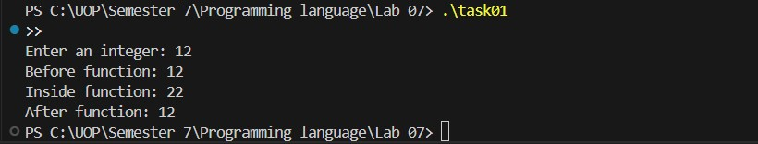

Explanation: Pass-by-Value in C
- Function Call: In the C program, when modify(a) is called, the function receives a copy of the variable a in the parameter x.
- Internal Modification: Inside the function, x is changed and printed, so the output shows the updated value locally within the function's scope.
- External Consistency: When printing a in main() after the function call, the value remains unchanged because only the local copy x was modified.
- Core Principle: This demonstrates that C uses pass-by-value by default, meaning the original variable is protected unless pointers are used to pass a memory address.

Task 02

Python
# Task 02 - Python (pass-by-reference simulation using mutable list)
def modify_list(lst): lst[0] = lst[0] + 10
print("Inside function:", lst)
numbers = [int(input("Enter an integer: "))] print("Before function:", numbers)
modify_list(numbers)
print("After function:", numbers)

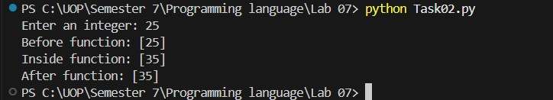

Explanation

Explanation: Pass-by-Object-Reference with Mutable Types
- Input Storage: In the Python program, the user input is stored inside a list (numbers = [value]).
- Function Call: This list is passed to the function modify_list(numbers).
- Internal Update: Inside the function, lst[0] is updated by adding 10, so the output shows a changed value inside the function.
- Persistent Change: After the function ends, the value remains changed when printed outside.
- Mutability: This occurs because lists in Python are mutable, meaning the main program and the function are both working on the same list object in memory.

C

#include <stdio.h>
void modify(int *x) { *x = *x + 10; printf("Inside function: %d\n", *x);
} int main() { int a; printf("Enter an integer: "); scanf("%d", &a);
printf("Before function: %d\n", a);
modify(&a);
printf("After function: %d\n", a); return 0;
}

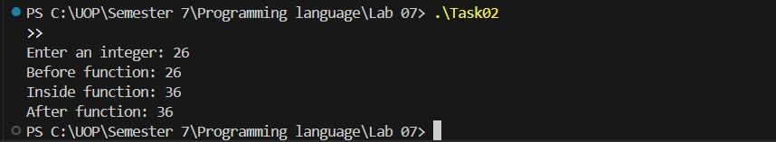

Explanation

Explanation: Pass-by-Reference via Pointers in C
- Pointer Reception: In the C program, the function modify() receives a pointer (int *x), which is the memory address of the variable a.
- Address Passing: When calling modify(&a), the address of a is passed rather than a copy of its value.
- Direct Modification: Inside the function, the operation *x = *x + 10 modifies the value stored specifically at that memory address.
- Persistent Update: The output shows the updated value inside the function, and it remains updated when printed in main() after the function call.
- Core Principle: This demonstrates pass-by-reference behavior in C, achieved by using pointers to manipulate the original variable's memory directly.

Task 03
def function_c(z): print(f" → ENTER function_c(z={z})") result = z * 2
print(f" Computing: {z} * 2 = {result}") print(f" ← EXIT function_c, returning {result}") return result

def function_b(y):
print(f" → ENTER function_b(y={y})") print(f" Calling function_c({y + 1})...") result = function_c(y + 1) final = result + 5 print(f" Computing: {result} + 5 = {final}") print(f" ← EXIT function_b, returning {final}") return final

def function_a(x):
print(f" → ENTER function_a(x={x})") print(f" Calling function_b({x * 2})...") result = function_b(x * 2) print(f" ← EXIT function_a, returning {result}") return result

final_result = function_a(3) print(f"\nFinal result: {final_result}")

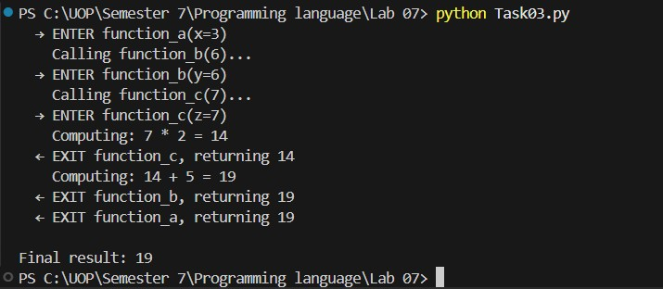

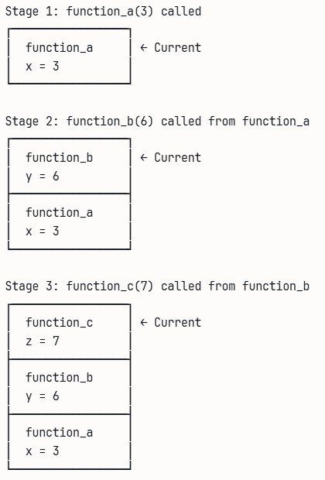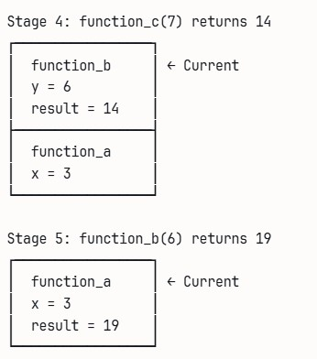

Explanation
This output shows how nested function calls execute using the call stack (LIFO). First, function_a(3) starts and calls function_b(6) (because 3 * 2 = 6). Then function_b(6) calls function_c(7) (because 6 + 1 = 7). Inside function_c, the computation 7 * 2 = 14 is done and it returns 14, so its stack frame ends. Control goes back to function_b, which then computes 14 + 5 = 19 and returns 19, ending its frame. Finally, function_a receives 19, returns it, and the program prints Final result: 19.

Task 04

def factorial(n, depth=0): indent = " " * depth print(f"{indent}→ CALL factorial({n}) [Depth: {depth}]")
if n <= 1:
print(f"{indent} Base case reached!") print(f"{indent}← RETURN 1") return 1
print(f"{indent} Recursive call: factorial({n-1})") result = n * factorial(n - 1, depth + 1) print(f"{indent} Computed: {n} * {result // n} = {result}") print(f"{indent}← RETURN {result}") return result

result = factorial(5) print(f"\nFinal Result: 5! = {result}")

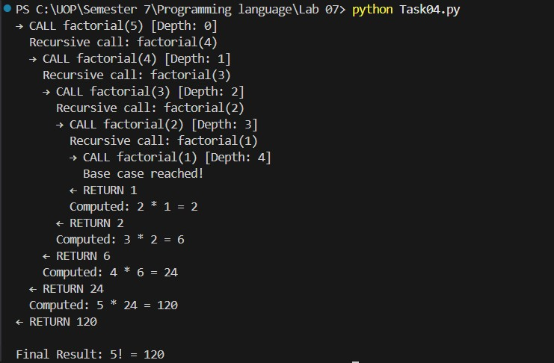

Explanation: Recursive Calls and Stack Overflow
- Missing Stopping Condition: Without the base case, the factorial function has no stopping condition, so it keeps calling itself infinitely
- Memory Growth: Every recursive call creates a new stack frame, causing stack memory to grow rapidly.
- Python Safety Limit: In Python, once the recursion goes beyond the recursion limit (around 1000 calls by default), the interpreter stops the program and raises a RecursionError: “maximum recursion depth exceeded”.
- Program Failure: The program fails because the call stack keeps expanding until Python forces it to stop or the system runs out of stack space.

Task 05

Python
def f(a):
b = a + 2 return b
def g(): x = 3 y = f(x) return y
g()

- g() called- Creates g frame (no params, locals: x=3, then y=f(3)).
- f(x) called- Creates f frame (param a=3, local b=5, returns 5). f frame popped.
- g returns y=5, g frame popped.

Stage | Function Name | Parameters | Local Variables | Return Value
1 (g call) | g | (none) | x = 3, y = (uninit) | (uninit)
2 (f call inside g) | f | a = 3 | b = 5 | 5
3 (f return) | g | (none) | x = 3, y = 5 | 5
4 (g return) | (end) | - | - | -

C
#include <stdio.h>
int f(int a) { int b = a + 2; return b;
} int g() { int x = 3; int y = f(x); return y;
} int main() { int result = g(); printf("Result: %d\n", result); return 0;
}

Similar to Python, main calls g (frame: locals x=3, y=f(3)). g calls f (frame: param a=3, local b=5, returns 5). Pops f, then g returns 5 to main.

Stage | Function Name | Parameters | Local Variables | Return Value
1 (g call from main) | g | (none) | x = 3, y = (uninit) | (uninit)
2 (f call inside g) | f | a = 3 | b = 5 | 5
3 (f return) | g | (none) | x = 3, y = 5 | 5
4 (g return to main) | main | (none) | result = 5 | 0

