Department of Computer Engineering University of Peradeniya

CO523 - Programming Languages

Lab 05: Data Types, Type Systems, and Type Checking

E/20/449
WIJEWARDHANA A.R.S.S.

Task 01
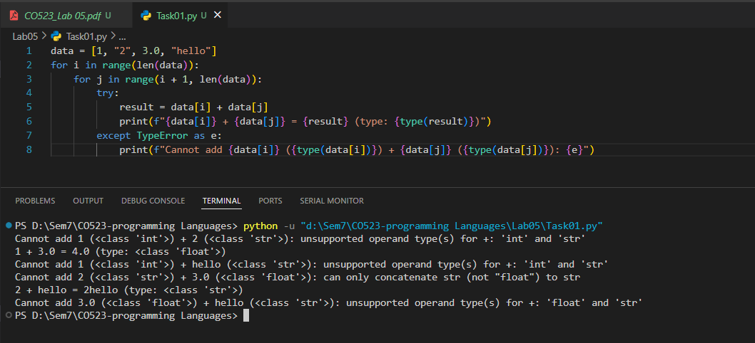
Observed Output
When you run this script, you will see output similar to this:
- Cannot add 1 (<class 'int'>) + 2 (<class 'str'>): unsupported operand type(s) for +: 'int' and 'str'
- 1 + 3.0 = 4.0 (type: <class 'float'>)
- Cannot add 1 (<class 'int'>) + hello (<class 'str'>): unsupported operand type(s) for +: 'int' and 'str'
- Cannot add 2 (<class 'str'>) + 3.0 (<class 'float'>): can only concatenate str (not "float") to str
- 2 + hello = 2hello (type: <class 'str'>)
- Cannot add 3.0 (<class 'float'>) + hello (<class 'str'>): unsupported operand type(s) for +: 'float' and 'str'
Explanation and Classification
Based on these results :
A. Python is Dynamically Typed
- The code executes the loop and checks the types of data[i] and data[j] only when it reaches the addition line during execution.
- In a statically typed language (like Java), an array must usually contain only one type of data. Python allows a single list (data) to hold an int, str, and float simultaneously, and it only determines if they can be added at the exact moment the program runs.
B. Python is Strongly Typed
- Most mixed-type operations failed with a TypeError. For example, when trying to add 1 (int) and "2" (str), Python did not automatically convert the number to a string to produce "12" or the string to a number to produce 3.
- Python strictly enforces that types must be compatible for an operation. It only allowed the addition of int + float because they are both numeric types, but it blocked int + str and float + str because they are fundamentally incompatible without an explicit conversion.

Task 02
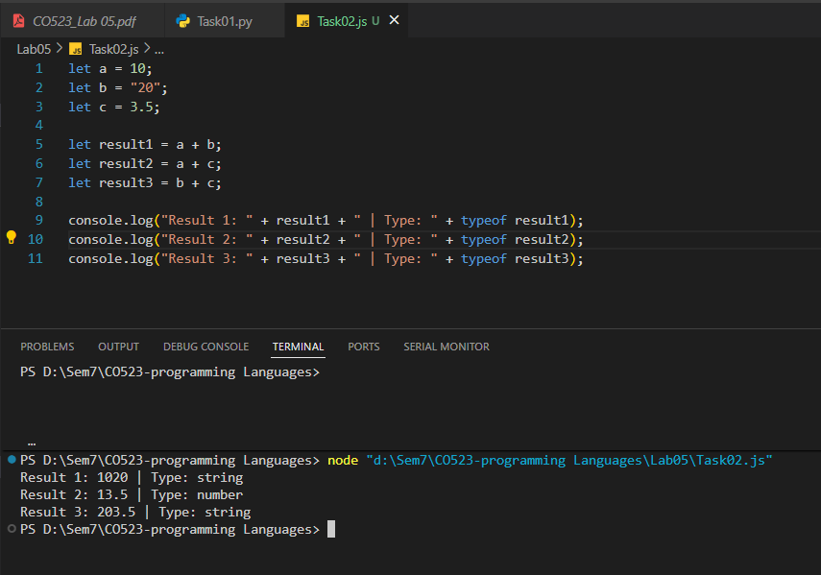
Observed Output
When you execute this code in a browser console or a Node.js environment, you will see:
- Result 1: 1020 | Type: string
- Result 2: 13.5 | Type: number
- Result 3: 203.5 | Type: string

Explanation and Classification
Based on these results:

A. JavaScript is Dynamically Typed
- Evidence: Variables a, b, and c are declared using let without specifying a type (like int or String).
- Reasoning: The language determines the type of the variable at runtime based on the value assigned to it. Furthermore, variables in such systems can hold values of different types at different times without causing a compilation error.

B. JavaScript is Weakly Typed
- Evidence: * Result 1 (a + b): The number 10 was implicitly converted to the string "10" and then concatenated with "20" to produce "1020".
  - Result 3 (b + c): The number 3.5 was implicitly converted to the string "3.5" to concatenate with "20", resulting in "203.5".
- Reasoning: Weak typing allows operations between incompatible types through implicit (automatic) type conversion (also known as coercion). Unlike Python (which would throw a TypeError), JavaScript "coerces" the values to a compatible form to complete the operation.

Analysis of Practical Implications
Feature | Advantage | Disadvantage
Weak Typing | Flexibility - Allows for faster development and less verbose code because you don't always have to manually convert types. | Unpredictability - Can lead to "silent" logical errors. For example, a developer might expect 10 + "20" to be 30, but getting "1020" could break later logic without crashing the program.
Dynamic Typing | Rapid Prototyping - Easier to write and change code quickly since you don't need to manage strict type declarations. | Performance & Safety - Can reduce execution performance and increase the risk of errors that only appear when the program is already running

Task 03
Step 1: Run and Observe Initial Programs
Python Program

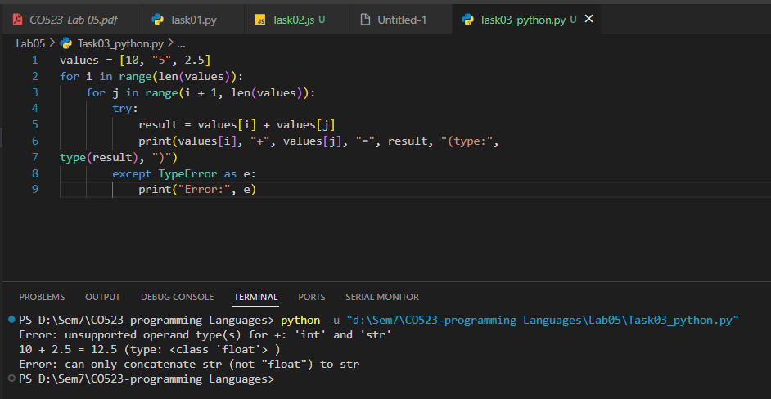
- Result 1 (10 + 2.5): Succeeds. Output: 10 + 2.5 = 12.5 (type: <class 'float'>).
- Result 2 (10 + "5" or "5" + 2.5): Fails. Output: Error: unsupported operand type(s) for +: 'int' and 'str'.
Java Program

- int r1 = a + b; Compile Error: Incompatible types; String cannot be converted to int⁵⁵⁵.
- double r2 = a + c; Success: Compiles and runs. Java performs implicit promotion of int to double⁶⁶.
- String r3 = b + c; Success: Compiles and runs. Java performs string concatenation by converting the number to a string⁷.

Step 2: Modify for Explicit Conversions
To make the failing operations work, we must apply explicit type conversion (casting or parsing).
Modified Python
Python
values = [10, "5", 2.5]
# Convert string to int explicitly
result = values[0] + int(values[1])
print(f"Result: {result}") # Output: 15
Modified Java
Java
int a = 10;
String b = "5";
// Parse the string to an integer explicitly
int r1 = a + Integer.parseInt(b);
System.out.println(r1); // Output: 15

Step 3: Comparison and Evidence
Feature | Python | Java
Typing Category | Dynamic Typing ⁸: Types are checked at runtime⁹. | Static Typing ¹⁰: Types are checked at compile time¹¹.
Enforcement | Strong Typing ¹²: Blocks int + str without explicit conversion¹³. | Strong Typing: Generally blocks incompatible assignments (e.g., int x = "hello")¹⁴.
Type Checking | Occurs during program execution (Runtime)¹⁵. | Occurs during compilation¹⁶. Errors prevent the program from running¹⁷.
Implicit Conversion | Limited (e.g., int to float). Highly restrictive with strings¹⁸. | Broad for strings (concatenation) and numeric promotion (widening)¹⁹¹⁹¹⁹¹⁹.
Discussion: Advantages and Disadvantages
- Static Typing (Java):
  - Pros: Detects errors early before deployment²⁰. Better performance due to compiler optimizations²¹.
  - Cons: More "boilerplate" code; you must declare every variable's type²².
- Dynamic Typing (Python):
  - Pros: Faster to write and more flexible; code is less verbose²³.
  - Cons: Errors might stay hidden until a specific line of code is executed at runtime²⁴.
- Explicit Conversion Requirement:
  - Advantage: Prevents logical bugs (like accidentally adding a zip code string to a price integer)²⁵.
  - Disadvantage: Requires more effort from the programmer to write conversion logic²⁶.

