Department of Computer Engineering

University of Peradeniya

CO523 - Programming Languages

Lab 10: Logical Programming Paradigm

E/20/449
WIJEWARDHANA A.R.S.S.

5. Lab Tasks

5.1. Building a Family Knowledge Base
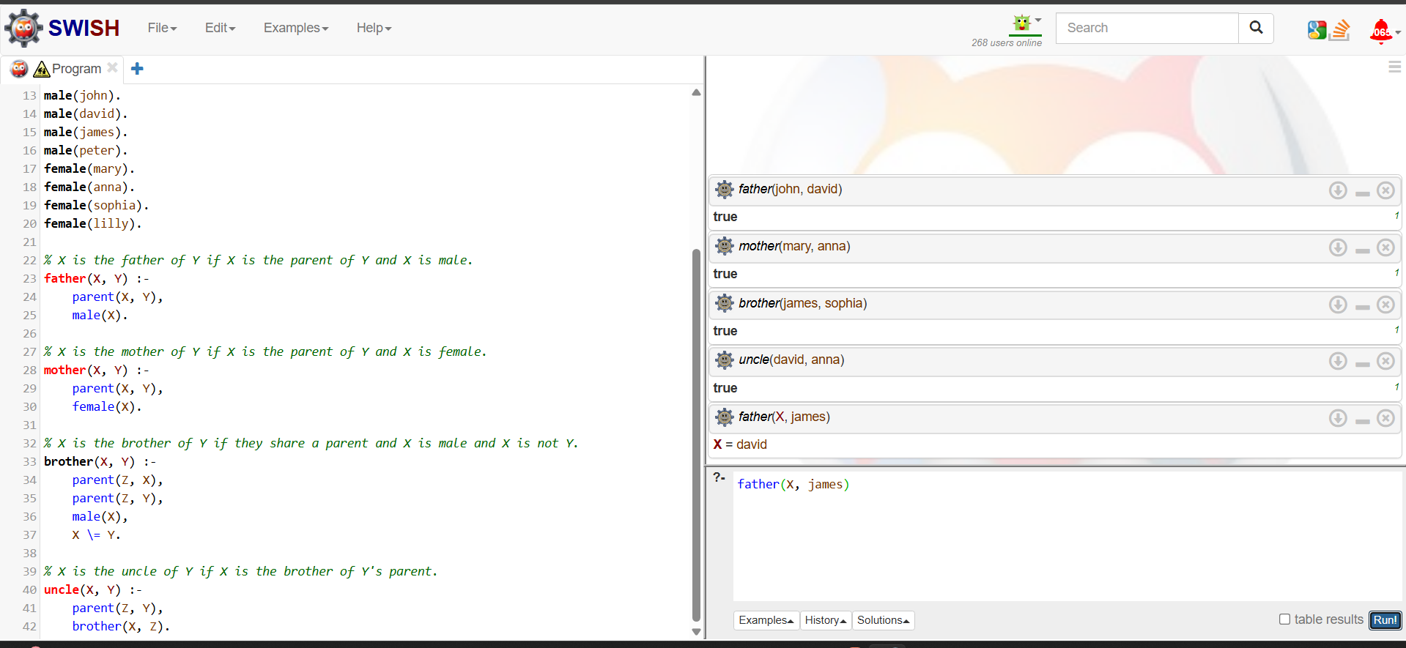

The objective of this task is to extend a family tree to three generations and define relational rules using the logical programming paradigm.

I. Knowledge Base (Facts)
In Prolog, facts are statements describing relationships that are always true. We define the lineage using parent/2 and identify individuals using male/1 and female/1.

II. Logical Rules
Rules are logical implications where a conclusion is reached if specific conditions are met.
Relationship | Prolog Rule Implementation | Logic Explanation
Father | father(X, Y) :- parent(X, Y), male(X). | X is the father of Y if X is a parent of Y AND X is male.
Mother | mother(X, Y) :- parent(X, Y), female(X). | X is the mother of Y if X is a parent of Y AND X is female.
Brother | brother(X, Y) :- parent(Z, X), parent(Z, Y), male(X), X \= Y. | X and Y share a parent Z, X is male, and X is not the same person as Y.
Uncle | uncle(X, Y) :- parent(Z, Y), brother(X, Z). | X is an uncle of Y if X is the brother of Y's parent (Z).

III. Query Execution & Results
Query | Explanation of Output
?- father(john, david). | Returns true because John is a parent of David and is male.
?- mother(mary, anna). | Returns true because Mary is a parent of Anna and is female.
?- brother(james, sophia). | Returns true because they both have the parent David, and James is male.
?- uncle(david, anna). | Returns true because David is the brother of Mary, and Mary is the parent of Anna.
?- father(X, james). | Returns X = david because Prolog finds the value that satisfies the father relationship.

5.2. Unification and Constraints
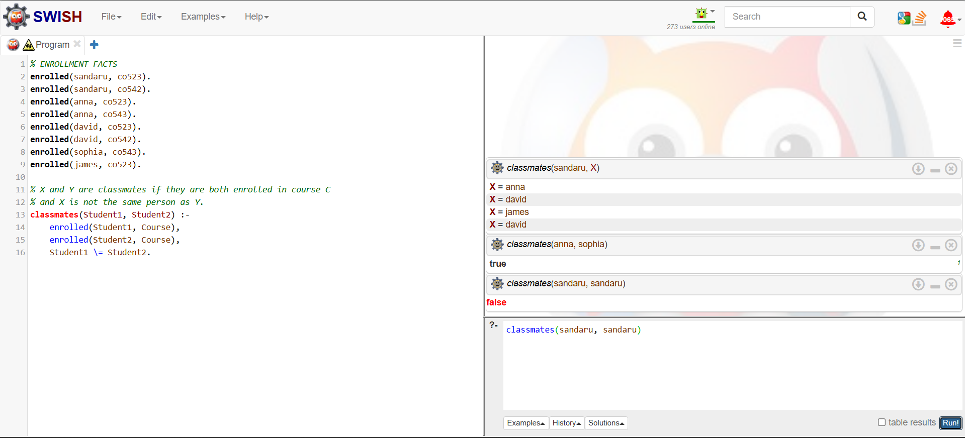

This task focuses on using the unification process to identify relationships within an educational database. It will learn to use the inequality operator \= to apply constraints, ensuring that logical results remain valid (Example: a student cannot be their own classmate).

1. Define Student Enrollment Facts
First,we must create a database of students and the courses they are taking. Use the format enrolled(student_name, course_code)..

% ENROLLMENT FACTS
enrolled(sandaru, co523).
enrolled(sandaru, co542).
enrolled(anna, co523).
enrolled(anna, co543).
enrolled(david, co523).
enrolled(david, co542).
enrolled(sophia, co543).
enrolled(james, co523).

2. Define the Classmates Rule
A classmate is defined as a student who is enrolled in the same course as another student. Crucially, we must use the \= operator to ensure the system doesn't list a student as a classmate of themselves.

% X and Y are classmates if they are both enrolled in course C
% and X is not the same person as Y.
classmates(Student1, Student2) :-
enrolled(Student1, Course),
enrolled(Student2, Course),
Student1 \= Student2.

3. Run Queries and Analyze Results

Query | Expected Output | Logic Explanation
?- classmates(sandaru, X). | X = anna, X = david, X = james (and more) | Prolog finds all students X who share at least one Course with sandaru.
?- classmates(anna, sophia). | true | Both are enrolled in co543, satisfying the rule.
?- classmates(sandaru, sandaru). | false | The constraint Student1 \= Student2 prevents this from being true.

5.3. Implementing Recursive Logic
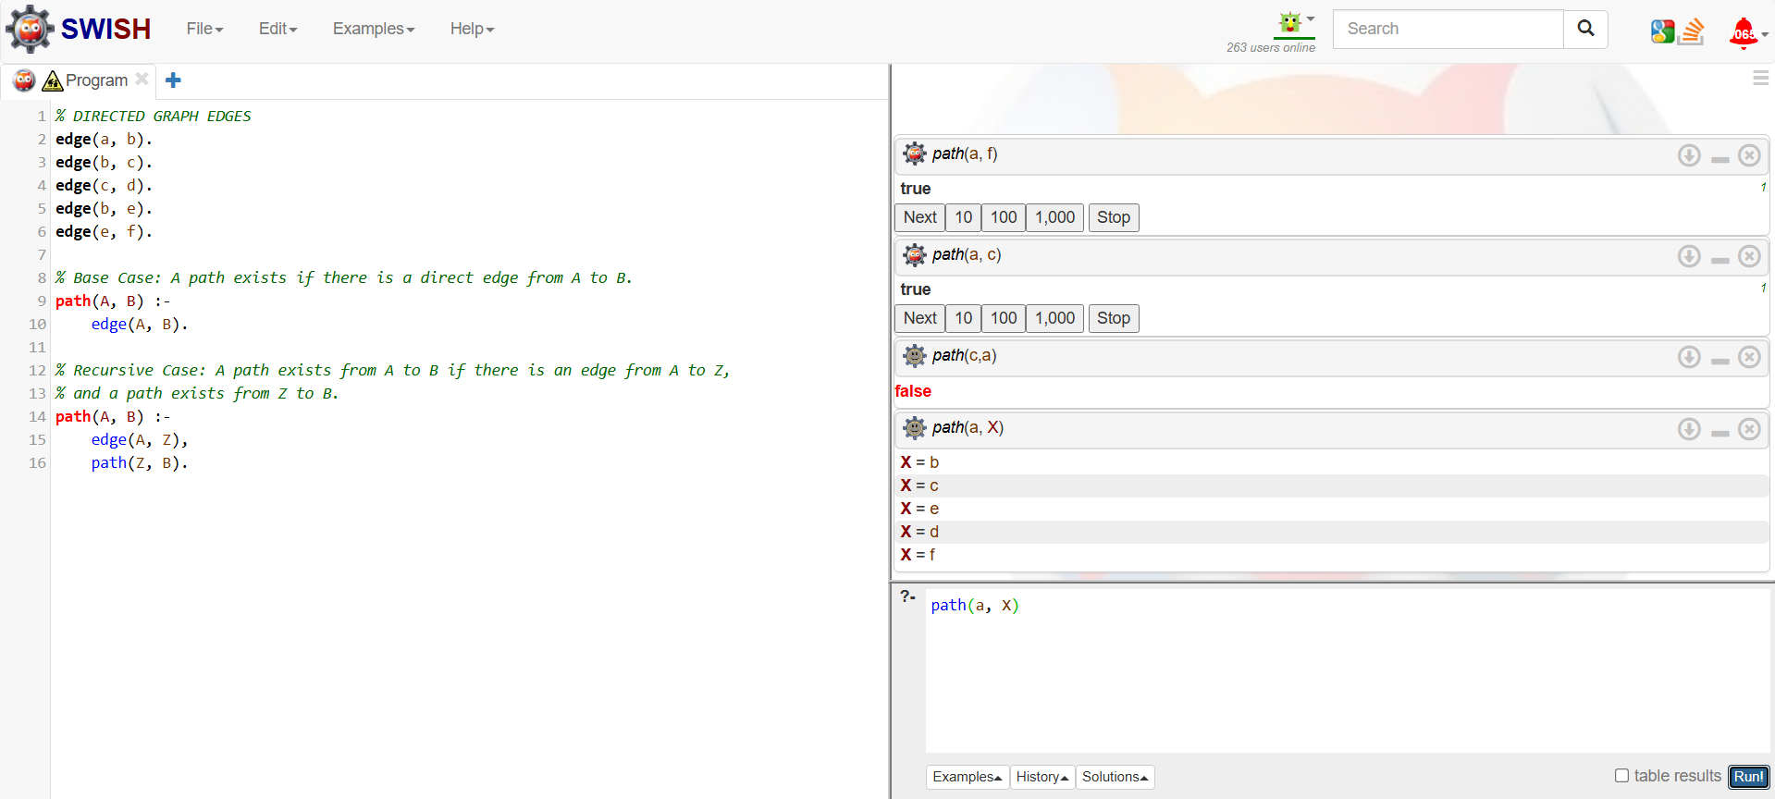

This involves modeling a directed graph and defining a recursive rule to determine if a path exists between two nodes. Recursion is a fundamental concept in Prolog, where a rule calls itself to solve a problem by breaking it down into smaller steps.

1. Define the Graph (Facts)
In a directed graph, an edge is a one-way connection from one node to another.

% DIRECTED GRAPH EDGES
edge(a, b).
edge(b, c).
edge(c, d).
edge(b, e).
edge(e, f).

Step 2: Define the Recursive Path Rule
The path(A, B) rule consists of two parts: a base case and a recursive case.

% Base Case: A path exists if there is a direct edge from A to B.
path(A, B) :-
edge(A, B).

% Recursive Case: A path exists from A to B if there is an edge from A to Z,
% and a path exists from Z to B.
path(A, B) :-
edge(A, Z),
path(Z, B).

3. Run Queries and Analyze Results
Query | Result | Logic Explanation
?- path(a, c). | true | Recursive Step: edge(a, b) -> edge(b, c). Prolog finds the connection through node 'b'.
?- path(a, f). | true | Multi-step: edge(a, b) -> edge(b, e) -> edge(e, f). Prolog uses recursion to follow the chain.
?- path(c, a). | false | Since the edges are directed, there is no way to go backward from 'c' to 'a'.
?- path(a, X). | X=b, X=c, X=d... | Using Backtracking, Prolog finds every node reachable from 'a'.

