Department of Computer Engineering

University of Peradeniya

CO523 - Programming Languages

Lab 04: Demonstrating Static vs Dynamic Scoping
E/20/449
Wijewardhana A.R.S.S.
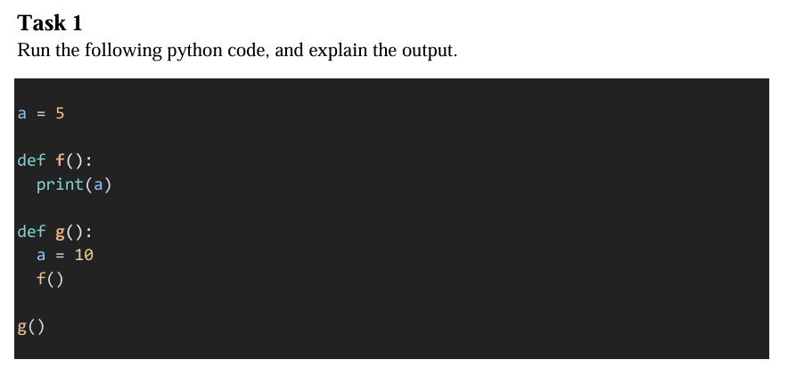
Output :5
- Why is it 5 and not 10?
  - Python uses Static Scoping (also called Lexical Scoping).
  - In static scoping, a variable's value is determined by the program text structure (where the function is defined), not the runtime call stack (where the function is called).
  - The function f() is defined in the global scope where a = 5.
  - Even though f() is called inside g() (where a is locally set to 10), f() cannot see g()'s local variables. It looks for a in its own definition environment, finds the global a, and prints 5.

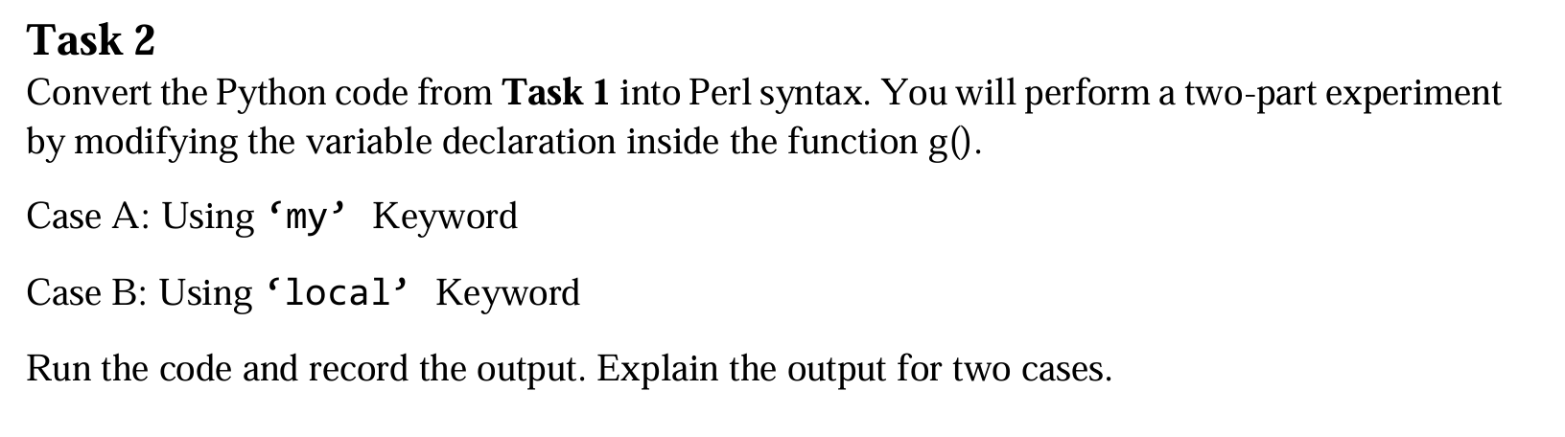
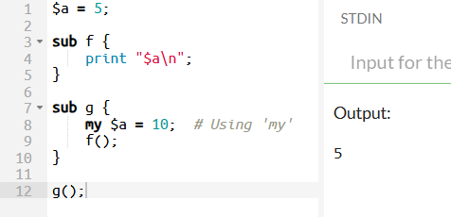
Case A: Using 'my' Keyword (Static Scoping)
- Why 5? You used the my keyword. This enforces Static (Lexical) Scoping.
- When f() runs, it needs to find $a.
- Because of static scoping, f() looks at where it was defined (the global scope), not where it was called.
- It ignores the $a = 10 inside g() because my keeps that variable private to g()'s physical block .
- Therefore, f() prints the global value: 5.
Case B: Using 'local' Keyword (Dynamic Scoping)
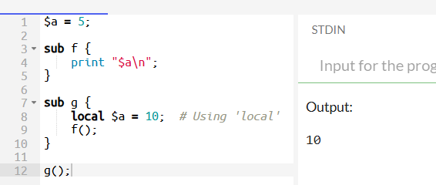
- Why 10? You used the local keyword. This enforces Dynamic Scoping.
- When f() runs, it looks for $a.
- Under dynamic scoping, f() looks at the Call Stack (who called me?).
- Since g() called f(), and g() used local $a = 10, the function f() "sees" this temporary value.
- Therefore, f() prints the value currently active in the call chain: 10.

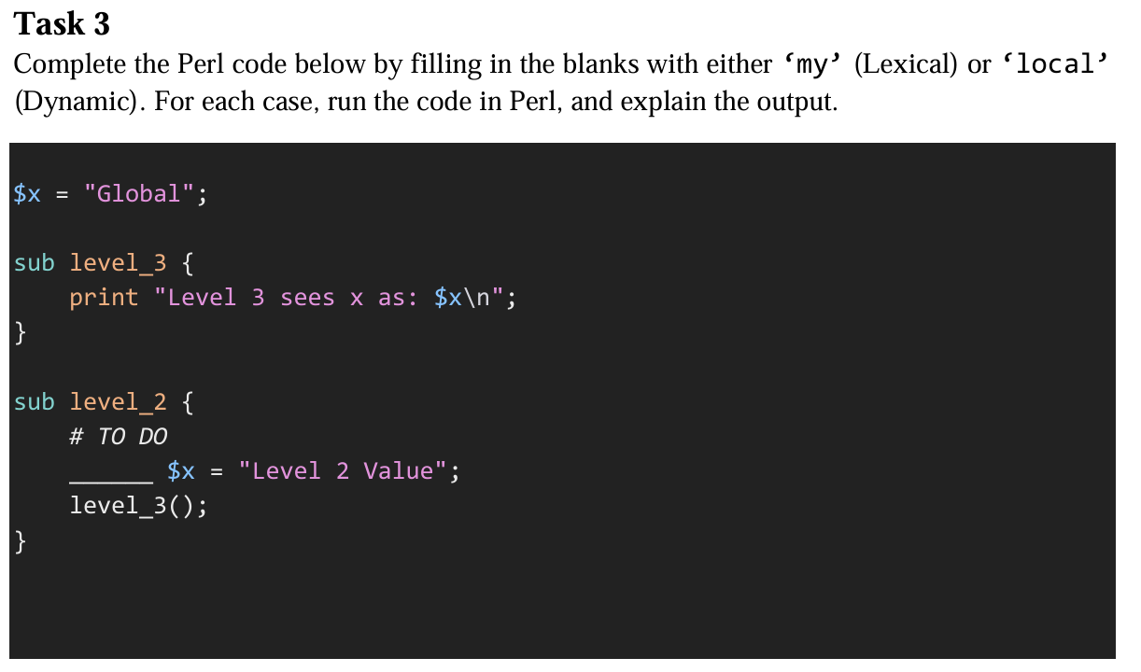
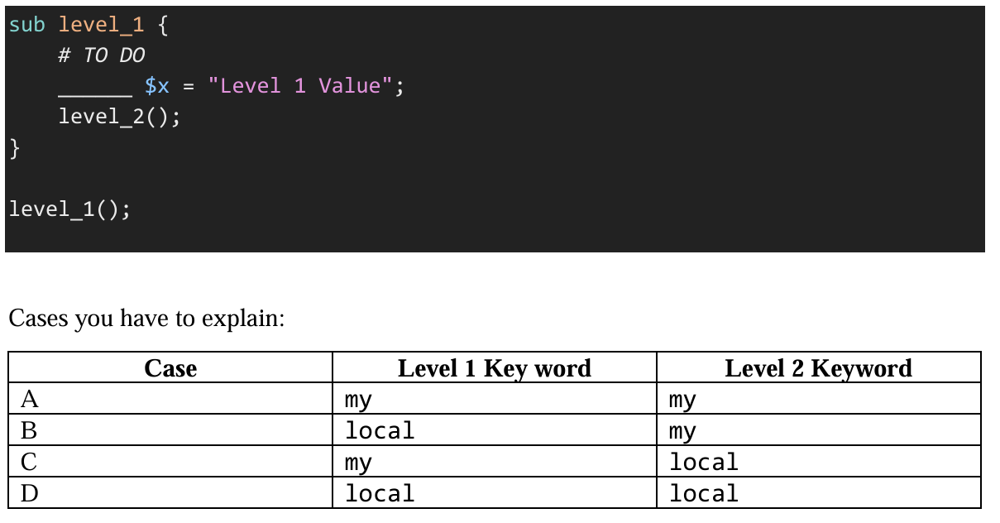

Case A: Level 1 = my, Level 2 = my
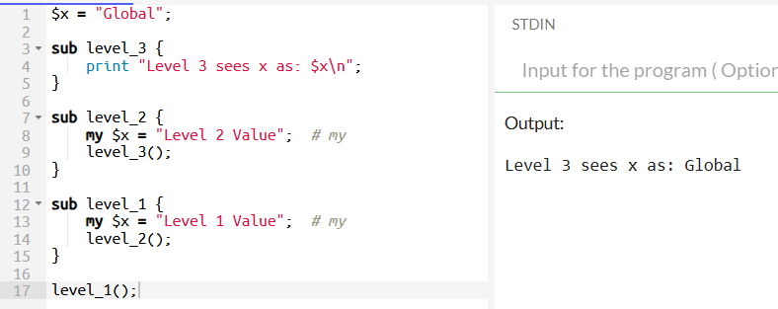
- Static Scoping: Both level_1 and level_2 use my. This creates purely private variables visible only inside their own curly braces {}.
- These private variables are not visible to level_3.
- When level_3 runs, it looks for $x. Since no one dynamically replaced the global variable, level_3 finds the original $x = "Global".

Case B: Level 1 = local, Level 2 = my
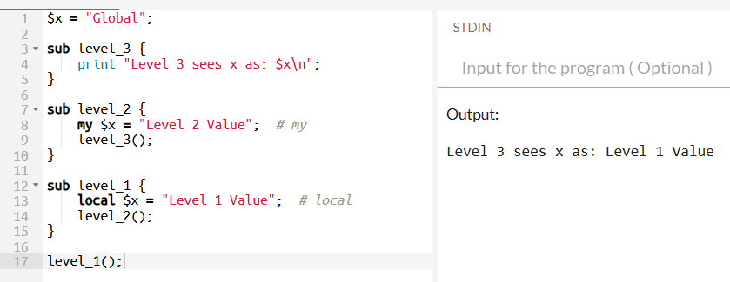
- level_1 uses local. This temporarily replaces the Global $x with "Level 1 Value".
- level_1 calls level_2.
- level_2 uses my. This creates a new, private variable $x = "Level 2 Value". This private variable only exists inside level_2 and does not touch the global variable.
- level_2 calls level_3.
- level_3 executes. It cannot see level_2's private my variable. It looks at the Global $x.
- The Global $x is currently holding "Level 1 Value" (because level_1 changed it dynamically).

Case C: Level 1 = my, Level 2 = local
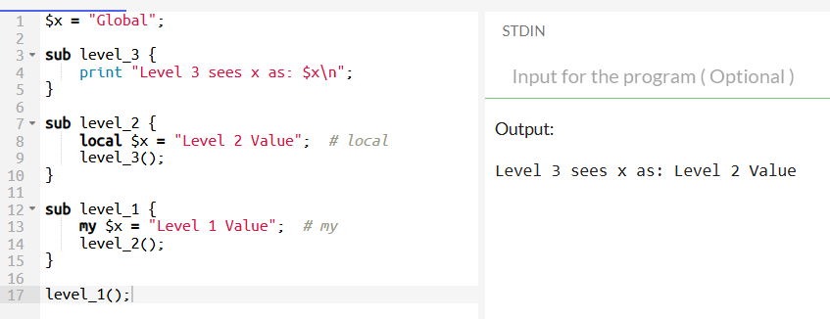
- level_1 uses my. It creates a private variable "Level 1 Value". The Global $x remains "Global".
- level_1 calls level_2.
- level_2 uses local. It temporarily replaces the Global $x with "Level 2 Value".
- level_2 calls level_3.
- level_3 executes. It looks at the Global $x.
- The Global $x is currently holding "Level 2 Value" (because level_2 changed it dynamically).
Case D: Level 1 = local, Level 2 = local
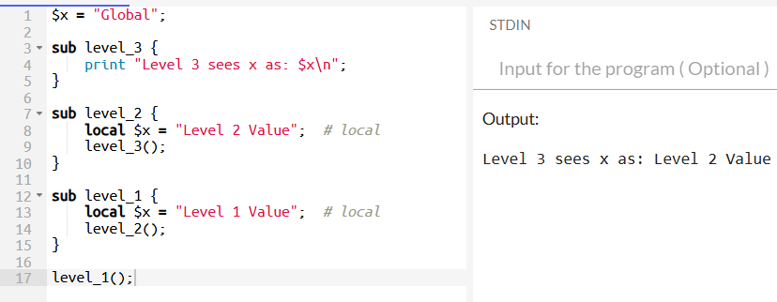
- level_1 uses local. Global $x becomes "Level 1 Value".
- level_1 calls level_2.
- level_2 uses local. It saves the previous value ("Level 1 Value") and temporarily sets Global $x to "Level 2 Value".
- level_2 calls level_3.
- level_3 executes. It looks at the Global $x.
- The Global $x is currently holding "Level 2 Value".
Summary
Case | Level 1 | Level 2 | Output | Reason
A | my | my | Global | Both are private; Global variable is untouched.
B | local | my | Level 1 Value | L1 updates Global; L2 creates a private var that L3 ignores.
C | my | local | Level 2 Value | L1 is private; L2 updates Global, which L3 sees.
D | local | local | Level 2 Value | L1 updates Global; L2 updates Global again (most recent change wins).

