**NEPAL COLLEGE OF INFORMATION TECHNOLOGY**

**Balkumari, Lalitpur**



(Affiliated to Pokhara University)

**A Lab Report**

**On**

**Subject: Web Technology**

**Lab Report: #0**

**Submitted by: Submitted to:**

**Name:** Rajan Raj Acharya **Instructor:** Er. Simanta Kasaju

**Roll No:** 231725 **Department of Software**

**Faculty:** Software **Engineering**

**Semester:** 2nd **Submission Date: 2081/**

**VS CODE:**

**Visual Studio Code, commonly known as VSCode, is a free and open-source code editor developed by Microsoft. It supports a wide range of programming languages, and features include debugging, syntax highlighting, and Git integration. Its popularity has made it one of the most widely used code editors among developers.**

**Theory:**

* **HTML was developed by Tim Berners Lee in the late 1991s.**
* **HTML stands for Hyper Text Markup Language.**
* **It is called Markup language because the contents can be displayed according to the tags.**
* **The building blocks of HTML are tags and attributes.**
* **It is used to build the websites.**
* **The extension of the HTML file is .htm or .html.**

**Structure of HTML**

**<!DOCTYPE html> : It represents the html of version 5.**

**<html> : Root tag.**

**<head> : Contains meta information.**

**<title>Title name</title>: Contains the title of webpage and displayed**

**In the title bar of web browser.**

**</head>**

**<body> : Contains the displaying part for the webpage.**

**<p>Web Technology</p>: Paragraph**

**<h1> Hello World</h1> : Large heading.**

**</body>**

**</html>**

**Types of Tags**

**Paired/Companion tags:** Those tags that have both starting and ending tags are called paired tags. For example: <p> </p>, <h1> </h1>, etc.

**Unpaired/Singular tags:** Those tags whose starting and ending tags are same are called unpaired tags. For example: <hr>, <br, etc.

**Some Formatting tags:**

|  |  |
| --- | --- |
| **Tags** | **Description** |
| **<b>** | **Bold text.** |
| **<strong>** | **Important text.** |
| **<i>** | **Italic text.** |
| **<em>** | **Emphasized text.** |
| **<mark>** | **Highlight the text.** |
| **<strike>** | **Strike a line on a section of the text.** |
| **<sub>** | **Subscript text.** |
| **<sup>** | **Superscript text.** |
| **<u>** | **Underline the text.** |
| **<tt>** | **Display in teletype format.** |
| **<small>** | **Smaller text.** |

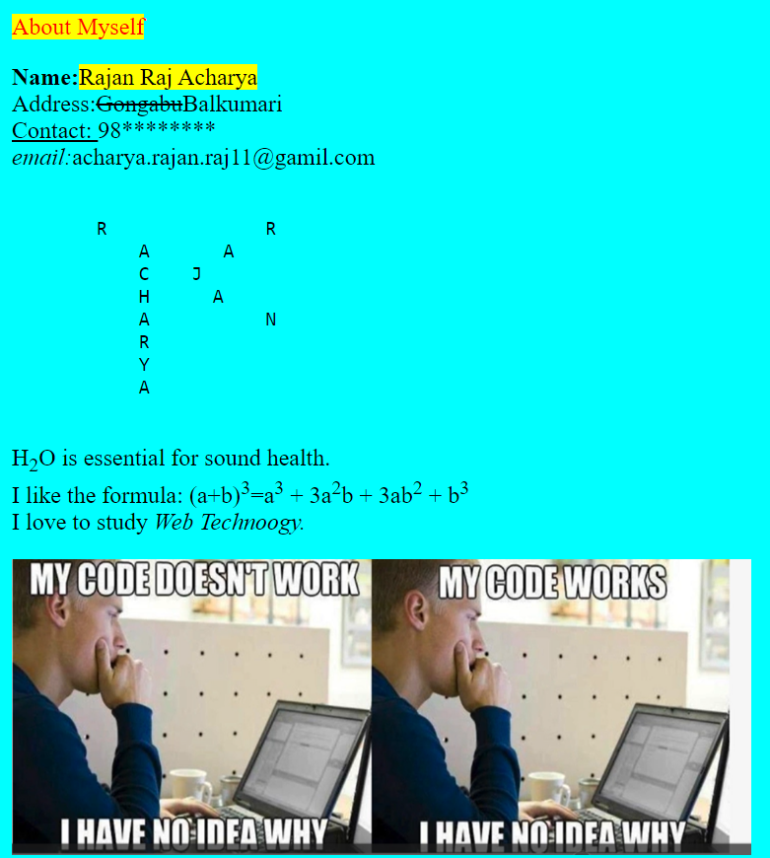**Using different tags creating a webpage.**

**HTML code:**

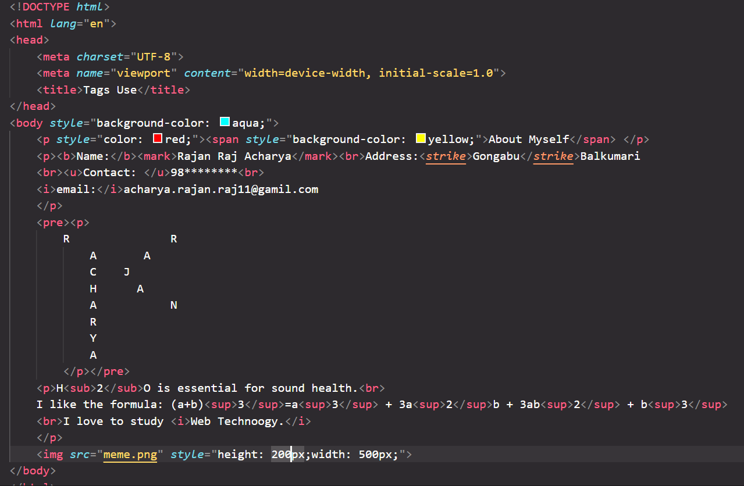

**Some Other Tags:**

**Meter tag:** It defines the scalar measurement within a known range.

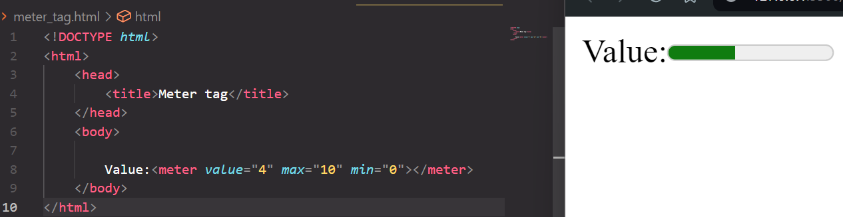

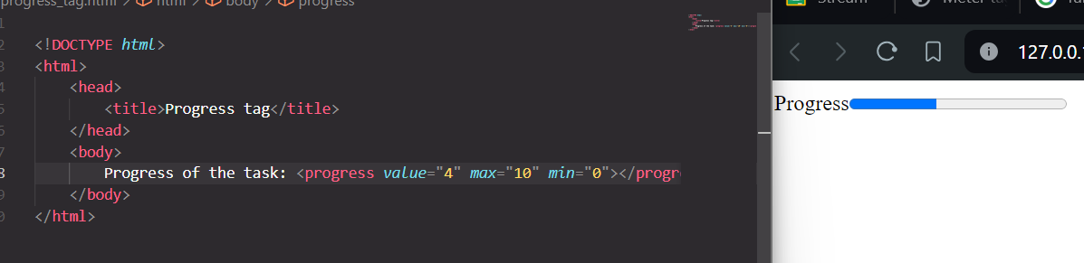**Progress tag:**  It represents the progress/completion of the task.

**Pre tag:** It is used to display the content as same as written in the html code.

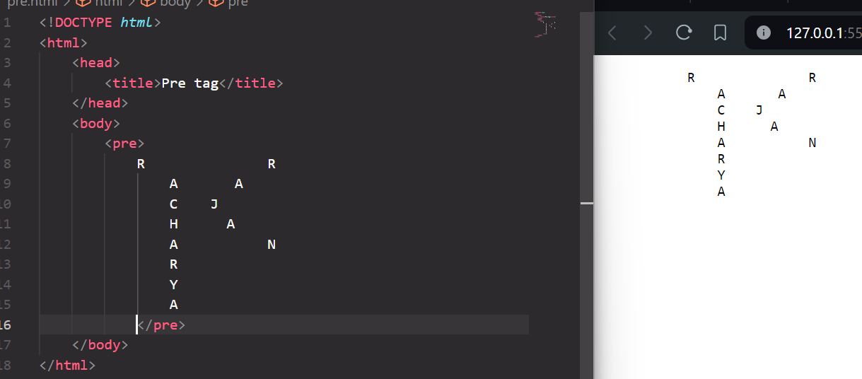

**Samp tag:** It is used to display the contents as in the computer program font (monospace font).

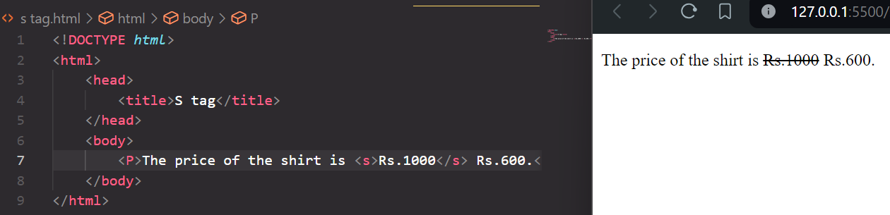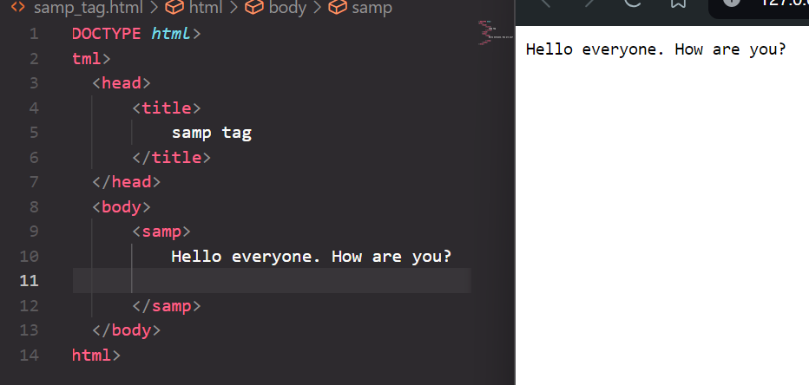**S tag:** It is used to render a text with a line through it.

**Time tag:** It is used to specify the time.

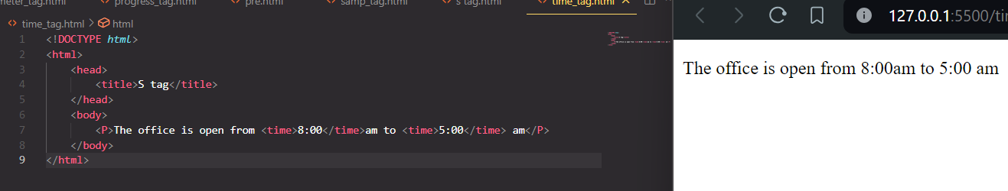

**Var tag:** It is used to define a variable in programming or in a mathematical expression.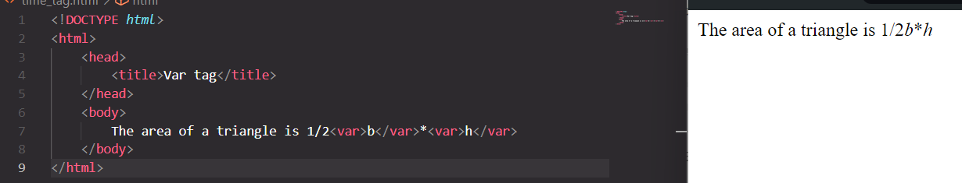

**WBR tag**: Word Breal Opportunity tag is used to specify to where it would be okay to break a line in a word.

**Article tag:** It is used to specify a content that is different from other contents. We can write blogs, articles, forum post, etc.

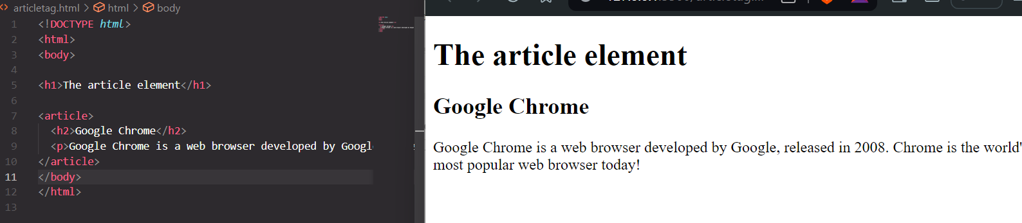**Aside tag:** It represents a portion of a document whose content is indirectly related to the document’s main content.

**Label tag:**A label tag is used to create a caption for a form control.

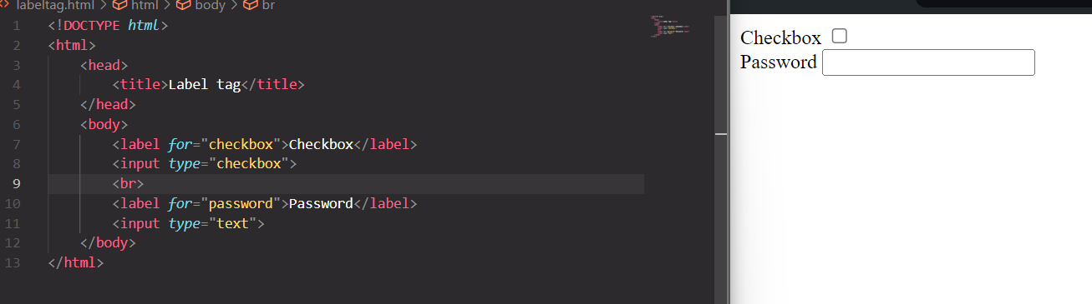

**Project 0:**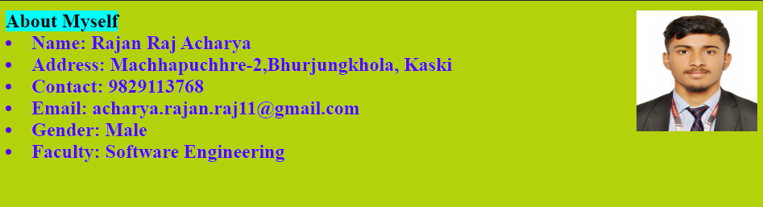

**HTML code:**

