**NEPAL COLLEGE OF INFORMATION TECHNOLOGY**

**Balkumari, Lalitpur**



(Affiliated to Pokhara University)

**A Lab Report**

**On**

**Subject: Web Technology**

**Lab Report: #0**

**Submitted by: Submitted to:**

**Name:** Sandarva Paudel Instructor**:** Er. Simanta Kasaju

**Roll No:** 231733 **Department of Software**

**Faculty:** Software **Engineering**

**Semester:** 2nd **Submission Date: 2081/**

**Code Editor:**

**A code editor is a software application designed for writing and editing programming code. It provides features like syntax highlighting, line numbering, and code formatting to help developers write, navigate, and understand code more efficiently. Code editors can also offer more advanced features such as code completion and error detection to streamline the coding process. I will be using VScode as code editor.**

**Theory:**

* **HTML was developed by Tim Berners Lee in the late 1991s.**
* **HTML stands for Hyper Text Markup Language.**
* **It is called Markup language because the contents can be displayed according to the tags.**
* **The building blocks of HTML are tags and attributes.**
* **It is used to build the websites.**
* **The extension of the HTML file is .htm or .html.**

**Structure of HTML**

**<!DOCTYPE html> : It represents the html of version 5.**

**<html> : Root tag.**

**<head> : Contains meta information.**

**<title>Title name</title>: Contains the title of webpage and displayed**

**In the title bar of web browser.**

**</head>**

**<body> : Contains the displaying part for the webpage.**

**<p>Web Technology</p>: Paragraph**

**<h1> Hello World</h1> : Large heading.**

**</body>**

**</html>**

**Types of Tags**

**Paired/Companion tags:** Those tags that have both starting and ending tags are called paired tags. For example: <strong> </strong>, <div> </div>, etc.

**Unpaired/Singular tags:** Those tags whose starting and ending tags are same are called unpaired tags. For example: <hr>, <br>, etc.

**Some Formatting tags:**

|  |  |
| --- | --- |
| **Tags** | **Description** |
| **<input>** | **Input field.** |
| **<strong>** | **Important text.** |
| **<i>** | **Italic text.** |
| **<bold>** | **Bold text.** |
| **<mark>** | **Highlight the text.** |
| **<strike>** | **Strike a line on a section of the text.** |
| **<sub>** | **Subscript text.** |
| **<sup>** | **Superscript text.** |
| **<u>** | **Underline the text.** |
| **<tt>** | **Display in teletype format.** |
| **<small>** | **Smaller text.** |

**Creating a webpage:**

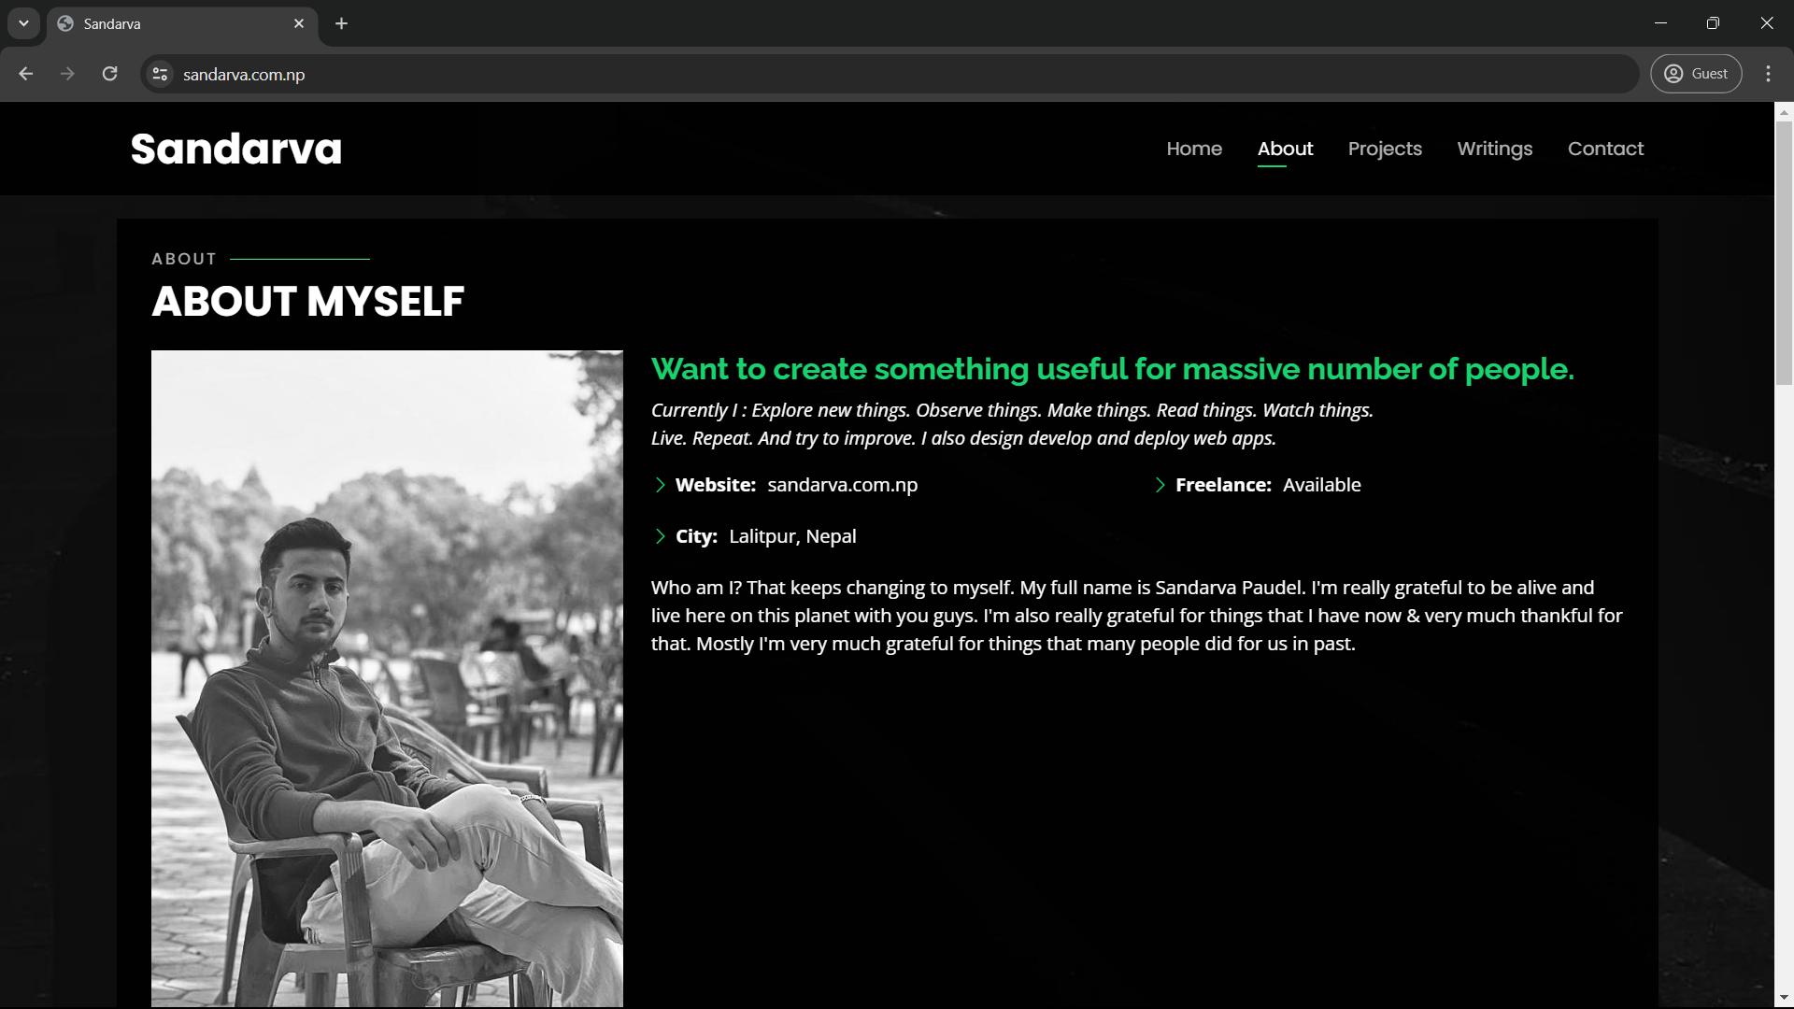

**Source code:**

**<!-- ======= About Me ======= -->**

**<div class="about-me container">**

**<div class="section-title">**

**<h2>About</h2>**

**<p>About myself</p>**

**</div>**

**<div class="row">**

**<div class="col-lg-4" data-aos="fade-right">**

**<img src="assets/img/myself3(bw).jpg" class="img-fluid" alt="">**

**</div>**

**<div class="col-lg-8 pt-4 pt-lg-0 content" data-aos="fade-left">**

**<h3>Want to create something useful for massive number of people.</h3>**

**<p class="fst-italic">**

**Currently I : Explore new things. Observe things. Make things. Read things. Watch things.<br>**

**Live. Repeat. And try to improve.**

**I also design develop and deploy web apps.**

**</p>**

**<div class="row">**

**<div class="col-lg-6">**

**<ul>**

**<li><i class="bi bi-chevron-right"></i> <strong>Website:</strong> <span>sandarva.com.np</span></li>**

**<li><i class="bi bi-chevron-right"></i> <strong>City:</strong> <span>Lalitpur, Nepal</span></li>**

**</ul>**

**</div>**

**<div class="col-lg-6">**

**<ul>**

**<li><i class="bi bi-chevron-right"></i> <strong>Freelance:</strong> <span>Available</span></li>**

**</ul>**

**</div>**

**</div>**

**<p>**

**Who am I? That keeps changing to myself. My full name is Sandarva Paudel.**

**I'm really grateful to be alive and live here on this planet with you guys.**

**I'm also really grateful for things that I have now & very much thankful for that.**

**Mostly I'm very much grateful for things that many people did for us in past.**

**</p>**

**</div>**

**</div>**

**</div>**

**<!-- End About Me -->**

**Some Other Tags:**

**Meter tag:** It defines the scalar measurement within a known range.

**Progress tag:**  It represents the progress/completion of the task.

**Input tag:** It is used to create input field where user can enter the input. It’s used forms in webpage.

**Samp tag:** It is used to display the contents as in the computer program font (monospace font).

**S tag:** It is used to render a text with a line through it.

**Time tag:** It is used to specify the time.

**Var tag:** It is used to define a variable in programming or in a mathematical expression.

**Article tag:** It is used to specify a content that is different from other contents. We can write blogs, articles, forum post, etc.

**Aside tag:** It represents a portion of a document whose content is indirectly related to the document’s main content.

**Label tag:**A label tag is used to create a caption for a form control.