**NEPAL COLLEGE OF INFORMATION TECHNOLOGY**

**Balkumari, Lalitpur**



(Affiliated to Pokhara University)

**A Lab Report**

**On**

**Subject: Web Technology**

**Lab Report: #2**

**Submitted by: Submitted to:**

**Name:** Rajan Raj Acharya **Instructor:** Er. Simanta Kasaju

**Roll No:** 231725 **Department of Software**

**Faculty:** Software **Engineering**

**Semester:** 2nd **Submission Date: 2024/06/02**

**Table of Contents:**

|  |  |  |
| --- | --- | --- |
| **S.N** | **Title** | **Submission Date** |
| **1.** | **Introduction to HTML** | 2024/05/08 |
| **2.** | **HTML lists, hyperlinks, image** | 2024/05/22 |
| **3.** | **Table** | 2024/06/02 |
|  |  |  |
|  |  |  |
|  |  |  |
|  |  |  |
|  |  |  |
|  |  |  |
|  |  |  |
|  |  |  |
|  |  |  |
|  |  |  |
|  |  |  |

**Theory:**

**Tables**

1. HTML table tag is used to display data in tabular form (row *column). There can be many columns in a row.

2. We can create a table to display data in tabular form, using

<table> element, with the help of <tr>, <td>, and <th>

elements.

3. In Each table, table row is defined by <tr> tag, table header is defined by <th>, and table data is defined by <td> tags.

4.HTML tables are used to manage the layout of the page e.g.

header section, navigation bar, body content, footer section

etc. But it is recommended to use div tag over table to

manage the layout of the page.

**Cellpadding and cellspacing Attributes:**

There are two attributes called cellpadding and cellspacing which you will use to adjust the white space in your table cells. The cellspacing attribute defines space between table cells, while cellpadding represents the distance between cell borders and the content within a cell.

**Rowspan and colspan:**

We use colspan attribute if we want to merge two or more columns into a single column. Similar way we use rowspan if we want to merge two or more rows.

**Marquee tag:**

Marquee is one of the important tags introduced in HTML

to support such scrollable texts and images within a web

page. The <marquee> tag is a container tag of HTML is

implemented for creating scrollable text or images within a

web page from either left to right or vice versa, or top to

bottom or vice versa. But this tag has been deprecated in

the new version of HTML, i.e., HTML 5.

**Lab Report questions Solutions:**

**Question No. 1:**

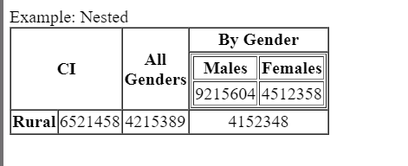

**HTML Code:**

<!DOCTYPE html>

<html lang="en">

<head>

<meta charset="UTF-8" />

<meta name="viewport" content="width=device-width, initial-scale=1.0" />

<title>Document</title>

<style>

td {

text-align: center;

}

</style>

</head>

<body>

Example: Nested

<table border="" cellspacing="0">

<tr>

<th colspan="2" rowspan="2">CI</th>

<th rowspan="2">

All <br />

Genders

</th>

<th>By Gender</th>

</tr>

<tr>

<td>

<table border="">

<tr>

<th>Males</th>

<th>Females</th>

</tr>

<tr>

<td>9215604</td>

<td>4512358</td>

</tr>

</table>

</td>

</tr>

<tr>

<th>Rural</th>

<td>6521458</td>

<td>4215389</td>

<td>4152348</td>

</tr>

</table>

</body>

</html>

**Question No. 2:**

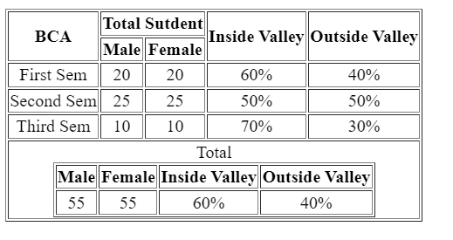

**HTML Code:**

<!DOCTYPE html>

<html lang="en">

<head>

<meta charset="UTF-8">

<meta name="viewport" content="width=device-width, initial-scale=1.0">

<title>Document</title>

<style>

td{

text-align: center;

}

.table-2{

align-items: center;

}

</style>

</head>

<body>

<table border="">

<tr>

<th rowspan="2">BCA</th>

<th colspan="2">Total Sutdent</th>

<th rowspan="2">Inside Valley</th>

<th rowspan="2">Outside Valley</th>

</tr>

<tr>

<th>Male</td>

<th>Female</td>

</tr>

<tr>

<td>First Sem</td>

<td>20</td>

<td>20</td>

<td>60%</td>

<td>40%</td>

</tr>

<tr>

<td>Second Sem</td>

<td>25</td>

<td>25</td>

<td>50%</td>

<td>50%</td>

</tr>

<tr>

<td>Third Sem</td>

<td>10</td>

<td>10</td>

<td>70%</td>

<td>30%</td>

</tr>

<tr>

<td colspan="5">

<table border="" class="table-2" align="center">

<caption>Total</caption>

<tr>

<th>Male</th>

<th>Female</th>

<th>Inside Valley</th>

<th>Outside Valley</th>

</tr>

<tr>

<td>55</td>

<td>55</td>

<td>60%</td>

<td>40%</td>

</tr>

</table>

</td>

</tr>

</table>

</body>

</html>

**Question No. 3:**

**HTML code:**

<!DOCTYPE html>

<html lang="en">

<head>

<meta charset="UTF-8" />

<meta name="viewport" content="width=device-width, initial-scale=1.0" />

<title>Document</title>

<link rel="stylesheet" href="que3.css" />

</head>

<body>

<body>

<p align="center">

<a href="">NCIT</a><br />

<b>Department of IT <br />EFFECTIVE FROM: 01-07-2022</b>

</p>

<table border="" align="center" cellpadding="15px" cellspacing="1px">

<caption>

Semester 3

<span style="margin-left: 300px"

>Class mentor: <a href="">Er: Simanta Kasaju</a></span

>

</caption>

<tr>

<th class="yellow">Day/Periods</th>

<th class="pinkr">1 <br />6:30-730</th>

<th class="pinkr">2 <br />7:30-8:30</th>

<th class="pinkr">3 <br />8:30-9:00</th>

<th class="pinkr">5 <br />9:30-10:00</th>

<th class="pinkr">6 <br />10:00-11:00</th>

<th class="pinkr">7 <br />11:00-12:00</th>

</tr>

<tr>

<td class="grey">Monday</td>

<td class="aqua">Web Technology</td>

<td class="green">DSA</td>

<td class="red">Break</td>

<td class="light-green">Java</td>

<td class="blue">Probability</td>

<td class="pink">SAD</td>

</tr>

<tr>

<td class="grey">Tuesday</td>

<td class="aqua" colspan="2">Web Technology</td>

<td class="red">Break</td>

<td class="light-green" colspan="2">Java</td>

<td class="pink">SAD</td>

</tr>

<tr>

<td class="grey">Wednesday</td>

<td class="green" colspan="2">DSA</td>

<td class="red">Break</td>

<td class="blue" colspan="2">Probability</td>

<td class="pink">SAD</td>

</tr>

<tr>

<td class="grey">Thursday</td>

<td class="pink" colspan="2">SAD</td>

<td class="red">Break</td>

<td class="lg" colspan="3">Java/Web tech lab</td>

</tr>

<tr>

<td class="grey">Friday</td>

<td class="pinkr" colspan="2">Extra Cirriculum</td>

<td class="red">Break</td>

<td class="lg" colspan="3">DSA/Web tech lab</td>

</tr>

<tr>

<th class="grey">Saturday</th>

<td class="aqua">Web Technology</td>

<td class="green">DSA</td>

<td class="red">Break</td>

<td class="light-green">Java</td>

<td class="blue">Probability</td>

<td class="pink">SAD</td>

</tr>

</table>

</body>

</body>

</html>

**CSS Code:**

body{

background-image: url(/images/ncit.jpg);

background-repeat: no-repeat;

background-size: cover;

}

td{

text-align: center;

}

.yellow{

background-color: yellow;

}

.pinkr{

background-color: pink;

}

.pink{

background-color: rgb(246, 74, 212);

}

.red{

background-color: red;

}

.grey{

background-color: grey;

}

.blue{

background-color: rgb(151, 177, 236);

}

.aqua{

background-color: aqua;

}

.light-green{

background-color: aquamarine;

}

.green{

background-color: chartreuse;

}

.lg{

background-color: rgb(173, 234, 220);

}

**Output:**

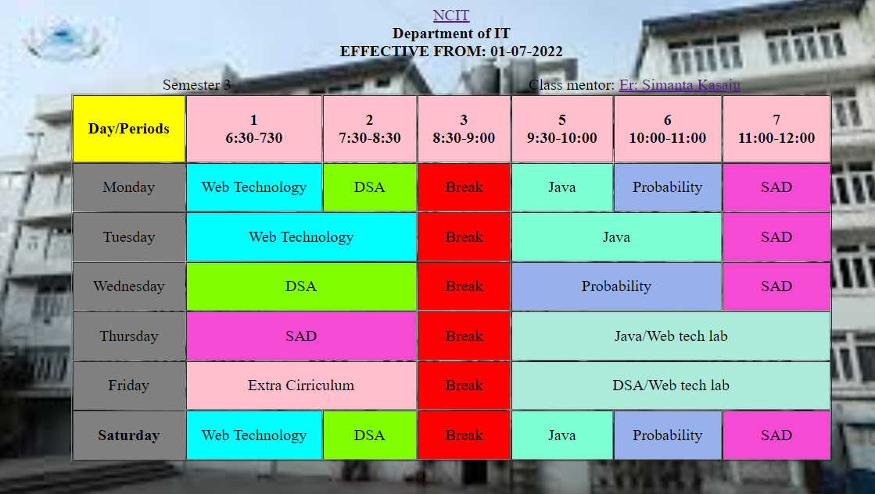

**Question No. 4:**

**HTML Code:**

<!DOCTYPE html>

<html lang="en">

<head>

<meta charset="UTF-8">

<meta name="viewport" content="width=device-width, initial-scale=1.0">

<title>Document</title>

</head>

<body>

<table border="" cellpadding="20px" width="1000px">

<tr style="background-color: rgb(243, 204, 131);">

<th>Category</th>

<th>Images</th>

<th>List</th>

<th>Table</th>

</tr>

<tr style="background-color: rgb(239, 216, 169);">

<th>Players</th>

<td>

<img src="/images/dhoni.jpg" alt="" height="200px"><br>

<img src="/images/ronaldo.jpg" alt="" height="200px">

</td>

<td>

1.Dhoni <br>

2.Ronaldo

</td>

<td>

<table border="">

<tr>

<th>Name</th>

<th>DOB</th>

<th>Famous <br>For</th>

</tr>

<tr>

<th>Mahindra <br>Singh <br>Dhoni</th>

<th>1981</th>

<th>Cricket</th>

</tr>

<tr>

<td>Cristiano <br>Ronaldo</td>

<td>1985</td>

<td>Football</td>

</tr>

</table>

</td>

</tr>

<tr style="background-color: rgb(247, 208, 247);">

<th>Food</th>

<td>

<img src="/images/burger.jpg" alt="" height="200px">

<br><img src="/images/pizza.jpg" alt="" height="200px">

</td>

<td>

<ul>

<li>Burger</li>

<li>Pizza</li>

</ul>

</td>

<td>

<table border="">

<tr>

<th>Name</th>

<th>Price</th>

</tr>

<tr>

<td>Burger</td>

<td>250</td>

</tr>

<tr>

<td>Pizza</td>

<td>340</td>

</tr>

</table>

</td>

</tr>

<tr style="background-color:rgb(156, 241, 241);">

<td>Movies</td>

<td>

<img src="/images/hrithik.jpg"height="200px" alt=""><br>

<img src="/images/shah rukh.jpg" alt="" height="200px">

</td>

<td>

<ol type="a">

<li>Hrithik Roshan</li>

<li>Shah Rukh Khan</li>

</ol>

</td>

<td>

<table border="">

<tr>

<th>Name</th>

<th>DOB</th>

<th>Film <br>Name</th>

</tr>

<tr>

<td>Hrithik Roshan</td>

<td>1974</td>

<td>War</td>

</tr>

<tr>

<td>Shah Rukh Khan</td>

<td>1965</td>

<td>Pathan</td>

</tr>

</table>

</td>

</tr>

</table>

</body>

</html>

**Output:**

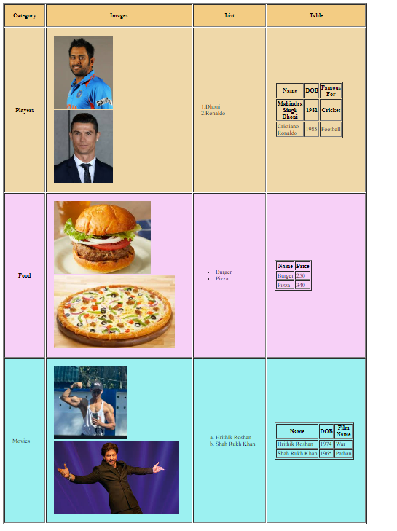

**Question No. 5**

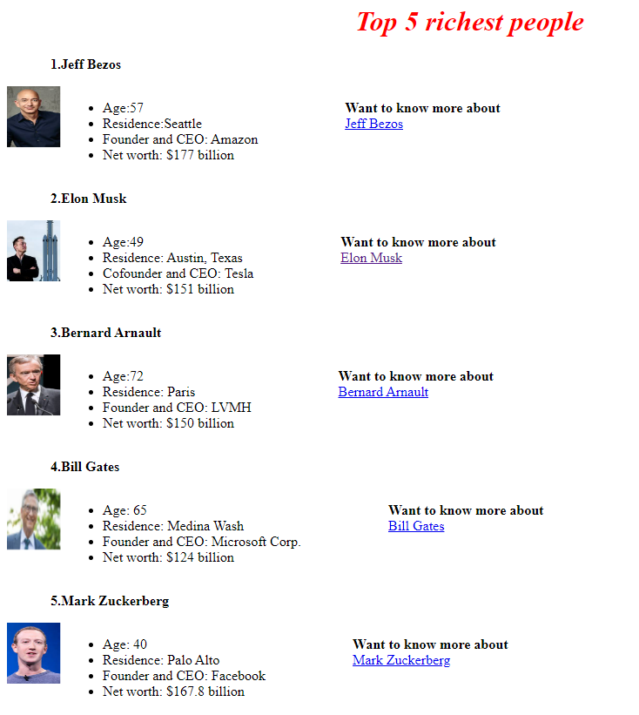

**HTML Code:**

<!DOCTYPE html>

<html lang="en">

<head>

<meta charset="UTF-8" />

<meta name="viewport" content="width=device-width, initial-scale=1.0" />

<title>Document</title>

<style>

.about{

display: flex;

}

i{

margin-left: 400px;

color: red;

}

.title{

margin-left: 50px;

font-weight: bold;

}

img{

height:70px;

width: 70px;

}

.photo-text{

display:flex;

}

.want-to-know{

margin-left: 100px;

}

</style>

</head>

<body>

<h1><i>Top 5 richest people</i></h1>

<div class="main">

<p class="title">1.Jeff Bezos</p>

<div class="about">

<div class="photo-text">

<div class="photo">

<marquee behavior="scroll" direction="left">

<img src="/images/jeff.jpg" alt="" />

</marquee>

</div>

<div class="text">

<ul>

<li>Age:57</li>

<li>Residence:Seattle</li>

<li>Founder and CEO: Amazon</li>

<li>Net worth: $177 billion</li>

</ul>

</div>

</div>

<div class="want-to-know">

<p>

<b>Want to know more about</b><br />

<a href="https://en.wikipedia.org/wiki/Jeff_Bezos">Jeff Bezos</a>

</p>

</div>

</div>

<p class="title">2.Elon Musk</p>

<div class="about">

<div class="photo-text">

<div class="photo">

<marquee behavior="scroll" direction="left">

<img src="/images/elon.jpg" alt="" />

</marquee>

</div>

<div class="text">

<ul>

<li>Age:49</li>

<li>Residence: Austin, Texas</li>

<li>Cofounder and CEO: Tesla</li>

<li>Net worth: $151 billion</li>

</ul>

</div>

</div>

<div class="want-to-know">

<p>

<b>Want to know more about</b><br />

<a href="https://en.wikipedia.org/wiki/Elon_Musk">Elon Musk</a>

</p>

</div>

</div>

<p class="title">3.Bernard Arnault</p>

<div class="about">

<div class="photo-text">

<div class="photo">

<marquee behavior="scroll" direction="left">

<img src="/images/bernard.jpg" alt="" />

</marquee>

</div>

<div class="text">

<ul>

<li>Age:72</li>

<li>Residence: Paris</li>

<li>Founder and CEO: LVMH</li>

<li>Net worth: $150 billion</li>

</ul>

</div>

</div>

<div class="want-to-know">

<p>

<b>Want to know more about</b><br />

<a href="https://en.wikipedia.org/wiki/Bernard_Arnault"

>Bernard Arnault</a

>

</p>

</div>

</div>

<p class="title">4.Bill Gates</p>

<div class="about">

<div class="photo-text">

<div class="photo">

<marquee behavior="scroll" direction="left">

<img src="/images/bill.jpg" alt="" />

</marquee>

</div>

<div class="text">

<ul>

<li>Age: 65</li>

<li>Residence: Medina Wash</li>

<li>Founder and CEO: Microsoft Corp.</li>

<li>Net worth: $124 billion</li>

</ul>

</div>

</div>

<div class="want-to-know">

<p>

<b>Want to know more about</b><br />

<a href="https://en.wikipedia.org/wiki/Bill_Gates">Bill Gates</a>

</p>

</div>

</div>

<p class="title">5.Mark Zuckerberg</p>

<div class="about">

<div class="photo-text">

<div class="photo">

<marquee behavior="scroll" direction="left">

<img src="/images/mark.jpg" alt="" />

</marquee>

</div>

<div class="text">

<ul>

<li>Age: 40</li>

<li>Residence: Palo Alto</li>

<li>Founder and CEO: Facebook</li>

<li>Net worth: $167.8 billion</li>

</ul>

</div>

</div>

<div class="want-to-know">

<p>

<b>Want to know more about</b><br />

<a href="https://www.forbes.com/profile/mark-zuckerberg/"

>Mark Zuckerberg</a

>

</p>

</div>

</div>

</div>

</body>

</html>

***Thank You!***