**NEPAL COLLEGE OF INFORMATION TECHNOLOGY**

**Balkumari, Lalitpur**



(Affiliated to Pokhara University)

**A Lab Report**

**On**

**Subject: Web Technology**

**Lab Report: #0**

**Submitted by: Submitted to:**

**Name:** Sandarva Paudel **Instructor:** Er. Simanta Kasaju

**Roll No:** 231733 **Department of Software**

**Faculty:** Software **Engineering**

**Semester:** 2nd **Submission Date: 2081/**

**Table of Contents:**

|  |  |
| --- | --- |
| **S.N** | **Title** |
| **1.** | **Code editor & Setting up development Environment.** |
| **2.** | **HTML & HTML tags.** |
| **3.** | **Some Formatting Tags.** |
| **4.** | **Some other Tags.** |
| **5.** | **About Myself** |
|  |  |
|  |  |
|  |  |
|  |  |
|  |  |
|  |  |
|  |  |
|  |  |
|  |  |

**VS CODE:**

**Visual Studio Code, commonly known as VSCode, is a free and open-source code editor developed by Microsoft. It supports a wide range of programming languages, and features include debugging, syntax highlighting, and Git integration. Its popularity has made it one of the most widely used code editors among developers.**

**Downloading VS Code from Web Browser:**

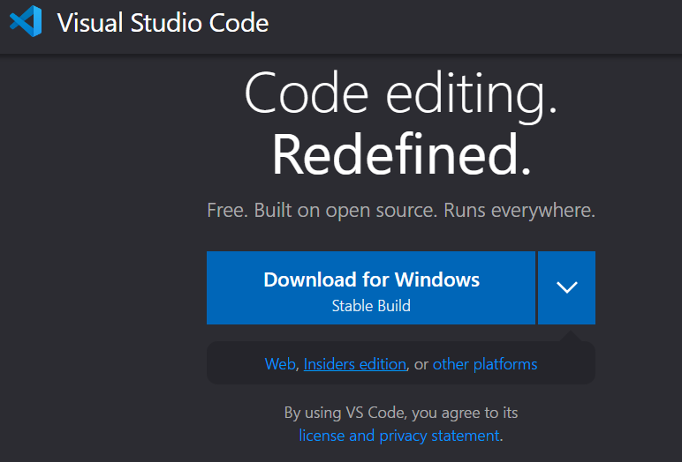

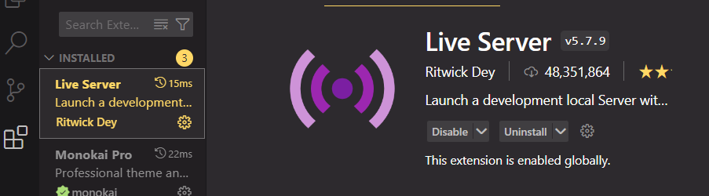Installing Live Server from the Extension section:

**Creating a folder and adding some html files (.html extension) for constructing the project:**

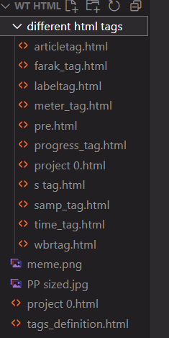

**Structure of HTML:**

**<!DOCTYPE html> : It represents the html of version 5.**

**<html> : Root tag.**

**<head> : Contains meta information.**

**<title>Title name</title>: Contains the title of webpage and displayed**

**In the title bar of web browser.**

**</head>**

**<body> : Contains the displaying part for the webpage.**

**<p>Web Technology</p>: Paragraph**

**<h1> Hello World</h1> : Large heading.**

**</body>**

**</html>**

**Types of Tags**

**Paired/Companion tags:** Those tags that have both starting and ending tags are called paired tags. For example: <p> </p>, <h1> </h1>, etc.

**Unpaired/Singular tags:** Those tags whose starting and ending tags are same are called unpaired tags. For example: <hr>, <br, etc.

**Some Formatting Tags:**

|  |  |
| --- | --- |
| **Tags** | **Description** |
| **<b>** | **Bold text.** |
| **<strong>** | **Important text.** |
| **<i>** | **Italic text.** |
| **<em>** | **Emphasized text.** |
| **<mark>** | **Highlight the text.** |
| **<strike>** | **Strike a line on a section of the text.** |
| **<sub>** | **Subscript text.** |
| **<sup>** | **Superscript text.** |
| **<u>** | **Underline the text.** |
| **<tt>** | **Display in teletype format.** |
| **<small>** | **Smaller text.** |

**Some Other Tags:**

**Meter tag:** It defines the scalar measurement within a known range.

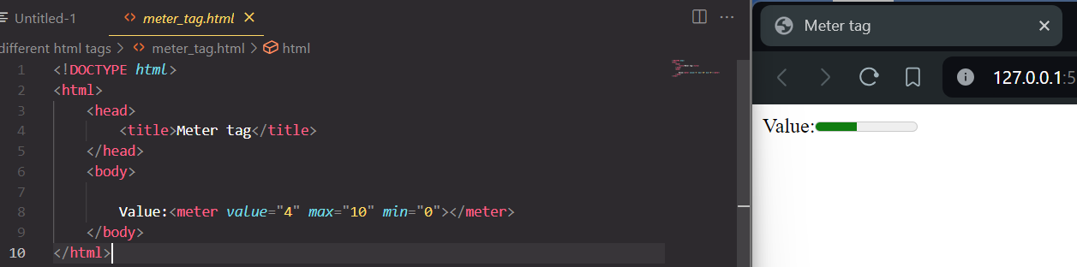

**Progress tag:**  It represents the progress/completion of the task.

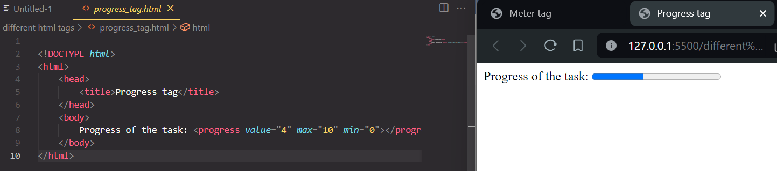

**Pre tag:** It is used to display the content as same as written in the html code.

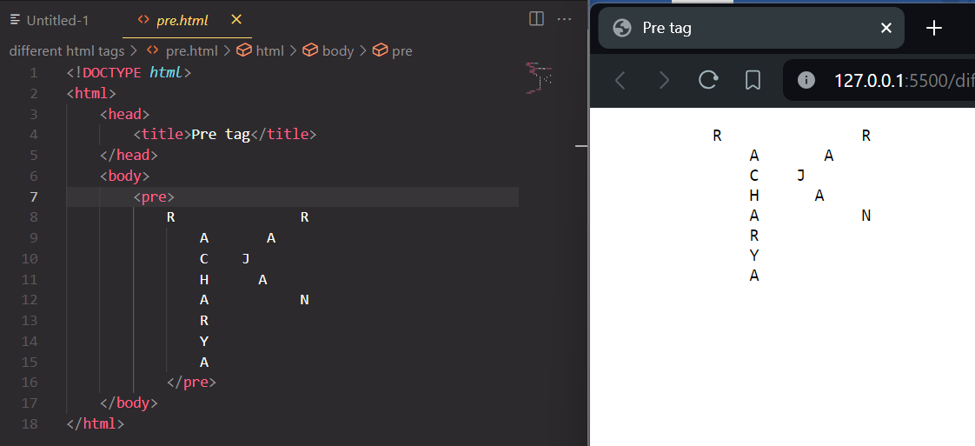

**Samp tag:** It is used to display the contents as in the computer program font (monospace font).

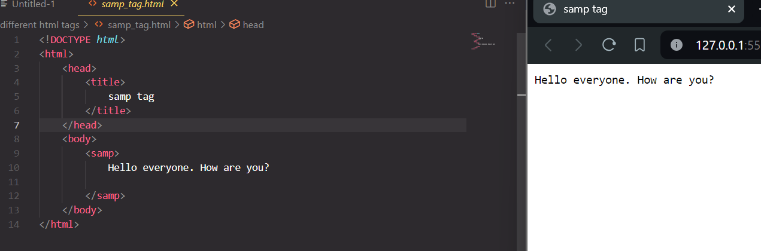

**S tag:** It is used to render a text with a line through it.

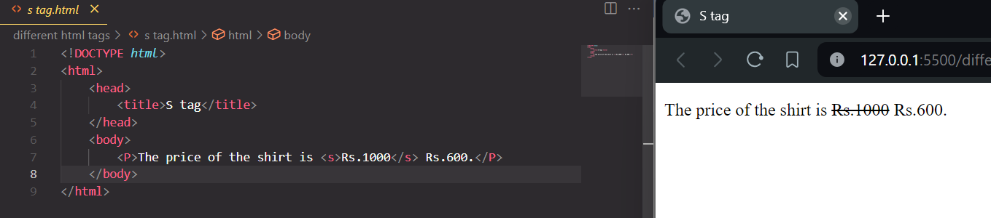

**Time tag:** It is used to specify the time.

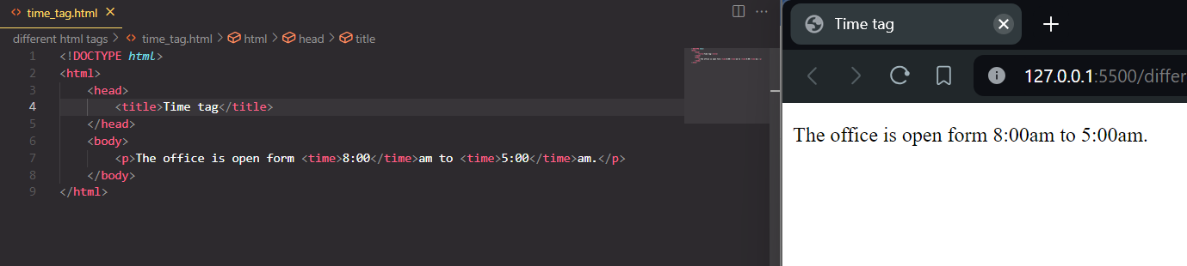

**Var tag:** It is used to define a variable in programming or in a mathematical expression.

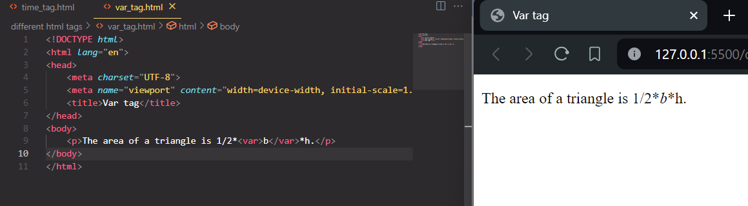

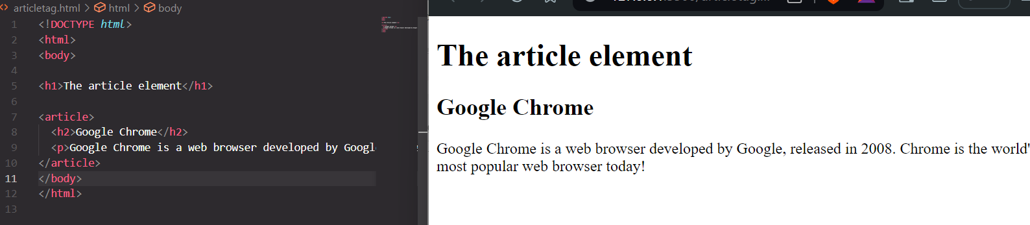**Article tag:** It is used to specify a content that is different from other contents. We can write blogs, articles, forum post, etc.

**Label tag:**A label tag is used to create a caption for a form control.

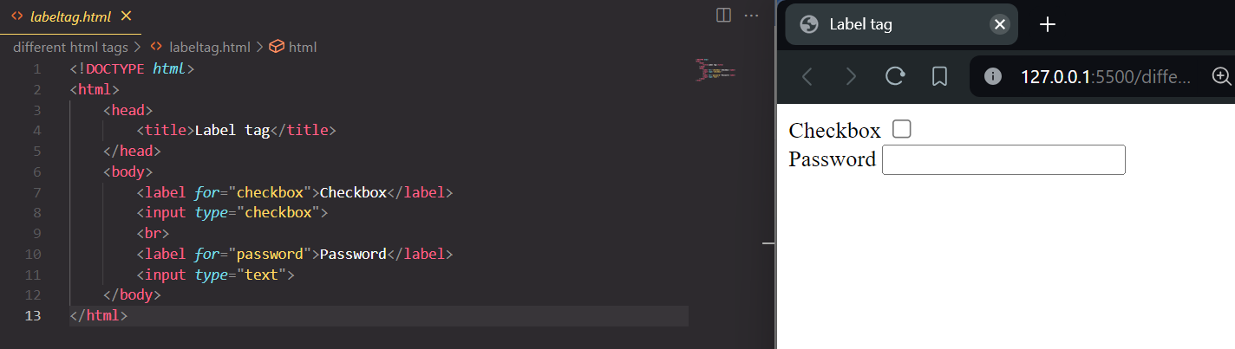

**Aside Tag:** It represents a portion of a document whose content is indirectly related to the document’s main content.

**WBR Tag:** Word Break Opportunity tag is used to specify to where it would be okay to break a line in a word.

**About Myself:**

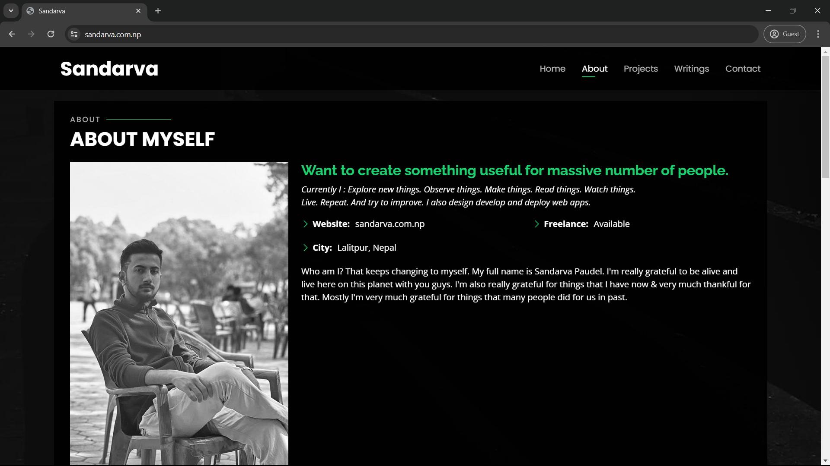

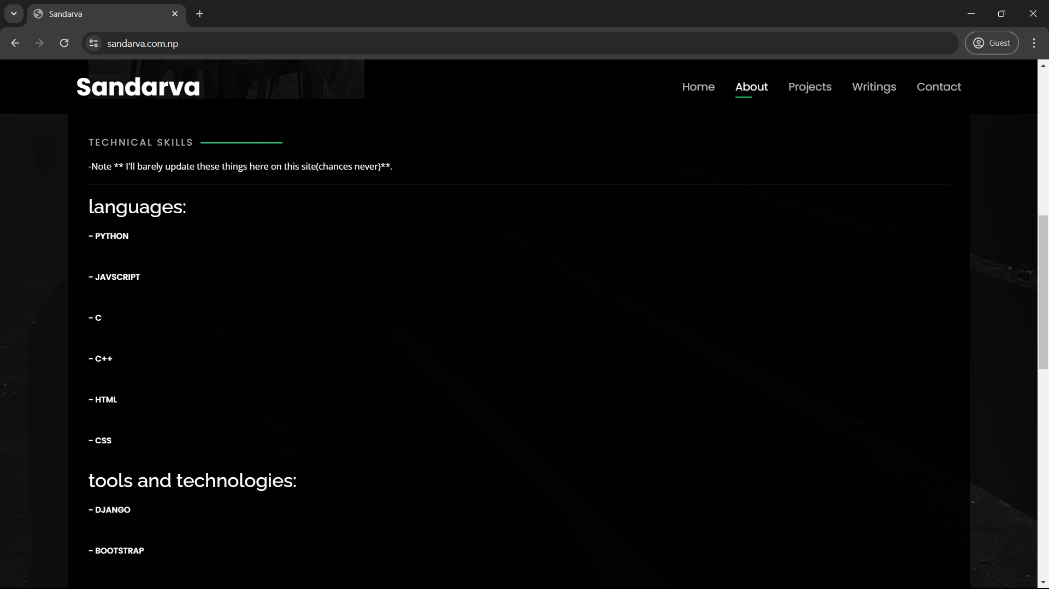

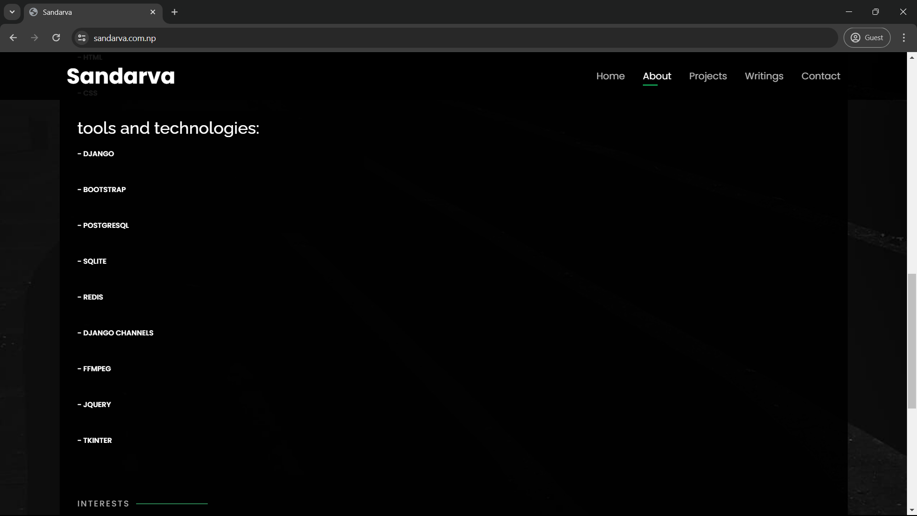

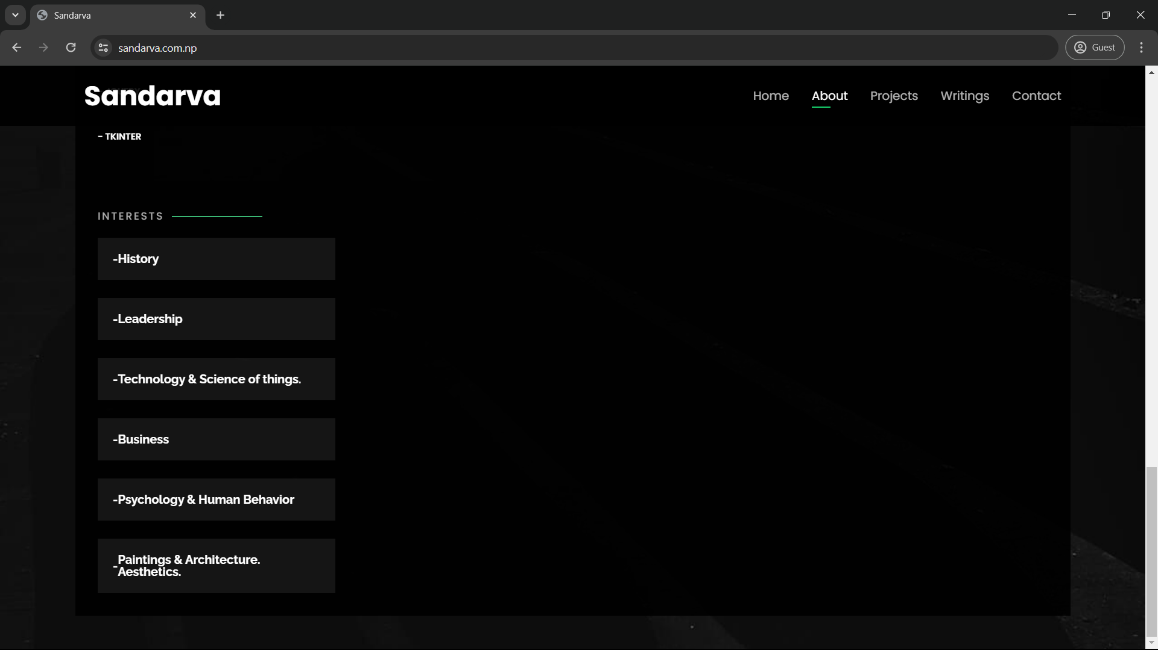

**Source Code(Only HTML, it’d be too long to include JS and CSS)*:**

<!-- ======= About Section ======= -->

<section id="about" class="about">

<!-- ======= About Me ======= -->

<div class="about-me container">

<div class="section-title">

<h2>About</h2>

<p>About myself</p>

</div>

<div class="row">

<div class="col-lg-4" data-aos="fade-right">

<img src="assets/img/myself3(bw).jpg" class="img-fluid" alt="">

</div>

<div class="col-lg-8 pt-4 pt-lg-0 content" data-aos="fade-left">

<h3>Want to create something useful for massive number of people.</h3>

<p class="fst-italic">

Currently I : Explore new things. Observe things. Make things. Read things. Watch things.<br>

Live. Repeat. And try to improve.

I also design develop and deploy web apps.

</p>

<div class="row">

<div class="col-lg-6">

<ul>

<li><i class="bi bi-chevron-right"></i> <strong>Website:</strong> <span>sandarva.com.np</span></li>

<li><i class="bi bi-chevron-right"></i> <strong>City:</strong> <span>Lalitpur, Nepal</span></li>

</ul>

</div>

<div class="col-lg-6">

<ul>

<li><i class="bi bi-chevron-right"></i> <strong>Freelance:</strong> <span>Available</span></li>

</ul>

</div>

</div>

<p>

Who am I? That keeps changing to myself. My full name is Sandarva Paudel.

I'm really grateful to be alive and live here on this planet with you guys.

I'm also really grateful for things that I have now & very much thankful for that.

Mostly I'm very much grateful for things that many people did for us in past.

</p>

</div>

</div>

</div><!-- End About Me -->

<!-- ======= Skills Section ======= -->

<div class="skills container">

<div class="section-title">

<h2>Technical Skills</h2>

</div>

<p style="font-size: small;">

-Note ** I'll barely update these things here on this site(chances never)**.

</p>

<hr>

<div class="row skills-content">

<!-- Technical Skills -->

<div class="col-lg-6">

<!-- Languages -->

<div class="row-lg-6">

<h3>languages:</h3>

<!-- Python Progress Bar -->

<div class="progress">

<span class="skill">- Python</span>

</div>

<div class="progress">

<span class="skill">- Javscript</span>

</div>

<div class="progress">

<span class="skill">- C</span>

</div>

<div class="progress">

<span class="skill">- C++</span>

</div>

<div class="progress">

<span class="skill">- HTML</span>

</div>

<div class="progress">

<span class="skill">- CSS</span>

</div>

</div>

</div>

<!-- Tools and Frameworks -->

<div class="row-lg-12">

<h3>tools and technologies:</h3>

<!-- Django Progress Bar -->

<div class="progress">

<span class="skill">- Django</span>

</div>

<div class="progress">

<span class="skill">- Bootstrap</span>

</div>

<div class="progress">

<span class="skill">- PostgreSQL</span>

</div>

<div class="progress">

<span class="skill">- SQLite</span>

</div>

<div class="progress">

<span class="skill">- Redis</span>

</div>

<div class="progress">

<span class="skill">- Django Channels</span>

</div>

<div class="progress">

<span class="skill">- FFmpeg</span>

</div>

<div class="progress">

<span class="skill">- JQuery</span>

</div>

<div class="progress">

<span class="skill">- Tkinter</span>

</div>

</div>

</div>

</div>

<!-- End Skills -->

<!-- ======= Interests ======= -->

<div class="interests container">

<div class="section-title">

<h2>Interests</h2>

</div>

<div class="col-lg-3 col-md-4 mt-4">

<div class="icon-box">

<h3>- </h3>

<h3>History</h3>

</div>

</div>

<div class="col-lg-3 col-md-4 mt-4">

<div class="icon-box">

<h3>- </h3>

<h3>Leadership</h3>

</div>

</div>

<div class="col-lg-3 col-md-4 mt-4">

<div class="icon-box">

<h3>- </h3>

<h3>Technology & Science of things.</h3>

</div>

</div>

<div class="col-lg-3 col-md-4 mt-4">

<div class="icon-box">

<h3>- </h3>

<h3>Business</h3>

</div>

</div>

<div class="col-lg-3 col-md-4 mt-4">

<div class="icon-box">

<h3>- </h3>

<h3>Psychology & Human Behavior</h3>

</div>

</div>

<div class="col-lg-3 col-md-4 mt-4">

<div class="icon-box">

<h3>- </h3>

<h3>Paintings & Architecture. Aesthetics. </h3>

</div>

</div>

<!-- <div class="col-lg-3 col-md-4 mt-4">

<div class="icon-box">

<i class="ri-base-station-line" style="color: #ff5828;"></i>

<h3>Verdo Park</h3>

</div>

</div> -->

</div>

</div><!-- End Interests -->

<!-- ======= Testimonials ======= -->

</section><!-- End About Section -->