MATLAB ASSIGNMENT
Numerical Methods: Secant, Runge-Kutta and Newton-Raphson
Solutions using FOR and WHILE loops, flowcharts and pseudocode

1. Secant Method
Formula: x(n+1) = x(n) - f(x(n)) [x(n) - x(n-1)] / [f(x(n)) - f(x(n-1))]

Flowchart
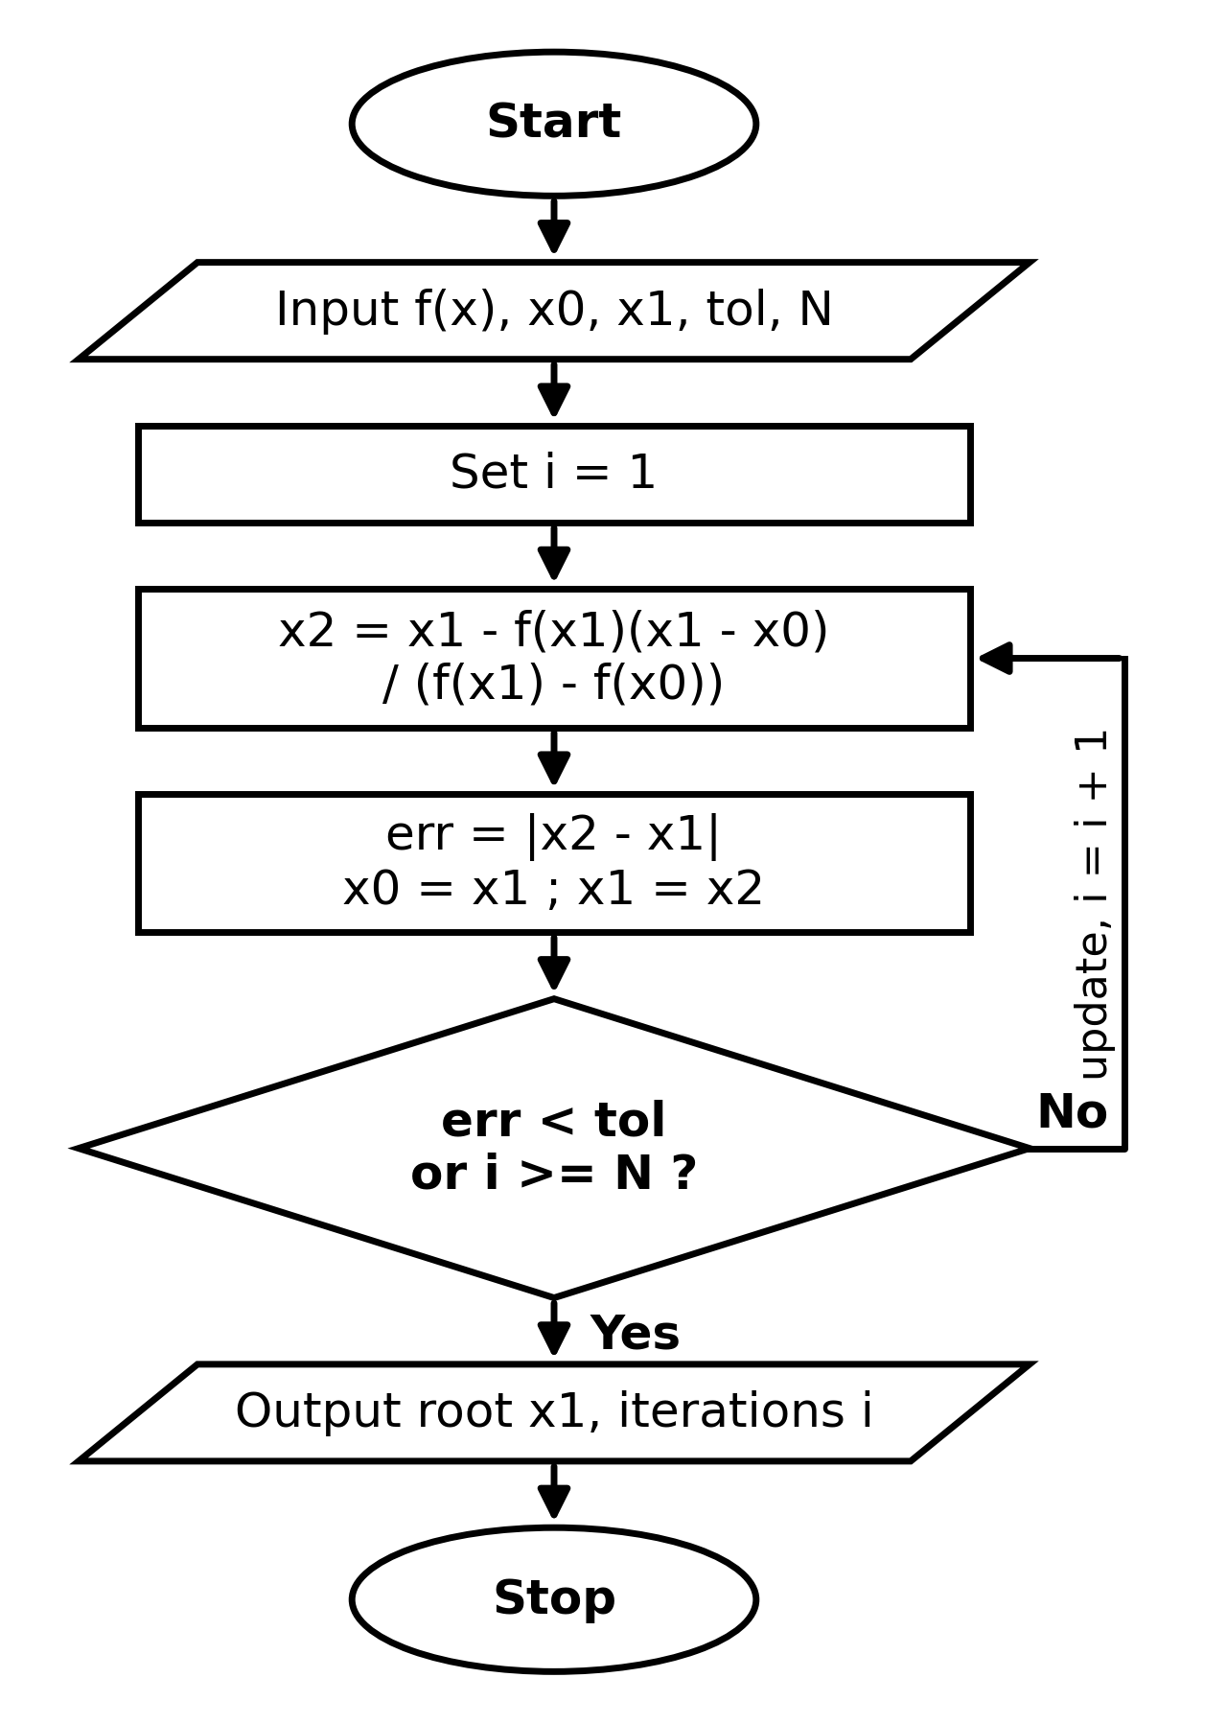

Pseudocode
FOR loop version:
INPUT f, x0, x1, tol, N
FOR i = 1 TO N
x2 = x1 - f(x1)(x1-x0)/(f(x1)-f(x0))
err = |x2 - x1|
x0 = x1 ; x1 = x2
IF err < tol THEN EXIT LOOP
END FOR
OUTPUT x1, i

WHILE loop version:
INPUT f, x0, x1, tol, N
i = 0 ; err = 1
WHILE err > tol AND i < N
i = i + 1
x2 = x1 - f(x1)(x1-x0)/(f(x1)-f(x0))
err = |x2 - x1|
x0 = x1 ; x1 = x2
END WHILE
OUTPUT x1, i

Example 1
Problem: f(x) = x^3 - 2x - 5, x0 = 2, x1 = 3
MATLAB code using a FOR loop:
f = @(x) x^3 - 2*x - 5;
x0 = 2; x1 = 3; tol = 1e-6; N = 50;
for i = 1:N
x2 = x1 - f(x1)*(x1-x0)/(f(x1)-f(x0));
err = abs(x2 - x1);
fprintf('%d %.6f %.2e\n',i,x2,err);
x0 = x1; x1 = x2;
if err < tol, break, end
end
fprintf('Root = %.6f\n', x1);

MATLAB code using a WHILE loop:
f = @(x) x^3 - 2*x - 5;
x0 = 2; x1 = 3; tol = 1e-6; N = 50;
i = 0; err = 1;
while err > tol && i < N
i = i + 1;
x2 = x1 - f(x1)*(x1-x0)/(f(x1)-f(x0));
err = abs(x2 - x1);
fprintf('%d %.6f %.2e\n',i,x2,err);
x0 = x1; x1 = x2;
end
fprintf('Root = %.6f\n', x1);

Iteration table (both loops give the same values):
i | x_i | f(x_i) | Error
0 | 2.000000 | -1.000000 | -
1 | 3.000000 | 16.000000 | -
2 | 2.058824 | -3.91e-01 | 9.41e-01
3 | 2.081264 | -1.47e-01 | 2.24e-02
4 | 2.094824 | 3.04e-03 | 1.36e-02
5 | 2.094549 | -2.29e-05 | 2.75e-04
6 | 2.094551 | -3.51e-09 | 2.05e-06
7 | 2.094551 | 3.55e-15 | 3.15e-10

Answer: Root x = 2.094551 (converged in 6 iterations)

Example 2
Problem: f(x) = e^(-x) - x, x0 = 0, x1 = 1
MATLAB code using a FOR loop:
f = @(x) exp(-x) - x;
x0 = 0; x1 = 1; tol = 1e-6; N = 50;
for i = 1:N
x2 = x1 - f(x1)*(x1-x0)/(f(x1)-f(x0));
err = abs(x2 - x1);
fprintf('%d %.6f %.2e\n',i,x2,err);
x0 = x1; x1 = x2;
if err < tol, break, end
end
fprintf('Root = %.6f\n', x1);

MATLAB code using a WHILE loop:
f = @(x) exp(-x) - x;
x0 = 0; x1 = 1; tol = 1e-6; N = 50;
i = 0; err = 1;
while err > tol && i < N
i = i + 1;
x2 = x1 - f(x1)*(x1-x0)/(f(x1)-f(x0));
err = abs(x2 - x1);
fprintf('%d %.6f %.2e\n',i,x2,err);
x0 = x1; x1 = x2;
end
fprintf('Root = %.6f\n', x1);

Iteration table (both loops give the same values):
i | x_i | f(x_i) | Error
0 | 0.000000 | 1.000000 | -
1 | 1.000000 | -0.632121 | -
2 | 0.612700 | -7.08e-02 | 3.87e-01
3 | 0.563838 | 5.18e-03 | 4.89e-02
4 | 0.567170 | -4.24e-05 | 3.33e-03
5 | 0.567143 | -2.54e-08 | 2.71e-05
6 | 0.567143 | 1.24e-13 | 1.62e-08

Answer: Root x = 0.567143 (converged in 5 iterations)

2. Runge-Kutta (4th Order) Method
Formula: y(i+1) = y(i) + (h/6)(k1 + 2k2 + 2k3 + k4)

Flowchart
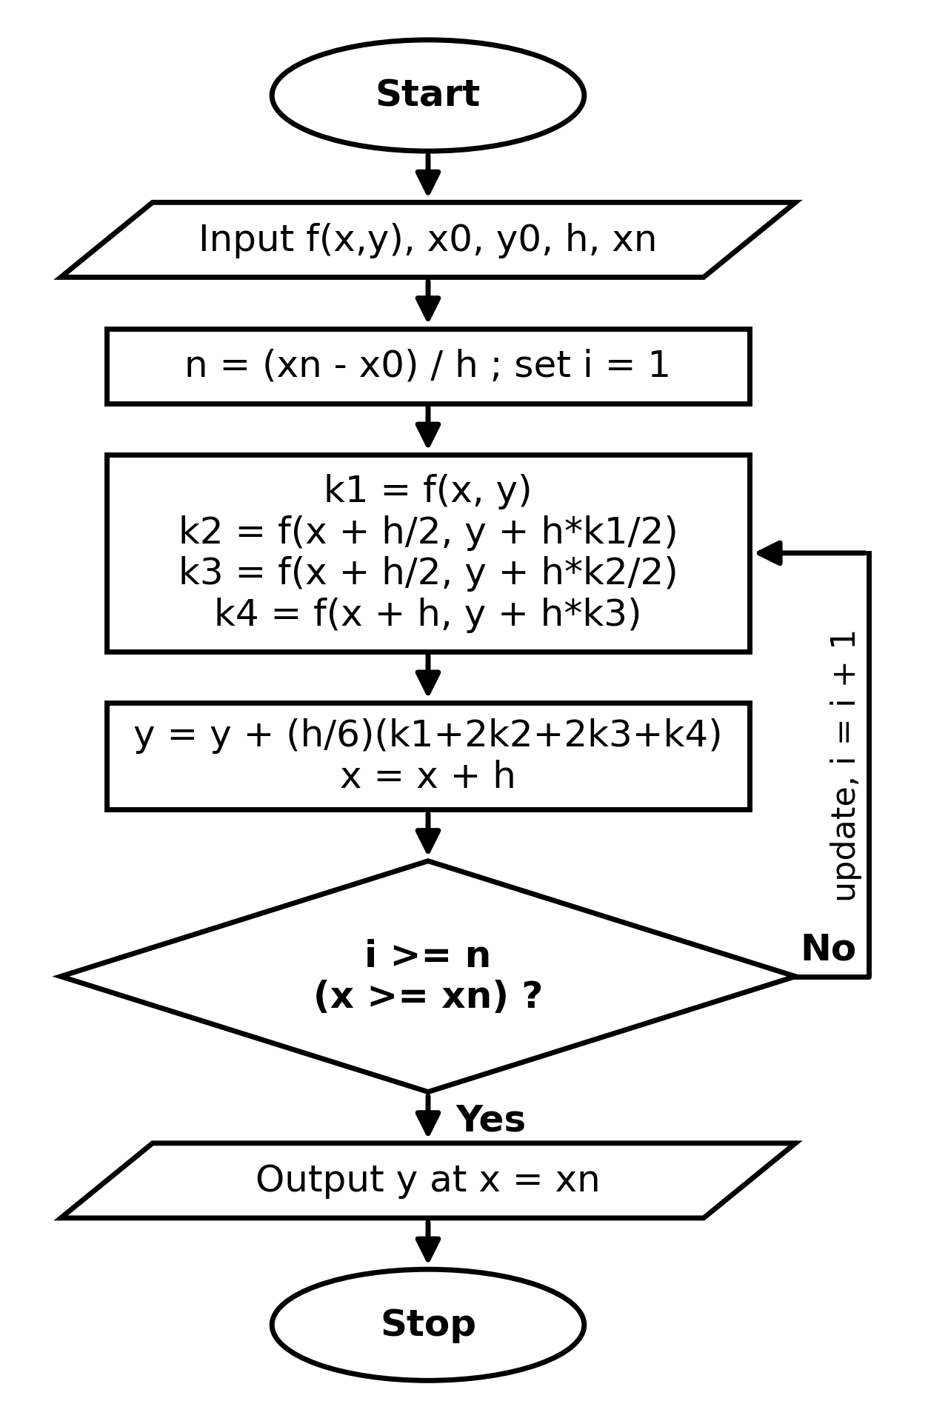

Pseudocode
FOR loop version:
INPUT f, x0, y0, h, xn
n = (xn - x0)/h
FOR i = 1 TO n
k1 = f(x,y)
k2 = f(x+h/2, y+h*k1/2)
k3 = f(x+h/2, y+h*k2/2)
k4 = f(x+h, y+h*k3)
y = y + (h/6)(k1+2k2+2k3+k4)
x = x + h
END FOR
OUTPUT y

WHILE loop version:
INPUT f, x0, y0, h, xn
WHILE x < xn
k1 = f(x,y)
k2 = f(x+h/2, y+h*k1/2)
k3 = f(x+h/2, y+h*k2/2)
k4 = f(x+h, y+h*k3)
y = y + (h/6)(k1+2k2+2k3+k4)
x = x + h
END WHILE
OUTPUT y

Example 1
Problem: dy/dx = x + y, y(0) = 1, h = 0.1, find y(0.5)
MATLAB code using a FOR loop:
f = @(x,y) x + y;
x = 0; y = 1; h = 0.1; xn = 0.5;
n = round((xn - x)/h);
for i = 1:n
k1 = f(x, y);
k2 = f(x + h/2, y + h*k1/2);
k3 = f(x + h/2, y + h*k2/2);
k4 = f(x + h, y + h*k3);
y = y + (h/6)*(k1 + 2*k2 + 2*k3 + k4);
x = x + h;
fprintf('x = %.1f y = %.6f\n', x, y);
end

MATLAB code using a WHILE loop:
f = @(x,y) x + y;
x = 0; y = 1; h = 0.1; xn = 0.5;
while x < xn - 1e-9
k1 = f(x, y);
k2 = f(x + h/2, y + h*k1/2);
k3 = f(x + h/2, y + h*k2/2);
k4 = f(x + h, y + h*k3);
y = y + (h/6)*(k1 + 2*k2 + 2*k3 + k4);
x = x + h;
fprintf('x = %.1f y = %.6f\n', x, y);
end

Iteration table (both loops give the same values):
Step | x | y (RK4) | Exact y | Abs. error
0 | 0.0 | 1.000000 | 1.000000 | 0
1 | 0.1 | 1.110342 | 1.110342 | 1.69e-07
2 | 0.2 | 1.242805 | 1.242806 | 3.75e-07
3 | 0.3 | 1.399717 | 1.399718 | 6.21e-07
4 | 0.4 | 1.583648 | 1.583649 | 9.15e-07
5 | 0.5 | 1.797441 | 1.797443 | 1.26e-06

Answer: y(0.5) = 1.797441 by RK4 (exact 1.797443)

Example 2
Problem: dy/dx = y - x^2 + 1, y(0) = 0.5, h = 0.2, find y(1)
MATLAB code using a FOR loop:
f = @(x,y) y - x^2 + 1;
x = 0; y = 0.5; h = 0.2; xn = 1;
n = round((xn - x)/h);
for i = 1:n
k1 = f(x, y);
k2 = f(x + h/2, y + h*k1/2);
k3 = f(x + h/2, y + h*k2/2);
k4 = f(x + h, y + h*k3);
y = y + (h/6)*(k1 + 2*k2 + 2*k3 + k4);
x = x + h;
fprintf('x = %.1f y = %.6f\n', x, y);
end

MATLAB code using a WHILE loop:
f = @(x,y) y - x^2 + 1;
x = 0; y = 0.5; h = 0.2; xn = 1;
while x < xn - 1e-9
k1 = f(x, y);
k2 = f(x + h/2, y + h*k1/2);
k3 = f(x + h/2, y + h*k2/2);
k4 = f(x + h, y + h*k3);
y = y + (h/6)*(k1 + 2*k2 + 2*k3 + k4);
x = x + h;
fprintf('x = %.1f y = %.6f\n', x, y);
end

Iteration table (both loops give the same values):
Step | x | y (RK4) | Exact y | Abs. error
0 | 0.0 | 0.500000 | 0.500000 | 0
1 | 0.2 | 0.829293 | 0.829299 | 5.29e-06
2 | 0.4 | 1.214076 | 1.214088 | 1.14e-05
3 | 0.6 | 1.648922 | 1.648941 | 1.86e-05
4 | 0.8 | 2.127203 | 2.127230 | 2.69e-05
5 | 1.0 | 2.640823 | 2.640859 | 3.64e-05

Answer: y(1) = 2.640823 by RK4 (exact 2.640859)

3. Newton-Raphson Method
Formula: x(n+1) = x(n) - f(x(n)) / f'(x(n))

Flowchart
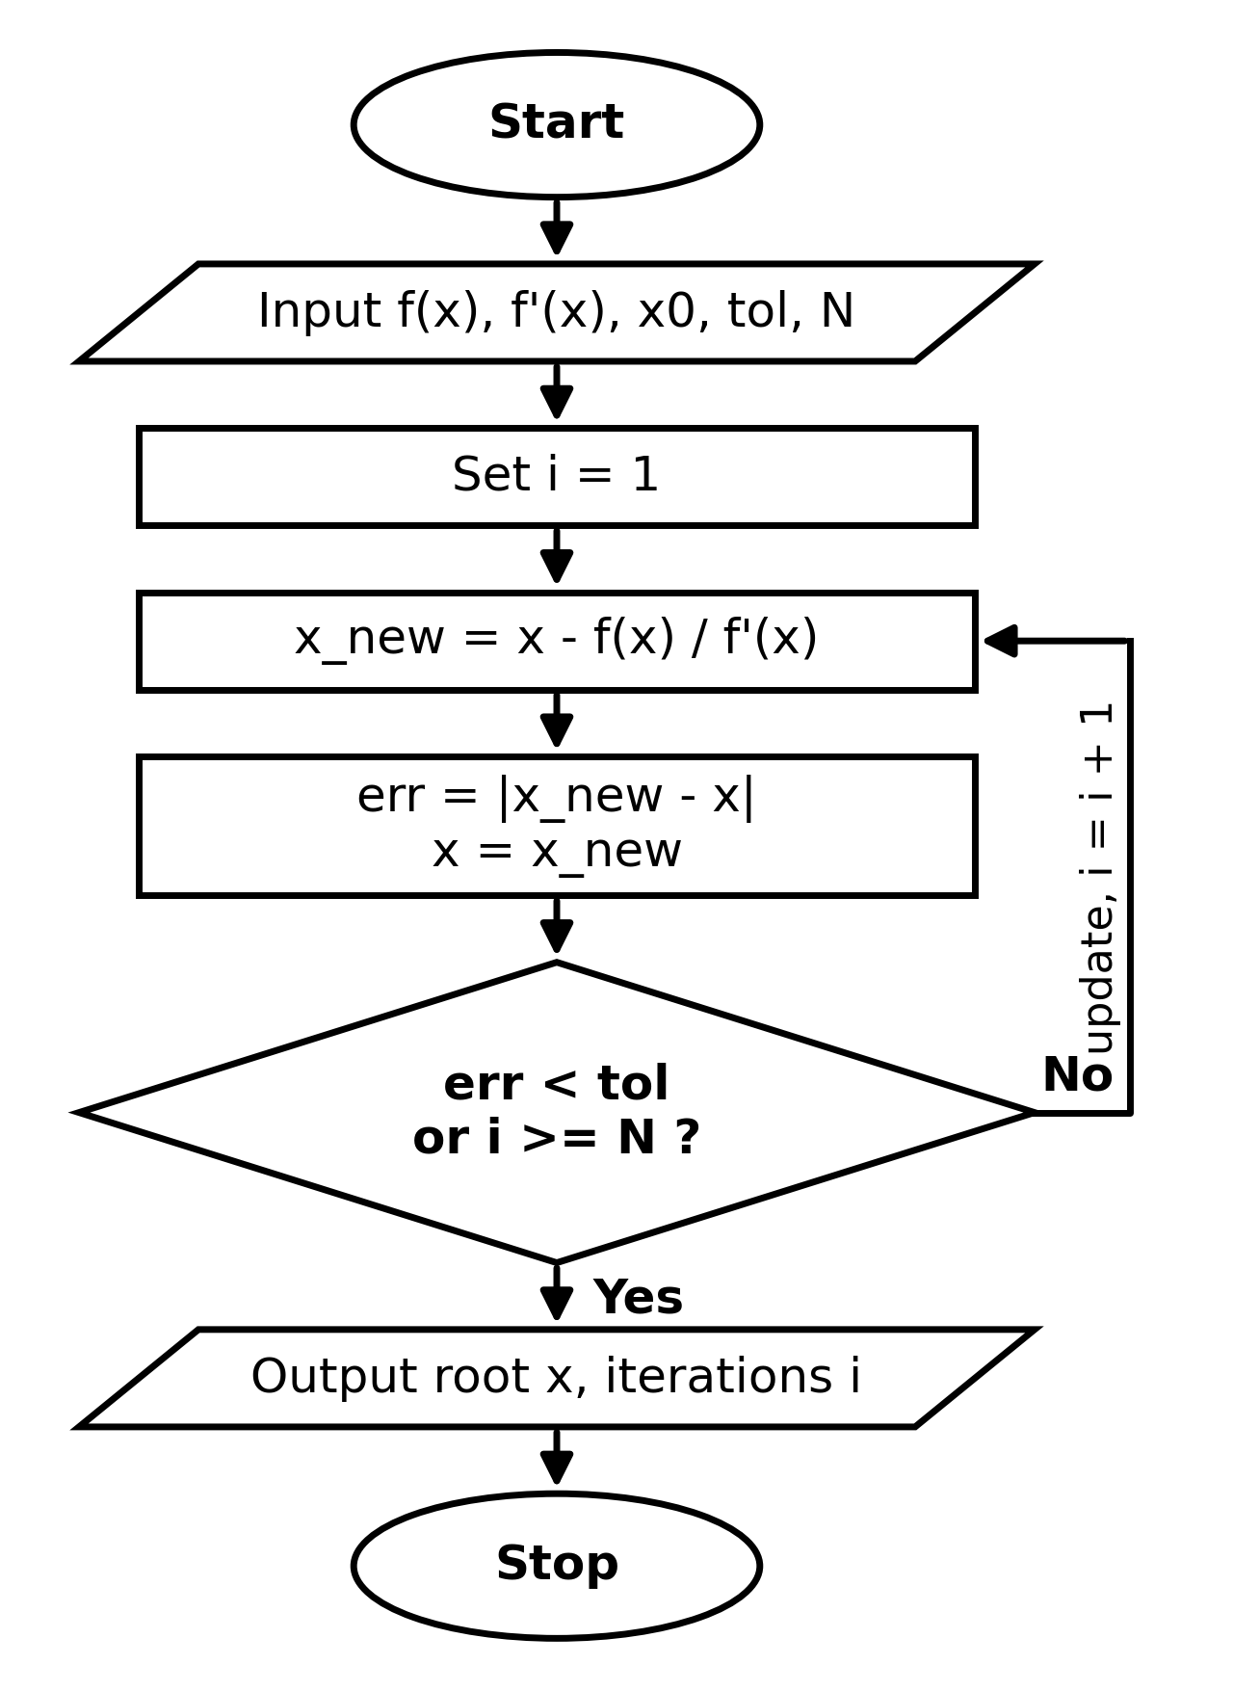

Pseudocode
FOR loop version:
INPUT f, f', x0, tol, N
x = x0
FOR i = 1 TO N
x_new = x - f(x)/f'(x)
err = |x_new - x|
x = x_new
IF err < tol THEN EXIT LOOP
END FOR
OUTPUT x, i

WHILE loop version:
INPUT f, f', x0, tol, N
x = x0 ; i = 0 ; err = 1
WHILE err > tol AND i < N
i = i + 1
x_new = x - f(x)/f'(x)
err = |x_new - x|
x = x_new
END WHILE
OUTPUT x, i

Example 1
Problem: f(x) = x^3 - x - 2, x0 = 1.5
MATLAB code using a FOR loop:
f = @(x) x^3 - x - 2;
df = @(x) 3*x^2 - 1;
x = 1.5; tol = 1e-6; N = 50;
for i = 1:N
xnew = x - f(x)/df(x);
err = abs(xnew - x);
x = xnew;
fprintf('%d %.6f %.2e\n',i,x,err);
if err < tol, break, end
end
fprintf('Root = %.6f\n', x);

MATLAB code using a WHILE loop:
f = @(x) x^3 - x - 2;
df = @(x) 3*x^2 - 1;
x = 1.5; tol = 1e-6; N = 50;
i = 0; err = 1;
while err > tol && i < N
i = i + 1;
xnew = x - f(x)/df(x);
err = abs(xnew - x);
x = xnew;
fprintf('%d %.6f %.2e\n',i,x,err);
end
fprintf('Root = %.6f\n', x);

Iteration table (both loops give the same values):
i | x_i | f(x_i) | Error
0 | 1.500000 | -0.125000 | -
1 | 1.521739 | 2.14e-03 | 2.17e-02
2 | 1.521380 | 5.89e-07 | 3.59e-04
3 | 1.521380 | 4.53e-14 | 9.92e-08

Answer: Root x = 1.521380 (converged in 3 iterations)

Example 2
Problem: f(x) = cos(x) - x, x0 = 0.5
MATLAB code using a FOR loop:
f = @(x) cos(x) - x;
df = @(x) -sin(x) - 1;
x = 0.5; tol = 1e-6; N = 50;
for i = 1:N
xnew = x - f(x)/df(x);
err = abs(xnew - x);
x = xnew;
fprintf('%d %.6f %.2e\n',i,x,err);
if err < tol, break, end
end
fprintf('Root = %.6f\n', x);

MATLAB code using a WHILE loop:
f = @(x) cos(x) - x;
df = @(x) -sin(x) - 1;
x = 0.5; tol = 1e-6; N = 50;
i = 0; err = 1;
while err > tol && i < N
i = i + 1;
xnew = x - f(x)/df(x);
err = abs(xnew - x);
x = xnew;
fprintf('%d %.6f %.2e\n',i,x,err);
end
fprintf('Root = %.6f\n', x);

Iteration table (both loops give the same values):
i | x_i | f(x_i) | Error
0 | 0.500000 | 0.377583 | -
1 | 0.755222 | -2.71e-02 | 2.55e-01
2 | 0.739142 | -9.46e-05 | 1.61e-02
3 | 0.739085 | -1.18e-09 | 5.65e-05
4 | 0.739085 | 0.00e+00 | 7.06e-10

Answer: Root x = 0.739085 (converged in 4 iterations)

