**TRIBHUWAN UNIVERSITY**

**INSTITUTE OF ENGINEERING**

**HIMALAYA COLLEGE OF ENGINEERING**



A THIRD YEAR MINOR PROJECT PROPOSAL ON

**BLOCKCHAIN BASED E-VOTING SYSTEM**

**PROJECT MEMBERS**

**Anil Shrestha (HCE076BEI002)**

**Sandesh Bhusal (HCE076BEI014)**

**Yubraj Bashyal (HCE076BEI015)**

**DEPAREMENT OF ELECTRONICS AND COMPUTER ENGINEERING**

**HIMALAYA COLLEGE OF ENGINEERNNG**

**Chyasal, Lalitpur**

**December, 2022**

**BLOCKCHAIN BASED E-VOTING SYSTEM**

A THIRD YEAR MINOR PROJECT PROPOSAL

**“A THIRD MINOR PROJECT**

**REPORT SUBMITTED FOR PARTIAL FULILLMENT OF THE**

**DEGREE OF BACHELOR’S IN ELECTRONICS,**

**COMMUNIATION AND INFORMATION ENGINEERING”**

**SUBMITTEED TO**

**HIMALAYA COLLEGE OF ENGINEERING**

**DEPARTMENT OF ELECTRONICS AND COMPUTER**

**ENGINEERING**

**Chyasal, Lalitpur**

**SUBMITTED BY**

**Anil Shrestha (HCE076BEI002)**

**Sandesh Bhusal (HCE076BEI014)**

**Yubraj Bashyal (HCE076BEI015)**

**December, 2022**

# ABSTRACT

An electronic voting system based on blockchain technology offers a secure and transparent means of conducting elections. The use of a decentralized, distributed ledger allows for each vote to be recorded and verified in a tamper-evident manner, ensuring the integrity of the electoral process. One potential implementation of a blockchain-based e-voting system involves the use of smart contracts to automate the voting process. Voters can cast their ballots electronically, with their votes being recorded and stored on the blockchain. The blockchain structure can then be used to tally the votes and determine the outcome of the election. In addition to providing security and transparency, a blockchain-based e-voting system also has the potential to increase accessibility and convenience for voters. It allows individuals to cast their votes remotely, eliminating the need to physically go to a polling station. This can be particularly beneficial for individuals with disabilities or those who live in remote areas. Overall, a blockchain-based e-voting system has the potential to revolutionize the way elections are conducted, providing a secure and transparent means of conducting elections that is accessible to all voters.

Keywords: blockchain, hash, node, proof of work

# **TABLE OF CONTENTS**

ABSTRACT I

TABLE OF CONTENTS II

LIST OF FIGURES IV

1. INTRODUCTION 1

1.1 BACKGROUND 1

1. BLOCKCHAIN 1

1.2 DECENTRALIZED NETWORK 2

1.3 GENESIS BLOCK 2

1.4 NODE 3

1.5 HASHING 3

1.5.1 SHA256 4

1.6 APPLICATION PROGRAMMING INTERFACE (API) 4

1.7 OBJECTIVE 5

1.8 SCOPE 5

1.9 APPLICATION 5

2. LITERATURE REVIEW 6

3. REQUIREMENTS 8

3.1 Functional Requirement 8

Non-Functional Requirement 8

4. METHODOLOGY 9

4.1 The block diagram of the project: 9

4.2 Management Application 9

4.3 Voting/Result Application 9

4.4 Blockchain 10

4.4.1 Attributes: 10

4.4.2 Methods: 10

4.5 API Server 11

4.6 The working model of API Server on Voting 13

4.7 The working model of User Interface 14

4.8 The flow chart for broadcasting transactions 15

4.9 The flow chart for consensus algorithm 16

4.10 The flow chart for mining block 17

4.11 The flow chart for connecting and synchronizing the nodes 19

5. DISCUSSION 20

6. EXPECTED OUTCOME 21

7. REFERENCES 22

# LIST OF FIGURES

Figure 1: Traditional vs. Blockchain Voting System 1

Figure 2: Blockchain Workflow 1

Figure 3: Genesis Block 2

Figure 4: Hashing 3

Figure 5: Sha256 hashing 4

Figure 6: Block diagram of project 9

Figure 7: Working model of API server 13

Figure 8: Working model of User Interface 14

Figure 9: Flowchart of /transaction/broadcast 16

Figure 10: Flow chart for consensus algorithm 17

Figure 11: Flow chart for mining block 17

Figure 12: Flow chart for connecting nodes and synchronizing the nodes 19

Figure 13: Expected Output 21

# INTRODUCTION

## BACKGROUND

Elections are a cornerstone of democratic societies, providing citizens with the opportunity to select their leaders and make decisions on important issues. However, the traditional voting process can be prone to issues such as fraud, intimidation, and the logistical challenges of physically going to a polling station. In recent years, there has been increasing interest in using electronic voting systems as a way to improve the voting process. These systems allow individuals to cast their votes electronically, typically through the use of computers or other electronic devices. However, traditional electronic voting systems can still be vulnerable to hacking and other forms of tampering, which can undermine the integrity of the electoral process. Blockchain technology offers a potential solution to these issues by providing a secure and transparent means of conducting elections. A blockchain is a decentralized, distributed ledger that allows for the recording and verification of transactions in a tamper-evident manner. This makes it ideal for use in an e-voting system, as it allows each vote to be recorded and verified in a secure and transparent manner.

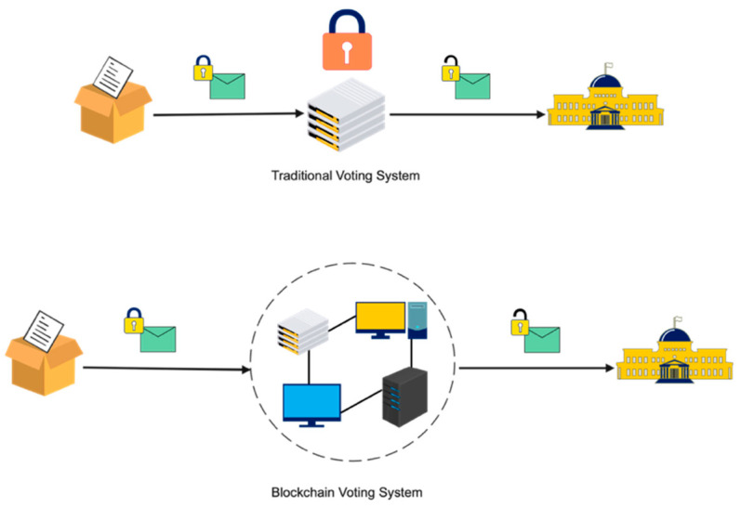In this project, we will explore the potential benefits and challenges of using a blockchain-based e-voting system, as well as potential implementation approaches. We will also consider the potential impact of such a system on the electoral process and on democracy more broadly.

Figure 1: Traditional vs. Blockchain Voting System

## BLOCKCHAIN

A blockchain is a decentralized, distributed ledger that allows for the recording and verification of transactions in a tamper-evident manner. It is composed of a series of blocks, each of which contains a record of multiple transactions. These blocks are linked together in a chain, with each block containing a unique code, called a "hash," that connects it to the block before it.

One of the key features of a blockchain is that it is decentralized, meaning it is not controlled by a single entity. Instead, it is maintained by a network of computers, called "nodes," that work together to validate and record transactions on the ledger. This decentralized structure allows for a high level of security, as there is no single point of failure that could be targeted by hackers.

Blockchains are also distributed, meaning that copies of the ledger are stored on multiple nodes across the network. This helps to ensure that the ledger is accurate and up-to-date, as any discrepancies or tampering attempts can be easily detected and corrected by the other nodes.

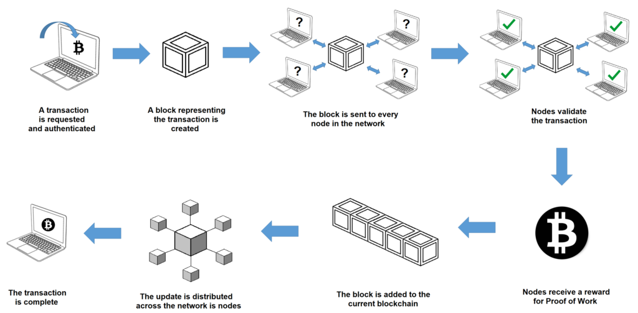

Figure 2: Blockchain Workflow

## DECENTRALIZED NETWORK

A decentralized network is a type of network that is not controlled by a single central authority, but rather is maintained by a network of participants who work together to ensure its operation. Decentralized networks can take many forms, including peer-to-peer networks, distributed systems, and blockchain networks.

One of the key features of a decentralized network is that it is distributed, meaning that it is composed of multiple nodes or devices that are connected to each other and work together to perform a specific task or function. This allows for a high level of redundancy and resilience, as there is no single point of failure that could bring the entire system down.

## GENESIS BLOCK

In a blockchain, the genesis block is the first block in the chain. It is a special block that serves as the starting point for the rest of the blockchain. The genesis block typically contains a small amount of data, such as a message or a list of initial transactions. It is created by the person or group responsible for initiating the blockchain and it is given a unique code, called a "hash," that distinguishes it from all other blocks in the chain.

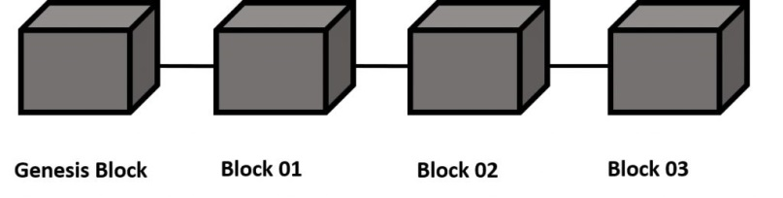

Figure 3: Genesis Block

## NODE

Nodes are computers or devices that are connected to the network and participate in its operation. Nodes are responsible for validating and recording transactions, and they play a crucial role in maintaining the integrity and security of the network.

## HASHING

Hashing is the process of taking input data and producing a fixed-size output, called a "hash," that serves as a unique identifier for the input data. Hashing algorithms are used in a wide range of applications, including data storage, password security, and blockchain technology.

In the context of a blockchain, hashing is used to create a unique code, or "hash," for each block in the chain. The hash is generated based on the data contained in the block, as well as the hash of the previous block in the chain. This creates a chain of hashes that link each block to the one before it, ensuring the integrity and immutability of the blockchain.

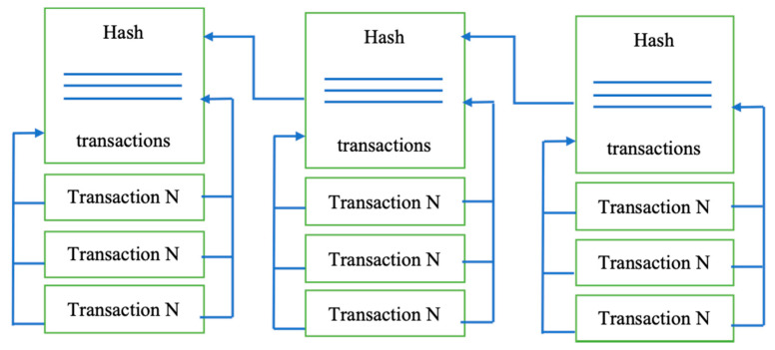

Figure 4: Hashing

### SHA256

SHA-256 is a one-way hash function, meaning that it is computationally infeasible to reverse the hashing process and recreate the original input data from the hash. This makes it useful for secure data storage, as it is difficult for someone to access the original data without the correct password or key.

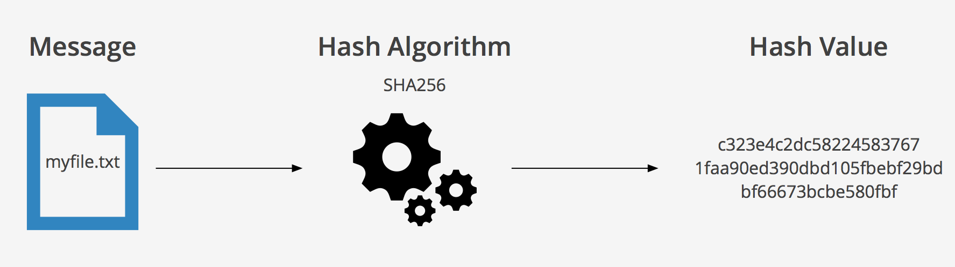The output of the SHA-256 hash function is a 256-bit (32-byte) hash value, which is typically represented as a hexadecimal string. The hash value is generated based on the input data, using a series of mathematical operations that are designed to be computationally expensive. This helps to ensure that it is difficult for an attacker to create a specific input data that produces a particular hash value.

Figure 5: Sha256 hashing

## APPLICATION PROGRAMMING INTERFACE (API)

Application Programming Interface is a set of rules and protocols that define how two software systems can communicate with each other. APIs allow different software systems to exchange data and functionality, enabling them to work together and build on each other's capabilities.

APIs are a key component of modern software development, as they enable developers to leverage the functionality of existing software systems and build new applications on top of them. For example, a developer might use an API to access data from a database, or to send a message via a messaging service.

## OBJECTIVE

The objective of the project:

* To develop the infrastructure for the blockchain and user-friendly interface to implement voting.

## 1.8 SCOPE

* Research and analysis: This could involve conducting a thorough review of existing e-voting systems and exploring the potential benefits and challenges of using blockchain technology to improve the voting process.
* System design and development: This could involve designing and building the technical infrastructure for the e-voting system.
* User interface design: This could involve designing a user-friendly interface that makes it easy for voters to cast their ballots electronically.

## 1.9 APPLICATION

The voting system could be used to enable individuals to cast their ballots remotely, eliminating the need to physically go to a polling station. This could be particularly beneficial for individuals with disabilities or those who live in remote areas.

# LITERATURE REVIEW

The first things that come to mind about the blockchain are cryptocurrencies and smart contracts because of the well-known initiatives in Bitcoin and Ethereum. Bitcoin was the first crypto-currency solution that used a blockchain data structure. Ethereum introduced smart contracts that leverage the power of blockchain immutability and distributed consensus while offering a crypto-currency solution comparable to Bitcoin. The concept of smart contracts was introduced much earlier by Nick Szabo in the 1990s and is described as “a set of promises, specified in digital form, including protocols within which the parties perform on these promises”' [1]. In Ethereum, a smart contract is a piece of code deployed to the network so that everyone has access to it. The result of executing this code is verified by a consensus mechanism and by every member of the network as a whole.

Today, we call a blockchain a set of technologies combining the blockchain data structure itself, distributed consensus algorithm, public key cryptography, and smart contracts [2]. Below we describe these technologies in more detail.

Blockchain creates a series of blocks replicated on a peer-to-peer network. Any block in blockchain has a cryptographic hash and timestamp added to the previous block, as shown in Figure 1. A block contains the Merkle tree block header and several transactions [3]. It is a secure networking method that combines computer science and mathematics to hide data and information from others that is called cryptography. It allows the data to be transmitted securely across the insecure network, in encrypted and decrypted forms [4].

As was already mentioned, the blockchain itself is the name for the data structure. All the written data are divided into blocks, and each block contains a hash of all the data from the previous block as part of its data [5]. The aim of using such a data structure is to achieve provable immutability. If a piece of data is changed, the block’s hash containing this piece needs to be recalculated, and the hashes of all subsequent blocks also need to be recalculated [6]. It means only the hash of the latest block has to be used to guarantee that all the data remains unchanged. In blockchain solutions, data stored in blocks are formed from all the validated transactions during their creation, which means no one can insert, delete or alter transactions in an already validated block without it being noticed [7]. The initial zero-block, called the “genesis block,” usually contains some network settings, for example, the initial set of validators (those who issue blocks).

Blockchain solutions are developed to be used in a distributed environment. It is assumed that nodes contain identical data and form a peer-to-peer network without a central authority. A consensus algorithm is used to reach an agreement on blockchain data that is fault-tolerant in the presence of malicious actors. Those that are intended to be used in fully decentralized self-organizing networks, such as cryptocurrency platforms, use algorithms such as proof-of-work or proof-of-stake, where validators are chosen by an algorithm so that it is economically profitable for them to act honestly [8]. When the network does not need to be self-organized, validators can be chosen at the network setup stage [9]. The point is that all validators execute all incoming transactions and agree on achieving results so that more than two-thirds of honest validators need to decide on the outcome.

As is the case with any other technology, blockchain technology has its drawbacks. Unlike other distributed solutions, a blockchain is hard to scale: An increasing number of nodes do not improve network performance because, by definition, every node needs to execute all transactions, and this process is not shared among the node [10]. Moreover, increasing the number of validators impacts performance because it implies a more intensive exchange of messages during consensus. For the same reason, blockchain solutions are vulnerable to various denial-of-service attacks. A network can be attacked by merely sending a considerable number of transactions: At some point, the system will refuse to receive anything else. In cryptocurrency solutions, all transactions have an execution cost: the more resources a transaction utilizes, the more expensive it will be, and there is a cost threshold, with transactions exceeding the threshold being discarded. In private blockchain networks [11] [12], this problem is solved depending on how the network is implemented via the exact mechanism of transaction cost, access control, or something more suited to the specific context.

# REQUIREMENTS

## Functional Requirement

1. It should manage voting category, candidate and voters.
2. Cast vote.
3. Talley Votes.
4. Display voting result.

## Non-Functional Requirement

1. It will be distributed, decentralized and secured system.
2. It will provide immutable and transparent result.
3. It will verify result integrity.
4. User friendly UI.

# METHODOLOGY

## The block diagram of the project:

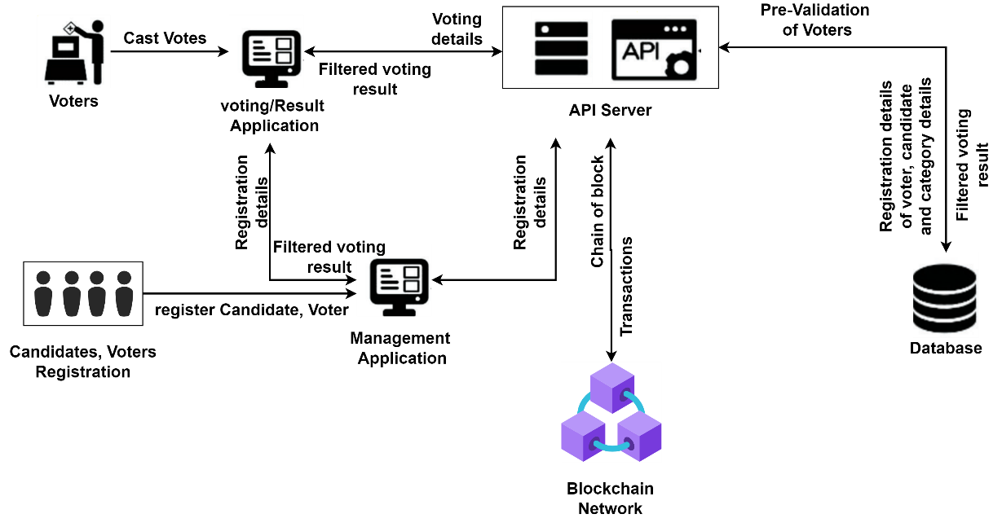

Figure 6: Block diagram of project

## Management Application

The management application implies the features like register candidate, register voter, adding category for the voting and calling endpoints for storing candidate and voter details in the database. The management application comprises the following methods:

**registerCandidate:** for registration of candidate

**registerVoter:** for registration of Voter

**addCategory:** for adding category of voting

**fetchRegistrationDetails:** for fetching the registration details from database

## Voting/Result Application

The voting/result application implies the features like casting vote and displaying voting result. It comprises the methods:

**vote:** for voting the candidate

**dispVotes:** for displaying the total votes of each candidate:

## Blockchain

It is the underlying blockchain platform and infrastructure that powers the system. It is responsible for recording and storing votes on the blockchain, as well as maintaining the integrity and security of the system. It has a class Blockchain with attributes and methods:

### Attributes:

**chain []:** for keeping track of the blocks in blockchain.

**pendingTransactions** []: for keeping track of the pending transactions.

**currentNodeUrl**: for keeping the track of currently running node.

**nodeNetworks** []: for keeping the track of number of nodes existing in the network.

### Methods:

**createNewBlock**: this method creates the new block in the blockchain taking an argument nonce, previousBlockHash, hash.

**createNewTransaction**: this method creates the transaction taking an argument candidate name, candidate unique address, category, voter unique address.

**hashBlock**: this method creates the hash of the block data taking an argument previousBlockHash, blockHash, nonce.

**proofOfWork**: It is mechanism used by blockchain networks to validate transactions and create new blocks. The proofOfWork method returns the value of nonce for the hash generated that contains first four zeros.

**addTransactionToPendingTransaction**: this method pushes the current transaction to the pending transactions so that it can be included in the succeeding block.

**getLastBlock**: the method returns the last block of the chain.

**consensus**: the method implements the consensus algorithm which checks whether the block is valid or not, if not replace by the longest valid chain in the network (implements longest chain rule).

## API Server

The API Server of a blockchain-based voting system is responsible for managing the underlying infrastructure and processes required to run the system. It handles tasks such as storing candidate and voter’s data in the database, validating voters, updating the blockchain ledger and filter the votes stored in chain and updating in the database. The Server comprises the following methods:

**initializeBlockchain:** handles the event for initializing and setting up every node in the network.

**createCandidate:** handles the event for registering the candidate.

**createVoter:** handles the event for registering the voter.

**vote:** handles the event for registering vote, voted by the voter to the candidate.

**voteCount:** handles the event for calculating the votes obtained by each candidate.

**voteStore:** handle the event for storing the votes voted by the voter in the database.

Also, the API Server has the endpoints for triggering createCandidate, createVoter and vote methods and to make interactions with the blockchain attributes and methods:

**/create-candidate**: triggers createCandidate method

**/create-voter:** triggers createVoter method

**/create-vote:** triggers vote method

**/blockchain:** it returns the entire blocks available in the network.

**/register-and-broadcast-node:** current node register and broadcast new node to the other nodes in the network.

**/register-node:** every node in the network register the new node.

**/register-node-bulk:** the new node registers every other node available in the network.

**/transaction:** it is used by the nodes to push the transaction in the pendingTransactions.

**/transaction-broadcast:** the current node pushes the transaction to the pendingTransactions and broadcast the transactions to other nodes in the network.

**/mine:** current node creates a newBlock and broadcast the block to other nodes in the network.

**/receive-new-block:** the other nodes receive the newBlock and push into the chain with verification.

## **The working model of API Server on Voting**

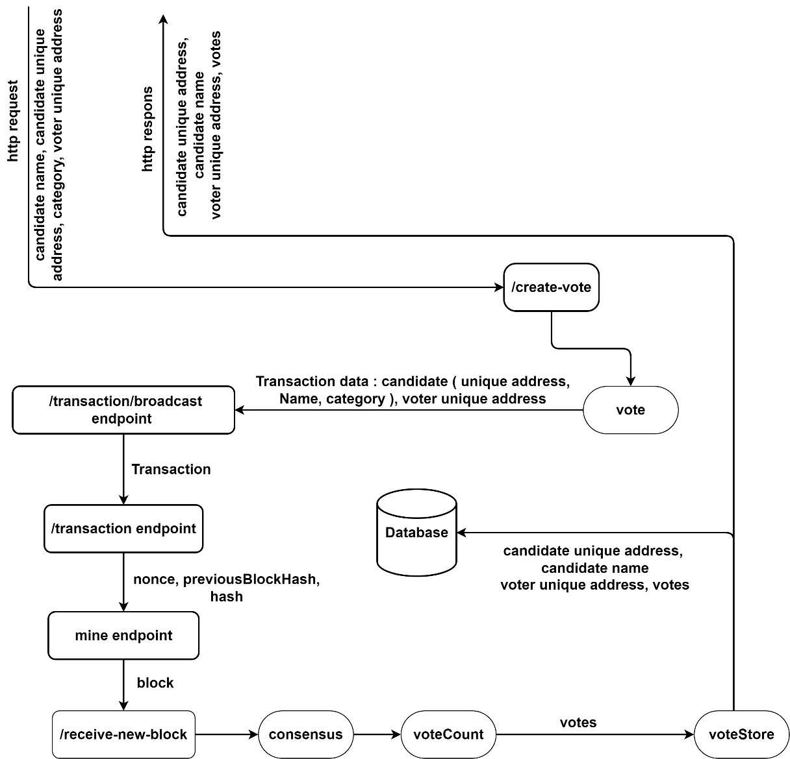

Figure 7: Working model of API server

The algorithm for the working model of the backend:

* The http request is received with end point /create-vote triggers the Vote () function containing unique candidate address, candidate name, category and voter unique address.
* The /transaction/broadcast endpoint is triggered with the transaction data containing candidate unique address, candidate name, category and voter unique address and creates transactions for each category and then broadcasted to all the nodes in the network.
* The /transaction endpoint is triggered in each node then pushed into their pendingTransactions array.
* Then the /mine endpoint is triggered which create a block, push into chain array and broadcast to other nodes.
* The /receive-new -block endpoint is triggered on each node in which a new block is pushed into their chain array.
* The consensus () method is invoked which validates the chain of blocks across the network.
* The voteCount () is invoked which counts the votes obtained by the candidates.
* The voteStore () method is then invoked which stores the data (candidate unique address, candidate name, category, voter address) into the database and also return the same copy of data as http response.

## The working model of User Interface

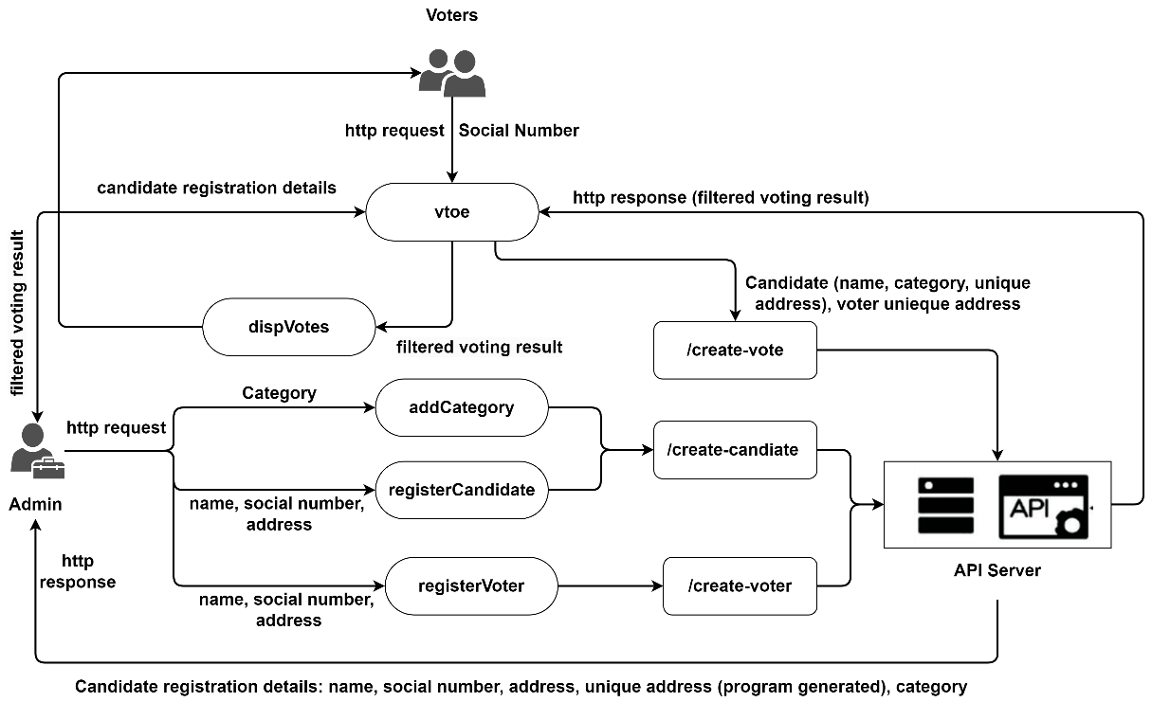

Figure 8: Working model of User Interface

The algorithm for the working model of the user interface:

* The admin sends http request to the API server calling endpoint /create-candidate and with parameters category name, social number and address to register candidate and in http response the server returns the registration details of the candidate with program generated unique candidate address.
* The admin sends http request to the API server calling endpoint /create-voter with parameters name, social number and address to register voter.
* The voters send http request to the server invoking the method vote () which call an endpoint /create-vote with parameters registration details of candidate and voter unique address and in http response the server sends the filtered voting result which is further passed to method dispVotes () (which displays result to the voters) and admin.

## The flow chart for broadcasting transactions

Figure 9: Flowchart of /transaction/broadcast

The algorithm for broadcasting transactions:

1. The category, name, sender, receiver parameters are fed into the function createNewTransaction which return a transaction and pushed into int pendingTransactions array.
2. For each node /transaction is called with parameter a transaction created in 1 and every node pushes the transaction into their pendingTransactions array.

## The flow chart for consensus algorithm

Figure 10: Flow chart for consensus algorithm

## The flow chart for mining block

Figure 11: Flow chart for mining block

The algorithm for mining block:

1. The parameter currentBlockdata is created using the data lastblock and

transaction and nonce generated passing into the method proofOfWork which is fed into the method BlockHash which return the hash of the newBlock.

1. New Block is created by passing the parameters nonce, previousBlockHash, hash into the method createNewBlock which is pushed into the current Node and broadcasted to every node in the network.
2. The /receive-new-block endpoint is then called in every node in which every node pushes the new block into their chain by checking the condition:
   1. If lastBlock hash == newBlock previous hash
   2. lastBlock index + 1 == newBlock index

## **The flow chart for connecting and synchronizing the nodes**

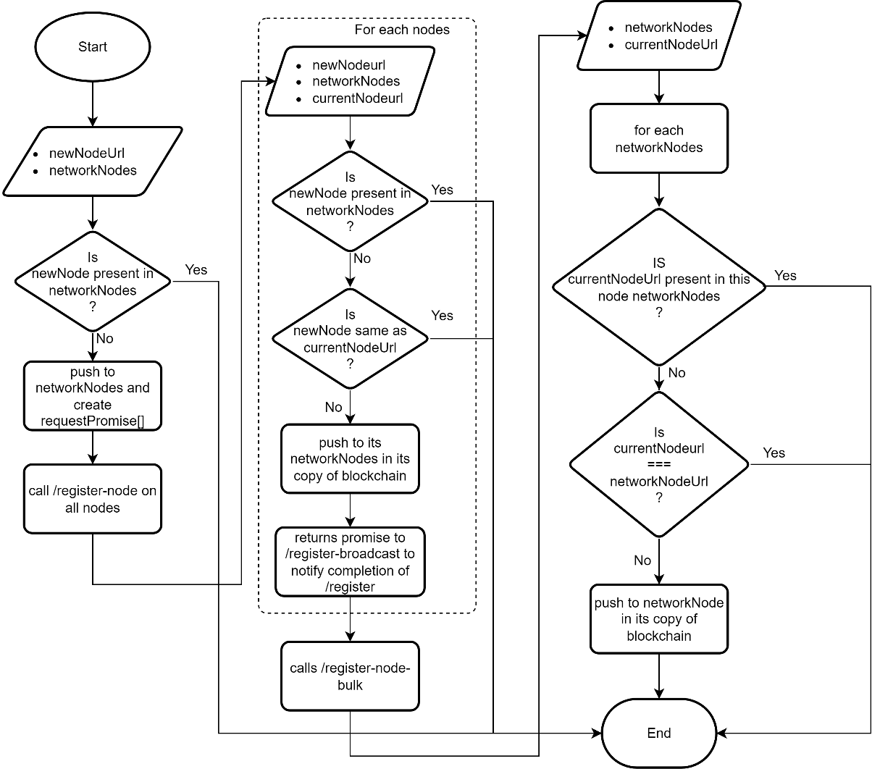

Figure 12: Flow chart for connecting nodes and synchronizing the nodes

The algorithm for connecting and synchronizing nodes:

1. The networkNodes lists every node connected with the current node. newNodeUrl is checked whether it is present in the networkNodes or not. If not, push into the networkNodes and broadcast the newNodeUrl to other Nodes in the network.
2. Every node in the network receive the newNodeUrl and pushes into the their networkNodes array checking the condition:
3. newNodeUrl not present in networkNodes.
4. newNodeUrl is not currentNodeUrl.

And send their nodeUrl as response to current node.

1. The current node captures the response sent by every node and send to the new node.
2. The new node pushes the every networkNodeUrl into its networkNode array.

# DISCUSSION

A blockchain-based voting system has the potential to significantly improve the security, transparency, and accessibility of elections. Some potential benefits of a blockchain-based voting system include:

Security: One of the main benefits of using a blockchain for voting is the increased security it provides. A blockchain is an immutable distributed ledger, which means that once a transaction (in this case, a vote) is added to the chain, it cannot be altered or deleted. This makes it much more difficult for votes to be tampered with or fraudulently altered.

Transparency: A blockchain-based voting system would allow anyone to verify the accuracy of the vote count by simply reviewing the transactions on the chain. This can help to build trust in the electoral process and ensure that the results are fair and accurate.

Accessibility: A blockchain-based voting system could potentially make it easier for people to vote, especially for those who may have difficulty physically accessing polling stations. For example, individuals could potentially vote using their smart phones or other devices, which could make voting more convenient and accessible for everyone.

Efficiency: A blockchain-based voting system could potentially reduce the amount of time and resources needed to conduct an election. For example, it could eliminate the need for manual vote counting, which can be time-consuming and error-prone.

There are also some challenges to consider when implementing a blockchain-based voting system, such as ensuring the privacy of individual votes and ensuring the security of the system against attacks. However, with careful planning and the use of proven security measures, these challenges can be overcome to create a secure, transparent, and efficient voting system.

# EXPECTED OUTCOME

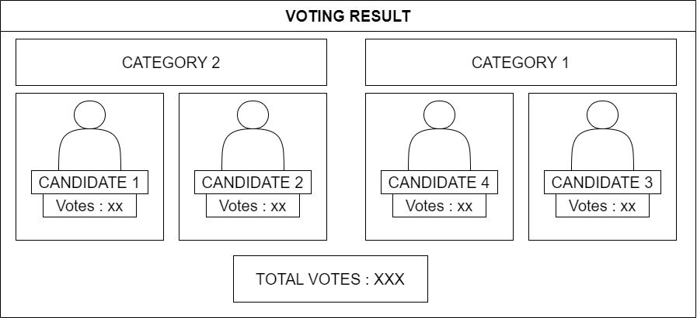

Figure 13: Expected Output

The voting system displays the total votes and the vote obtained by each candidate according to the category as shown in the fig. 13. The candidate obtaining the highest votes according to their respective category

# REFERENCES

|  |  |
| --- | --- |
| [1] | N. Szabo, "Formalizing and securing relationships on public networks," 1997. |
| [2] | W. Tan, H. Zhu, J. Tan, Y. Zhao, L. D. Xu and K. Guo, "A novel service level agreement model using blockchain and smart contract for cloud manufacturing in industry 4.0," Taylor & Francis, 2022. |
| [3] | S. Nakamoto, "bitcoin.org," 2008. [Online]. Available: bitcoin.org/bitcoin.pdf. |
| [4] | K. Garg, P. Saraswat, S. Bisht, S. K. Aggarwal, S. K. Kothuri and S. Gupta, "A comparitive analysis on e-voting system using blockchain," IEEE, 2019. |
| [5] | S. Abed, R. Jaffal, B. J. Mohd and M. Al-Shayeji, "An analysis and evaluation of lightweight hash functions for blockchain-based IoT devices," Springer, 2021. |
| [6] | M. Nofer, P. Gomber, O. Hinz and D. Schiereck, "Blockchain," Springer, 2017. |
| [7] | L. Zhang, M. Peng, W. Wang, Z. Jin, Y. Su and H. Chen, "Secure and efficient data storage and sharing scheme for blockchain‐based mobile‐edge computing," Wiley Online Library, 2021. |
| [8] | B. L. a. R. Clayton, " Proof-of-Work Proves Not to Work.". |
| [9] | D. Prashar, N. Jha, S. Jha, G. P. Joshi and C. Seo, "Integrating IOT and blockchain for ensuring road safety: An unconventional approach," Multidisciplinary Digital Publishing Institute, 2020. |
| [10] | Z. Zheng, S. Xie, H.-N. Dai, W. Chen, X. Chen, J. Weng and M. Imran, "An overview on smart contracts: Challenges, advances and platforms," Elsevier, 2020. |
| [11] | M. T. Oliveira, G. R. Carrara, N. C. Fernandes, C. V. N. Albuquerque, R. C. Carrano, D. S. V. Medeiros and D. M. F. Mattos, "Towards a performance evaluation of private blockchain frameworks using a realistic workload," IEEE, 2019. |
| [12] | H. A. Hussain, Z. Mansor and Z. Shukur, "Comprehensive Survey And Research Directions On Blockchain Iot Access Control," Science and Information (SAI) Organization Limited, 2021. |
| [13] | R. S. S. S. S. S. N. B. A. Raj Shrestha, "Blockchain Interfaced Sacure E-Voting System," Journal of the Institute of Engineering, 2019. |