Overview
Tribe is an application for efficient families.
Each member of the family uses Tribe. Family members complete daily tasks to earn points which unlock rewards.

The Problem Tribe solves
- Kids need motivation to do homework and do tasks like cleaning their bedrooms
- Families are busy and find it hard to keep track of what other family members are doing and when
- Family members spend their days in different locations

Aims of Tribe
Motivation Create motivation for family members to work together on completing day-to-day tasks.
Schoolwork Remind and encourage kids to complete homework.
Accountability Allow parents to check that kids' homework has been done. Make sure everybody knows the dog has already been walked and fed.
Family Interaction Encourage the family to spend time together and co-operate.
Fun Give a sense of satisfaction and joint achievement and add a fun element to day-to-day tasks.

Requirements spec

User Manual

Technical Report

Source Control

Agile

Taiga.io

Testing

My tests
...

Continuous Integration
Travis CI was used.
https://travis-ci.com/
Travis CI is a web service which links to a Github account to provide continuous integration. Travis CI is notified when your Github repository is updated and then clones the repository and runs the instructions in the .travis.yml file to download the required dependencies and run the tests for your application.
I followed the following steps to set up Travis CI and activate continuous integration with my project's repository.
I created a .travis.yml file in my repository's base directory. The travis.yml had the following content:
I set the language to Python so Travis knows which interpreter to use.
language: python
Tell Travis the Python version. This is very important as between Python versions especially version 2 to 3 code may become invalid.
python:
- "3.4"
The following tells Travis to install the required libraries for my project. The requirements.txt file is in the base folder of the repository and is simply a list of my required libraries and their versions.
install:
- pip install -r tribe/requirements.txt
The next section tells Travis what it has to do to run my tests. Each line of this represents a command to be run.
script:
- cd tribe
- python manage.py test
Signing up for a Travis account was quite straightforward. It is important to note that for my purposes travis-ci.com was used and not travis-ci.org, because travis-ci.org only allows for public accounts and for academic purposes I needed to keep my builds private.
I signed up for the free trial using my Github account. This was a one-click operation. I was then able to navigate to the billing settings and notify Travis that I had a Github student account. Travis are part of this plan so I was then allowed free access to a private account.
I was then able to switch on or off repositories from my Github account.
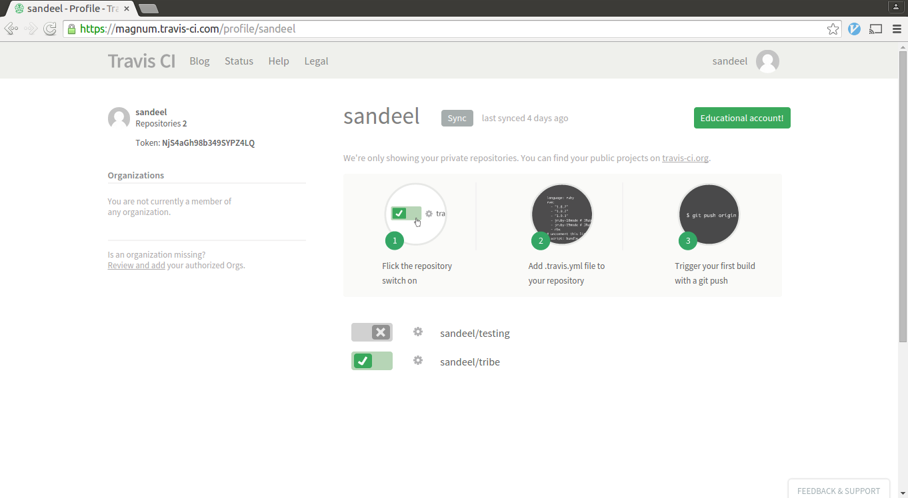
Travis-CI helpfully then sent me emails stating when my build had failed and when it was fixed.
The build can be watched in real-time if you log into your Travis account and then push to your Github repository.
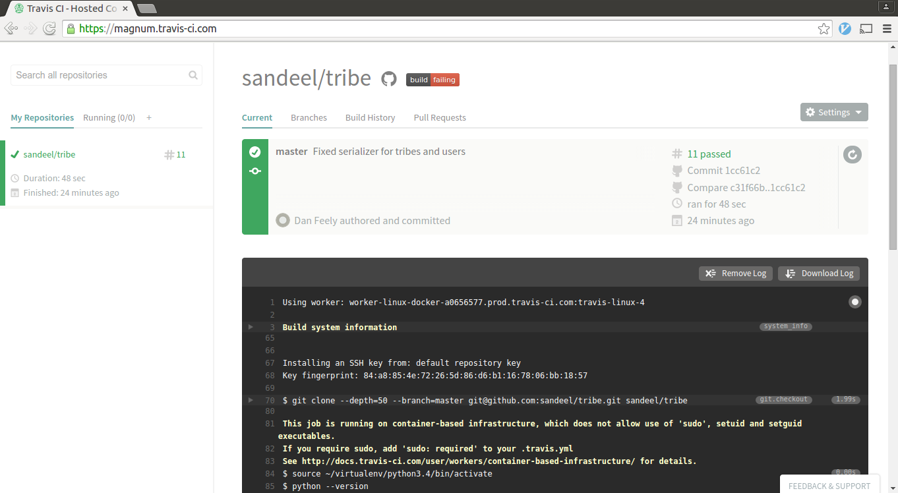
There are also various tools available on Travis's web interface. One of the more useful views I found was the "Build History" view.
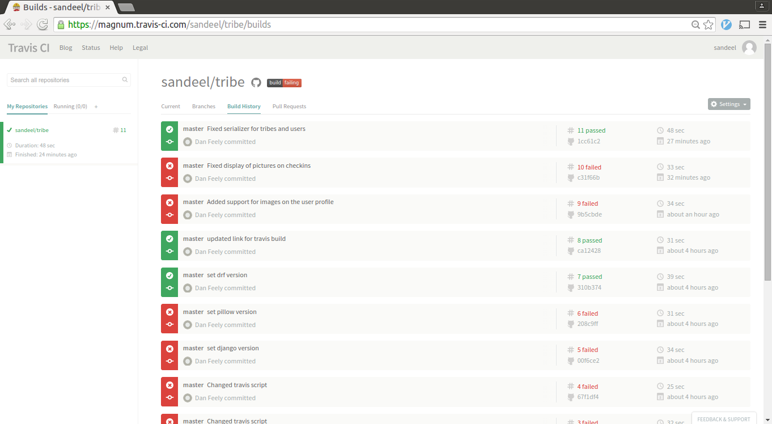
I was also able to put a "light" on my repository's Github page which turned green when build was passing and red when build failing.
Overall I think that while using continuous integration didn't gain me a huge amount because I was only a one-person team, it still had some benefits and didn't take too much time to set up. It was also of benefit to learn this skill as I can see how continuous integration would be extremely useful in large teams who are working together on a single codebase.

Deployment
----- why was do chosen
I needed to install git to clone my repository. This was done using Ubuntu's apt-get package manager:
apt-get update
apt-get install git
I then cloned my repository:
git clone https://github.com/sandeel/tribe.git
And changed into the directory for the Django project
cd tribe/tribe
To install the python libraries needed, I first had to install Python's package manager, PIP.
apt-get install [[python-pip]]
And some Python development libraries:
apt-get install python-dev
The requirements are stored in a text file called requirements.txt. PIP can parse through this file and install all the dependencies:
pip install -r requirements.txt
Then to run the development server for testing:
python manage.py runserver 0.0.0.0:8000

Timeline and diary

