Integration Plan: Sync Invoices to Taxilla
Platforms: WordPress (WooCommerce), Shopify, Taxilla
Middleware: Windows Application

Overview
This document outlines the integration plan to sync invoices from two clothing e-commerce platforms—WordPress (WooCommerce) and Shopify—into the Taxilla platform using a Windows application as middleware.

Workflow Steps

1. Fetch Orders (Invoices)

a. From WooCommerce (WordPress):
- Use WooCommerce REST API: GET /wp-json/wc/v3/orders
- Authenticate with API keys
- Parse customer, items, totals, and tax information

b. From Shopify:
- Use Shopify Admin API: GET /admin/api/2023-10/orders.json
- Use private app or custom app access token
- Extract billing, shipping, line items, and tax breakdown

2. Transform Data to Taxilla Format
- Map fields from both platforms to Taxilla’s e-invoice schema (JSON or XML)
- Normalize GSTIN, HSN codes, customer details, and tax values

3. Post Invoice to Taxilla
- Use Taxilla’s e-Invoice API endpoint (e.g., /einvoice/generate)
- Authenticate with access token and GSP credentials
- Handle response: IRN, QR Code, or errors

4. Store Logs or Status
- Maintain sync status (success, failed)
- Log timestamps and IRNs for reference

Tools Required
- Middleware: .NET-based Windows Application

Windows Application Screens

Authentication Screen
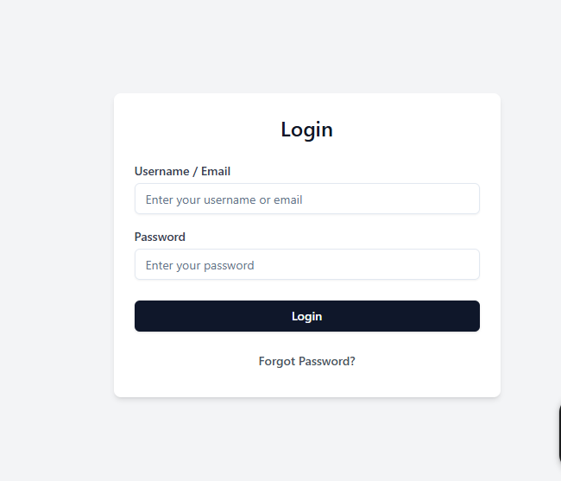
- Secure login system for authorized users
- Access control for different roles (Admin, Viewer)

Orders Screen
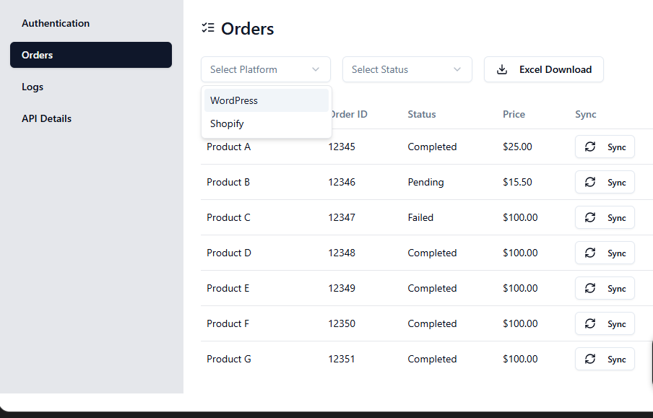
- View and filter synced orders from both platforms
- Status indication for invoice generation

Logs Screen
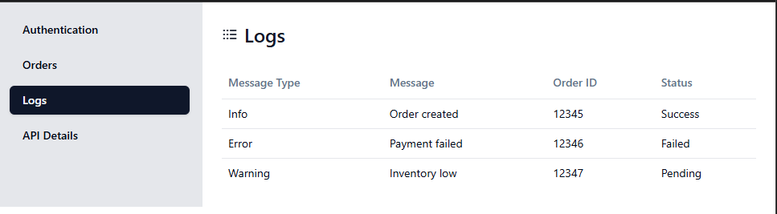
- Track sync history, success/failure logs

API Details Screen
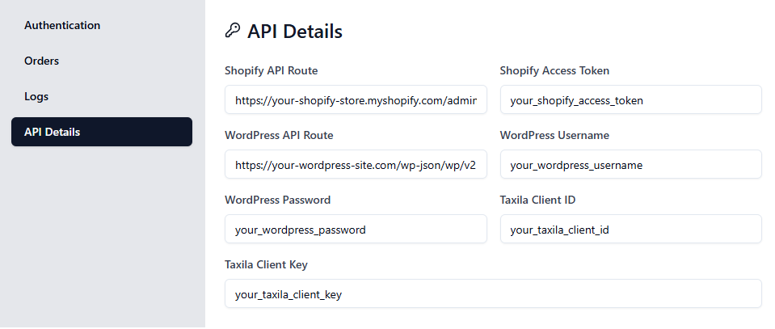
- Display API credentials and endpoint settings
- Manage tokens and configuration details

Quotation
The following quotation outlines the estimated costs for the integration project.
Description | Estimated Hours | Cost (USD)
WooCommerce Integration | 8 | 400
Shopify Integration | 10 | 500
Windows Middleware Development | 15 | 750
Taxilla API Integration | 8 | 400
Testing & Documentation | 5 | 250
**Total Estimated Cost: $2,300**

