Add Privacy Policy Page and Link in Footer

**Privacy Policy**

**Effective Date: 1-1-2022**

**Introduction**

At The Rural Art, operated by Swa-Kustom LLC, we are committed to protecting the privacy and confidentiality of our customers' personal information. This Privacy Policy describes the types of personal information we collect, how we use and protect it, and the choices you have regarding your personal information.

**Information We Collect**

We collect various types of personal information when you interact with us, including:

Contact Information: Name, email address, phone number, shipping and billing addresses.

Payment Information: Credit/debit card details, bank account details.

Demographic Information: Age, gender, occupation.

Preferences and Interests: Information about your preferences and interests.

Interaction Information: Purchase history and customer service inquiries.

**How We Use Your Information**

We use your personal information to provide you with our products and services, including:

Processing and fulfilling orders.

Sending order and shipping confirmations.

Providing customer service and responding to inquiries.

Sending marketing and promotional materials, including newsletters and special offers.

Conducting market research and improving our products and services.

We may also use your information for other purposes disclosed to you at the time we collect the information or with your consent.

**Sharing Your Information**

We may share your personal information with third-party service providers who assist us with our business operations, such as:

Shipping companies.

Payment processors.

We require these third parties to maintain the confidentiality of your information and to use it only for the purposes for which we disclose it to them.

We may also share your personal information as required by law or to protect our rights and property.

**Protecting Your Information**

We take reasonable measures to protect your personal information from unauthorized access, use, and disclosure. We use secure servers and encryption technology to protect your information during transmission. However, no data transmission over the internet or electronic storage system can be guaranteed to be 100% secure. Therefore, we cannot guarantee the absolute security of your personal information.

**Your Choices**

You may opt out of receiving marketing and promotional materials from us by following the unsubscribe instructions provided in the materials. However, we may still send you transactional and customer service-related communications, such as order confirmations and shipping notifications.

You may also access, correct, or delete your personal information by contacting us at info@theruralart.com.

**Changes to This Policy**

We may update this Privacy Policy from time to time. We will notify you of any material changes to this Policy by posting the updated Policy on our website and providing you with notice of the changes.

**Contact Us**

If you have any questions or concerns about our Privacy Policy, please contact us at:

Swa-Kustom LLC

Email: [info@theruralart.com](mailto:info@theruralart.com)

—---------------------------------------------------------------------------------------------------------------

**Order Receipt** Company Logo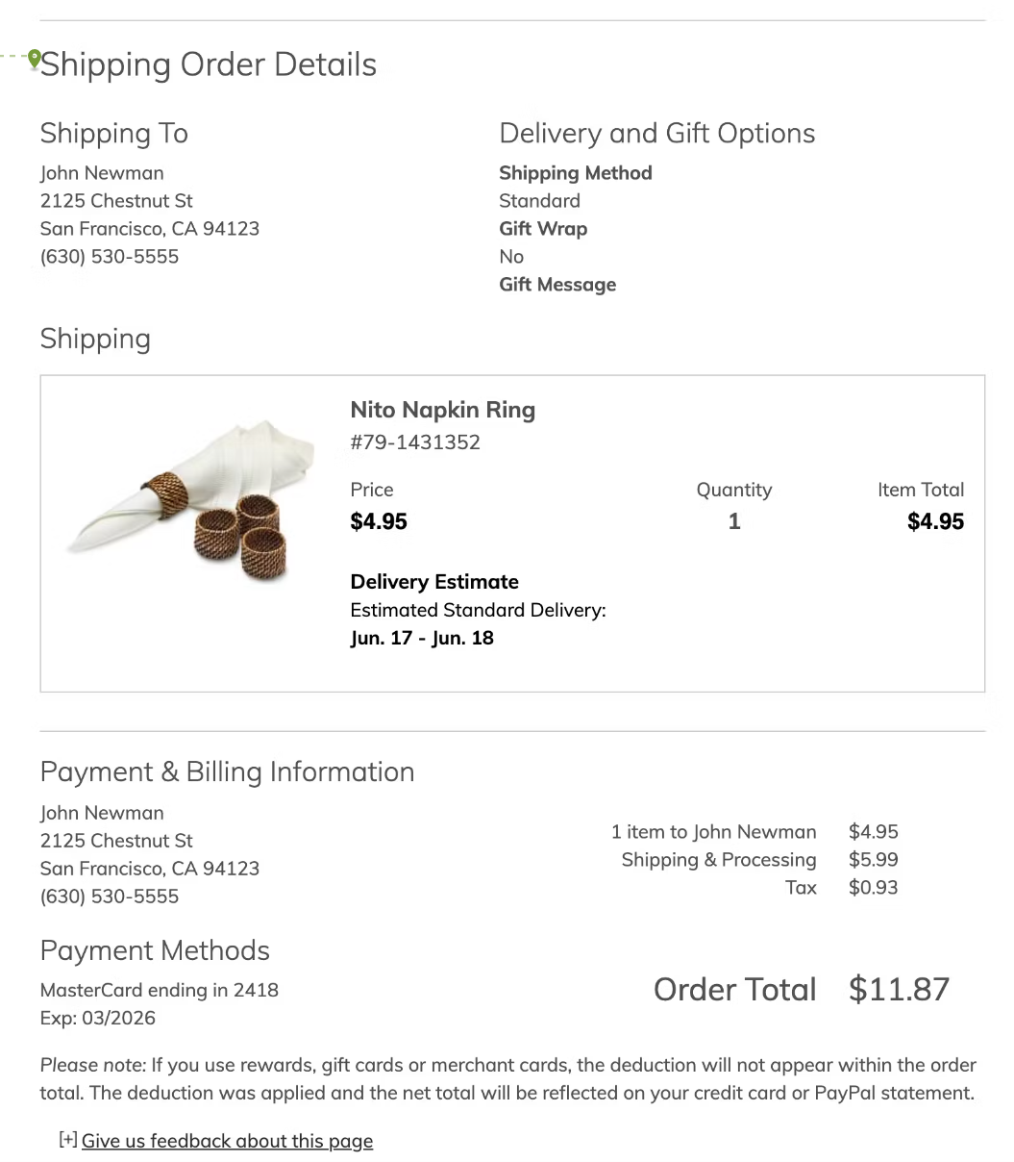

**Please Note:**

Thank you for your esteemed order. We greatly value your patronage and are delighted to craft a unique piece specifically for you. Kindly be advised that each product is meticulously made to order, ensuring unparalleled quality and attention to detail.

The processing times are as follows: Regular Orders: 8-10 weeks Custom Orders: 10-12 weeks.

To keep you informed throughout the creation process, we will provide periodic updates accompanied by in-progress images of your product. Should you wish to inquire about the status of your order or if you have any questions, please feel free to contact us. We are available by phone at +1-844-722-1919 or via email at info@theruralart.com.

We sincerely appreciate your patience and understanding as we endeavour to deliver a beautifully handcrafted item that exceeds your expectations.

Best regards,

The Rural Art Team

—-------------------------------------------------------------------------------------------------------------------------

**Return Policy**

**General Return Policy:**

We want you to be completely satisfied with your purchase. If you are not satisfied, you have 7 days from the date of delivery to return an item in its original condition

You can return the Product(s), purchased from us provided the Product(s) satisfy below mandatory conditions:

(i)  The Product has not been worn, cleaned or tampered with by you.

(ii)  The price tag /barcode, brand tags, original packaging material, accompanying accessories are intact and not altered, damaged or discarded by you.

(iii)  The Product is not altered, unless proven vendor defect.

(iv)  Return is being initiated against the order under which it was bought and from the same account and the serial number/ barcode of the Product matches our records.

(v)  There is no foul odour, perfume, stains, dents, scratches, tears or damage on the Product.

(vi)  The Product(s) if bought as a set should be exchanged as the complete set.

(vii)  Products returned should be in unused, undamaged, unwashed and in a saleable condition.

(viii)  We are satisfied that the Product has not been rendered defective or unusable.

We reserve the right to reject the return request for a Product if it does not satisfy the aforementioned conditions.

Please note that return shipping costs are the responsibility of the customer. Once your merchandise is returned and inspected, we will issue the appropriate credits and/or refunds for the item(s), along with any applicable tax refunds according to state law.

Refunds will be processed back to your original payment method after we receive your returned item, minus shipping charges and a 25% restocking fee based on your order subtotal. If you wish to cancel your initial order, you must do so within 24 hours of placing the order to receive a full refund. Cancelling after 24 hours but before delivery will result in a partial refund (minus a 20% processing charge).

**Made-to-Order Items:**

Made-to-order items are crafted specifically for you, and as such, they are not eligible for return unless they arrive damaged or with a manufacturing defect. If you still wish to return a made-to-order item within 48 Hours from the date of receipt, a 50% restocking fee plus shipping charges will be deducted from your refund. It is the customer's responsibility to ship the item back to our warehouse in New Jersey.

**Accessory and Decor Returns:**

For accessory returns, please contact us within 14 days of receiving your item(s) for specific return instructions. You'll be responsible for return shipment costs. Once we receive your return, refunds will be credited back to your original payment method, minus a 25% restocking fee. Accessories not returned within this 14-day window cannot be accepted for return. Items listed below $99 are final sale and cannot be returned.

Accessory cancellations are accepted within 48 hours of purchase, before shipping. After this window, our 14-day return policy applies.

**Damaged Items:**

If your item arrives damaged or defective, please contact us upon receipt, and we'll take care of it promptly.

**Clearance Items:**

Clearance items are final sale and not eligible for returns, except in cases of documented damage upon arrival. Warranty claims for clearance items require reporting defects within 48 hours of delivery.

**Promotions:**

If you make a purchase during a promotion where the discount depends on the total order cost (e.g., Buy More, Save More Sale), and part of the order is cancelled or returned, the discount may be adjusted accordingly. Limited edition collections/products/fabrics are not eligible for promotional discounts.

We strive to provide excellent customer service and satisfaction. Please contact us with any questions or concerns regarding your purchase or our return policy.