**In RHEL/OEL 7/8/9**

Files : /usr/lib/systemd/system

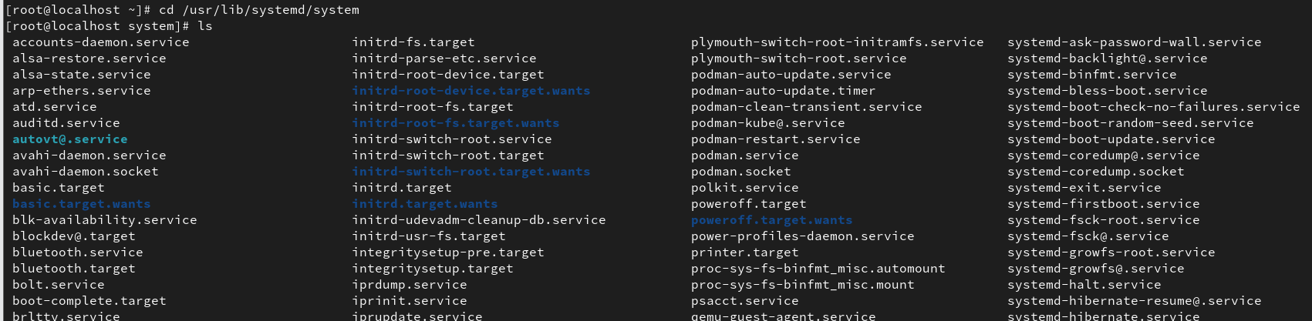

/etc/systemd/system

1. Start and Stop services
   1. systemctl start crond

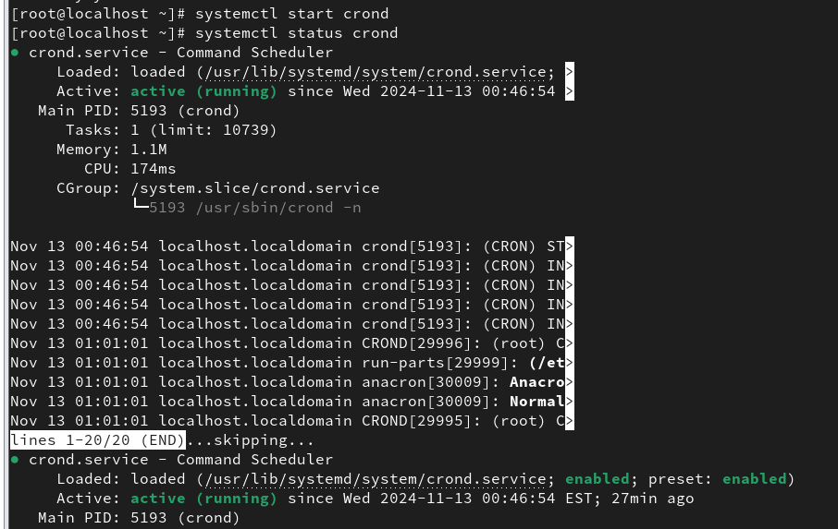

* 1. systemctl start firewalld

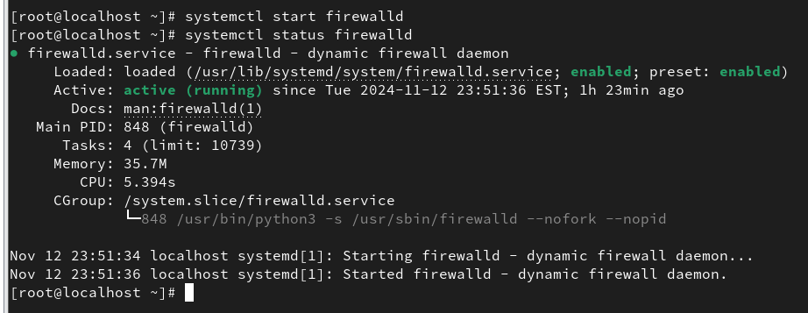

* 1. systemctl stop crond

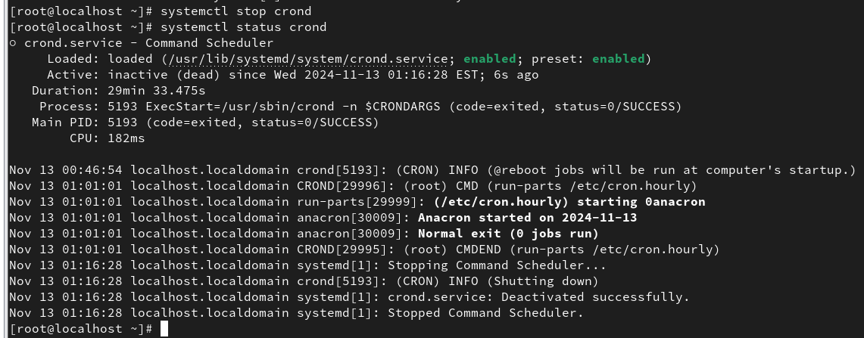

* 1. systemctl stop firewalld

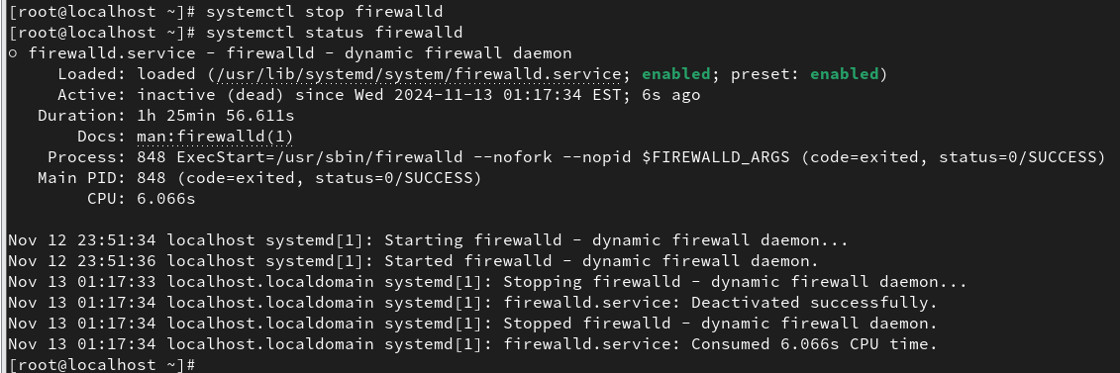

1. Restart and Reload services
   1. systemctl restart crond

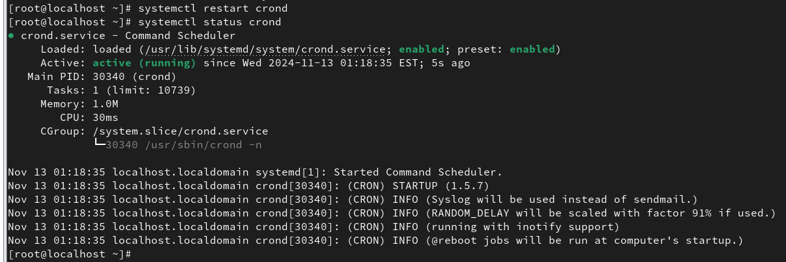

1. To reload all the configuration files forcefully on your system
   * 1. systemctl reload crond

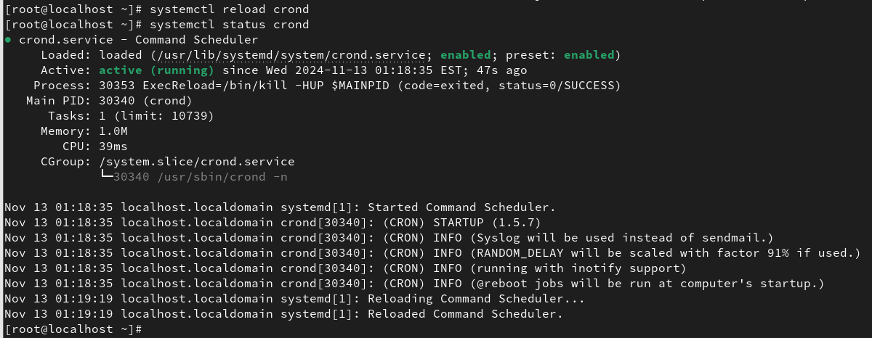

1. Enable and Disable services
   * 1. systemctl enable crond

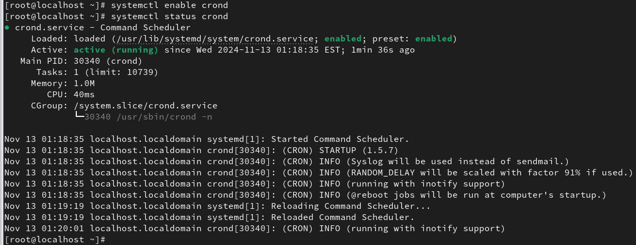

* + 1. systemctl enable firewalld

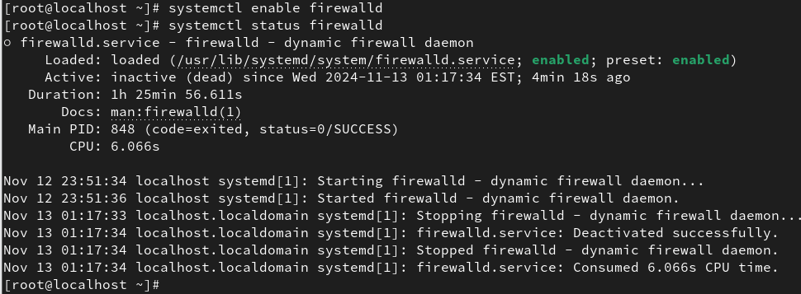

* + 1. systemctl disable crond

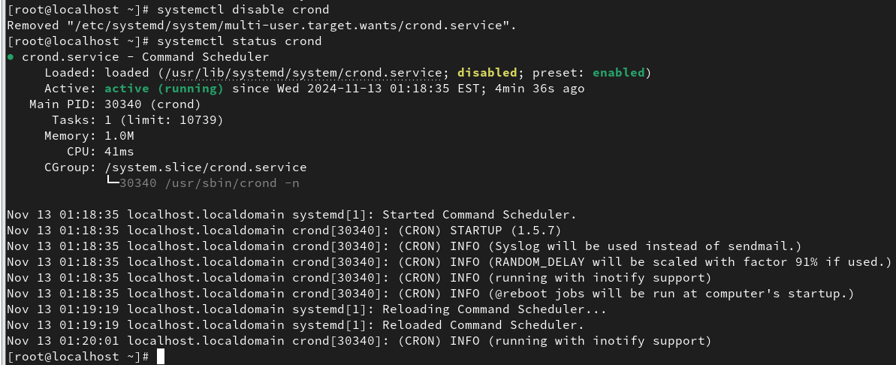

* + 1. systemctl disable firewalld

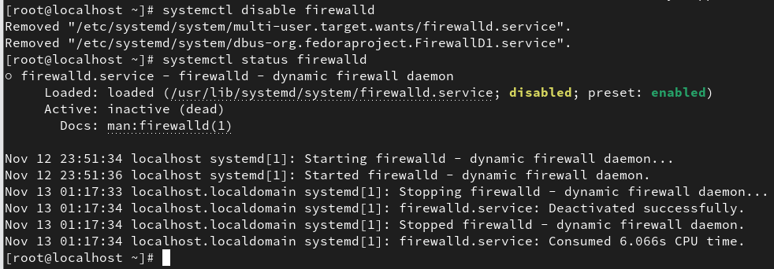

* + 1. systemctl enable sshd --now ( enable the service and start it now)

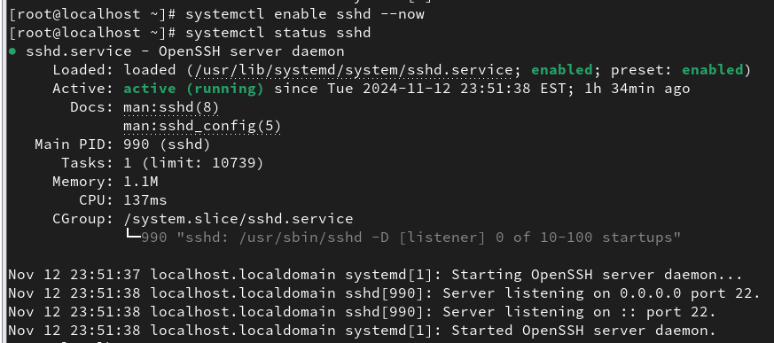

* + 1. systemctl disable sshd --now (disable the service and stop it now)

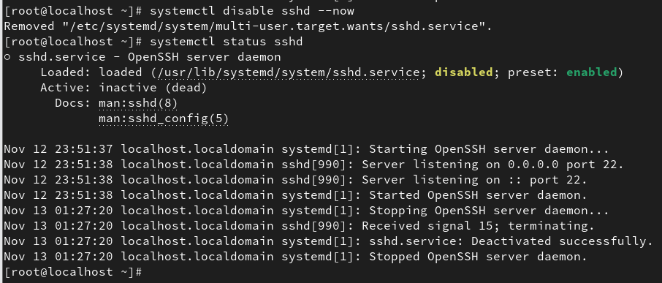

1. To check the status of the service
   * 1. systemctl is-active sshd
     2. systemctl is-enabled sshd

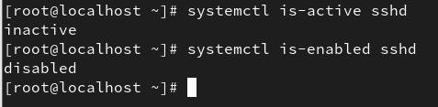

* + 1. systemctl status firewalld

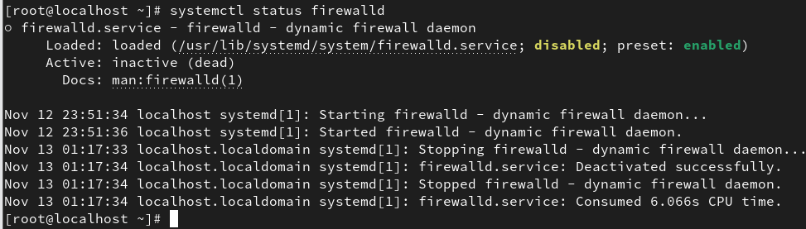

* + 1. systemctl status --all

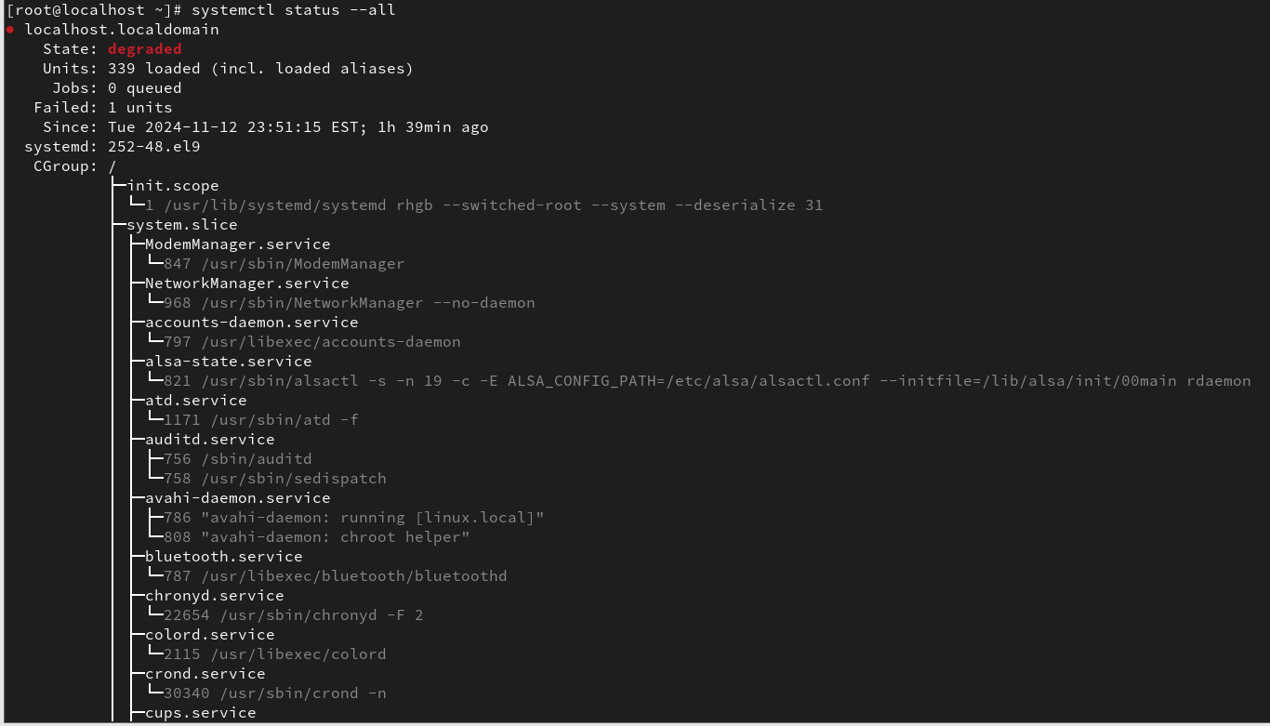

1. List all services
   * 1. systemctl list-units --type service --all

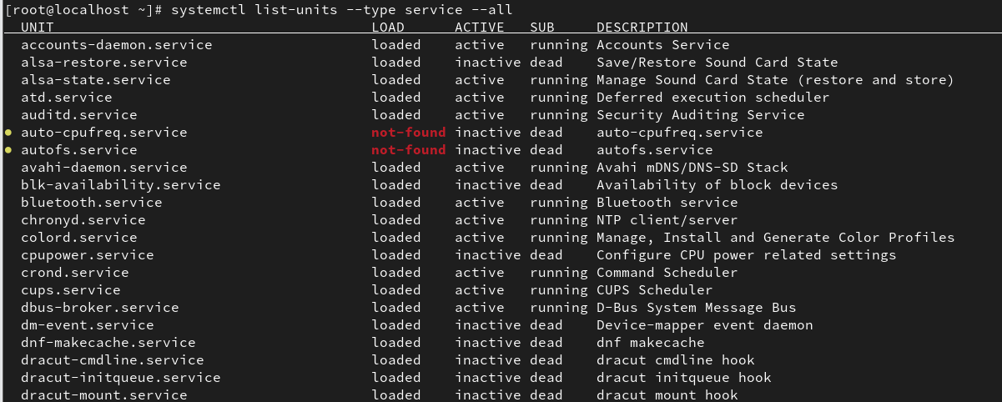

* + 1. systemctl list-unit-files --type=service

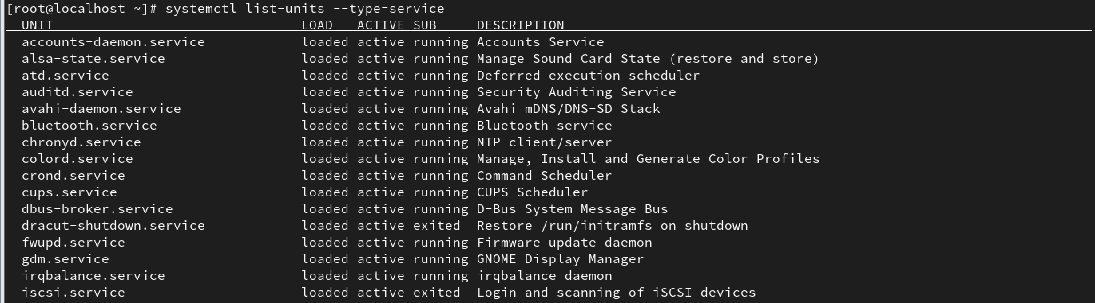

1. list of services that are active now
   * 1. systemctl -t service

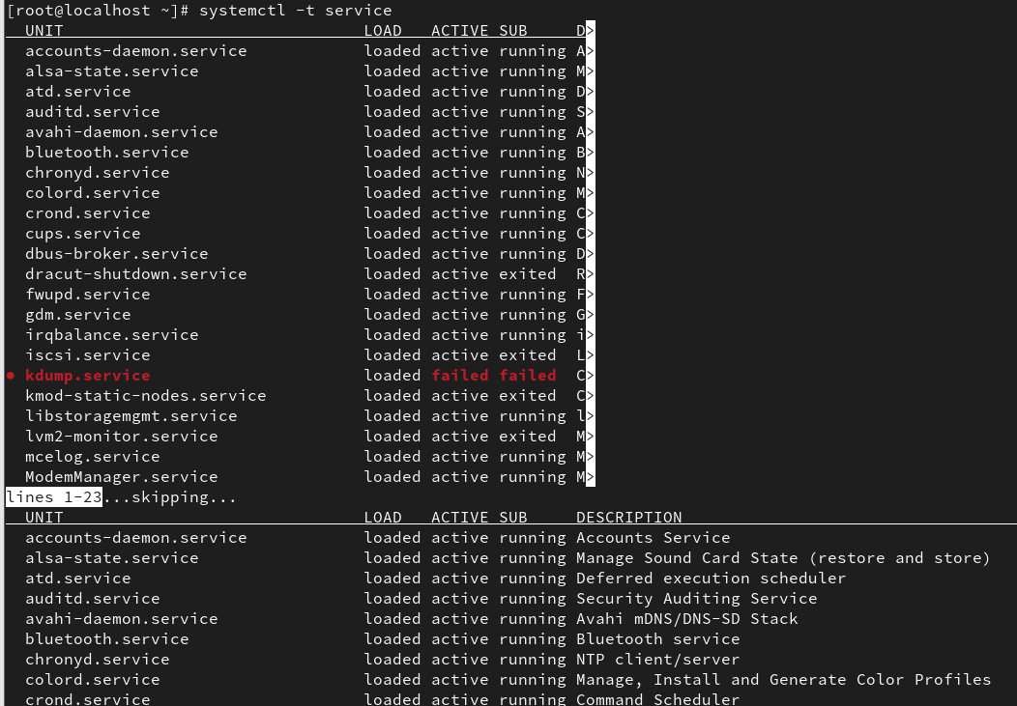

1. Reload Unit Files
   * 1. systemctl daemon-reload - This command reloads the systemd manager configuration files. Use this command after modifying any service files or after adding new units to the system.

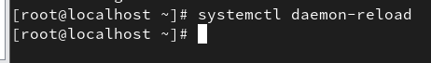

**RHEL/OEL/CentOS – 6**

* 1. Start and Stop services
     1. service <service name> start/stop

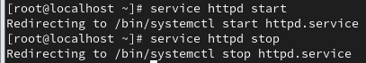

Its redirecting t systemctl cmd to start and stop

* + 1. service crond start
    2. service crond stop

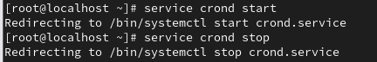

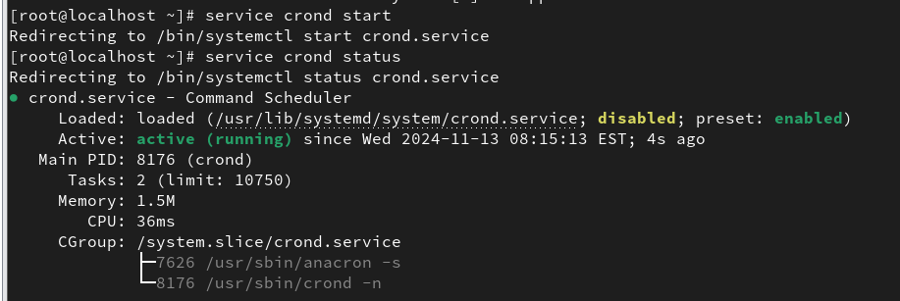

* + 1. service httpd status

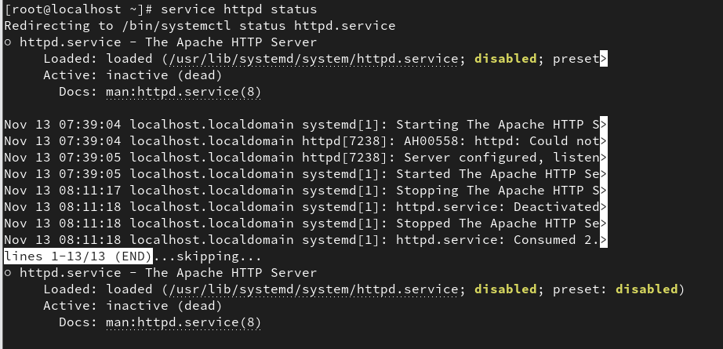

* + 1. /etc/init.d/crond start
    2. /etc/init.d/httpd stop

* 1. Restart and Reload services
     1. service <service name> restart/reload
     2. service crond restart

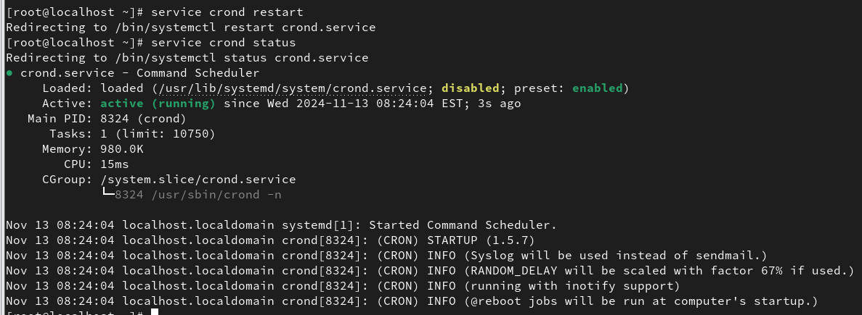

* + 1. service crond reload

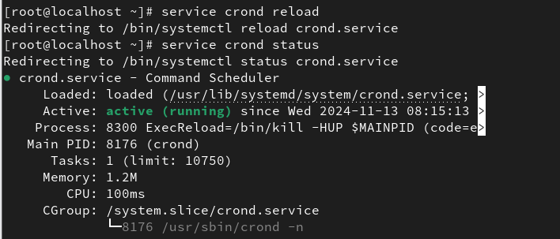

* + 1. service httpd restart

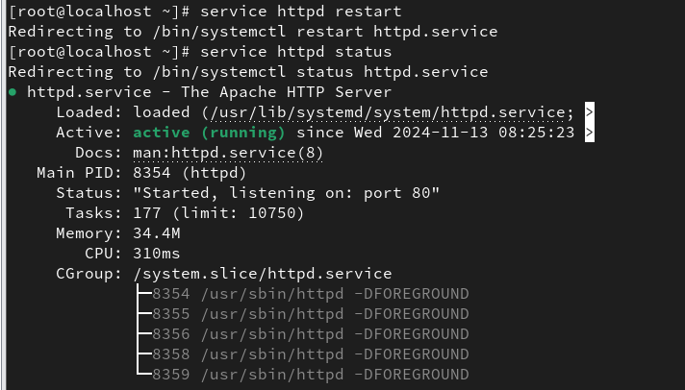

* 1. To list all services
     1. service --status-all
     2. service --status-all | more
     3. service --status-all | grep ntpd
     4. service --status-all | less
  2. chkconfig --list

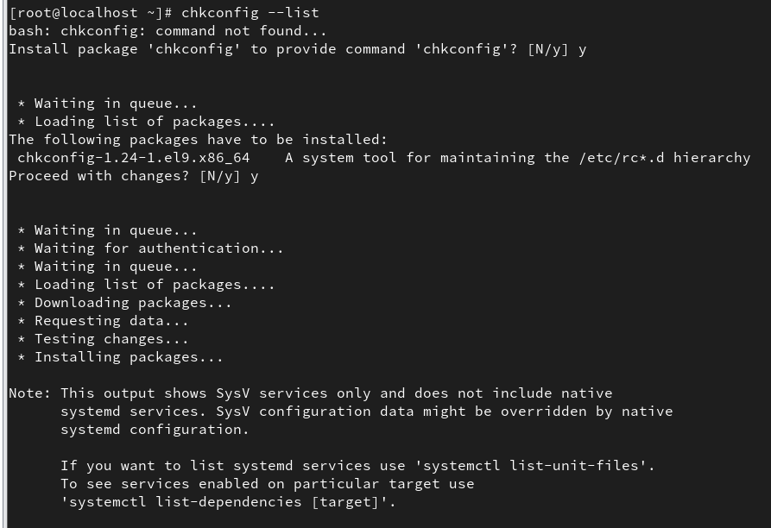

* 1. chkconfig sshd on
  2. chkconfig sshd off

