Project Descrption calculator

A calculator is a machine which allows people to do math operations more easily. For example, most calculators will add, subtract, multiply, and divide. Some also do square roots, and more complex calculators can help with calculus and draw function graphs. Calculators are found everywhere. A smartphone or other computer can also act as a calculator.

Some calculators, like the abacus, will work without electricity. Others, like the electronic calculator, use batteries. Some calculators are simple, and can only add, subtract, multiply and divide, and sometimes take square roots. Scientific calculators can do many other things, such as use exponents (or powers or indices) and trigonometry functions.

Advantages:

This technology allows students solve complicated problems quickly and in an efficient manner. Additionally, it can reduce the problem to simpler tasks and allows the student to devote more time in understanding the problem. Secondly, they are saved from monotonous calculations and the same boring mundane procedure.

Disadvantages:

The Calculator is available in variety of brands, and each brand and model requires a specific set of instructions. It is a proven fact that many of us do not bother to read these manual, and it gets lost. Although the instructions are quite simple, there are chances that students might make mistake. A small mistake is sufficient to lead to the wrong answer. A student must have the ability of estimating the correct answers or the student would not cross check the problem. It is in the best interest of students to repeat all the mathematical calculation once. Alternatively, if there is difference in answers between the first and second calculation, the student must repeat the operations again.

System overview:

[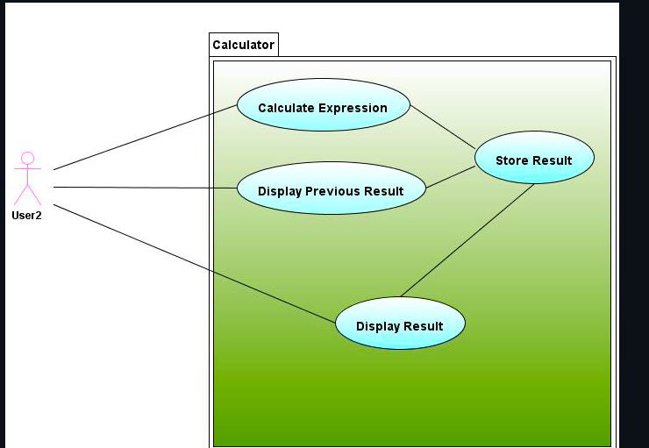](https://user-images.githubusercontent.com/61178705/132502882-630f3221-1b32-4360-b7bb-ae00a4f9bb36.png)

SWOT analysis:

[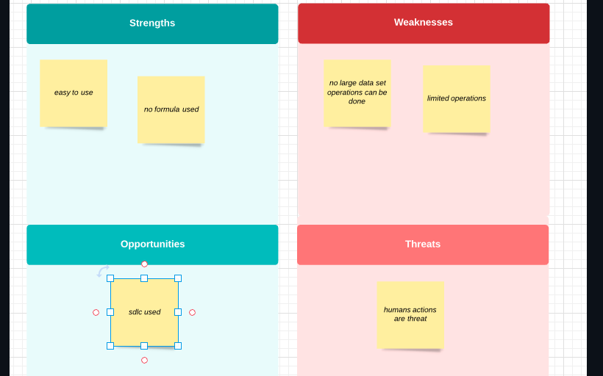](https://user-images.githubusercontent.com/61178705/132503021-133c1ef1-a1a7-4e8a-b251-1d50e00a640d.png)

Details:

high level requiremets :

HR01 - User shall be able to perform Arthimetic Operations

HR02- User shall be able to Other operations

lowlevel requirements:

LR01 Permorming Addition HR01

LR02 Performing Subtraction HR01

LR03 Performing Multiplication HR01

LR04 Performing Division HR01

LR05 Performing Power HR02

LR06 Performing Squarerootof a number HR02

LR05 Performing Logarithm with base 10 HR02

**Table no: High level test plan**

|  |  |  |  |  |
| --- | --- | --- | --- | --- |
| **Test ID** | **Description** | **Exp I/P** | **Exp O/P** | **Actual O/P** |
| **H_00** | **Select operator** | **Choice** | **Success** | **success** |
| H_01 | Enter number1 | choice | Success | Success |
| H_02 | Enter number2 | Choice | Success | Success |

## Table no: Low level test plan

|  |  |  |  |  |  |  |  |  |
| --- | --- | --- | --- | --- | --- | --- | --- | --- |
| Test ID | HL_ID | **Description** | **Exp Input** | **Exp Output** | **Actual Output** | | **Type Of Test** | | --- | |  | |
| L_01 | H_01 | Enter num1 | 1 | 1 | 1. | Pass |
| L_02 | H_02 | Enter num2 | 1 | 1 | 1. | Pass |
| L_03 | H_00 | Add module | 2 | 2 | 2 | Pass |
| L_04 | H_00 | Select operator | ) | error | error | Fail |
| L_05 | H_00 | Exit | 7 | 7 | pass | Pass |

Code :

#include <stdio.h>

#include <math.h>

#include <stdlib.h>

int main()

{

// declaration of local variable op;

int op, n1, n2;

float res;

char ch;

do

{

// displays the multiple operations of the C Calculator

printf (" Select an operation to perform the calculation in C Calculator: ");

printf (" \n 1 Addition \t \t 2 Subtraction \n 3 Multiplication \t 4 Division \n 5 Square \t \t 6 Square Root \n 7 Exit \n \n Please, Make a choice ");

scanf ("%d", &op); // accepts a numeric input to choose the operation

// use switch statement to call an operation

switch (op)

{

case 1:

// Add two numbers

printf (" You chose: Addition");

printf ("\n Enter First Number: ");

scanf (" %d", &n1);

printf (" Enter Second Number: ");

scanf (" %d", &n2);

res = n1 + n2; // Add two numbers

printf (" Addition of two numbers is: %.2f", res);

break; // break the function

case 2:

// Subtract two numbers

printf (" You chose: Subtraction");

printf ("\n Enter First Number: ");

scanf (" %d", &n1);

printf (" Enter Second Number: ");

scanf (" %d", &n2);

res = n1 - n2; // subtract two numbers

printf (" Subtraction of two numbers is: %.2f", res);

break; // break the function

case 3:

// Multiplication of the numbers

printf (" You chose: Multiplication");

printf ("\n Enter First Number: ");

scanf (" %d", &n1);

printf (" Enter Second Number: ");

scanf (" %d", &n2);

res = n1 * n2; // multiply two numbers

printf (" Multiplication of two numbers is: %.2f", res);

break; // break the function

case 4:

// Division of the numbers

printf (" You chose: Division");

printf ("\n Enter First Number: ");

scanf (" %d", &n1);

printf (" Enter Second Number: ");

scanf (" %d", &n2);

if (n2 == 0)

{

printf (" \n Divisor cannot be zero. Please enter another value ");

scanf ("%d", &n2);

}

res = n1 / n2; // divide two numbers

printf (" Division of two numbers is: %.2f", res);

break; // break the function

case 5:

// getting square of a number

printf (" You chose: Square");

printf ("\n Enter First Number: ");

scanf (" %d", &n1);

res = n1 * n1; // get square of a number

printf (" Square of %d number is: %.2f", n1, res);

break; // break the function

case 6:

// getting the square root of the number

printf (" You chose: Square Root");

printf ("\n Enter First Number: ");

scanf (" %d", &n1);

res = sqrt(n1); // use sqrt() function to find the Square Root

printf (" Square Root of %d numbers is: %.2f", n1, res);

break; // break the function

case 7:

printf (" You chose: Exit");

exit(0);

break; // break the function

default:

printf(" Something is wrong!! ");

break;

}

printf (" \n \n ********************************************** \n ");

} while (op != 7);

return 0;

}