**Static Code Analysis**

for

**my-Social-Connect-App**



AUTHOR: **SANDEEP PAPUDESI**

EMAIL ID: **SANDEEP.PAPUDESI@YAHOO.COM**

**TABLE OF CONTENTS**

1. iNTRODUCTION 4

1.1 Overall Report 4

1.2 Code Issues 4

1.3 Code Measures 5

1.4 Code Analysis 5

**Revision History**

|  |  |  |  |
| --- | --- | --- | --- |
| **Version** | **Date of Revision** | **Description of Change** | **Author** |
| 0.1 | 08/10/2018 | Initial Draft | Sandeep Papudesi |
| 0.2 | 08/12/2018 | Final | Sandeep Papudesi |
|  |  |  |  |
|  |  |  |  |
|  |  |  |  |
|  |  |  |  |

# iNTRODUCTION

The purpose of this document is to present static code analysis report executed in SONARQUBE

## Overall Report

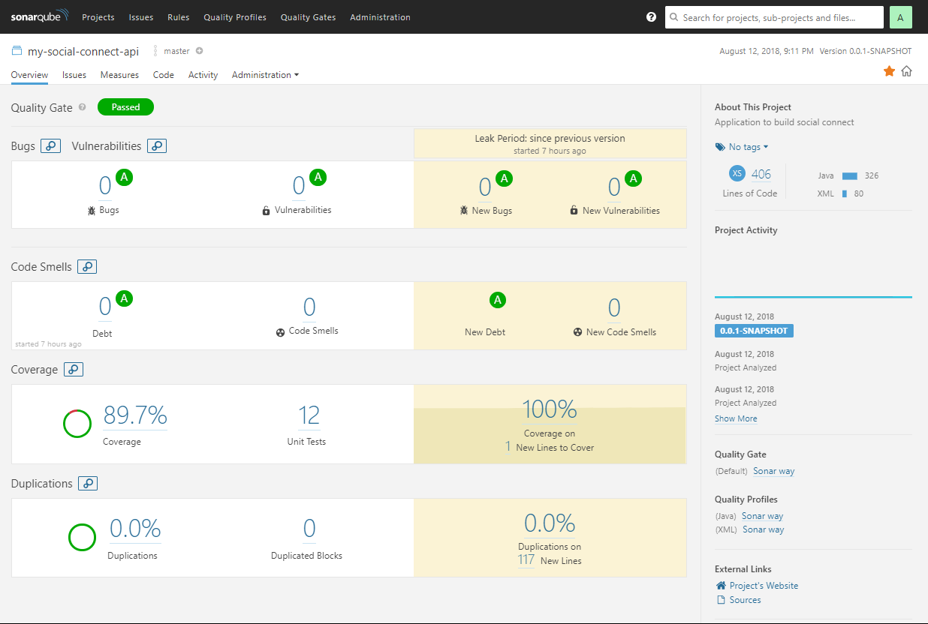

## Code Issues

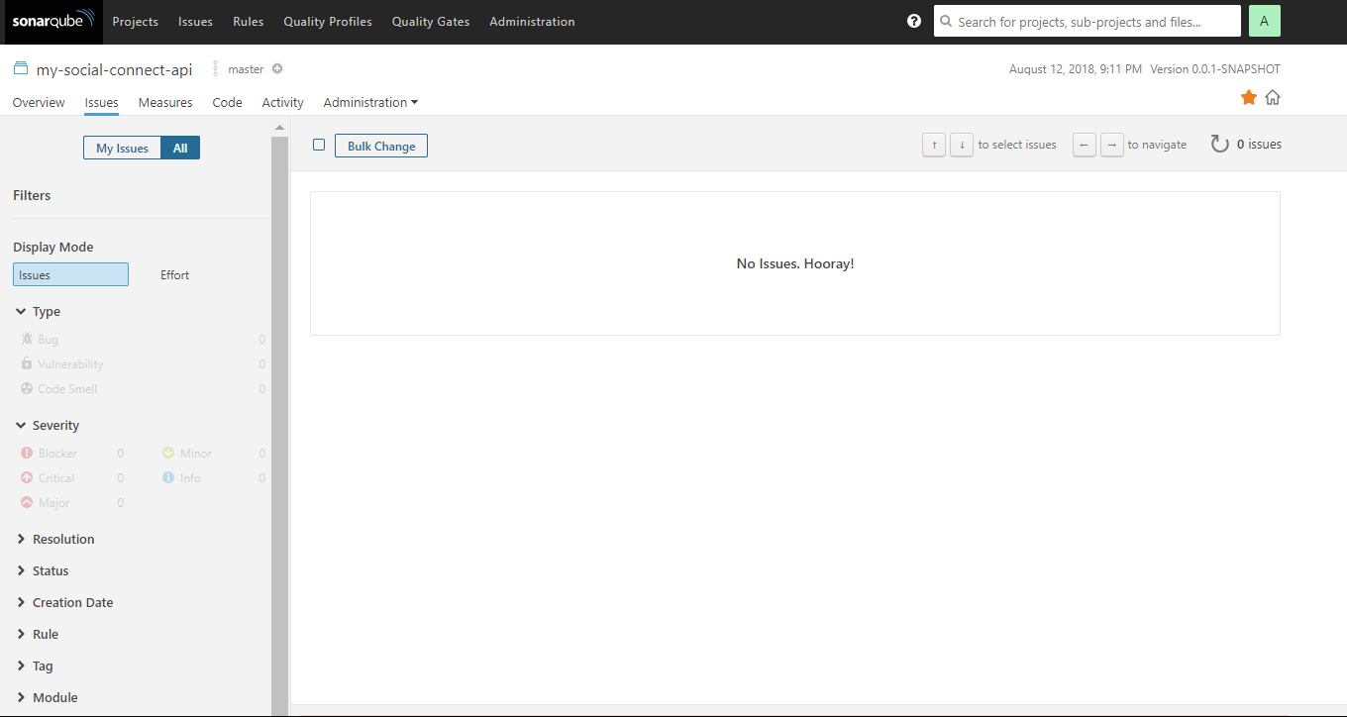

## Code Measures

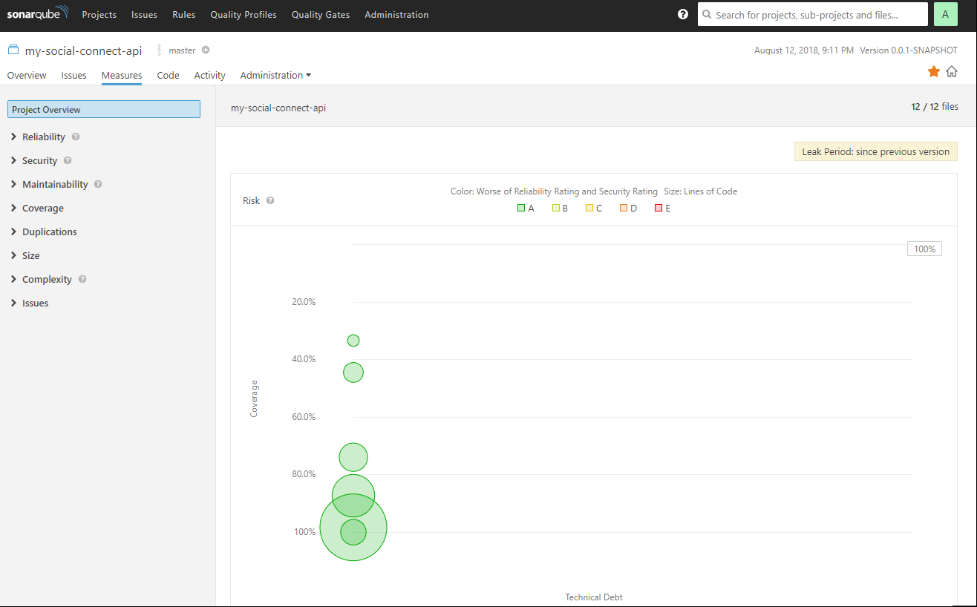

## Code Analysis

