factors setting:

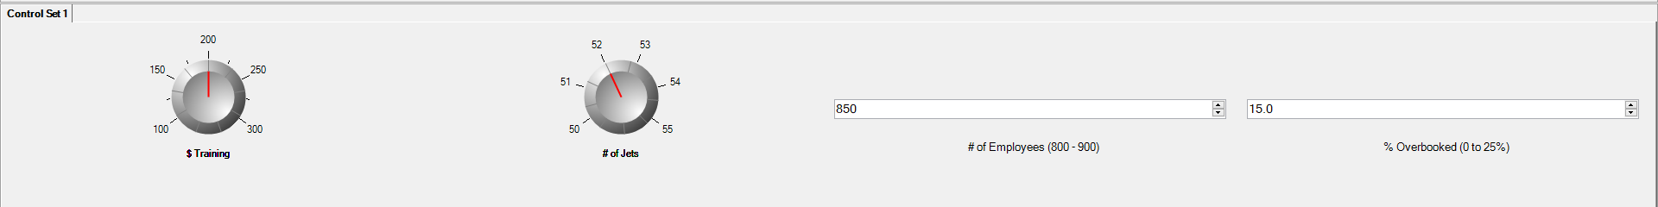

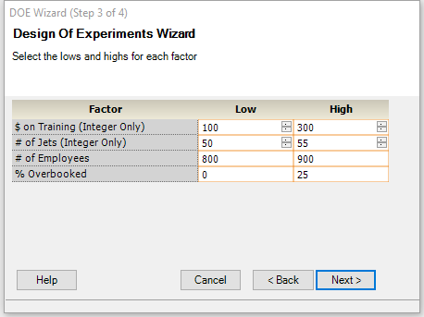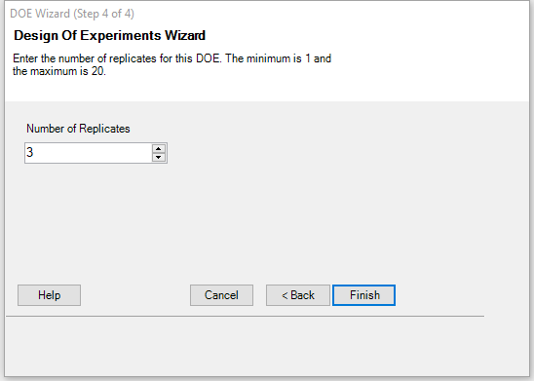

DOE generation:

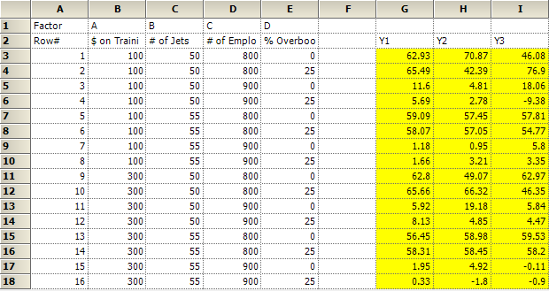

FACTOR AFFECTS VARIATION

1. define a factorial design

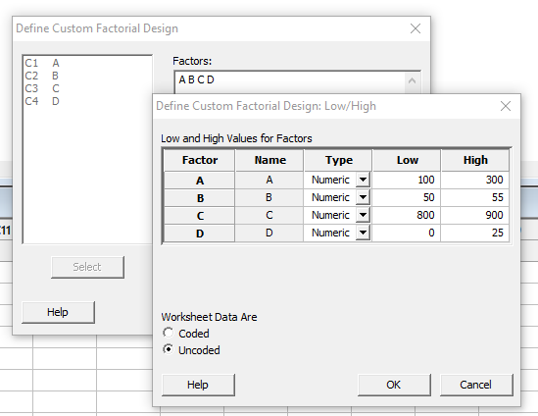

2. analyze a factional design of all main effects and 2 terms intersections:

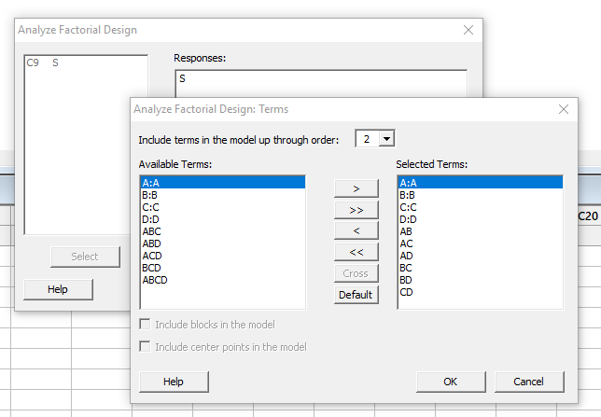

3. according to the output p-value, B(number of Jets) is the factor affect variation

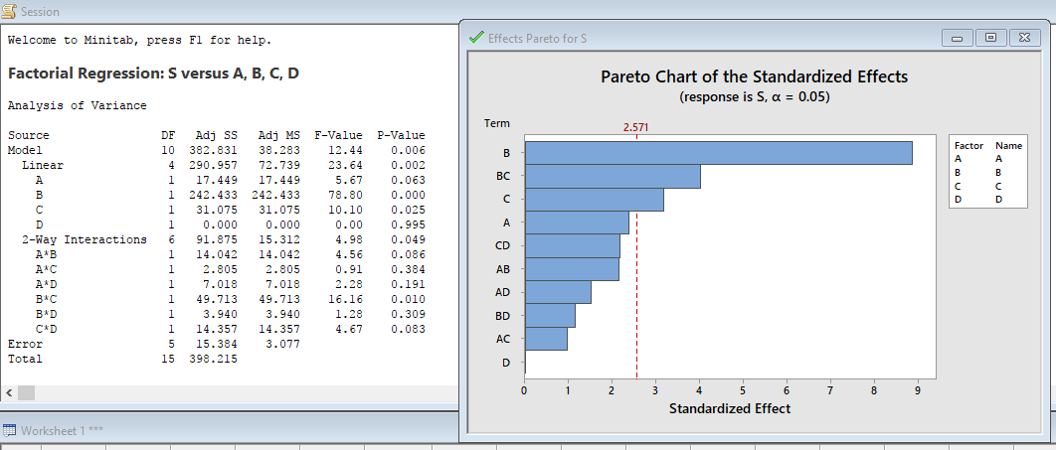

Factorial Regression: S versus A, B, C, D

Analysis of Variance

Source DF Adj SS Adj MS F-Value P-Value

Model 10 382.831 38.283 12.44 0.006

Linear 4 290.957 72.739 23.64 0.002

A 1 17.449 17.449 5.67 0.063

B 1 242.433 242.433 78.80 0.000

C 1 31.075 31.075 10.10 0.025

D 1 0.000 0.000 0.00 0.995

2-Way Interactions 6 91.875 15.312 4.98 0.049

A\*B 1 14.042 14.042 4.56 0.086

A\*C 1 2.805 2.805 0.91 0.384

A\*D 1 7.018 7.018 2.28 0.191

B\*C 1 49.713 49.713 16.16 0.010

B\*D 1 3.940 3.940 1.28 0.309

C\*D 1 14.357 14.357 4.67 0.083

Error 5 15.384 3.077

Total 15 398.215

Model Summary

S R-sq R-sq(adj) R-sq(pred)

1.75406 96.14% 88.41% 60.44%

Coded Coefficients

Term Effect Coef SE Coef T-Value P-Value VIF

Constant 5.342 0.439 12.18 0.000

A -2.089 -1.044 0.439 -2.38 0.063 1.00

B -7.785 -3.893 0.439 -8.88 0.000 1.00

C -2.787 -1.394 0.439 -3.18 0.025 1.00

D 0.006 0.003 0.439 0.01 0.995 1.00

A\*B 1.874 0.937 0.439 2.14 0.086 1.00

A\*C 0.837 0.419 0.439 0.95 0.384 1.00

A\*D -1.325 -0.662 0.439 -1.51 0.191 1.00

B\*C 3.525 1.763 0.439 4.02 0.010 1.00

B\*D -0.992 -0.496 0.439 -1.13 0.309 1.00

C\*D -1.895 -0.947 0.439 -2.16 0.083 1.00

Regression Equation in Uncoded Units

S = 768 - 0.272 A - 14.09 B - 0.766 C + 2.228 D + 0.00375 A\*B + 0.000084 A\*C - 0.000530 A\*D

+ 0.01410 B\*C - 0.0159 B\*D - 0.001516 C\*D

Alias Structure

Factor Name

A A

B B

C C

D D

Aliases

I

A

B

C

D

AB

AC

AD

BC

BD

CD

Fits and Diagnostics for Unusual Observations

Std

Obs S Fit Resid Resid

11 7.68 5.63 2.05 2.09 R

R Large residual

Effects Pareto for S

4. analyze a factional design of S versus B

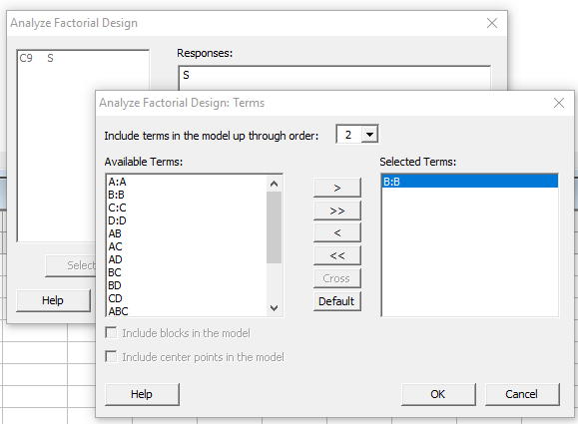

Factorial Regression: S versus B

Analysis of Variance

Source DF Adj SS Adj MS F-Value P-Value

Model 1 242.4 242.43 21.79 0.000

Linear 1 242.4 242.43 21.79 0.000

B 1 242.4 242.43 21.79 0.000

Error 14 155.8 11.13

Total 15 398.2

Model Summary

S R-sq R-sq(adj) R-sq(pred)

3.33576 60.88% 58.09% 48.90%

Coded Coefficients

Term Effect Coef SE Coef T-Value P-Value VIF

Constant 5.342 0.834 6.41 0.000

B -7.785 -3.893 0.834 -4.67 0.000 1.00

Regression Equation in Uncoded Units

S = 87.1 - 1.557 B

Alias Structure

Factor Name

A A

B B

C C

D D

Aliases

I

B

Fits and Diagnostics for Unusual Observations

Obs S Fit Resid Std Resid

2 17.58 9.23 8.35 2.68 R

12 2.01 9.23 -7.22 -2.31 R

R Large residual

the coded equation of S versus B would be:

**S = 5.342 -3.893\*B**

we can set B = 1 (55) to minimize S

DETERMIN MODEL FOR MINS. LATE

1. define a factorial design

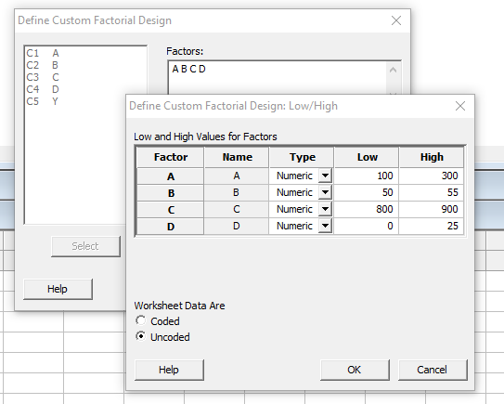

2. analyze factorial design of all main effects and intersections

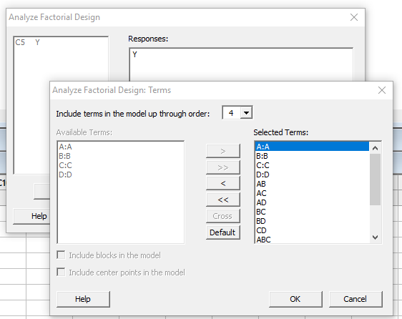

Factorial Regression: Y versus A, B, C, D

Analysis of Variance

Source DF Adj SS Adj MS F-Value P-Value

Model 15 36211.0 2414.1 45.19 0.000

Linear 4 35936.0 8984.0 168.18 0.000

A 1 0.2 0.2 0.00 0.957

B 1 150.8 150.8 2.82 0.103

C 1 35724.8 35724.8 668.75 0.000

D 1 60.3 60.3 1.13 0.296

2-Way Interactions 6 132.7 22.1 0.41 0.864

A\*B 1 1.8 1.8 0.03 0.854

A\*C 1 1.6 1.6 0.03 0.862

A\*D 1 5.0 5.0 0.09 0.761

B\*C 1 29.7 29.7 0.56 0.462

B\*D 1 15.4 15.4 0.29 0.595

C\*D 1 79.2 79.2 1.48 0.232

3-Way Interactions 4 113.5 28.4 0.53 0.714

A\*B\*C 1 39.9 39.9 0.75 0.394

A\*B\*D 1 13.5 13.5 0.25 0.619

A\*C\*D 1 1.8 1.8 0.03 0.854

B\*C\*D 1 58.3 58.3 1.09 0.304

4-Way Interactions 1 28.8 28.8 0.54 0.468

A\*B\*C\*D 1 28.8 28.8 0.54 0.468

Error 32 1709.4 53.4

Total 47 37920.5

Model Summary

S R-sq R-sq(adj) R-sq(pred)

7.30891 95.49% 93.38% 89.86%

Coded Coefficients

Term Effect Coef SE Coef T-Value P-Value VIF

Constant 31.55 1.05 29.91 0.000

A -0.11 -0.06 1.05 -0.05 0.957 1.00

B -3.54 -1.77 1.05 -1.68 0.103 1.00

C -54.56 -27.28 1.05 -25.86 0.000 1.00

D -2.24 -1.12 1.05 -1.06 0.296 1.00

A\*B -0.39 -0.20 1.05 -0.19 0.854 1.00

A\*C 0.37 0.19 1.05 0.18 0.862 1.00

A\*D 0.65 0.32 1.05 0.31 0.761 1.00

B\*C -1.57 -0.79 1.05 -0.75 0.462 1.00

B\*D 1.13 0.57 1.05 0.54 0.595 1.00

C\*D -2.57 -1.28 1.05 -1.22 0.232 1.00

A\*B\*C -1.82 -0.91 1.05 -0.86 0.394 1.00

A\*B\*D -1.06 -0.53 1.05 -0.50 0.619 1.00

A\*C\*D 0.39 0.20 1.05 0.19 0.854 1.00

B\*C\*D 2.20 1.10 1.05 1.04 0.304 1.00

A\*B\*C\*D -1.55 -0.77 1.05 -0.73 0.468 1.00

Regression Equation in Uncoded Units

Y = -38 - 0.56 A + 9.8 B + 0.16 C + 75.1 D + 0.011 A\*B + 0.00057 A\*C - 0.215 A\*D - 0.0129 B\*C

- 1.39 B\*D - 0.0918 C\*D - 0.000011 A\*B\*C + 0.00404 A\*B\*D + 0.000263 A\*C\*D + 0.00170 B\*C\*D

- 0.000005 A\*B\*C\*D

Alias Structure

Factor Name

A A

B B

C C

D D

Aliases

I

A

B

C

D

AB

AC

AD

BC

BD

CD

ABC

ABD

ACD

BCD

ABCD

Fits and Diagnostics for Unusual Observations

Obs Y Fit Resid Std Resid

18 42.39 61.59 -19.20 -3.22 R

33 46.08 59.96 -13.88 -2.33 R

34 76.90 61.59 15.31 2.56 R

42 46.35 59.44 -13.09 -2.19 R

R Large residual

Effects Pareto for Y

3. reduce terms

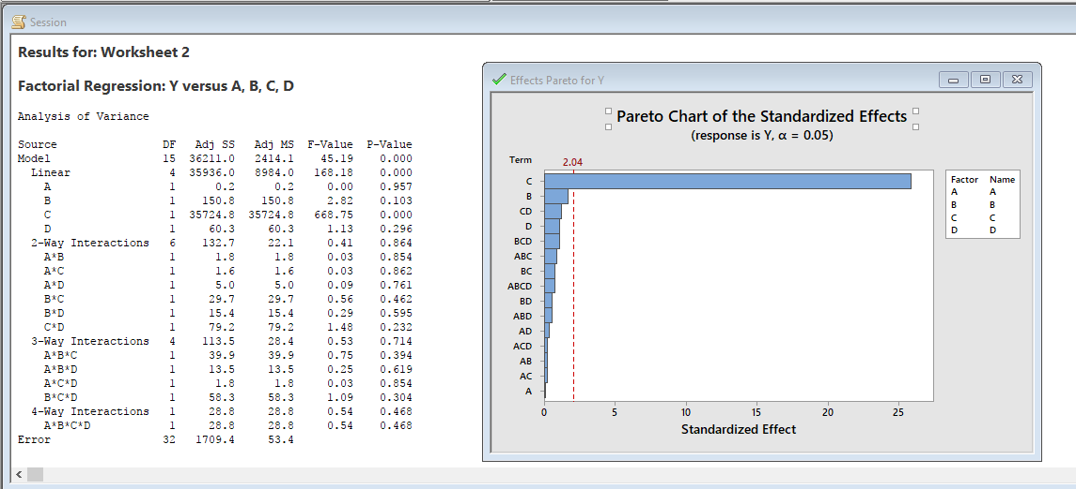

let alpha equals 0.01, we only have C as the factor:

Factorial Regression: Y versus C

Analysis of Variance

Source DF Adj SS Adj MS F-Value P-Value

Model 1 35724.8 35724.8 748.45 0.000

Linear 1 35724.8 35724.8 748.45 0.000

C 1 35724.8 35724.8 748.45 0.000

Error 46 2195.7 47.7

Lack-of-Fit 14 486.2 34.7 0.65 0.803

Pure Error 32 1709.4 53.4

Total 47 37920.5

Model Summary

S R-sq R-sq(adj) R-sq(pred)

6.90883 94.21% 94.08% 93.70%

Coded Coefficients

Term Effect Coef SE Coef T-Value P-Value VIF

Constant 31.552 0.997 31.64 0.000

C -54.562 -27.281 0.997 -27.36 0.000 1.00

Regression Equation in Uncoded Units

Y = 495.3 - 0.5456 C

Alias Structure

Factor Name

A A

B B

C C

D D

Aliases

I

C

Fits and Diagnostics for Unusual Observations

Obs Y Fit Resid Std Resid

18 42.39 58.83 -16.44 -2.43 R

27 19.18 4.27 14.91 2.20 R

34 76.90 58.83 18.07 2.67 R

35 18.06 4.27 13.79 2.04 R

36 -9.38 4.27 -13.65 -2.02 R

R Large residual

Effects Pareto for Y

OPTIMAL SETTING

1. set up LSL and USL

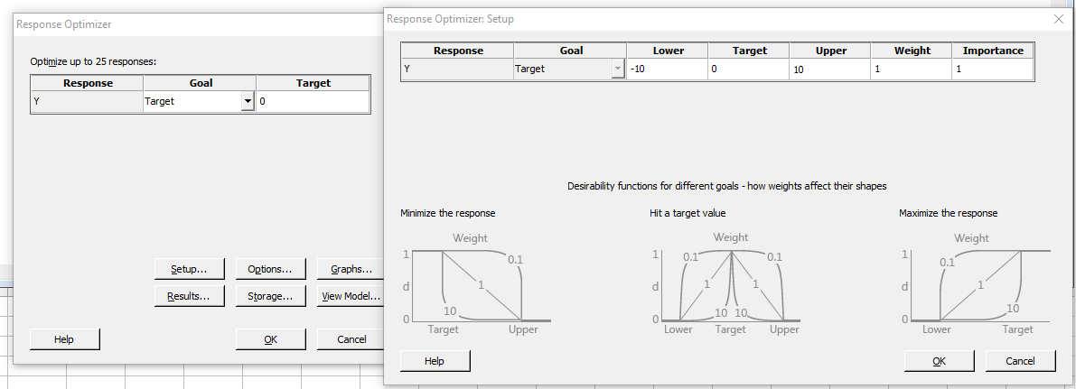

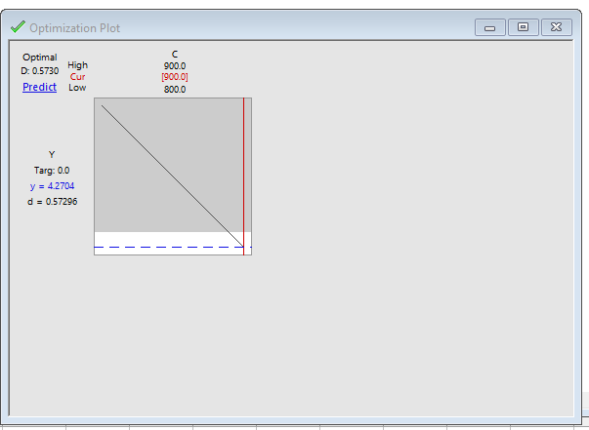

when C = 900

Y would be 4.27

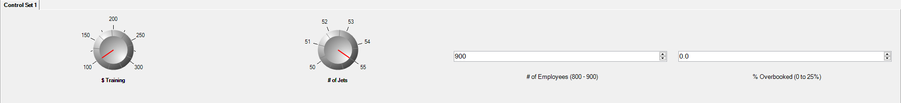

for 100 data, we have

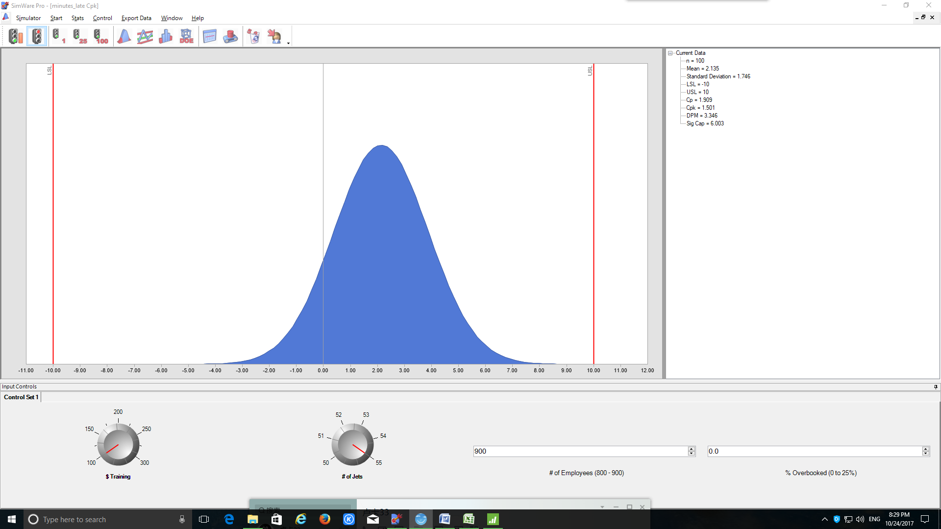

mean=2.135

standard deviation=1.746

for 25 data

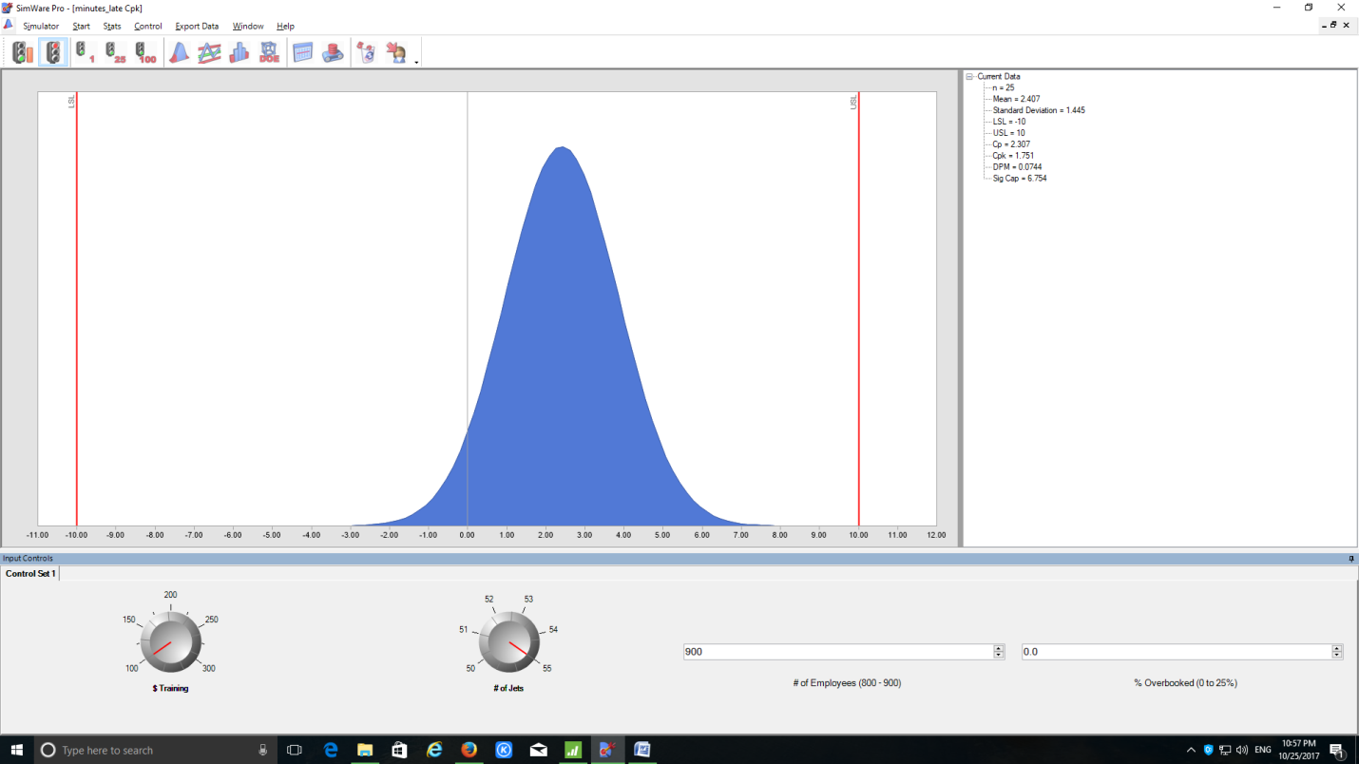

mean = 2.407

standard deviation = 1.445

