DOE generation

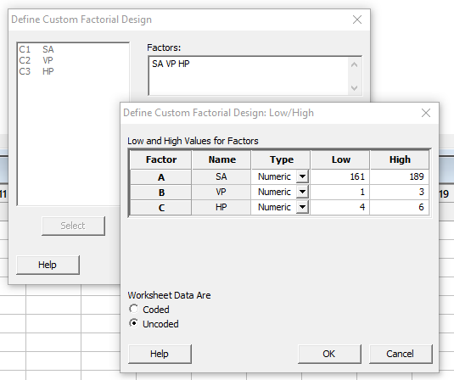

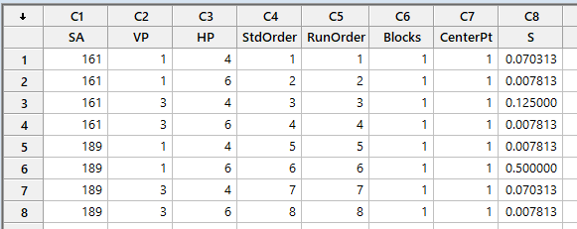

analyze fatorial design for main effects and 2 terms interections

**Factorial Regression: S versus SA, VP, HP**

Analysis of Variance

Source DF Adj SS Adj MS F-Value P-Value

Model 6 0.165131 0.027522 0.88 0.672

Linear 3 0.042969 0.014323 0.46 0.764

SA 1 0.017578 0.017578 0.56 0.590

VP 1 0.017578 0.017578 0.56 0.590

HP 1 0.007812 0.007812 0.25 0.705

2-Way Interactions 3 0.122162 0.040721 1.30 0.554

SA*VP 1 0.029327 0.029327 0.94 0.510

SA*HP 1 0.046417 0.046417 1.49 0.437

VP*HP 1 0.046417 0.046417 1.49 0.437

Error 1 0.031250 0.031250

Total 7 0.196381

Model Summary

S R-sq R-sq(adj) R-sq(pred)

0.176777 84.09% 0.00% 0.00%

Coded Coefficients

Term Effect Coef SE Coef T-Value P-Value VIF

Constant 0.0996 0.0625 1.59 0.357

SA 0.0938 0.0469 0.0625 0.75 0.590 1.00

VP -0.0938 -0.0469 0.0625 -0.75 0.590 1.00

HP 0.0625 0.0313 0.0625 0.50 0.705 1.00

SA*VP -0.1211 -0.0605 0.0625 -0.97 0.510 1.00

SA*HP 0.1523 0.0762 0.0625 1.22 0.437 1.00

VP*HP -0.1523 -0.0762 0.0625 -1.22 0.437 1.00

Regression Equation in Uncoded Units

S = 1.94 - 0.0152 SA + 1.091 VP - 0.769 HP - 0.00432 SA*VP + 0.00544 SA*HP - 0.0762 VP*HP

Alias Structure

Factor Name

A SA

B VP

C HP

Aliases

I

A

B

C

AB

AC

BC

all p-values of the terms are large, none of the variables affects variation.

determine model for response vairable

data we have

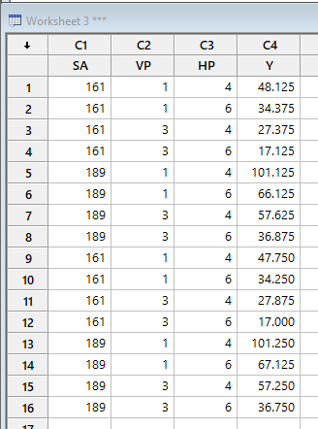

full factorial design for all main effects and their interections

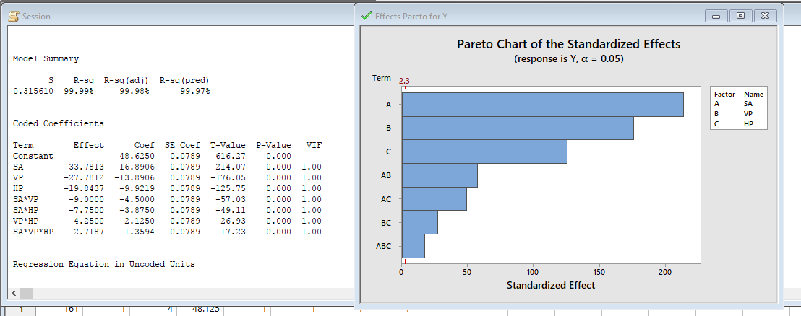

all p-values are 0, means all terms are significant. In this case, we don't reduce the model