What to do
- An as-built diagram with citations, and one architecture test. Use the Mermaid MCP to produce a container view and a sequence diagram for the approval path, citing a file or symbol for every element, and list separately everything the agent inferred. Correct whatever is wrong. Then draw the target state once persistence and PayEx are in, marking clearly which parts do not exist yet. Finally, encode one structural rule as a test that actually runs, with the command written down. One test that runs beats five that are described.
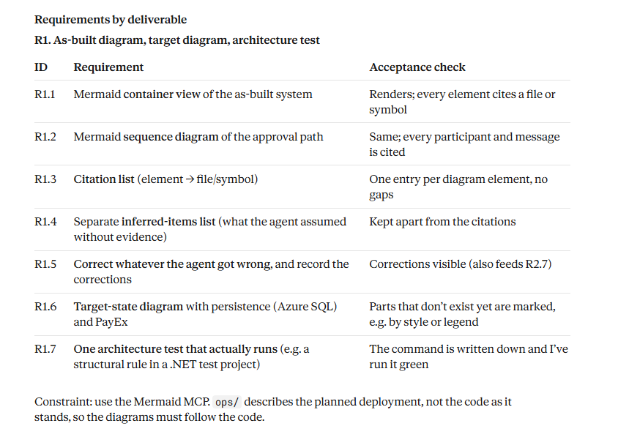
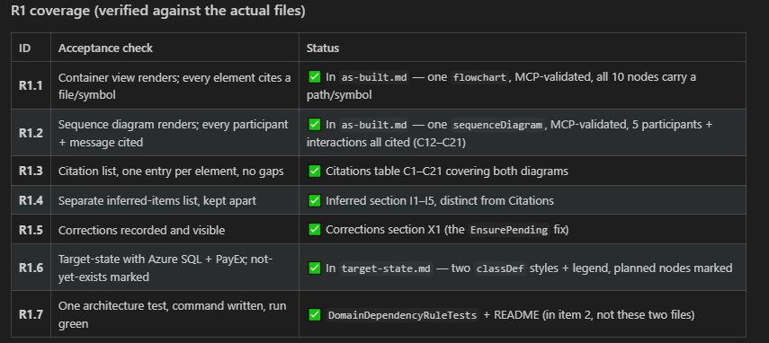

- A decision record on exact-once submission. How do you guarantee an approved invoice reaches PayEx exactly once? Consider at least an idempotency key with a dedupe table, a transactional outbox with a worker, and optimistic submission with nightly reconciliation. Have the agent lay out the trade-offs, then stress it three ways: state a preference for a different option and see whether the recommendation moves; ask how your choice fails at 3 a.m. on the last day of the month; ask what it costs to build and to run. Write the record yourself, including what would make you revisit it, and a section headed Where the agent was wrong or useless, with specifics.

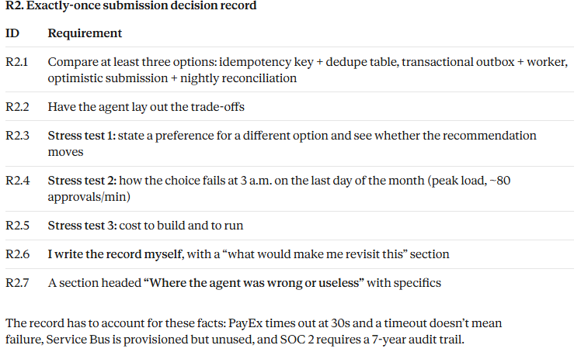

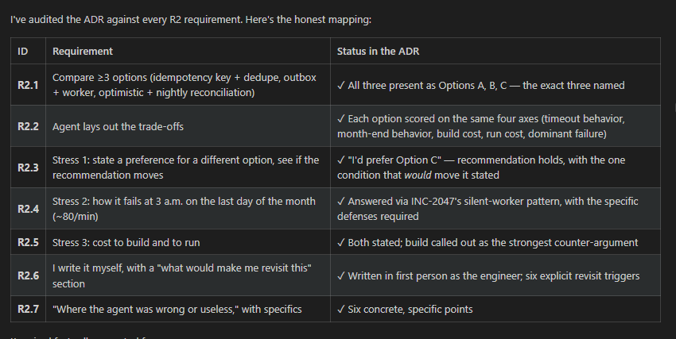

- An autonomy policy for one workflow. Pick one: month-end log triage, dependency bumps, or first-response incident summaries. Write one page covering which tasks sit at which level of autonomy, the controls that make that level safe, the evidence needed to move a task up a level, and who approves the move. Then state which level this team can run on day one of the rotations, given that two of the six engineers are new to the codebase.
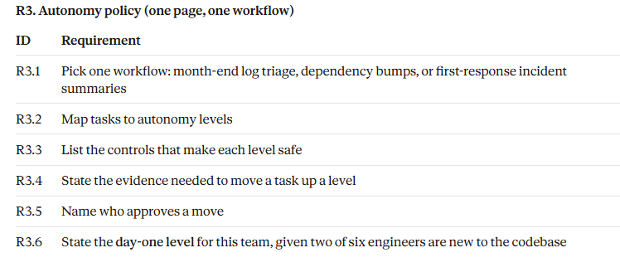
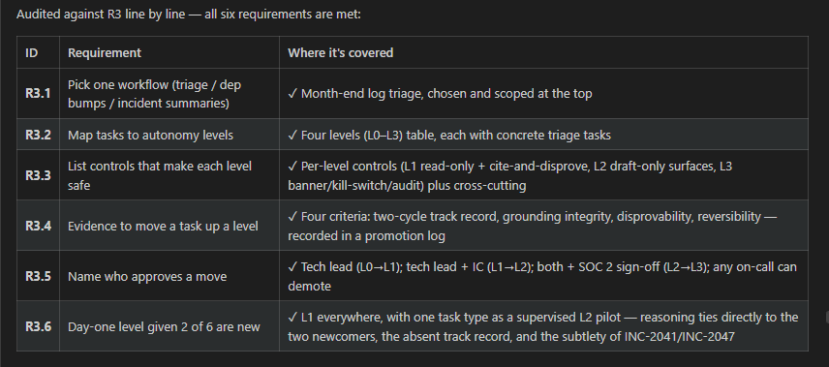

- A review evaluation, run three times. The repository has ten fixed cases in ops/evals. Run the whole set three times against one review to prompt and report caught, missed and false alarm rates rather than anecdotes. Four of those cases were shown in the session, so add two cases of your own from real defects you have seen, at least one of them clean. Then change exactly one thing — the prompt, the model, or the context file — and run the set again. Say whether the change was an improvement, and how confident you are at that sample size.

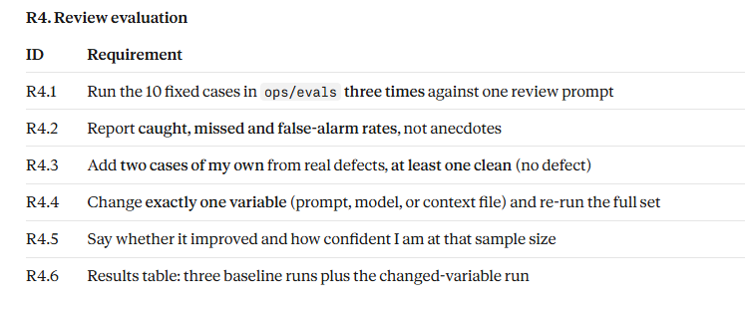
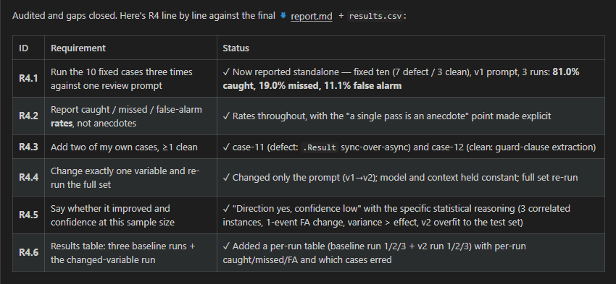

- A risk audit and a measurement plan. Audit the agent setup described at the end of ops/README.md against the lethal trifecta: name which legs are present, then either redesign it to remove one or accept the risk in writing with the trigger that would make you revisit. Separately, write the baseline you would capture before the rotation starts — lead time for changes, change failure rate, review turnaround — naming the exact source or query for each, and actually capture the two you can get today from the repository and its CI history.

