

VULNTRACK VAPT VULNERABILITY MANAGEMENT
AND RISK PRIORITIZATION SYSTEM
A REPORT
submitted by
MADHUMITHA R (MADHUMITHA RAMASAMY)
REGISTER NO.: 24BCE1231
in partial fulfilment for the award
of
B. Tech. Computer Science and Engineering
School of Computer Science and Engineering
Vellore Institute of Technology
Chennai Campus, Chennai
Industry Internship at FutureCalls
11 May 2026 – 26 June 2026
October 2026
Implementation revision 15 October 2026

DECLARATION
I hereby declare that the project entitled “VulnTrack: VAPT Vulnerability Management and Risk Prioritization System” submitted by me to the School of Computer Science and Engineering, Vellore Institute of Technology, Chennai Campus, in partial fulfilment of the requirements for the award of the degree of Bachelor of Technology – Computer Science and Engineering, is a record of work carried out by me during my industry internship at FutureCalls. I further declare that this report has not been submitted, either in part or in full, for the award of any other degree or diploma of this or any other institute or university.
Signature: __________________________
Madhumitha R (Madhumitha Ramasamy)
Register No.: 24BCE1231

CERTIFICATE
The project report entitled “VulnTrack: VAPT Vulnerability Management and Risk Prioritization System” is prepared and submitted by Madhumitha R (Madhumitha Ramasamy), Register No. 24BCE1231. The report is submitted in partial fulfilment of the requirements for the award of the degree of Bachelor of Technology – Computer Science and Engineering at Vellore Institute of Technology, Chennai, India.
Examined by:
Examiner I | Examiner II
Signature: __________________ | Signature: __________________

INDUSTRY CERTIFICATE
Attach the original internship completion certificate issued by FutureCalls before academic submission.

ACKNOWLEDGEMENT
I express my sincere gratitude to Dr. J. Prassanna, Head of the Department, B.Tech. Computer Science and Engineering, Vellore Institute of Technology, Chennai, for the academic leadership and support provided to students.
I am thankful to Dr. Viswanathan V, Dean, School of Computer Science and Engineering, Vellore Institute of Technology, Chennai, and to Dr. Nithyanandam P, Dr. Suganya G, and Dr. Sweetlin Hemalatha C, Associate Deans of the School, for their contribution to the academic environment in which this work was completed.
I would like to express my sincere thanks to FutureCalls for providing me with an opportunity to learn cybersecurity fundamentals, web application security testing, vulnerability assessment, and reporting. I am particularly grateful to the team members who guided me through the development of VulnTrack and explained the practical challenge of managing scan results from multiple customers. Their training sessions and technical guidance helped me connect theoretical concepts with an applied software solution.
I also thank the trainers and organizers of the online cybersecurity session conducted by Infosys and the cybersecurity training session conducted by FutureCalls for a larger group of participants. Finally, I thank my parents, faculty members, and peers for their encouragement and support.

CONTENTS
Section | Page
Declaration | 2
Certificate | 3
Industry Certificate | 4
Acknowledgement | 5
List of Tables | 7
List of Figures | 8
List of Abbreviations | 9
Abstract | 10
Chapter 1 – Introduction | 11
Chapter 2 – Internship Overview and Requirement Analysis | 13
Chapter 3 – System Analysis and Technology Stack | 15
Chapter 4 – System Design and Implementation | 17
Chapter 5 – Testing, Results and Discussion | 25
Chapter 6 – Internship Learning and Conclusion | 28
References | 30
Appendix I – Internship Day-to-Day Activities | 31
Appendix II – Test Summary and Demonstration Data | 33
Appendix III Code Reference and Deployment | 35
Page numbers refer to this implementation revision.

LIST OF TABLES
Table | Title
Table 1 | Functional requirements
Table 2 | Technology stack and code role
Table 3 | Risk scoring priority bands
Table 4 | Automated verification summary
Table 5 | Acceptance criteria
Table 6 | Historical internship activity log
Table 7 | Code module reference
Table 8 | Persistent model reference
Table 9 | Route groups
Table 10 | Railway deployment variables

LIST OF FIGURES
Figure 4.1 High level architecture of VulnTrack
Figure 4.2 Dashboard with synthetic demonstration data
Figure 4.3 Guided finding intake with three choices
Figure 4.4 Excel upload validation preview
Figure 4.5 Saved report generation and history

LIST OF ABBREVIATIONS
Abbreviation | Expansion
API | Application Programming Interface
CSRF | Cross-Site Request Forgery
CWE | Common Weakness Enumeration
CRUD | Create, Read, Update, Delete
CSS | Cascading Style Sheets
HTML | HyperText Markup Language
HTTP | Hypertext Transfer Protocol
JSON | JavaScript Object Notation
OWASP | Open Worldwide Application Security Project
PDF | Portable Document Format
SQL | Structured Query Language
VAPT | Vulnerability Assessment and Penetration Testing
WSTG | Web Security Testing Guide
XSS | Cross-Site Scripting
XML | Extensible Markup Language
ZAP | Zed Attack Proxy

ABSTRACT
VulnTrack centralizes authorized vulnerability assessment work from intake through remediation and reporting. The implemented web application provides three focused ways to add findings: an automatic website check using the free ZAP engine, a validated Excel or scanner-report upload, and manual entry. These paths converge on a common review list with risk scores, suggested OWASP Top 10 2025 categories, evidence, and duplicate links. The interface follows Scope, Add findings, Review issues, Track fixes, and Reports. Flask, SQLAlchemy, Flask-Login, Flask-WTF, Jinja2, Bootstrap, Chart.js, ReportLab, and openpyxl implement the application. SQLite stores users, assessments, findings, scan jobs, audit events, and generated report snapshots. Administrators manage accounts and review scan authorization; testers operate on their own assessments. Default scanning records one unauthenticated public response and analyzes it with built-in checks and ZAP passive rules. Optional reflected XSS and SQL injection tests require a separate administrator approval and explicit per-run selection. Destination validation and a pinned-address gateway constrain scanner traffic. Excel uploads use a downloadable template, row validation, a private preview, and atomic confirmation. Reports are saved as immutable PDF or Excel snapshots behind authenticated downloads. The custom risk formula weights severity, exploitability, business impact, and exposure at 40, 25, 25, and 10 percent. Verification on 15 October 2026 completed 69 regression tests with one opt-in integration test skipped; the real-ZAP integration had also passed separately against a disposable local fixture. These results demonstrate the tested prototype workflows and do not establish exhaustive vulnerability detection or production security certification. This revision documents the current code and a prepared Railway container deployment, while retaining the original internship activity record.

CHAPTER 1: INTRODUCTION

1.1 Background
Web application security testing is an important activity in identifying weaknesses that may affect confidentiality, integrity, availability, and business operations. Security teams use automated scanners such as OWASP ZAP and manual testing tools such as Burp Suite to examine applications and collect evidence of potential vulnerabilities. The output of these tools can differ in structure, terminology, severity labels, and level of detail. A team responsible for assessments for multiple customers therefore needs a dependable way to organize findings and preserve their assessment context.

1.2 Internship Context
The internship was undertaken at FutureCalls from 11 May 2026 to 26 June 2026. The training began with cybersecurity fundamentals, OWASP Top 10 concepts, web application testing with ZAP, vulnerability report preparation, networking and firewall fundamentals, Active Directory, authentication and authorization, password security, SQL injection, cross-site scripting, Burp Suite, session handling, Linux commands, and vulnerability assessment and penetration testing (VAPT). Training also included an online cybersecurity session conducted by Infosys and a separate session delivered by FutureCalls to a larger group.
During the internship, FutureCalls described a practical product-related challenge: scan results associated with different customers needed to be maintained in a more centralized and consistent manner. The requested application needed to support both scan-result ingestion and manual entry or upload of results already obtained by testers. VulnTrack was developed in response to this requirement, using synthetic demonstration data rather than actual customer scan records.

1.3 Problem Statement
When vulnerability findings are stored in separate scanner exports, spreadsheets, and manual notes, assessment teams may have difficulty consolidating records, avoiding duplicate tracking, assigning consistent priorities, recording remediation decisions, and comparing an initial assessment with a retest. The project therefore addresses the need for a centralized application that can organize findings from different sources and produce traceable risk and reporting outputs.

1.4 Objectives
- Provide a centralized repository for vulnerability findings grouped by assessment and scope.
- Support low-impact automatic ZAP checks, validated Excel/CSV and ZAP JSON/XML uploads, and manual entry through three separate intake choices.
- Calculate an explainable risk score using severity, exploitability, business impact, and exposure.
- Suggest OWASP Top 10:2025 categories and allow assessor review and correction.
- Identify likely duplicate findings without deleting records automatically.
- Track remediation status, retest outcomes, and accepted-risk justifications.
- Compare baseline and retest assessments and save downloadable PDF and Excel report snapshots for the assessment owner.
- Apply baseline application security controls, including CSRF protection, password hashing, input sanitization, file-size limits, and audit logging.

1.5 Scope and Boundaries
The implemented scope covers authenticated assessment management, three intake paths, risk prioritization, classification suggestions, duplicate review, remediation, retest comparison, reporting, and audit events. Synthetic demonstration data is separate from real assessment records. The scanner checks the selected public URL without broad crawling or authentication. Its optional active profile contains only reflected XSS and SQL injection rules and is restricted to an approved scope. Human review remains necessary for scanner observations and business-logic testing.

1.6 Organization of the Report
Chapters 2 and 3 describe the requirement and verified code structure. Chapter 4 explains the workflow, security controls, scanner, imports, persistence, and reports. Chapter 5 records current verification evidence. Chapter 6 distinguishes completed work from future improvements. Appendix I retains the historical activity log, Appendix II summarizes current verification, and Appendix III maps the code and explains Railway deployment.

CHAPTER 2: INTERNSHIP OVERVIEW AND REQUIREMENT ANALYSIS

2.1 Organization and Internship Overview
The internship was undertaken at FutureCalls Technology Private Limited, an active company registered in India under CIN U74999TN1997PTC039051. During the internship, the organization provided training in cybersecurity fundamentals, web application security testing, vulnerability assessment, and penetration testing. The internship project involved developing VulnTrack, a web-based application intended to centralize vulnerability findings from different customer assessments and support both scan-report imports and manual entry.
Company Name | FutureCalls Technology Private Limited
CIN | U74999TN1997PTC039051
Company Status | Active
FutureCalls provided cybersecurity training and project guidance during the internship. The learning activities progressed from foundational concepts to practical assessment tools and report preparation. The student also attended an online cybersecurity training session conducted by Infosys and a group training session conducted directly by FutureCalls. Organization-specific descriptions beyond the information provided for this report have not been assumed.

2.2 Existing Workflow and Identified Need
The implementation separates finding intake into Scan a website, Upload a report, and Add manually. All three feed a shared assessment repository. Upload a report accepts the standard Excel template, CSV, and exported ZAP JSON/XML; manual entry supports findings obtained through authorized tools such as Burp Suite. Burp Suite has no direct API integration in this version.

2.3 Functional Requirements
ID | Requirement | Implemented behavior
FR-01 | Authentication and ownership | Admin/tester roles, enabled accounts, login throttling, password/session management, owner-scoped records.
FR-02 | Assessments | Scope, target, authorization, ownership, baseline/retest link, scan approvals, guarded deletion.
FR-03 | Three intake choices | Default passive ZAP, approved optional active tests, Excel/CSV/ZAP uploads, and manual findings.
FR-04 | Review and repository | Search, filters, sorting, evidence, source, confidence, classification, and duplicate review.
FR-05 | Explainable risk | Validated 0-100 inputs, 40/25/25/10 weighting, visible contribution breakdown.
FR-06 | OWASP suggestions | Reviewable CWE/keyword heuristics across the 2025 taxonomy.
FR-07 | Duplicate detection | SHA-256 normalized fingerprint with reviewer-controlled duplicate links.
FR-08 | Remediation | Six states, contact label, retest sign-off, justification, preserved accepted risk.
FR-09 | Comparison | Baseline/retest fingerprint groups and safe count/open-risk deltas.
FR-10 | Reports and audit | Saved PDF/Excel snapshots with hash and authenticated download; key action events.
FR-11 | Upload confirmation | Owner-private preview, whole-file validation, atomic confirm, expiry, formula/macro rejection.
FR-12 | Queue and deployment | Queued/running/completed/failed/cancelled states, progress polling, Docker and Railway configuration.

2.4 Non-Functional Requirements
- Security: protect forms against CSRF, hash passwords, validate input, and sanitize imported evidence.
- Traceability: preserve assessment context and log important actions.
- Usability: provide a responsive interface, filters, status indicators, and clear risk explanations.
- Maintainability: separate routes, data models, and service logic into modules.
- Reliability: handle malformed import files and zero-baseline comparisons safely.
- Report quality: produce readable PDF and Excel outputs with assessment context, risk details, and saved version history.

2.5 Assumptions and Constraints
The local implementation uses SQLite and a single scan worker. Customer names organize assessments; access is enforced per owner with administrator oversight, rather than through shared organization memberships. The heuristic OWASP mapping and custom risk score need assessor review. The default scan is low impact but still makes a request to an approved public website. The prepared Railway deployment keeps SQLite on a persistent volume and requires hosted validation before operational use.

CHAPTER 3: SYSTEM ANALYSIS AND TECHNOLOGY STACK

3.1 System Overview
VulnTrack is a Flask-based web application organized around assessment records and vulnerability findings. Its design separates presentation routes from independent service engines. This makes it possible to test risk calculation, OWASP mapping, deduplication, import parsing, comparison, and report generation independently from the user interface.

3.2 Technology Stack
Technology | Code role | Purpose
Python 3.11+ and Flask | app.py; application factory and views.py | Web requests, configuration, CLI commands, worker execution.
SQLAlchemy and SQLite | models.py; extensions.py | Persistent users, assessments, findings, scan jobs, reports, and audit records.
Flask-Login; Werkzeug | Session loader; User model | Authentication, scrypt hashing, session revocation.
Flask-WTF and WTForms | forms.py | Server-side validation and CSRF-protected mutations.
Jinja2 and Bootstrap 5.3.8 | templates/; static/vendor/ | Responsive five-step UI with focused intake pages.
Chart.js 4.5.1 | dashboard.js and vendored script | Severity, status, category, and priority summaries.
Beautiful Soup; defusedxml | intake.py; scanner.py | Text sanitization, HTML observations, safer XML parsing.
openpyxl | spreadsheet_import.py; reports.py | Standard XLSX template, workbook validation, Excel exports.
ReportLab | reports.py | PDF assessment reports generated from saved snapshots.
ZAP 2.17.0 and Java 17+ | zap_engine.py; scan_gateway.py | Real passive analysis and restricted optional active checks.
pytest | tests/ | 69 passing regression checks and opt-in real engine integration.
Waitress; Docker; Railway | Dockerfile; railway.toml; launcher | Prepared hosted web and worker runtime with persistent storage.

3.3 Application Structure
The application is organized into the following major components:
- app.py and vulntrack/__init__.py: application entrypoint, environment configuration, security headers, session loading, and administrative/worker CLI commands.
- vulntrack/models.py, forms.py, and extensions.py: nine database models, validated forms, SQLAlchemy, CSRF, and login integration.
- vulntrack/views.py: a blueprint containing authentication, scoped queries, assessments, finding intake, reports, remediation, comparisons, and administrator routes.
- vulntrack/services/: independent modules for ingestion, spreadsheet validation, risk, comparison, reports, scanner orchestration, ZAP, active-scan authorization, network gateway, and synthetic data.
- vulntrack/templates/ and static/: server-rendered workflow pages, responsive styles, Chart.js dashboard behavior, progress polling, and vendored frontend libraries.
- tests/: service, route, ownership, import, reporting, and scanner tests. Dockerfile, railway.toml, and deploy/railway_start.py provide the prepared hosted runtime.

3.4 Data Model
Nine SQLAlchemy models implement persistence. User holds identity, role, password hash, enabled state, and session token. Assessment owns scope and approval context. Finding stores evidence, classification, risk, duplicate links, and remediation state. AuditLog records actions. Report stores a JSON snapshot, binary output, hash, and generator. ScanJob stores queue state and progress. LoginAttempt persists throttling events. ImportBatch holds a private upload preview. ActiveScanApproval stores the administrator and scope digest for optional active tests. SQLite is the current database; schema migrations are not implemented.

3.5 Security and Standards Alignment
Application controls include scrypt password hashing, CSRF protection, per-record ownership checks, bound ORM queries, escaped templates, sanitized imports, bounded uploads, hardened XML parsing, and authenticated report downloads. The scanner validates public destinations and pins network connections. These controls reduce specific risks; they do not prove that every VAPT vulnerability is prevented. OWASP categories provide a reviewable taxonomy, and the project score is distinct from CVSS.

CHAPTER 4: SYSTEM DESIGN AND IMPLEMENTATION

4.1 High-Level Architecture
An authenticated user creates an assessment and authorized scope, then selects one of three intake methods. Uploads and scan observations pass through normalization, risk scoring, OWASP suggestion, and duplicate fingerprinting before findings are stored. The UI presents review, remediation, comparison, and saved reports. A durable database queue separates scanning from HTTP requests. Railway packaging runs the web server and one worker in a single service attached to the persistent application volume.
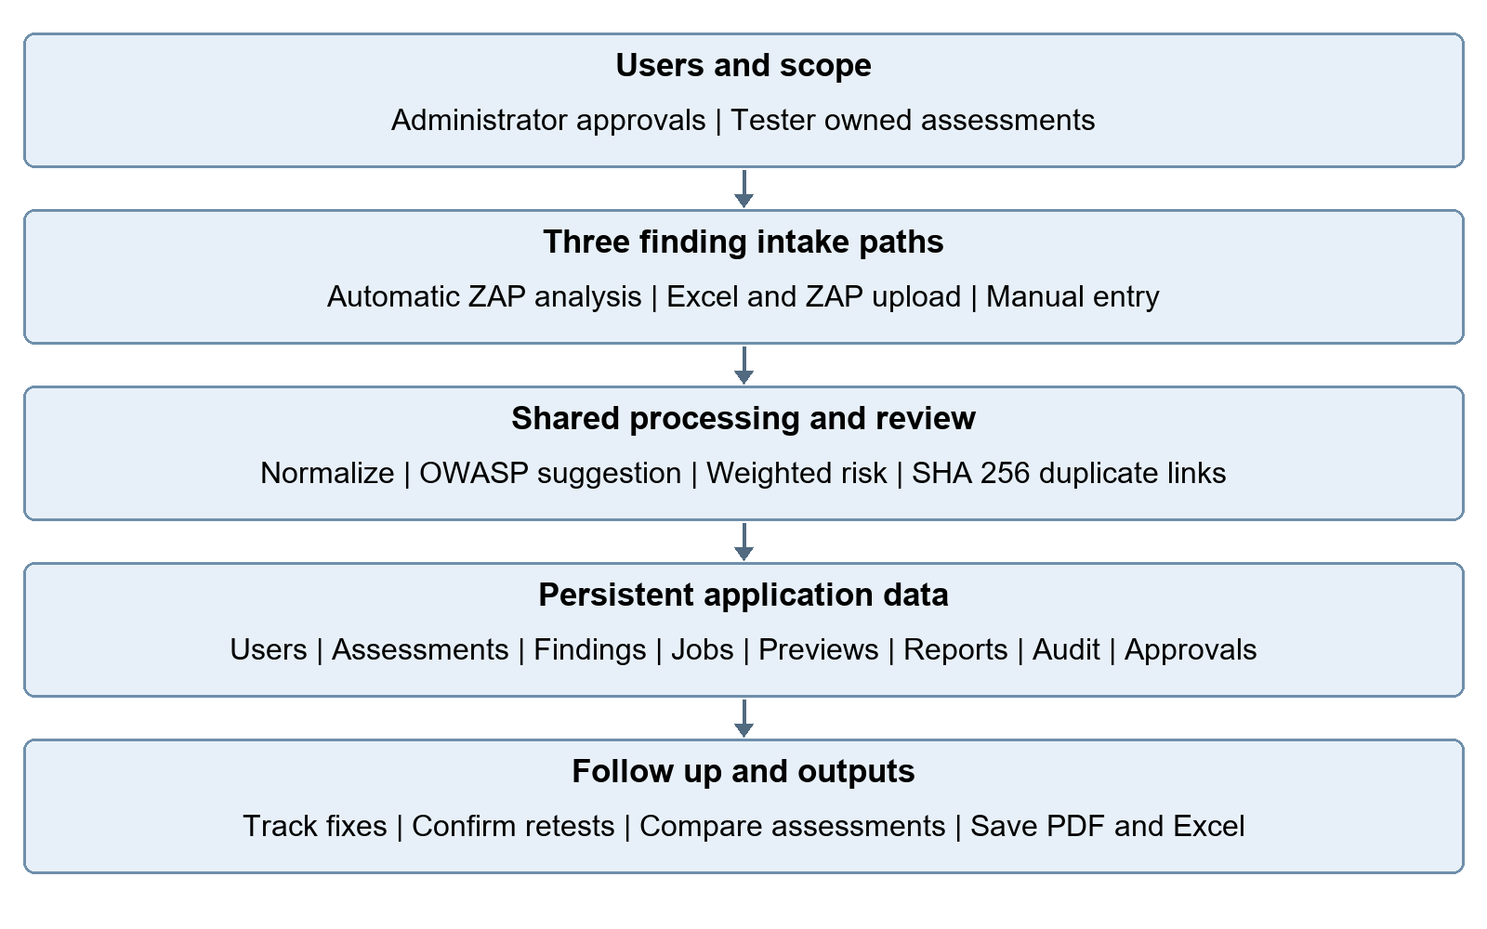
Figure 4.1 High level architecture of VulnTrack
Assessment owner and administrator authorization
Three choices: Scan a website | Upload a report | Add manually
Validate and normalize > OWASP suggestion > Risk score > Fingerprint review
SQLite: identity, scope, findings, queue, previews, reports, approvals, audit
Review issues > Track fixes > Compare retests > Generate saved PDF or Excel
The following flow summarizes the shared processing and review path.

4.2 Assessment and Finding Lifecycle
- Create an assessment with customer/project label, target URL, scope/exclusions, and authorization reference.
- Choose Scan a website, Upload a report, or Add manually from the Add findings page.
- For an upload, review its private preview and resolve all row errors before confirmation. For a scan, review approval, progress, and completion.
- Review title, affected URL, evidence, confidence, severity, weighted risk components, OWASP suggestion, and potential duplicates.
- Confirm the classification and business context, then prioritize findings for remediation.
- Assign a remediation contact, update status, and record retest evidence or justification for accepted risk/false positive.
- Compare linked baseline and retest assessments, then generate and save PDF or Excel reports from the Reports step.

4.3 Explainable Risk Prioritization
VulnTrack uses a deterministic weighted formula to create a project-specific risk score on a 0–100 scale:
Risk Score = (Severity × 0.40) + (Exploitability × 0.25) + (Business Impact × 0.25) + (Exposure × 0.10)
Severity contributes 40 percent, exploitability 25 percent, business impact 25 percent, and exposure 10 percent. Severity presets are Critical 100, High 80, Medium 55, Low 30, and Informational 10. The other inputs are validated integer values from 0 to 100; imported and automated findings initially use 50, 50, and 75 for exploitability, business impact, and exposure. Assessors can replace these defaults.
Risk score | Priority band
80–100 | Critical Priority
60–79.99 | High Priority
40–59.99 | Medium Priority
0–39.99 | Low Priority
Each finding view exposes the component values and calculation trace. This improves transparency and allows a reviewer to understand why one issue is ranked above another. The formula is a custom project model; it is not a replacement for CVSS or a formal business risk assessment.

4.4 OWASP Top 10:2025 Mapping
The mapping service supports the A01:2025 through A10:2025 taxonomy and uses rule-based heuristics, including CWE identifiers and regular-expression keyword matching. The result is a suggested classification. Because the title or evidence of a finding may be ambiguous, the tester can review and override the suggestion. This human-review step is important to avoid treating a heuristic match as a confirmed security conclusion.

4.5 Duplicate Fingerprinting
The SHA-256 fingerprint covers normalized title, URL, HTTP method, parameter, and CWE. Scheme and hostname are lowercased, default ports and URL fragments are removed, and query pairs are sorted. Path case and trailing slashes are preserved because they can identify different resources. Duplicate candidates are linked within an assessment and can be dismissed by a reviewer; records are not silently deleted.

4.6 Validated Uploads and Manual Entry
The upload service accepts .xlsx, .csv, .json, and .xml. A standard Excel template contains Findings and Instructions worksheets; Title and Severity are required, and a blank URL uses the assessment target. Optional columns include evidence, remediation, method, parameter, CWE, category, and risk inputs. Common header aliases are recognized. ZAP JSON/XML uses a separate parser with defusedxml for XML. Every upload creates an owner-private ImportBatch preview with valid rows, errors, warnings, and duplicate indications. Confirmation requires zero errors and atomically claims the batch before saving findings. A repeat submission cannot import the same preview twice. Pending previews expire after 30 minutes and their temporary rows are cleared by the worker. Formula cells, macro contents, invalid risk values, and oversized workbooks are rejected; limits are 16 MB uploaded, 32 MB expanded ZIP, 2,000 rows, and 80 columns. Manual entry shows essential fields first, with classification and risk controls expandable.

4.7 Dashboard and Reporting
The dashboard provides six summary cards: total assessments, total findings, open findings, critical and high-priority findings, remediated findings, and findings pending retest. Four charts summarize severity, OWASP categories, remediation status, and risk-priority distribution. A scope filter supports global or assessment-specific views.
ReportLab builds PDF reports and openpyxl builds Excel workbooks. Generation creates a Report record containing the assessment snapshot, generated binary, format, filename, generating user, timestamp, and SHA-256. Later finding edits do not change older reports. Downloads require access to the associated assessment. Excel output writes untrusted text as explicit text cells, including formula-like values. Reports are generated synchronously and capped at 500 findings; large volumes require a different reporting architecture.

4.8 Remediation and Before-and-After Comparison
The remediation states are Open, In progress, Ready for retest, Remediated, Accepted risk, and False positive. Marking a finding remediated requires explicit retest confirmation and notes; accepted risks and false positives require justification. Accepted risks remain part of open risk. The assignee is a recorded contact label, not a delegated permission grant. A retest assessment links to its baseline. Comparison groups fingerprints as remediated, persisting, new, and not observed, and calculates count/risk changes with safe zero-baseline handling. Not observed is not automatically treated as fixed.

4.9 Application Security Controls
- Flask-WTF CSRF tokens protect state-changing forms; input is validated on the server.
- Werkzeug scrypt hashes passwords; changing a password or disabling a user invalidates existing sessions.
- SQLAlchemy binds query values; owner-scoped queries protect reads and mutations, with administrator access checks.
- Uploads are size bounded; Excel formula/macro content and unsafe XML entities are rejected before import confirmation.
- Jinja escapes displayed values, imported HTML is reduced to text, and CSP restricts scripts, framing, objects, and form destinations.
- Audit events record key operations. Reports remain behind authenticated downloads with saved snapshots and SHA-256 hashes.
- Login failures are limited to ten per source IP in ten minutes. Sessions use HttpOnly, SameSite=Lax, a 60-minute lifetime, and Secure cookies for HTTPS deployments.

4.10 Guided User Interface
The assessment navigation is Scope, Add findings, Review issues, Track fixes, and Reports. Assessment creation leads directly to the three-choice intake page. The sidebar keeps Overview, Assessments, Findings, Remediation, and Reports prominent; scan history, retest comparison, and administration sit in expandable groups. Finding filters and manual classification/risk fields are collapsed until needed. Scan progress polls an authenticated status endpoint every 2.5 seconds and exposes review, retry, or cancellation actions according to state.

4.11 Default Automatic Website Analysis
scanner.py validates the target, fetches one unauthenticated response through a pinned connection, and applies built-in header, cookie, and HTML checks. zap_engine.py starts an isolated, headless ZAP process, records responses as HAR, and calls the HAR importer with sendRequests=false. Passive ZAP analysis therefore inspects captured traffic without replaying it. The loopback API uses a random per-job key. Silent mode disables update/telemetry traffic, and the process, session, HAR, and temporary working directory are cleaned up after the job.
Targets must use HTTP or HTTPS on ports 80/443 without embedded credentials. Every resolved address must be public. The client preserves certificate verification and SNI, ignores environment proxies, caps response size at 1 MB, and follows at most three same-origin redirects. Private, loopback, metadata, link-local, multicast, and transition addresses are rejected. Scanner availability is checked before queueing; missing ZAP is reported rather than presented as a successful scan.

4.12 Optional Active SQLi and XSS Tests
An administrator must separately acknowledge active testing. ActiveScanApproval binds that approval to the exact target, scope, and authorization reference through SHA-256; it expires after seven days and becomes invalid if the approving administrator is disabled. The user must opt in on each run, and the worker revalidates approval at execution. A general scan approval alone does not enable attack payloads.
The active profile enables only ZAP rule 40012 for reflected XSS and 40018 for SQL injection, at LOW attack strength and MEDIUM alert threshold. It uses one thread, a 250 ms delay, one-minute scan/rule limits, Protected mode, and a context for the selected endpoint. It does not crawl, log in, discover forms, or submit authenticated workflows. The loopback gateway restricts the approved public origin and pins each outgoing connection to a newly validated public address. Plain HTTP also checks endpoint path and method; HTTPS CONNECT enforces the origin while the ZAP context limits the endpoint. Time, connection, request, response, and transfer budgets are bounded.

4.13 Queue Reliability and Account Administration
ScanJob moves through queued, running, completed, failed, or cancelled states. A partial unique index allows at most one queued/running job per assessment. The worker updates progress stages, honors cancellation, expires old upload previews, and recovers stale jobs as failures. Failed or cancelled jobs do not save partial findings. Default and active stale-job limits differ to allow the engine startup and analysis budgets. OS DNS timing and hard resource isolation still need deployment-level controls.
Administrators create and disable tester accounts and review all assessments; testers access their own records. There is no public signup, MFA, or email recovery. CLI create-admin and reset-password support operator setup/recovery. Password changes rotate the stored authentication token. Assessment deletion requires the current password and exact title and is blocked by active scans or linked retests. Finding deletion also reauthenticates; earlier report snapshots remain available.

4.14 Application Screenshots
The following screenshots were captured from the running application using synthetic demonstration records. They show the dashboard, guided intake, upload preview, and saved report workflow.
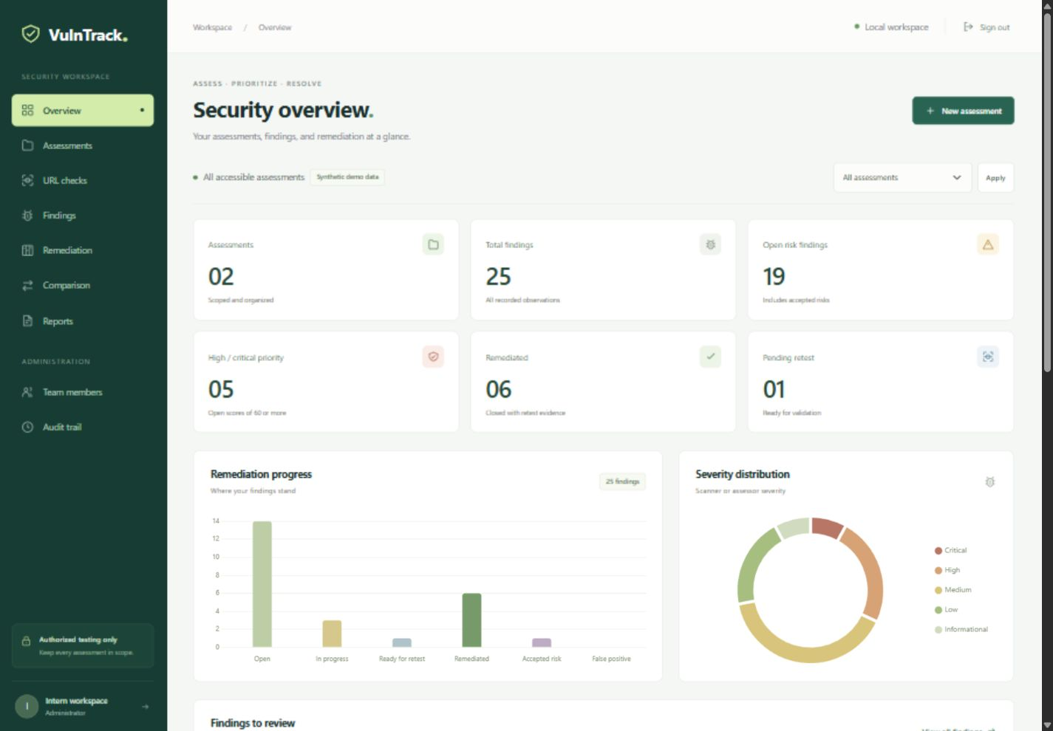
Figure 4.2 Dashboard with synthetic demonstration data
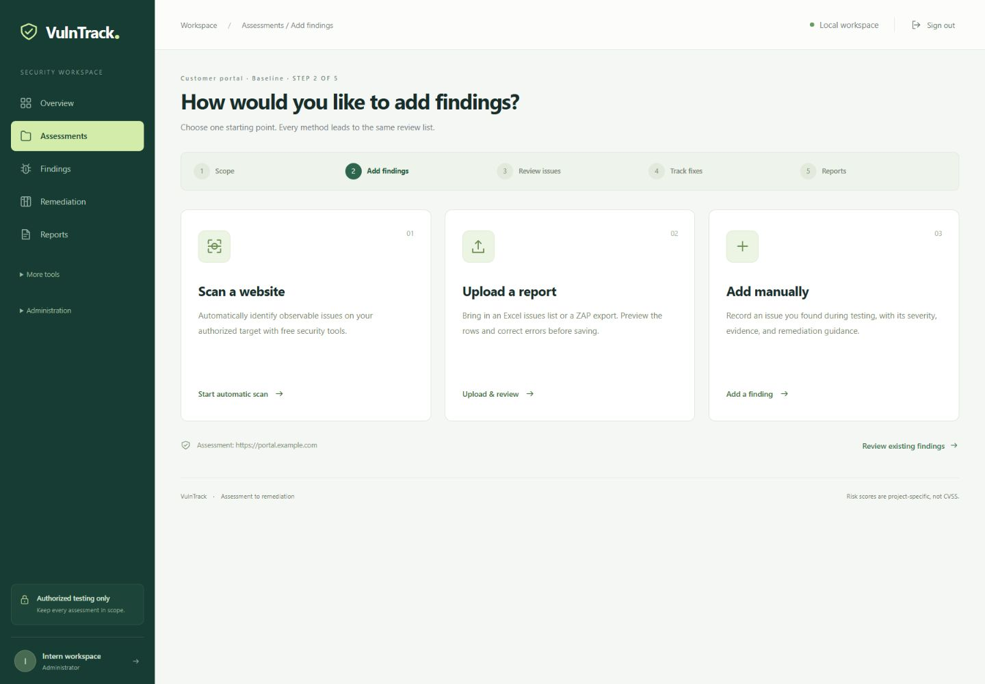
Figure 4.3 Guided finding intake with three choices
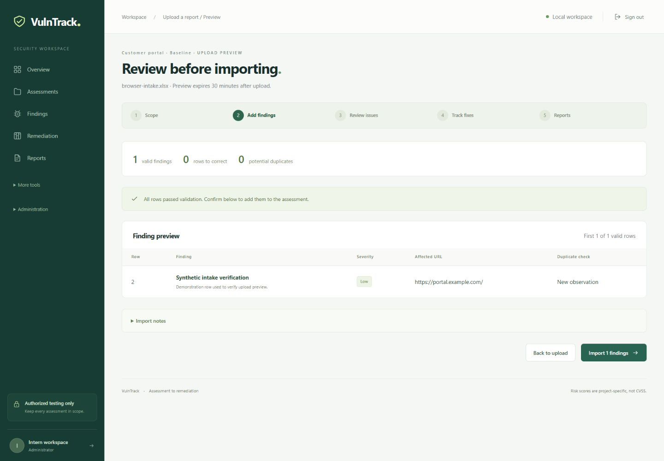
Figure 4.4 Excel upload validation preview
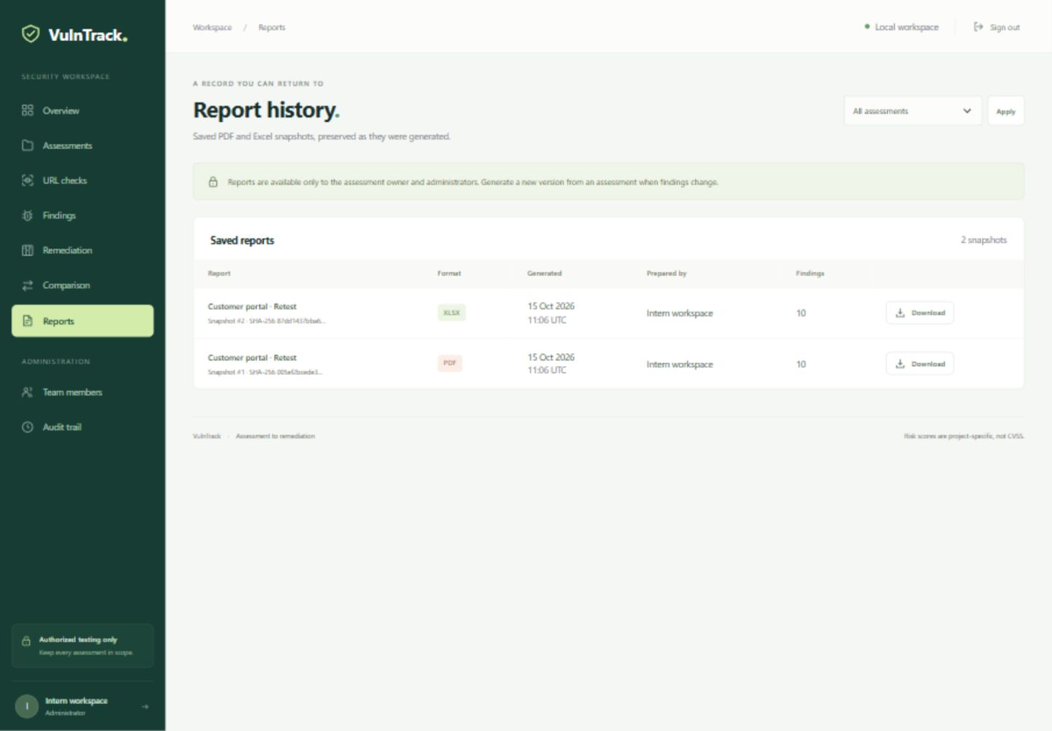
Figure 4.5 Saved report generation and history

CHAPTER 5: TESTING, RESULTS AND DISCUSSION

5.1 Test Strategy
Verification combines pytest service/route regression tests, browser checks of the guided UI, and a separately enabled real-ZAP integration test. The regression suite covers validation, authentication, ownership, session invalidation, assessment and finding lifecycle, imports, risk, comparison, reporting, scanner destination controls, and queue behavior. Scanner unit tests use simulated responses or disposable loopback fixtures, so routine tests do not contact external websites.

5.2 Automated Test Results
Test area | Representative coverage | Result
Identity and permissions | CSRF, owner/admin reads and mutations, disabled users, session revocation, throttling. | Passed
Assessment lifecycle | Creation, edits, retest links, authorization invalidation, guarded deletion. | Passed
Intake and uploads | Excel/CSV and ZAP JSON/XML, validation, unsafe content, private previews, atomic confirmation. | Passed
Risk and duplicates | Weight boundaries, OWASP suggestions, URL normalization, SHA-256 matching. | Passed
Remediation and retests | Evidence requirements, accepted risk, comparison groups and zero-baseline math. | Passed
Report history | PDF/Excel generation, immutable snapshots, ownership, hash and formula-like text. | Passed
Network and queue | SSRF rejection, pinned connections, redirects, cancel/failure, scope approvals. | Passed
Real ZAP integration | Reflected XSS and MySQL SQLi detected on disposable local fixture. | Passed separately
Railway container runtime | Configuration prepared; image build and hosted acceptance not executed. | Pending hosted checks
Regression result on 15 October 2026: 69 passed and 1 skipped in 29.70 seconds.
The skipped test is the opt-in real-ZAP integration test. It passed separately in 29.91 seconds against a disposable local vulnerable fixture and detected reflected XSS and MySQL SQL injection. Test counts refer to the executed suite, not code coverage or a guarantee that all vulnerabilities have been detected.

5.3 Browser and Real Scanner Verification
- Authenticated browser pages displayed the guided five-step workflow and exactly three finding-intake cards.
- An Excel upload produced a private preview with valid/error/duplicate counts; the preview was discarded without saving findings.
- Manual entry kept advanced classification and risk fields collapsed by default.
- A 390-pixel viewport showed no horizontal page overflow in the checked flows.
- Reports exposed format selection, generation, and saved history within the Reports step.
- The checked browser console reported no errors or warnings.
- Real ZAP passive analysis and the opt-in active integration were exercised locally; external customer targets were not tested.
The active integration enabled only ZAP rules 40012 and 40018 against an isolated fixture with test-only destination mapping. Production public-destination restrictions were not relaxed. Docker Compose configurations validate and the Railway launcher compiles; image build, Railway deployment, public HTTPS, and hosted persistence remain destination-host acceptance checks.

5.4 Demonstration Dataset and Scenario
The demo generator creates 25 clearly labelled synthetic findings across a baseline assessment and a linked retest. It demonstrates a mix of fixed, persisting, accepted-risk, new, and not-observed records. Demo setup makes no network scan and does not reset an existing account. These records demonstrate application behavior and are not evidence of a customer security assessment.

5.5 Discussion
All three intake paths converge on a consistent review, prioritization, remediation, and reporting workflow. Current tests verify the implemented sample cases and permission boundaries. The real local ZAP integration confirms that the configured scanner can identify the two exercised active vulnerability classes under fixture conditions. The guided UI reduces competing page actions while retaining advanced controls in expandable sections.
Coverage remains bounded. A selected unauthenticated URL is not a full website assessment. Authenticated paths, access-control decisions, business logic, broad crawling, and other active policies need separate authorized testing. Heuristic mapping and duplicate matching can be wrong. SQLite, synchronous reporting, application-level audit records, and absent schema migrations constrain production operation. Hosted security review, backups, restore exercises, resource monitoring, and representative authorized testing remain required operational work.

5.6 Acceptance Criteria Status
Acceptance criterion | Evidence | Status
Automatic detection | Built-in checks; real passive HAR analysis; real local active fixture integration. | Implemented and locally exercised
Excel report upload | Downloadable template, bounded parser, row preview, atomic confirm. | Implemented and regression tested
Manual entry | Focused form, optional details, shared risk/classification service. | Implemented and regression tested
User separation | Owner-scoped queries and admin checks; session invalidation. | Tested prototype controls
Reports by assessment/user | Snapshot JSON and binary, SHA-256, scoped PDF/Excel download. | Implemented and regression tested
Risk and review | Weighted score, suggestions, duplicate links and retest requirements. | Implemented with human review
Systematic UI | Five-step navigation, three intake cards, responsive browser checks. | Locally verified
Hosted deployment | Docker/Railway files, volume guard, process supervision, deployment guide. | Prepared; hosted acceptance pending

CHAPTER 6: INTERNSHIP LEARNING AND CONCLUSION

6.1 Technical Learning
The internship strengthened my understanding of cybersecurity from foundational concepts to application-level testing. I learned about the CIA triad, common cyber threats, OWASP Top 10 vulnerabilities, networking and firewall fundamentals, Active Directory, authentication and authorization, password policies and hashing, SQL injection, cross-site scripting, cookies and session handling, Linux commands, and the purpose of vulnerability assessment reports. I gained practical exposure to OWASP ZAP and Burp Suite and learned to review alerts, assess severity, and document observations.

6.2 Software Engineering Learning
The current implementation demonstrates modular data models and services, safe spreadsheet parsing, preview/confirmation flows, scoped permissions, scan orchestration, and immutable report snapshots. Its tests connect these controls to observable outcomes. Container packaging also exposes the difference between a request-serving platform and the persistent storage and background execution required by a scanner.

6.3 Professional Learning and Training
The online cybersecurity session conducted by Infosys and the group training conducted by FutureCalls provided additional exposure to cybersecurity topics beyond day-to-day project tasks. The internship also reinforced the value of documenting findings clearly, asking questions when a security result is ambiguous, and distinguishing between a scanner alert and a manually confirmed vulnerability.

6.4 Challenges and How They Were Addressed
- Different intake formats are normalized through separate parsers and a shared finding service; uploads are previewed before commitment.
- Repeated findings: normalized attributes and SHA-256 fingerprints are used to flag likely duplicates without deleting records.
- Risk prioritization: a weighted formula and visible calculation trace make the ranking explainable.
- Ambiguous categories: OWASP mappings are suggestions and can be reviewed or overridden.
- Retest interpretation: comparison labels distinguish remediated, persisting, newly introduced, and not-observed findings.
- Reliability is checked through 69 passing regression tests, browser review, and a separate real-ZAP local integration. Queue failures and cancellations do not save partial findings.

6.5 Conclusion
VulnTrack implements a complete internship-scale workflow for maintaining authorized vulnerability records: authentication and account administration, scoped assessments, automatic checks, validated uploads, manual entry, transparent risk prioritization, OWASP suggestions, duplicate review, remediation, retest comparison, audit events, and PDF/Excel report history.
The verified local implementation satisfies the three requested finding-intake paths and preserves reviewable evidence and reporting history. Railway configuration is prepared for a single service with a persistent SQLite volume and a supervised worker, while actual hosted acceptance remains to be performed. The prototype is a basis for further engineering and independent security assessment rather than a production certification.

6.6 Future Enhancements
- Extend controlled scanning to additional policies and authenticated contexts after designing authorization, scope, isolation, and rate controls.
- Add shared organization memberships, delegated assignments, MFA, and independently tested tenant isolation beyond the current owner/admin model.
- Add reviewed schema migrations, a production database migration path, and larger-format scanner integrations.
- Evaluate prioritization against CVSS data and business-defined risk criteria without mislabeling the custom score.
- Improve duplicate matching with configurable rules and reviewer feedback.
- Add scheduled reports, email notifications, attachment evidence storage, and tested backup/restore automation.
- Conduct independent security testing and measure performance with larger synthetic or explicitly authorized datasets.

REFERENCES
[1] FutureCalls. Internship training notes and original VulnTrack report. 2026.
[2] OWASP. Top 10 2025. https://owasp.org/Top10/
[3] OWASP. Web Security Testing Guide. https://owasp.org/www-project-web-security-testing-guide/
[4] ZAP. Documentation. https://www.zaproxy.org/docs/
[5] PortSwigger. Burp Suite documentation. https://portswigger.net/burp/documentation
[6] Pallets. Flask documentation. https://flask.palletsprojects.com/
[7] ReportLab. Documentation. https://docs.reportlab.com/
[8] Python Software Foundation. Python documentation. https://docs.python.org/3/
[9] pytest. Documentation. https://docs.pytest.org/
[10] OWASP. Cross Site Scripting Prevention Cheat Sheet. https://cheatsheetseries.owasp.org/cheatsheets/Cross_Site_Scripting_Prevention_Cheat_Sheet.html
[11] VulnTrack source code and local verification. Implementation revision 15 October 2026.
[12] Railway. Volumes, healthchecks, configuration, and CLI. https://docs.railway.com/
[13] Docker. Compose deployment and persistent storage. https://docs.docker.com/compose/
[14] Vercel. Flask deployment. https://vercel.com/docs/frameworks/backend/flask

APPENDIX I: INTERNSHIP DAY-TO-DAY ACTIVITIES
The following activity log is transcribed and lightly normalized from the daily activity details supplied for the internship. Dates marked as leave or weekends are retained. The report does not infer activities for dates that were not included in the supplied log.
Date | Activity
11-May-2026 | Company introduction and tour.
12-May-2026 | Started the course on Introduction to Cybersecurity.
13-May-2026 | Learned about the ten vulnerabilities listed under the OWASP Top 10.
14-May-2026 | Learned web application testing using ZAP and how to prepare a report based on testing performed.
15-May-2026 | Leave.
16-May-2026 | Saturday – no internship.
17-May-2026 | Sunday – no internship.
18-May-2026 | Learned computer fundamentals and generations of computers; installed ZAP for security testing.
19-May-2026 | Analyzed scan alerts and documented identified vulnerabilities and severity in a report.
20-May-2026 | Learned about common types of web application vulnerabilities.
21-May-2026 | Performed another URL test using ZAP, reviewed scan results, and prepared a vulnerability assessment report.
22-May-2026 | Continued learning computer fundamentals and basic concepts.
23-May-2026 | Saturday – no internship.
24-May-2026 | Sunday – no internship.
25-May-2026 | Explored domains and career areas within cybersecurity.
26-May-2026 | Studied cybersecurity fundamentals, including the Confidentiality, Integrity, and Availability (CIA) triad.
27-May-2026 | Learned categories of cyber threats and their potential impact on systems and networks.
28-May-2026 | Reviewed OWASP Top 10 vulnerabilities and mapped previously identified web vulnerabilities to relevant categories.
29-May-2026 | Learned networking and firewall fundamentals and the basic methodology for website security testing.
30-May-2026 | Saturday – no internship.
31-May-2026 | Sunday – no internship.
01-Jun-2026 | Learned networking and firewall fundamentals and the methodology for authorized web application security testing.
02-Jun-2026 | Learned computer hardware and Active Directory fundamentals; created and configured a live Active Directory environment.
03-Jun-2026 | Learned authentication and authorization; observed login mechanisms and access control for different users.
04-Jun-2026 | Studied password policies and password hashing; reviewed how hashing supports secure credential storage.
05-Jun-2026 | Reviewed cybersecurity concepts, OWASP vulnerabilities, and secure web practices.
06-Jun-2026 | Saturday – no internship.
07-Jun-2026 | Sunday – no internship.
08-Jun-2026 | Studied firewall rules and configurations, performed a basic configuration assessment, and documented observations.
09-Jun-2026 | Continued firewall assessment by reviewing configuration parameters and identifying potential weaknesses.
10-Jun-2026 | Learned SQL Injection and examined vulnerable input handling in web applications.
11-Jun-2026 | Reviewed SQL Injection examples and analyzed how vulnerable inputs can cause unintended database queries.
12-Jun-2026 | Studied XSS and how malicious scripts can affect vulnerable applications and users.
13-Jun-2026 | Saturday – no internship.
14-Jun-2026 | Sunday – no internship.
15-Jun-2026 | Installed and configured Burp Suite; practiced intercepting and analyzing HTTP requests and responses.
16-Jun-2026 | Tested VAPT vulnerabilities using Burp Suite, including malicious file upload and direct URL access vulnerabilities.
17-Jun-2026 | Analyzed cookies and session tracking; reviewed secure handling of session information.
18-Jun-2026 | Practiced basic Linux commands used in authorized penetration-testing activities.
19-Jun-2026 | Attended training on network security and firewall concepts.
20-Jun-2026 | Saturday – no internship.
21-Jun-2026 | Sunday – no internship.
22-Jun-2026 | Prepared and finalized the Firewall Configuration Assessment Report.
23-Jun-2026 | Performed vulnerability assessment activities, reviewed weaknesses, analyzed impact, and documented findings.
24-Jun-2026 | Reviewed vulnerabilities from previous VAPT testing and their possible impact on web applications.
25-Jun-2026 | Learned about common security misconfigurations and how to identify them during vulnerability assessment.
26-Jun-2026 | Compiled and reviewed the firewall configuration and VAPT reports prepared during the internship.

APPENDIX II: TEST SUMMARY AND DEMONSTRATION DATA

A. Automated verification summary
Current verification on 15 October 2026: 69 passed, 1 skipped, 29.70 seconds. The opt-in test requires ZAP_INTEGRATION=1, Java, and the installed ZAP JAR. It passed separately in 29.91 seconds against a disposable local fixture. Neither result represents code-coverage measurement or production certification.

B. Verified workflow summary
- Authentication, CSRF, owner/admin access, throttling, and session invalidation passed regression checks.
- Assessment CRUD, linked retests, finding edits, duplicate review, and guarded deletion passed tested scenarios.
- Excel/CSV parsing, unsafe workbook rejection, preview ownership, and atomic confirmation passed tested scenarios.
- ZAP JSON/XML parsing, malformed inputs, and XML entity rejection passed tested scenarios.
- Risk boundaries, OWASP suggestions, fingerprint normalization, and comparison calculations passed regression checks.
- Saved PDF/Excel snapshots, authenticated downloads, and Excel formula safety passed regression checks.
- Gateway destination checks, pinned connections, queue cancellation/failure, and optional active-approval checks passed tested scenarios.

C. Demonstration data note
The two assessment records and 25 findings are synthetic demonstration data. The described baseline and retest scenario is included to demonstrate how the application represents finding status and risk change. It does not represent a real security assessment of a customer system.

D. Reproduce verification
- Run .\.venv\Scripts\python.exe -m pytest -q for the regression suite.
- Set $env:ZAP_INTEGRATION="1" in PowerShell, then run .\.venv\Scripts\python.exe -m pytest tests/test_zap_integration.py -q -s.
- Remove the ZAP_INTEGRATION environment variable after the opt-in test.
- The integration test starts its own disposable loopback fixture; it must not be repointed at an external website.
- Compile the Railway launcher with python -m py_compile deploy/railway_start.py.
- Validate Compose with a generated SECRET_KEY using docker compose --env-file .env.docker config --quiet.
- Verify the image build, Railway volume persistence, HTTPS access, and scanner resource usage on the destination host.
- Use synthetic or explicitly authorized data for demonstrations and remove confidential details from shared screenshots.
- Keep screenshots, test output, and deployment observations with the relevant release evidence.
The local app remains a separate environment from Railway. A fresh hosted volume starts without local users, assessment records, or report history unless they are deliberately migrated using a consistent database backup.

APPENDIX III CODE REFERENCE AND DEPLOYMENT

A. Module Reference
Module | Implemented responsibility
app.py; vulntrack/__init__.py | Entrypoint, factory, config, security headers, session loading, CLI init-db/create-admin/reset-password/seed-demo/setup-demo/worker.
models.py; extensions.py | Nine models and shared SQLAlchemy, Flask-Login, and CSRF objects.
forms.py; views.py | Validated form types; scoped queries; authentication, intake, lifecycle, reporting, account and admin route handlers.
services/intake.py | ZAP JSON/XML parsing, text cleaning, common finding creation, defaults and duplicate links.
services/spreadsheet_import.py | XLSX/CSV header aliases, row/risk validation, formula and macro rejection, ZIP/row/column limits.
services/risk.py; constants.py | Risk formula, priority bands, URL normalization, fingerprints, OWASP taxonomy and heuristic mapping.
services/scanner.py | Public destination validation, pinned fetch, built-in observations, queue claiming and processing.
services/zap_engine.py | HAR construction, isolated Java/ZAP process, passive and limited active policies, API polling, cleanup.
services/authorization.py; scan_gateway.py | Digest-bound active approvals and bounded public-origin upstream gateway.
services/comparison.py; reports.py | Fingerprint-based comparison; immutable report snapshot, Excel/PDF output and report hashing.
services/demo.py | Synthetic baseline/retest fixtures and 25 demonstration findings.
templates/; static/ | Guided pages, responsive interface, dashboard charts, progress polling, vendored Bootstrap/Chart.js.
Dockerfile; railway.toml; deploy/railway_start.py | Java/Python image, healthcheck/restart configuration, persistent-volume guard, privilege drop, two-process supervision.
RAILWAY.md; DEPLOYMENT.md | Railway setup/CLI guide; optional self-managed Compose/HTTPS operations.

B. Persistent Model Reference
Model | Important data and constraints
User | Unique email, role, enabled state, scrypt password hash, rotating authentication token.
Assessment | Owner, title/client, target, scope, authorization reference, kind/baseline link, general scan approval.
Finding | Assessment, affected resource/method/parameter/CWE, severity/confidence/category, evidence, risk inputs/score, fingerprint, duplicate link, lifecycle and retest metadata.
Report | Assessment and generator links, filename/format, snapshot JSON, generated bytes, SHA-256, timestamp.
ScanJob | Assessment/requester, target, state, counters, cancellation, result/profile/stage, error and execution timestamps; one active job per assessment.
ImportBatch | Random ID, owner/assessment, format/name, records/errors/warnings JSON, state and commit timestamp; preview expires after 30 minutes.
ActiveScanApproval | Unique assessment approval, administrator, scope digest, creation time; validity checked at request and execution.
AuditLog; LoginAttempt | Actor/action/context events; hashed source-IP throttling records and timestamps.

C. Route Groups
Route group | Behavior and access
/login; /logout; /account | Login/logout, own password change; mutations use CSRF.
/assessments; /assessments/new; /assessments/<id> | Owner/admin list and scoped assessment create/detail/edit/delete.
/assessments/<id>/add-findings; /automatic-scan | Three-choice intake and focused scan configuration within an assessment.
/assessments/<id>/upload-report; /import | Upload to owner-private draft; /imports/<id> previews and confirm/discard POSTs.
/templates/findings.xlsx | Authenticated standard workbook download.
/findings; /assessments/<id>/findings/new | Shared repository and manual creation; scoped finding detail/edit/status/delete.
/scans; /scans/<id>; /scans/<id>/status | Scoped scan history, progress page, JSON polling, and cancellation.
/remediation; /comparison; /reports | Scoped fix tracking, linked retest comparison, report generation/history/download.
/users; /audit | Administrator account management and global audit view.

D. Railway Deployment Architecture
The prepared Railway deployment uses one Docker service and one volume mounted at /app/instance. The volume holds SQLite, report binaries, import drafts, and audit records. Tini launches deploy/railway_start.py, which requires a stable secret, checks the Railway volume, fixes directory ownership if started as root, drops to UID/GID 10001, initializes missing tables, and supervises Waitress plus one worker. A child exit fails the service so Railway can restart it. The launcher reads PORT and the generated public domain; /login is the deployment healthcheck. Keep one region/replica and disable sleeping. This is a single-service internship layout, not a horizontally scalable architecture.
Variable | Deployment setting
SECRET_KEY | New stable random 64-character hex value, stored as a Railway secret.
DATABASE_URL | sqlite:////app/instance/vulntrack.db
COOKIE_SECURE | 1 for Railway HTTPS
RAILWAY_RUN_UID | 0 for initial mounted-directory ownership repair; runtime drops privileges.
PORT | 5000; Waitress listens on 0.0.0.0 and this port.
TRUSTED_HOSTS | Normally derived from RAILWAY_PUBLIC_DOMAIN plus healthcheck.railway.app. Set exact custom hostnames when needed.
At railway.com/new, select the GitHub repository containing Dockerfile, railway.toml, deploy/, app.py, requirements.lock.txt, and vulntrack/. Attach the volume before deployment and set variables. Do not use a pre-deploy database command because volumes mount only at service startup. Generate the public domain for port 5000 and deploy. Allow enough service memory for Python and a Java process with a 512 MB heap; a 2 GB ceiling is a starting configuration to measure, not a benchmark. Railway plan and trial limits may constrain memory and outbound connections.

E. Railway CLI Commands
Run these PowerShell commands from the project folder after installing Node.js/npm. For an existing Railway project, use railway link instead of creating another project/service. These are deployment instructions; no Railway deployment has been performed as part of this report.
npm install -g @railway/cli
railway login
railway init --name vulntrack
railway add --service vulntrack
railway volume add --mount-path /app/instance
.\.venv\Scripts\python.exe -c "import secrets; print(secrets.token_hex(32))" | railway variable set SECRET_KEY --stdin --skip-deploys
railway variable set COOKIE_SECURE=1 RAILWAY_RUN_UID=0 PORT=5000 DATABASE_URL=sqlite:////app/instance/vulntrack.db --skip-deploys
railway domain --port 5000
railway up
railway ssh
Inside the remote SSH shell, run gosu vulntrack python -m flask --app app create-admin and follow the prompts. Then exit the shell and sign in through the Railway HTTPS URL. If SSH already uses UID 10001, run python directly. railway run executes locally and must not be used to initialize the hosted SQLite database.

F. Hosting Acceptance and Operational Limits
After deployment, verify sign-in, owner/admin isolation, all three intake methods, saved PDF/Excel downloads, and persistence across a restart. Check worker progress using an authorized public target, review memory and volume usage, and enable/test volume backups. Hosted acceptance, image build, certificate routing, and restore testing remain pending. The local Windows app and database are not copied automatically. Preserve the session secret and use a consistent SQLite backup for any deliberate migration.
The optional Docker Compose files provide separate web/worker services with a shared named volume and a Caddy HTTPS override for self-managed servers. DEPLOYMENT.md contains those commands. The entire current application is not a single Vercel Functions deployment: request handlers, persistent storage, scanner process, and static-asset layout require a different hosting arrangement. Railway.md is the primary guide for the selected hosted approach.

