Trainity Assignments

**Project 2 – Instagram User Analytics**

**Project Description:**

As per the project, I have been asked to analyze user interactions on Instagram user data and provide valuable insights to the product team regarding their questions, so I have to use SQL to work on the database provided and collect useful information for their marketing campaigns. A few questions have been asked by the management team regarding insights, which I have

mentioned below:

1. **Marketing Analysis:**
   1. **Loyal User Reward:** The marketing team wants to reward the most loyal users, i.e., those who have been using the platform for the longest time.

**Your Task**: Identify the five oldest users on Instagram from the provided database.

**2.Inactive User Engagement:** The team wants to encourage inactive users to start posting by sending them promotional emails.

**Your Task**: Identify users who have never posted a single photo on Instagram.

**3.Contest Winner Declaration:** The team has organized a contest where the user with the most likes on a single photo win.

**Your Task**: Determine the winner of the contest and provide their details to the team.

**4.Hashtag Research:** A partner brand wants to know the most popular hashtags to use in their posts to reach the most people.

**Your Task**: Identify and suggest the top five most commonly used hashtags on the platform.

**5.Ad Campaign Launch:** The team wants to know the best day of the week to launch ads.

**Your Task**: Determine the day of the week when most users register on Instagram. Provide insights on when to schedule an ad campaign.

## Investor Metrics:

* 1. **User Engagement:** Investors want to know if users are still active and posting on Instagram or if they are making fewer posts.

**Your Task**: Calculate the average number of posts per user on Instagram. Also, provide the total number of photos on Instagram divided by the total number of users

* 1. **Bots & Fake Accounts:** Investors want to know if the platform is crowded with fake and dummy accounts.

**Your Task**: Identify users (potential bots) who have liked every single photo on the site, as this is not typically possible for a normal user.

## Approach:

For all the questions to be answered, I have installed a SQL workbench and later created a database. After getting all the information provided, I started writing queries for all the questions that had been raised and finally executed all the queries to get the output.

## Tech Stack used:

* + 1. My SQL Workbench 8.0
    2. Microsoft word Document

## Insights:

I learned a lot about SQL fundamentals from this project. While working on this project, I became aware of how simple it was to manage complex data and discovered the practical applications of SQL and databases.

## Result:

Given below are the SQL queries along with the output

# Marketing Analysis:

* 1. **Loyal User Reward:** The marketing team wants to reward the most loyal users, i.e., those who have been using the platform for the longest time.

Your Task: Identify the five oldest users on Instagram from the provided database.

**QUERY:**

use ig_clone;

SELECT username, created_at

FROM users

ORDER BY created_at

LIMIT 5;

**OUTPUT:**

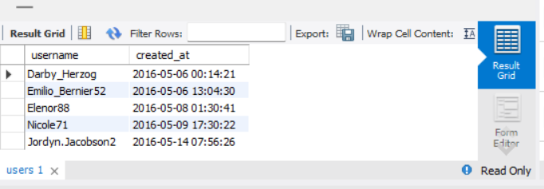

* 1. **Inactive User Engagement:** The team wants to encourage inactive users to start posting by sending them promotional emails.

Your Task: Identify users who have never posted a single photo on Instagram.

**QUERY:**

SELECT u.username

FROM users u

LEFT JOIN photos p ON u.id=p.user_id

WHERE p.id IS NULL

ORDER BY u.username

**OUTPUT:**

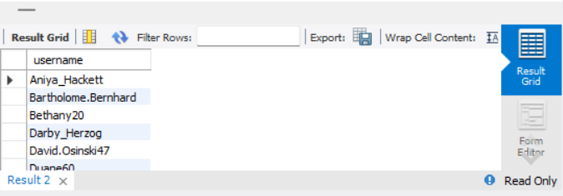

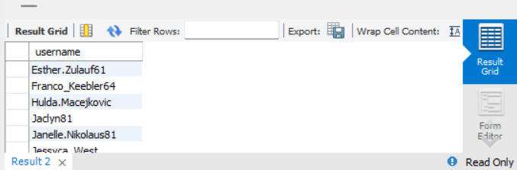

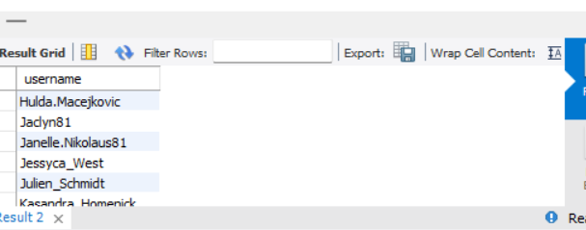

**3.Contest Winner Declaration:** The team has organized a contest where the user with the most likes on a single photo win.

Your Task: Determine the winner of the contest and provide their details to the team.

**QUERY:**

SELECT l.photo_id, p.user_id, COUNT(l.user_id) AS like_count

FROM likes l

JOIN photos p ON l.photo_id = p.id

GROUP BY l.photo_id

ORDER BY like_count DESC

LIMIT 1;

**OUTPUT:**

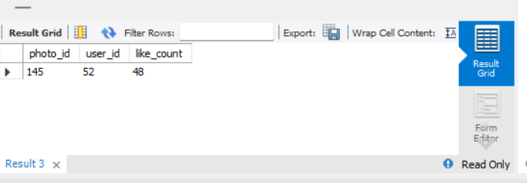

**4.Hashtag Research:** A partner brand wants to know the most popular hashtags to use in their posts to reach the most people.

Your Task: Identify and suggest the top five most commonly used hashtags on the platform.

**QUERY:**

SELECTt.tag_name,

COUNT(pt.photo_id) AS usage_count

FROM tags t

INNER JOIN photo_tags pt ON t.id = pt.tag_id

GROUP BY t.id, t.tag_name

ORDER BY usage_count DESC

LIMIT 5;

**OUTPUT:**

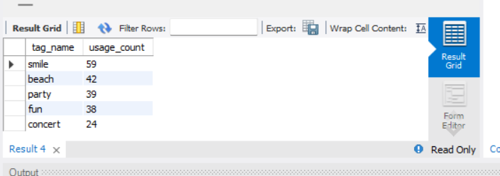

**5.Hashtag Research:** A partner brand wants to know the most popular hashtags to use in their posts to reach the most people.

Your Task: Identify and suggest the top five most commonly used hashtags on the platform.

**QUERY:**

SELECT DAYOFWEEK(created_at)AS registration_day_number,

DAYNAME(created_at)AS registration_day,

COUNT(id)AS user_count

FROM users

GROUP BY registration_day_number,registration_day

ORDER BY user_count DESC;

**OUTPUT:**

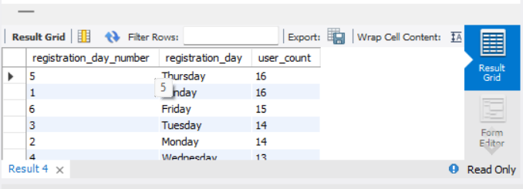

**B ​Investor Metrics:**

**1.User Engagement:** Investors want to know if users are still active and posting on Instagram or if they are making fewer posts.

Your Task: Calculate the average number of posts per user on Instagram. Also, provide the total number of photos on Instagram divided by the total number of users.

**QUERY:**

SELECT

COUNT(p.id) / COUNT(DISTINCT u.id) AS average_posts_per_user,

(SELECT COUNT(id) FROM photos) / (SELECT COUNT(id) FROM users) AS photos_ratio

FROM users u

LEFT JOIN photos p ON u.id = p.user_id;

**OUTPUT:**

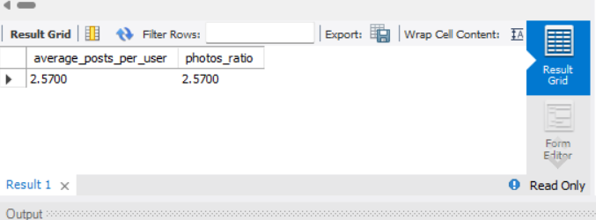

**2.Bots & Fake Accounts:** Investors want to know if the platform is crowded with fake and dummy accounts.

Your Task: Identify users (potential bots) who have liked every single photo on the site, as this is not typically possible for a normal user

**QUERY:**

SELECT u.username, COUNT(l.photo_id) AS num_likes

FROM users u

JOIN likes l ON u.id = l.user_id

GROUP BY u.id

HAVING COUNT(l.photo_id) = (SELECT COUNT(*) FROM photos);

**OUTPUT:**

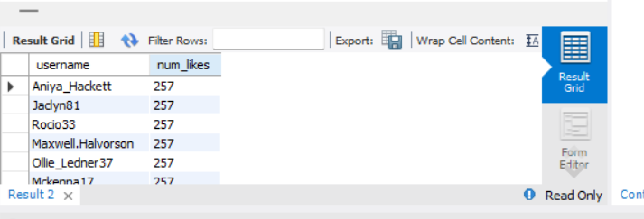

Finally, I analyzed and answered all the questions in the form of queries statements. Additionally, this project provided me with practical real- world experience and gave me good confidence about my SQL skills