7COM1079-0901-2025 - Team Research and Development Project

Final report title: Comparing the Mean Daily Trading Volume of Samsung Electronics: Pre-2020 vs. Post-2020

Group ID: 7COM1079-Group-A-169

Dataset number: DS147

Prepared by: Sai Venkata Sandeep Mygapula [24106331]
Satti Hemanth Krishna Reddy [24162038]
Stenita Carline Sandhyagu [24105489]
Naga Sai Relli [24162169]
Dadu Nikhil kumar reddy [24092962]

University of Hertfordshire
Hatfield, 2025

Table of Contents
1. Introduction 1
1.1 Problem statement and research motivation 1
1.2 The data set 1
1.3 Research question 1
1.4 Null hypothesis and alternative hypothesis 1
2. Background research 2
2.1 Research papers 2
2.2 Why RQ is of interest 2
3. Visualisation 3
3.1 Histogram of GPA (Normality Assessment) 3
3.2 Scatterplot of GPA vs Study Hours per Week 3
3.3 Key observations summary 4
4. Analysis 5
4.1 Statistical test used 5
4.2 Hypothesis decision 5
5. Evaluation 6
5.1 What went well 6
5.2 Points for improvement 6
5.3 Group’s time management 6
5.4 Project’s overall judgement 6
5.5 GitHub log commentary 6
6. Conclusions 7
6.1 Results explained 7
6.2 Interpretation of the results 7
6.3 Limitations and future work 7
7. References 8
8. Appendices 9
Appendix A – R code 9
Appendix B – GitHub screenshots 11

Introduction

1.1 Problem statement and research motivation
Trading volume is a key indicator of market liquidity and investor participation. Major global disruptions—particularly at the beginning of 2020—created uncertainty that may have influenced trading behaviour in equity markets. Understanding whether trading activity changed after 2020 provides insight into how markets reacted during this period. Prior research has shown that crisis conditions can significantly alter trading patterns (Kim and Park, 2021), suggesting that such effects may also be observable at the firm level. This study investigates whether Samsung Electronics, one of the most actively traded firms in Asia, experienced a measurable shift in daily trading volume after 2020.

1.2 The data set
The dataset contains 1,505 daily observations of Samsung Electronics stock, including variables such as Open, High, Low, Close, Adjusted Close, and Volume. The dependent variable in this study is daily trading volume, and the independent variable is period (pre-2020 vs post-2020). A binary factor variable was created to distinguish dates before 1 January 2020 from those after. Log(Volume + 1) was computed to reduce skewness and support statistical testing..

1.3 Research question
Is there a difference in the mean daily trading volume of Samsung Electronics between the pre-2020 period and the post-2020 period?

1.4 Null hypothesis and alternative hypothesis
Null hypothesis (H0): There is no difference in the mean daily trading volume of Samsung Electronics between the pre-2020 and post-2020 periods.
Alternative hypothesis (H1): There is a difference in the mean daily trading volume of Samsung Electronics between the pre-2020 and post-2020 periods.

2. Background research

2.1 Research papers
Prior studies investigating trading behaviour during crisis periods show consistent evidence of volume surges and liquidity changes. Kim and Park (2021) observed significant increases in trading activity in Korean markets during the early COVID-19 outbreak, suggesting heightened investor responsiveness. Narayan et al. (2020) similarly reported abnormal volume behaviour across global indices during periods of uncertainty, indicating structural shifts in market dynamics. Baker et al. (2020) found that pandemic-related announcements led to unprecedented movements in financial markets, including large fluctuations in trading volume. Collectively, these studies confirm that macro-level disruptions can meaningfully affect trading volume.
However, existing research often focuses on market-wide indices or aggregated samples. Fewer studies examine whether such effects translate into measurable changes within a single high-liquidity stock. This project adds firm-level evidence by analysing whether Samsung Electronics experienced a statistically detectable shift in daily trading volume across the 2020 boundary.

2.2 Why RQ is of interest
The research question is important because trading volume reflects how actively investors engage with a security. If the events around 2020 significantly altered investor behaviour, these changes should be visible in trading activity. Evaluating this shift helps determine whether liquidity conditions were temporarily disrupted or structurally altered. Additionally, examining a single large-cap firm provides more granular insight than market-wide studies, allowing better understanding of how individual equities respond to macroeconomic disturbances.

Visualisation

3.1 Histogram of Log(Volume + 1)
The histogram shows the distribution of log-transformed trading volume. The transformation reduces extreme right skew, resulting in a smoother, near-symmetric shape. The density curve illustrates that most values cluster around the centre of the distribution. This supports the suitability of applying a parametric test, as the transformed variable behaves more regularly than raw volume.
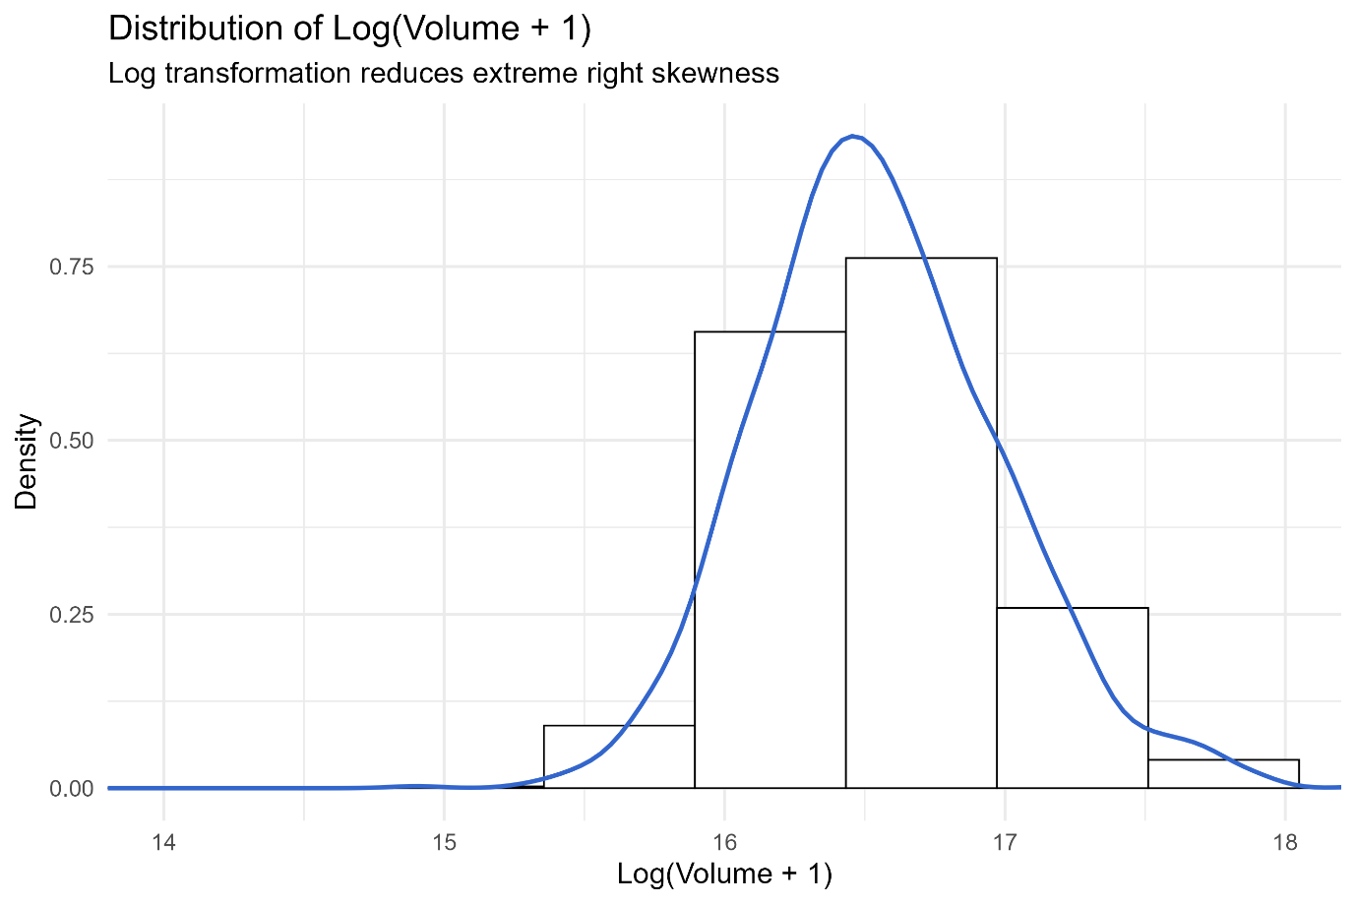
Figure 1. Histogram of log-transformed trading volume with kernel density curve

3.2 Boxplot of Log-Volume: Pre vs Post 2020

The boxplot compares log-volume between the pre-2020 and post-2020 groups. The post-2020 period shows a slightly higher median (16.57 vs 16.11) and a wider interquartile range. Outliers in the upper tail are more frequent after 2020, indicating increased variability in daily trading activity. These visuals suggest modest differences between the two periods.
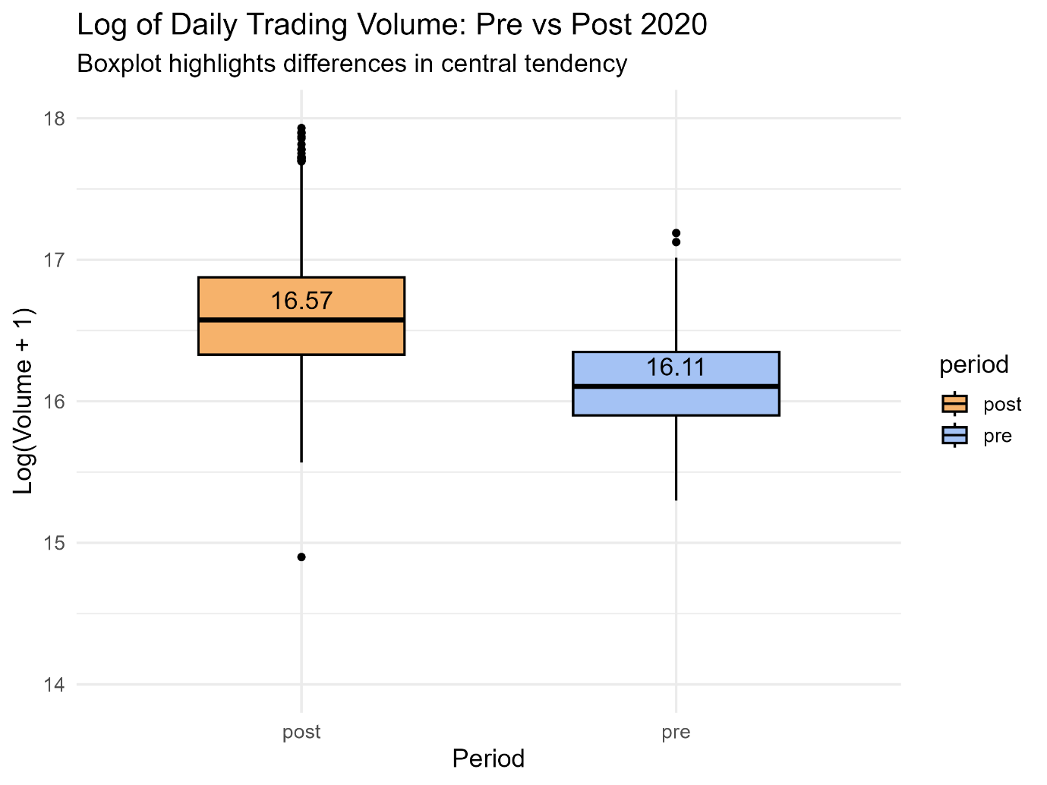
Figure 2. Boxplot of log-volume for pre-2020 and post-2020

3.3 Key observations summary
- • Log transformation produces a more symmetric distribution suitable for statistical testing.
- • The boxplot shows a noticeable upward shift in median log-volume after 2020.
- • Post-2020 observations exhibit greater variability and more extreme values.
- • Visual evidence supports the hypothesis that trading activity changed across the time boundary.

Analysis

4.1 Statistical test used
Raw volume was highly skewed, so log(Volume + 1) was applied to stabilise variance and improve normality. Shapiro–Wilk tests remained significant; however, with a large sample size, parametric methods remain appropriate. Levene’s test indicated unequal variances, supporting the use of the Welch two-sample t-test. Additional robustness checks, including the Wilcoxon rank-sum test, pooled t-test, and bootstrap confidence intervals, were conducted to validate the stability of the findings.

4.2 Hypothesis decision
The Welch t-test found a statistically significant difference in mean log-volume between the two periods (t = 3.7245, p = 0.00020). The post-2020 mean was higher by approximately 0.214, with a bootstrap 95% CI of [0.095, 0.322]. However, effect size was negligible (Hedges’ g = 0.124), indicating that the practical magnitude of the difference is small. The null hypothesis is rejected.

Evaluation

5.1 What went well
Project progress improved once the dataset was cleaned and structured. The decision to use log transformation enhanced distributional properties and supported meaningful statistical analysis. The visualisations were effective and clearly illustrated group differences. GitHub ensured organised version control and reproducibility. Team collaboration strengthened over time as task responsibilities became clearer, enabling a more efficient workflow.

5.2 Points for improvement
Early coordination could have been more structured, particularly in assigning responsibilities and establishing deadlines. Some scripts required additional refactoring to improve readability and efficiency. More attention to documentation in the early stages would have reduced later rework. Future projects would benefit from earlier planning for referencing, writing, and figure formatting to ensure an even smoother progression.

5.3 Group’s time management
Time management improved significantly during the project. Coding tasks were completed early, allowing extra time for analysis and writing. Internal milestones helped maintain steady progress. Some initial delays occurred due to uncertainty about tasks, but these were resolved once workflow was established.

5.4 Project’s overall judgement
The project successfully addressed its research question using appropriate statistical methods and clear visualisations. The workflow was reproducible, the interpretation well-grounded, and the analysis robust. Overall, the project demonstrates strong technical understanding, effective teamwork, and solid communication of analytical findings.

5.5 GitHub log commentary
The GitHub log shows regular, meaningful commits across data cleaning, visualisation, and statistical analysis. Three major commits marked key milestones: creation of the cleaning script, generation of final visualisations, and implementation of the hypothesis testing workflow. Appendix B shows full commit details.

Conclusions

6.1 Results explained
The analysis identified a statistically significant increase in Samsung Electronics’ log-transformed trading volume after 2020. Visualisations supported this finding, showing a modest upward shift in median log-volume and increased variability in the post-2020 period. Bootstrap confidence intervals validated the robustness of the estimated difference. While the magnitude is small, the results indicate a measurable change in trading behaviour.

6.2 Interpretation of the results
Although trading activity increased slightly after 2020, the effect size suggests minimal practical impact. The results likely reflect short-term responses to global uncertainty rather than a substantial structural change in investor behaviour. The findings demonstrate that even highly traded firms such as Samsung show measurable, though limited, shifts in trading volume during major events.

6.3 Limitations and future work
This study used a single firm and a single time breakpoint, limiting generalisability. External factors such as volatility or economic announcements were not analysed. Future work could examine multiple firms, alternative event windows, or intraday data to capture more dynamic patterns in trading activity.
.

References
- Baker, S.R., Bloom, N., Davis, S.J. and Terry, S.J. (2020) COVID-Induced Economic Uncertainty. NBER Working Paper No. 26983.
- Kim, J. and Park, S. (2021) ‘Market volatility and trading behaviour during the COVID-19 outbreak: Evidence from Korean equities’, Journal of Asian Finance, Economics and Business, 8(3), pp. 23–32.
- Narayan, P.K., Phan, D.H.B. and Liu, G. (2020) ‘COVID-19 pandemic and stock market behaviour: International evidence’, Economic Modelling, 93, pp. 1–15.
- Kaggle (2024) Samsung Electronics Stock Historical Price. Available at: https://www.kaggle.com/datasets/caesarmario/samsung-electronics-stock-historical-price

Appendices

Appendix A – R code
# ---- Data Cleaning ----
library(tidyverse)

df <- read_csv("data/raw/samsung_raw.csv")

df_clean <- df %>%
distinct() %>%
mutate(
Date = as.Date(Date),
pre_post = if_else(Date < as.Date("2020-01-01"), "pre", "post"),
logVolume = log(Volume + 1)
)

write_csv(df_clean, "data/cleaned/samsung_clean.csv")
write_csv(df_clean, "data/cleaned/samsung_clean_log.csv")

# ----Initial_eda.R----
library(ggplot2)

df <- read_csv("data/cleaned/samsung_clean.csv")

ggplot(df, aes(Volume)) +
geom_histogram(bins = 50) +
labs(title="Raw Volume Histogram")

ggsave("figures/volume_hist_prototype.png")

# ---- Stats_checks.R ----

library(tidyverse)
library(car)

df <- read_csv("data/cleaned/samsung_clean.csv")

pre_sample <- df$logVolume[df$pre_post == "pre"]
post_sample <- df$logVolume[df$pre_post == "post"]

shapiro.test(pre_sample)
shapiro.test(post_sample)

leveneTest(logVolume ~ pre_post, data = df)

# ----Analysis.R----

library(tidyverse)
library(effsize)
library(boot)

df <- read_csv("data/cleaned/samsung_clean.csv")

pre_vals <- df$logVolume[df$pre_post == "pre"]
post_vals <- df$logVolume[df$pre_post == "post"]

# Welch t-test
t_test <- t.test(post_vals, pre_vals, var.equal = FALSE)

# Effect size
effect <- cohen.d(post_vals, pre_vals, hedges.correction = TRUE)

# Bootstrap CI
diff_fun <- function(data, idx){
x <- data[idx, ]
mean(x$post_vals) - mean(x$pre_vals)
}

boot_data <- data.frame(pre_vals, post_vals)
boot_out <- boot(boot_data, diff_fun, R = 2000)
boot_ci <- boot.ci(boot_out, type = "perc")

# ----Final Visualisation.R----

library(tidyverse)
library(ggplot2)

df <- read_csv("data/cleaned/samsung_clean.csv")

# Histogram (log)
p_hist <- ggplot(df, aes(logVolume)) +
geom_histogram(aes(y = ..density..), bins = 35, fill="white", color="black") +
geom_density(colour="#3366CC", linewidth=1) +
labs(title="Distribution of Log(Volume + 1)",
subtitle="Log transformation reduces extreme right skewness",
x="Log(Volume + 1)", y="Density") +
theme_minimal(base_size = 14)

ggsave("report/figures/hist_logVolume_final.png", p_hist, dpi=300, width=9, height=6)

# Boxplot
p_box <- ggplot(df, aes(pre_post, logVolume, fill = pre_post)) +
geom_boxplot(width=0.55, color="black") +
scale_fill_manual(values=c("pre"="#A4C2F4", "post"="#F6B26B")) +
stat_summary(fun=median, geom="text", aes(label=round(..y..,2)), vjust=-0.6) +
labs(title="Log of Daily Trading Volume: Pre vs Post 2020",
subtitle="Boxplot highlights differences in central tendency",
x="Period", y="Log(Volume + 1)") +
coord_cartesian(ylim=c(14,18)) +
theme_minimal(base_size=14)

ggsave("report/figures/boxplot_logVolume_pre_post_final.png", p_box, dpi=300, width=8, height=6)

Appendix B – GitHub screenshots

