Node Application

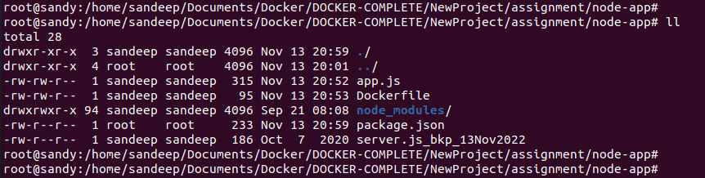

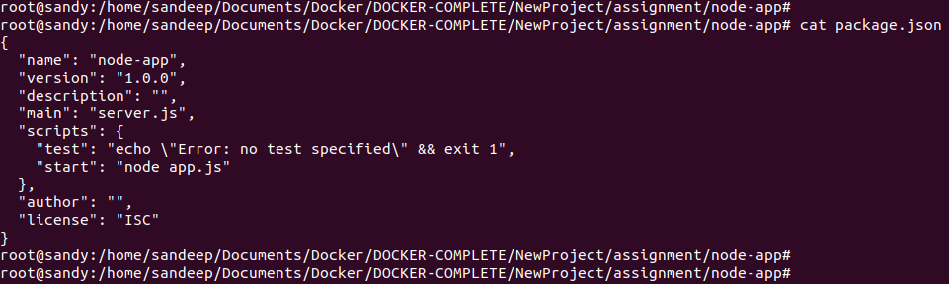

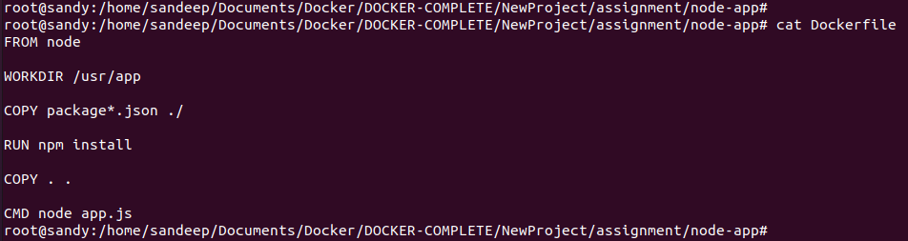

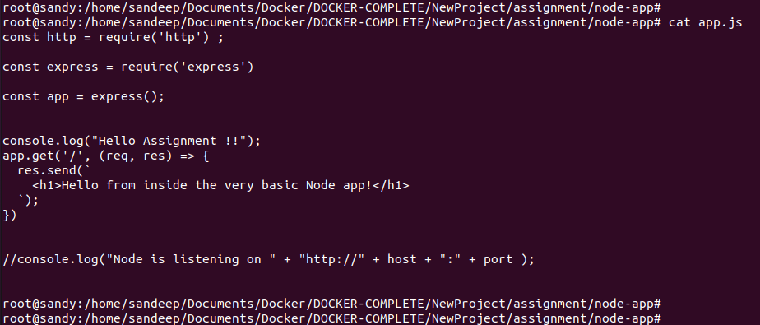

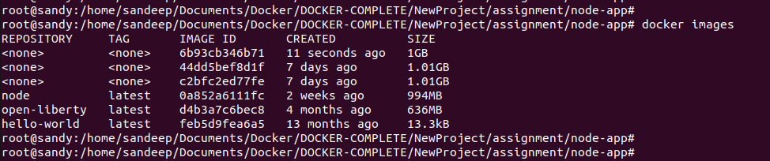

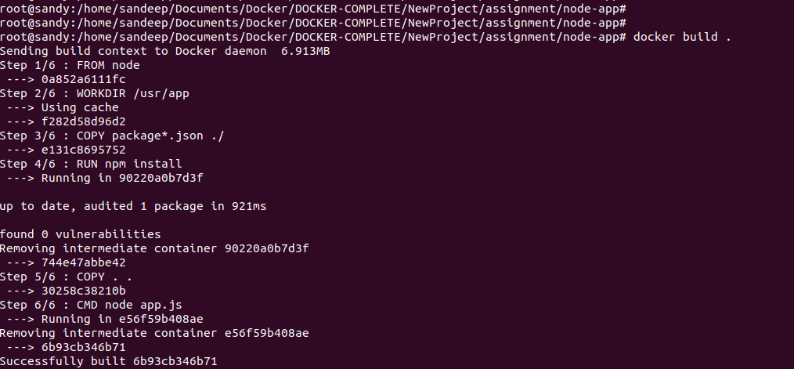
14/11/2022
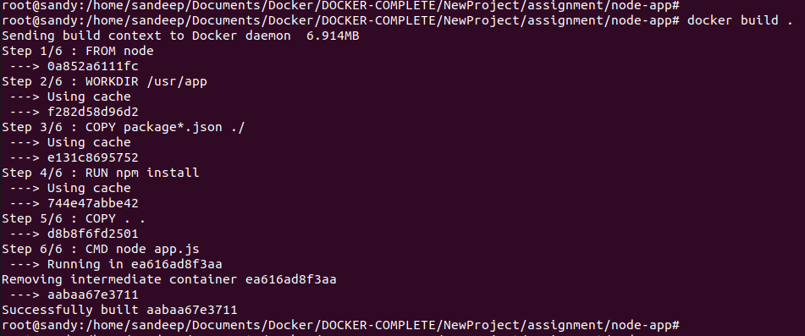
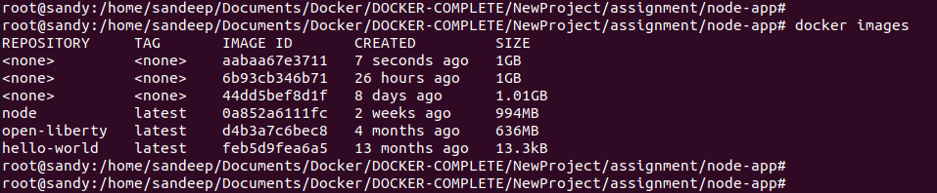
dfa

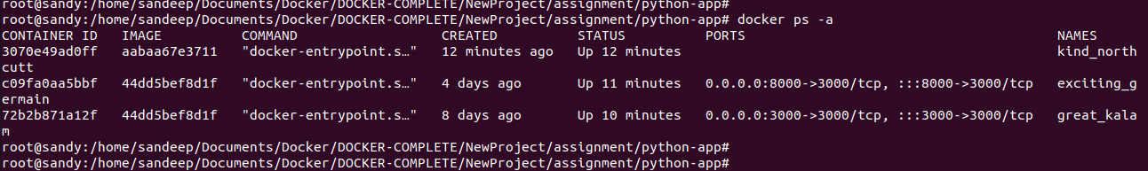

Python Application

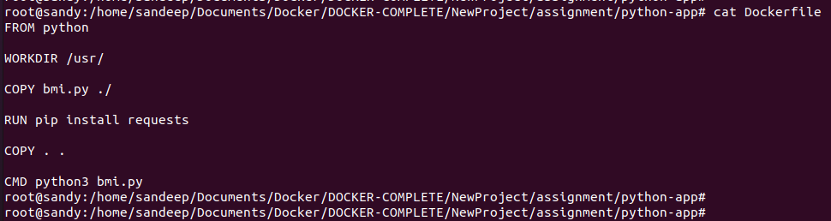
df

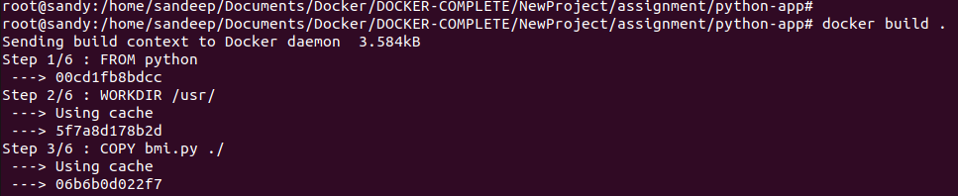

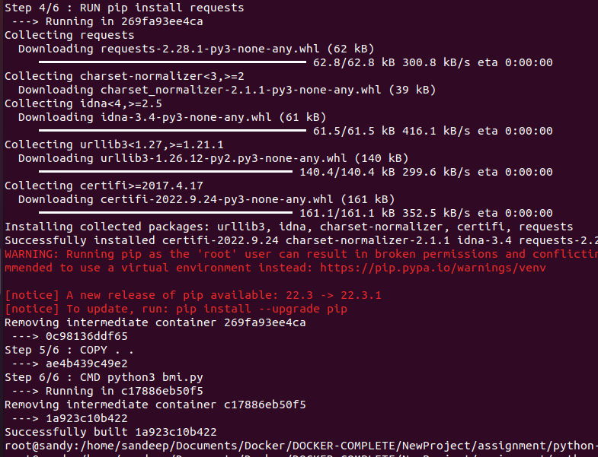

yu

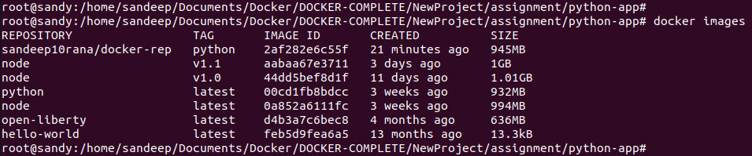

To solve exited issue

Note : Run the images in detach , interactive mode .

Reference :

https://stackoverflow.com/questions/30209776/docker-container-will-automatically-stop-after-docker-run-d

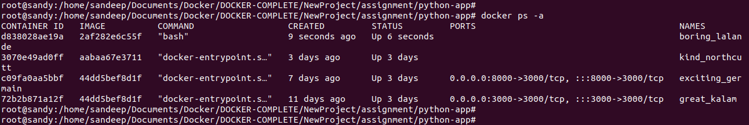
Part 2 : To re-create build images

Node App & Python App

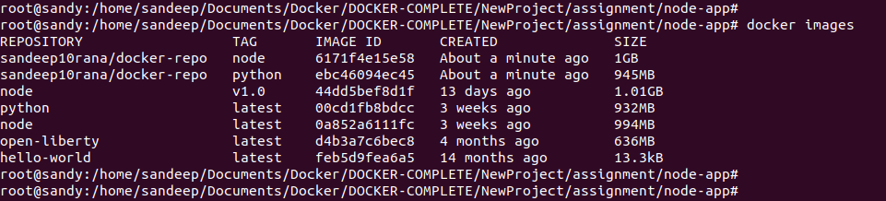
Docker –rm command to remove stop container automatically

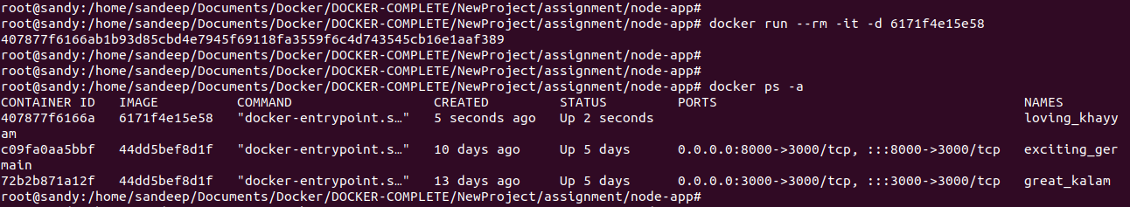
Docker stop command & removed automatically
