Issue while connecting Host ( MongoDB ) from Container ( Node JS )

- In container Node JS Application is running
- In Host MongoDB is running
- while initiating from postman getting Error: socket hang up

Node JS Code to connect

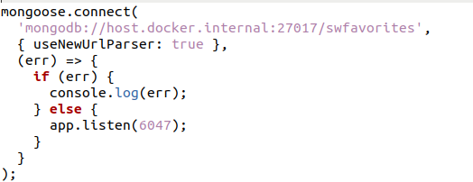
MongoDB Process

Starting a container

Command :

docker run -it -d --name mongod-6047-1 -d -p 6047:6047 mongod-6047

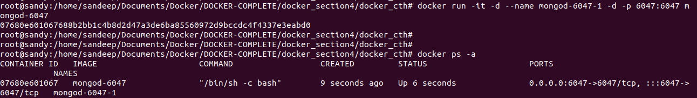
Output :

