CHECKING FILES:
- Open command prompt by pressing windows + r then type cmd in it .
- Check java –version in cmd prompt, if not present then install java (above 21 bits)
- Check python –version in cmd prompt, if not present then install python (python 3.11.9)
- Download meatbase.jar file from the metabase website

METABASE FILE RUNNING:
- After downloading meatbase.jar file -paste in the “d-drive”
- Type cmd in the d drive
- Then next type the “java -jar meatbase.jar” in the cmd prompt to run the meatbase file.
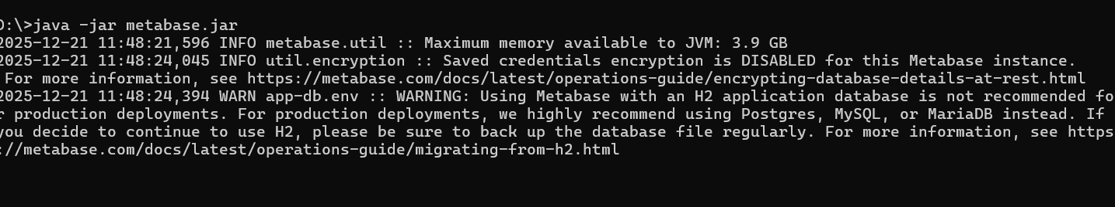
- Then open “localhost:3000” in the url of chrome or edge
- Login in to your account
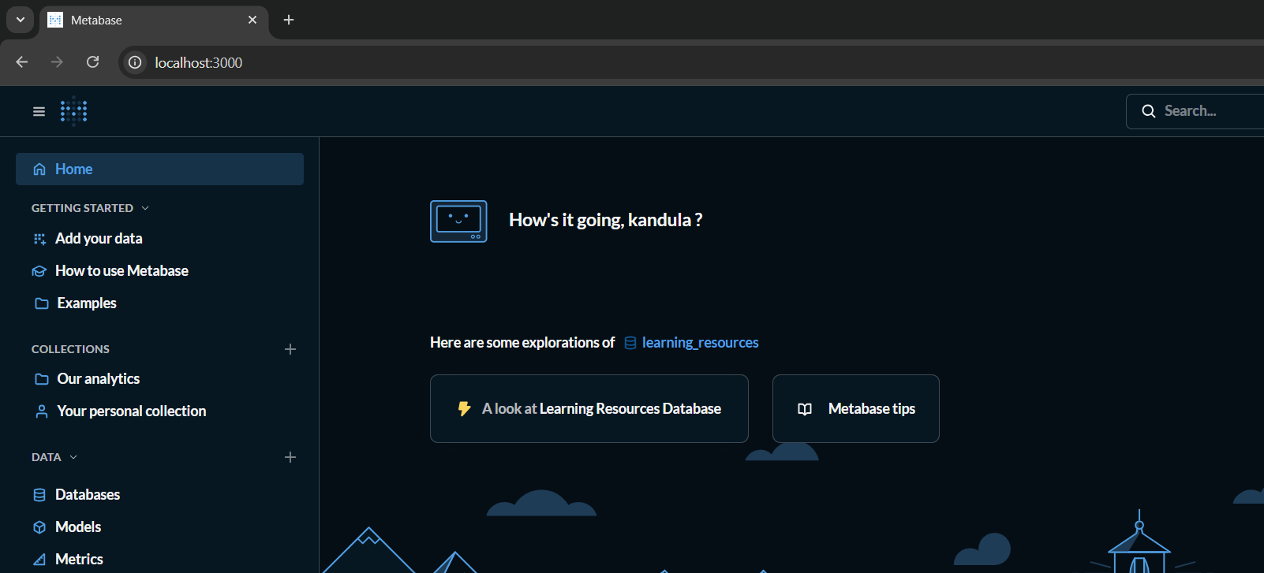

OPEN KAGGLE WEBSITE:
- Download your application from the Kaggle website
- Check the usability consisting of more than “8.0”
- Download the zip file
- After downloading the zip file
- Then extract the zip file in the file manager.
- After completion of extracting the zip file then copy the file path by right clicking on the file.

OPEN CSV FILE:
- Open “CSV to SQLite Converter”

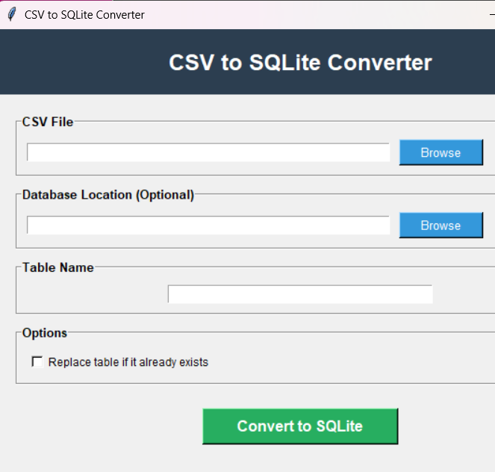

- Paste the path in the csv file
- Then click on the browse button
- Select the file where it is (Kaggle downloaded file )
- Then click on the convert to SQLite button
- Then it will show “successfully created”
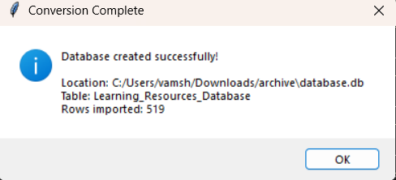

- Then copy the database location on in the converter

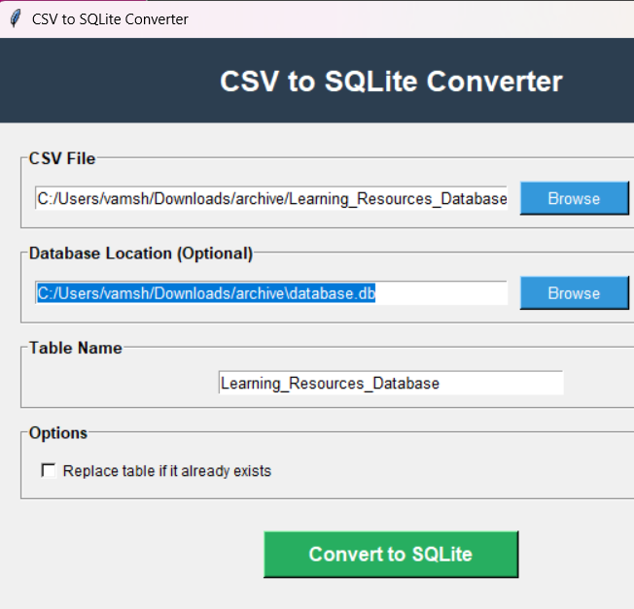

OPEN LOCALHOST:
- Type localhost:3000 in the url
- It opens the metabase website.
- Then click on the databases in the meatbase
- Then click on the “add a database”
- Then shows below
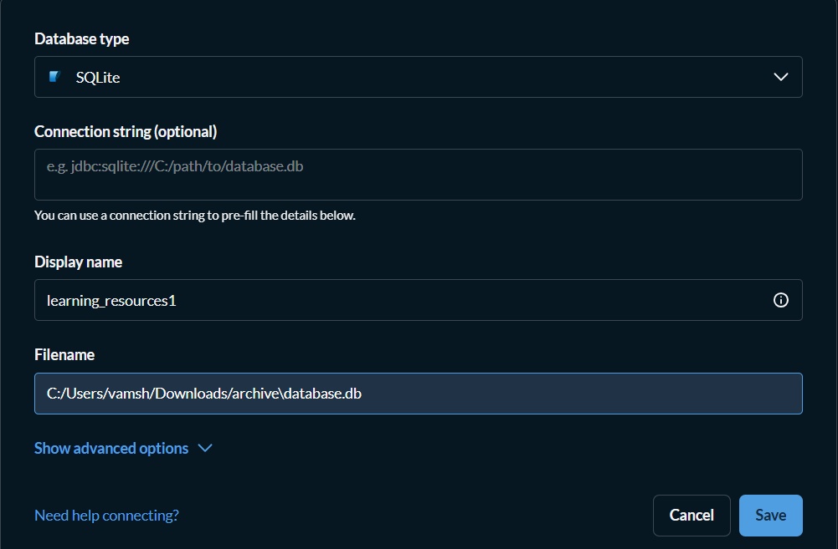

- Click on the save button
- Then it shows lije below

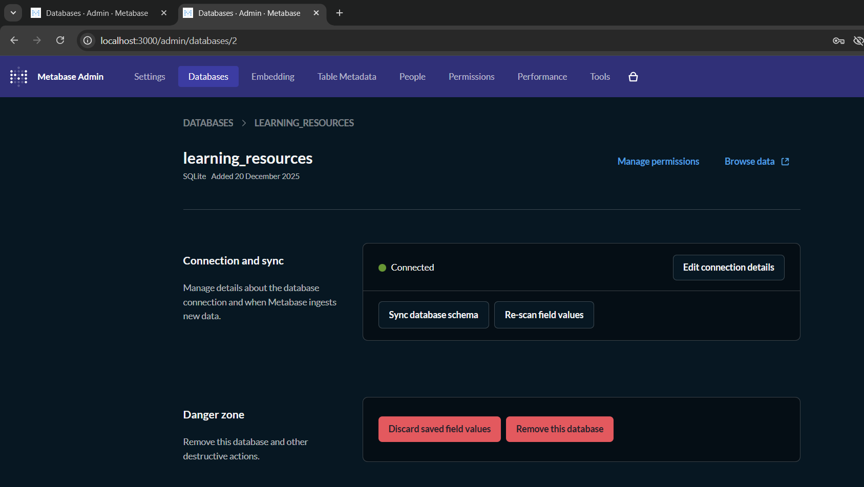

- Then click on the browse data
- Then select the database file (ex: learing_resourses)

- Then it shows like the below fig

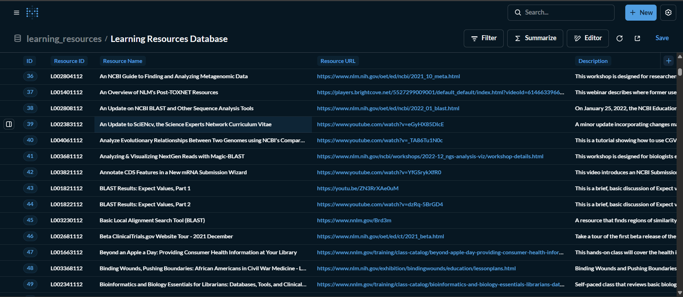

- Then perform the operations you want
- It has many operations to perform
- Click on editor then summarize then select the operation and the column to perform the operation.
- Example images are shown below

