
INSTALLATION GUIDE

FlowNote
Step-by-step instructions to install, update and uninstall FlowNote on Linux and Windows.
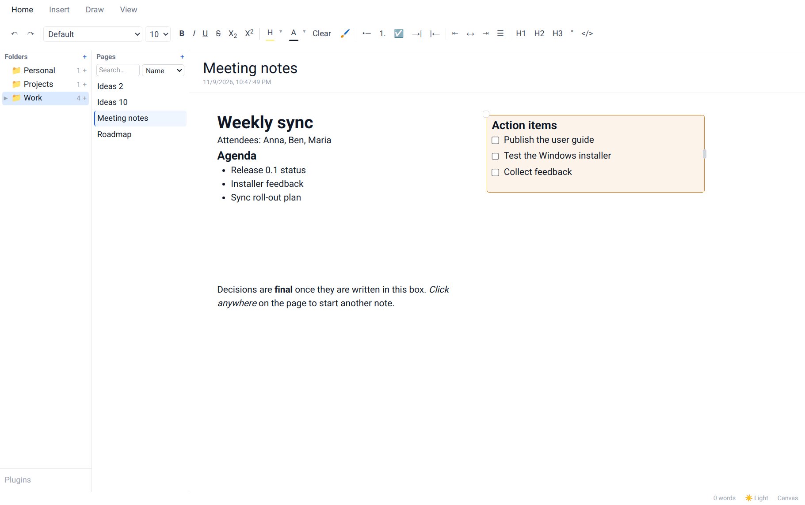
Version 0.1.0 · Linux · Windows
Contents
1. Before you start
1.1 Which file do I need?
1.2 System requirements
1.3 Already using FlowNote?
1.4 Optional: check the download
2. Installing on Linux
2.1 Method A: one-file installer (graphical)
2.2 Method B: one-file installer in a terminal
2.3 Method C: from the bundle folder
2.4 Check that it worked
2.5 Where FlowNote is installed
3. Installing on Windows
3.1 Method A: setup wizard (recommended)
3.2 Method B: MSI package (all users / IT departments)
3.3 Method C: unattended install
3.4 Check that it worked
3.5 Where FlowNote is installed
4. Updating and backing up
4.1 Updating to a new version
4.2 Backing up your notes
5. Uninstalling
5.1 Linux
5.2 Windows
6. Solving installation problems
6.1 Linux
6.2 Windows

1. Before you start

1.1 Which file do I need?
Your computer | Download | Size
Linux (64-bit) | FlowNote-<version>-linux-x86_64.run: one-file installer (recommended)  or FlowNote-<version>-linux-x86_64.tar.gz: the same, as a folder | ≈ 185 MB
Windows 10 / 11 (64-bit) | FlowNote-<version>-windows-x64.zip: setup wizard, MSI package and uninstaller | < 100 MB

Not sure if your computer is 64-bit? On Linux run uname -m in a terminal; it should print x86_64. On Windows open Settings → System → About and look for 64-bit operating system.

1.2 System requirements
 | Linux | Windows
Operating system | Any 64-bit distribution. The system-wide install needs a Debian/Ubuntu-based one (Ubuntu, Debian, Linux Mint, Pop!_OS, elementary…). | Windows 10 or Windows 11, 64-bit
Disk space | ≈ 280 MB (system-wide) or ≈ 110 MB (just for me) | Less than 100 MB
Permissions | Your password only for the system-wide install | No administrator rights for the setup wizard; the MSI needs them
Other | A desktop session. For graphical installer windows, zenity or kdialog (most desktops have one) | Microsoft Edge WebView2 (built into Windows 11; added automatically on Windows 10)

1.3 Already using FlowNote?
You don't need to uninstall first. Installing a newer version upgrades FlowNote in place and keeps all your notes. If you want an extra safety copy, see Backing up your notes in chapter 4.

1.4 Optional: check the download
Each download comes with checksums so you can confirm it isn't damaged:
# Linux, in the download folder
$ sha256sum -c FlowNote-<version>-linux-x86_64.sha256
FlowNote-<version>-linux-x86_64.run: OK
# Windows PowerShell — compare with the value in FlowNote-<version>-windows-x64.zip.sha256
PS> Get-FileHash .\FlowNote-<version>-windows-x64.zip -Algorithm SHA256

2. Installing on Linux
Choose one of the three methods below. Method A is the easiest.

2.1 Method A: one-file installer (graphical)
- Download FlowNote-<version>-linux-x86_64.run (for example into your Downloads folder).
- Allow it to run. In your file manager, right-click the file → Properties → Permissions → tick Allow executing file as program (in KDE Dolphin: Is executable). Close the dialog.
- Double-click the file. If your file manager asks what to do, choose Run (not Display or Open in text editor).
- Welcome. A FlowNote window shows the version being installed. Click OK.
- Release notice. Read it and click Continue (Cancel stops without changing anything).
- Choose the install type and click OK:
  - For everyone on this computer: a normal system package. You'll be asked for your password in the next step. Recommended on Ubuntu, Debian and Mint.
  - Just for me: no password, works on every distribution, installed in your home folder.
- Enter your password if asked (system-wide install only), then wait while a progress window is shown. This takes from a few seconds to a minute.
- Finished. The last window says where FlowNote was installed and asks Start FlowNote now? Click Yes to open it.
Tip
From now on, open FlowNote from your application menu: look for FlowNote under Office, or search for "FlowNote".

2.2 Method B: one-file installer in a terminal
The same installer asks the same questions as text when you run it in a terminal. Type the answer and press Enter; pressing Enter alone takes the default (marked * or written in capitals, like [Y/n]).
- Open a terminal in the download folder (right-click inside the folder → Open in Terminal, or cd ~/Downloads).
- Make the installer executable and start it:
$ chmod +x FlowNote-*.run
$ ./FlowNote-*.run
- Answer the questions. A typical session looks like this:
Welcome to the FlowNote 0.1.0 installer.
...
Continue? [Y/n] y
How do you want to install FlowNote?
1) * For everyone on this computer (system package, needs your password)
2) Just for me (anna), no password needed
Choose 1-2 [default: the one marked *, q to cancel]: 2
==> Copying FlowNote to /home/anna/.local/opt/flownote
==> Adding FlowNote to the app menu
==> FlowNote 0.1.0 is installed for anna (in /home/anna/.local/opt/flownote).
Start FlowNote now? [Y/n] y
- If you chose For everyone, type your password when sudo asks for it (nothing appears on screen while you type; that's normal).

2.3 Method C: from the bundle folder
Use this if you downloaded the .tar.gz, or want to install without any questions (for example on several computers).
- Unpack the bundle and go into its folder:
$ tar xzf FlowNote-<version>-linux-x86_64.tar.gz
$ cd FlowNote-<version>-linux-x86_64
- Run the installer with the options you want:
$ ./install.sh # guided, like Method B
$ ./install.sh --appimage --silent # just for me, no questions
$ ./install.sh --deb --silent # for everyone, no questions (asks for sudo password)
$ ./install.sh --help # all options
Option | Meaning
--deb | System-wide install (the .deb package)
--appimage | Just-for-me install (the AppImage)
--silent or -y | Don't ask anything; use defaults
--gui / --cli | Force graphical windows / terminal questions
--launch / --no-launch | Start (or don't offer to start) FlowNote at the end

Note
Advanced users can also install the packages directly: sudo apt install ./FlowNote-<version>-amd64.deb, or make the .AppImage executable and run it. The installer does this for you and also adds the menu entry, the flownote command and an uninstaller.

2.4 Check that it worked
- FlowNote appears in your application menu.
- Typing flownote in a new terminal starts it. (Just-for-me install: if the command isn't found, log out and in again once, or use ~/.local/bin/flownote.)
- FlowNote opens with empty Folders and Pages panels, or with your existing notes after an upgrade.

2.5 Where FlowNote is installed
 | For everyone (.deb) | Just for me (AppImage)
Program | /opt/FlowNote | ~/.local/opt/flownote
Command | /usr/bin/flownote | ~/.local/bin/flownote
Uninstaller | uninstall.sh in the bundle, or sudo apt remove flownote | ~/.local/opt/flownote/uninstall.sh
Your notes (both) | ~/.config/@flownote/electron/
Install log (both) | ~/.cache/flownote-install.log

3. Installing on Windows
Choose one method. Method A suits almost everyone.

3.1 Method A: setup wizard (recommended)
- Download FlowNote-<version>-windows-x64.zip.
- Unzip it. Right-click the zip → Extract All… → Extract. A folder with the same name opens.
- Start setup. Double-click FlowNote_<version>_x64-setup.exe.
- SmartScreen warning. Preview builds aren't code-signed yet, so Windows may show "Windows protected your PC". Click More info, check the app name says FlowNote, then click Run anyway.
- Language. Choose English, Deutsch, Français or Español and click OK.
- Welcome page. Click Next.
- Release notice. Read it and click I Agree.
- Install location. Keep the suggested folder (in your user profile, no admin rights needed) or click Browse… to choose another. Click Next.
- Start Menu folder. Keep FlowNote and click Install.
- Wait a few seconds while files are copied.
- Finish. Tick Create desktop shortcut if you want an icon on the desktop. Leave Run FlowNote ticked and click Finish.
Tip
Your Start Menu → FlowNote folder now contains FlowNote, FlowNote User Guide, FlowNote Feature Guide and Uninstall FlowNote.

3.2 Method B: MSI package (all users / IT departments)
- Unzip the download as above.
- Double-click FlowNote_<version>_x64_en-US.msi.
- Click through the installer: Next → accept the release notice → Next → Install.
- Click Yes when Windows asks for administrator permission (the MSI installs for every user of the PC).
- Click Finish, then open FlowNote from the Start Menu.

3.3 Method C: unattended install
For scripts and managed deployments, open PowerShell or Command Prompt in the unzipped folder:
# per user, no admin, no windows shown
PS> .\FlowNote_<version>_x64-setup.exe /S
# all users (run as administrator)
PS> msiexec /i FlowNote_<version>_x64_en-US.msi /qn /norestart

3.4 Check that it worked
- FlowNote appears in the Start Menu (and on the desktop, if you chose a shortcut).
- Settings → Apps → Installed apps lists FlowNote with the version you installed.
- FlowNote opens with empty Folders and Pages panels, or with your existing notes after an upgrade.

3.5 Where FlowNote is installed
 | Setup wizard | MSI
Program | %LOCALAPPDATA%\FlowNote (unless you changed it) | C:\Program Files\FlowNote
Your notes (both) | %APPDATA%\com.sandeep.flownote\

4. Updating and backing up

4.1 Updating to a new version
- Close FlowNote (the installer also closes it for you if it's running).
- Download the new version and install it exactly as described above, using the same install type as before.
  - Linux: the installer says "FlowNote x is installed. Upgrade it to y?"; answer Yes.
  - Windows: run the new setup wizard; it replaces the old version.
- Open FlowNote. Your folders and pages are all still there.
Running the installer for the version you already have offers to repair it, which fixes a damaged install without touching your notes.

4.2 Backing up your notes
- Close FlowNote.
- Copy the whole notes folder to a USB drive or another safe place:
  - Linux: ~/.config/@flownote/electron/ (in the file manager press Ctrl+H to show hidden folders)
  - Windows: type %APPDATA%\com.sandeep.flownote into the File Explorer address bar
- To restore, close FlowNote and copy the folder back to the same place.
For automatic, encrypted backups across computers, set up Backup & Sync (View → Sync…) as described in the User Guide.

5. Uninstalling
Important
Uninstalling removes the program but keeps your notes unless you choose to delete them. Reinstalling later brings them back automatically.

5.1 Linux
- Close FlowNote.
- Start the uninstaller. Any one of:
  - Double-click uninstall.sh in the unpacked bundle folder (choose Run).
  - Just-for-me install: run ~/.local/opt/flownote/uninstall.sh (works without the download).
  - In a terminal in the bundle folder: ./uninstall.sh
- Confirm that you want to remove FlowNote.
- Choose what happens to your notes: answer No to keep them (default), or Yes to delete them permanently.
- Enter your password if asked (system-wide install only). A final message confirms that FlowNote is uninstalled.
$ ./uninstall.sh --keep-data # remove FlowNote, keep notes, no questions about them
$ ./uninstall.sh --remove-data # remove FlowNote and delete notes
$ sudo apt remove flownote # system-wide install only, keeps notes

5.2 Windows
- Close FlowNote.
- Open Start → FlowNote → Uninstall FlowNote, or Settings → Apps → Installed apps, click ⋯ next to FlowNote and choose Uninstall.
- On the confirmation page, tick Delete the application data only if you also want to delete your notes.
- Click Uninstall, then Close when it's done.
Alternatively, double-click Uninstall FlowNote.cmd in the unzipped download folder. It finds either kind of install (wizard or MSI) and shows a small window with an Also delete my notes checkbox. For scripts:
PS> powershell -ExecutionPolicy Bypass -File .\Uninstall-FlowNote.ps1 -Silent -KeepData
PS> powershell -ExecutionPolicy Bypass -File .\Uninstall-FlowNote.ps1 -Silent -RemoveData

6. Solving installation problems

6.1 Linux
Problem | Solution
Double-clicking the .run file opens a text editor or does nothing | It isn't executable yet: see Method A step 2, or run chmod +x FlowNote-*.run. Some file managers need you to pick Run or Execute when asked.
No installer windows appear, only terminal questions | Neither zenity nor kdialog is installed. Answer in the terminal, or install one: sudo apt install zenity.
"These packages are built for 64-bit PCs" | FlowNote currently needs an x86_64 computer; ARM devices (e.g. Raspberry Pi) aren't supported yet.
The system-wide install fails | Check your password and that no other update/software centre is running, then try again. Or choose Just for me. Details are in ~/.cache/flownote-install.log.
"The system install needs apt" | Your distribution isn't Debian/Ubuntu-based. Use the Just for me install.
Note about FUSE 2 during install; FlowNote starts slowly | Optional speed-up: sudo apt install libfuse2t64 (Ubuntu 24.04+) or libfuse2 (older), then run the installer again.
flownote: command not found | Just-for-me install: log out and back in, or run ~/.local/bin/flownote. FlowNote is also in the app menu.

6.2 Windows
Problem | Solution
"Windows protected your PC" | Click More info → Run anyway. Preview installers aren't code-signed yet.
Setup says FlowNote is running | Close FlowNote (check Task Manager if no window is open), or let setup close it, then continue.
The MSI asks for an administrator | The MSI installs for all users. Use the setup wizard instead for a per-user install without admin rights.
Antivirus blocks the installer | Make sure the file came from the official download and its checksum matches, then allow it in your antivirus.
FlowNote doesn't start on Windows 10 | Install Microsoft Edge WebView2 Runtime from microsoft.com, then start FlowNote again.
Uninstall-FlowNote.ps1 "cannot be loaded because running scripts is disabled" | Use Uninstall FlowNote.cmd, or start PowerShell with -ExecutionPolicy Bypass as shown above.

Still stuck? Open an issue at github.com/sandeep12biswas/noteApp and attach ~/.cache/flownote-install.log (Linux) or a screenshot of the error (Windows).

