
FEATURE GUIDE

FlowNote
Every FlowNote feature in one place: what it does, how to use it, and how it fits into the way you take notes.
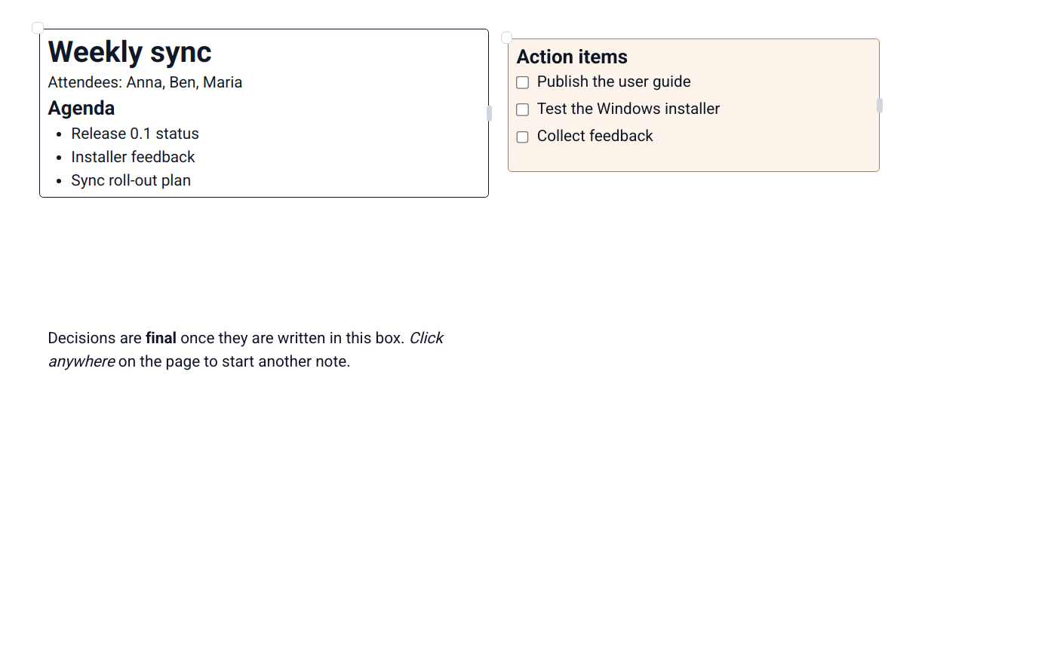
Version 0.1.0 · Linux · Windows
Contents
1. FlowNote at a glance
2. Organising: folders and pages
2.1 Folders and sub-folders
2.2 Folder icons
2.3 Pages and the New page flow
2.4 Natural sort order and smart names
3. The canvas editor
3.1 Click anywhere and write
3.2 Moving and resizing segments
3.3 Segment colours
3.4 Delete segment, with Undo
3.5 Tidy by default
3.6 Linear mode
4. Text formatting
4.1 Fonts and text styles
4.2 Lists, checklists and alignment
4.3 Headings, quotes and code
4.4 Format Painter
4.5 Clear formatting, Undo and Redo
4.6 Live spell check
5. Inserting content
5.1 The "/" block menu
5.2 Code blocks with syntax highlighting
5.3 Pictures and file attachments
6. Drawing and ink
7. Appearance
7.1 Light and dark theme
7.2 Page colours
7.3 Contrast assistant
7.4 Zoom and resizable panels
7.5 Status bar
8. Search
9. AI writing assistant
10. Plugins
11. Backup & Sync
11.1 Conflict handling
11.2 Mass-deletion safeguard
11.3 Sync status
12. Installers and uninstallers
12.1 Linux Linux
12.2 Windows Windows

1. FlowNote at a glance
FlowNote combines the freedom of a paper notebook with the organisation of a filing cabinet. It runs on Linux and Windows, works fully offline, and can keep your devices in sync with end-to-end encryption.
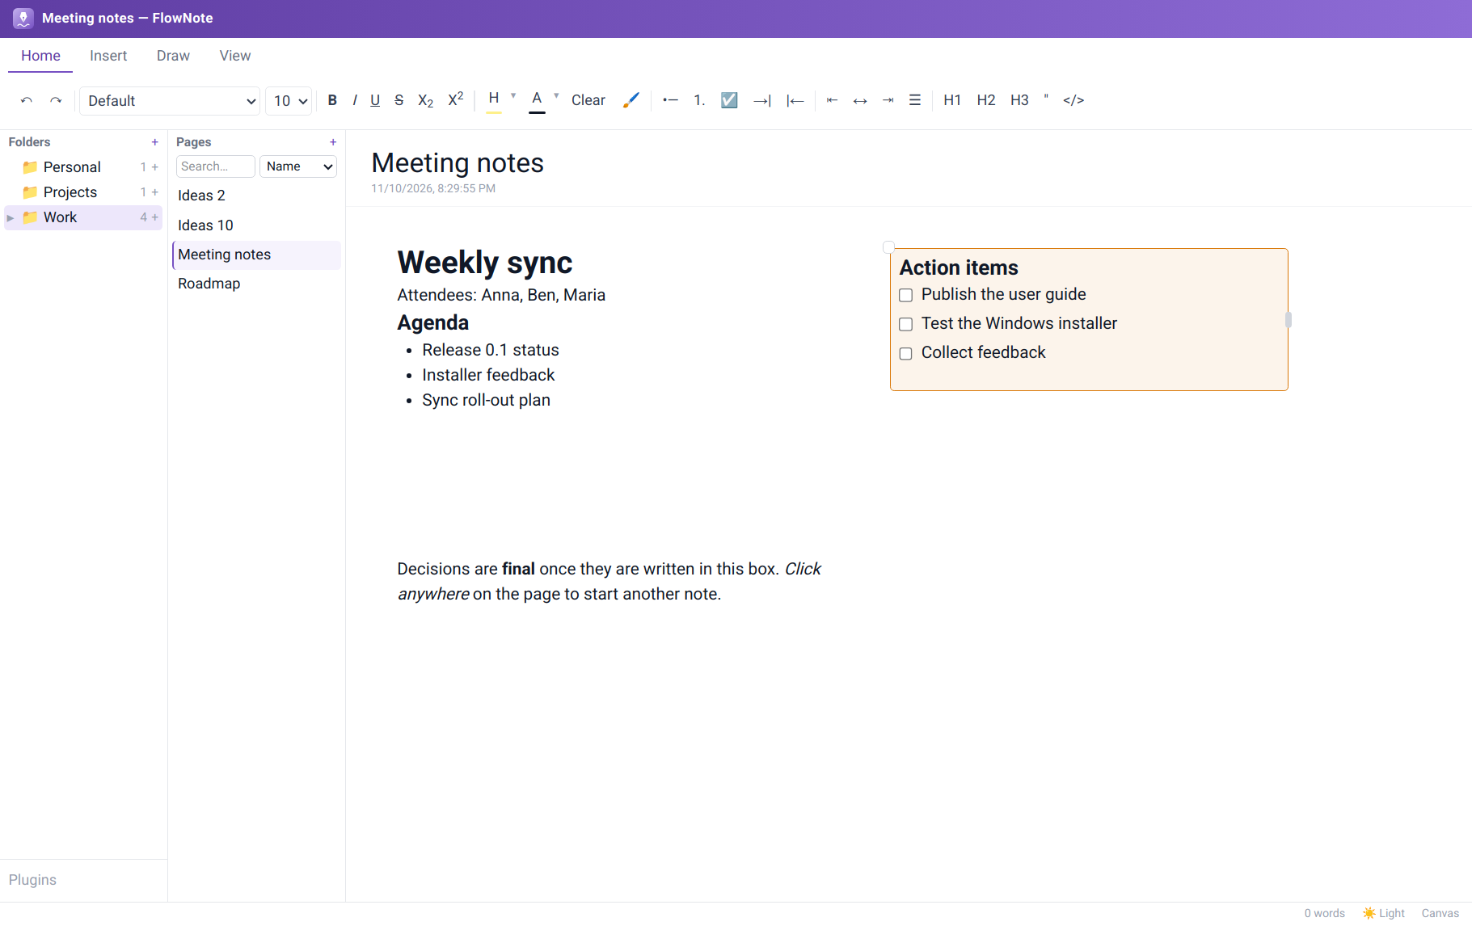
Figure: Folders, pages and the canvas editor
What's new
- Richer colour pickers for page colours and segment colours: a darkest-to-lightest shade grid for ten colour families, recently used colours, and an in-app colour wheel with a brightness slider and hex input (sections 3 and 7).
- Delete segment from a segment's right-click menu, with a few seconds to Undo (section 3).
- Lowercase page names are now allowed (section 2).
- Clearer swatches: every colour swatch has a visible edge, so pale colours are easy to tell apart.

Area | Features | Section
Organising | Folders and sub-folders, folder icons, page counts, natural sort, drag to reorganise | 2
Writing | Click-anywhere canvas, segments (colour, delete with Undo), Linear mode, rich text, lists and checklists, headings, quotes | 3, 4
Inserting | "/" block menu, code blocks with highlighting, pictures and file attachments | 5
Drawing | Pen, marker and eraser in five colours | 6
Appearance | Light/dark theme, page colours with shades and a colour wheel, contrast assistant, zoom | 7
Finding | Search by page name or by contents | 8
AI | Draft text with Claude, Gemini, OpenAI, or a local model through Ollama | 9
Plugins | Extend FlowNote with new block types, such as the Spreadsheet plugin | 10
Sync | End-to-end encrypted Backup & Sync via OneDrive, Google Drive or any folder | 11
Install | Guided installers and clean uninstallers for Linux and Windows | 12

2. Organising: folders and pages

2.1 Folders and sub-folders
What it does. The left panel shows only folders, never pages, so the structure of your notebook is always visible at a glance. Each folder shows how many pages it holds. Folders can contain sub-folders up to 7 levels deep; folders with sub-folders get an arrow to expand or collapse them.
How to use it. Click + next to Folders for a new top-level folder. Hover a folder and click its own +, or right-click it and choose New subfolder, to nest one inside. Drag a folder onto another to move it there, or onto empty space to bring it back to the top level. Right-click for Rename and Delete.
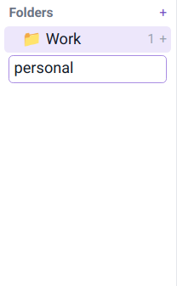  Figure: Creating a folder | 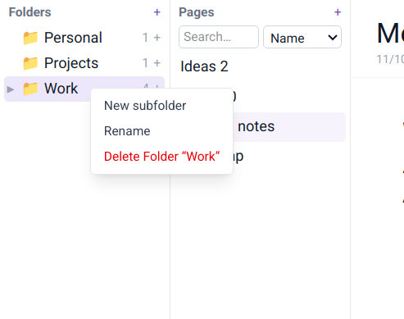  Figure: Folder actions

2.2 Folder icons
What it does. Gives each folder its own icon so you can find it quickly: briefcase for work, house for home, lightbulb for ideas.
How to use it. Click a folder's icon and pick one from the set. Default restores the plain folder icon.
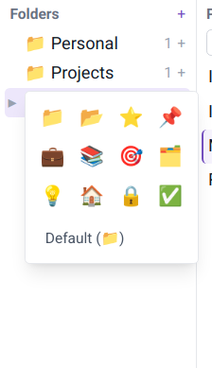
Figure: The folder icon picker

2.3 Pages and the New page flow
What it does. The middle panel lists the pages in the selected folder. Creating a page always asks where it belongs first, so pages never end up loose.
How to use it. Click + next to Pages, choose an existing folder or create a new one, then name the page. Page names start with a letter, lowercase or capital (not a number or symbol), and keep the case you type. The same name can be reused in different folders. Rename a page by editing its title in the editor; delete it from its right-click menu.
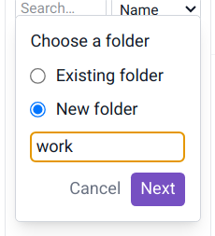  Figure: Choose a folder… | 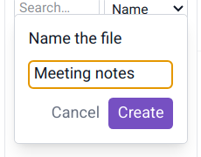  Figure: …then name the page

2.4 Natural sort order and smart names
What it does. Folders and pages are sorted the way people count, so Ideas 2 comes before Ideas 10. Folder names get their first letter capitalised as you type.
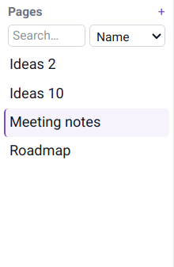
Figure: Natural order

3. The canvas editor

3.1 Click anywhere and write
What it does. Each page is an open canvas. Clicking an empty spot creates a segment, an invisible text box, exactly where you clicked. Lay out notes the way you think: side-by-side columns, a to-do list in the corner, a summary at the bottom.
How to use it. Click empty space, click into the new segment, and type. Click elsewhere for another one.
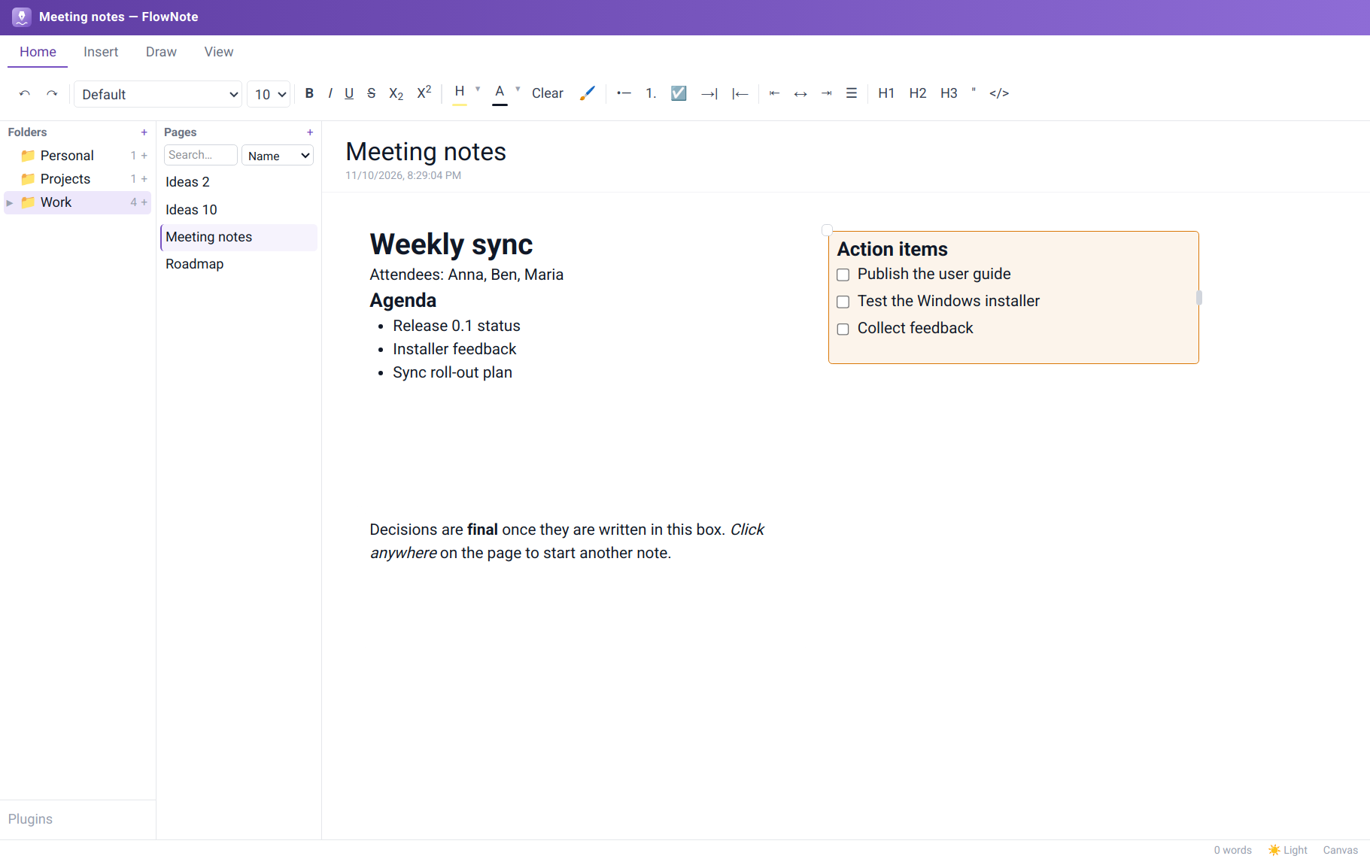
Figure: Three segments arranged freely on one page

3.2 Moving and resizing segments
What it does. Segments have no visible border until you select one. Then a move handle (top-left corner) and a resize handle (right edge) appear.
How to use it. Drag the corner circle to move a segment and the side bar to change its width. Text reflows to fit.
Figure: A selected segment with its border and handles

3.3 Segment colours
What it does. Colour-code segments, for example orange for action items or green for decisions. A colour gives the segment a visible border and a matching soft background.
How to use it. Right-click a segment. Pick one of the nine quick picks, a colour from the shades grid (ten colour families, darkest at the top), one of your recent colours, or choose More colours… for the colour wheel. None removes the colour. The two palest shades are left out here, because they'd make a border you can't see on a white page.
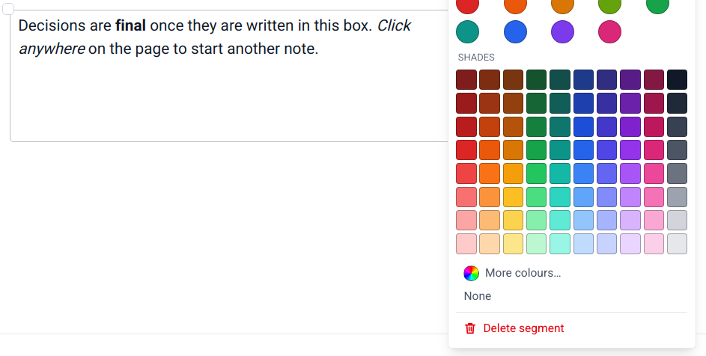
Figure: Quick picks, shades, More colours… and Delete segment

3.4 Delete segment, with Undo
What it does. Removes a segment in one step, whatever it contains and whether or not it has a colour, and gives you a few seconds to change your mind.
How to use it. Right-click the segment and choose Delete segment. A Segment deleted message appears with a bar that counts down. Click Undo (or press Ctrl+Z when you're not typing in a segment) to restore it, with its text, colour and position, or ✕ to make the deletion final straight away. Deleting another segment makes the earlier deletion final.
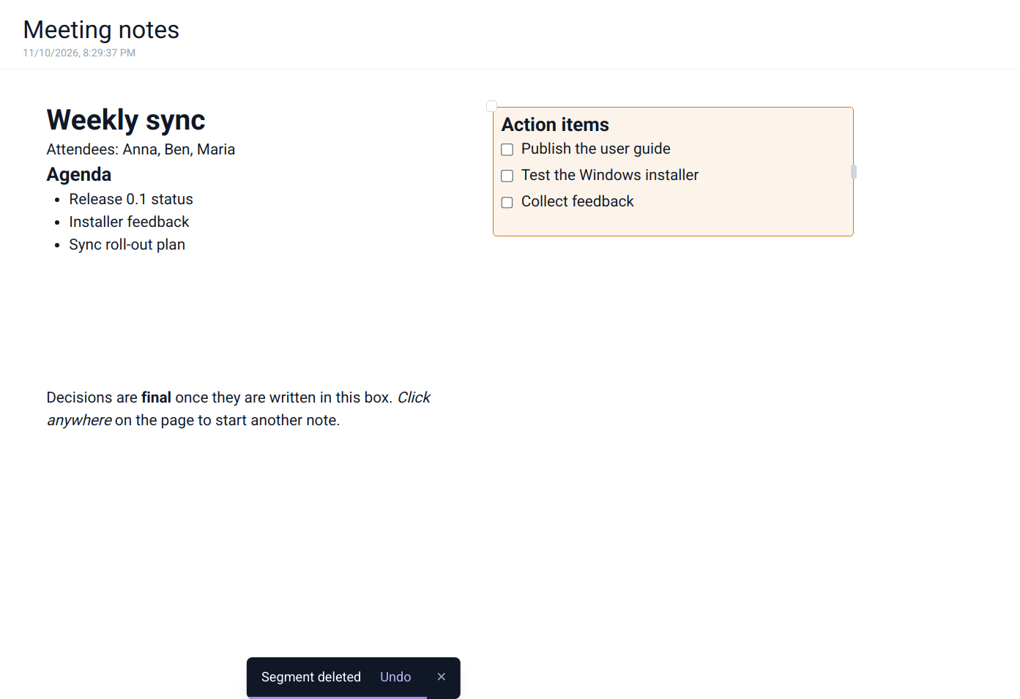
Figure: The Undo message after deleting a segment

3.5 Tidy by default
What it does. Empty segments remove themselves when you click away, so stray clicks never leave clutter behind. A coloured segment is kept even when empty, so you can use it as a placeholder.

3.6 Linear mode
What it does. Shows a page's segments as one continuous document, in reading order. It's the same content, just laid out like a normal document. Ideal for reading, reviewing or printing.
How to use it. Click Canvas in the status bar to switch to Linear, and click again to switch back. Each page remembers its mode.
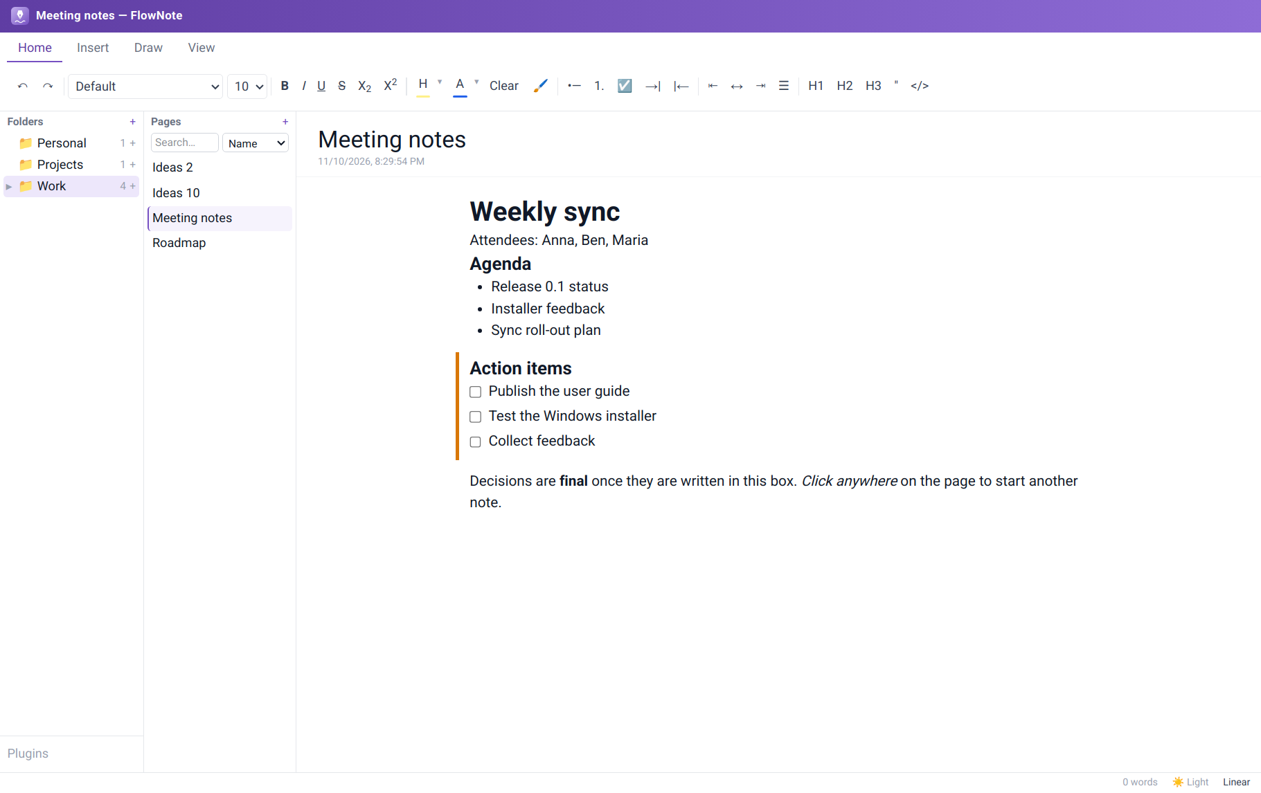
Figure: Linear mode

4. Text formatting
Figure: The Home tab of the ribbon

4.1 Fonts and text styles
What it does. Choose the font family and size; apply bold, italic, underline, strikethrough, subscript and superscript; highlight text and change its colour, each from a palette.
How to use it. Select text and click a button, or use the keyboard shortcuts in the User Guide. The small ▾ next to Highlight and Text colour opens their colour choices.
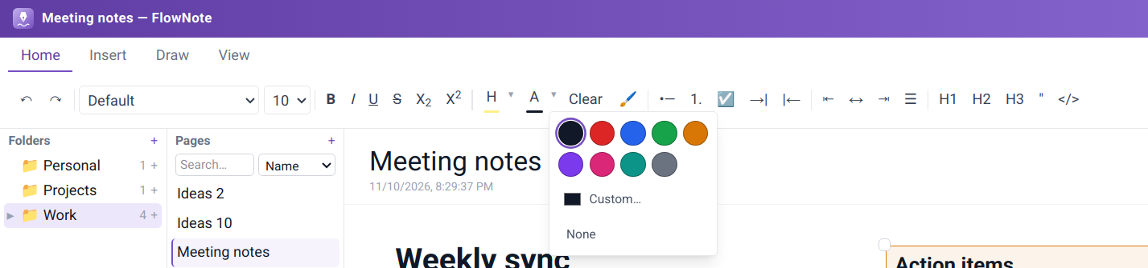
Figure: Text colour choices

4.2 Lists, checklists and alignment
What it does. Bulleted and numbered lists, checklists with tick boxes, indent and outdent for nesting, and left, centre, right or justified alignment.
How to use it. Use the Lists and Alignment groups, or Tab / Shift+Tab inside a list. Click a checklist box to tick it.

4.3 Headings, quotes and code
What it does. Three heading levels to structure a page, block quotes, and inline or block code.

4.4 Format Painter
What it does. Copies the formatting of one piece of text onto another, like the paintbrush in office suites.
How to use it. Select the text whose look you want, click the brush, then select the target text. Double-click the brush to paint repeatedly; click it again to stop.

4.5 Clear formatting, Undo and Redo
What it does. Clear strips all formatting from the selection. Undo and Redo step backwards and forwards through your changes.

4.6 Live spell check
What it does. Underlines misspelled words as you type. Right-click one for suggestions, or choose Add to Dictionary so it isn't flagged again. Your dictionary is kept with your notes.

5. Inserting content

5.1 The "/" block menu
What it does. A quick way to insert any kind of block without leaving the keyboard: text, three heading levels, bulleted and numbered lists, checklist, quote, code block, blocks from plugins, and Ask AI.
How to use it. Type /, use ↑ ↓ and Enter (or click), or Esc to close.
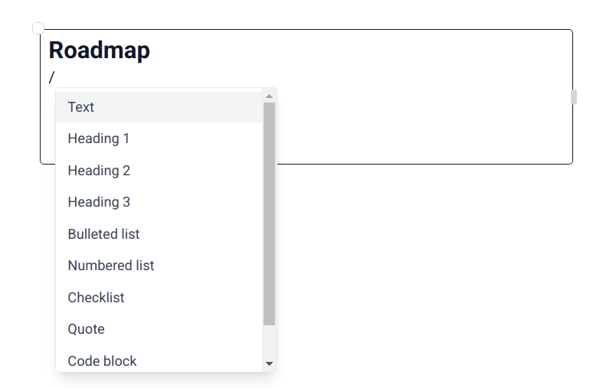
Figure: The "/" menu

5.2 Code blocks with syntax highlighting
What it does. Monospaced code blocks with colour highlighting for many programming languages. The chosen language is saved with the note.
How to use it. Insert a code block from the "/" menu or the ribbon (</>), then choose the language from the drop-down in its corner.
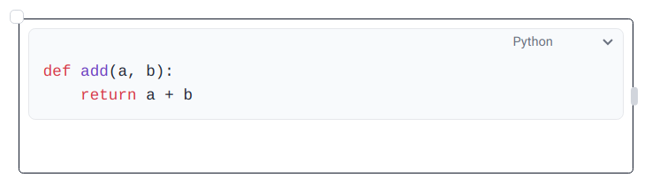
Figure: A Python code block

5.3 Pictures and file attachments
What it does. Paste files and pictures straight into a note. Pictures are shown inline. Other files can be attached as a compact chip (icon, name, size) that opens in its usual app, or embedded as an inline preview. Files are copied into FlowNote's own storage, so notes keep working if the original moves.
How to use it. Copy a file or picture and press Ctrl+V in a segment. Screenshots embed immediately; for other files choose Attach as file or Embed in note. Drag an embedded item's corner to resize it.
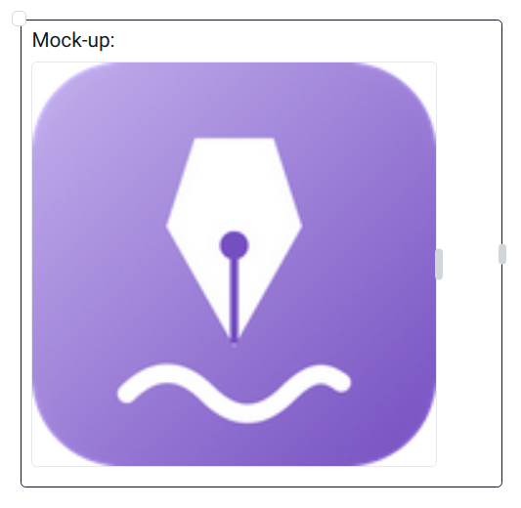
Figure: A pasted picture

6. Drawing and ink
What it does. Draw or handwrite anywhere on a page, over and around your text: sketches, diagrams, arrows, signatures. Ink is saved with the page.
How to use it. Open the Draw tab and choose Pen (solid line), Marker (translucent, like a highlighter) or Eraser, and one of five colours. Draw with the mouse, touchpad or a pen tablet. Go back to Home to type again.
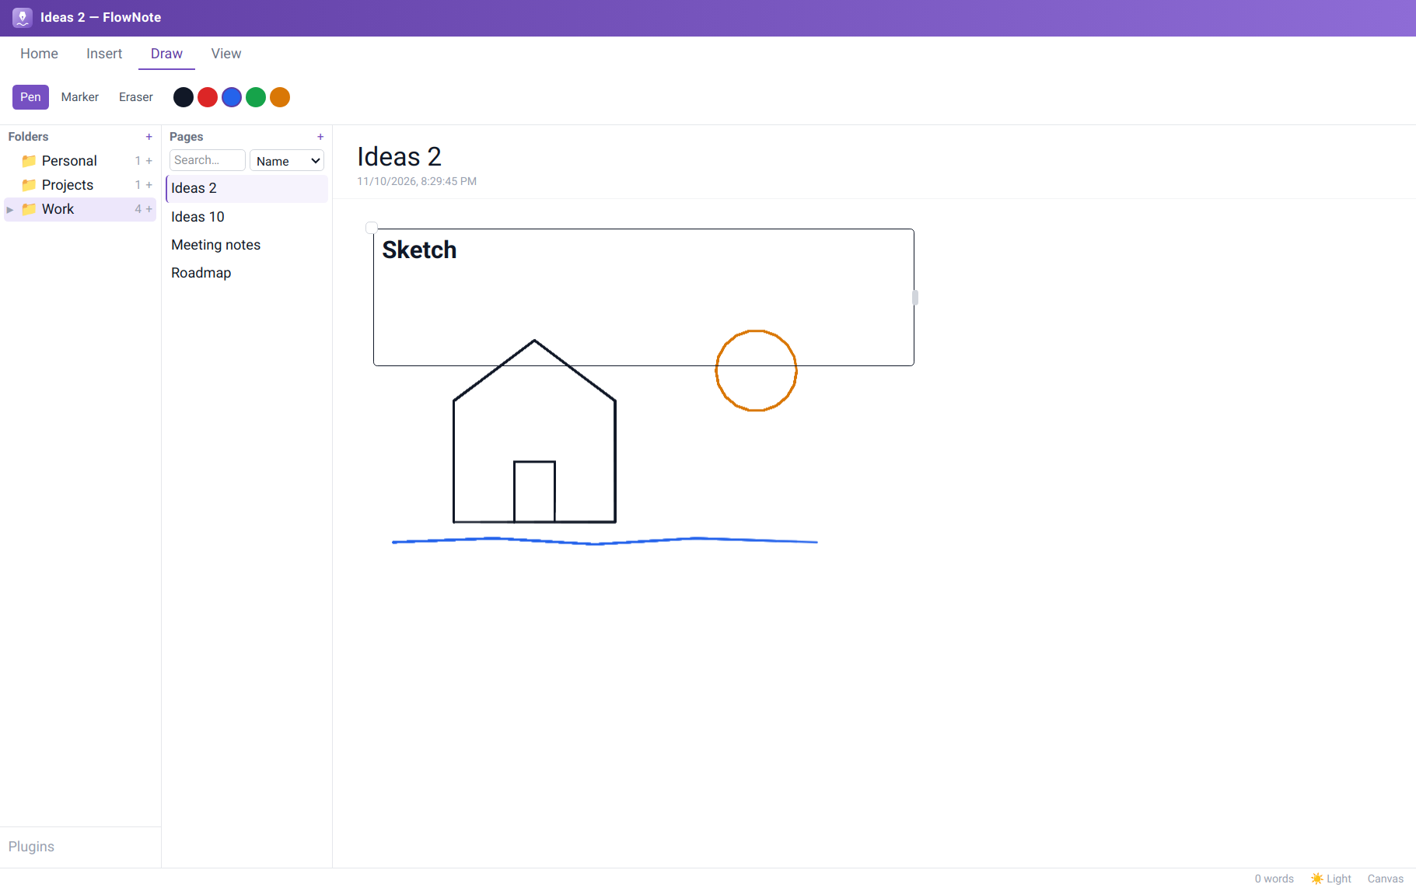
Figure: Pen strokes in three colours

7. Appearance

7.1 Light and dark theme
What it does. A full dark theme for evening work, a light theme, or System to follow your computer's setting automatically.
How to use it. Click the theme button in the status bar to cycle System → Light → Dark.
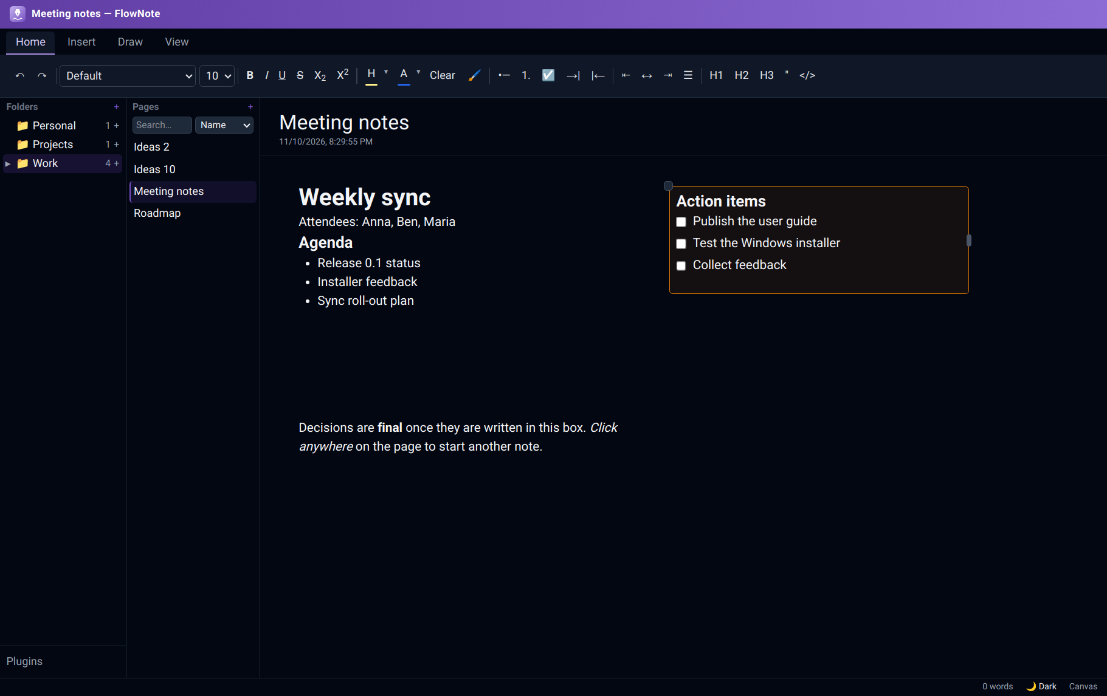
Figure: Dark theme

7.2 Page colours
What it does. Gives a page a background colour: a paper tone (Ivory, Sepia, Cream, Mint, Sky, Lavender, Rose, Grey), any of 100 shades, or any colour at all from the colour wheel. Set it for one page, or as the default for all pages. Dark colours work too: the editor's text turns light to stay readable.
How to use it. View → Page colour. Choose This page or All pages under Apply to, then pick from Paper, Shades (ten colour families, darkest to lightest) or Recent. Use default / White removes the colour.
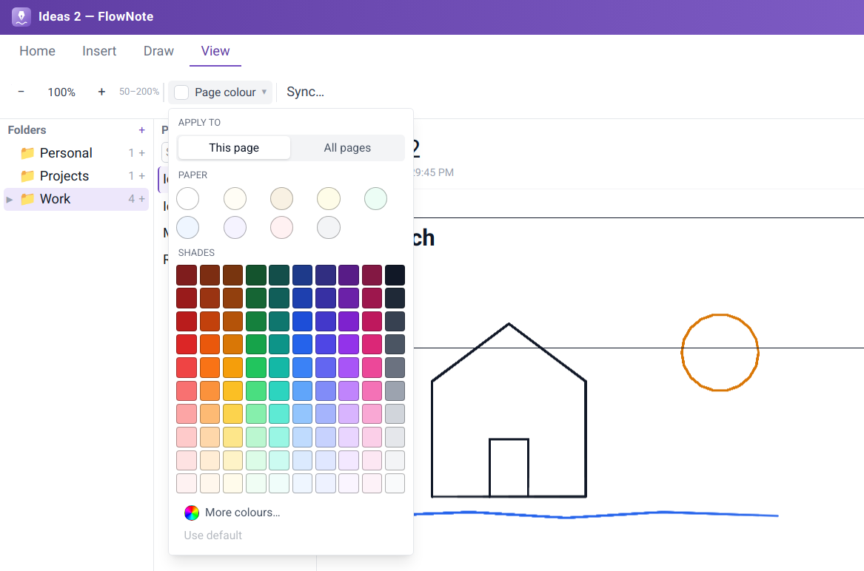
Figure: Apply to, paper tones and the shade grid
The colour wheel. More colours… opens a colour wheel inside the menu. Drag on the wheel (or use the arrow keys) to choose hue and strength, set Brightness with the slider, or type a hex code. The preview compares the current and new colour; Apply sets it and adds it to Recent, Cancel goes back.
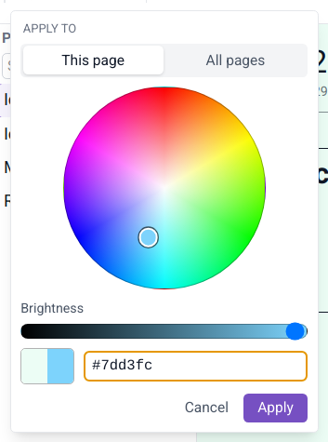
Figure: The in-app colour wheel

7.3 Contrast assistant
What it does. Watches for coloured text that becomes hard to read on the page colour you picked, and offers to fix it. Nothing changes unless you ask.
How to use it. When the notice appears, choose Adjust (recolour the affected text so it's readable), Show me (briefly highlight it) or Keep (leave it and don't ask again for this colour).
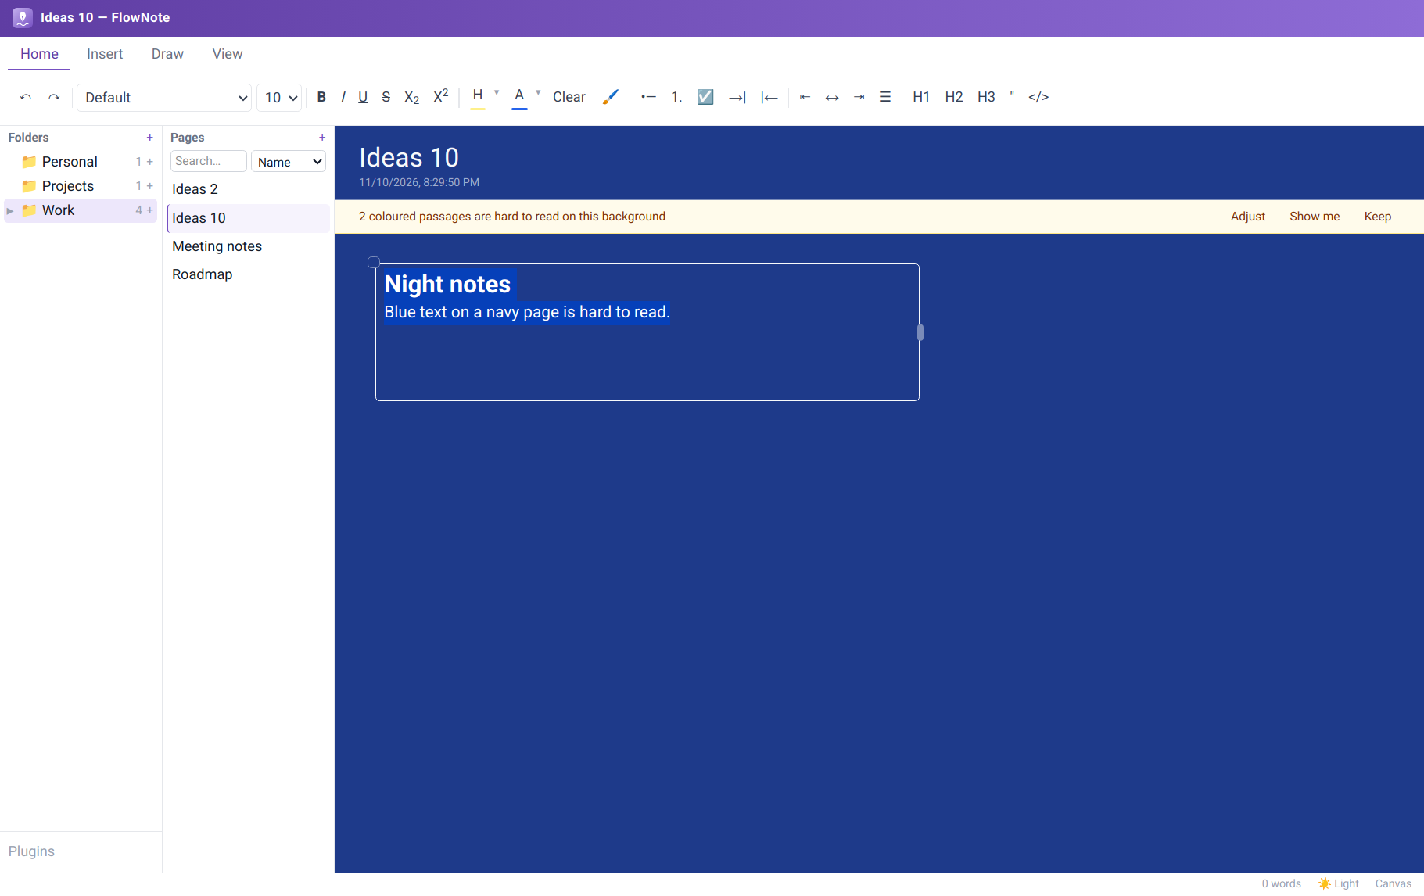
Figure: The contrast notice…
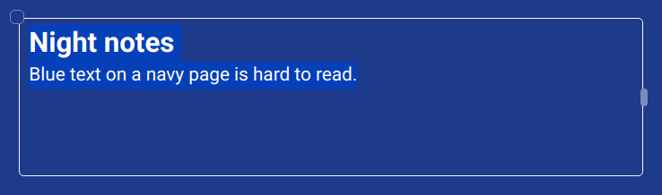
Figure: …and the same text after Adjust

7.4 Zoom and resizable panels
What it does. Zoom the canvas from 50% to 200% (View tab), and drag the borders between the folder, page and editor panels to give each the room you need.

7.5 Status bar
What it does. Shows the sync state, the theme switch, and the page's editing mode (Canvas or Linear), each clickable.
Figure: The status bar

8. Search
What it does. Finds pages in two ways. Name matches page names. Contents searches the full text of every page in every folder, using a fast full-text index kept up to date as you type.
How to use it. Type in the search box at the top of the Pages panel and pick Name or Contents from the drop-down. Click a result to open it.
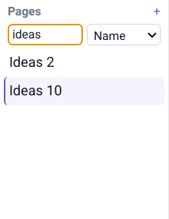  Figure: By name: "ideas" | 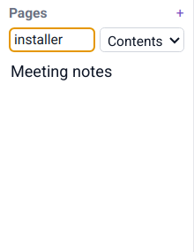  Figure: By contents: "installer"

9. AI writing assistant
What it does. Drafts text for you from a prompt: summaries, outlines, rewrites, ideas. You choose the AI service, and nothing is sent anywhere until you set one up and ask. Supported services:
Service | Needs | Where your text goes
Ollama (local) | Ollama running on your computer | Nowhere. It stays on your computer
Claude (Anthropic) | An API key | Anthropic
Gemini (Google) | An API key | Google
OpenAI | An API key | OpenAI
Other OpenAI-compatible service | Its address (and key, if it needs one) | That service

How to set it up. On the Insert tab click ⚙ (AI settings), then Add provider. Pick a service, check the model name, paste an API key if needed, and save. Add several providers and mark one as the default.
  Figure: The Insert tab | 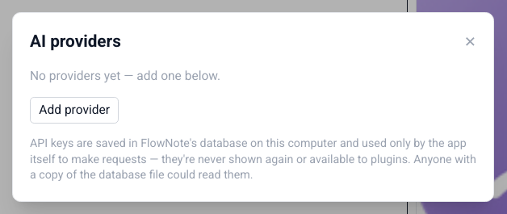  Figure: AI settings

How to use it. Type a request in the Ask AI… box on the Insert tab and click Generate, or type / in a segment and choose Ask AI… from the list. The answer streams into the segment as a tinted draft. Then choose Keep (Ctrl+Enter), Discard (Esc) or Try again. Stop ends a long answer early.
Note
API keys are stored in FlowNote's database on your computer and used only to make your requests. They're never shown again and are not available to plugins.

10. Plugins
What it does. Plugins add new kinds of blocks to FlowNote. Each plugin runs in its own sandbox and can only do what its manifest declares (for example, store its own data). The first plugin, Spreadsheet, adds a live grid you can type numbers and text into, inside any segment.
How to install a plugin. Click Plugins at the bottom of the Folders panel, then Install…. Paste the plugin's manifest and click Install. Untick Enabled to switch a plugin off, or click Uninstall to remove it.
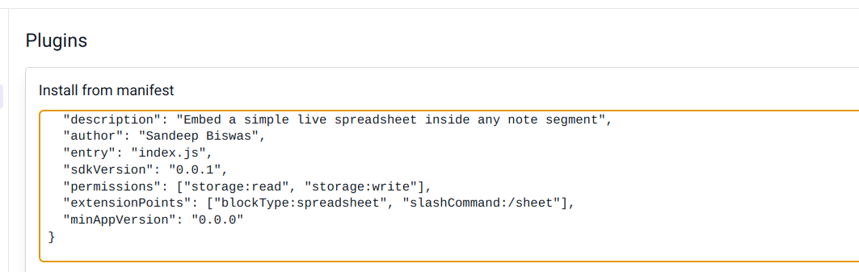
Figure: Installing a plugin from its manifest
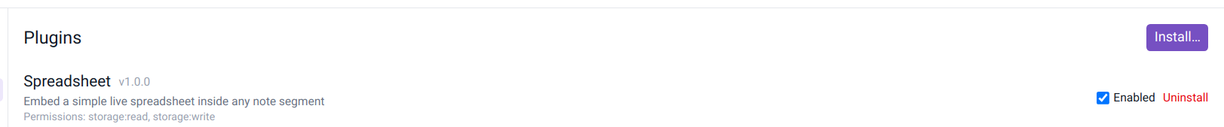
Figure: The Spreadsheet plugin, installed and enabled
How to use a plugin block. Type / in a segment. Plugin blocks appear in the menu after the built-in ones. Choose Spreadsheet to insert a grid.
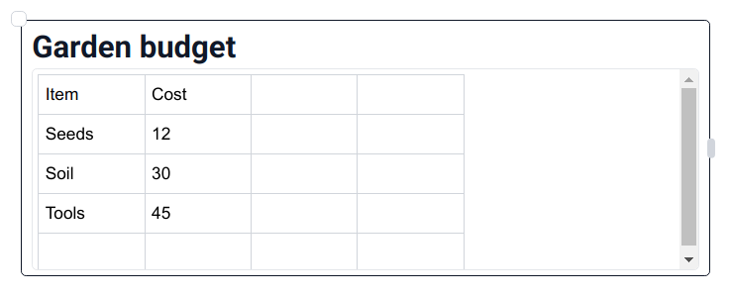
Figure: A Spreadsheet block in a note
Note
Known issue on Windows: in this version, plugins don't load in the Windows app, so Spreadsheet doesn't appear in the "/" menu there. Plugins work on Linux. A fix is planned.

Tip
Developers can build their own plugins with the FlowNote plugin SDK (@flownote/sdk) and the @flownote/cli scaffolding tool in the FlowNote source repository.

11. Backup & Sync
What it does. Keeps an encrypted copy of your notes in a place you choose, and keeps all your computers up to date with each other. FlowNote works offline first: you can write without a connection, and changes sync when you're back online.
- End-to-end encryption. Notes are encrypted on your device with your passphrase before they're uploaded. The storage provider only ever sees scrambled data.
- Your own storage. OneDrive (kept in Apps/FlowNote), Google Drive (a FlowNote folder), or any folder on your computer, which works with Dropbox, Syncthing, a USB drive or a network share.
- Safety copies. FlowNote saves a copy of your notes before it applies changes from other devices.
How to use it. View → Sync…, choose where to sync, sign in if needed, and choose a passphrase. On your other computers, choose the same place and enter the same passphrase.
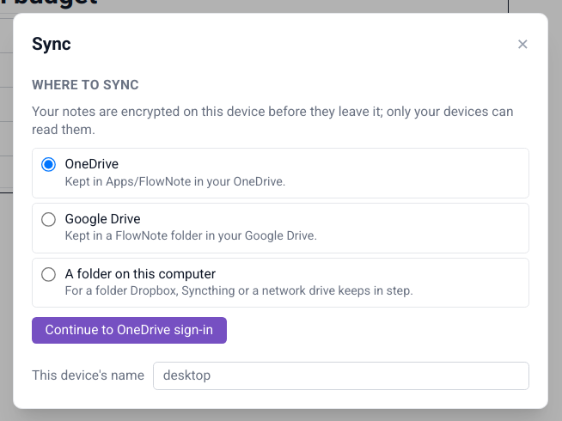
Figure: Choosing where to sync

11.1 Conflict handling
What it does. If the same segment was edited on two devices at the same time, nothing is lost: FlowNote keeps both versions side by side and marks the other device's copy with a badge. Keep what you need and delete the rest.

11.2 Mass-deletion safeguard
What it does. If another device deletes a large part of your notes at once (by accident, or because something went wrong), FlowNote holds those deletions and asks first. Apply carries them out here, Not now hides the question for this session, and Details opens the sync settings.

11.3 Sync status
What it does. The status bar always shows where things stand: Synced, Syncing…, Not synced yet, Sync needs attention or Sync error. Click it to open the sync settings.

12. Installers and uninstallers

12.1 Linux Linux
- One-file installer (.run): double-click it for a graphical, step-by-step install, or run it in a terminal for the same steps as text.
- Two install types: a system package for everyone (Debian/Ubuntu family), or a no-password install just for you on any distribution.
- Upgrade and repair: running a newer installer upgrades FlowNote in place; running the same version repairs it.
- Clean uninstall that asks whether to keep your notes, and removes menu entries and icons.
- Unattended use: --silent, --deb, --appimage, --remove-data, --keep-data.

12.2 Windows Windows
- Setup wizard with language choice, release notice, install folder and Start Menu folder choice, an optional desktop shortcut, and Run FlowNote on finish. Installs per user, no administrator rights needed.
- Start Menu folder with FlowNote, the User Guide, the Feature Guide and the uninstaller.
- MSI package for managed, all-users deployments.
- Clean uninstall from the Start Menu, Settings → Apps, or the standalone Uninstall FlowNote tool, with an option to delete your notes.
- Unattended use: setup.exe /S, msiexec /qn, Uninstall-FlowNote.ps1 -Silent.
See the FlowNote User Guide for step-by-step instructions.

