
USER GUIDE

FlowNote
Install FlowNote on Linux or Windows, and learn the everyday tasks: folders, pages, writing on the canvas, drawing, search, and keeping your notes safe.
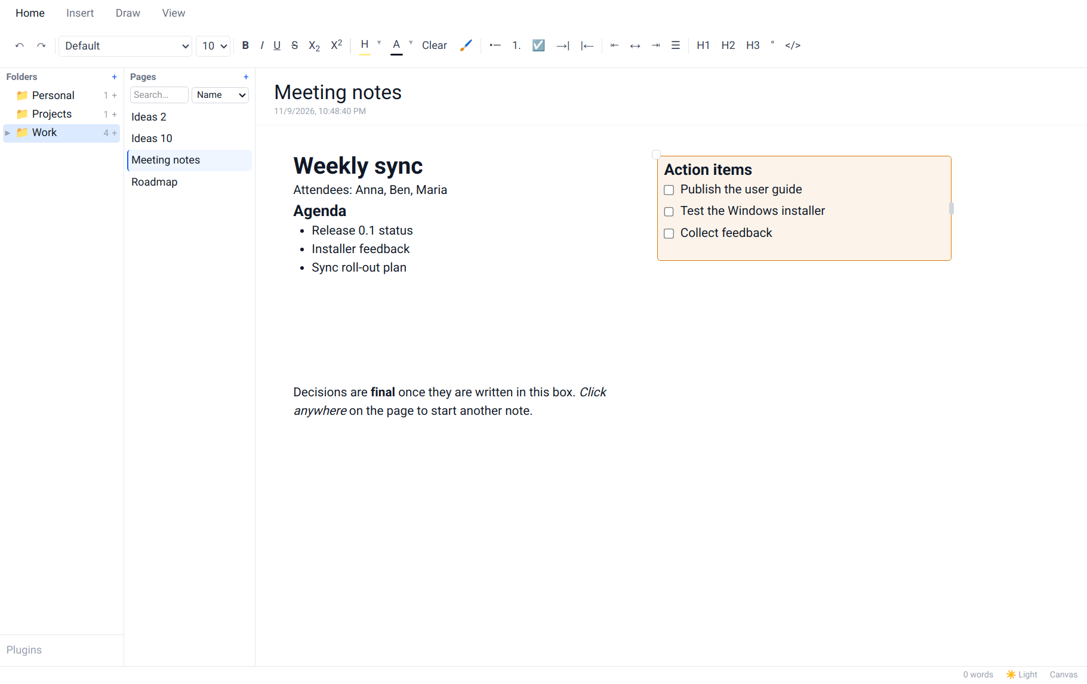
Version 0.1.0 · Linux · Windows
Contents
1. Welcome to FlowNote
1.1 What's in this guide
1.2 System requirements
2. Installing on Linux
2.1 The easy way: the one-file installer
2.2 From the bundle folder (terminal)
2.3 What gets installed where
3. Installing on Windows
3.1 Using the setup wizard (recommended)
3.2 Using the MSI package
3.3 Unattended installs
4. Uninstalling FlowNote
4.1 On Linux
4.2 On Windows
5. A tour of the window
6. Folders and pages
6.1 Creating your first page
6.2 Adding folders and sub-folders
6.3 Renaming, deleting and changing icons
6.4 Natural sort order
7. Writing on the canvas
7.1 Click anywhere and type
7.2 Moving, resizing, colouring and deleting segments
7.3 Formatting text
7.4 The "/" menu
7.5 Code blocks
7.6 Spell check
7.7 Canvas and Linear mode
8. Drawing and handwriting
9. Pictures and attachments
10. Finding notes
11. Making FlowNote look the way you like
11.1 Light and dark theme
11.2 Page colour
11.3 Zoom
12. Keeping your notes safe
12.1 Where your notes are stored
12.2 Backup & Sync
13. Keyboard shortcuts
14. Troubleshooting
15. Frequently asked questions

1. Welcome to FlowNote
FlowNote is a note-taking app with a free-form canvas. Click anywhere on a page and start writing: there are no fixed lines or boxes to fight with.
Notes are organised the way you'd organise a binder:
- Folders (left panel) hold related pages, and can contain sub-folders.
- Pages (middle panel) are the notes inside the selected folder.
- The editor (right) is the page itself: a canvas where every click on an empty spot starts a new block of text called a segment.
Everything is saved automatically as you type. There is no Save button.
What's new
- Many more colours. The Page colour and segment colour menus now offer a grid of shades for ten colour families (darkest to lightest), your recently used colours, and a built-in colour wheel under More colours….
- Delete a segment directly. Right-click a segment and choose Delete segment. Changed your mind? Click Undo, or press Ctrl+Z.
- Page names can start with a lowercase letter, and keep the case you type.
- Easier-to-see colour swatches. Every swatch now has a visible edge, so pale colours no longer blend into the menu.

1.1 What's in this guide
- Installing and uninstalling on Linux and Windows.
- A tour of the window, then step-by-step instructions for folders, pages, writing, formatting, drawing, attachments and search.
- Keeping your notes safe: where they're stored, and encrypted Backup & Sync.
- Keyboard shortcuts, troubleshooting and an FAQ.
The companion FlowNote Installation Guide has detailed step-by-step installation instructions and troubleshooting, and the FlowNote Feature Guide describes every feature in more depth.

1.2 System requirements
 | Linux | Windows
Operating system | 64-bit (x86_64) Linux. The system package needs a Debian/Ubuntu-based distribution; the per-user install works on any distribution. | Windows 10 or 11, 64-bit
Disk space | About 280 MB (system package) or 110 MB (just for me), plus your notes | Less than 100 MB, plus your notes
Other | A desktop environment. Graphical installer dialogs use zenity or kdialog if present. | Microsoft Edge WebView2 (included with Windows 11; the installer adds it on Windows 10 if needed)

2. Installing on Linux
Download FlowNote-<version>-linux-x86_64.run (the one-file installer), or the .tar.gz bundle that contains the same installer plus the individual packages.

2.1 The easy way: the one-file installer
- In your file manager, right-click the .run file and choose Properties → Permissions → Allow executing file as program. In a terminal you can run chmod +x FlowNote-*.run instead.
- Double-click the file. (Or run ./FlowNote-*.run in a terminal for a text-based installer with the same steps.)
- Read the welcome and release notice, then click Continue.
- Choose how to install:
  - For everyone on this computer installs a system package (Debian, Ubuntu, Linux Mint, Pop!_OS and similar). You'll be asked for your password.
  - Just for me needs no password and works on any distribution. FlowNote goes into your home folder.
- Wait a few seconds while FlowNote is copied, then choose whether to start it straight away.
FlowNote is now in your application menu (under Office), and you can also start it by typing flownote in a terminal.
Tip
If FlowNote is already installed, the installer offers to upgrade it (newer version) or repair it (same version). Your notes are never touched by an upgrade.

2.2 From the bundle folder (terminal)
Unpack the bundle and run its installer. Every question can also be answered with an option:
tar xzf FlowNote-<version>-linux-x86_64.tar.gz
cd FlowNote-<version>-linux-x86_64
./install.sh # guided install
./install.sh --appimage # just for me, no password
./install.sh --deb # for everyone (system package)
./install.sh --silent # no questions; picks the best option for this system
./install.sh --help # all options
Check that the download is intact with sha256sum -c SHA256SUMS in the bundle folder.

2.3 What gets installed where
Install type | Program | Command | Menu entry
For everyone (.deb) | /opt/FlowNote | /usr/bin/flownote | System-wide
Just for me (AppImage) | ~/.local/opt/flownote | ~/.local/bin/flownote | ~/.local/share/applications

Note
The "just for me" install is an AppImage, which normally needs the FUSE 2 library to start quickly. If your system doesn't have it, the installer sets FlowNote up to unpack itself on each start instead. That works fine but takes a few seconds longer. For faster starts, run sudo apt install libfuse2t64 (Ubuntu 24.04 and later; libfuse2 on older releases), then run the installer again.

Every install is logged to ~/.cache/flownote-install.log.

3. Installing on Windows
Download FlowNote-<version>-windows-x64.zip and unzip it (right-click → Extract All…).

3.1 Using the setup wizard (recommended)
- Double-click FlowNote_<version>_x64-setup.exe.
- Because the preview installers aren't code-signed yet, Windows may show "Windows protected your PC". Click More info, then Run anyway.
- Pick a language, then follow the wizard: Welcome → release notice (click I Agree) → install folder → Start Menu folder.
- On the last page, tick Create desktop shortcut if you want one, and leave Run FlowNote ticked to start it now.
The setup wizard installs for your user account only and does not need administrator rights. You'll find FlowNote in the Start Menu, together with FlowNote User Guide, FlowNote Feature Guide and Uninstall FlowNote.

3.2 Using the MSI package
If your organisation prefers Windows Installer packages, double-click FlowNote_<version>_x64_en-US.msi instead. It installs for all users and needs administrator rights.

3.3 Unattended installs
FlowNote_<version>_x64-setup.exe /S
msiexec /i FlowNote_<version>_x64_en-US.msi /qn

4. Uninstalling FlowNote
Important
Uninstalling FlowNote keeps your notes unless you choose to delete them. If you reinstall later, your notes are picked up again automatically.

4.1 On Linux
- Run uninstall.sh from the bundle folder (double-click it, or run it in a terminal). It asks you to confirm, then asks whether to also delete your notes.
- The "just for me" install keeps its own copy of the uninstaller, so you don't need the download: ~/.local/opt/flownote/uninstall.sh.
- For the system package you can also use sudo apt remove flownote or your software centre.
./uninstall.sh # asks before removing, and about your notes
./uninstall.sh --keep-data # removes FlowNote, keeps your notes
./uninstall.sh --remove-data # removes FlowNote and your notes

4.2 On Windows
Use any one of these:
- Start Menu → FlowNote → Uninstall FlowNote. On the confirmation page you can tick Delete the application data to remove your notes too.
- Settings → Apps → Installed apps → FlowNote → Uninstall.
- Double-click Uninstall FlowNote.cmd in the download folder. It finds either kind of install (setup wizard or MSI) and shows a small window with an Also delete my notes option.
From PowerShell:
powershell -ExecutionPolicy Bypass -File .\Uninstall-FlowNote.ps1
powershell -ExecutionPolicy Bypass -File .\Uninstall-FlowNote.ps1 -RemoveData
powershell -ExecutionPolicy Bypass -File .\Uninstall-FlowNote.ps1 -Silent -KeepData

5. A tour of the window
When you start FlowNote for the first time the window is empty. You'll create your first folder and page in the next chapter.
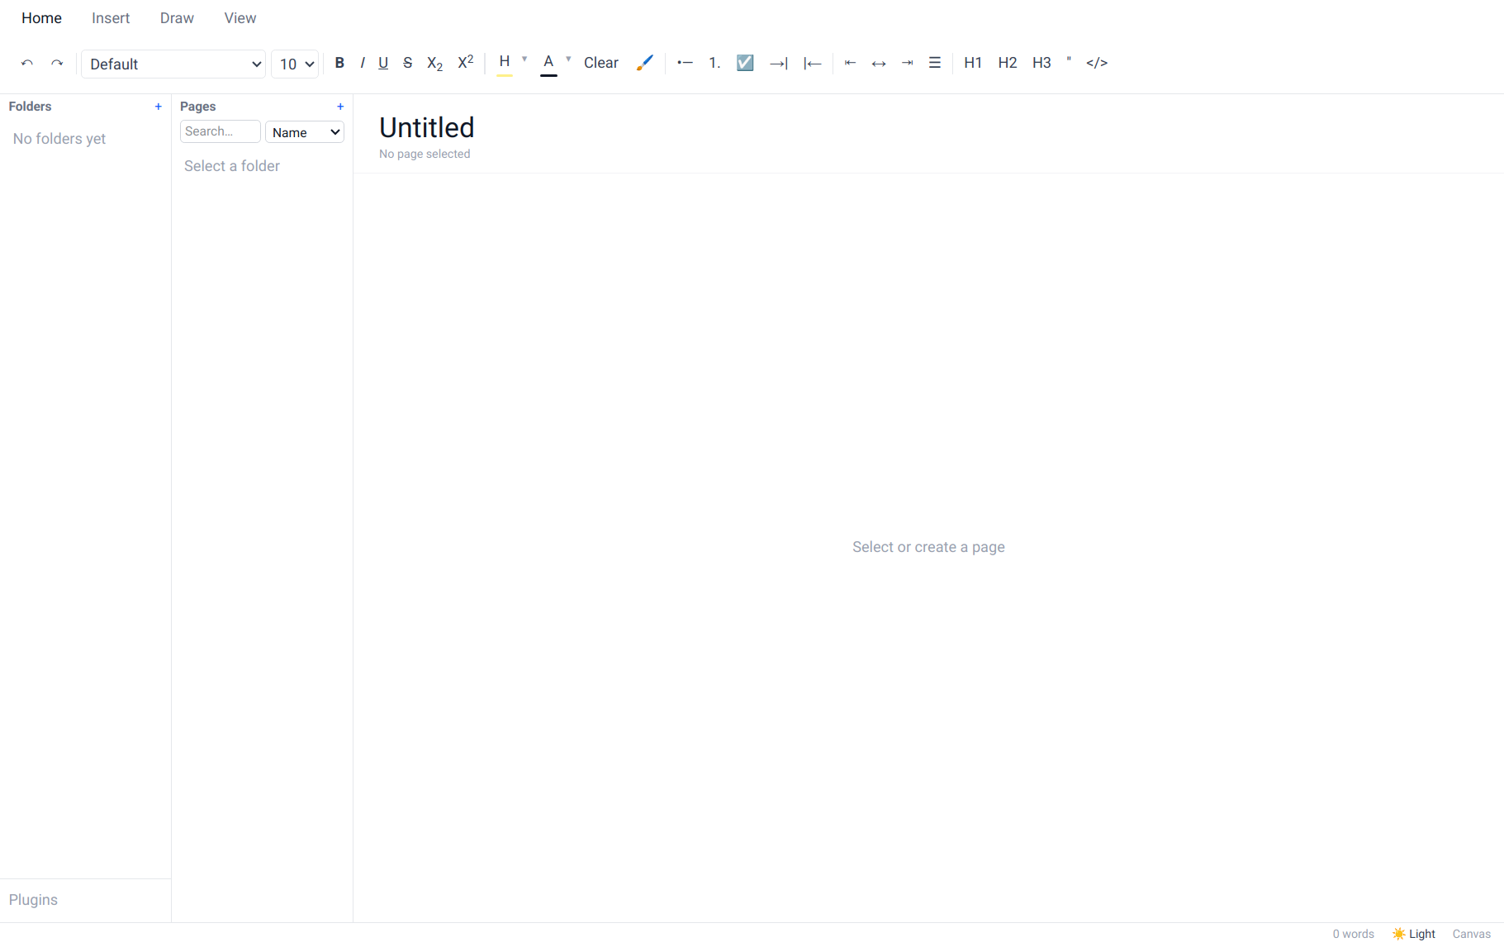
Figure: FlowNote on first launch
Once you have some notes, the window looks like this:
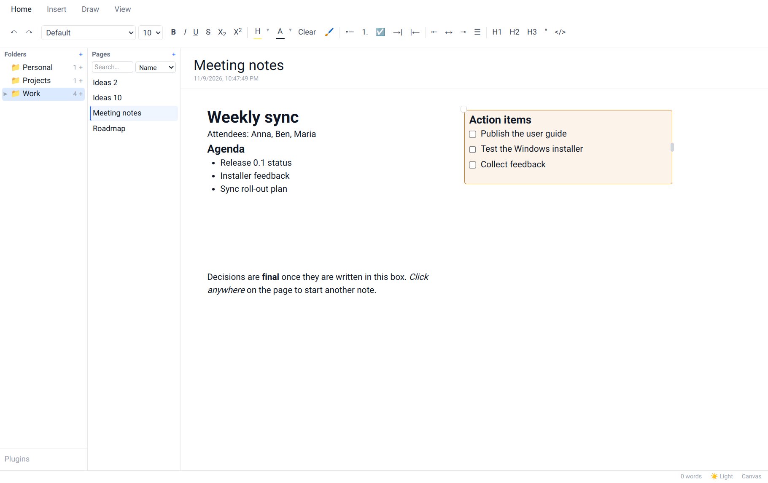
Figure: The main window
Area | What it's for
Ribbon (top) | Tabs of tools: Home (text formatting), Insert (AI), Draw (ink), View (zoom, page colour, sync).
Folders panel (left) | Your folders and sub-folders, each with a count of its pages. Plugins at the bottom opens the Plugin Manager.
Pages panel (middle) | The pages in the selected folder, a + button for a new page, and search.
Editor (right) | The page title and date, and the canvas you write on.
Status bar (bottom) | Sync status, the theme switch (System / Light / Dark), and the editing mode (Canvas / Linear).

Drag the thin borders between the panels to make them wider or narrower.

6. Folders and pages

6.1 Creating your first page
- Click + next to Pages (or right-click an empty part of a panel and choose New page).
- Choose New folder and type a folder name, or choose Existing folder and pick one. Click Next.
- Type the page name and click Create.
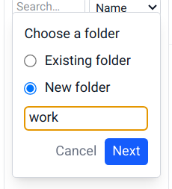  Figure: Step 2: choose or create a folder | 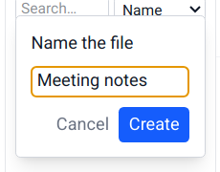  Figure: Step 3: name the page

Note
Page names must start with a letter, lowercase or capital (not a number or symbol), and keep the case you type: meeting notes stays meeting notes. Folder names are capitalised for you as you type: work becomes Work. The same page name can be used in different folders.

6.2 Adding folders and sub-folders
- New folder: click + next to Folders, type a name, press Enter.
- Sub-folder: hover over a folder and click its small +, or right-click the folder and choose New subfolder. Folders can be nested up to 7 levels deep.
- Move a folder: drag it onto another folder, or onto empty space to make it a top-level folder.
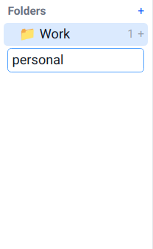  Figure: Typing a new folder name | 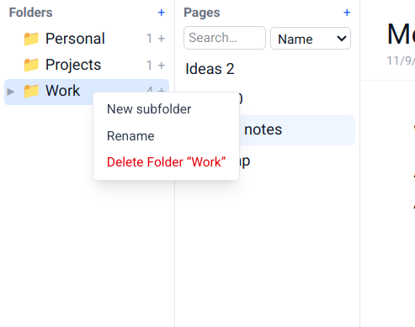  Figure: Right-click a folder for more actions

6.3 Renaming, deleting and changing icons
- Rename a folder from its right-click menu. To rename a page, edit its title at the top of the editor.
- Delete a folder or page from its right-click menu. You're asked to confirm. Deleting a folder deletes the pages inside it.
- Change a folder's icon: click the folder icon and pick a new one.
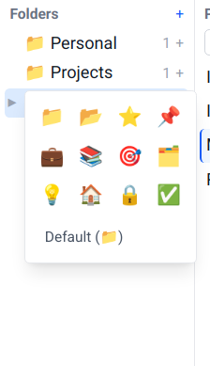
Figure: Choosing a folder icon

6.4 Natural sort order
Folders and pages are listed in "natural" order, so Ideas 2 comes before Ideas 10.
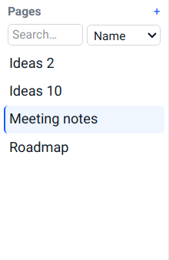
Figure: Pages sorted naturally

7. Writing on the canvas

7.1 Click anywhere and type
Click any empty spot on a page. A segment (a block of text) appears exactly there. Click inside it and start typing. Click somewhere else on the page to start another segment. Arrange segments side by side, in columns, or wherever suits your notes.
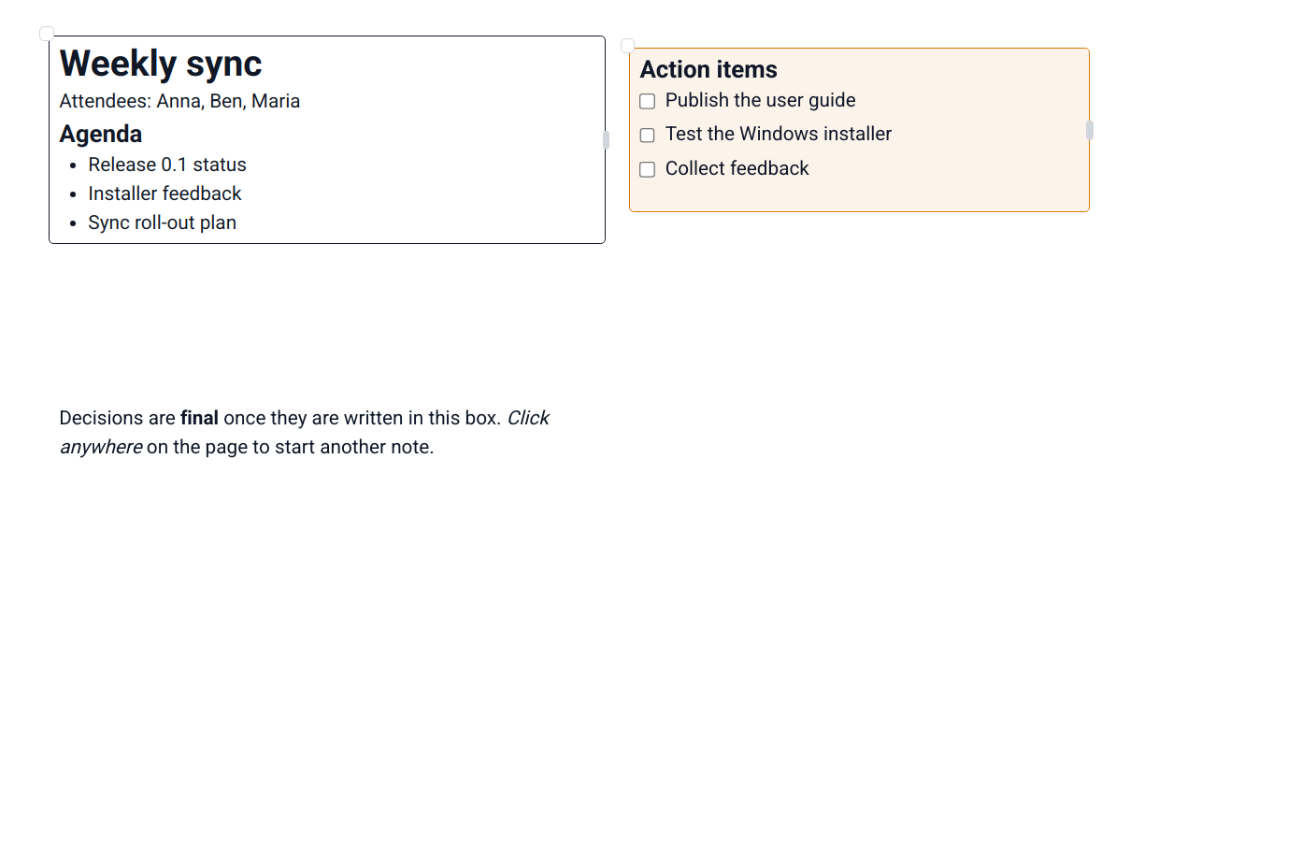
Figure: Segments placed freely on a page; the selected one shows its border and handles

7.2 Moving, resizing, colouring and deleting segments
- Move: drag the small circle at the segment's top-left corner.
- Resize: drag the small bar on the segment's right edge.
- Colour: right-click the segment (not on a misspelled word) and pick a colour. Its border and a soft background tint are coloured. The menu has nine quick picks, a grid of shades for ten colour families (darkest at the top), your recent colours, and More colours… for the colour wheel (see Page colour below). Choose None to remove the colour.
- Delete: right-click the segment and choose Delete segment (at the bottom of the menu). This works for any segment, even one with text or a colour.
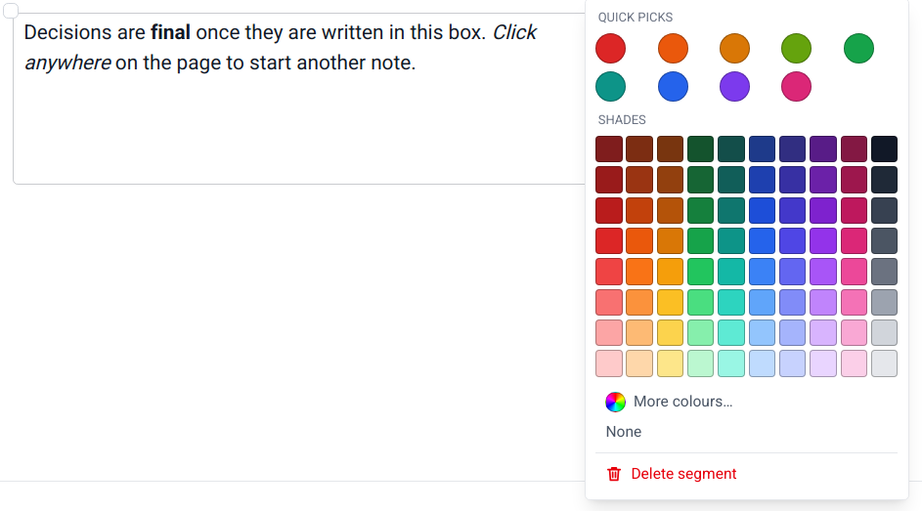
Figure: Right-click a segment to colour or delete it
After you delete a segment, a Segment deleted message appears at the bottom of the window for a few seconds. Click Undo (or press Ctrl+Z while you're not typing in a segment) to bring it back exactly as it was. Click ✕, or wait for the bar to run out, to make the deletion final.
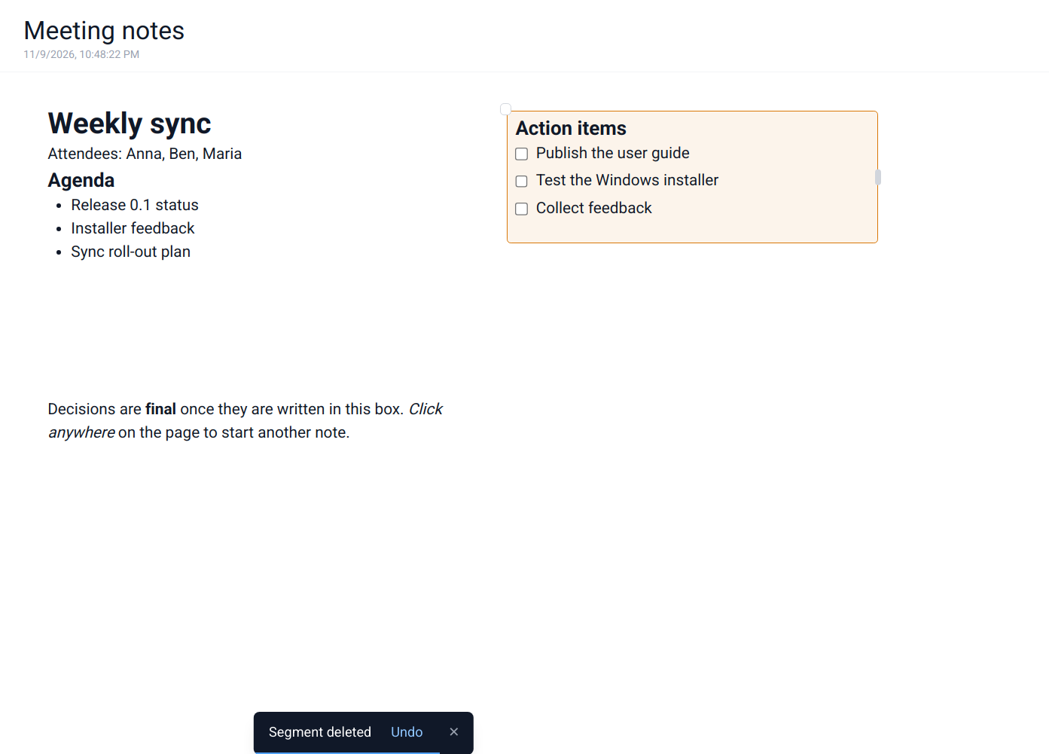
Figure: A deleted segment can be brought back with Undo
Tip
Empty segments still tidy themselves away: delete all of a segment's text and click elsewhere, and it disappears, unless it has a colour.

7.3 Formatting text
Select some text and use the Home tab of the ribbon:
Figure: The Home tab
Group | Buttons
History | Undo, Redo
Font | Font family (Default, Sans Serif, Serif, Monospace…), font size
Text style | Bold, Italic, Underline, Strikethrough, subscript, superscript, Highlight (with colour choices), Text colour (with colour choices), Clear formatting, Format Painter
Lists | Bulleted list, Numbered list, Checklist, Indent, Outdent
Alignment | Left, Centre, Right, Justify
Blocks | Heading 1, Heading 2, Heading 3, Quote, Code

Format Painter: select text whose look you like, click the brush, then select the text you want to look the same. Double-click the brush to keep painting until you click it again.

7.4 The "/" menu
Type / at the start of a line (or after a space) to insert a block without reaching for the ribbon. Use the arrow keys and Enter, or click. The list includes text, headings, lists, a checklist, a quote, a code block, any plugin blocks you've installed, and Ask AI.
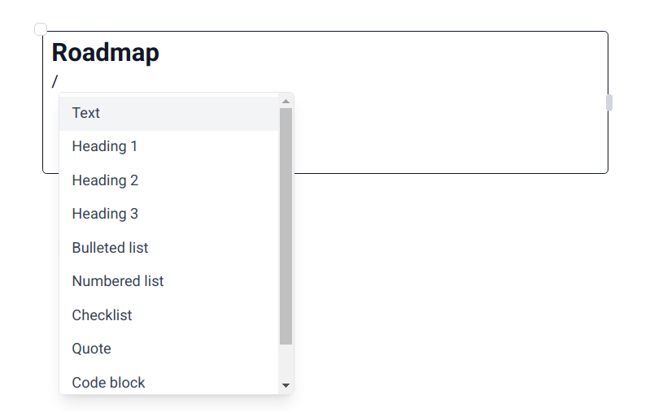
Figure: The "/" menu

7.5 Code blocks
Insert a Code block from the "/" menu or the ribbon, then pick its language in the top-right corner for syntax highlighting.
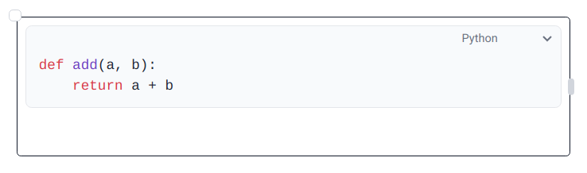
Figure: A code block with Python highlighting

7.6 Spell check
Misspelled words get a wavy red underline. Right-click one to see suggestions, or to add it to your dictionary.

7.7 Canvas and Linear mode
Each page has two ways to be viewed. Canvas mode (the default) is free placement. Linear mode shows the same segments as one continuous document, top to bottom, which is handy for reading or printing. Switch by clicking Canvas / Linear in the status bar.
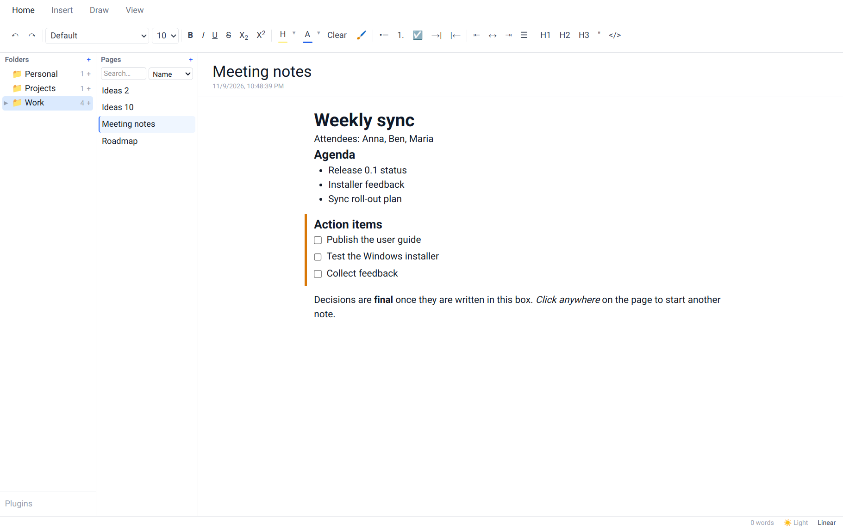
Figure: The same page in Linear mode

8. Drawing and handwriting
Open the Draw tab to draw anywhere on the page with the mouse, a touchpad or a pen.
- Pen draws a thin line, Marker a translucent, highlighter-style one, and Eraser removes strokes.
- Pick a colour from the swatches.
- Switch back to the Home tab to type again. Your drawing stays on the page.
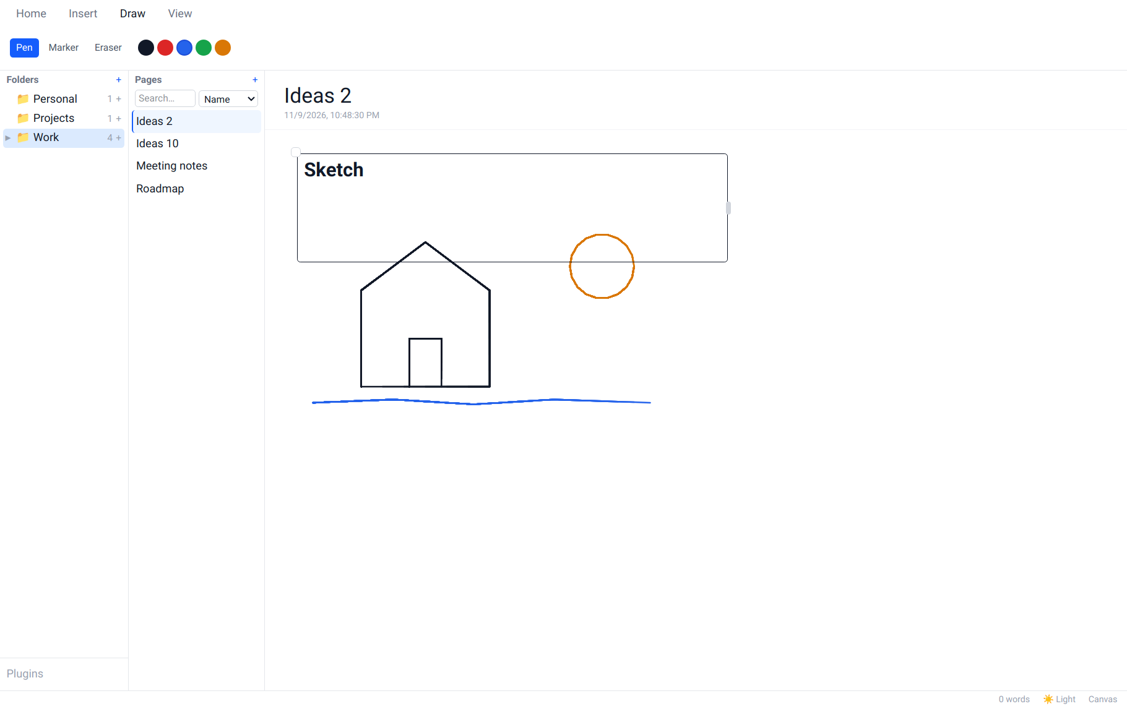
Figure: Drawing with the pen in different colours

9. Pictures and attachments
Copy a file or picture (for example in your file manager, or a screenshot) and paste it into a segment with Ctrl+V.
- Screenshots and copied images are embedded straight away.
- Other files ask how you want them: Attach as file shows a compact chip with the file name and size (click it to open the file), and Embed in note shows the file inline.
- Resize an embedded picture by dragging its corner.

Figure: An embedded picture
Note
Attached files are copied into FlowNote's own data folder, so the note keeps working even if you move or delete the original.

10. Finding notes
Use the search box at the top of the Pages panel. The drop-down next to it chooses what to search:
- Name finds pages whose name matches what you type.
- Contents finds pages whose text contains it, across all folders.
Click a result to open it. Clear the search box to go back to the folder's page list.
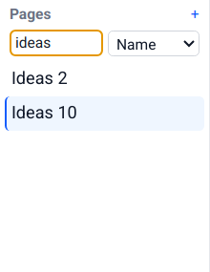  Figure: Searching by name | 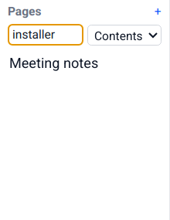  Figure: Searching by contents

11. Making FlowNote look the way you like

11.1 Light and dark theme
Click the theme button in the status bar to switch between System (follow your computer's setting), Light and Dark.
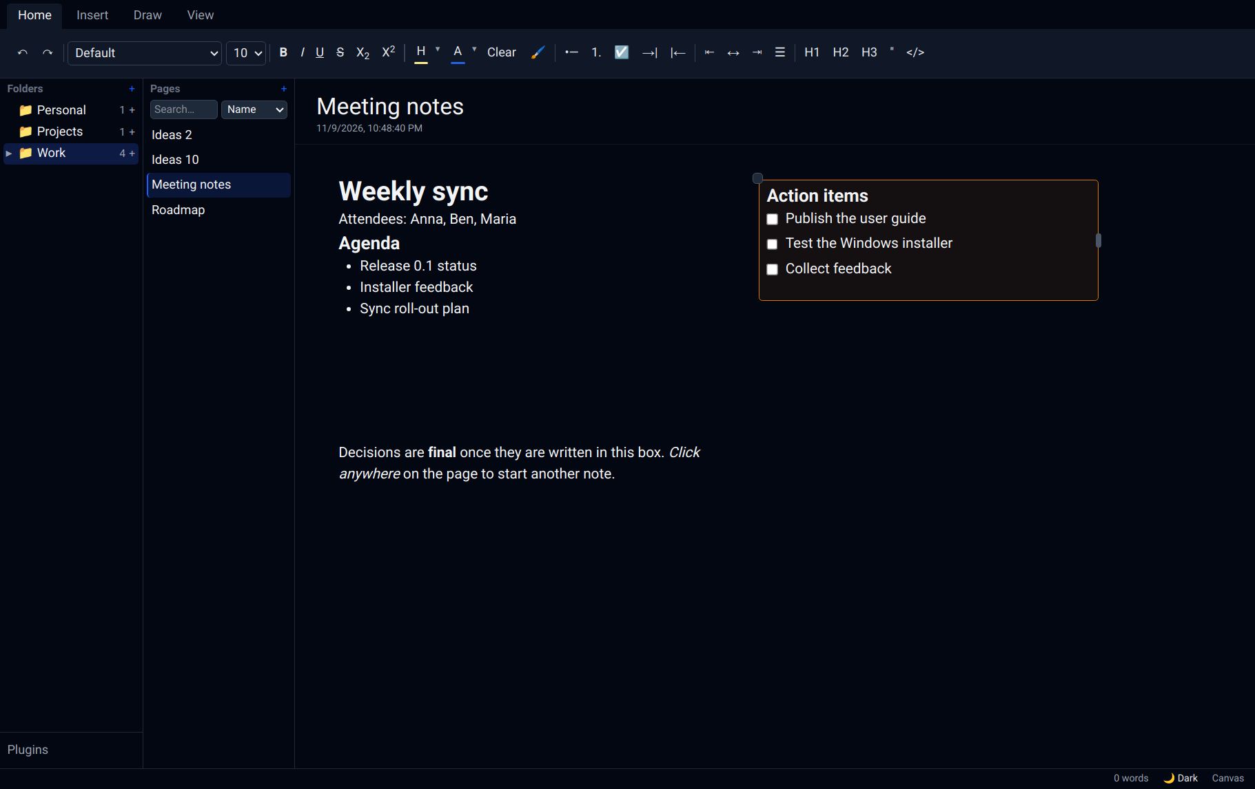
Figure: Dark theme

11.2 Page colour
On the View tab, click Page colour. Page colours show in the light theme.
- Under Apply to, choose This page or All pages (the default for every page that doesn't have its own colour).
- Pick a colour:
  - Paper: soft paper tones such as Ivory, Sepia and Mint.
  - Shades: ten colour families, each from darkest (top) to lightest (bottom). Dark colours are fine: the text turns light so it stays readable.
  - Recent: colours you recently chose on the colour wheel.
  - More colours…: opens the colour wheel.
- Use default (for this page) or White (for all pages) removes the colour.
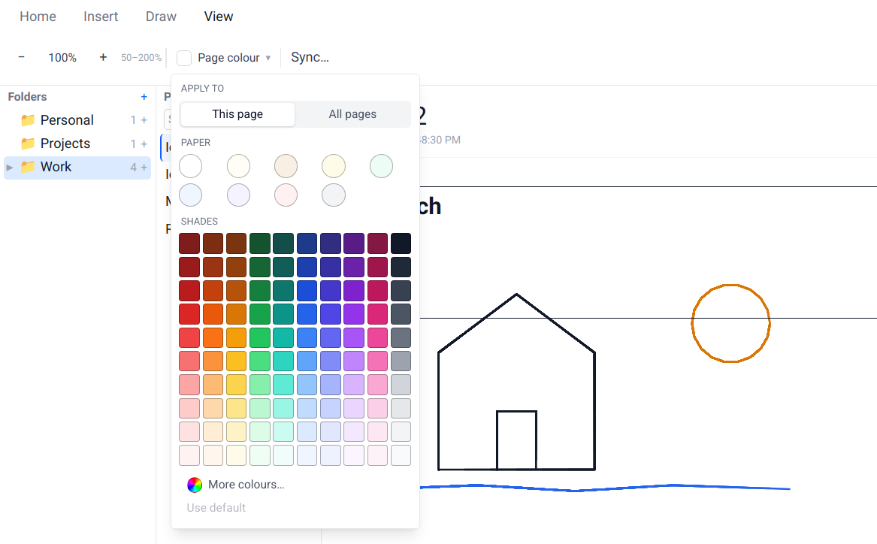
Figure: The Page colour menu on the View tab
On the colour wheel, drag across the wheel to choose the colour, use the Brightness slider to make it lighter or darker, or type an exact hex code such as #7dd3fc. The two squares compare the current and the new colour. Nothing changes until you click Apply; Cancel goes back to the palette.
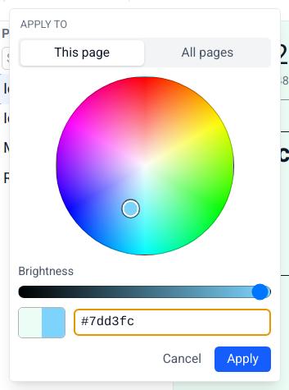
Figure: The colour wheel
If you choose a page colour that makes some coloured text hard to read, FlowNote tells you. Adjust fixes the colours for you, Show me highlights the affected text, and Keep leaves it as it is.
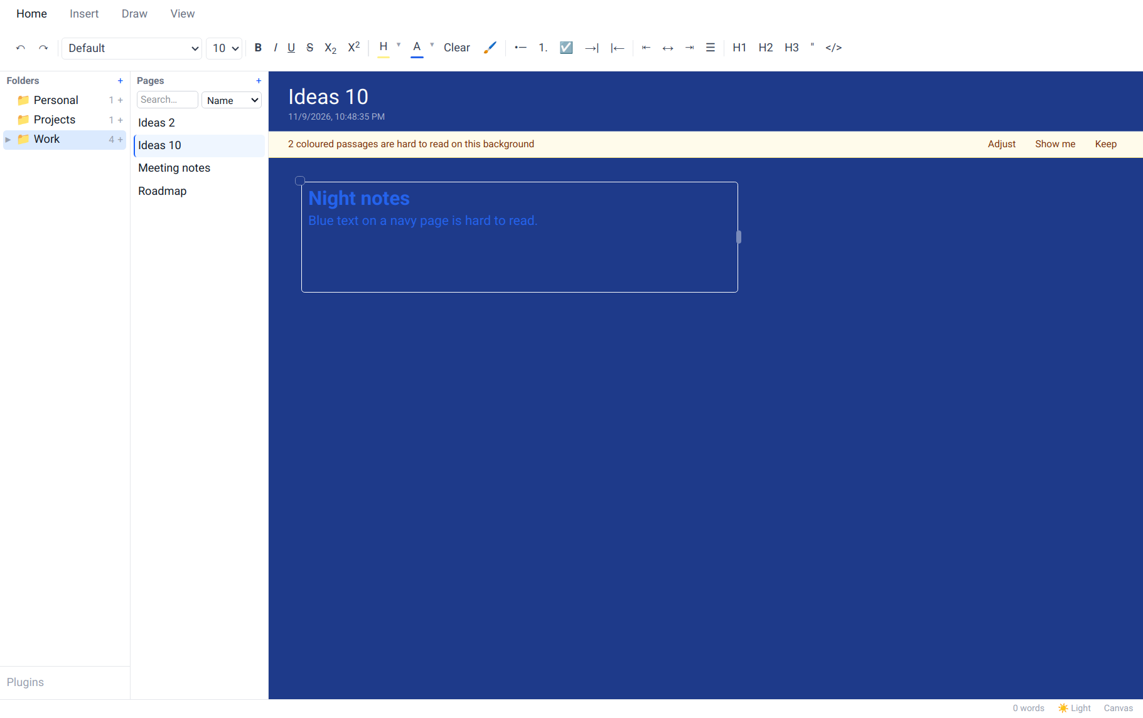
Figure: The contrast notice on a dark page

11.3 Zoom
The View tab has zoom out (−), zoom in (+) and a reset button that shows the current zoom level (50% to 200%).

12. Keeping your notes safe

12.1 Where your notes are stored
 | Linux | Windows
Notes database | ~/.config/@flownote/electron/flownote.sqlite3 | %APPDATA%\com.sandeep.flownote\flownote.sqlite3
Attached files | ~/.config/@flownote/electron/attachments/ | %APPDATA%\com.sandeep.flownote\attachments\
Copies made before syncing | ~/.config/@flownote/electron/backups/ | %APPDATA%\com.sandeep.flownote\backups\

To make a manual backup, close FlowNote and copy that folder somewhere safe.

12.2 Backup & Sync
Sync keeps an end-to-end encrypted copy of your notes in a place you choose, and keeps several computers in step. Your notes are encrypted on your computer before they leave it, so only your devices can read them, not the cloud provider.
- On the View tab, click Sync….
- Choose where to sync: OneDrive, Google Drive, or A folder on this computer (for example a Dropbox or Syncthing folder, or a network drive).
- For OneDrive or Google Drive, click Continue to … sign-in and sign in with your browser.
- Choose a passphrase. Use the same passphrase on every device you want to sync.
- Give this device a name, so you can tell your devices apart.
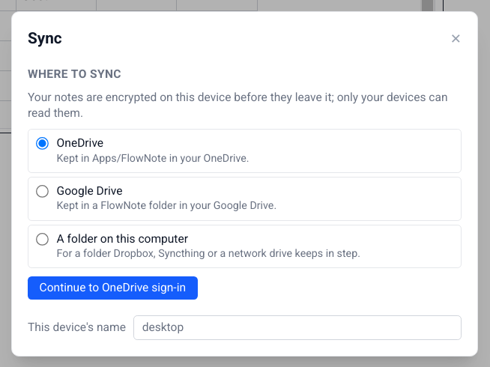
Figure: Sync settings
Important
Keep your passphrase somewhere safe. Without it, nobody (including you) can read the synced copy. Your notes on this computer are unaffected.

The status bar shows the sync state: Synced, Syncing…, Not synced yet, Sync needs attention or Sync error.
- Conflicts: if two devices edit the same segment at the same time, FlowNote keeps both versions and marks the other one with a badge. Keep what you need and delete the rest.
- Large deletions: if another device deletes a lot at once, FlowNote pauses and asks before applying it here (Apply, Not now or Details).

13. Keyboard shortcuts
These work while you're typing in a segment.
Action | Shortcut
Bold / Italic / Underline | Ctrl+B / Ctrl+I / Ctrl+U
Strikethrough | Ctrl+Shift+S
Subscript / Superscript | Ctrl+, / Ctrl+.
Highlight | Ctrl+Shift+H
Heading 1 / 2 / 3 | Ctrl+Alt+1 / 2 / 3
Bulleted list / Numbered list / Checklist | Ctrl+Shift+8 / 7 / 9
Indent / Outdent a list item | Tab / Shift+Tab
Quote | Ctrl+Shift+B
Code block | Ctrl+Alt+C
Insert block menu | /
Undo / Redo | Ctrl+Z / Ctrl+Shift+Z (or Ctrl+Y)
Undo deleting a segment (while the message shows) | Ctrl+Z, when you're not typing in a segment
Select all text in a segment | Ctrl+A
Paste a picture or file | Ctrl+V
Close a menu or dialog | Esc

14. Troubleshooting
Problem | What to do
Double-clicking the Linux .run file opens it as text | Make it executable (Properties → Permissions → Allow executing file as program), or run chmod +x FlowNote-*.run.
The Linux installer asks questions in a terminal instead of windows | Graphical dialogs need zenity or kdialog. Install one (e.g. sudo apt install zenity) or simply answer in the terminal.
FlowNote takes several seconds to start (just-for-me install) | Install FUSE 2: sudo apt install libfuse2t64 (or libfuse2), then run the installer again.
The system install fails | Check your password, and that no other software update is running. The log is in ~/.cache/flownote-install.log. Alternatively choose "Just for me".
Windows says "Windows protected your PC" | The preview installers aren't code-signed yet. Click More info → Run anyway.
flownote isn't found in a terminal (just-for-me install) | ~/.local/bin isn't on your PATH. Open FlowNote from the app menu, or run ~/.local/bin/flownote. Logging out and in again usually fixes the PATH.
Typing after clicking the page does nothing | Click inside the new segment first, then type.
"File name must start with a letter" | Page names can start with any letter, lowercase or capital, but not with a number or a symbol. Put a word first, e.g. Draft 2 instead of 2nd draft.
I deleted a segment by mistake | Click Undo in the message at the bottom of the window, or press Ctrl+Z, before it disappears (a few seconds).
The Spreadsheet plugin doesn't appear in the "/" menu on Windows | A known issue in this version: plugins don't load yet in the Windows app. It works on Linux. A fix is planned.
Sync says it needs attention | Open View → Sync… to see what's wrong. Often you just need to sign in again.

15. Frequently asked questions

Does FlowNote need an internet connection?
No. Everything works offline. The internet is only used for Backup & Sync to OneDrive or Google Drive, and for AI services you choose to set up.

Will uninstalling delete my notes?
Not unless you ask it to. Both the Linux and Windows uninstallers keep your notes by default.

How do I move my notes to a new computer?
Set up Backup & Sync on both computers with the same passphrase. Or close FlowNote, copy the data folder (see Where your notes are stored) to the same place on the new computer, and start FlowNote there.

Can I use FlowNote without segments, like a normal document?
Yes. Switch the page to Linear mode in the status bar.

Is my data sent to an AI service?
Only if you add an AI provider yourself (Insert → ⚙), and only the text you ask it about. With Ollama (local), nothing leaves your computer. See the Feature Guide for details.

