Case Study 2 - Problem Statement | Containerization using Docker Part – II

docker build -t docker-drupal-httpd:v1.0 .

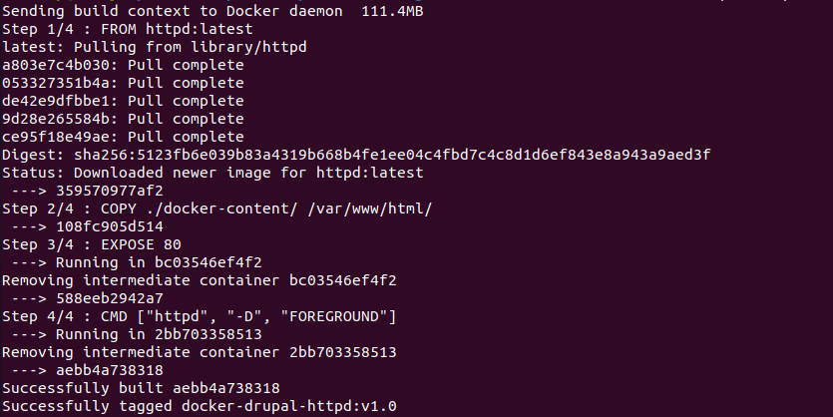
docker push sandeep10rana/docker-drupal:v1.0

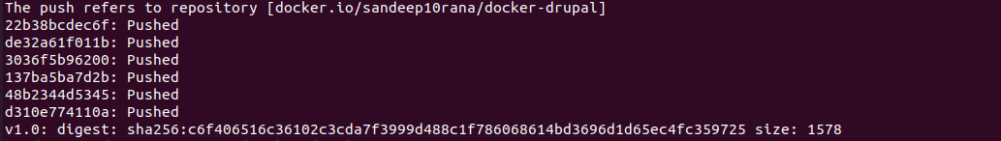
Docker Swarm cluster setup

Reference:

https://medium.com/google-cloud/docker-swarm-services-in-gcp-edcaa14913f8

Master Node

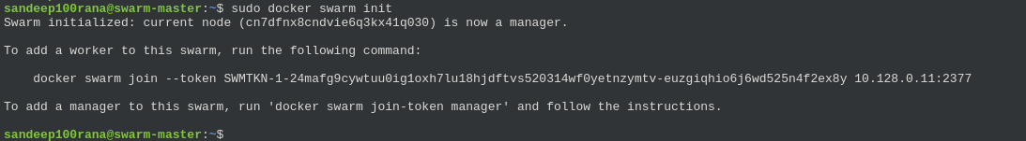
Worker Node

drupal-swarm.yaml

version: '3'

services:
web:
image: sandeep10rana/docker-drupal:v1.0
ports:
- "80:80"
volumes:
- website-data:/var/www/html/
deploy:
replicas: 1

volumes:
website-data:

Dockerfile

FROM httpd:latest

COPY ./docker-content/ /var/www/html/

EXPOSE 80

CMD ["httpd", "-D", "FOREGROUND"]

Deployment in Docker swarm cluster

docker stack deploy -c drupal-swarm.yaml my-drupal-website

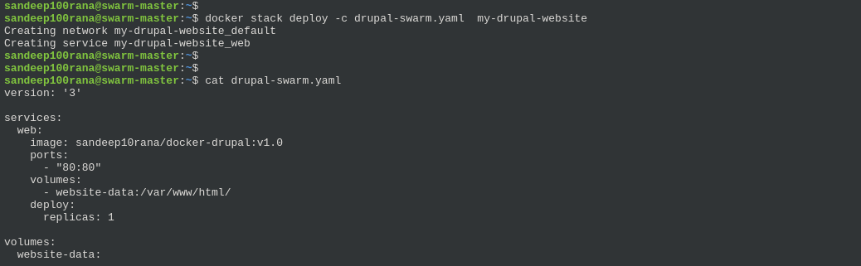
docker service ls

Docker service log

