Case Study Statement | Module 5: Configuration Management with Ansible

Ansible installation on Ubuntu

Reference:

https://docs.ansible.com/ansible/latest/installation_guide/installation_distros.html#installing-ansible-on-ubuntu

Steps:

- Create role hierachy structure using command
ansible-galaxy init tomcat_role
ansible-galaxy init maven_role

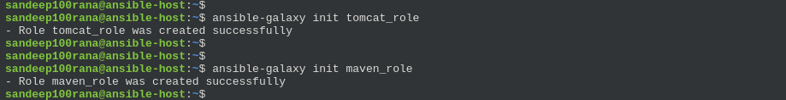
- Create role for each tomcat and maven task/main.yaml
- Generate key value pair at destination server
ssh-keygen -t rsa -b 4096

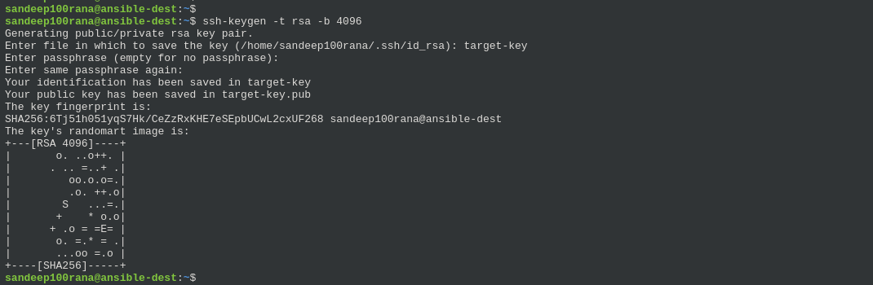
- Create inventory.yaml and provision.yaml

inventory.yaml

all:
hosts:
host1:
ansible_host: 10.128.0.15
ansible_user: sandeep100rana
ansible_ssh_private_key_file: /home/sandeep100rana/target-key

children:
ansible-dest:
hosts:
host1:

provision.yaml

- name: Provision Production Environment
hosts: ansible-dest
become: yes

roles:
- tomcat_role
- maven_role

- To execute playbook

ansible-playbook -i inventory.yaml -vvv provision.yaml

