Case Study 3 – Problem Statement | Container Orchestration using Kubernetes Part-II

NodeJS and MongoDB Pod

Service

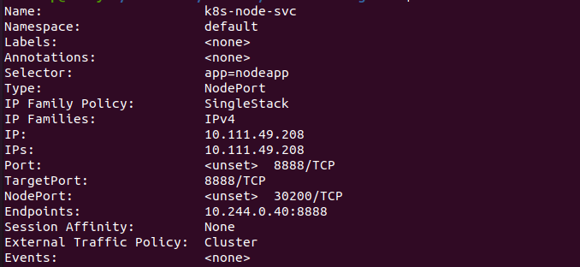
Output:

a.

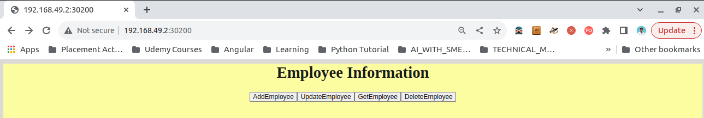
b.


c.


Reference:

https://hub.docker.com/r/devopsedu/employee

https://www.serverlab.ca/tutorials/linux/administration-linux/how-to-base64-encode-and-decode-from-command-line/

