**SCREENSHOTS:--**

**1. HOME:** It is home page of site where details of web and

some useful links will be given.

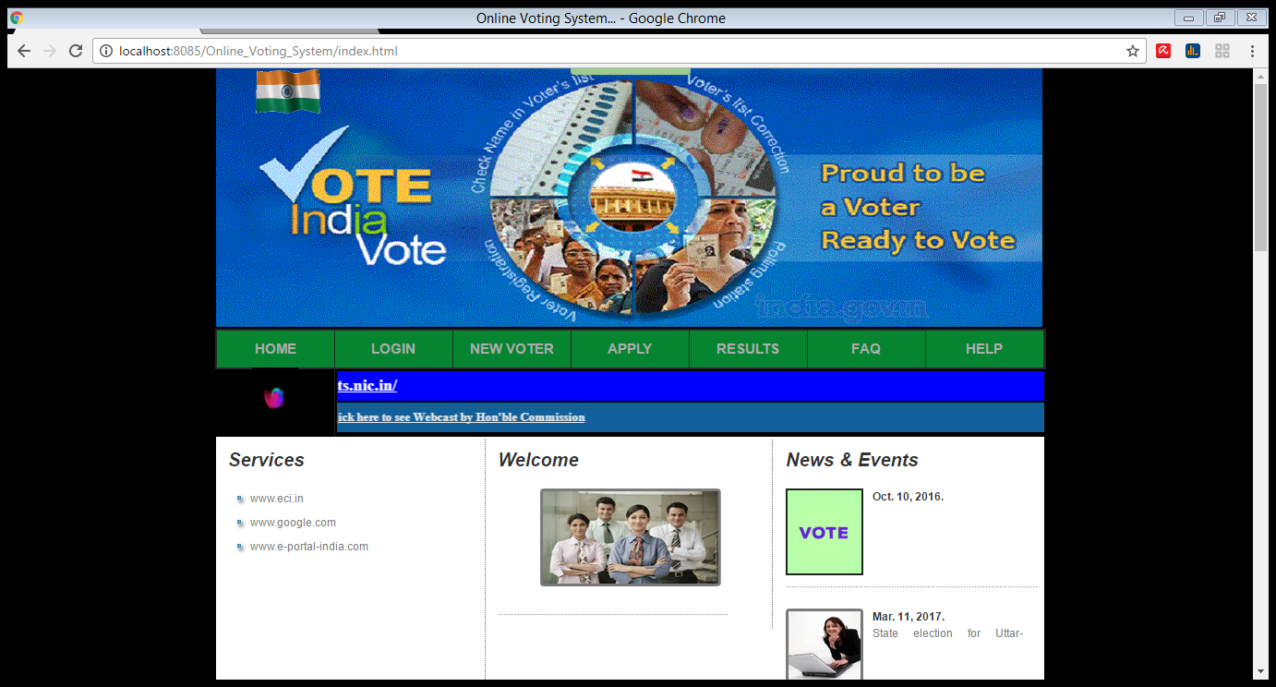

**2. LOGIN :** It is the login session for the admin and

voter for giving their precious vote .It is used to view

voter details from database.

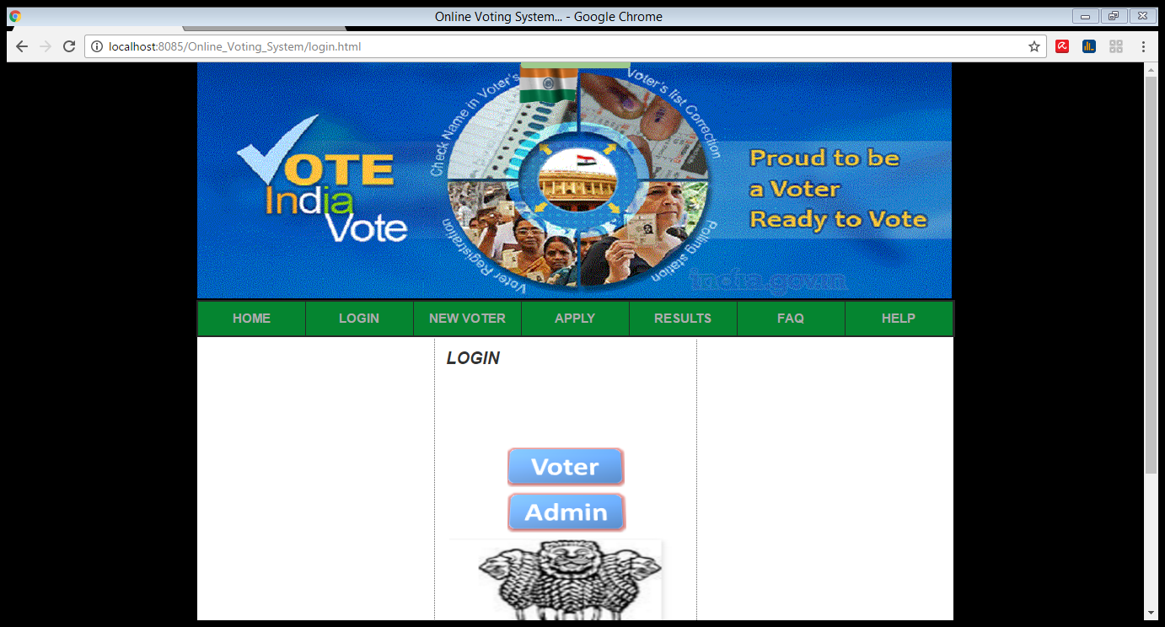

**USER WELCOME**

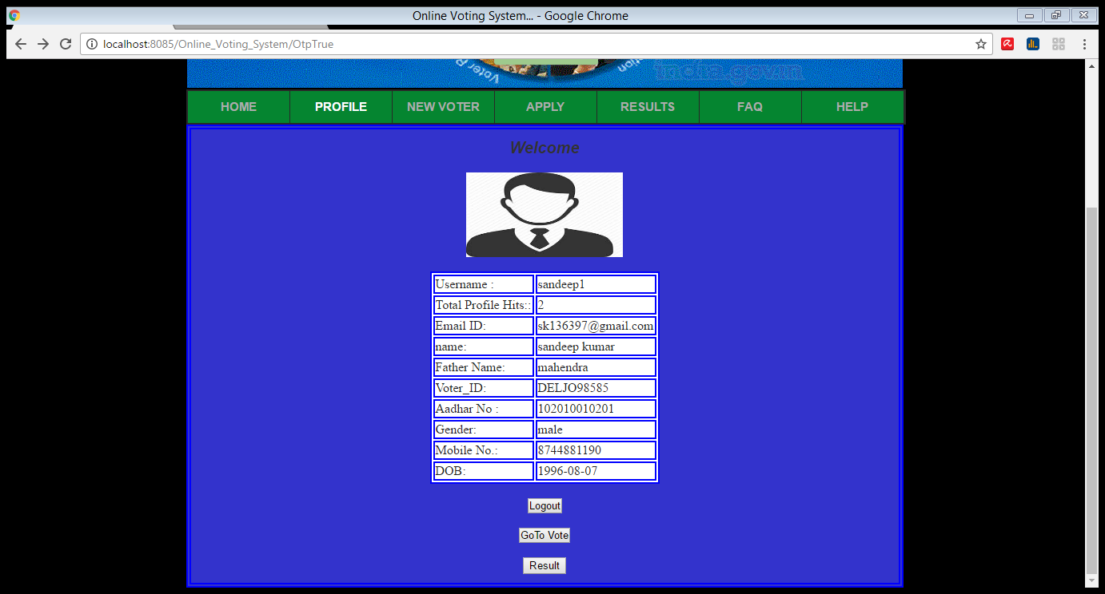

**POLLING PAGE..**

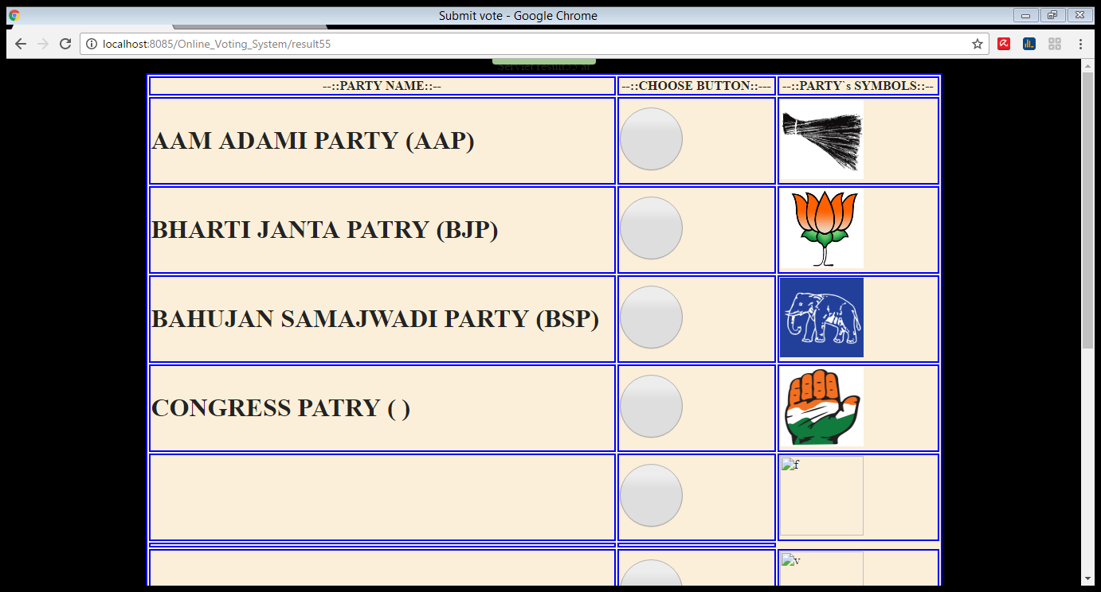

**3. NEW VOTER:** It is used to add a voter into database and it includes searching a voter from database.

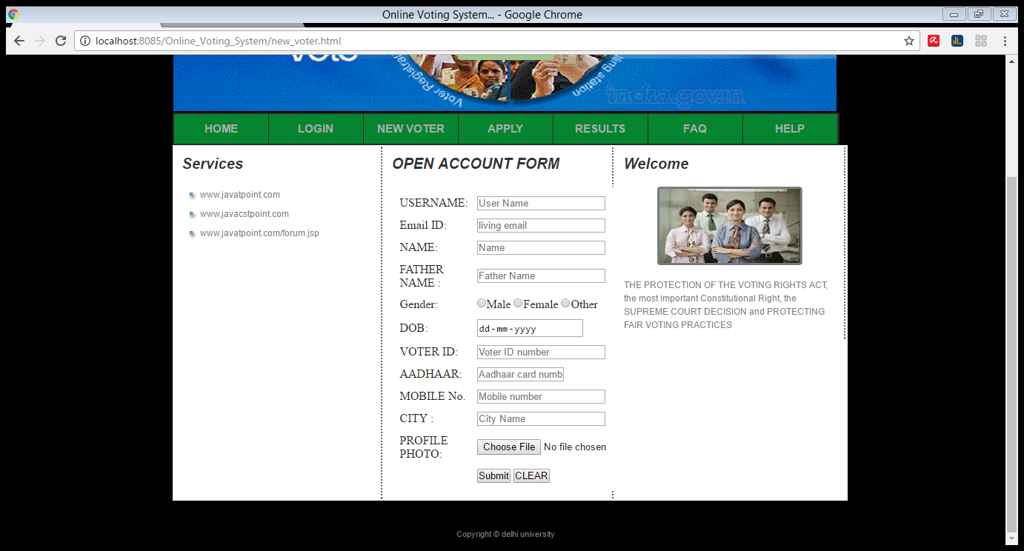

**4. APPLY:** It is used for applying different important

documents like aadhaar and voter id card.

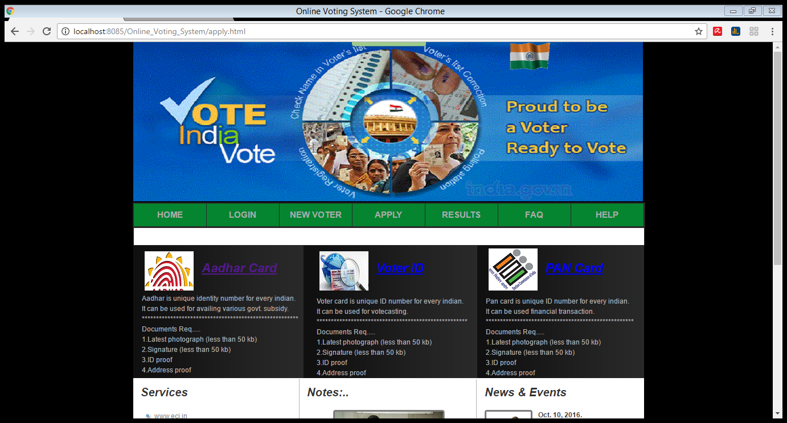

**5. RESULT:** Here the results of election will displayed

with details of candidates. It is used to get election

results and also reset database after all process is

completed.

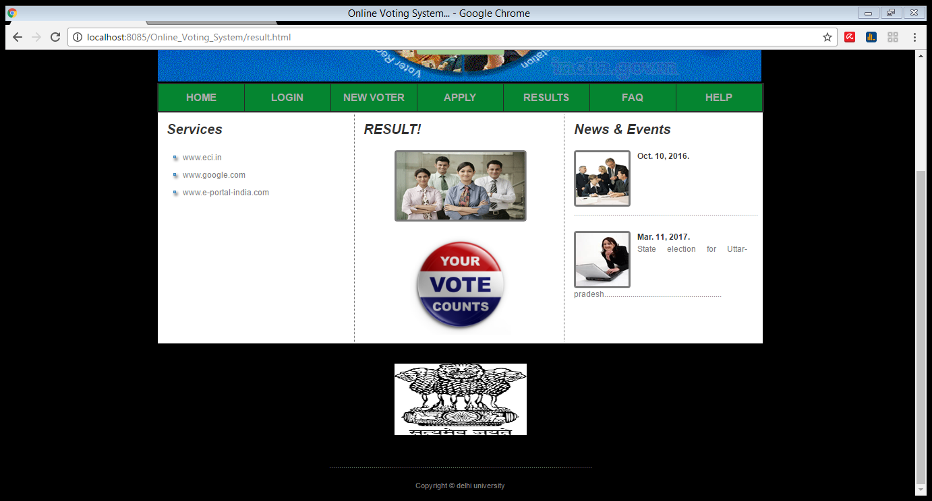

**6.FAQ:** Here some general questions answer related to web are given.

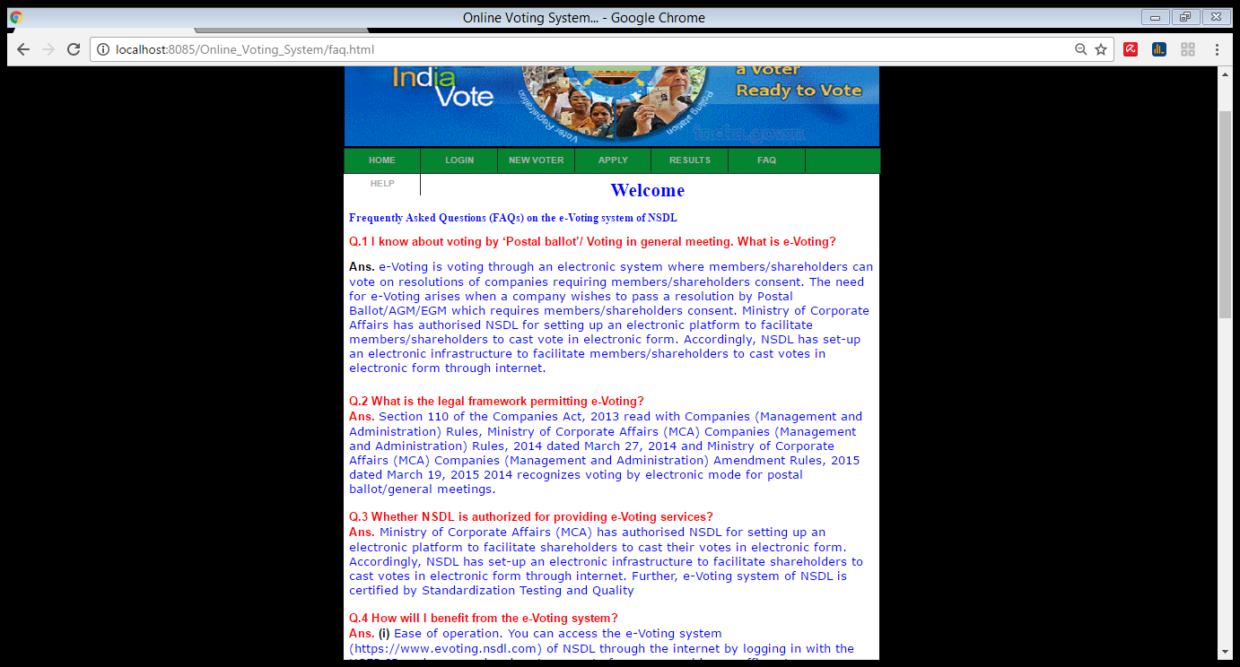

**7.HELP:** this is help page where anyone can complain

or write their suggestions.

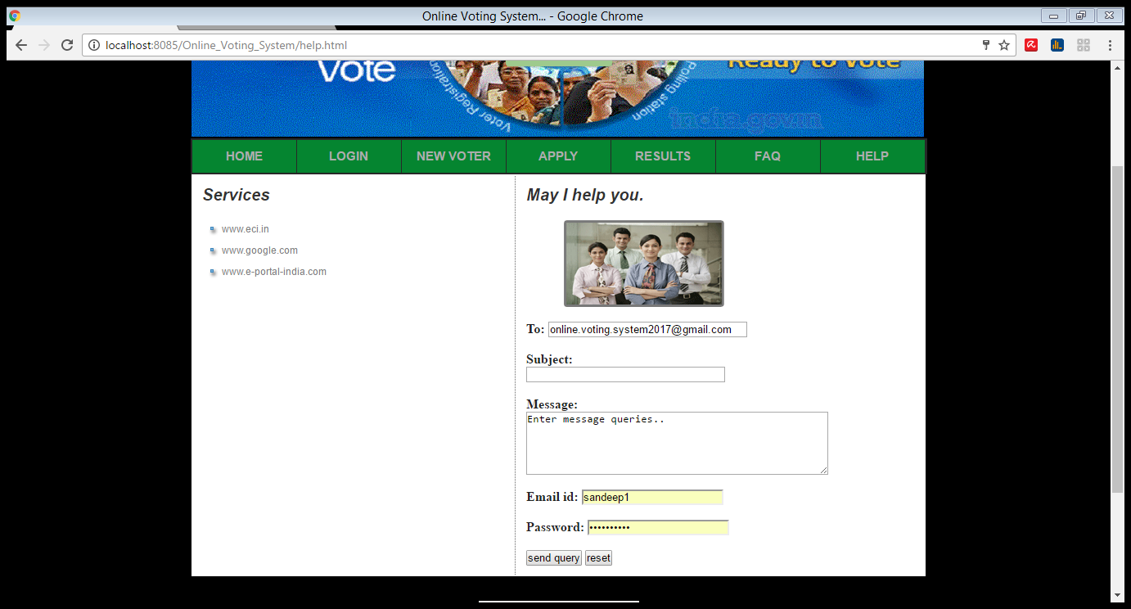

**CONCLUSION**

This Online Voting system will manage the Voter’s information by which voter can login and use his voting rights. The system will incorporate all features of Voting System. It provides the tools for maintaining voter’s vote to every party and it count total no. of votes of every party. There is a DATABASE which is maintained by the ELECTION COMMISION OF INDIA in which all the names of voter with complete information is stored.

In this user who is above 18 year’s register his/her information on the database and when he/she want to vote he/she has to login by his id and password and can vote to any party only single time. Voting detail store in database and the result is displayed by calculation. By online voting system percentage of voting is increases. It decreases the cost and time of voting process. It is very easy to use and it is vary less time consuming. It is very easy to debug.