**Lab no:7**

**Objective:**

To Understand Multithreading.

**Task:**

Write the same code for matrix multiplication and divide the code into ten threads. Also note the timestamp at the start and end of the program. Give your conclusion.

**Matrix Multiplication Without Threading:**

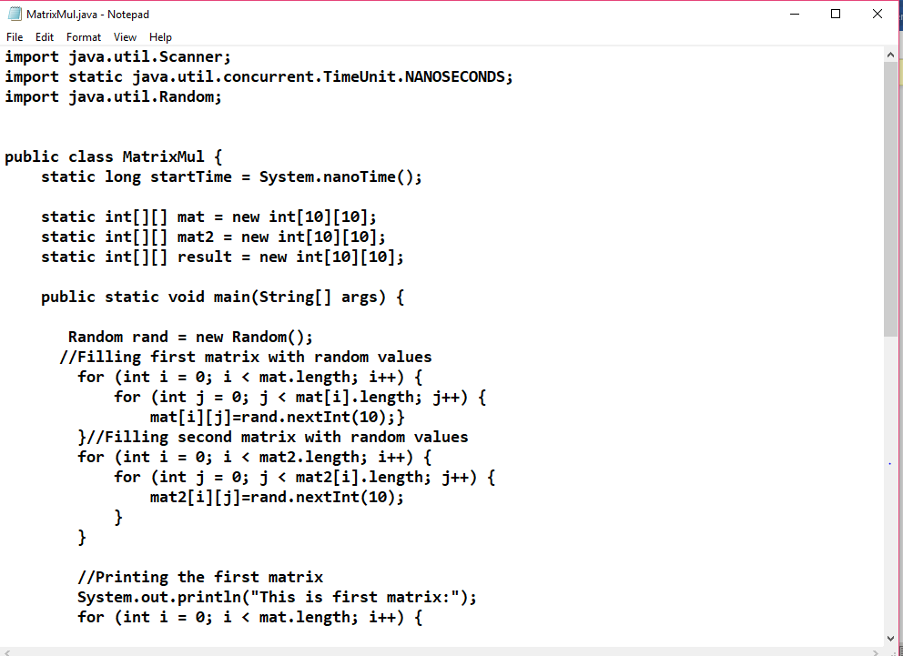

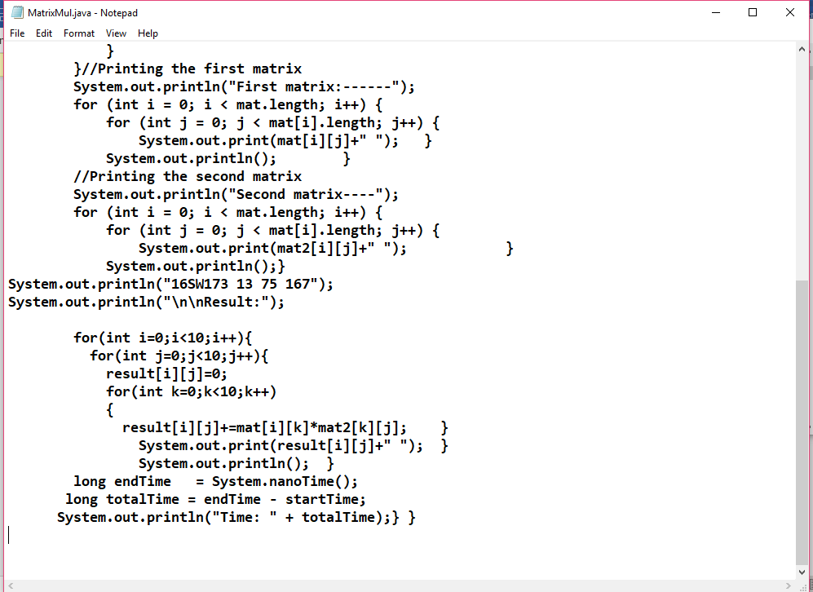

Result:

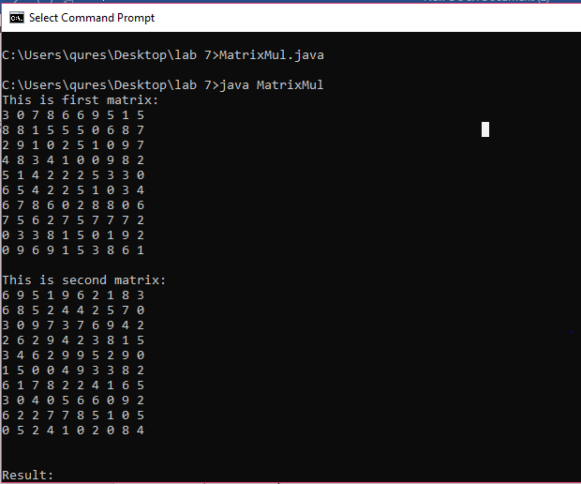

RESULT

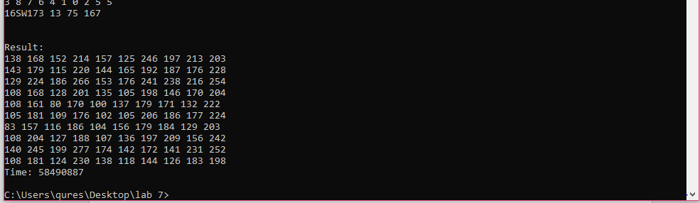

TASK 2

**Matrix Multiplication With Threading:**

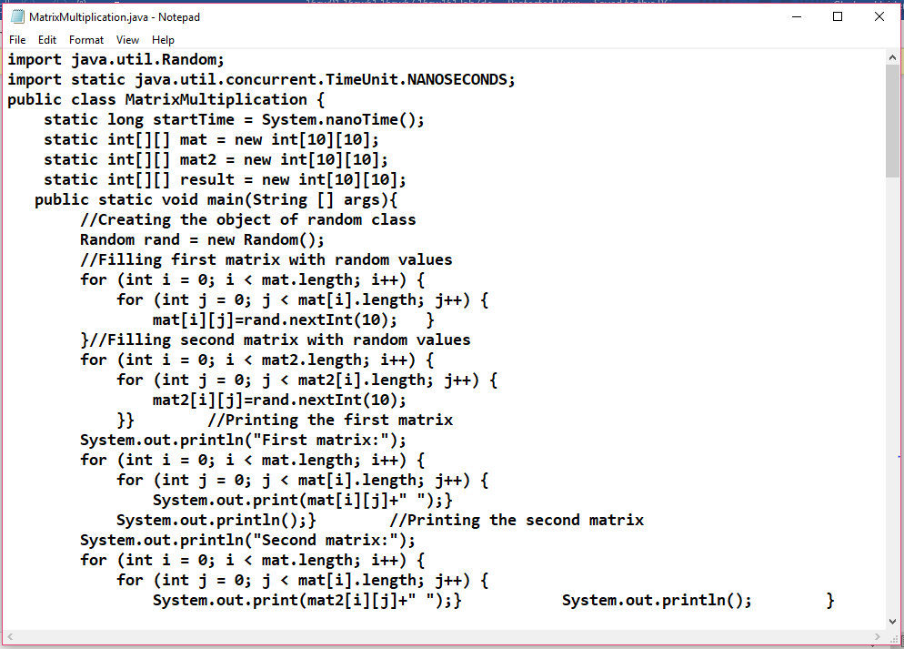

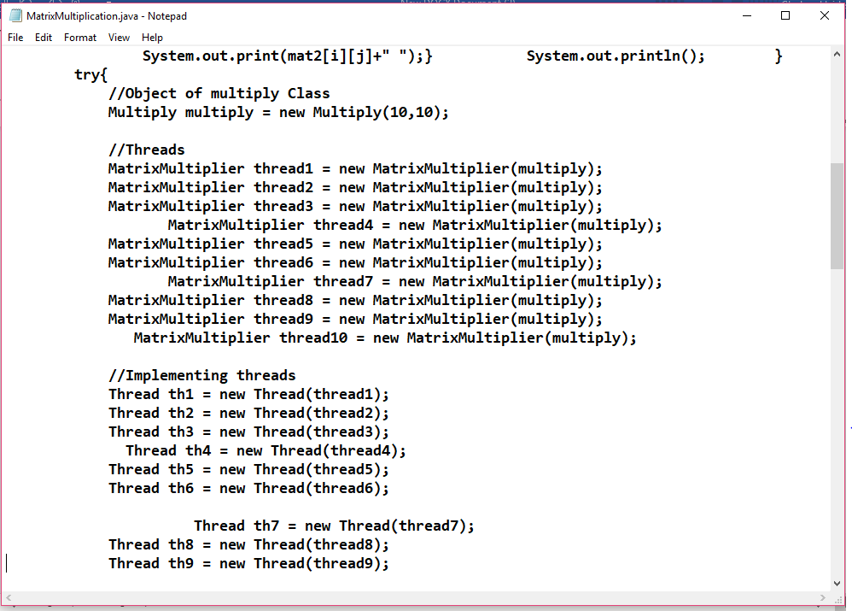

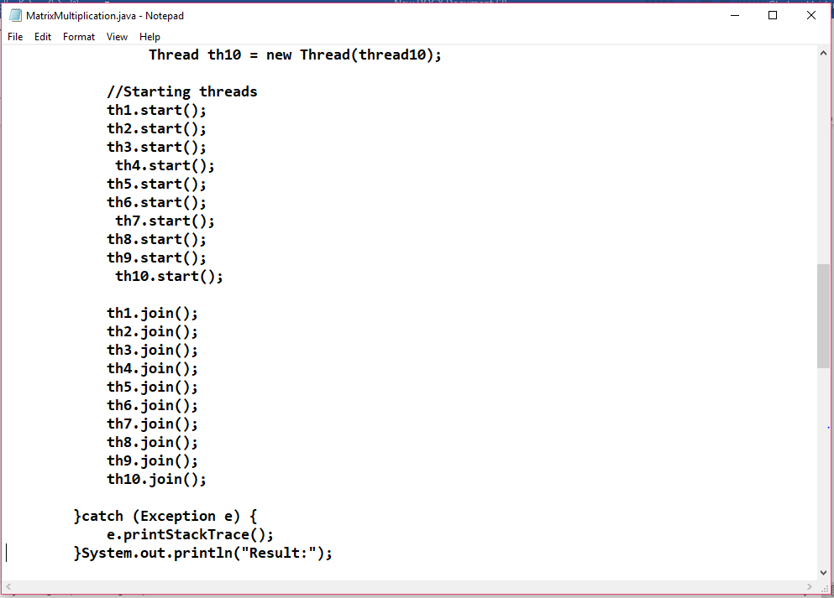

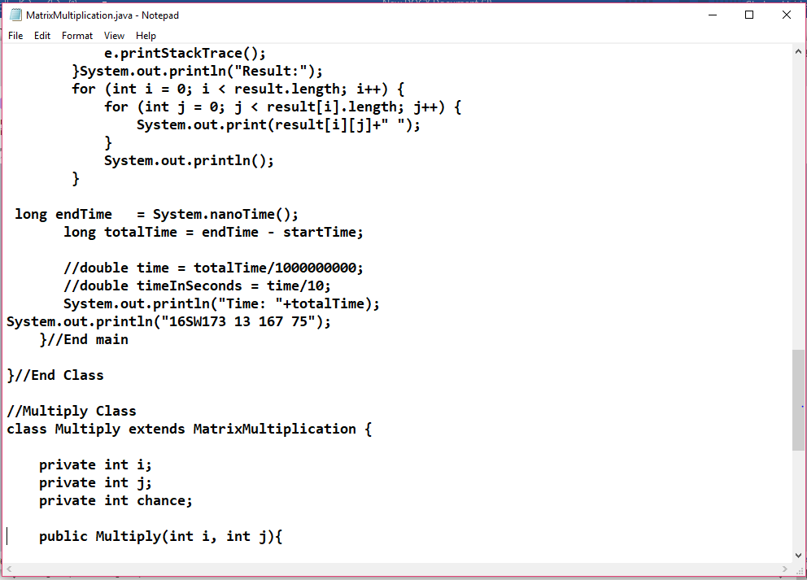

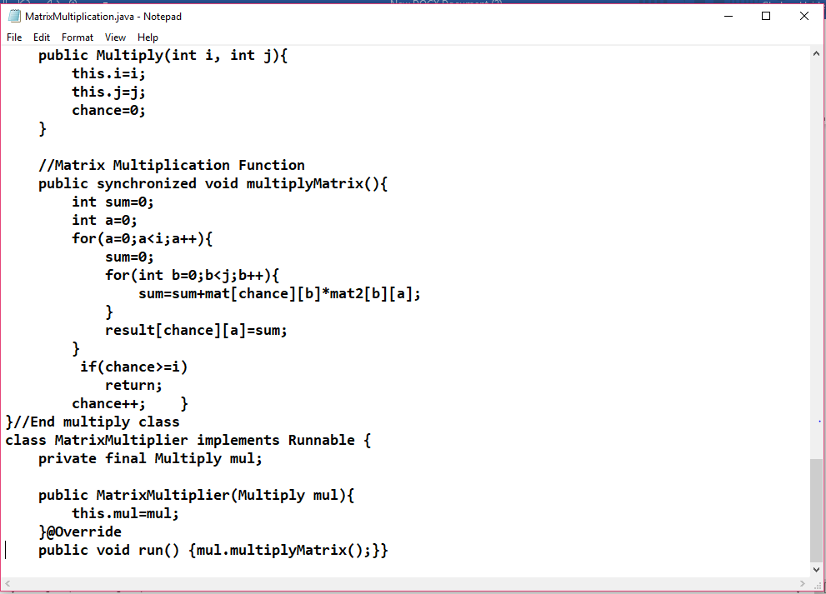

RESULT:

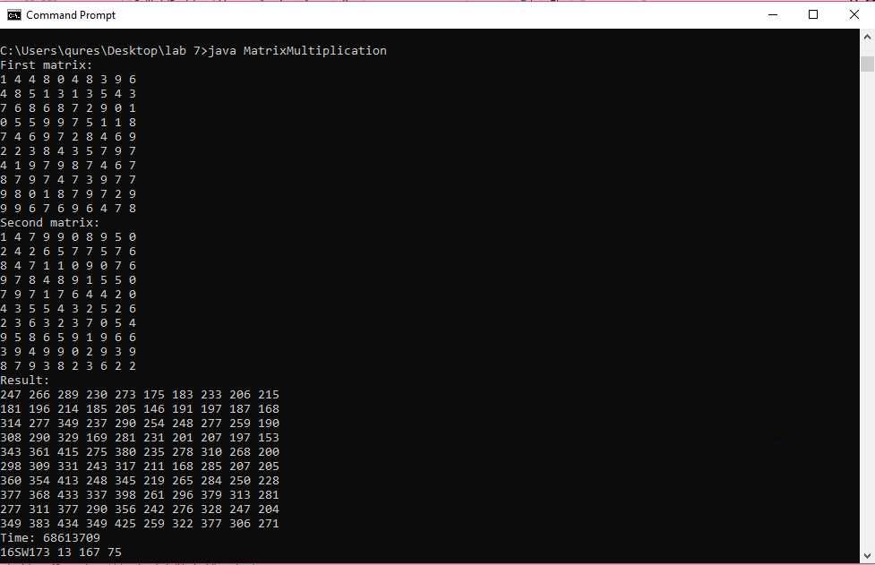

**Conclusion**

**Matrix Multiplication WithThreading time :58490887**

**Matrix Multiplication without Threading time :** **68613709**

**It is observed that matrix multiplication without Threading takes time more than matrix multiplication with Threading**